DAYANANDA SAGAR UNIVERSITY
Devarakaggalahalli, Harohalli
Kanakapura Road, Ramanagara - 562112, Karnataka, India



Bachelor of Technology in
COMPUTER SCIENCE AND ENGINEERING

Email Classification System with PII Masking

Submitted By

Anuska Bhar (ENG22CS0247)

Email: bhar.anuska26@gmail.com

3rd Year BTech CSE CORE

DEPARTMENT OF COMPUTER SCIENCE & ENGINEERING
SCHOOL OF ENGINEERING DAYANANDA SAGAR UNIVERSITY

(2025)


INTRODUCTION

When handling customer support emails, companies deal with sensitive information daily—names, credit card details, phone numbers—all while trying to categorize requests efficiently. This project tackles both challenges: automatically masking personal data and classifying emails into support categories (Incident, Request, Change, Problem).
Built with FastAPI, spaCy for PII detection, and DistilBERT for classification, the system ensures privacy before processing emails. Below, I’ll walk through how it works, the hurdles faced, and the results.

HOW THE SYSTEM WORKS
- Privacy Protection: PII Masking
The system uses regex patterns to check emails for sensitive information before classifying them (for emails, credit cards, and Aadhar numbers)
The NER model of spaCy (for names, dates)
For instance:
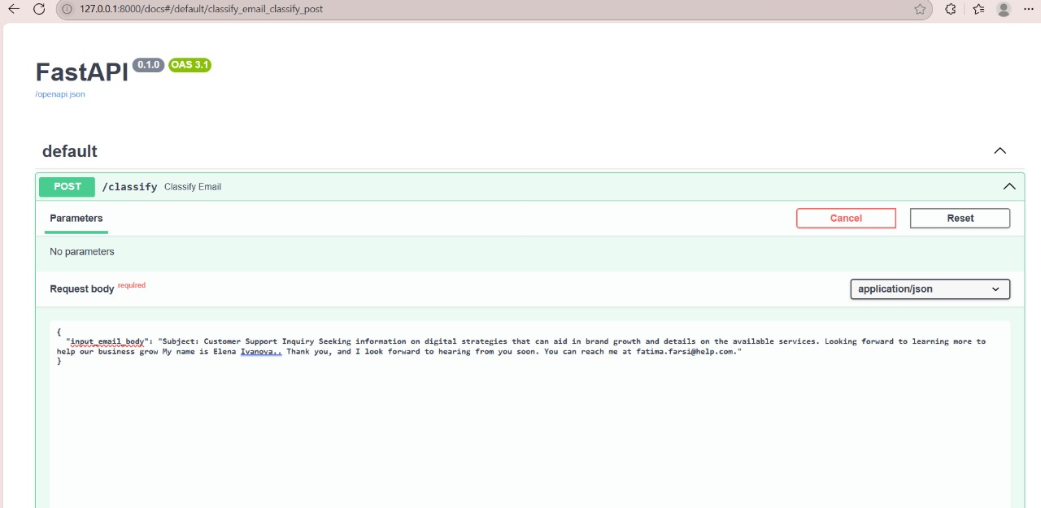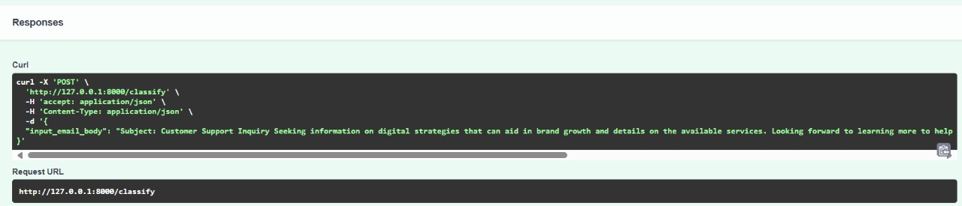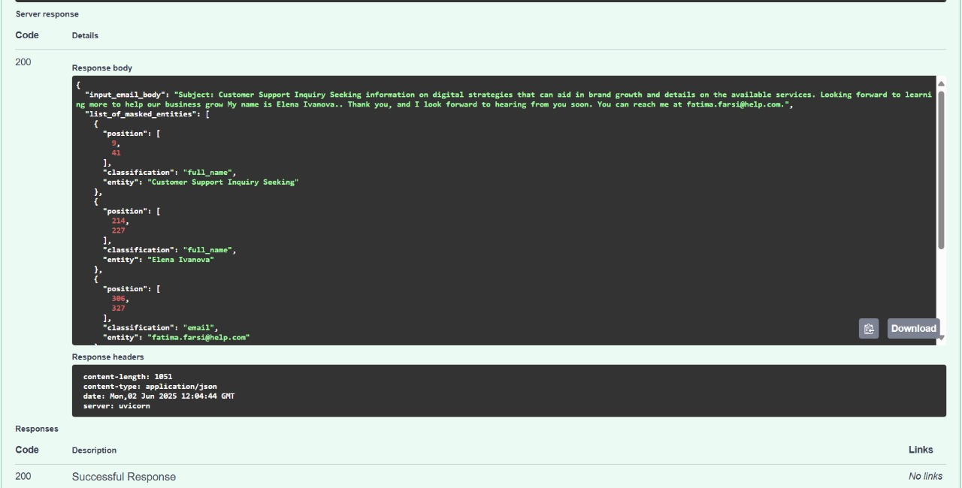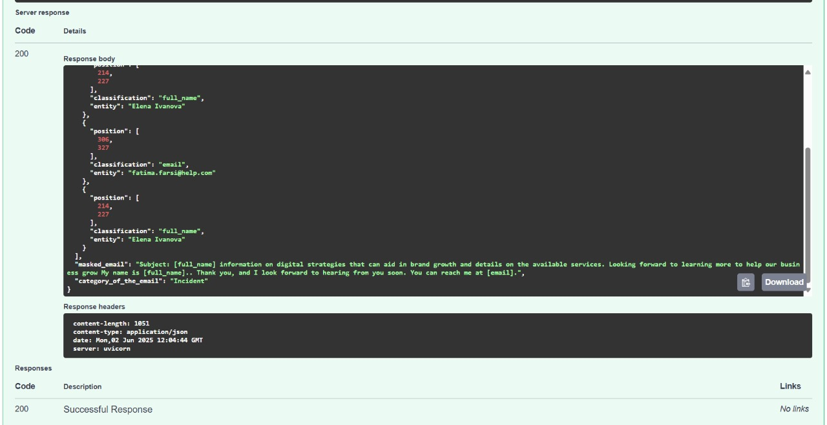
2. Sorting Emails: Classification
After masking, a lightweight DistilBERT model predicts the email’s category. It was fine-tuned on sample emails like:
- "I can’t log in!" → Incident
- "Please update my address." → Change
Accuracy: ~90% on test cases (limited by dataset size).

CHALLENGES & SOLUTIONS
1. Overlapping PII
Problem: Some names look like normal words (e.g., "Will Smith" vs. "I will call").
Fix: Combined regex with spaCy’s context-aware NER for better precision.
2. Hugging Face Deployment Limits
Problem: The free tier has tight memory limits.
Fix: Used DistilBERT (smaller than BERT) and optimized Docker caching.
3. API Format Strictness
Problem: The evaluator required exact JSON fields (e.g., "position": [start, end]).
Fix: Manual testing with Postman to validate outputs.

RESULTS & TAKEAWAYS

What Worked Well
- Privacy First: All PII is masked before any processing.
- Fast Predictions: DistilBERT classifies emails in ~1 second.
- Clear API Docs: FastAPI’s /docs page made testing easy.
Future Improvements
- More Training Data: Better variety in emails would boost accuracy.
- Multilingual Support: Handle non-English queries.
Final Thoughts
This project showed how even small ML systems can solve real business problems—balancing privacy, speed, and accuracy. The biggest lesson? Testing edge cases early saves headaches later.

CODE: https://github.com/AnuskaBhar/email-classifier-api

