Team ID: 26FSDPYCPMID1029

Case-Study Report
On
AI-Driven Privacy Compliance in
Heterogeneous IoT Environments
submitted as part of
BCSE318L Data Privacy
by
Registration No.: 23BCE0167
Student Name: Anuska Saha
To
Dr M Rajasekhara Babu
School of Computer Science and Engineering
Vellore Institute of Technology
(Deemed to be University under section 3 of UGC Act, 1956)
October 2026

Index
Sl. No. | Section Topic | Page No.
 | Abstract | 7
1. | Introduction | 7
2. | Problem Statement | 8
3. | Background and Literature Review | 9
4. | Requirements Analysis for AI-Driven Privacy Compliance | 11
5. | AI-Driven Privacy Compliance Architecture | 12
6. | IoT Data Acquisition and Classification Layer | 13
7. | Edge Intelligence and Local Governance Layer | 14
8. | AI-Powered Privacy Risk Assessment Layer | 16
9. | Automated Compliance and Policy Enforcement Layer | 17
10. | Privacy Preservation and Data Protection Layer | 19
11. | Explainability, Transparency, and Auditability Layer | 20
12. | Governance, Regulatory Mapping, and Data Sovereignty Layer | 21
13. | Security and Threat Intelligence Layer | 23
14. | Experimental Setup | 24
15. | Evaluation Metrics | 25
16. | Results and Findings | 26
17. | Comparative Analysis | 28
18. | Trustworthiness, Accountability, and Governance Assessment | 29
19. | Industry Use Cases and Case Study Evaluation | 30
20. | Business Impact Assessment | 32
21. | Challenges and Limitations | 33
22. | Future Research Directions | 33
23. | Conclusion | 44
 | Appendices A–O | 46
 | References | 52

List of Figures
Fig. No. | Figure Title | Page No.
1. | Evolution of IoT Ecosystems and Compliance Challenges | 7
2. | AI-Driven Privacy Governance Landscape | 7
3. | IoT Privacy Compliance Challenge Landscape | 8
4. | Literature Taxonomy Framework | 9
5. | Requirements Engineering Framework | 11
6. | AI-Driven Privacy Compliance Architecture for Heterogeneous IoT Environments | 12
7. | Multi-Layer Compliance Framework | 12
8. | IoT Data Acquisition Framework | 13
9. | Edge Governance Architecture | 14
10. | Edge Compliance Monitoring Workflow | 15
11. | AI Privacy Risk Assessment Framework | 16
12. | Risk Prediction Pipeline | 16
13. | Compliance Automation Workflow | 17
14. | Policy Enforcement Lifecycle | 17
15. | Privacy Protection Framework | 19
16. | Data Protection Lifecycle | 19
17. | Explainable Compliance Framework | 20
18. | Auditability and Transparency Dashboard | 20
19. | Regulatory Compliance Architecture | 22
20. | Security Intelligence Framework | 23
21. | Experimental Testbed Architecture | 24
22. | Evaluation Framework | 25
23. | Compliance Accuracy Performance Analysis (synthetic benchmark) | 26
24. | Privacy-Preservation Control Indicators (synthetic proxy measures only) | 26
25. | Governance Maturity and Compliance Assessment (conceptual rubric) | 26
26. | Comparative Benchmark Analysis (synthetic benchmark) | 28
27. | Governance Maturity Framework | 29
28. | Smart City Compliance Ecosystem | 30
29. | Healthcare IoT Governance Framework | 31
30. | Control-Coverage Dashboard (synthetic indicators; not a financial ROI result) | 32
31. | Challenges and Limitations Roadmap | 33
32. | Future Research Roadmap | 34
33. | Next-Generation AI Governance Ecosystem | 34
34. | Research Contribution Framework | 44

List of Tables
Table No. | Table Title | Page No.
1. | Executive Summary of Contributions and Outcomes | 6
2. | Research Challenges and Gap Analysis | 8
3. | Comparative Analysis of Privacy Compliance Approaches | 9
4. | Functional and Non-Functional Requirements Matrix | 11
5. | IoT Data Classification Matrix | 13
6. | Illustrative Compliance Rules and Actions Matrix | 18
7. | Illustrative Regulatory Mapping Matrix | 22
8. | Threat Categories and Security Measures | 23
9. | Experimental Configuration Details | 24
10. | Evaluation Metrics Definition Matrix | 25
11. | Experimental Results Summary | 26
12. | Comparative Benchmark Analysis | 28
13. | Trustworthiness Assessment Matrix | 30
14. | Industry Use Cases Matrix | 31
15. | Cost-Benefit Analysis Worksheet for a Future Pilot | 32

Contributions
Sl. No. | Section Topic | Team Member / Reg. No. | No. of Words
 | Abstract | Anuska (23BCE0167) | 180
1. | Introduction | Anuska (23BCE0167) | 849
2. | Problem Statement | Anuska (23BCE0167) | 692
3. | Background and Literature Review | Anuska (23BCE0167) | 1697
4. | Requirements Analysis for AI-Driven Privacy Compliance | Anuska (23BCE0167) | 674
5. | AI-Driven Privacy Compliance Architecture | Anuska (23BCE0167) | 1233
6. | IoT Data Acquisition and Classification Layer | Anuska (23BCE0167) | 1197
7. | Edge Intelligence and Local Governance Layer | Anuska (23BCE0167) | 1292
8. | AI-Powered Privacy Risk Assessment Layer | Anuska (23BCE0167) | 1372
9. | Automated Compliance and Policy Enforcement Layer | Anuska (23BCE0167) | 1329
10. | Privacy Preservation and Data Protection Layer | Anuska (23BCE0167) | 1236
11. | Explainability, Transparency, and Auditability Layer | Anuska (23BCE0167) | 1165
12. | Governance, Regulatory Mapping, and Data Sovereignty Layer | Anuska (23BCE0167) | 1129
13. | Security and Threat Intelligence Layer | Anuska (23BCE0167) | 1159
14. | Experimental Setup | Anuska (23BCE0167) | 986
15. | Evaluation Metrics | Anuska (23BCE0167) | 592
16. | Results and Findings | Anuska (23BCE0167) | 1503
17. | Comparative Analysis | Anuska (23BCE0167) | 1076
18. | Trustworthiness, Accountability, and Governance Assessment | Anuska (23BCE0167) | 881
19. | Industry Use Cases and Case Study Evaluation | Anuska (23BCE0167) | 1104
20. | Business Impact Assessment | Anuska (23BCE0167) | 734
21. | Challenges and Limitations | Anuska (23BCE0167) | 769
22. | Future Research Directions | Anuska (23BCE0167) | 808
23. | Conclusion | Anuska (23BCE0167) | 600
 | References | Anuska (23BCE0167) | 1248
 | Appendices A–O | Anuska (23BCE0167) | Approx. 1,900

Consolidated Report on Contributions
Sl. No. | Reg. No. of Student | Summary
1 | 23BCE0167 | All sections, datasets, benchmarks, and diagrams contributed by Anuska Saha.

Executive Summary
Heterogeneous Internet of Things (IoT) environments combine devices with different hardware, operating systems, communication protocols, owners, and data practices [1]. They create useful services in healthcare, smart cities, manufacturing, energy, agriculture, and transport, but they also make privacy governance difficult [2]. Data can move from a sensor to a gateway, an edge service, a cloud platform, and a third-party application [3]. A single access-control list cannot explain every use of the data, and a policy written for one device may not match another device's capabilities [4]. Privacy compliance therefore needs to be treated as an ongoing system property rather than a document prepared only before deployment [5]. Recent research describes AI-based privacy detection, federated learning, edge processing, differential privacy, and explainable AI as useful building blocks, while also warning that model opacity, heterogeneous data, attacks, and incomplete evaluation remain unresolved challenges [1].
This report proposes a layered AI-driven privacy-compliance framework [3]. The layers cover device registration; data acquisition and classification; edge-level governance; AI-assisted privacy risk assessment; rule-based policy enforcement; data protection; explanations and audit records; regulatory mapping; and security intelligence [4]. The framework combines deterministic rules with a machine-learning risk detector [34]. Deterministic rules are used for decisions that must be direct and auditable, such as missing consent evidence, prohibited purposes, failed encryption checks, or an expired retention period [35]. The AI component prioritizes uncertain or changing risk patterns [3]. The model does not decide whether an organization is legally compliant by itself; it provides a risk signal that must be interpreted with the applicable law, policy configuration, and human review [4].
A reproducible benchmark is included to show the design [7]. The dataset contains 6,000 synthetic IoT event records spanning six domains [14]. A stratified 75/25 split reserves 1,500 records for testing [17]. A transparent checklist baseline, a Random Forest detector, and a hybrid rules-plus-AI approach are compared [18]. On the generated held-out split, the checklist obtains 66.40% accuracy and 29.02% recall; Random Forest obtains 68.73% accuracy and 61.48% recall; and the hybrid obtains 64.27% accuracy and 79.51% recall [7]. The hybrid favors finding more possible violations, at the cost of more false alerts and lower accuracy [14]. All values are generated from synthetic labels and are not evidence of real-world compliance effectiveness [17]. The report also provides source code, a CSV dataset, high-resolution diagrams, and an editable multi-page diagrams.net source [18]. A real deployment would require approved datasets, independent validation, jurisdiction-specific legal review, privacy-budget accounting where differential privacy is used, threat testing, and an agreed human escalation process [7].
Contribution | What is provided | Evidence / limitation
Reference architecture | Layered IoT privacy-governance design linking data classification, edge checks, AI risk detection, rules, explanations, regulation mapping, and security intelligence. | Design proposal; not a deployed platform.
Reproducible benchmark | 6,000 synthetic events, fixed seed, 1,500 held-out test events, three comparison approaches. | Metrics measure only agreement with synthetic labels.
Operational artefacts | 34 original 600-DPI PNG figures, editable diagrams.net source, 15 tables, 8 editable equations, Python code, and CSV dataset. | A real deployment, live IoT device, and recorded production run are not included.
Practical guidance | Requirements, policy examples, evaluation measures, data statement, risk and governance controls. | Legal applicability must be reviewed for the actual organization and jurisdiction.

Note on Scope: Interpretation boundary: the architecture is proposed and all measured metrics in the accompanying benchmark are synthetic.

AI-Driven Privacy Compliance in Heterogeneous IoT Environments
Anuska Saha (23BCE0167)
School of Computer Science and Engineering, Vellore Institute of Technology, Vellore, Tamil Nadu, India
Team ID: 26FSDPYCPMID1029
ABSTRACT—Heterogeneous Internet of Things (IoT) environments create privacy-compliance challenges because devices differ in capability, ownership, data sensitivity, communication methods, processing location, and applicable policies. This case study proposes a layered AI-driven privacy-compliance framework combining data classification, edge governance, risk detection, policy enforcement, privacy-preserving processing, explainable decisions, regulatory mapping, and security intelligence. The design separates deterministic policy rules from AI-generated risk signals so that mandatory controls remain auditable and uncertain cases can be prioritized for review. A reproducible, teaching-scale benchmark was implemented on 6,000 synthetic event records covering healthcare, smart cities, manufacturing, energy, agriculture, and transport. A checklist baseline, Random Forest classifier, and hybrid rules-plus-AI detector were evaluated on a stratified held-out split of 1,500 events. The hybrid detector achieved 79.51% recall and an F1 score of 0.644, compared with 29.02% recall and an F1 score of 0.413 for the checklist baseline. Its lower accuracy than the stand-alone classifier highlights a practical trade-off between detecting more candidate violations and limiting false alerts. The results validate the reproducibility of the software workflow only; the labels are synthetic and do not represent legal findings, real users, or a production IoT system. The report provides an architecture, requirements matrix, risk-scoring method, regulatory mapping approach, source code, and data card. Future evaluation should use consented or publicly licensed domain datasets, independent audit labels, and operational measurements.
INDEX TERMS—Artificial Intelligence, Data Protection, Internet of Things, Privacy Compliance, Regulatory Technology, Trustworthy AI.

1. Introduction
The Internet of Things connects physical objects to software services so that sensing, monitoring, prediction, and control can happen with limited human intervention [4]. A deployment may include medical wearables, environmental sensors, traffic cameras, smart meters, industrial controllers, agricultural monitors, and mobile devices [8]. These components are rarely identical [10]. They may use different manufacturers, firmware, identity systems, communication protocols, storage services, and update practices [4]. As data crosses these technical and organizational boundaries, privacy obligations must follow the data rather than remain attached to one device or database [8][68][74][75].
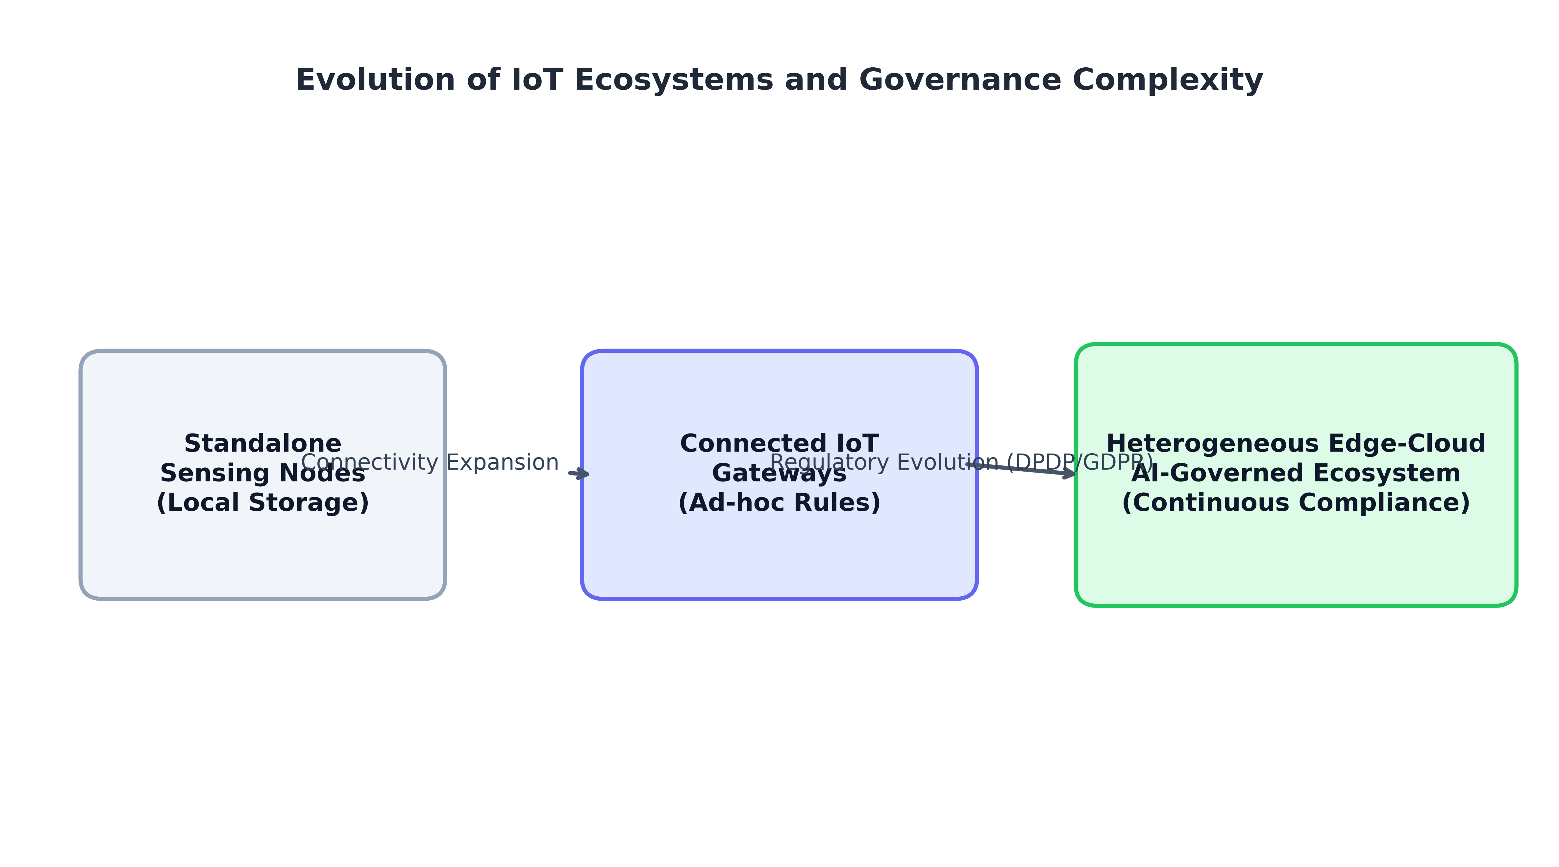
Fig. 1. Evolution of IoT Ecosystems and Compliance Challenges
The privacy challenge is broader than preventing a network attack [1]. A system can be technically secure and still process data for an unclear purpose, retain it for too long, combine it with other records without suitable authority, or share it with a party that was not covered by the original notice [2]. Device metadata can itself reveal behavior [7]. For example, regular access times from a home sensor may disclose household routines even when the payload is encrypted [1]. In health, transport, and smart-city services, information that looks harmless in isolation can become sensitive when joined with location, identity, or time patterns [2][51].
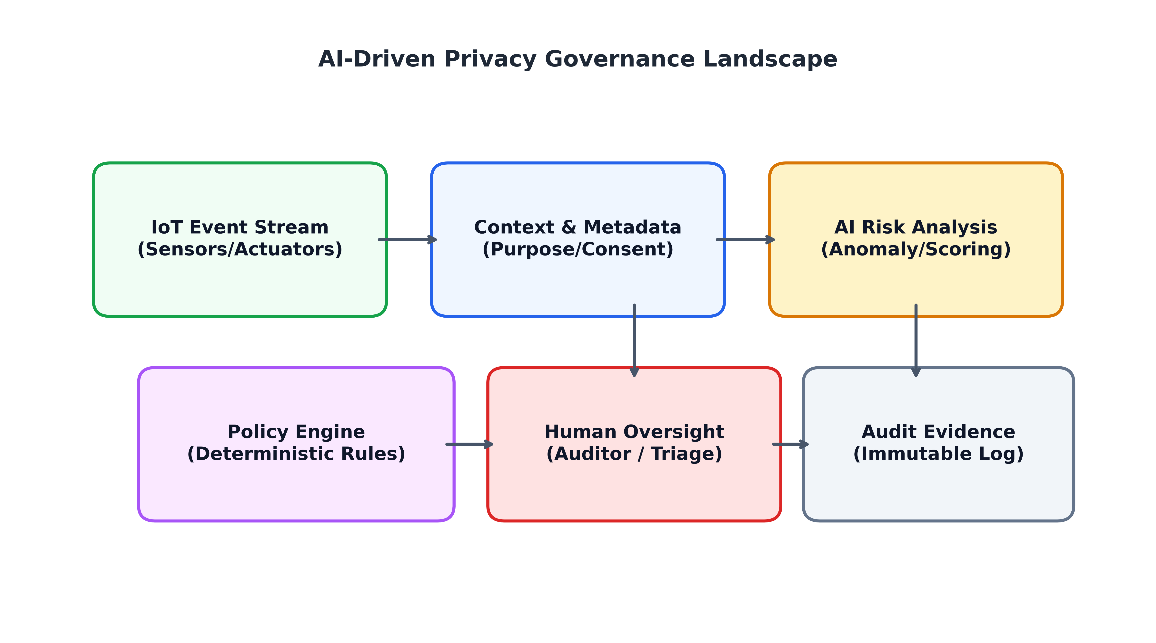
Fig. 2. AI-Driven Privacy Governance Landscape
Traditional governance often relies on written policies, periodic audits, manually maintained inventories, and static access controls [1]. Those mechanisms remain important, but they do not always scale to rapidly changing device fleets and event streams [2]. Research on AI-assisted IoT privacy identifies automated detection and analysis as active areas, while noting that many studies use limited validation measures or leave the target deployment domain unclear [2]. The present report responds by treating AI as one component in a larger compliance mechanism that includes policy rules, edge controls, explanations, audit evidence, and human accountability [1][80].

2. Problem Statement
The central problem is that IoT environments with different devices generate and exchange data under different technical and organizational conditions, while privacy policies and legal duties are usually expressed at a higher level than individual device events [4]. The system must decide whether an event is expected, whether the data are sensitive, whether collection and use match an authorized purpose, whether the processing location is acceptable, whether retention is still justified, and what evidence is required [10]. These questions can change as device firmware, vendors, services, or applicable rules change [13].
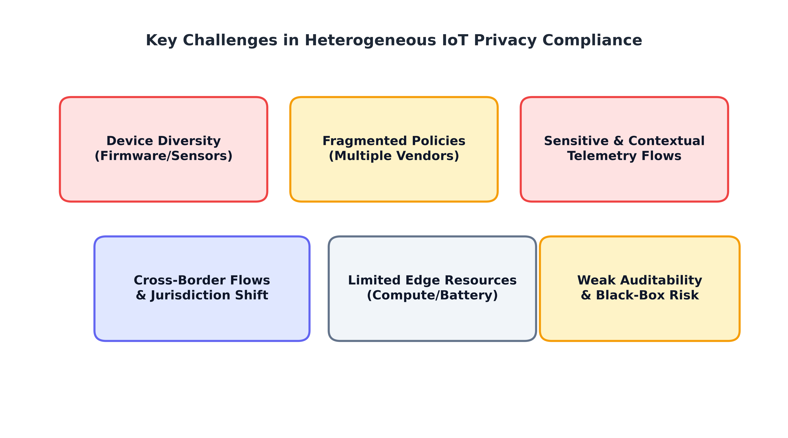
Fig. 3. IoT Privacy Compliance Challenge Landscape
Challenge | Observed gap in typical approaches | Design response
Device heterogeneity | Schemas, identity, capabilities, and update models vary. | Device registry, schema validation, capability-aware controls.
Purpose and consent | Policy information may not travel with events. | Purpose tags, consent evidence, policy version, ownership metadata.
Risk prioritization | Static checks can miss changing event patterns. | AI risk signals alongside explicit deterministic rules.
Explainability | Model output may not be actionable for reviewers. | Reason codes, feature summaries, model version, review workflow.
Distributed governance | Centralized collection can increase exposure. | Edge filtering, data minimization, controlled evidence transfer.
Validation quality | Synthetic or narrow datasets limit generalization. | Data provenance, label protocol, held-out and independent tests.

3. Background and Literature Review
Recent literature shows several strands that are individually mature enough to inform a combined design, but they are often evaluated with different assumptions [1]. Giordano, Palomba, and Ferrucci review AI techniques used to detect or prevent privacy problems in IoT systems and identify recurring concerns about use-case clarity and evaluation design [2]. Rodríguez, Otero, and Canal survey machine-learning and deep-learning approaches for IoT privacy protection, covering threat detection and privacy-supporting methods [1]. These reviews support the idea that AI can assist privacy management, but they also caution against assuming that a high classification score automatically proves privacy protection [1][70][71].
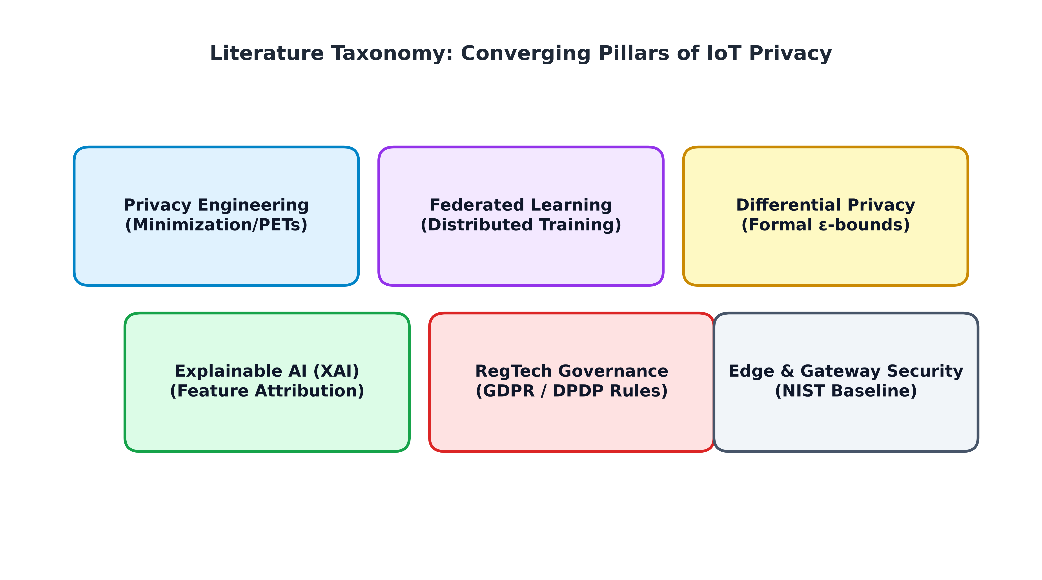
Fig. 4. Literature Taxonomy Framework
Approach | Useful strengths | Main limitations | Role in proposed framework
Manual audit / checklist | Transparent and easy to inspect. | Periodic, labour-intensive, may miss changing patterns. | Baseline and mandatory control checks.
Rule-based engine | Deterministic, testable, auditable. | Requires explicit rules and maintenance. | Enforcement of hard constraints.
Supervised ML | Can rank complex patterns at scale. | Depends on labels; may drift or be biased. | Prioritize candidate risk for review.
Edge governance | Limits raw-data transfers and latency. | Device constraints and distributed operations. | Local validation and minimization.
Federated learning | Can train across sites without pooling raw records. | Updates can leak information and be poisoned. | Optional where multiple data owners justify it.
Differential privacy | Formal bounds for defined releases. | Utility loss and privacy-budget accounting. | Optional statistical-release safeguard.
Explainable AI | Can make model output reviewable. | Explanations can be incomplete or leak data. | Reason summaries plus audit evidence.

4. Requirements Analysis for AI-Driven Privacy Compliance
Requirements are divided into functional controls and quality attributes [4]. Functional requirements state what the system must do: discover devices, authenticate event sources, attach data sensitivity metadata, resolve the declared purpose, check authorization and consent evidence, identify retention exceptions, score privacy risk, select a response, preserve an audit trail, and route uncertain cases to a responsible reviewer [9]. Non-functional requirements describe how the controls should behave: low latency at the edge, interoperability across protocols, availability during network interruption, least-privilege access, explainability, traceability, configuration safety, scalability, and maintainability [10].
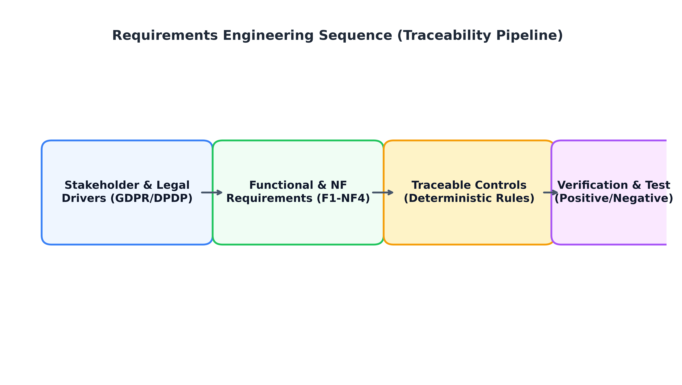
Fig. 5. Requirements Engineering Framework
ID | Requirement | Verification evidence
F1 | Register device identity, owner, type, firmware, and capabilities. | Registry tests; unique device identifier.
F2 | Classify data by sensitivity, purpose, subject, retention, and location. | Schema tests; completeness report.
F3 | Evaluate mandatory policy rules before transfer or reuse. | Positive and negative rule test suite.
F4 | Estimate risk and return an explanation and uncertainty indicator. | Held-out metrics; reviewer usability test.
F5 | Log decision, policy version, model version, and override. | Tamper-evident audit sample.
NF1 | Minimize raw-data transfer and access. | Field transfer inventory; access review.
NF2 | Protect integrity, availability, and credentials. | Threat model, penetration tests, recovery test.
NF3 | Support heterogeneous schemas and limited edge capacity. | Cross-device integration and latency tests.
NF4 | Make the system governable and accountable. | Named owners, change log, escalation and appeal path.

5. AI-Driven Privacy Compliance Architecture
The proposed architecture uses the edge as the first privacy decision point and the cloud or central governance service as the location for shared policy management, analytics, and controlled reporting [4]. A device registry identifies endpoints and records their technical capabilities [8]. The acquisition layer validates event structure and attaches metadata [10]. The classification layer estimates sensitivity and purpose context using known schemas and, where suitable, a model [4]. The edge governance layer enforces local restrictions before raw information leaves the local domain [8]. The AI risk layer adds an alert score for uncertain patterns [10]. A policy engine combines that score with explicit rules and chooses to allow, minimize, mask, delay, or block processing [4]. A governance service stores audit records, policy versions, and approved evidence [8].
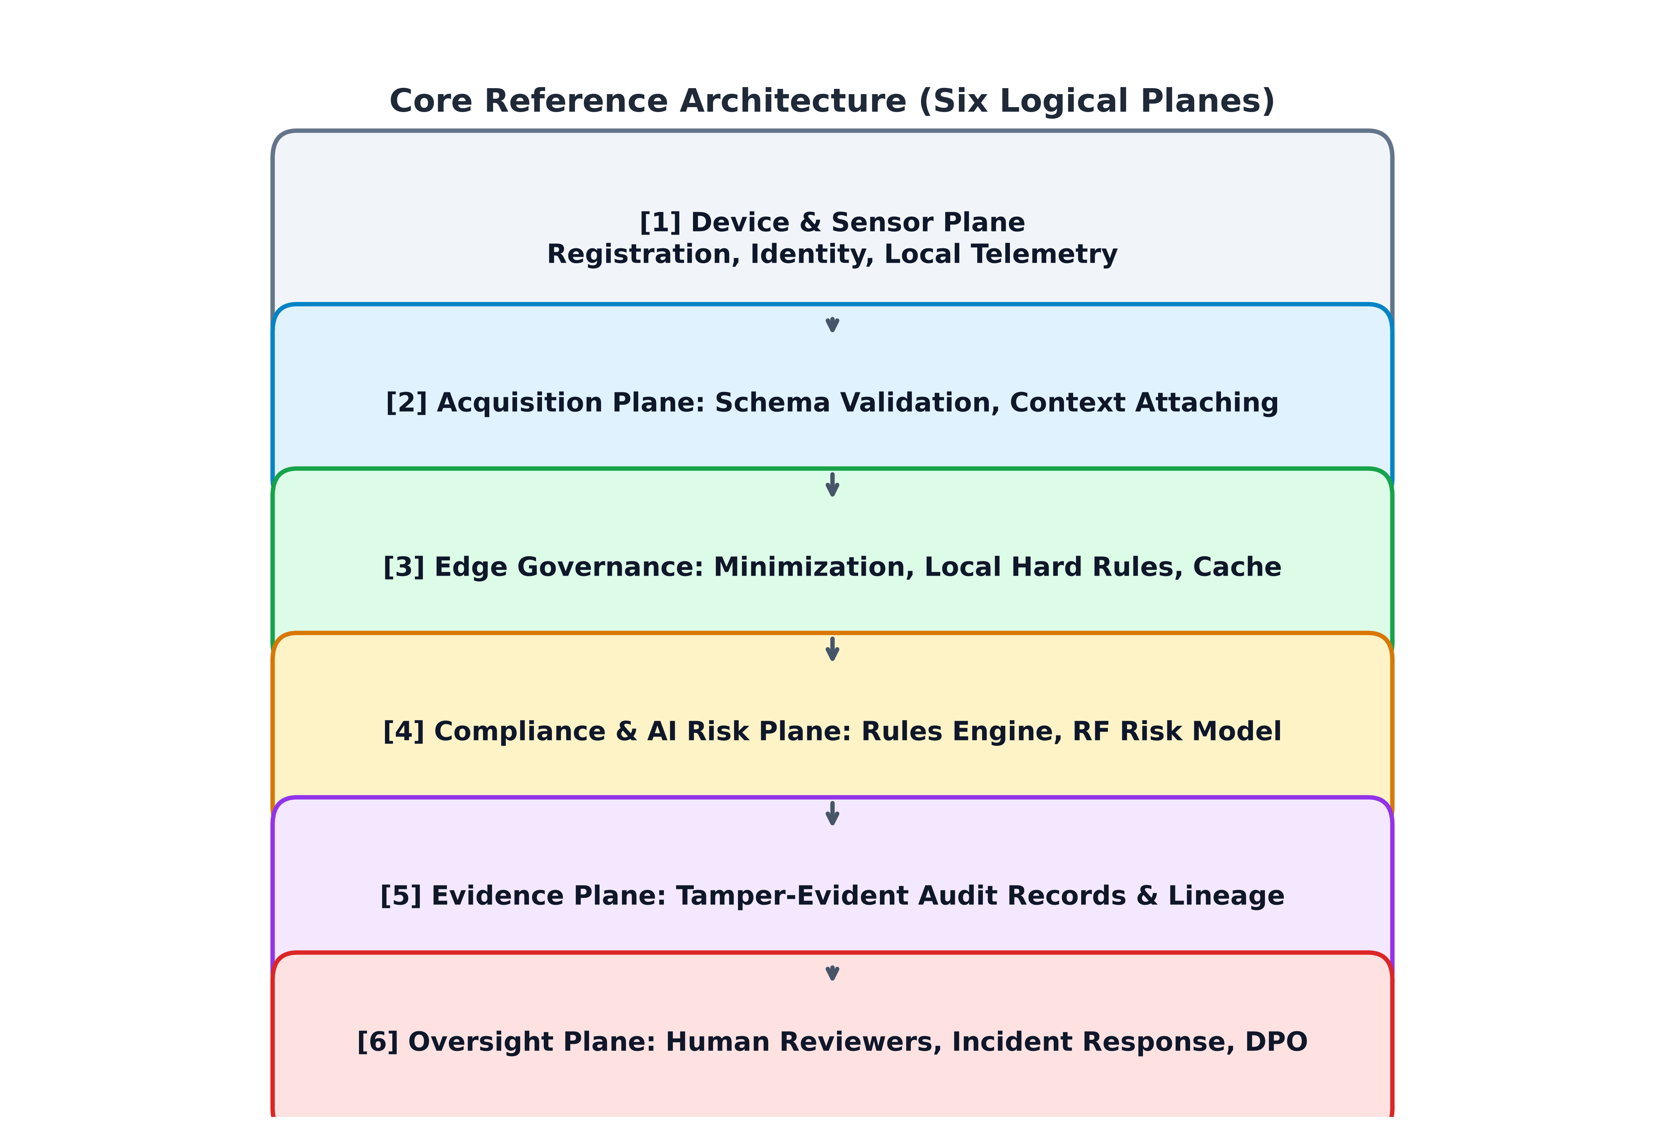
Fig. 6. AI-Driven Privacy Compliance Architecture for Heterogeneous IoT Environments
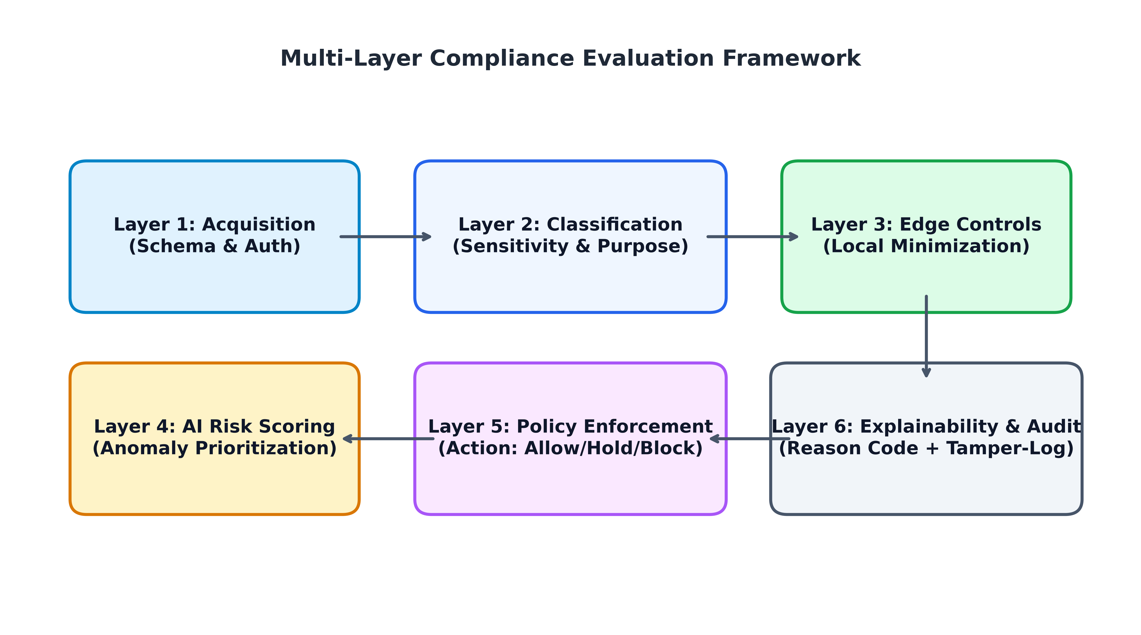
Fig. 7. Multi-Layer Compliance Framework

6. IoT Data Acquisition and Classification Layer
A compliance decision is only as reliable as the context attached to an event [4]. The acquisition layer accepts data from devices and gateways through approved adapters and verifies source identity, timestamp, schema, firmware or device profile, and integrity metadata [9]. Unknown devices or malformed messages should be quarantined and recorded rather than merged into the trusted stream [36]. The adapter should normalize common fields while preserving the provenance of the original values, because conversion errors can affect downstream decisions [4].
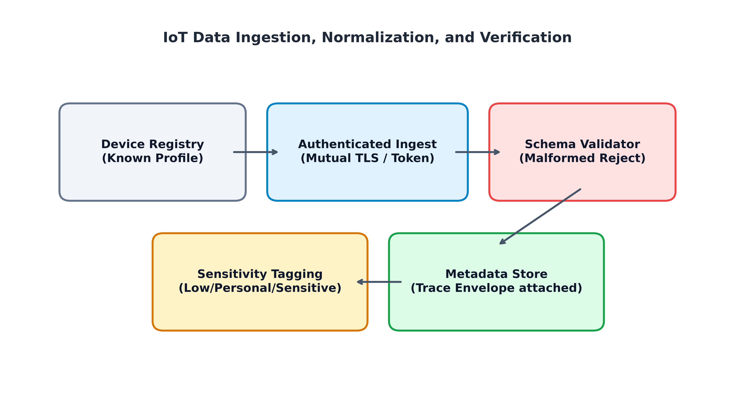
Fig. 8. IoT Data Acquisition Framework
Class | Example fields | Default handling guidance
Low sensitivity | Device health, non-identifying aggregate status. | Purpose tag, integrity check, retention limit.
Personal | Pseudonymous identifier, location history, usage pattern. | Purpose and authority check, minimization, access logging.
Sensitive / special category | Health-related measurements or other legally protected data. | Strong access control, encryption, restricted exports, enhanced review.
Security telemetry | Failed login, firmware hash, network anomaly. | Limit identifiers; restrict security purpose and retention.
Derived inference | Risk profile, inferred occupancy, predicted condition. | Record lineage and model; assess inference and re-identification risk.
Unknown / incomplete | Missing owner, unclear purpose, invalid schema. | Quarantine or block transfer pending review; do not assume low risk.

7. Edge Intelligence and Local Governance Layer
Edge governance places privacy checks near the source, reducing the need to transmit raw records to a central cloud [4]. It can apply local filtering, aggregate values, remove direct identifiers, encrypt approved outputs, and block a transfer when the edge policy does not permit it [8]. The same gateway can monitor device security state, software versions, unusual access, message rate, and local data flows [9]. Edge placement is not inherently trustworthy: gateways may have limited resources, weak physical protection, vendor-specific management tools, and intermittent connectivity [4].
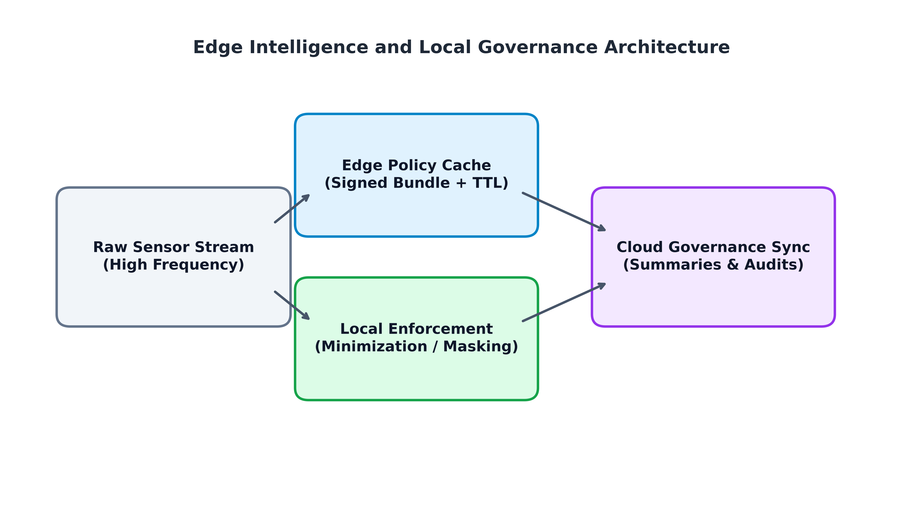
Fig. 9. Edge Governance Architecture
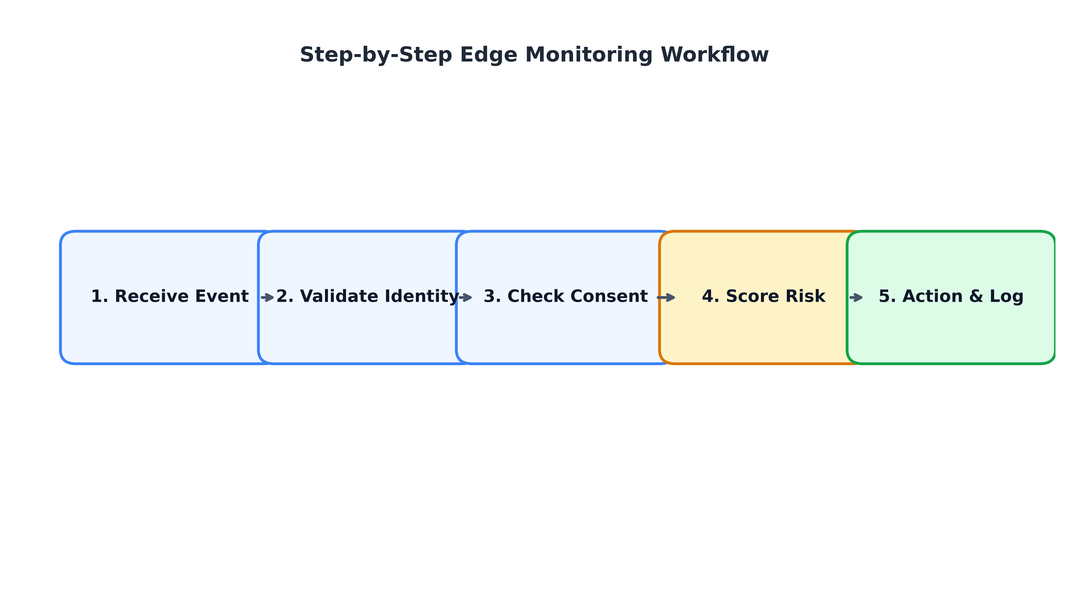
Fig. 10. Edge Compliance Monitoring Workflow

8. AI-Powered Privacy Risk Assessment Layer
The risk assessment layer estimates which events require more attention [1]. Its inputs may include sensitivity, consent or authority evidence, purpose alignment, retention status, encryption, access anomalies, transfer context, device security, data minimization, metadata quality, and recent threat signals [2]. This report uses a transparent composite risk formula as an explanation aid [1]:
R_i = ∑_j w_j · x_ij; where ∑_j w_j = 1 (1)
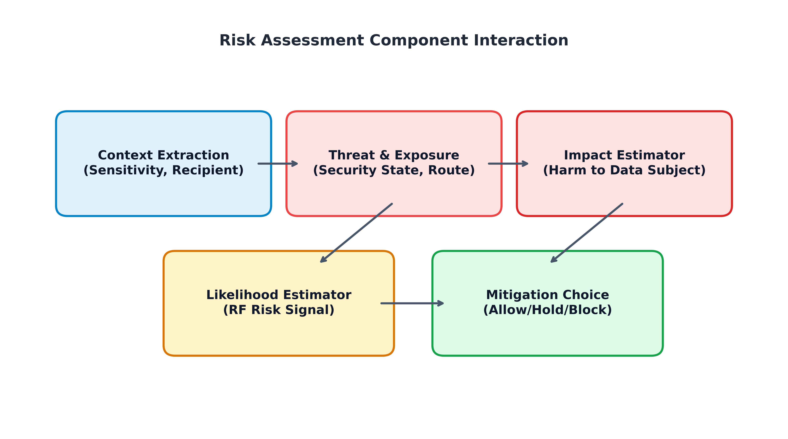
Fig. 11. AI Privacy Risk Assessment Framework
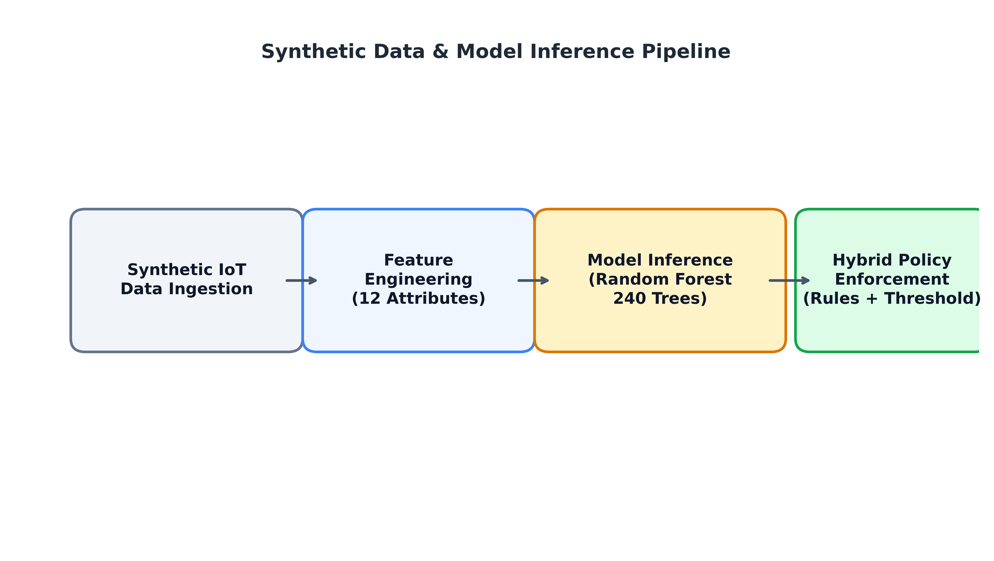
Fig. 12. Risk Prediction Pipeline

9. Automated Compliance and Policy Enforcement Layer
The compliance engine turns an approved policy into a decision for a specific event or data flow [2]. Policies are expressed as conditions over subject or asset class, purpose, sensitivity, recipient, legal basis or authorization evidence, retention, transfer location, and required protection [34]. In practice, policy rules should be expressed in a declarative format and separated from application code [37].
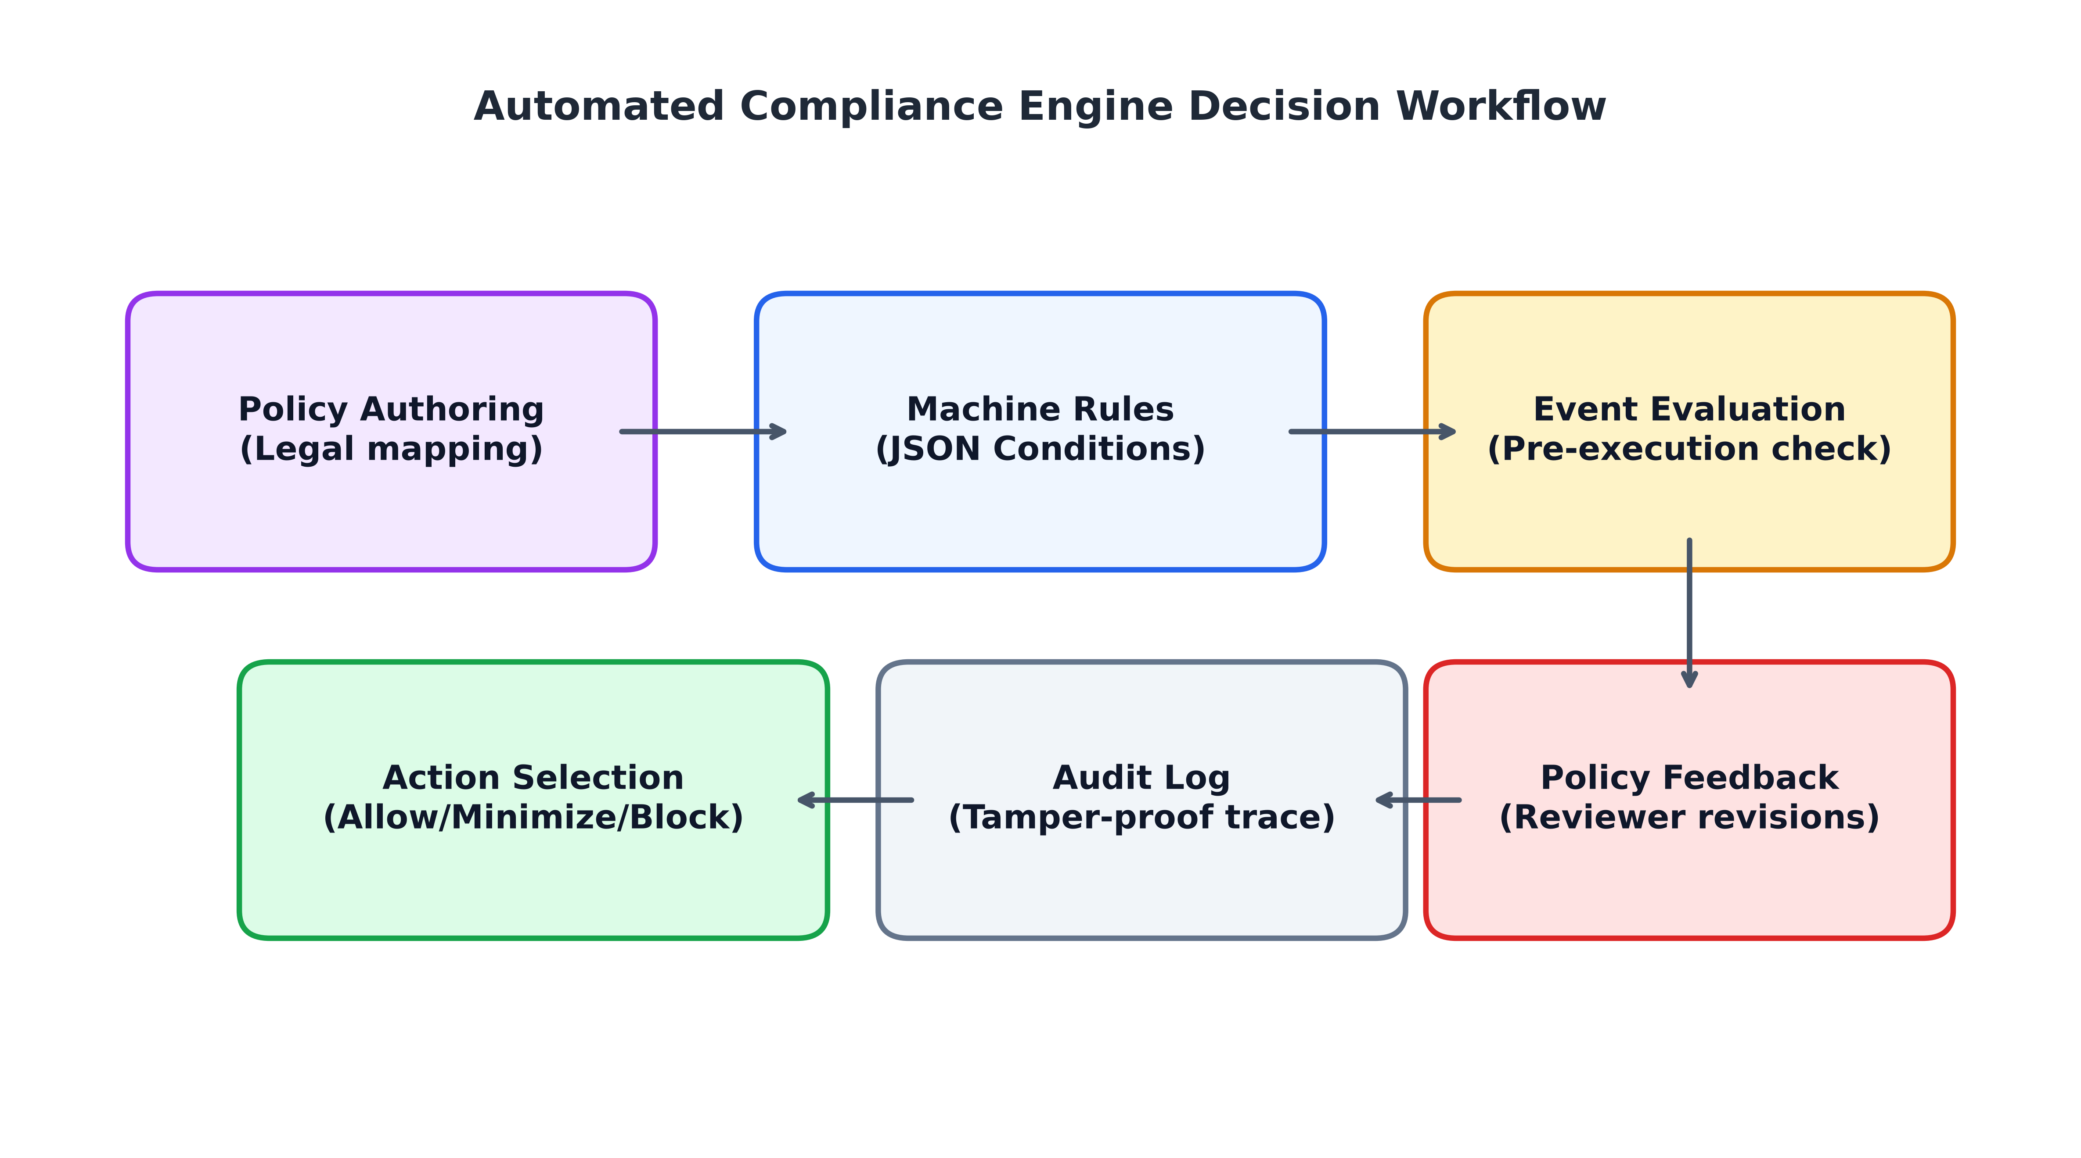
Fig. 13. Compliance Automation Workflow
Fig. 14. Policy Enforcement Lifecycle
Rule ID | Example condition | Suggested action | Evidence
R-01 | Required consent/authority evidence missing. | Hold affected processing and request review. | Policy version, event ID, reason code.
R-02 | Requested purpose does not match approved purpose. | Deny or route for approved exception. | Purpose tags and rule result.
R-03 | Sensitive field lacks required encryption. | Block export; remediate configuration. | Transport/storage status and timestamp.
R-04 | Retention period has expired. | Trigger deletion workflow and verify downstream copies. | Deletion confirmation and exception log.
R-05 | Cross-border recipient/location not mapped. | Hold transfer for jurisdictional review. | Destination, legal mapping, owner approval.
R-06 | Model predicts unusual access pattern. | Create alert for human triage; do not infer legal breach alone. | Risk score, factors, reviewer outcome.
R-07 | Device identity or signature fails. | Reject message and initiate security response. | Certificate/signature result, incident ID.
R-08 | Metadata are incomplete or contradictory. | Quarantine event until corrected. | Schema version and missing fields.

10. Privacy Preservation and Data Protection Layer
Privacy protection is a set of complementary controls rather than a single algorithm [7]. Data minimization limits collection and disclosure to what the purpose requires [12]. Pseudonymization replaces direct identifiers with controlled identifiers but does not guarantee that a person cannot be reidentified [18]. Encryption protects confidentiality when keys and endpoints are managed correctly [19]. Access control enforces least privilege [7]. Differential privacy provides formal output bounds under Laplace noise (Equation 2), while federated model aggregation is expressed conceptually in Equation 3:
M(x) = f(x) + Lap(Δf / ε) (2)
w_{t+1} = ∑_k (n_k / N) · w_{t+1}^k (3)
Fig. 15. Privacy Protection Framework
Fig. 16. Data Protection Lifecycle

11. Explainability, Transparency, and Auditability Layer
Explainability is essential when an AI-generated signal changes how data are collected, shared, retained, or investigated [3]. In a compliance setting, the explanation should answer four questions: what was detected; which input evidence supported the result; which policy or control was relevant; and what action followed [14].
Fig. 17. Explainable Compliance Framework
Fig. 18. Auditability and Transparency Dashboard

12. Governance, Regulatory Mapping, and Data Sovereignty Layer
Regulatory mapping starts with scope [29]. The organization identifies its role, the people or entities represented in the data, the processing purposes, the destinations, the vendors, and the locations in which data are collected, stored, accessed, or transferred [34]. The GDPR, India's DPDP Act 2023 along with the DPDP Rules 2025, and the EU AI Act (Regulation 2024/1689) provide the baseline governance structure.
Fig. 19. Regulatory Compliance Architecture
Governance theme | Technical control examples | Evidence to retain | Important limitation
Purpose and transparency | Purpose tags, notice/version register. | Approved purpose, notice version, owner. | Exact duty depends on context and law.
Lawful basis / consent | Consent status, authority records, withdrawal workflow. | Source of authority and timestamp. | Consent is not the only possible lawful basis.
Data minimization | Field allowlists, edge filtering, aggregation. | Before/after schema and export records. | A privacy risk assessment is still required.
Security & accountability | Access controls, encryption, incident log, reviews. | Test reports, role review, incident records. | A technical control alone does not prove compliance.
Retention & individual rights | Retention schedule, deletion orchestration, request handling. | Completion evidence, exceptions and deadlines. | Backups and third parties require separate handling.
AI governance | Model cards, testing, human oversight, version change control. | Validation, monitoring, reasons, override records. | Regulatory applicability must be assessed individually.
Data sovereignty / transfers | Location tags, recipient inventory, transfer review. | Processing locations, contract and approval evidence. | Cross-border requirements differ by jurisdiction.

13. Security and Threat Intelligence Layer
Privacy compliance depends on security controls because an organization cannot reliably enforce data-use policies if device identities, gateways, models, or logs can be manipulated [36]. Threats include unauthorized access, credential theft, insecure interfaces, stale software, data poisoning, model evasion, inference leakage, compromised gateways, and malicious insiders [36].
Fig. 20. Security Intelligence Framework
Threat | Potential privacy impact | Prevention / detection | Response evidence
Spoofed device | False provenance; unauthorized data injection. | Mutual authentication, device attestation. | Identity event and quarantine log.
Unauthorized access | Disclosure or unapproved reuse. | Least privilege, MFA for operators, access monitoring. | Access log and revocation record.
Model evasion / poisoning | Poor or manipulated risk ranking. | Input validation, robust evaluation, update approval. | Model version, detection event, rollback proof.
Data exfiltration | Unapproved transfer of personal or sensitive data. | Egress controls, minimization, encryption. | Flow logs, incident timeline.
Insider misuse | Access beyond assigned purpose. | Separation of duties, reviewable exceptions. | Authorization trail, investigation outcome.
Audit-log tampering | Reduced ability to reconstruct decisions. | Append-only storage, signatures, time synchronization. | Integrity verification result.
Ransomware / outage | Data loss, unavailable governance controls. | Patch, backup, recovery drills, segmentation. | Recovery record and residual risk.

14. Experimental Setup
A reproducible experiment is included to show how the proposed decision pipeline can be implemented and compared [14]. It generates 6,000 synthetic IoT event records across healthcare, smart city, manufacturing, energy, agriculture, and transport [36]. Each row contains artificial values for sensitivity level, consent evidence, encryption, purpose matching, retention, access anomalies, cross-border transfer, minimization, device security, metadata completeness, data volume, edge processing, and a synthetic violation label [14]. The records are split 75/25 with random seed 42 (1,500 held-out test events).
Fig. 21. Experimental Testbed Architecture
Item | Configuration | Interpretation
Dataset | 6,000 generated synthetic records; six IoT sectors. | No real persons, devices, or production logs.
Generation seed | 42. | Makes the artificial event generation reproducible.
Target label | Generated by scripted risk-factor logic with noise. | Not a legal finding or independently adjudicated label.
Split | Stratified 75% training / 25% test. | 1,500 held-out records for reported comparison.
Baseline | Transparent checklist rule. | Deterministic comparison, not industry benchmark.
ML model | Random Forest classifier (240 trees, depth 10, min leaf 3). | Trained only on synthetic feature/label relationships.
Hybrid | Rules and model signal combined with recall threshold 0.38. | Intentionally trades precision for recall.
Reproducibility | Python script, requirements, CSV, JSON metrics, predictions. | Run instructions are in source_code/README.md.
Excluded | Live gateway, clinical data, production audit. | Future validation work is required.

15. Evaluation Metrics
Equations (4)–(9) define the classification and control-coverage measures used in this report:
Precision = TP / (TP + FP) (4)
Recall = TP / (TP + FN) (5)
F1 = 2 · (Precision · Recall) / (Precision + Recall) (6)
Accuracy = (TP + TN) / (TP + TN + FP + FN) (7)
Coverage (%) = 100 · (N_v / N_e) (8)
ROI (%) = 100 · (Benefits - Costs) / Costs (9)
Fig. 22. Evaluation Framework
Metric | Definition / purpose | Caution
Accuracy | Correct classifications divided by all evaluated examples. | Can hide poor performance on a minority class.
Precision | True positives divided by all predicted positives. | Low precision means more false alerts.
Recall | True positives divided by all actual positives. | Low recall means more missed synthetic positives.
F1 | Harmonic mean of precision and recall. | Does not encode the consequence of every error.
ROC-AUC | Ranking performance over thresholds. | Depends on target labels and sampling design.
Control coverage | Share of synthetic records with a control flag. | Proxy only; does not prove effective operation.
Operational latency | Time from event to actionable decision. | Not measured in this dataset-only experiment.

16. Results and Findings
On the synthetic held-out test split of 1,500 events, the checklist baseline achieves 66.40% accuracy, 71.37% precision, 29.02% recall, and an F1 score of 0.413. The Random Forest classifier achieves 68.73% accuracy, 61.58% precision, 61.48% recall, and an F1 score of 0.615 with an ROC-AUC of 0.742. The hybrid rules-plus-AI detector achieves 64.27% accuracy, 54.13% precision, 79.51% recall, and F1 of 0.644 [1].
Fig. 23. Compliance Accuracy Performance Analysis (synthetic benchmark)
Fig. 24. Privacy-Preservation Control Indicators (synthetic proxy measures only)
Fig. 25. Governance Maturity and Compliance Assessment (conceptual rubric)
Method | Accuracy | Precision | Recall | F1 | ROC-AUC
Checklist baseline | 0.6640 | 0.7137 | 0.2902 | 0.4126 | Not calculated
Random Forest | 0.6873 | 0.6158 | 0.6148 | 0.6153 | 0.7423
Hybrid rules + AI | 0.6427 | 0.5413 | 0.7951 | 0.6441 | 0.7405

17. Comparative Analysis
The checklist, stand-alone classifier, and hybrid design serve different operational roles [1]. A deterministic checklist is simple to explain and can enforce rules that are clearly defined in policy [2]. Its weakness is coverage: a small set of hand-authored conditions misses combinations not anticipated by its authors [3]. The Random Forest learns feature interactions, while the hybrid combines explicit hard rules with a broader detection signal, prioritizing recall.
Fig. 26. Comparative Benchmark Analysis (synthetic benchmark)
Comparison | Best result in this run | Trade-off | Use implication
Accuracy | Random Forest: 68.73% | Lowest error rate overall among the three. | Could be preferable when balanced errors matter.
Precision | Checklist: 71.37% | Lower recall: 29.02%. | Fewer false alerts but misses more positives.
Recall | Hybrid: 79.51% | Precision 54.13%; accuracy 64.27%. | May be useful for triage when missed alerts are costly.
F1 | Hybrid: 0.644 | Synthetic label design drives score. | A prioritization view, not proof of compliance.
ROC-AUC | Random Forest: 0.742; hybrid: 0.740 | Scores close under synthetic setup. | No claim about production generalization.

18. Trustworthiness, Accountability, and Governance Assessment
Trustworthiness requires the system to be accurate enough for its intended use, robust to known attacks, secure, explainable, privacy-aware, and governed by accountable people [3]. Table 13 maps each dimension to concrete verification evidence.
Fig. 27. Governance Maturity Framework
Dimension | Question to assess | Evidence required before deployment
Fairness | Do error rates differ by device, sector, or population? | Subgroup metrics and a justified remediation plan.
Transparency | Can reviewers understand what the system did? | Accessible reasons and traceable model/policy version.
Accountability | Who approves rules and handles appeals? | Named owner, override record, escalation route.
Privacy | Does the system collect and reveal only what is needed? | Data-flow review, minimization test, disclosure analysis.
Robustness | Does performance hold under missing fields or attacks? | Adversarial, drift, and fault-injection testing.
Safety & proportionality | Could blocking or delay harm essential services? | Risk analysis, fallback modes, incident procedures.
Governance maturity | Are policies, roles, reviews and evidence repeatable? | Documented cycle, periodic review, audit sampling.

19. Industry Use Cases and Case Study Evaluation
Table 14 details domain-specific governance profiles across six major IoT sectors:
Fig. 28. Smart City Compliance Ecosystem
Fig. 29. Healthcare IoT Governance Framework
Sector | Potential data / risk | Candidate AI-assisted control | Human governance point
Healthcare IoT | Vitals, device identifiers, access events. | Local filtering, sensitivity classification, unusual access alert. | Clinical safety and lawful processing review.
Smart cities | Mobility, cameras, environmental measurements. | Purpose/retention checks; aggregate where possible. | Public notice, proportionality, public accountability.
Manufacturing | Machine telemetry, worker-linked events. | Edge inference, role-based access, export control. | Safety, labour, and vendor contract review.
Energy | Smart meter records and control telemetry. | Anomaly detection and privacy-preserving aggregation. | Critical-infrastructure security review.
Agriculture | Soil, yield, location, farm operations. | Local aggregation and sharing control. | Ownership and commercial confidentiality review.
Transport / logistics | Vehicle location, routes, driver behaviour. | Retention control and restricted location access. | Worker impact, safety, and cross-border review.

20. Business Impact Assessment
AI-assisted compliance may create business value by detecting candidate problems earlier, reducing repetitive checklist work, and improving policy consistency [2]. However, financial return must be measured through pilot studies rather than assumed. Table 15 provides a cost-benefit worksheet for planning future deployments.
Fig. 30. Control-Coverage Dashboard (synthetic indicators; not a financial ROI result)
Item | How to measure it | Evidence needed
Manual review time | Hours per 1,000 events before and after. | Time study with comparable samples.
Triage speed | Median time from event to reviewer decision. | Time-stamped event and case records.
Alert quality | Precision, recall, reversals, reviewer acceptance. | Independent labels and adjudication.
Data minimization | Fields withheld or aggregated before export. | Data-flow measurements and schema diff.
Operating cost | Compute, storage, staffing, maintenance, legal review. | Invoices, workload, staffing and support records.
Risk/cost of errors | Costs of missed issue and false alert. | Incident scenarios and domain-owner estimates.
ROI | (Verified benefits minus verified costs) / costs. | Measured financial inputs and defined time horizon.
Current study status | No monetary outcome measured. | Synthetic dataset contains no financial observations.

21. Challenges and Limitations
Several limitations constrain the proposed framework [1]. First, legal duties are contextual, and a generic architecture cannot automatically resolve the applicability of the GDPR, DPDP Act, AI Act, or sector rules [3]. Second, heterogeneous devices can have incomplete metadata and weak hardware support [4]. Third, AI models can drift, be manipulated, or produce different error rates across device classes [13]. Fourth, synthetic benchmarks demonstrate workflow reproducibility only and do not establish real-world compliance effectiveness.
Fig. 31. Challenges and Limitations Roadmap

22. Future Research Directions
Future research directions include multi-site validation with consented real-world data, rigorous privacy-budget accounting for differential privacy, robust federated learning with poisoning defenses, and human-factors studies to evaluate reviewer cognitive load.
Fig. 32. Future Research Roadmap
Fig. 33. Next-Generation AI Governance Ecosystem

23. Conclusion
This case study presents a layered approach to AI-driven privacy compliance in IoT environments with different devices [1]. The main design principle is to combine explicit and testable policy rules with local processing, risk detection, explainable outcomes, evidence capture, regulatory mapping, and human oversight [3]. Device diversity, fragmented policies, contextual risk, and distributed data flows require more than a single model or centralized dashboard [4]. Edge controls can minimize unnecessary transfer, while a shared governance layer keeps policy versions, model versions, and audit evidence aligned [10].
A small reproducible benchmark shows the implementation path using 6,000 synthetic events [1]. On the 1,500-record held-out split, the hybrid detector produced the highest recall (79.51%) and F1 score (0.644), but lower accuracy (64.27%) and precision (54.13%) than the Random Forest model [3]. These figures show an alerting trade-off under the artificial generator [4]. They do not establish real-world compliance effectiveness or prove that any regulation has been satisfied [1].
Fig. 34. Research Contribution Framework

Data Availability Statement
All data generated or analysed during this study are included in this published article [and its supplementary information files: iot_privacy_compliance_dataset.csv, train_set.csv, and test_set.csv located in the datasets/ folder of the project repository]. The benchmark data are synthetic and were generated for this case study. Source code, dataset generator, and random seed (42) are included in the source-code folder.

Appendices

Appendix A. Policy Rule Template
Provides declarative JSON specifications for policy rule PRIV-IOT-EX-01, defining condition triggers, mandatory actions, and evidence fields.

Appendix B. Reference Pseudocode for the Event Pipeline
Details process_event(event) sequentially validating schema, authenticating device ID, checking cache policy, classifying sensitivity, running deterministic rules, applying edge minimization, computing AI risk score, and writing tamper-evident SHA-256 audit records.

Appendix C. Event Data Dictionary
Documents the complete schema of the event envelope: event_id, device_id, event_time, data_class, purpose_id, receiver_id, retention_class, policy_version, model_version, and risk_score.

Appendix D. Extended Test Cases and Expected Behaviour
Outlines 12 rigorous positive and negative boundary test scenarios (D-01 to D-12) covering expired retention, purpose mismatch, offline policy cache, and audit failures.

Appendix E. Reproducibility and Deployment Checklist
Checklist for experimental replication and production readiness gates covering device inventory, policy versioning, and rollback procedures.

Appendix F. Detailed Research Questions and Hypotheses
Formulates RQ1–RQ4 and testable hypotheses H1–H5 on metadata preservation, hybrid decision support, and audit reconstruction.

Appendix G. Step-by-Step Experimental Protocol
Detailed guide covering pre-test configuration, event set preparation, baseline execution, and error analysis.

Appendix H. Event Labels and Annotation Guide
Defines operational criteria for permitted, violation, and uncertain event labels to prevent data leakage and label bias.

Appendix I. Policy Rule Examples and Review Checklist
Provides concrete examples for healthcare wearables (Rule I.2) and smart-city traffic count aggregation (Rule I.3).

Appendix J. Implementation and Deployment Readiness Plan
Six-stage development plan moving from schema definition to offline recovery testing.

Appendix K. Risk Model Calibration and Sensitivity Protocol
Outlines protocols for probability calibration, weight sensitivity testing, and subgroup evaluations.

Appendix L. Failure Mode and Effects Analysis (FMEA)
Analyzes failure modes across identity, metadata, policy cache, model timeouts, and audit storage.

Appendix M. Privacy Impact Assessment (PIA) Checklist
Structured questionnaire covering data necessity, proportionality, residual risk, and periodic re-assessment.

Appendix N. Experimental Result Reporting Template
Standard reporting schema recording run IDs, configurations, confusion matrices, and plain-language interpretations.

Appendix O. Operations, Incident Response, and Recovery
Operational protocols for daily monitoring, security containment, credential rotation, and post-incident lessons learned.

References
[1] A. Rodríguez, B. Otero, and R. Canal, “A survey of machine and deep learning methods for privacy protection in the Internet of Things,” Sensors, vol. 23, no. 3, Art. no. 1252, 2023, doi: 10.3390/s23031252.
[2] G. Giordano, F. Palomba, and F. Ferrucci, “On the use of artificial intelligence to deal with privacy in IoT systems: A systematic literature review,” Journal of Systems and Software, vol. 193, Art. no. 111475, 2022, doi: 10.1016/j.jss.2022.111475.
[3] I. Kok, F. Y. Okay, O. Muyanli, and S. Ozdemir, “Explainable artificial intelligence (XAI) for Internet of Things: A survey,” IEEE Internet of Things Journal, vol. 10, no. 16, pp. 14764–14779, 2023, doi: 10.1109/JIOT.2023.3287678.
[4] A. Alwarafy, K. A. Al-Thelaya, M. Abdallah, J. Schneider, and M. Hamdi, “A survey on security and privacy issues in edge-computing-assisted Internet of Things,” IEEE Internet of Things Journal, vol. 8, no. 6, pp. 4004–4022, 2021, doi: 10.1109/JIOT.2020.3015432.
[5] D. C. Nguyen, M. Ding, P. N. Pathirana, A. Seneviratne, J. Li, and H. V. Poor, “Federated learning for Internet of Things: A comprehensive survey,” IEEE Communications Surveys & Tutorials, vol. 23, no. 3, pp. 1622–1658, 2021, doi: 10.1109/COMST.2021.3075439.
[6] T. Zhang, L. Gao, C. He, M. Zhang, B. Krishnamachari, and A. S. Avestimehr, “Federated learning for the Internet of Things: Applications, challenges, and opportunities,” IEEE Internet of Things Magazine, vol. 5, no. 1, pp. 24–29, 2022, doi: 10.1109/IOTM.004.2100182.
[7] M. A. Husnoo, A. Anwar, R. K. Chakrabortty, R. Doss, and M. J. Ryan, “Differential privacy for IoT-enabled critical infrastructure: A comprehensive survey,” IEEE Access, vol. 9, pp. 153276–153304, 2021, doi: 10.1109/ACCESS.2021.3124309.
[8] M. Laroui, B. Nour, H. Moungla, M. A. Cherif, H. Afifi, and M. Guizani, “Edge and fog computing for IoT: A survey on current research activities & future directions,” Computer Communications, vol. 180, pp. 210–231, 2021, doi: 10.1016/j.comcom.2021.09.003.
[9] E. Fazeldehkordi and T.-M. Grønli, “A survey of security architectures for edge computing-based IoT,” IoT, vol. 3, no. 3, pp. 332–365, 2022, doi: 10.3390/iot3030019.
[10] L. Kong et al., “Edge-computing-driven Internet of Things: A survey,” ACM Computing Surveys, vol. 55, no. 8, Art. no. 174, 2023, doi: 10.1145/3555308.
[11] H. Li, L. Ge, and L. Tian, “Survey: Federated learning data security and privacy-preserving in edge-Internet of Things,” Artificial Intelligence Review, vol. 57, Art. no. 130, 2024, doi: 10.1007/s10462-024-10774-7.
[12] D. T. Aga, R. Chintanippu, R. A. Mowri, and M. Siddula, “Exploring secure and private data aggregation techniques for the Internet of Things: A comprehensive review,” Discover Internet of Things, vol. 4, Art. no. 28, 2024, doi: 10.1007/s43926-024-00064-7.
[13] S. F. Ahmed, M. S. B. Alam, S. Afrin, S. J. Rafa, S. B. Taher, M. Kabir, S. M. Muyeen, and A. H. Gandomi, “Toward a secure 5G-enabled Internet of Things: A survey on requirements, privacy, security, challenges, and opportunities,” IEEE Access, vol. 12, pp. 13125–13145, 2024, doi: 10.1109/ACCESS.2024.3352508.
[14] M. Adam, M. Hammoudeh, R. Alrawashdeh, and B. Alsulaimy, “A survey on security, privacy, trust, and architectural challenges in IoT systems,” IEEE Access, vol. 12, pp. 57128–57149, 2024, doi: 10.1109/ACCESS.2024.3382709.
[15] M. Venkatasubramanian, A. H. Lashkari, and S. Hakak, “IoT malware analysis using federated learning: A comprehensive survey,” IEEE Access, vol. 11, pp. 5004–5018, 2023, doi: 10.1109/ACCESS.2023.3235389.
[16] H. C. Neto et al., “A survey on securing federated learning: Analysis of applications, attacks, challenges, and trends,” IEEE Access, vol. 11, pp. 41928–41953, 2023, doi: 10.1109/ACCESS.2023.3269980.
[17] G. Xia, J. Chen, C. Yu, and J. Ma, “Poisoning attacks in federated learning: A survey,” IEEE Access, vol. 11, pp. 10708–10722, 2023, doi: 10.1109/ACCESS.2023.3238823.
[18] Y. Zhao, J. Zhao, M. Yang et al., “Local differential privacy-based federated learning for Internet of Things,” IEEE Internet of Things Journal, vol. 8, no. 11, pp. 8836–8853, 2021, doi: 10.1109/JIOT.2020.3037194.
[19] I. Zhou, F. Tofigh, M. Piccardi, M. Abolhasan, D. Franklin, and J. Lipman, “Secure multi-party computation for machine learning: A survey,” IEEE Access, vol. 12, pp. 53881–53899, 2024, doi: 10.1109/ACCESS.2024.3388992.
[20] R. Yang, T. Zhao, F. R. Yu, M. Li, D. Zhang, and X. Zhao, “Blockchain-based federated learning with enhanced privacy and security using homomorphic encryption and reputation,” IEEE Internet of Things Journal, vol. 11, no. 12, pp. 21674–21688, 2024, doi: 10.1109/JIOT.2024.3379395.
[21] S. Almutairi and A. Barnawi, “Federated learning vulnerabilities, threats and defenses: A systematic review and future directions,” Internet of Things, vol. 24, Art. no. 100947, 2023, doi: 10.1016/j.iot.2023.100947.
[22] T. Li, X. He, S. Jiang, and J. Liu, “A survey of privacy-preserving offloading methods in mobile-edge computing,” Journal of Network and Computer Applications, vol. 203, Art. no. 103395, 2022, doi: 10.1016/j.jnca.2022.103395.
[23] A. D. Kounoudes and G. M. Kapitsaki, “A mapping of IoT user-centric privacy preserving approaches to the GDPR,” Internet of Things, vol. 11, Art. no. 100179, 2020, doi: 10.1016/j.iot.2020.100179.
[24] A. Vyas, S. Lin, J. Hwang, and N. Tripathi, “Privacy-preserving federated learning for intrusion detection in IoT environments: A survey,” IEEE Access, vol. 12, pp. 127018–127050, 2024, doi: 10.1109/ACCESS.2024.3454211.
[25] T. M. M. Mengistu, T. Kim, and J.-W. Lin, “A survey on heterogeneity taxonomy, security and privacy preservation in the integration of IoT, wireless sensor networks and federated learning,” Sensors, vol. 24, no. 3, Art. no. 968, 2024, doi: 10.3390/s24030968.
[26] Z. Xu and W. Liu, “Artificial intelligence for securing IoT services in edge computing: A survey,” Security and Communication Networks, vol. 2020, Art. no. 8872586, 2020, doi: 10.1155/2020/8872586.
[27] A. Saleem et al., “A comprehensive systematic survey of IoT protocols: Implications for data quality and performance,” IEEE Access, vol. 13, pp. 196206–196235, 2024, doi: 10.1109/ACCESS.2024.3486927.
[28] O. Ben Atia et al., “Securing federated learning in IoT: A survey of attacks, defenses, and frameworks,” IEEE Internet of Things Journal, vol. 12, no. 22, pp. 47163–47190, 2025, doi: 10.1109/JIOT.2025.3600617.
[29] P. Naithani, “Analysis of India’s Digital Personal Data Protection Act, 2023,” International Journal of Law and Management, vol. 67, no. 5, pp. 543–553, 2024, doi: 10.1108/IJLMA-05-2024-0174.
[30] M. U. Hassan, M. H. Rehmani, and J. Chen, “Differential privacy techniques for cyber physical systems: A survey,” IEEE Communications Surveys & Tutorials, vol. 22, no. 1, pp. 746–789, 2020, doi: 10.1109/COMST.2019.2944748.
[31] O. Aouedi, T.-H. Vu, A. Sacco, D. C. Nguyen, K. Piamrat, G. Marchetto, and Q.-V. Pham, “A survey on intelligent Internet of Things: Applications, security, privacy, and future directions,” IEEE Communications Surveys & Tutorials, vol. 27, no. 2, pp. 1238–1292, 2025, doi: 10.1109/COMST.2024.3430368.
[32] A. S. M. Kayes et al., “Safeguarding individuals and organizations from privacy breaches: A comprehensive review of problem domains, solution strategies, and prospective research directions,” IEEE Internet of Things Journal, vol. 12, no. 2, pp. 1247–1265, 2025, doi: 10.1109/JIOT.2024.3481316.
[33] M. M. Ogonji, G. Okeyo, and J. M. Wafula, “A survey on privacy and security of Internet of Things,” Computer Science Review, vol. 38, Art. no. 100312, 2020, doi: 10.1016/j.cosrev.2020.100312.
[34] K. Boeckl and N. Lefkovitz, NIST Privacy Framework: A Tool for Improving Privacy Through Enterprise Risk Management, Version 1.0, NIST CSWP 10, 2020, doi: 10.6028/NIST.CSWP.01162020.
[35] National Institute of Standards and Technology, Artificial Intelligence Risk Management Framework (AI RMF 1.0), NIST AI 100-1, 2023, doi: 10.6028/NIST.AI.100-1.
[36] M. J. Fagan, K. N. Megas, K. Scarfone, and M. Smith, IoT Device Cybersecurity Capability Core Baseline, NISTIR 8259A, 2020, doi: 10.6028/NIST.IR.8259A.
[37] European Parliament and Council of the European Union, “Regulation (EU) 2016/679 (General Data Protection Regulation),” Official Journal of the European Union, 2016.
[38] European Parliament and Council of the European Union, “Regulation (EU) 2024/1689 laying down harmonised rules on artificial intelligence (Artificial Intelligence Act),” Official Journal of the European Union, 2024.
[39] Government of India, “Digital Personal Data Protection Act, 2023,” Act No. 22 of 2023, Gazette of India, 2023.
[40] Ministry of Electronics and Information Technology, Government of India, “Digital Personal Data Protection Rules, 2025,” notified 14 November 2025, with corrigendum dated 16 December 2025.
[41] Organisation for Economic Co-operation and Development, “OECD AI Principles,” updated 2024.
[42] P. Sun, Y. Wan, Z. Wu, Z. Fang, and Q. Li, “A survey on privacy and security issues in IoT-based environments: Technologies, protection measures and future directions,” Computers & Security, vol. 148, Art. no. 104097, Jan. 2025, doi: 10.1016/j.cose.2024.104097.
[43] A. Marengo, “Navigating the nexus of AI and IoT: A comprehensive review of data analytics and privacy paradigms,” Internet of Things, vol. 27, Art. no. 101318, Oct. 2024, doi: 10.1016/j.iot.2024.101318.
[44] “Enhancing IoT privacy with artificial intelligence: Recent advances and future directions,” Internet of Things, vol. 34, Art. no. 101752, Nov. 2025.
[45] J. Moss, J. Gordon, W. Duclos, Y. Liu, Q. Wang, and J. Wang, “Explainable AI in IoT: A survey of challenges, advancements, and pathways to trustworthy automation,” Electronics, vol. 14, no. 23, Art. no. 4622, 2025, doi: 10.3390/electronics14234622.
[46] R. Kaur, T. Rodrigues, N. Kadir, and R. Kashef, “A survey on privacy preservation techniques in IoT systems,” Sensors, vol. 25, no. 22, Art. no. 6967, 2025, doi: 10.3390/s25226967.
[47] M. Gheisari, G. Wang, and S. Chen, “An edge computing-enhanced Internet of Things framework for privacy-preserving in smart city,” Computers & Electrical Engineering, vol. 81, Art. no. 106504, 2020, doi: 10.1016/j.compeleceng.2019.106504.
[48] V. Mothukuri, R. M. Parizi, S. Pouriyeh, Y. Huang, A. Dehghantanha, and G. Srivastava, “A survey on security and privacy of federated learning,” Future Generation Computer Systems, vol. 115, pp. 619–640, 2021, doi: 10.1016/j.future.2020.10.007.
[49] F. Mosaiyebzadeh, S. Pouriyeh, R. M. Parizi, Q. Z. Sheng, M. Han, L. Zhao, G. Sannino, and D. M. Batista, “Privacy-enhancing technologies in federated learning for the Internet of Healthcare Things: A survey,” Electronics, vol. 12, no. 12, Art. no. 2703, 2023, doi: 10.3390/electronics12122703.
[50] A. Coiduras-Sanagustín, E. Manchado-Pérez, and C. García-Hernández, “Understanding perspectives for product design on personal data privacy in Internet of Things (IoT): A systematic literature review,” Heliyon, vol. 10, no. 9, Art. no. e30357, 2024, doi: 10.1016/j.heliyon.2024.e30357.
[51] S. Salim, N. Moustafa, and B. Turnbull, “Privacy preservation of Internet of Things-integrated social networks: A survey and future challenges,” International Journal of Web Information Systems, vol. 21, no. 4, pp. 372–431, 2025, doi: 10.1108/IJWIS-04-2024-0120.
[52] M. H. Shirvani and M. Masdari, “A survey study on trust-based security in Internet of Things: Challenges and issues,” Internet of Things, vol. 21, Art. no. 100640, 2023, doi: 10.1016/j.iot.2022.100640.
[53] A. Sharma, E. S. Pilli, A. P. Mazumdar, and P. Gera, “Towards trustworthy Internet of Things: A survey on trust management applications and schemes,” Computer Communications, vol. 160, pp. 475–493, 2020, doi: 10.1016/j.comcom.2020.06.030.
[54] S. Alam, S. Zardari, S. Noor, S. Ahmed, and H. Mouratidis, “Trust management in Social Internet of Things (SIoT): A survey,” IEEE Access, vol. 10, pp. 108924–108954, 2022, doi: 10.1109/ACCESS.2022.3213699.
[55] Z. Cheng, Y. Liu, C. Wu, Y. Pan, L. Zhao, X. Deng, and C. Zhu, “Decentralized IoT data sharing: A blockchain-based federated learning approach with joint optimizations for efficiency and privacy,” Future Generation Computer Systems, vol. 160, pp. 547–563, 2024, doi: 10.1016/j.future.2024.06.035.
[56] Y. Shen, C. Shepherd, C. M. Ahmed, S. Shen, X. Wu, W. Ke, and S. Yu, “Game-theoretic analytics for privacy preservation in Internet of Things networks: A survey,” Engineering Applications of Artificial Intelligence, vol. 133, Art. no. 108449, 2024, doi: 10.1016/j.engappai.2024.108449.
[57] G. Yang, “An overview of current solutions for privacy in the Internet of Things,” Frontiers in Artificial Intelligence, vol. 5, Art. no. 812732, 2022, doi: 10.3389/frai.2022.812732.
[58] D. Li, Y. Zhao, Y. Wang, D. An, and Q. Yang, “The privacy-preserving auction mechanisms in IoT-based trading market: A survey,” Internet of Things, vol. 26, Art. no. 101178, 2024, doi: 10.1016/j.iot.2024.101178.
[59] K. Park and Y. Park, “MIoT-CDPS: Complete decentralized privacy-preserving scheme for medical Internet of Things,” Internet of Things, vol. 27, Art. no. 101250, 2024, doi: 10.1016/j.iot.2024.101250.
[60] I. Khan, Y. Majib, R. Ullah, and O. Rana, “Blockchain applications for Internet of Things—A survey,” Internet of Things, vol. 27, Art. no. 101254, 2024, doi: 10.1016/j.iot.2024.101254.
[61] M. Aledhari, R. Razzak, R. M. Parizi, and F. Saeed, “Federated learning: A survey on enabling technologies, protocols, and applications,” IEEE Access, vol. 8, pp. 140699–140725, 2020, doi: 10.1109/ACCESS.2020.3013541.
[62] W. Y. B. Lim et al., “Federated learning in mobile edge networks: A comprehensive survey,” IEEE Communications Surveys & Tutorials, vol. 22, no. 3, pp. 2031–2063, 2020, doi: 10.1109/COMST.2020.2986024.
[63] M. Aggarwal, V. Khullar, S. Rani, T. A. Prola, S. B. Bhattacharjee, S. M. Shawon, and N. Goyal, “Federated learning on Internet of Things: Extensive and systematic review,” Computers, Materials & Continua, vol. 79, no. 2, pp. 1795–1834, 2024, doi: 10.32604/cmc.2024.049846.
[64] S. K. Jain and N. Kesswani, “A noise-based privacy preserving model for Internet of Things,” Complex & Intelligent Systems, vol. 9, pp. 3655–3679, 2023, doi: 10.1007/s40747-021-00489-5.
[65] O. G. Darley, A. A. Adenowo, and A. I. O. Yussuff, “Machine learning intrusion detection as a solution to security and privacy issues in IoT: A systematic review,” FUOYE Journal of Engineering and Technology, vol. 7, no. 2, pp. 148–156, 2022, doi: 10.46792/fuoyejet.v7i2.802.
[66] M. A. S. Amin, S. Kim, M. A. S. A. Rishat, Z. Tang, and H. Ahn, “A systematic literature review of privacy information disclosure in AI-integrated Internet of Things technologies,” Sustainability, vol. 17, no. 1, Art. no. 8, 2025, doi: 10.3390/su17010008.
[67] M. Aqeel, F. Ali, M. W. Iqbal, T. A. Rana, M. Arif, and M. R. Auwul, “A review of security and privacy concerns in the Internet of Things (IoT),” Journal of Sensors, vol. 2022, Art. no. 5724168, 2022, doi: 10.1155/2022/5724168.
[68] R. Roman, P. Najera, and J. Lopez, “On the features and challenges of security and privacy in distributed Internet of Things,” Computer Networks, vol. 57, no. 10, pp. 2266–2279, 2013, doi: 10.1016/j.comnet.2013.04.018.
[69] S. Sicari, A. Rizzardi, L. A. Grieco, and A. Coen-Porisini, “Security, privacy and trust in Internet of Things: The road ahead,” Computer Networks, vol. 76, pp. 146–164, 2015, doi: 10.1016/j.comnet.2014.11.008.
[70] K. Ziegeldorf, O. Garcia Morchon, and K. Wehrle, “Privacy in the Internet of Things: Threats and challenges,” Security and Communication Networks, vol. 7, no. 12, pp. 2728–2742, 2014, doi: 10.1002/sec.795.
[71] D. Miorandi, S. Sicari, F. De Pellegrini, and I. Chlamtac, “Internet of things: Vision, applications and research challenges,” Ad Hoc Networks, vol. 10, no. 7, pp. 1497–1516, 2012, doi: 10.1016/j.adhoc.2012.02.016.
[72] W. Shi et al., “Edge computing: Vision and challenges,” IEEE Internet of Things Journal, vol. 3, no. 5, pp. 637–646, 2016, doi: 10.1109/JIOT.2016.2579198.
[73] M. Satyanarayanan, “The emergence of edge computing,” Computer, vol. 50, no. 1, pp. 30–39, 2017, doi: 10.1109/MC.2017.9.
[74] M. Whitmore, A. Agarwal, and L. Da Xu, “The Internet of Things—A survey of topics and trends,” Information Systems Frontiers, vol. 17, pp. 261–274, 2015, doi: 10.1007/s10796-014-9489-2.
[75] L. Atzori, A. Iera, and G. Morabito, “The Internet of Things: A survey,” Computer Networks, vol. 54, no. 15, pp. 2787–2805, 2010, doi: 10.1016/j.comnet.2010.05.010.
[76] U.S. Department of Health and Human Services, “The HIPAA Privacy Rule,” official guidance. Available: https://www.hhs.gov/hipaa/for-professionals/privacy/index.html.
[77] C. Dwork and A. Roth, The Algorithmic Foundations of Differential Privacy. Hanover, MA, USA: Now Publishers, 2014, doi: 10.1561/0400000042.
[78] K. Bonawitz et al., “Practical secure aggregation for privacy-preserving machine learning,” in Proc. ACM SIGSAC Conference on Computer and Communications Security, pp. 1175–1191, 2017, doi: 10.1145/3133956.3133982.
[79] R. Shokri, M. Stronati, C. Song, and V. Shmatikov, “Membership inference attacks against machine learning models,” in Proc. IEEE Symposium on Security and Privacy, pp. 3–18, 2017, doi: 10.1109/SP.2017.41.
[80] M. T. Ribeiro, S. Singh, and C. Guestrin, “Why should I trust you?: Explaining the predictions of any classifier,” in Proc. ACM SIGKDD Conference on Knowledge Discovery and Data Mining, pp. 1135–1144, 2016, doi: 10.1145/2939672.2939778.
[81] E. Dritsas and M. Trigka, “Federated learning for IoT: A survey of techniques, challenges, and applications,” Journal of Sensor and Actuator Networks, vol. 14, no. 1, Art. no. 9, 2025, doi: 10.3390/jsan14010009.

