A Final Dissertation Report on
Minimalist Alert Network for Threat Intelligence System

By
Anuskar Sigdel
UON ID: 24812606
A dissertation submitted in partial fulfilment of the requirements for the degree of
BSc. (Hons.) Computer Science

Supervisor: Nischal Khadka
Naaya Aayam Multi-Disciplinary Institute
University of Northampton
August 2026

Abstract
MANTIS (Minimalist Alert Network for Threat Intelligence System) is a lightweight host-based intrusion detection and prevention prototype implemented with the Python Standard Library. It combines AF_PACKET and PCAP input with five transparent methods: Z-Score, K-Nearest Neighbours, Multinomial Naive Bayes, online K-Means and a Bloom Filter. A common verdict path supports CSV logging, JSON/UDP telemetry, a local web dashboard, saved engine state and optional policy-controlled iptables response.

Constructive research and Agile Kanban guided the design, implementation and evaluation. Evidence includes unit, integration and system tests, controlled replay and labelled data, together with explicit operational limits. The result shows that an inspectable detector can run on modest Linux hardware, but laboratory scores and passing software tests do not prove production accuracy or unknown-attack detection. The main contribution is therefore reproducible architecture whose assumptions, decisions and limitations remain visible.

Keywords: intrusion detection; zero dependency; edge computing; machine learning; CIC-IoT2023; evaluation validity; Python

Acknowledgements
I would like to express my sincere gratitude to my supervisor, Nischal Khadka, for his guidance, patience and detailed feedback throughout the project. His questions helped me strengthen the research methodology, connect technical decisions to evidence and present the limitations of the evaluation more clearly. I also thank the academic staff at Naaya Aayam Multi-Disciplinary Institute and the University of Northampton for the teaching and resources that supported this dissertation.

I am grateful to my family and friends for their encouragement during the design, implementation, testing and writing stages. I also acknowledge the open-source researchers, standards bodies and security communities whose datasets, documentation and published studies made the work reproducible. All experiments were conducted in controlled environments using researcher-owned systems, and responsibility for the final implementation, analysis and conclusions remains my own.

Table of Contents
1. Introduction 1
1.1 Background 1
1.2 Rationale 2
1.3 Aim and Objectives 2
1.4 Overview of Methodology 4
1.5 Limitations 5
2. Requirement Engineering 6
2.1 Literature Review 6
2.2 Comparable Systems 10
2.2.1 Snort 3.x 10
2.2.2 Suricata 7.x 11
2.2.3 Zeek 8.x 12
2.2.4 Wazuh 4.x 13
2.3 Research Methodology 15
2.4 Implementation Traceability 16
2.5 Development Methodology 16
2.6 Evaluation Strategy 17
2.7 Methodology for Comparable Analysis 17
2.8 Algorithms Implemented 29
2.8.1 Z-Score Statistical Engine 30
2.8.2 K-Nearest Neighbours (KNN) Engine 31
2.8.3 Multinomial Naive Bayes Engine 34
3. System Analysis and Design 36
3.1 Preliminary System Design 36
3.2 Detailed System Design 36
3.2.1 Use Case Diagram 36
3.2.1.1 Use Case Documentation 37
3.2.2 Sequence Diagrams 40
3.2.3 Class Diagram 44
3.2.4 Activity Diagrams 46
3.2.5 Data Storage and Logging Design 51
3.2.6 Detailed Algorithm Design 52
3.2.6.1 Online Mini-Batch K-Means Engine 52
3.2.6.2 Bloom Filter Reputation Engine 54
3.2.7 Interface Design 55
3.2.7.1 Wireframe 56
3.2.7.2 Mockup 58
4. System Build and Technical Notes 62
4.1 Packet Capture and Protocol Parsing 62
4.2 Detection, Dispatch and Active Response 62
4.3 Training, State and Evidence Interface 64
4.4 Technical Constraints Encountered 65
5. Testing Strategy and Evaluation 67
5.1 Testing Definitions and Approach 67
5.2 Algorithm Tests 68
5.3 Test Cases and Scenarios 69
6. Conclusion 79
6.1 Technical Difficulties Encountered 79
6.2 Future Scope 79
7. References 80
Appendix A: Gantt Chart 83
Appendix B: Project Logs 84
Appendix C: Presentation Slide 88

List of Figures
S.N. Figure Description Page no.
Figure 2.1: Snort product and documentation page (Cisco Talos, 2024) 10
Figure 2.2: Suricata documentation page (OISF, 2024) 12
Figure 2.3: Zeek documentation page (Zeek Project, 2026) 13
Figure 2.4: Wazuh documentation page (Wazuh, 2026) 14
Figure 2.5: Constructive research methodology with Agile Kanban feedback 15
Figure 2.6: Kanban development workflow from the project plan 16
Figure 2.7: Qualitative comparable system functionality ranking using the project rubric 18
Figure 2.8: Current monitoring and manual response workflow 27
Figure 2.9: Proposed end to end MANTIS workflow 28
Figure 2.9: Z-Score statistical engine flowchart 31
Figure 2.10: K-Nearest Neighbours engine flowchart 33
Figure 2.11: Multinomial Naive Bayes engine flowchart 35
Figure 3.1: MANTIS use case model 37
Figure 3.2: Live detection sequence from captured frame to operator visible alert 41
Figure 3.3: Training pipeline from validated data to persistent engine state 42
Figure 3.4: SIEM alert delivery and browser dashboard retrieval 43
Figure 3.5: Offline PCAP replay and finite analysis completion 44
Figure 3.6: Corrected MANTIS class model with inheritance, composition and explicit UML multiplicities 45
Figure 3.7: Live detection, verdict aggregation and optional response activity 46
Figure 3.8: Training pipeline from input validation to brain export 47
Figure 3.9: Evaluation harness and confusion matrix metric activity 48
Figure 3.10: Brain persistence and orderly shutdown activity flow 49
Figure 3.11: Linux installation activity with if-else-if package manager decisions 50
Figure 3.12: Online Mini-Batch K-Means flow from explicit feature input to normal or anomaly output 53
Figure 3.16: Bloom Filter reputation membership decision flow 55
Figure 3.17: Overview page wireframe showing system health, recent events and engine activity 56
Figure 3.18: Packets page wireframe showing capture controls, packet history and selected frame detail 57
Figure 3.19: Alerts page wireframe showing the complete bounded threat activity log 57
Figure 3.20: Architecture page wireframe showing all five engines and the response path 58
Figure 3.21: Overview page mockup with controlled health metrics, recent events and five engine activity 59
Figure 3.22: Packets page mockup with filters, protocol counters, exports and packet detail 59
Figure 3.23: Alerts page mockup with the complete in memory threat log and ATT&CK context 60
Figure 3.24: Architecture page mockup documenting all five engines and policy gated response 61
Figure 4.1: AF_PACKET capture and bounded queue implementation 62
Figure 4.2: Guarded Z-Score threat decision and baseline protection 63
Figure 4.3: Opt-in active-response policy checks 64
Figure 4.4: Dashboard packet retrieval and evidence export endpoints 65
Figure A.1: MANTIS constructive research methodology Gantt chart 83

List of Tables
S.N. Table Description Page no.
Table 1.1: Measurable project objectives and success criteria 2
Table 2.1: Snort 3.x pros and cons 11
Table 2.2: Suricata 7.x pros and cons 12
Table 2.3: Zeek 8.x pros and cons 13
Table 2.4: Wazuh 4.x pros and cons 14
Table 2.5: Comparable-system ranking checklist 18
Table 2.6: Comparable system strengths and limitations 19
Table 2.7: Functional requirements with inputs and implementation logic 22
Table 2.8: Performance and environment targets for final evaluation 29
Table 3.1: Actor use case associations, include and extend 38
Table 3.2: Principal MANTIS use case documentation 39
Table 3.3: Logical to physical persistence mapping 51
Table 4.1: MANTIS build components and technical constraints 65
Table 5.1: Test levels mapped to requirements and evidence modules 67
Table 5.2: External CIC-IoT2023 Z-Score stress-test results 69
Table 5.3: Twenty eight representative executed test cases and scenarios 70
Table 5.4: Terminal execution evidence for test cases TC-01 to TC-28 72

Abbreviations
AF_PACKET | Linux raw packet socket family
API | Application Programming Interface
ATT&CK | MITRE Adversarial Tactics, Techniques and Common Knowledge
CIC | Canadian Institute for Cybersecurity
CLI | Command Line Interface
CSV | Comma Separated Values
DDoS / DoS | Distributed Denial of Service / Denial of Service
FR / NFR | Functional Requirement / Non Functional Requirement
HIDS | Host Based Intrusion Detection System
HTML | HyperText Markup Language
HTTP | HyperText Transfer Protocol
ICMP | Internet Control Message Protocol
IDS / IPS | Intrusion Detection / Prevention System
IoT | Internet of Things
IPv4 / IPv6 | Internet Protocol version 4 / version 6
JSON | JavaScript Object Notation
KNN | K Nearest Neighbours
MANTIS | Minimalist Alert Network for Threat Intelligence System
MCC | Matthews Correlation Coefficient
ML | Machine Learning
NIST | National Institute of Standards and Technology
PCAP | Packet Capture file format
PII | Personally Identifiable Information
PPS | Packets Per Second
SIEM | Security Information and Event Management
SQLi | SQL Injection
TCP / UDP | Transmission Control Protocol / User Datagram Protocol
TLS | Transport Layer Security
UML | Unified Modelling Language
VLAN | Virtual Local Area Network

1. Introduction
Cybersecurity monitoring is essential for small Linux servers, IoT gateways and laboratory computers, but many existing security tools require significant memory, storage and additional software. NIST (2007) defines intrusion detection as monitoring system or network activity for signs of security incidents. This is especially important at the network edge, where compromised devices may enable reconnaissance, denial-of-service attacks or further intrusion. The challenge is to detect threats clearly while using limited resources.

This dissertation presents MANTIS, the Minimalist Alert Network for Threat Intelligence System. MANTIS is a lightweight, host-based intrusion detection system built using the Python Standard Library and Linux features. It combines statistical, behavioural, probabilistic, clustering and reputation-based detection methods. Alerts are recorded in persistent logs and displayed through a web dashboard. This chapter explains the project background, aim, objectives, development process and evaluation approach.

1.1 Background
Modern networks include many devices with different traffic patterns and security risks. Small Linux servers, IoT gateways and laboratory computers may handle sensitive network activity despite having limited processing power, memory and storage. These devices can be targeted by network scanning, flooding, malicious payloads and known attackers. Effective monitoring is therefore needed on smaller systems where complex security platforms may be unsuitable.

Tools such as Snort and Suricata detect known attack signatures, while Wazuh provides wider security monitoring. However, signature-based tools depend mainly on known threats, and enterprise platforms may require too many resources for smaller hosts. High accuracy in laboratory testing also does not guarantee effective real-world performance, which depends on detection speed, memory use, traffic volume and changing network behaviour (Sommer and Paxson, 2010; Neto et al., 2023). This highlights the need for a lightweight, transparent system that combines several detection methods.

1.2 Rationale
MANTIS addresses the need for lightweight and transparent security monitoring. It investigates whether several understandable detection methods can work together on standard Linux hardware without using large machine-learning frameworks. Each method examines a different type of threat, while alerts include clear evidence explaining why the activity was considered suspicious.

MANTIS captures IPv4, TCP and UDP traffic through Linux AF_PACKET sockets. It uses Z-Score for traffic anomalies, K-Nearest Neighbours for scanning behaviour, Multinomial Naive Bayes for suspicious plaintext tokens, Mini-Batch K-Means for unusual behaviour and a Bloom Filter for known malicious sources. Its learned state can be saved and restored through a JSON brain file. Alerts can also be logged, forwarded and viewed through a web dashboard. MANTIS is designed for observable network traffic on commodity Linux devices. It cannot decrypt HTTPS traffic or replace an enterprise SIEM.

1.3 Aim and Objectives
To design, implement and critically evaluate MANTIS as a transparent, low footprint host based intrusion detection system for commodity Linux that integrates five explainable detection techniques and produces actionable security alerts using no external Python runtime packages
The aim is assessed through six measurable objectives. Success is defined by artefacts and tests, not by listing implemented features.

Table 1.1: Measurable project objectives and success criteria
ID | Measurable objective | Success criterion
1 | Produce a testable requirements specification linking each detection, persistence and response obligation to an acceptance check. | Table 2.6 and the NFR table exist; each Table 5.3 case names a level, expected outcome and evidence module.
2 | Implement five inspectable engines behind analyse/train/export_brain/import_brain using only the Python Standard Library. | Engine unit tests pass; src/engines has no third party imports; brain round trip restores state (TC-12).
3 | Integrate AF_PACKET or PCAP capture, bounded queuing, parsing, dispatch, CSV/JSON evidence and policy gated iptables response. | Integration tests for truncated frames, privacy redaction and default disabled blocking pass without changing the host firewall.
4 | Provide reproducible training that validates labelled columns, including CIC-IoT2023 derived unique_ports, and writes JSON brain state. | A missing column file raises a clear loader error (TC-28); valid train export import restores engine state.
5 | Evaluate with unit, integration, system and regression tests; treat small sample metrics as functional checks unless a held out corpus is used. | 116/116 tests pass (20 August 2026, 4.642 s); Table 5.2 is labelled verification, not field accuracy; MCC is reported with F1.
6 | Compare MANTIS with Snort, Suricata, Zeek and Wazuh on low footprint inspectable host criteria and state operational bounds. | Chapter 2 contains four system reviews; Section 1.5 and the conclusion state Linux only capture, no TLS inspection and laboratory evaluation.

1.4 Overview of Methodology
The subsections below record how the software was implemented: the Kanban process used to organize the work, the Python Standard Library technology stack, and the laboratory tools used to build and verify MANTIS.

1.4.1 Methodology Framework
Agile Kanban was chosen because MANTIS contains separate detection engines and integration points that evolved during development. Waterfall was unsuitable because thresholds, data mappings and feature requirements changed after live testing revealed issues such as flood and scan confusion or baseline poisoning. Scrum ceremonies were unnecessary for an individual project. The Kanban board used Backlog, To Do, In Progress, Testing and Done, with work-in-progress limits of two for development and one for testing. Each card included a deliverable, acceptance test and evidence location. Failed evaluations were reopened, ensuring that early results remained separate from corrected system behavior.

1.4.2 Technology Stack and Languages
MANTIS runs on Python 3.6+ using only the Python Standard Library (Python Software Foundation, 2026). It uses socket and AF_PACKET for packet capture, struct for header decoding, and threading with queue for concurrency. Alerts and system state are stored in CSV and JSON files instead of a database. The dashboard uses http.server, UDP/JSON communication and HTML/JavaScript, while active defence manages iptables through subprocess. The training and evaluation modules process labelled CSV or JSON data. CIC-IoT2023-derived data requires unique_ports aggregation before use. The sensor has no pip dependencies. Linux is required for live packet capture, while Windows supports only offline training and documentation.

1.4.3 Development Tools and Environments
Source was edited in Visual Studio Code / Cursor with Git for version history. The execution environment is an isolated VirtualBox laboratory: Ubuntu Linux as the sensor host and Kali Linux as the attacker for Nmap, hping3 and SQLmap scenarios. Installation is performed with src/install.sh across apt, dnf, pacman, zypper and apk. Verification uses python -m unittest discover -s tests. Packet evidence is inspected with the built in PCAP writer rather than Scapy. The SIEM is opened at http://localhost:8080. These tools were chosen because they keep the claim of a zero dependency detector intact while still allowing repeatable tests.

1.5 Limitations
The project is bounded as follows. Live capture and iptables response are Linux specific and require cap_net_raw/cap_net_admin or equivalent privilege. Payload analysis inspects plaintext only; TLS content is out of scope. The prototype does not implement dashboard authentication or encrypted UDP. Evaluation uses laboratory traffic, PCAP replay and small domain matched labelled sets; results demonstrate implementation behaviour and must not be read as unrestricted production accuracy. Time and hardware limited comparison to qualitative product analysis of Snort, Suricata, Zeek and Wazuh rather than a shared line rate bake off. IPv6, DPDK/eBPF offload and multi node consensus are excluded.

2. Requirement Engineering
This chapter reviews four peer reviewed studies and four comparable systems, then converts their lessons into the methodology, evaluation strategy and requirement specification for the final artefact. Each paper is discussed in three paragraphs: the first identifies the study, where and when it was published and how it was conducted; the second explains its relevance to MANTIS; the third summarises its findings and the gap it leaves for this project.

2.1 Literature Review
The four peer-reviewed sources below appear in reverse chronological order. Each uses the paper title and authors as its heading, followed by two analytical paragraphs, as directed by the supervisor.

2.1.1 Applying Generative Machine Learning to Intrusion Detection: A Systematic Mapping Study and Review Halvorsen, J., Izurieta, C., Cai, H., Gebremedhin, A. 2024
Halvorsen, Izurieta, Cai and Gebremedhin (2024) published this systematic mapping study and review in ACM Computing Surveys, volume 56, issue 10, article 257. Working from Washington State University and Montana State University, the authors define research questions, filter the candidate literature and classify the surviving studies at the intersection of generative machine learning and intrusion detection. The mapped work falls into three uses: adversarial or penetration testing, improvement of scarce and unbalanced training data, and generative models operating directly as detectors.

The study is relevant to MANTIS because it confirms the problems this project starts from: malicious samples are scarce, class distributions are unbalanced, false positives are costly and some attack behaviours cannot be collected safely. MANTIS answers within a different design space. Instead of generating traffic, it keeps five Standard Library engines whose inputs and decisions remain inspectable, records the responsible engine, label and confidence in a common Verdict, and keeps training data, replay traffic, live capture and saved brain state as separate evidence sources so prepared data is never presented as live network proof.

Finding: The review covers 52 studies on generative machine learning applied to intrusion detection. Generated data from GANs and similar models can help with rare attack classes, but fidelity metrics are inconsistent across studies and no shared standard exists for evaluating synthetic security traffic. Gap: The paper measures no deployment outcome such as packet latency, memory use or safe host response. A gap remains between improved synthetic training data and a working, lightweight detector running on commodity hardware. MANTIS Response: MANTIS addresses this gap directly. It trains five interpretable engines on real CIC-IoT2023 data, measures operational resource use and provides a complete packet-to-alert pipeline that closes the missing edge deployment path.

2.1.2 CICIoT2023: A Real Time Dataset and Benchmark for Large Scale Attacks in IoT Environment Neto, E.C.P., Dadkhah, S., Ferreira, R., Zohourian, A., Lu, R., Ghorbani, A.A. 2023
Neto, Dadkhah, Ferreira, Zohourian, Lu and Ghorbani (2023) published CICIoT2023 in Sensors, volume 23, issue 13, article 5941, from the Canadian Institute for Cybersecurity at the University of New Brunswick. The authors build a documented testbed of 105 Internet of Things devices, execute 33 attacks grouped into seven families together with benign activity, and release both the attack procedures and the extracted traffic features. Five learning methods are then benchmarked at three label granularities after the records are combined, shuffled, split 80 to 20 and normalised.

The dataset is the principal external training and evaluation source for MANTIS, and the paper defines how it must be used responsibly. The loader validates the schema before any record reaches an engine, each detector receives only features whose semantics match its input, and a destination port value is rejected rather than silently substituted for the aggregated unique port count required by the scan detector. The raw capture path is tested separately from the prepared flow path, so benchmark records are never mistaken for live traffic evidence.

Finding: The benchmark reports binary classification F1 scores above 0.99 for several supervised models across 33 attack categories. Accuracy alone is shown to be misleading given a 97.6% attack prevalence in the dataset. Gap: The study measures no queue behaviour, state persistence or alert delivery. The shuffled row-level split can place related flows in both training and test sets, and the controlled topology limits how far results transfer to other network environments. MANTIS Response: MANTIS uses CICIoT2023 as a training source but acknowledges these limits. Column names are validated at load time and functional test passes are kept separate from precision, recall and MCC results to avoid the accuracy inflation problem the benchmark itself identifies.

2.1.3 Machine Learning Based Intrusion Detection System: An Experimental Comparison
Hidayat, I., Ali, M.Z., Arshad, A. 2023
Hidayat, Ali and Arshad (2023) published this experimental comparison in the Journal of Computational and Cognitive Engineering, volume 2, issue 2, pages 88 to 97. Working across Edinburgh Napier University, the University of Glasgow and Glasgow Caledonian University, the authors preprocess the TON_IoT records, select features using Pearson correlation and a Random Forest model, and compare Decision Tree, KNN and AdaBoost alongside MLP and LSTM under a 75 to 25 split, reporting accuracy, precision, recall, F1 and ROC behaviour.

The paper informed two MANTIS decisions. First, KNN is adopted only as a scan-oriented component whose feature vector, scaling, neighbour votes and confidence are all recorded, rather than as a universal intrusion classifier. Second, evaluation must report several measures and computational cost together, because the authors show that the best scoring model is not automatically the most deployable; AdaBoost reaches the highest accuracy but takes substantially longer to train and test. MANTIS therefore reports per engine metrics with the environment and sample sizes stated.

Finding: Decision Tree, KNN and AdaBoost each reach above 99% accuracy on the TON_IoT dataset. KNN performance depends on feature selection and normalisation, and Euclidean neighbours work well for scan-like patterns when data is prepared correctly. Gap: A single split from one controlled dataset cannot validate generalisation to unseen attacks or new environments. The study provides no packet capture layer, online feature windows, bounded queue, state persistence or response path. MANTIS Response: MANTIS uses KNN as a scan-oriented component with a fixed feature vector (unique ports, packet count, payload bytes) validated at load time. Training is separated from live analysis and the sample store is capped to limit memory use.

2.1.4 A False Sense of Security? Revisiting the State of Machine Learning Based Industrial Intrusion Detection Kus, D., Wagner, E., Pennekamp, J., Wolsing, K., Fink, I.B., Dahlmanns, M., Wehrle, K., Henze, M. 2022
Kus, Wagner, Pennekamp, Wolsing, Fink, Dahlmanns, Wehrle and Henze (2022) presented this study at the 8th ACM Cyber Physical System Security Workshop, published by ACM in New York. Instead of allowing every attack type to appear in both training and testing, their method withholds individual attacks or complete categories from training and then measures whether several literatures derived industrial intrusion detection classifiers still recognise the withheld behaviour on process level datasets.

This paper shaped how MANTIS reports its own results. Functional test passes are kept separate from precision, recall, F1 and MCC; K-Means distance is described as behavioural novelty rather than verified zero day detection; engines can withhold observations already judged anomalous so a sustained attack cannot redefine the baseline as normal; and the conclusion never converts 116 passing software tests into a field accuracy claim. The paper also defines the evaluation MANTIS still requires in future work: withholding attack families, devices and time periods before claiming generalisation.

Finding: Detection rates under familiar splits near 99% can fall to between 3.2% and 14.7% for withheld attack variants. Models learn characteristics of attacks seen during training rather than stable properties of normal traffic. Gap: The paper critiques evaluation practice on industrial datasets but builds no lightweight Linux monitoring system. It identifies the problem without providing a deployable solution, and its warning applies to any small verification set, including those used in Chapter 5 of this report. MANTIS Response: MANTIS treats the Kus et al. finding as a design rule. Chapter 5 labels small-sample results as functional checks rather than field accuracy claims. MCC is reported alongside F1, and the CIC-IoT2023 re-analysis in Section 5.2 derives an always-positive baseline to show why accuracy alone is not an adequate evaluation metric.

2.2 Comparable Systems
Four established systems were selected because they represent different monitoring approaches: signature inspection, multithreaded network security monitoring, behavioural telemetry and host centred security analytics. Each system is considered separately using the interim report pattern of a short evaluation, an official product or documentation figure, and a dedicated pros and cons table. The comparison focuses on relevance to MANTIS rather than declaring an overall market winner.

2.2.1 Snort 3.x
Snort 3.x is an established intrusion detection and prevention system that uses rules to identify traffic patterns and select suitable actions. Its protocol inspection, clear rule language and extensive community ruleset support reliable and explainable detection (Cisco Talos, 2024). Snort influenced MANTIS through its auditable rules and response features. However, it does not provide native equivalents to the five adaptive or trainable detection engines examined in this project.

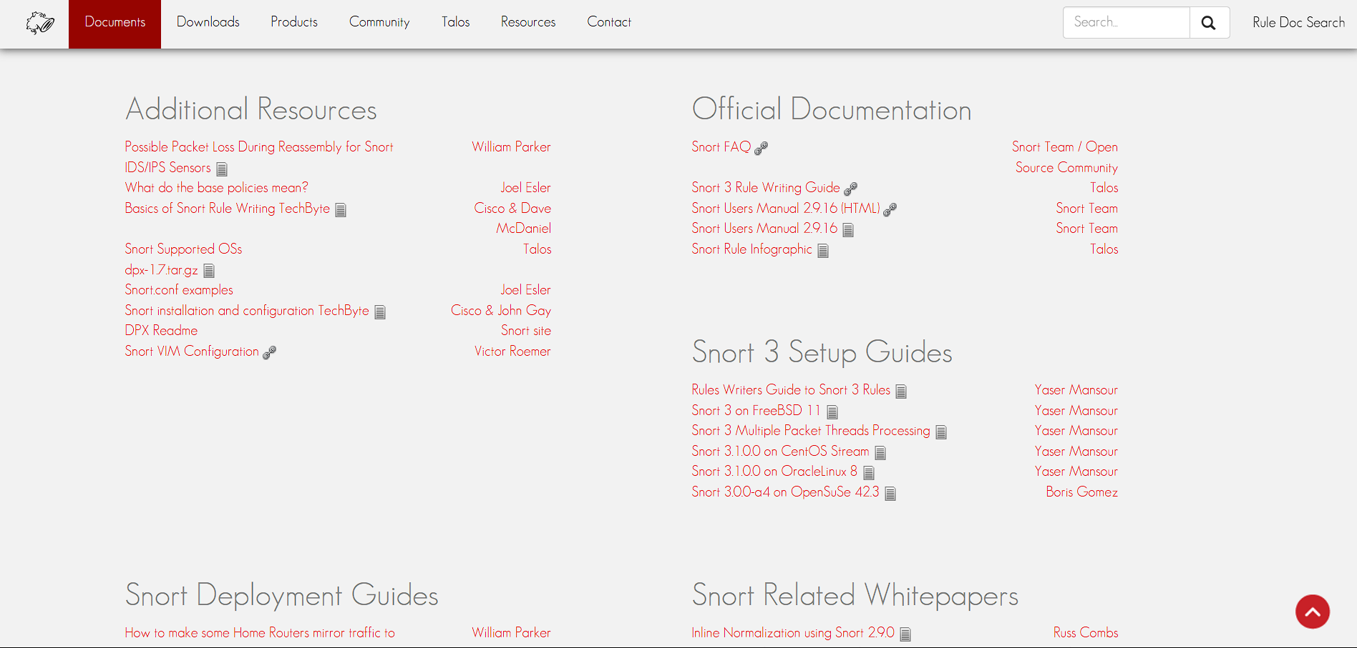
Figure 2.1: Snort product and documentation page (Cisco Talos, 2024)

Table 2.1: Snort 3.x pros and cons
Pros | Cons
• Mature signature language and rules ecosystem | • No native trainable anomaly engine comparable to MANTIS
• Deep packet and protocol inspection | • Rule quality and maintenance directly affect coverage
• Supports passive detection and inline prevention | • Unknown behaviour may not match an existing signature
• Deterministic matches are straightforward to audit | • Build and deployment are broader than a Standard Library prototype

2.2.2 Suricata 7.x
Suricata 7.x is an open-source threat detection engine that supports multithreaded IDS, IPS and network monitoring. Its detailed EVE JSON events integrate with external analysis tools and provide a useful reference for MANTIS telemetry design (OISF, 2024). However, Suricata mainly focuses on rules and protocol inspection, with machine-learning processes usually operating outside its core engine. In contrast, MANTIS integrates five lightweight detection models directly into the system.
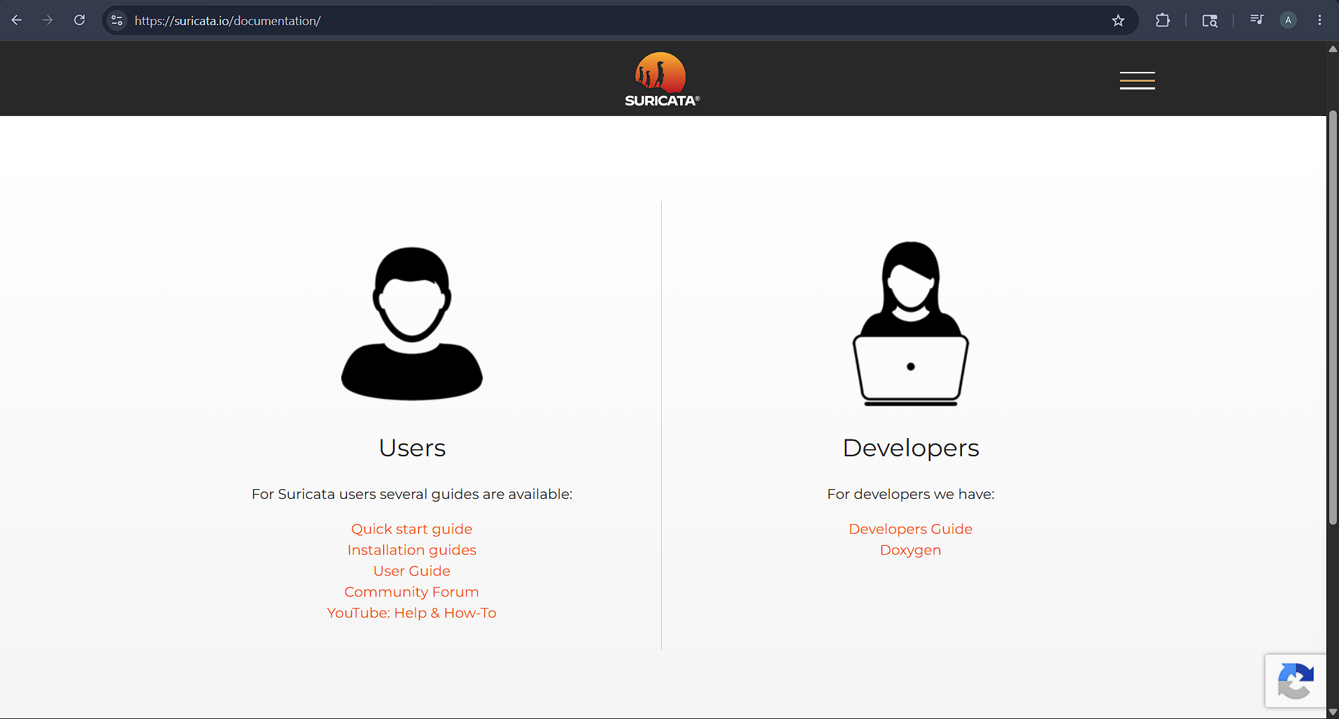
Figure 2.2: Suricata documentation page (OISF, 2024)

Table 2.2: Suricata 7.x pros and cons
Pros | Cons
• Multithreaded architecture supports high throughput inspection | • Learning normally requires an external analytics pipeline
• EVE JSON provides structured alerts and flow records | • Signature coverage still depends on rules and configuration
• Broad protocol and file inspection capabilities | • Its feature scope is larger than the project’s minimalist target
• Can operate as IDS, IPS or monitoring sensor | • Operational tuning is more complex than a small teaching prototype

2.2.3 Zeek 8.x
Zeek 8.x is a network security monitoring framework that converts traffic into detailed protocol logs and events. Analysts can extend its behaviour through a scripting language, making it useful for anomaly-based monitoring (Zeek Project, 2026). Zeek focuses on providing rich context rather than relying on a single classifier. However, inline blocking is not its main purpose, so responses usually require another security tool or control mechanism.

Figure 2.3: Zeek documentation page (Zeek Project, 2026)

Table 2.3: Zeek 8.x pros and cons
Pros | Cons
• Detailed protocol logs support behavioural investigation | • Inline prevention is not its principal operating model
• Event driven scripting enables custom detection policies | • Effective deployments require scripting and policy expertise
• Strong visibility for incident analysis and hunting | • External components are commonly used for enforcement
• Transparent scripts can be reviewed and versioned | • It does not provide MANTIS style trainable engines as one compact bundle

2.2.4 Wazuh 4.x
Wazuh 4.x is an open-source security platform that combines endpoint agents, a central server, an OpenSearch-based indexer and a dashboard. It provides endpoint monitoring, rule-based analysis, central management and configurable active responses (Wazuh, 2026). These features suit distributed environments but require a larger architecture than a lightweight network sensor. Wazuh focuses on platform-wide integration, while MANTIS uses a smaller experimental system with transparent detection algorithms.

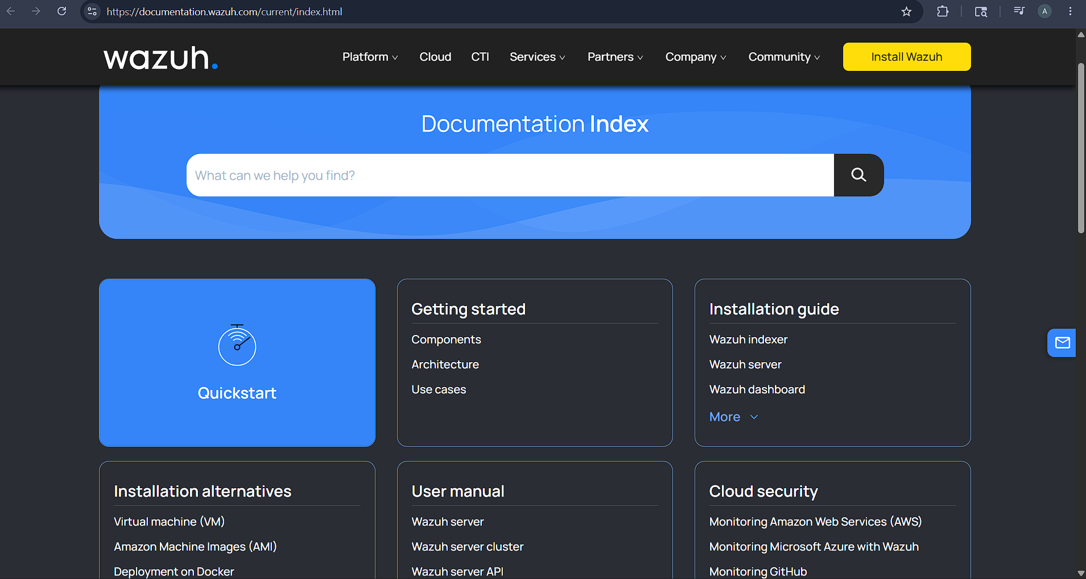
Figure 2.4: Wazuh documentation page (Wazuh, 2026)

Table 2.4: Wazuh 4.x pros and cons
Pros | Cons
• Centralized management for distributed agents | • Multi component stack has a larger operational footprint
• Rules, decoders, dashboards and active response | • Deployment and maintenance exceed a single sensor prototype
• Searchable security event storage and correlation | • Network anomaly learning is not its sole design focus
• Suitable for wider endpoint and compliance monitoring | • Central services create more configuration and security responsibilities

2.3 Research Methodology
This project follows a constructive research methodology, where knowledge is gained by building and evaluating an artefact that addresses a practical problem (Crnkovic, 2010). Requirements were identified from existing research, comparable tools and the intended deployment environment. MANTIS was then developed and tested against these requirements, linking the research problem to its design, implementation and evaluation.

The evaluation uses both quantitative and qualitative evidence. Quantitative measures include unit and integration tests, confusion matrices, precision, recall, F1 score, latency, throughput and resource use. Qualitative evidence includes structured usability observations and architectural review. These results assess whether MANTIS is suitable for low-resource environments, not whether it is equivalent to mature security platforms.

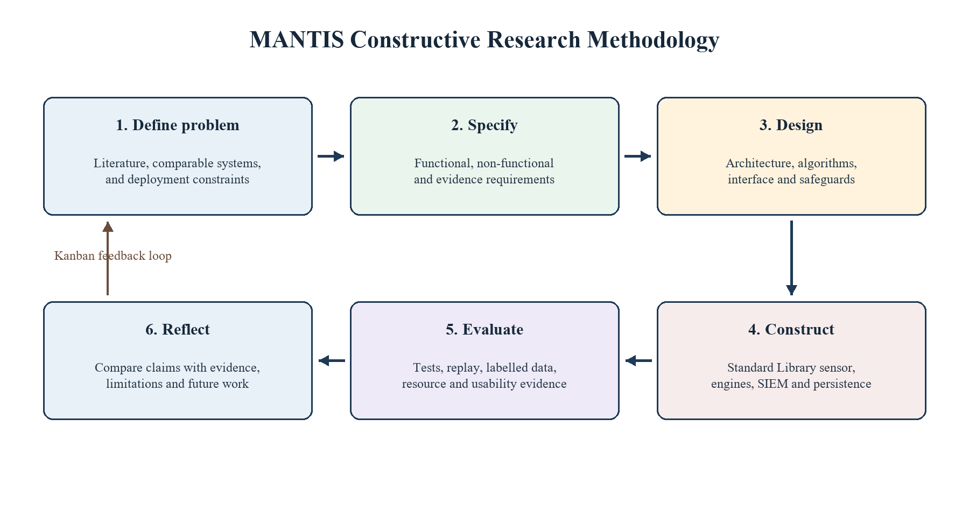
Figure 2.5: Constructive research methodology with Agile Kanban feedback

2.4 Implementation Traceability
A pragmatic philosophy was chosen because this research evaluates whether a transparent, lightweight detector can work under real-world constraints. Mathematical analysis explains its decisions, testing verifies its components, and performance measurements assess the complete system.

Dataset sources, preprocessing, configuration, hardware and test conditions are documented for repeatability. Conclusions apply only to the tested system and environment. Areas not examined, such as unknown traffic, encrypted payloads and adversarial evasion, are acknowledged as limitations.

2.5 Development Methodology
Development followed Kanban, with a limit of two coding tasks and one testing task in progress. Each card identified a module, acceptance test and evidence file. Engine tasks linked to src/engines and test_engines.py; capture and parsing tasks linked to sensor.py, parser.py and test_integration.py; and SIEM tasks linked to siem.py and test_siem_api.py. Failed evaluations were returned to In Progress.
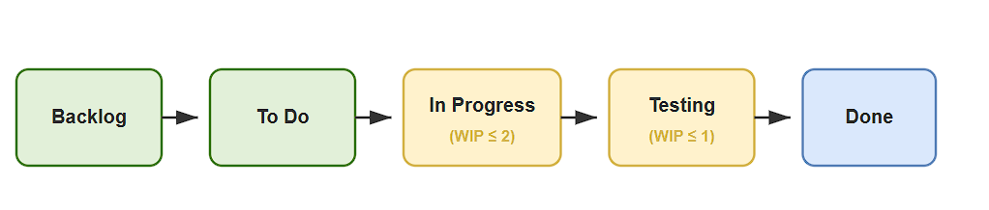
Figure 2.6: Kanban development workflow from the project plan
The board was updated throughout development. Engine defects were reopened, SIEM tests were added, and privacy checks were moved to the dispatcher. Appendix A contains the complete Gantt chart, while the mapped modules and suite of 116 tests provide evidence of progress.

Each task followed a short cycle: define acceptance criteria, implement the change, test it, record the evidence and update the project documentation. This kept development connected to the proposal and interim milestones while allowing earlier assumptions to be corrected.

2.6 Evaluation Strategy
Evaluation is organized in layers. Unit tests examine packet parsing, engine calculations, configuration and state serialization. Integration tests examine the path from parsed traffic through engine verdicts, dispatch, logging, UDP telemetry, dashboard ingestion, optional response and PCAP export. System tests use controlled replay and live loopback traffic to verify end to end behavior without exposing public networks or relying on uncontrolled attack activity.

Detection quality is reported separately for applicable engines using true positives, false positives, true negatives, false negatives, precision, recall and F1 score. Runtime evaluation records latency, traffic rate, CPU, memory and test environment together, because an isolated latency value is not interpretable without load and hardware. Training and testing data are separated before model fitting. Results that use small synthetic samples are labelled as functional checks, while claims about detection effectiveness require an adequately sized held out dataset.

2.7 Methodology for Comparable Analysis
The comparable analysis uses five project defined criteria: anomaly detection support, active response, suitability for a low footprint deployment, transparency of decision logic, and support for training or adaptation. Each system is assigned a qualitative alignment score from 1 to 5, where 1 indicates weak alignment with the MANTIS research context and 5 indicates strong alignment. The chart is a requirements oriented rubric based on documented capabilities; it is not a throughput benchmark or an independent product ranking.
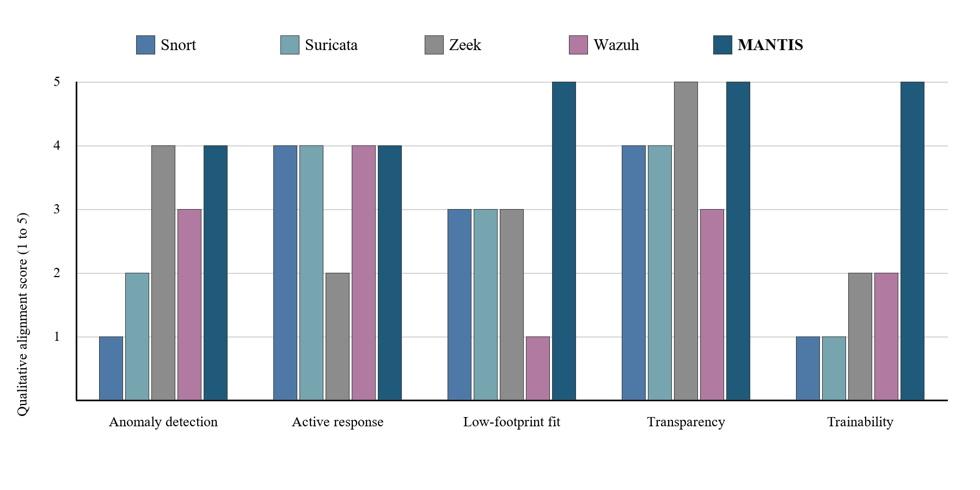
Figure 2.7: Qualitative comparable system functionality ranking using the project rubric

Table 2.5: Comparable-system ranking checklist
Criterion | Snort | Suricata | Zeek | Wazuh | MANTIS
Anomaly support | 2 [ ] | 3 [ ] | 5 [x] | 3 [ ] | 4 [x]
Active response | 4 [x] | 4 [x] | 2 [ ] | 5 [x] | 3 [ ]
Low footprint fit | 4 [x] | 3 [ ] | 3 [ ] | 2 [ ] | 5 [x]
Decision transparency | 5 [x] | 4 [x] | 4 [x] | 3 [ ] | 5 [x]
Training/adaptation | 2 [ ] | 2 [ ] | 4 [x] | 3 [ ] | 4 [x]
Checklist rule: [x] indicates a score of 4 or 5 on the five-point project rubric; [ ] indicates a score of 1 to 3. The checklist records alignment with this dissertation context, not overall product quality.

Table 2.6: Comparable system strengths and limitations
System | Principal strength | Limitation in the MANTIS context
Snort 3.x | Mature rule language and deep packet inspection | No native learning or anomaly model; deployment centres on rule maintenance
Suricata 7.x | Multithreaded inspection with structured EVE JSON output | Learning normally depends on an external analytics component
Zeek 8.x | Rich behavioural telemetry and scriptable protocol analysis | Detection and response policies require scripting and external enforcement
Wazuh 4.x | Centralised agent management, correlation and active response | Multi component platform is broader and heavier than a small standalone sensor
MANTIS | Five inspectable engines, training, state persistence and optional response in one prototype | Narrower protocol coverage and less operational maturity than established platforms
The comparison shows why MANTIS is a focused experimental artefact rather than a replacement for the four systems: Snort and Suricata offer greater signature and protocol maturity, Zeek provides richer behavioural telemetry, and Wazuh offers broader central management. The final evaluation therefore tests only the low footprint, inspectable criteria deliberately built into the MANTIS scope and acknowledges the prototype's narrower coverage and lower operational maturity.

2.8.1 Problem Domain
MANTIS addresses network monitoring on commodity Linux hosts where a learner or small operator needs inspectable detection without deploying a full security platform. The problem is defined by the following linked constraints:
- The runtime should remain small enough for a modest virtual machine, teaching laboratory, or edge Linux host, without requiring third-party Python packages for detection.
- Signature-only monitoring may miss behaviour without a prepared rule, while opaque models make it difficult to explain why an alert was generated.
- Capture, alerting, persistence, evaluation, and optional response should form one reproducible workflow, while privileged actions and sensitive payload collection remain controlled.
- Reconnaissance, volumetric anomalies, malicious payloads, behavioural novelty, and known malicious indicators require complementary detection mechanisms rather than a single universal classifier.
- Operators should be able to trace every alert to observable features, a stated threshold or learned state, and a documented decision path.
- Labelled training data, replay traffic, and live network behaviour differ, so the evidence should distinguish implementation verification from claims of real-world accuracy.
- Packet payloads and addresses may expose personal or confidential information, so data minimisation, redaction, bounded retention, and controlled export are required.
- Learned engine state and audit evidence should survive an orderly restart without silently accepting corrupted or incompatible brain data.
- Claims about detection, response, and resource use should be reproducible through traceable tests, explicitly defined environments, and reviewable output artefacts.

2.8.2 Proposed Solution Strategy
Each constraint in Section 2.8.1 is answered below by a corresponding solution decision. Keeping the same order and number makes the link from the problem domain to implementation explicit:
- MANTIS uses Python Standard Library detection code, bounded queues and buffers, compact online state, and configurable retention limits so that it can operate on a modest Linux host.
- The system combines transparent statistical, supervised, probabilistic, clustering, and membership methods instead of relying solely on prepared signatures or an opaque end-to-end model.
- Capture, parsing, five-engine analysis, alert dispatch, persistence, SIEM delivery, reporting, and optional active response are connected through a single producer-consumer workflow with controlled privileges.
- Complementary mechanisms are assigned to the principal threat patterns, with Z-Score detecting volumetric anomalies, KNN identifying reconnaissance, Naive Bayes analysing malicious payloads, K-Means recognising behavioural novelty, and Bloom Filter checking known malicious indicators.
- Each engine returns a common Verdict containing the responsible engine, label, confidence, threat flag, and decision details, while thresholds, features, and learned states remain inspectable.
- Training data, controlled PCAP replay, live observations, and evaluation artefacts are separated, while dataset schemas are validated and each result is clearly identified as evidence of either implementation behaviour or wider detection accuracy.
- Retained payloads are minimised, credentials and email addresses are redacted before persistence or telemetry, packet storage is bounded, and evidence can only be exported through controlled functions.
- All five engine states are exported to JSON during an orderly shutdown, while only compatible brain data is loaded at startup and the system safely returns to an initialised state when a valid snapshot is unavailable.
- Requirements are traced to unit, integration, system, regression, and training tests, with reviewable outputs preserved and accuracy, latency, CPU usage, and memory consumption measured only under an explicitly documented environment and workload.
Together, these nine decisions provide one implementation response for every problem domain constraint. The mapping also separates completed technical controls from performance and field accuracy claims that still require controlled measurement.

2.8.3 Alternative Solution Strategy
Three alternative approaches were considered but not selected as the main dissertation artefact:
- Extending Snort or Suricata with an external learning component would provide mature packet inspection, but the research contribution would shift toward integration with a large existing engine rather than implementation and evaluation of transparent algorithms.
- Using scikit-learn, ONNX Runtime or a neural framework would shorten model development and support more complex algorithms, but it would introduce runtime dependencies and reduce the project’s emphasis on first principles, inspectable implementation.
- Deploying Wazuh would provide broader endpoint management and response, but its multi component platform addresses a different operational scale from the single host experimental sensor defined by the aim.
These alternatives remain valid engineering choices outside the dissertation boundary. The selected strategy is justified only for the stated research purpose: to examine what can be achieved with a compact Standard Library runtime and five visible decision mechanisms.

2.8.4 Functional Requirements
Table 2.6 records the implemented functional requirements. Inputs and logic are taken from the MANTIS source modules rather than from an aspirational specification.
Table 2.7: Functional requirements with inputs and implementation logic
Subcategory | Goal / Objective | Required Inputs | Implementation Details / Logic
Packet acquisition | Capture live Ethernet frames or replay a finite PCAP without stopping the analyser on unsupported frames. | Linux interface name or PCAP path; AF_PACKET raw socket or libpcap format file; optional VLAN/ICMP frames. | SensorNode binds SOCK_RAW/AF_PACKET or opens the PCAP stream. PacketParser unpacks Ethernet/IPv4/TCP/UDP/ICMP with struct; truncated frames are rejected and counted, not fatal.
Pipeline decoupling | Prevent capture stalls when classification is slower than arrival rate. | Raw frame bytes; configured queue size; producer and analyser threads. | A bounded queue.Queue receives frames from the sniffer. On overflow the sniffer drops and records loss. The analyser dequeues, parses and fans observations to the engines.
Five engine classification | Detect volumetric floods, reconnaissance, malicious plaintext payloads, behavioural novelty and known bad sources through one contract. | Per interval PPS and unique port counts; payload bytes; source IP; trained or seeded engine state. | Each engine implements analyse/train/export_brain/import_brain. Interval engines (Z-Score, KNN, K-Means) run once per second; Bloom and Naive Bayes run per packet. A Verdict {label, confidence, detail, is_threat} is returned.
Training and brain persistence | Fit applicable engines from labelled data and restore inspectable state after restart. | CSV/JSON/CIC-IoT2023 derived tables with validated columns (unique_ports, packet_count, payload, label); brain JSON path. | training.train and Loader reject illegal mappings such as raw Dst Port as unique_ports. Compatible sections of the newest brain file are imported at start; export occurs on orderly shutdown.
Alert construction | Produce an auditable alert that an operator can explain. | Engine Verdict; packet 5 tuple; optional payload excerpt; MITRE mapping tables. | AlertDispatcher deduplicates, enriches ATT&CK technique/severity/risk, truncates excerpts to 64 bytes and redacts PII before any sink is written.
Persistence and telemetry | Retain a forensic trail and notify a SIEM without blocking capture. | Sanitised alert record; CSV path; UDP host/port default 9999. | Logger appends a locked CSV row. UDPSender emits JSON datagrams. Failures are logged; they do not terminate the analyser.
Operator interface | Display current alerts, evidence and exports in a browser. | HTTP GET on port 8080; in memory alert buffer; packet store identifiers. | siem.py serves HTML/JSON from a standard library HTTP server. Malformed UDP is discarded. The dashboard is a local prototype and is not authenticated.
Optional active defence | Block a confirmed source only under explicit operator policy. | --block flag; --block-on categories; whitelist; source IP; iptables availability. | ActiveDefense inserts iptables -I INPUT 1 -s IP -j DROP only when enabled, category permitted, not whitelisted and not already blocked. flush() removes MANTIS rules on exit.
Evidence export | Support post incident review and external analysis. | Session alerts; bounded packet store; shutdown event. | ReportGenerator writes forensic HTML. Packet evidence can be exported as a valid PCAP. Stores are bounded to prevent unbounded RAM growth.
Evaluation reporting | Produce reproducible confusion matrix metrics for applicable engines. | Held out labelled samples; imported brain state; output path. | evaluation.evaluate writes TP/FP/TN/FN, precision, recall, F1 and related files. Small synthetic sets are labelled as functional checks, not field accuracy.
Configuration and shutdown | Control runtime behaviour and release resources cleanly. | CLI/config options for interface, ports, brain, logs, PCAP and defence; stop signal. | Config supplies defaults. Shutdown stops threads, closes sockets, exports brain state and completes the HTML report.

2.8.5 Non-Functional Requirements
- NFR1 Performance: Meet the latency, CPU and memory targets in Table 2.7 under a documented reference load and environment.
- NFR2 Transparency: Keep each engine’s mathematics, thresholds, features and state visible in source code and report per engine results.
- NFR3 Portability: Require only the Python Standard Library for detection logic; use documented Linux facilities for live capture and response; keep offline training and replay usable on other operating systems where supported.
- NFR4 Security: Disable active defence by default, validate externally supplied paths and data, minimise payload retention, and avoid exposing dashboard or UDP services directly to an untrusted network.
- NFR5 Reliability: Bound queues and buffers, handle malformed packets and telemetry without terminating the service, and preserve valid logs and brain data across controlled shutdown.
- NFR6 Maintainability: Implement engines as separate modules sharing analyse, train, export_brain, import_brain and reset operations, with automated tests for their contracts.
- NFR7 Usability: Provide documented installation, command help, clear configuration defaults and operator readable alerts without requiring an external database or web framework.
- NFR8 Reproducibility: Record dataset, split, configuration, software version, hardware and test commands for every reported experiment.

2.8.6 Goals of Implementation
Implementation of success requires one coherent and testable prototype. The principal goals are:
- Capture live Ethernet or finite PCAP input, decode supported protocols and reject malformed frames safely.
- Route correct features to five engines and preserve the engine, label, confidence, threat state and decision detail.
- Bound queues and evidence, redact sensitive content and keep active defence disabled unless policy checks pass.
- Persist compatible engine state and provide operator-visible alerts, packet evidence and architecture information.
- Trace each requirement to unit, integration, system, regression or evaluation evidence while keeping authentication, encrypted payload inspection and enterprise case management outside scope.

2.8.7 System Workflow Diagrams
Figure 2.7 represents the conventional workflow used as the problem reference: multiple security data sources feed an alert queue, after which analyst correlates evidence and applies a response manually. Figure 2.8 represents the proposed MANTIS workflow, linking training and brain state loading to packet capture, five engine analysis, alert dispatch, dashboard presentation and optional iptables response. The diagrams retain the workflow presentation used in the interim report.
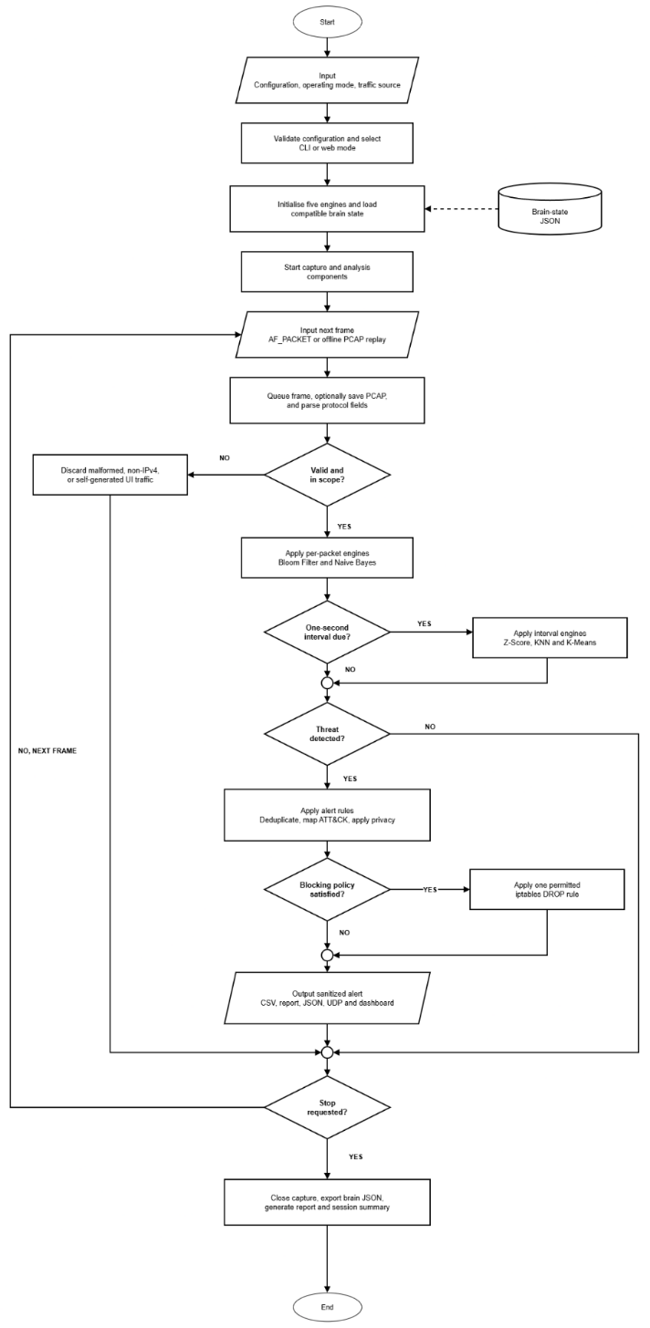
Figure 2.8: Current monitoring and manual response workflow
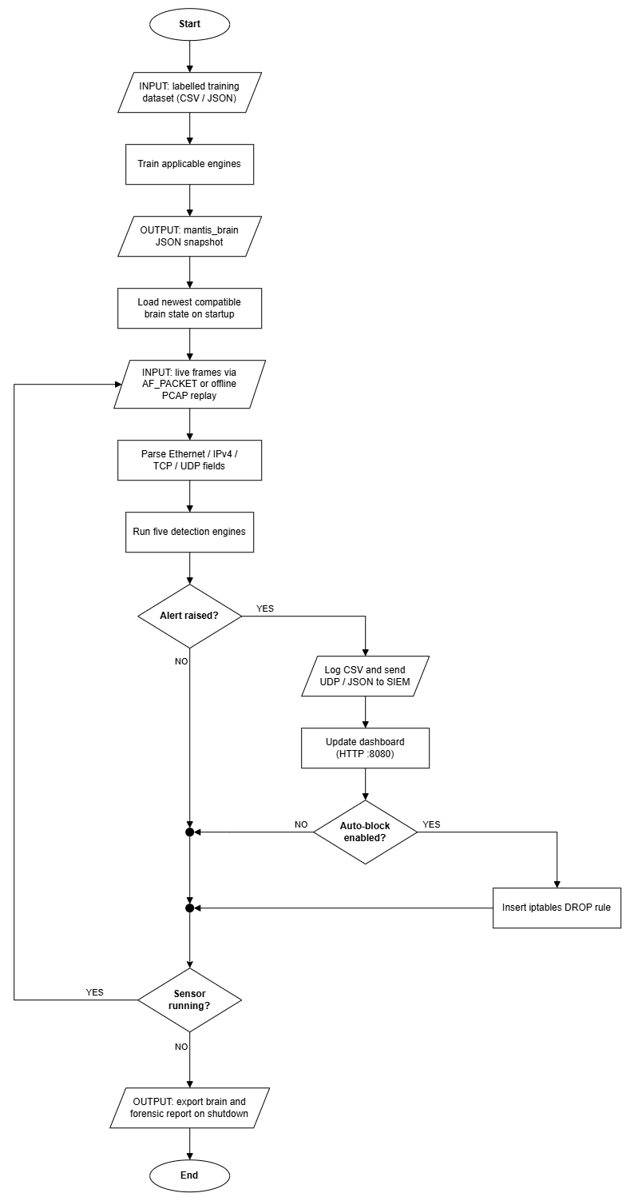
Figure 2.9: Proposed end to end MANTIS workflow
2.8.8 Performance and Environment Requirements
Live capture requires a Linux host that provides AF_PACKET and sufficient privilege or capability for raw sockets. The reference environment will record processor, memory, operating system version, Python version, interface, traffic source and test duration. The detection runtime uses the Python Standard Library; iptables and Linux capabilities are operating system facilities rather than Python package dependencies. Offline training, evaluation and PCAP replay can be exercised separately where live AF_PACKET capture is unavailable.
Table 2.8: Performance and environment targets for final evaluation
Requirement | Target | Verification method
Packet processing latency | p95 below 15 ms in the stated test environment | Timed replay and live loopback benchmark
Memory footprint | Sensor process below 100 MB resident memory | Repeated process sampling during controlled traffic
CPU utilisation | Below 25% of one reference vCPU at the stated load | Process monitoring with traffic rate recorded
Reliability | No crash or corrupted alert file during a 30 minute run | Sustained replay, shutdown and restart checks
Portability | Live capture on supported Linux; offline training and replay on other operating systems | Installation and smoke test matrix
Security | Active response disabled by default; captured payload minimised | Configuration review and negative tests
Table 2.7 defines evaluation targets, not completed results. The final discussion will report measured values with sample size, load and environment, and will identify any unmet target. This prevents interim observations or single loopback measurements from being presented as general performance claims.

2.8 Algorithms Implemented
The three algorithms below retain the interim report’s documentation pattern. Each is defined, expressed mathematically, described as a procedure, represented in pseudocode and linked to a flowchart. Mini-Batch K-Means and Bloom Filter are documented with the remaining system design material because their state update and persistence behaviour is closely connected to that chapter.

2.8.1 Z-Score Statistical Engine
The Z-Score engine monitors a packet rate observation x relative to an online estimate of the normal mean and standard deviation. It raises a volumetric anomaly indication when the absolute standardised deviation exceeds the configured threshold after sufficient baseline observations.

Mathematical Model
z = (x - mu) / sigma, alerting when |z| > 3. Mean mu and variance sigma are updated online via Welford's incremental method.
z = (X - μ) / σ

Step by Step Procedure
1. Read the current packets per second observation.
2. Update the running count, mean and second moment using Welford’s equations.
3. Derive the standard deviation when enough observations exist.
4. Calculate the absolute Z-Score and compare it with the configured threshold.
5. Return a normal or flood oriented verdict with the supporting score.

Pseudocode
INPUT current observation x and threshold τ
UPDATE n, mean μ and second moment M2
IF n < minimum_samples OR standard_deviation = 0: RETURN Normal
z = (x - μ) / standard_deviation
IF absolute(z) > τ: RETURN FloodAlert with score
RETURN Normal
Flowchart
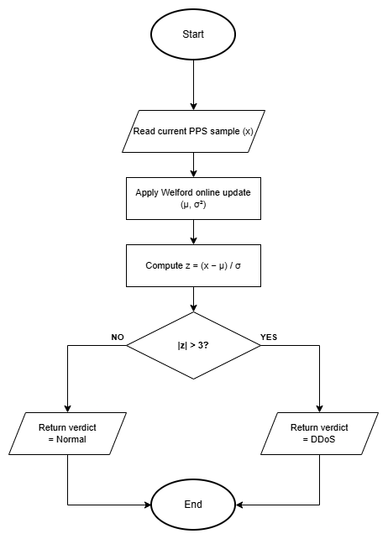
Figure 2.9: Z-Score statistical engine flowchart

2.8.2 K-Nearest Neighbours (KNN) Engine
The KNN engine is a supervised, instance based classifier used for scan oriented observations. A query vector is compared with labelled training vectors, and the majority label among the k closest neighbours determines the predicted class.

Mathematical Model
Euclidean distance d(p,q) = sqrt (sum_i (p_i q_i) ^2). Majority vote of K=3 nearest labelled neighbours assigns Normal vs Scan.
$$d(x,y)=(∑_{i=1}^{n}​{(xi​-yi​)}^{p})\frac{1}{p}​$$

Step by Step Procedure
1. Construct the live feature vector, including the configured scan oriented counts.
2. Validate that a compatible labelled training set is available.
3. Calculate Euclidean distance to every stored training vector.
4. Select the k vectors with the smallest distances and count their labels.
5. Return the majority class with vote based confidence and distance evidence.

Pseudocode
INPUT query vector q and labelled training data D
distances = [(euclidean(q, vector), label) for each item in D]
neighbours = first k items after sorting distances
prediction = majority_label(neighbours)
confidence = votes_for_prediction / k
RETURN prediction, confidence and neighbour distance
Flowchart
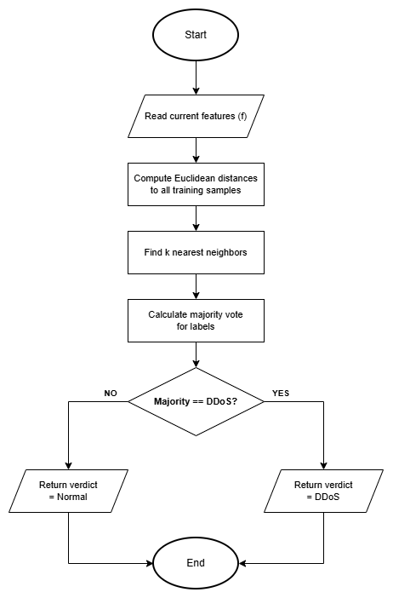
Figure 2.10: K-Nearest Neighbours engine flowchart

2.8.3 Multinomial Naive Bayes Engine
The Multinomial Naive Bayes engine classifies tokenised, unencrypted payload excerpts using class priors and token likelihoods learned from labelled examples. It is intentionally limited to visible payload text and cannot inspect encrypted application content.

Mathematical Model
log P(class|tokens) = log P(class) + sum_i log P(token_i|class); Laplace smoothing prevents zero counts on unseen tokens.
$$P\left(wn​ ∣ wn-1​,…,w1​\right)=\frac{C(w1​,…,wn​)+1}{C(w1​,…,wn-1​)+V}​$$

Step by Step Procedure
- Decode the privacy limited payload excerpt and tokenise visible text.
- Initialise each class score with its log prior probability.
- Add the smoothed log likelihood of each token for each class.
- Select the class with the largest score and derive confidence from the class scores.
- Return a payload alert verdict only when the malicious class and threshold conditions are satisfied.

Pseudocode
INPUT payload bytes and trained class statistics
tokens = tokenise(decode(payload excerpt))
FOR each class c: score[c] = log_prior[c]
FOR each token w: score[c] += log(smoothed_probability(w, c))
prediction = class with maximum score
IF prediction is Malicious AND confidence >= threshold: RETURN PayloadAlert
RETURN Safe
Flowchart
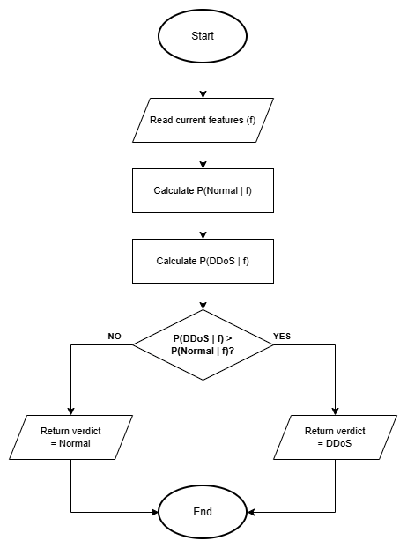
Figure 2.11: Multinomial Naive Bayes engine flowchart

3. System Analysis and Design
System analysis converts the requirements established in Chapter 2 into actors, interactions, data structures and decision paths, grounded in the implemented MANTIS modules. Each diagram answers a different question: the use case identifies user goals, the sequence diagram shows message order, the class diagram allocates responsibility, the activity diagram shows control flow, and the data schema explains how evidence is retained.

The design keeps acquisition, parsing, detection, dispatch, persistence and presentation separate. A bounded producer consumer queue prevents packet capture from being tied directly to analysis time, while a common Verdict contract allows five different algorithms to feed the same dispatcher. Detection code cannot change the firewall directly; an explicit policy check controls the optional response path.

3.1 Preliminary System Design
The preliminary design defines the system boundary, principal actors, evidence flow and operator questions before module-level detail. It establishes a Linux sensor, a bounded capture-to-analysis path, five independent detection methods, one common verdict contract, a local interface and an optional policy-gated response.

3.2 Detailed System Design
The detailed design allocates those responsibilities through use cases, sequences, classes, activities, storage structures, algorithm flows and interface layouts. Every diagram is linked to an implemented module or observable output.

3.2.1 Use Case Diagram
A use case represents a goal achieved through interaction between an actor and the system. In MANTIS the primary actor is the Security Administrator, who starts monitoring, investigates alerts, manages learned state and requests evidence exports. The Host Operating System supplies frames and enforces an approved firewall rule, while an External SIEM may receive structured telemetry. These actors are outside the MANTIS system boundary even when they run on the same host. Figure 3.1a shows this abstract goal level with every actor placed on the left of the system boundary.

Figure 3.1b refines the abstract model to level 1 detail. Include relationships mark behaviour that always occurs, capturing and analysing traffic during live monitoring, while the extend relationship attaches blocking only when a verdict is raised and the block policy is enabled. This distinction prevents the diagram from implying that every alert automatically blocks a source.

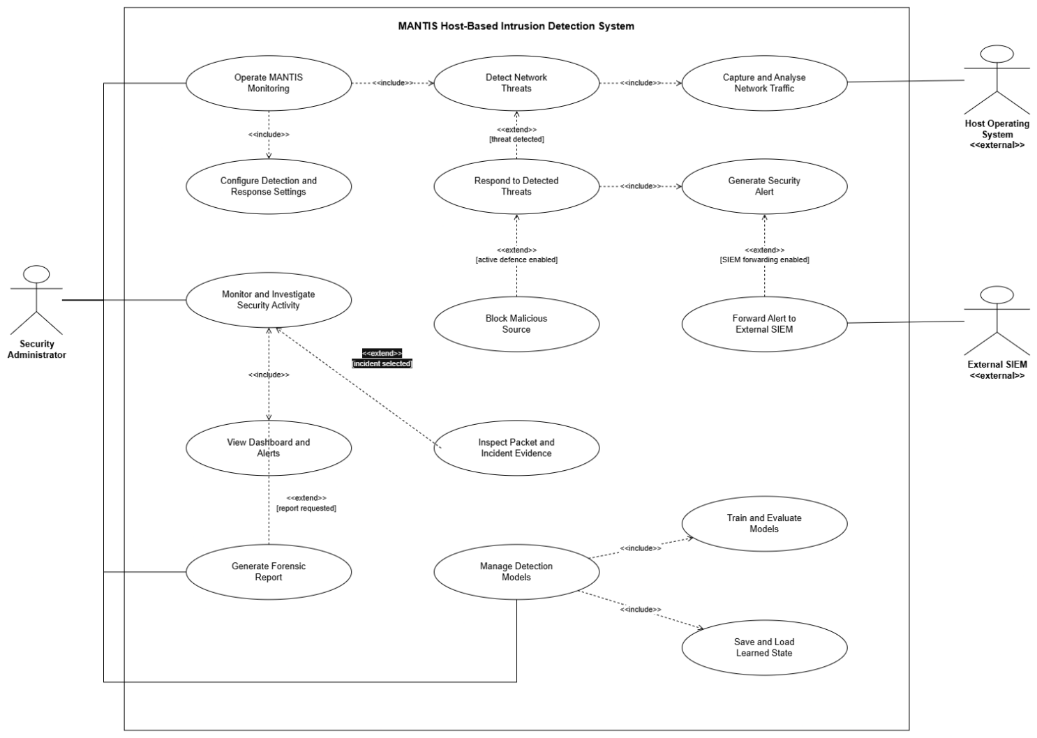
Figure 3.1: MANTIS use case model

3.2.1.1 Use Case Documentation
Table 3.1 states the actor associations the use case diagram shows: a solid association between each actor and the use cases it initiates or supports, include for behaviour that always occurs during monitoring, and extend for optional blocking. Table 3.2 then documents the preconditions, main path and exceptions for each principal use case.
Table 3.1: Actors use case associations, include and extend
Actor or included behaviour | Use case | Association | Meaning in MANTIS
Security Administrator | UC-01 Live monitoring | Association (primary) | Starts and stops the sensor; include Capture Traffic and Analyse Frames.
Security Administrator | UC-02 Investigate and export | Association (primary) | Uses the local dashboard and evidence export.
Security Administrator | UC-03 Train and restore models | Association (primary) | Runs train.py and supplies labelled CSV/JSON.
Security Administrator | UC-04 Apply active defence | Association (primary) | Enables --block; does not occur by default.
Host Operating System | UC-01 Live monitoring | Association | Supplies Ethernet frames via AF_PACKET and process privileges.
Host Operating System | UC-04 Apply active defence | Association | Enforces iptables DROP when the dispatcher requests it.
External SIEM / browser | Receive telemetry / view alerts | Association | UDP JSON to port 9999; HTTP GET on port 8080.
Capture Traffic | UC-01 | Include | Always executed during live or replay monitoring.
Analyse Frames | UC-01 | Include | Always executed after a supported frame is parsed.
Block Source | UC-01 | Extend | Occurs only when a threat verdict is raised and --block policy is satisfied.
The documentation below defines the implemented preconditions, normal outcome and exceptions for the principal use cases. Authentication is not claimed because the local dashboard has no login mechanism, and active defence is described as optional and policy gated, matching the default configuration and current dispatcher behaviour.

Table 3.2: Principal MANTIS use case documentation
ID and goal | Actor | Preconditions | Main success path | Alternative and postcondition
UC-01 Live monitoring | Security Administrator | Supported Linux host; sensor configured; raw capture permission for live mode. | Start sensor; capture frames; parse supported protocols; analyse relevant features; publish qualifying alerts. | Malformed frames are rejected without stopping the loop. Monitoring continues until a stop request; brain state and report are then written.
UC-02 Investigate and export | Security Administrator | Web SIEM running and packet or alert records available. | Open dashboard; filter packets or alerts; inspect source, engine, severity and ATT&CK context; request JSON or PCAP evidence. | An empty store returns a valid empty state. Exported records follow the configured privacy and snap length controls.
UC-03 Train and restore models | Security Administrator | Labelled CSV fields match the selected loader; output directory is writable. | Validate rows; train the selected engines; serialise a timestamped JSON brain; import the latest compatible sections on start up. | Missing columns raise a dataset error. Missing or incompatible sections retain safe seeded state rather than corrupting the engine.
UC-04 Apply active defence | Security Administrator and Host OS | A threat identifies a source; blocking is explicitly enabled; kind is permitted; source is not whitelisted. | Dispatcher evaluates policy; ActiveDefense inserts one iptables DROP rule; response status and rule are recorded. | Disabled policy, failed command, duplicate source or whitelist match produces no block. MANTIS rules are removable during shutdown.

3.2.2 Sequence Diagrams
A sequence diagram shows messages in time order. During live detection, the Linux kernel supplies an Ethernet frame to the sniffer thread, which places raw bytes in the bounded queue. The analyser thread removes the frame, PacketParser validates and decodes it, and the relevant engines return Verdict objects. AlertDispatcher then applies one common route for logging, UDP/JSON telemetry, dashboard publication and optional response.

The response message occurs after the dispatcher has checked block enabled status, the configured block on categories and the whitelist. Brain export is a shutdown operation rather than part of every packet path. This ordering keeps the high frequency capture loop small and makes privacy processing occur at the persistence boundary.
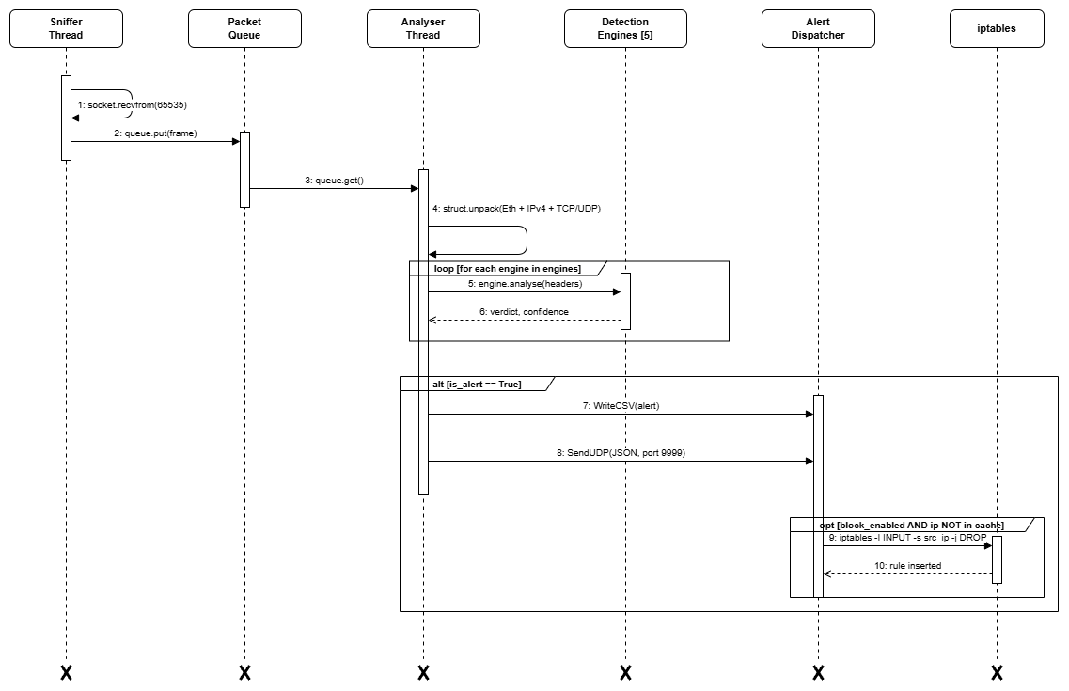
Figure 3.2: Live detection sequence from captured frame to operator visible alert
The training sequence shows the administrator invoking train.py, Loader validating labelled CSV records, the applicable engines fitting their state, and the completed brain snapshot being written as JSON.
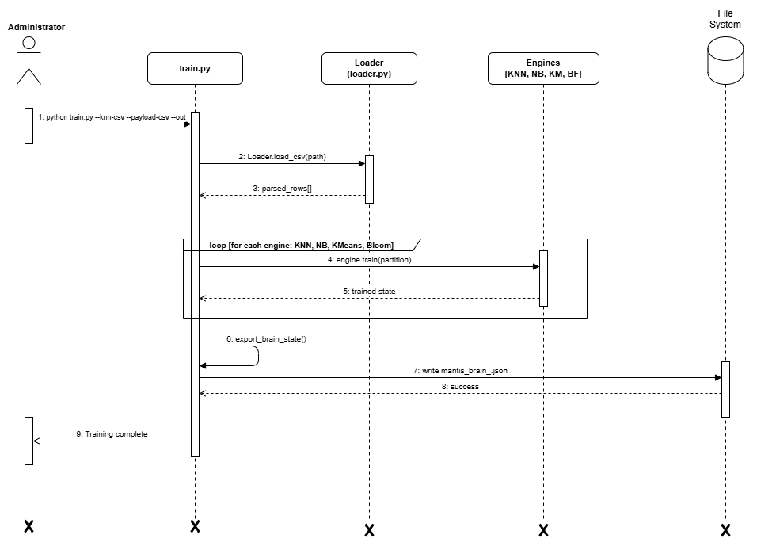
Figure 3.3: Training pipeline from validated data to persistent engine state
The SIEM sequence separates asynchronous alert ingestion from browser retrieval. AlertDispatcher sends JSON to the UDP listener, the listener updates the bounded alert buffer, and the browser obtains the current operator view over HTTP.
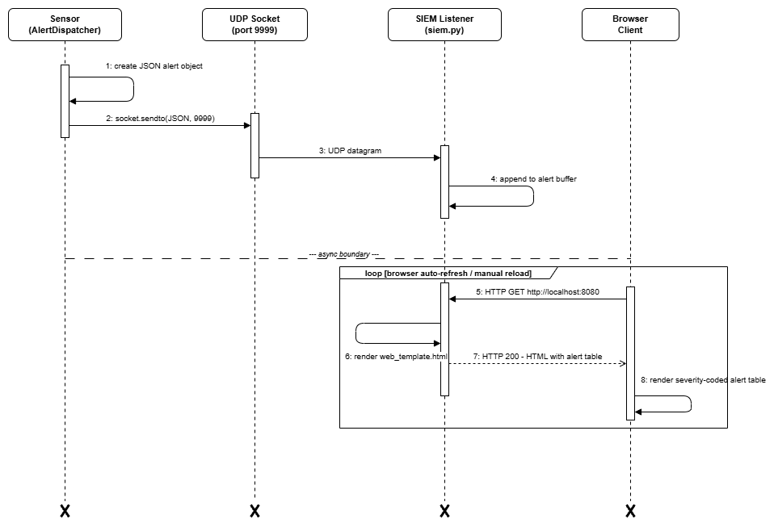
Figure 3.4: SIEM alert delivery and browser dashboard retrieval
The offline sequence provides a deterministic alternative to privileged live capture. main.py opens a finite PCAP stream, submits each decoded packet to the detection engines, and returns the completed analysis evidence to the administrator.
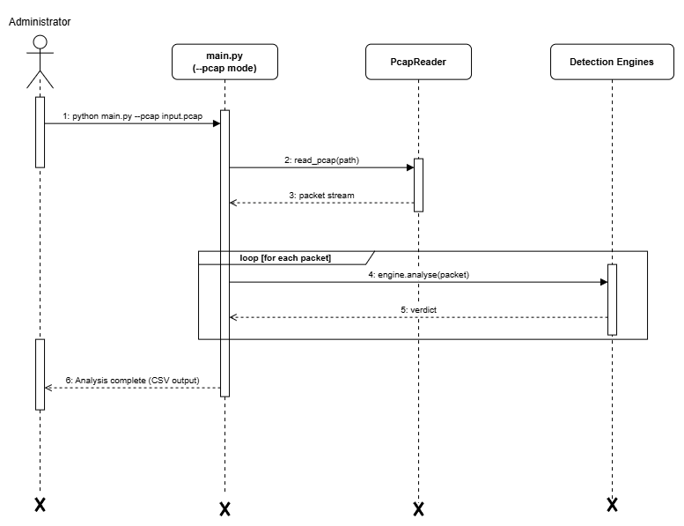
Figure 3.5: Offline PCAP replay and finite analysis completion

3.2.3 Class Diagram
The class diagram illustrates that a Sensor Node exclusively composes exactly one Packet Parser, exactly one Alert Dispatcher capable of optionally invoking an Active Defense service, and one or more concrete Detection Engines that inherit a shared interface to output standardized Verdicts
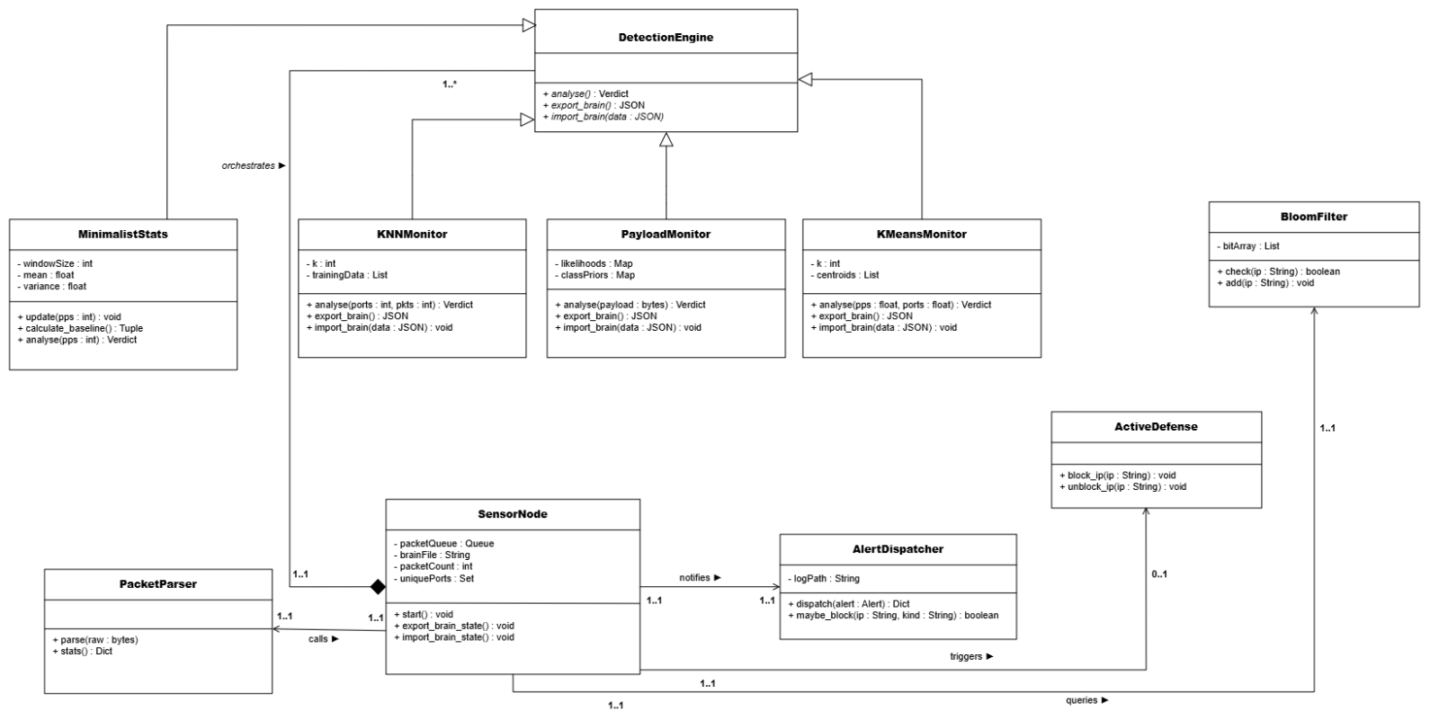
Figure 3.6: Corrected MANTIS class model with inheritance, composition and explicit UML multiplicities

3.2.4 Activity Diagrams
Live detection moves each captured frame through the bounded queue, parser and five engine fork. Verdicts are joined before alert persistence, SIEM delivery and policy controlled response, while normal traffic returns without a response action.
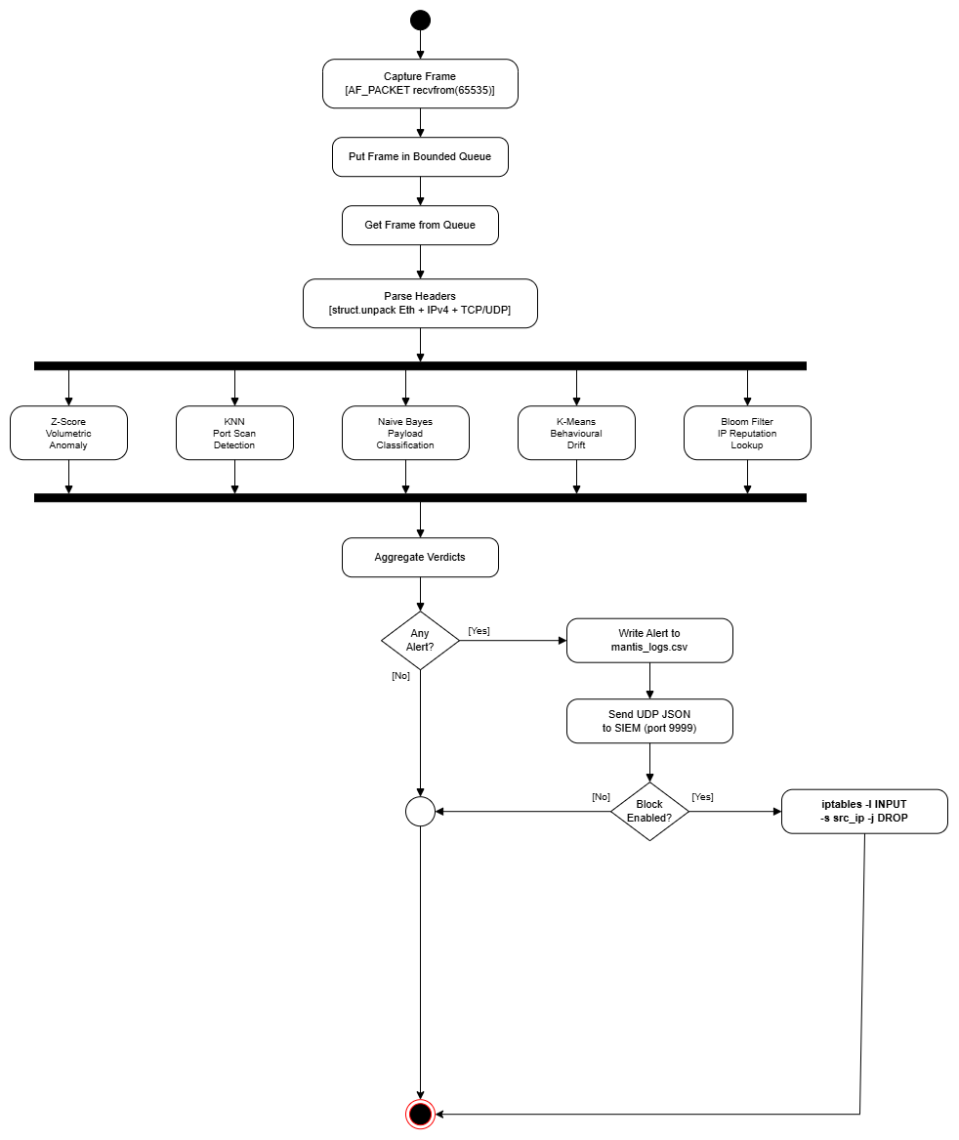
Figure 3.7: Live detection, verdict aggregation and optional response activity
Training validates and projects the supplied data before fitting KNN, Naive Bayes and K-Means and seeding the Bloom Filter. The parallel results converge into one JSON brain export and a training summary.
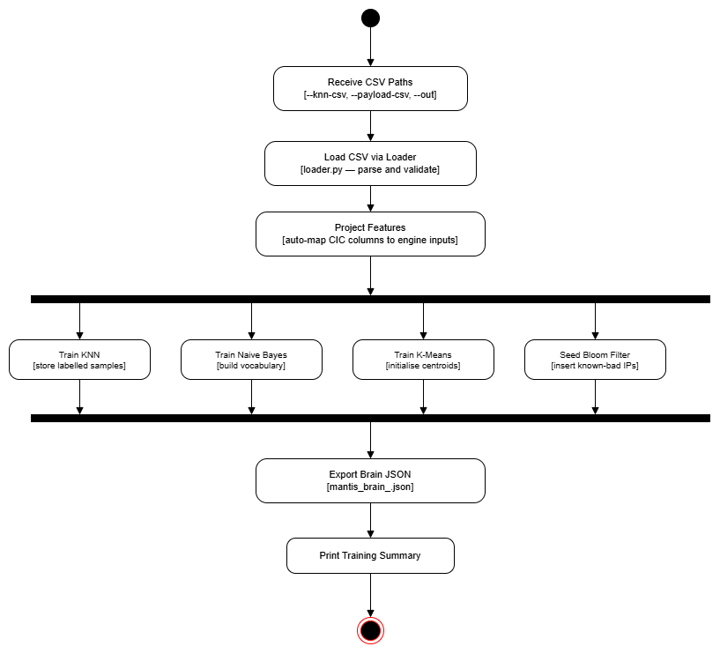
Figure 3.8: Training pipeline from input validation to brain export
Evaluation imports trained state, classifies every labelled sample and updates TP, FP, FN and TN counts. After the final sample, the harness calculates precision, recall, F1 and accuracy for reproducible interpretation.
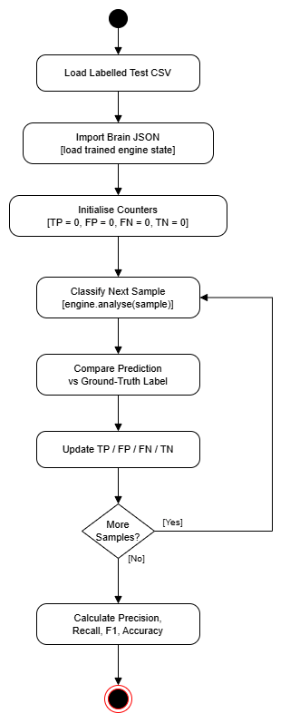
Figure 3.9: Evaluation harness and confusion matrix metric activity
An activity diagram represents processing steps, guarded alternatives and end states. The corrected brain persistence flow begins with engine initialisation and a search for the newest timestamped JSON file. Only after this work does the system decide whether compatible learned state is available. A successful import and a safe default path both converge on the ready state before monitoring starts.

A stop request leaves the monitoring activity, closes threads and any PCAP writer, exports all engine states, writes the timestamped brain file and generates the forensic report. The first node after Start is therefore an action, not a startup or shutdown decision. This matches the SensorNode lifecycle implemented by import_brain_state(), start(), shutdown() and export_brain_state().
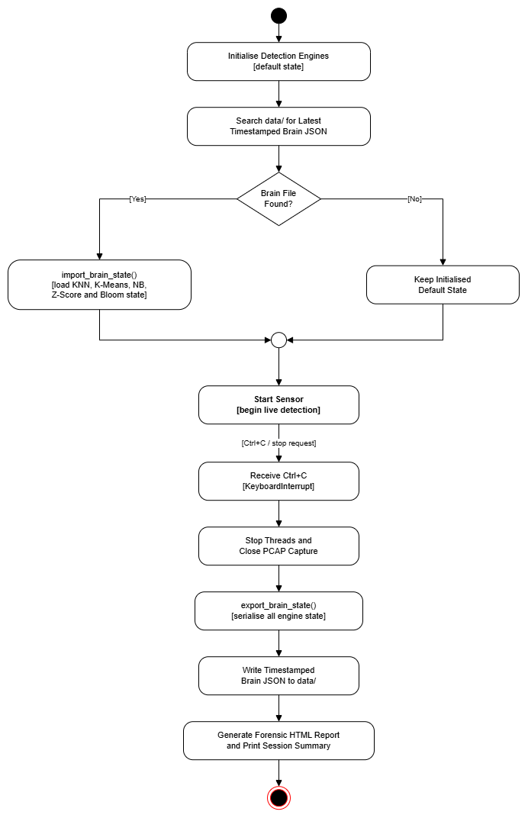
Figure 3.10: Brain persistence and orderly shutdown activity flow
Installation identifies the Linux package manager through a chain of if-else-if decisions (apt, then dnf/yum, then pacman, then zypper, then apk), installs the operating system firewall facility, grants the required capture capabilities and creates the command entry point before reporting success.
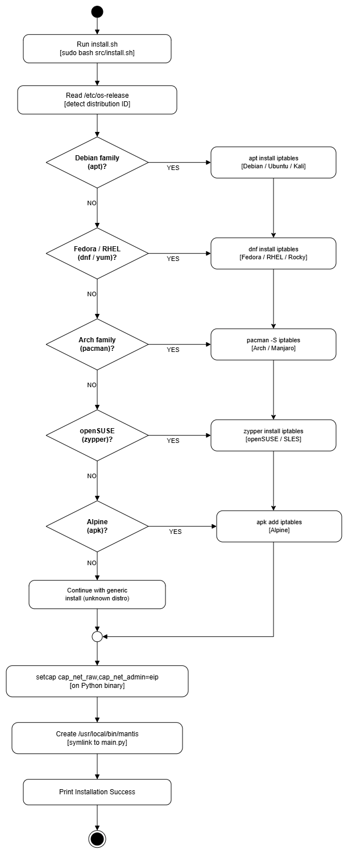
Figure 3.11: Linux installation activity with if-else-if package manager decisions

3.2.5 Data Storage and Logging Design
MANTIS does not use a relational database. The zero dependency requirement favours bounded memory and human readable files, so this section documents a logical data schema and its physical flat file mappings. Packet events may produce multiple engine verdicts; a threatening verdict may produce one alert; and an alert may produce one firewall rule only when response policy permits it. Timestamps, source addresses and engine details provide traceability across these records.

Alerts are appended to CSV after redaction, UDP telemetry is encoded as JSON, engine state is stored in timestamped JSON brain files, packet evidence may be exported as PCAP, and session findings may be rendered as HTML. The packet store is a bounded in memory deque rather than durable history. This design improves portability and inspection, but it does not provide relational querying, concurrent transactions or long term enterprise retention.

Table 3.3: Logical to physical persistence mapping
Logical record | Physical representation | Principal fields | Purpose
Packet event | In memory PacketStore; optional PCAP | Timestamp, addressing, protocol, ports, length, frame excerpt | Bounded investigation and replay evidence
Threat alert | CSV and UDP/JSON | Engine, message, confidence, MITRE fields, severity, risk, sanitised excerpt | Audit trail and real time SIEM ingestion
Brain snapshot | mantis_brain_*.json | KNN samples, K-Means centroids, NB likelihoods, Z-Score statistics, Bloom bits | Readable restart and training state
Firewall response | Runtime iptables rule and dispatcher summary | Source, policy category, applied status | Opt in and reversible local containment
Forensic report | HTML | Session summary and alert chronology | Human readable hand off evidence

3.2.6 Detailed Algorithm Design
Chapter 2 introduced the five detection algorithms. This section completes the design account for the two stateful engines not expanded there: online Mini-Batch K-Means for distance based novelty and a Bloom Filter for reputation membership. Both implement the common engine contract and serialise their state into the JSON brain.

3.2.6.1 Online Mini-Batch K-Means Engine
KMeansMonitor receives the input feature vector f = (packets per second, unique ports) and represents normal traffic with k centroids. It selects the nearest centroid c by Euclidean distance and returns an anomaly only when the distance exceeds the configured novelty threshold. A normal observation updates the centroid incrementally as c_new = c_old + alpha(f c_old), allowing bounded online adaptation without retaining the full stream.

Mathematical Model
For nearest centroid c_k: c_k := c_k + alpha * (x - c_k) with learning rate alpha, following the mini batch update of Sculley (2010).
$$ck​←ck​+η_{k}​({\overline{x}}_{k}-c_{k}​)$$

Step by Step Procedure
- Compute distance from point x to each centroid.
- Assign x to argmin centroid index.
- Update centroid with learning rate alpha.
- Flag alert if distance exceeds configured threshold.

Pseudocode
Mini-Batch K-Means classify (x = [pps, unique_ports]):
nearest_k = argmin (euclidean (x, c) FOR c IN centroids)
min_dist = euclidean (x, centroids[nearest_k])
centroids[nearest_k] += alpha * (x centroids[nearest_k]) // Sculley 2010
IF min_dist > threshold: RETURN BehaviouralDrift
ELSE: RETURN Normal
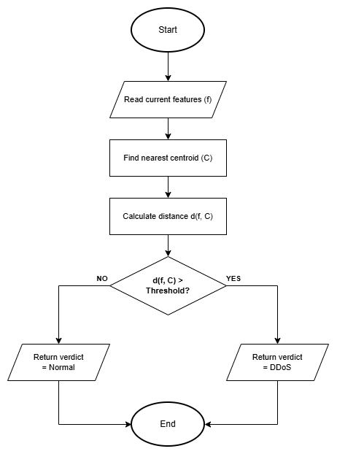
Figure 3.12: Online Mini-Batch K-Means flow from explicit feature input to normal or anomaly output

3.2.6.2 Bloom Filter Reputation Engine
BloomFilter stores known malicious source indicators in a bit array. Adding an indicator computes k hash positions and sets their bits. A lookup returns Unknown when any required bit is zero and returns Blacklisted only when all bits are set. Lookup cost is O(k), independent of the number of inserted indicators, which makes the reputation check suitable for the per packet path.

Mathematical Model
m bits and k hash functions give an expected false positive rate of (1 - exp(-kn/m))^k for n inserted items (Mitzenmacher and Upfal, 2017).
$${( 1-e^{-\frac{kn}{m}} )}^{k}$$

Step by Step Procedure
- Hash item with k independent hash functions.
- Add all k bit positions to 1.
- On check: return true only if all k positions are 1.

Pseudocode
Bloom Filter check(ip):
FOR seed IN hash_seeds:
pos = adler32(encode (ip + str(seed))) mod m
IF bit_array[pos] == 0: RETURN Clean // Definite non member
// All k bits set -> probable member
fp_rate = (1 - exp(-k*n/m))^k // Mitzenmacher & Upfal 2017
RETURN KnownMalicious, confidence = 1.0 fp_rate
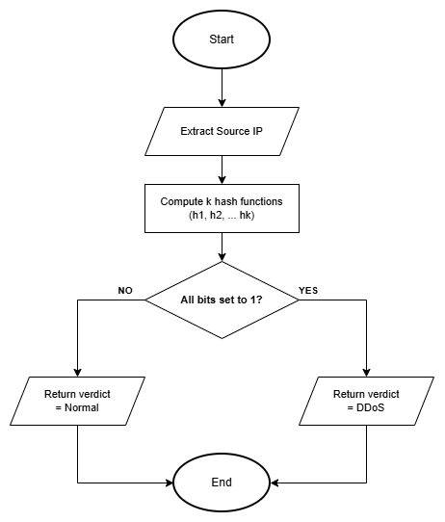
Figure 3.16: Bloom Filter reputation membership decision flow

3.2.7 Interface Design
The system interface supports monitoring and investigation without requiring a separate SIEM dependency. The terminal view serves headless operation, while the embedded web console exposes the current packet rate, bounded packet history, alerts, risk and effective configuration. REST endpoints provide statistics, packet records, configuration and PCAP export; UDP port 9999 receives structured alerts and HTTP port 8080 serves the interface.

Interface decisions follow operator questions rather than source modules: what happened, where it originated, which engine decided, how severe it is and what evidence can be exported. Severity always has a textual label, ATT&CK identifiers give investigation context, and empty states explain that monitoring is waiting for data. Active defence and privacy settings remain visible through configuration data rather than being implied by colour alone.

3.2.7.1 Wireframe
The low-fidelity wireframes define structure and information priority without final colour or demonstration values. The four pages separate system health, packet inspection, alert investigation and architecture explanation.

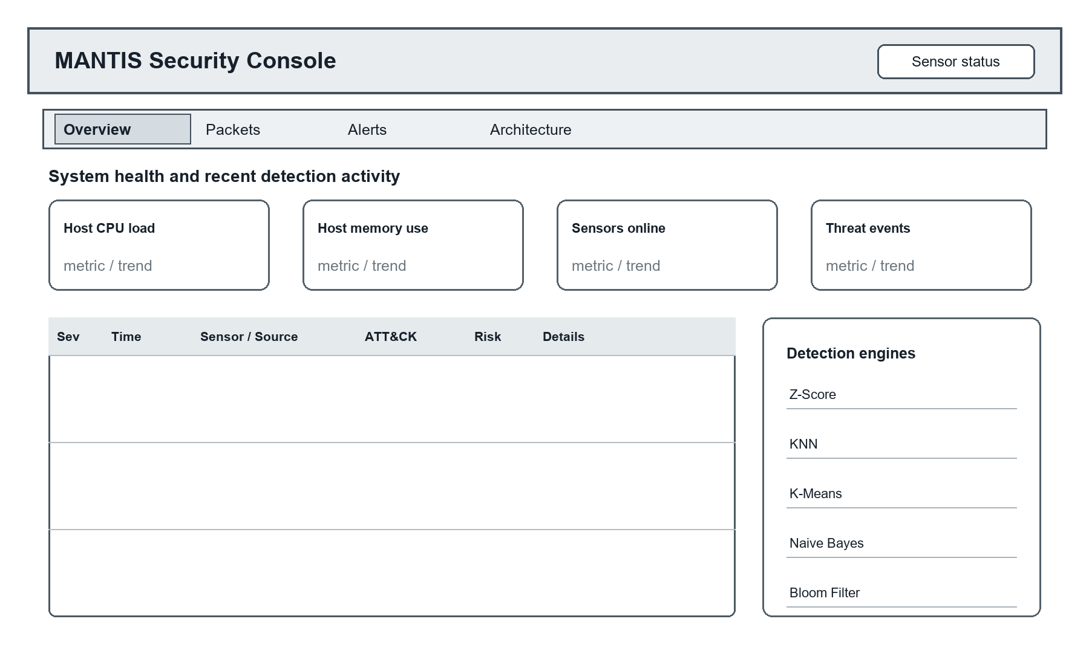
Figure 3.17: Overview page wireframe showing system health, recent events and engine activity
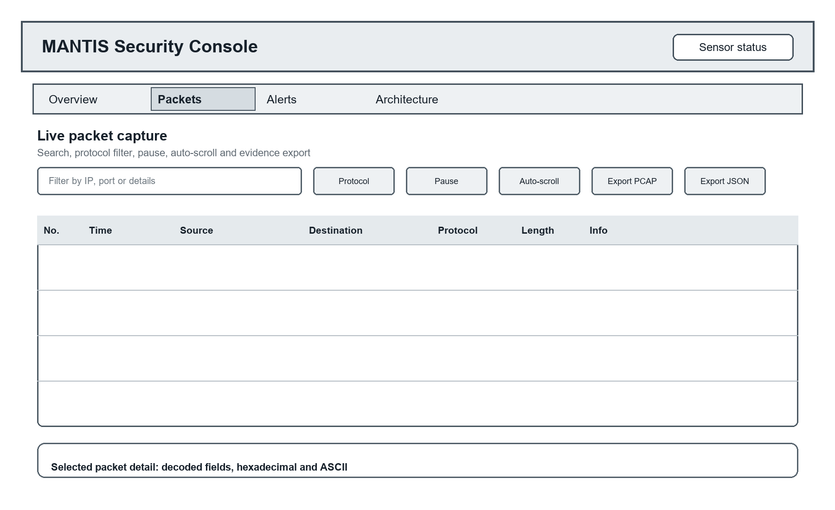
Figure 3.18: Packets page wireframe showing capture controls, packet history and selected frame detail
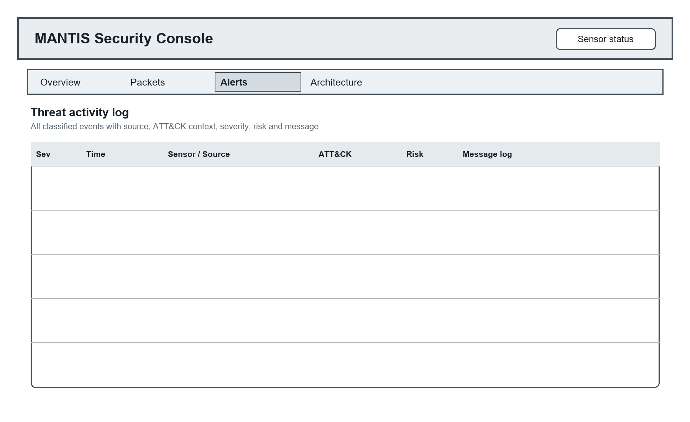
Figure 3.19: Alerts page wireframe showing the complete bounded threat activity log
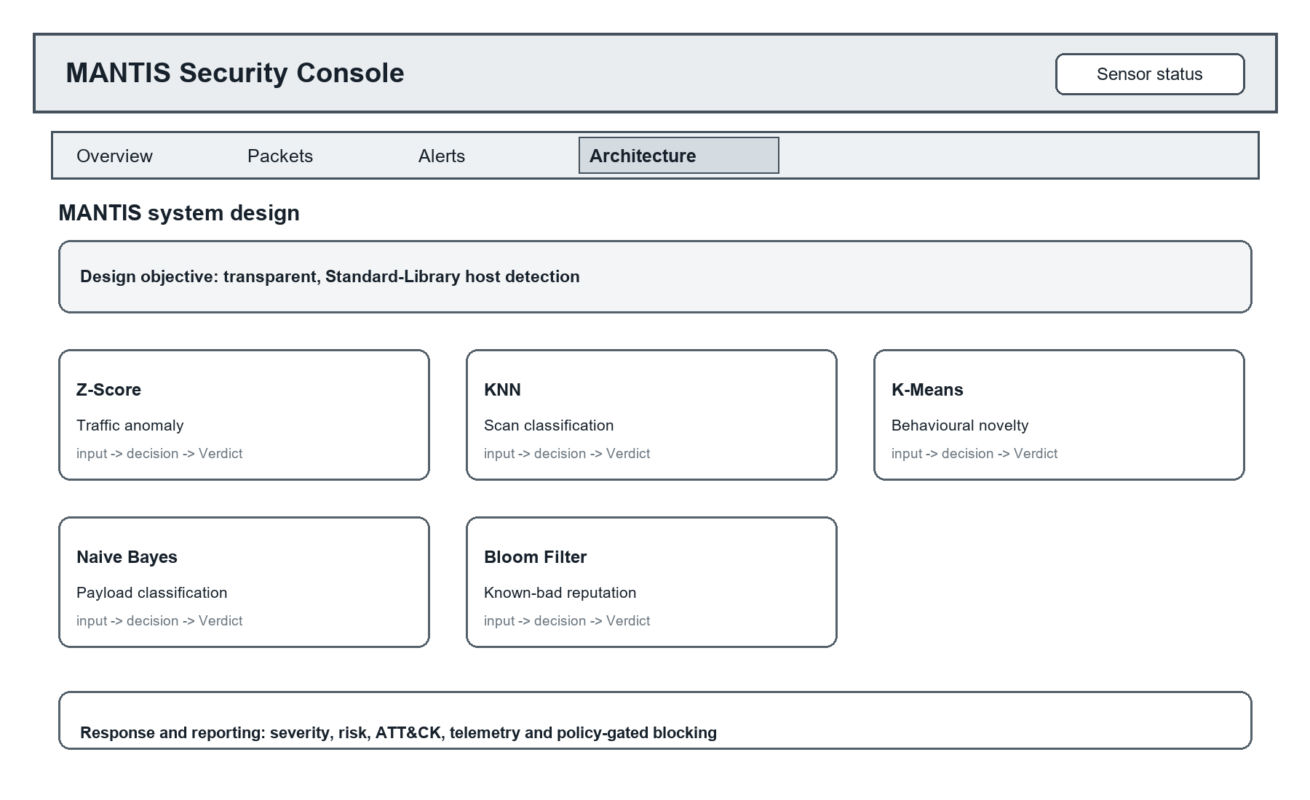
Figure 3.20: Architecture page wireframe showing all five engines and the response path

3.2.7.2 Mockup
The high-fidelity mockups apply the implemented styling and controlled demonstration data to the same four layouts. They show only behaviour supported by web_template.html and siem.py.
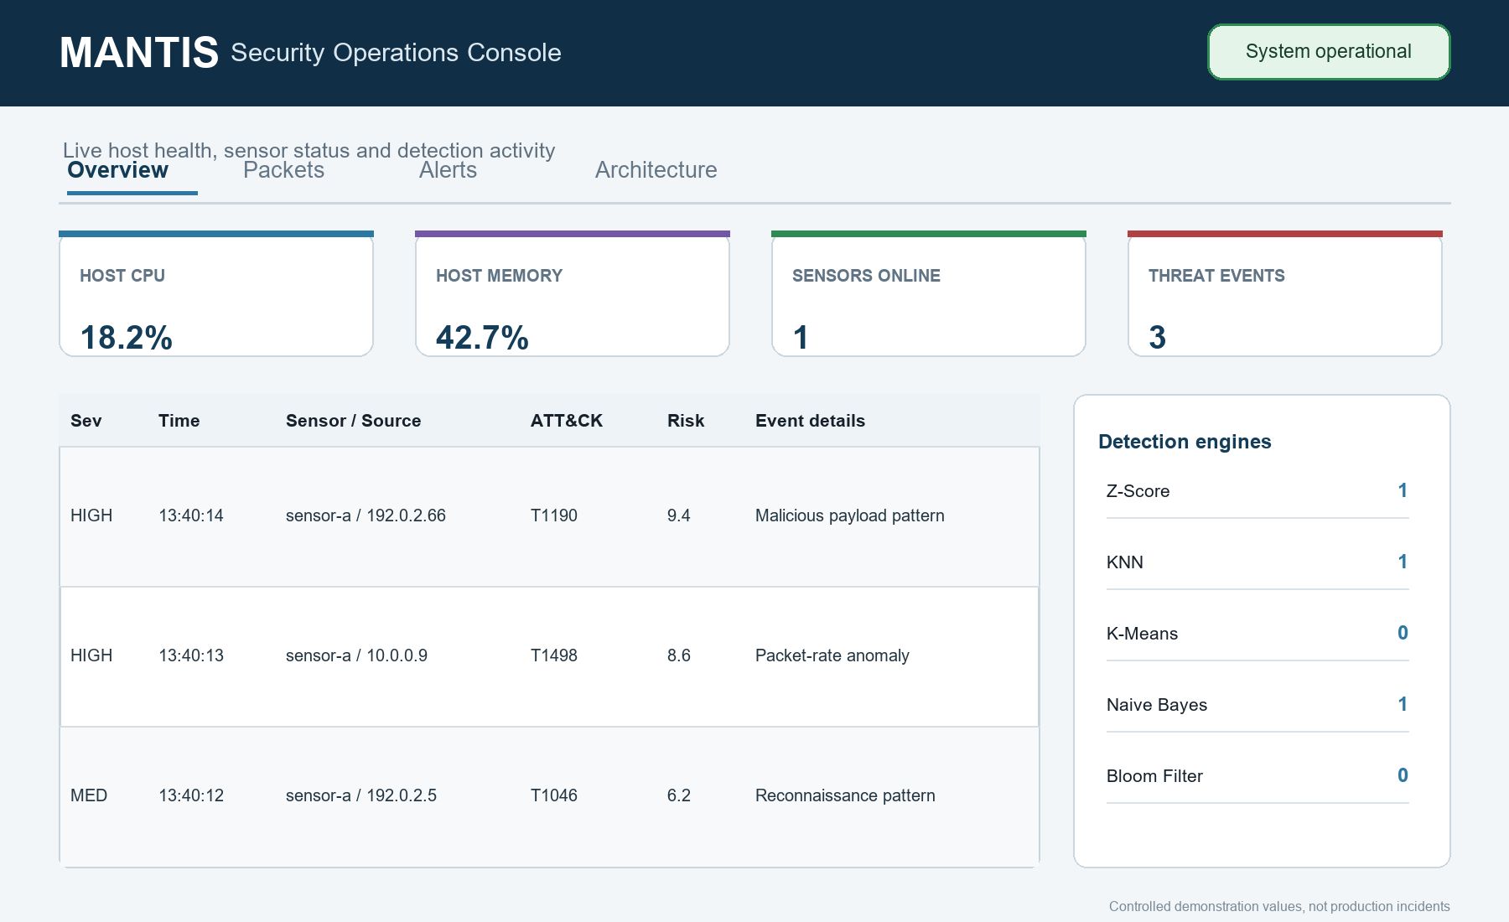
Figure 3.21: Overview page mockup with controlled health metrics, recent events and five engine activity

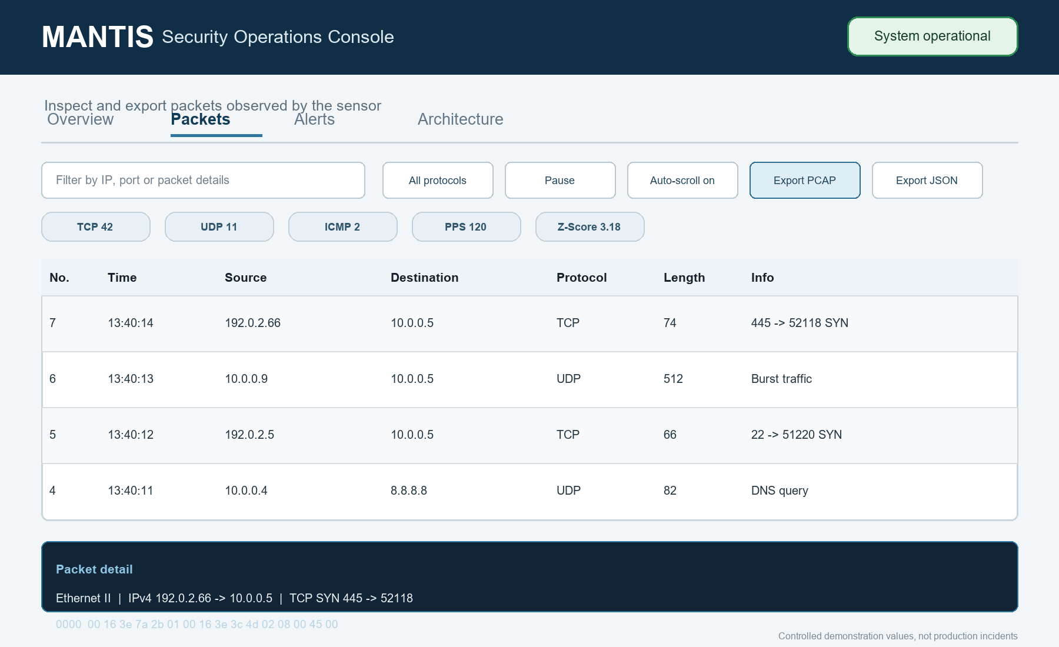
Figure 3.22: Packets page mockup with filters, protocol counters, exports and packet detail

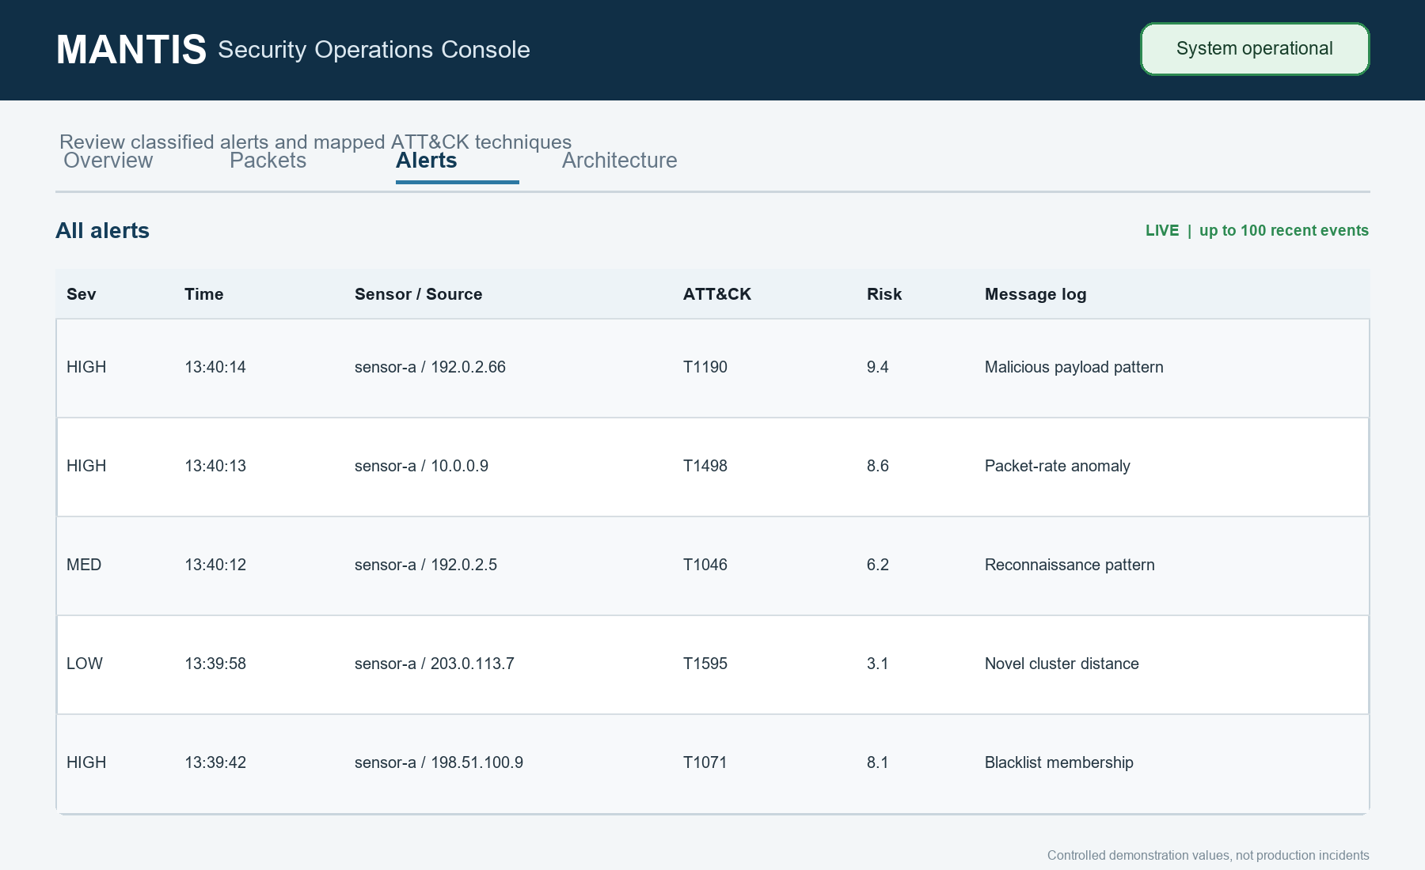
Figure 3.23: Alerts page mockup with the complete in memory threat log and ATT&CK context

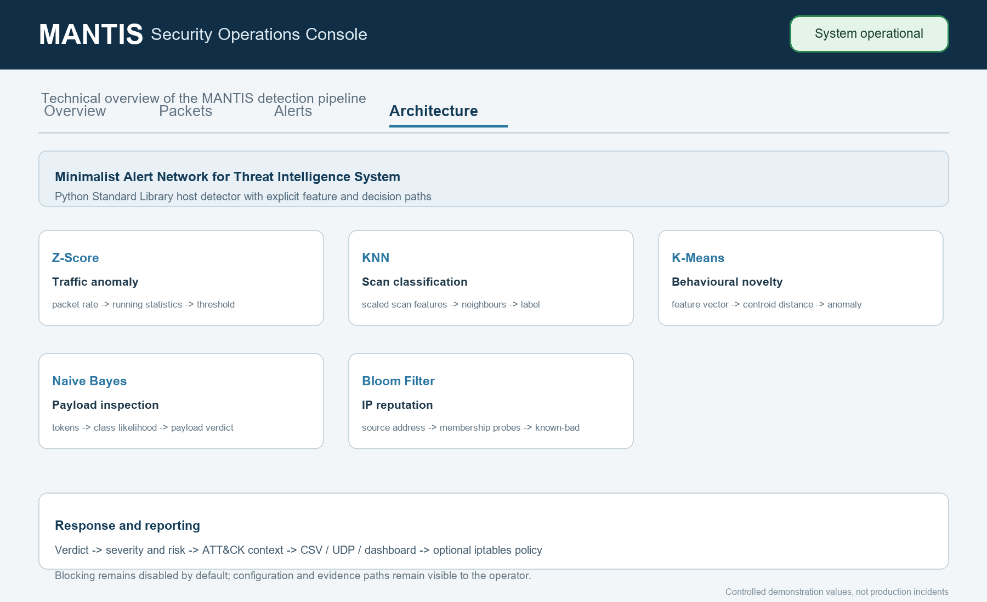
Figure 3.24: Architecture page mockup documenting all five engines and policy gated response

The console also supports responsive layout, protocol filtering, packet details, effective policy reporting and bounded evidence export. Authentication, TLS, multi user case management and durable database search are intentionally absent from the mockups because they require a separate security and persistence design beyond the embedded local prototype.

4. System Build and Technical Notes
The approved design was built as a Python Standard Library application. The executable path begins in main.py, where command line options are merged with environment, JSON file and seeded defaults. Live operation checks for Linux AF_PACKET capability, starts the optional web SIEM, constructs SensorNode and launches separate capture and analysis threads. Offline PCAP replay exercises the same parser and engines without raw socket privileges.

4.1 Packet Capture and Protocol Parsing
SensorNode opens a Linux AF_PACKET raw socket and places frames into a bounded queue. The non-blocking insertion in Figure 4.1 counts overflow instead of allowing uncontrolled memory growth; PacketParser then validates and decodes supported Ethernet, VLAN, IPv4, TCP, UDP and ICMP structures.
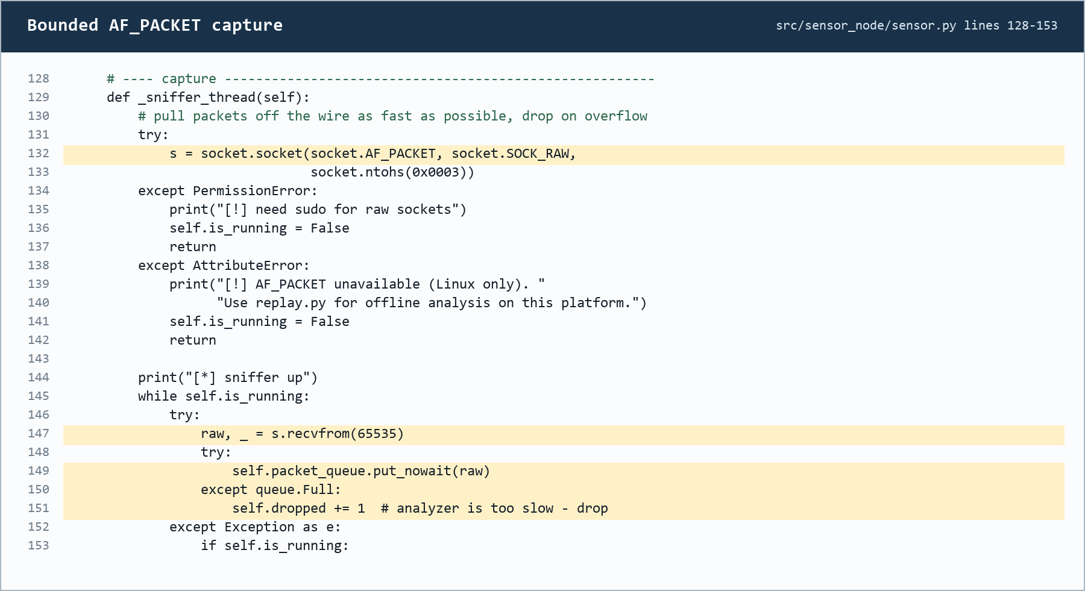
Figure 4.1: AF_PACKET capture and bounded queue implementation

4.2 Detection, Dispatch and Active Response
All engines return a common Verdict, but each applies its own evidence rules. Figure 4.2 shows the Z-Score volume and persistence guards, while Figure 4.3 shows that a firewall rule requires explicit enablement, an allowed threat category and a non-whitelisted source.
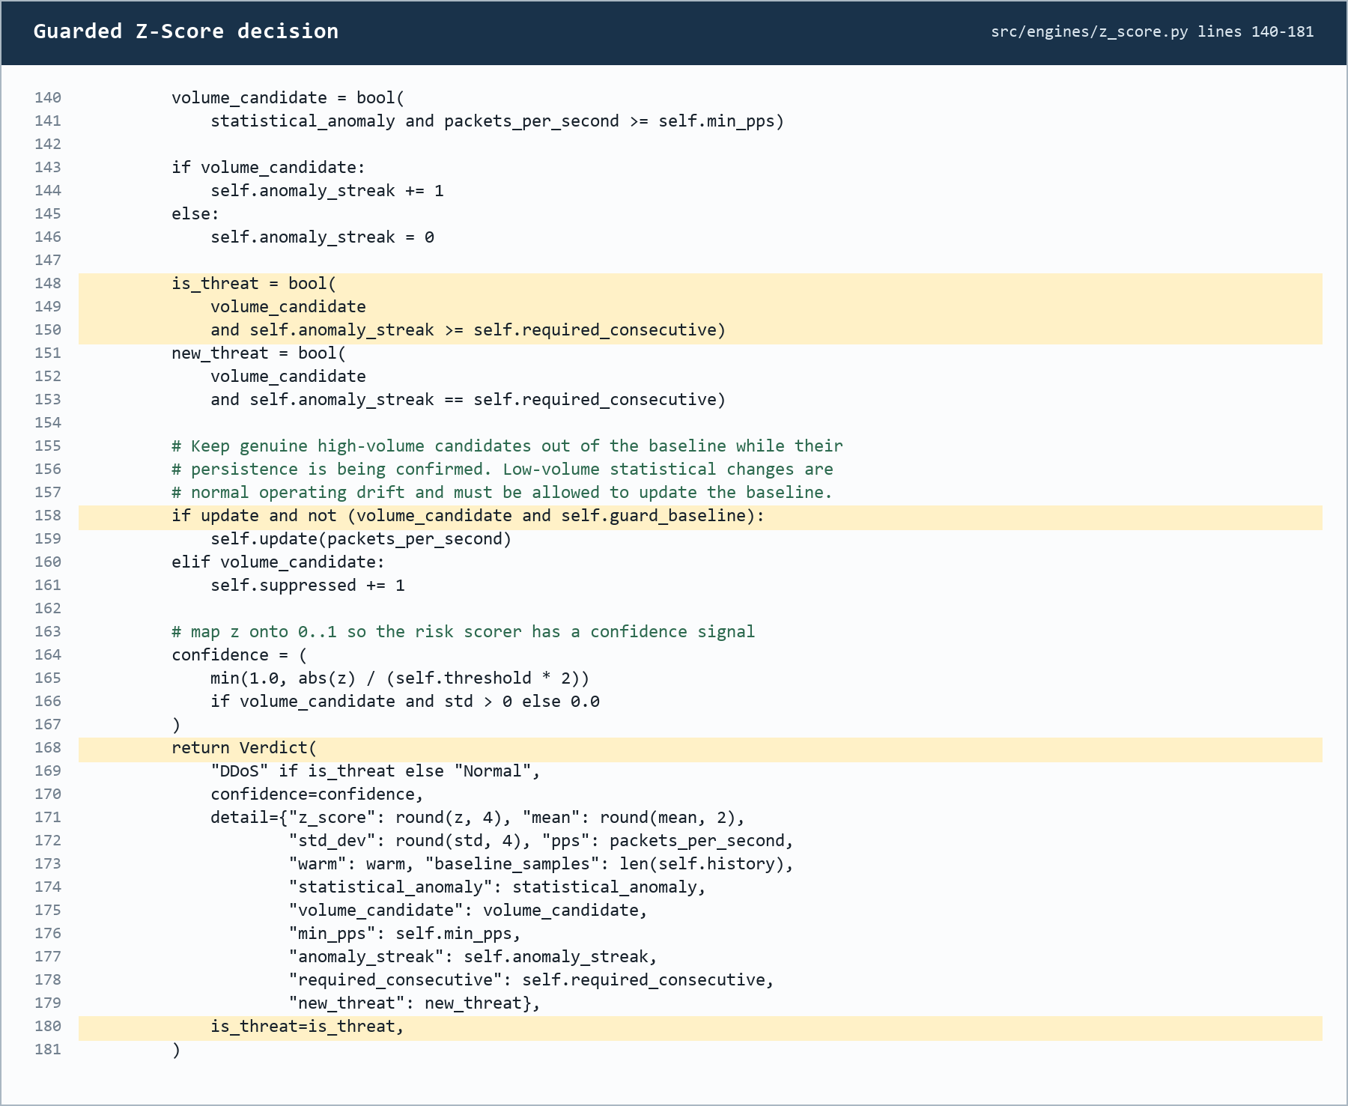
Figure 4.2: Guarded Z-Score threat decision and baseline protection
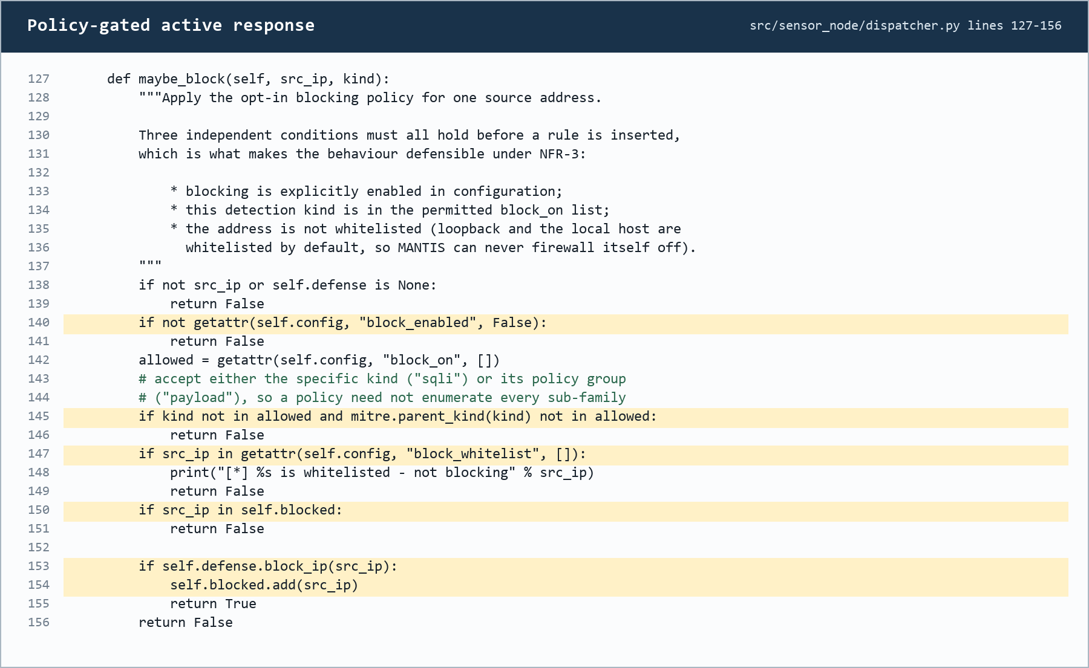
Figure 4.3: Opt-in active-response policy checks

4.3 Training, State and Evidence Interface
Validated training data produces inspectable brain state, while live evidence remains bounded and exportable. Figure 4.4 shows how the dashboard retrieves recent packets and exports JSON or PCAP data for independent review. Training records, replay traffic and live capture are retained as separate evidence categories.
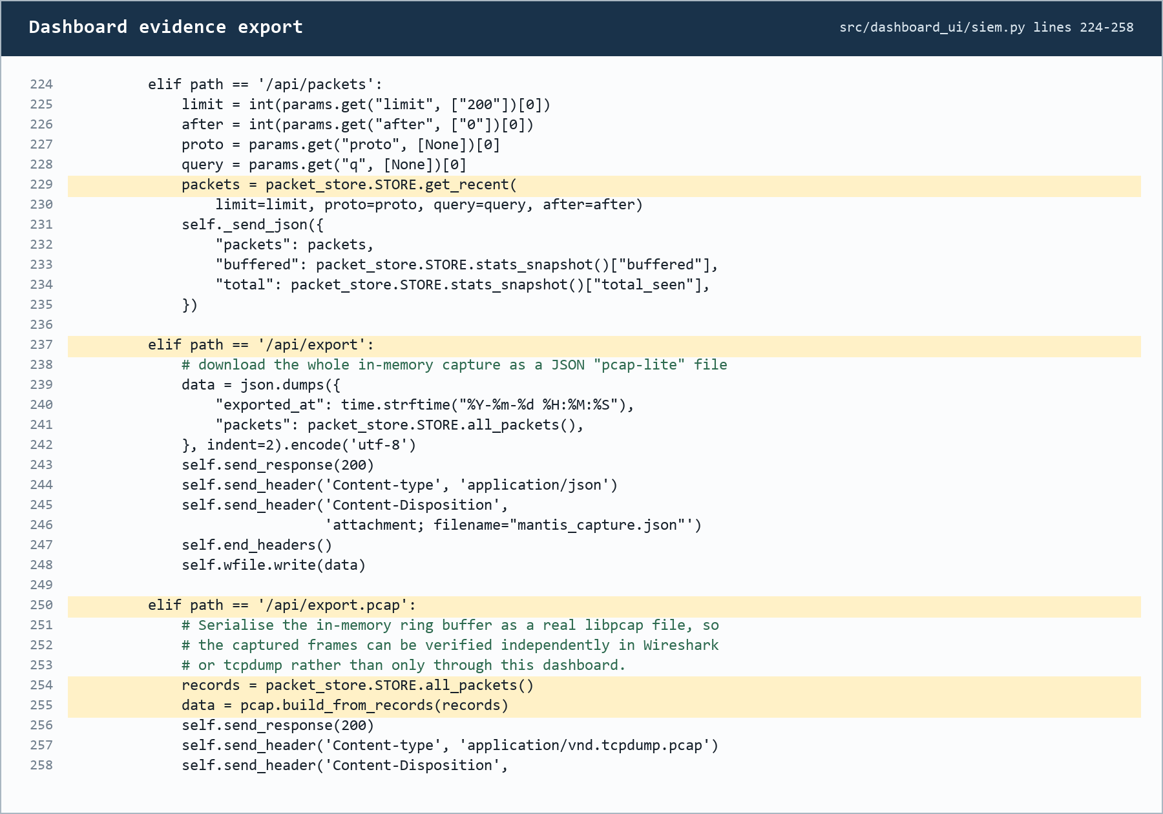
Figure 4.4: Dashboard packet retrieval and evidence export endpoints

4.4 Technical Constraints Encountered
Live capture and iptables response are Linux specific and require suitable capabilities or administrative permission. Payload analysis cannot inspect encrypted application content, UDP telemetry is intentionally lightweight rather than guaranteed delivery, and the in memory packet store is bounded rather than a forensic database. The embedded HTTP server is suitable for a controlled local prototype, not an internet facing multi user deployment. These constraints define the conditions under which the build should be evaluated.

Table 4.1: MANTIS build components and technical constraints
Build area | Principal modules | Implemented responsibility | Technical note
Entry and configuration | main.py, config.py | Argument parsing, precedence, safe defaults, privilege check | No third party runtime package
Acquisition and parsing | sensor.py, parser.py | AF_PACKET producer, bounded queue, protocol decoding | Live capture is Linux specific
Detection | engines/*.py | Five engines under DetectionEngine and Verdict | State exported through a uniform JSON contract
Dispatch and response | dispatcher.py, active_defense.py | Audit, telemetry, UI publication and policy gated iptables | Blocking is off by default
Presentation and evidence | siem.py, web_template.html, pcap.py, reporting.py | HTTP/UDP console, packet export and HTML report | HTTP 8080 and UDP 9999 by default
Training and evaluation | training/*, evaluation/*, replay.py | Validated loaders, model training, metrics and deterministic replay | External datasets must match engine semantics

5. Testing Strategy and Evaluation
Testing establishes whether the implementation behaves as specified; evaluation interprets whether the observed behaviour supports the dissertation's claims. MANTIS separates component tests, integration tests and system tests so that a correct formula is not mistaken for a correct end to end sensor. Algorithm metrics and replay evidence are interpreted separately from software test pass counts.

The current repository was re executed on 20 August 2026 using unittest discovery. It ran 116 tests in 4.642 seconds and all tests passed. A small number of ResourceWarning messages reported test process UDP sockets that were not explicitly closed; they did not fail any assertion but remain a test harness clean up item. No new CPU, memory or latency result is asserted here because those measurements require a declared reference environment and controlled workload.

5.1 Testing Definitions and Approach
Unit tests isolate one rule. Integration tests cross real module boundaries without requiring root. System tests bind a real UDP socket and HTTP server on loopback. Regression tests lock fixes for flood/scan confusion, baseline poisoning and stealth scans. Table 5.1 maps these levels to FR/NFR identifiers and the unittest modules that were executed.
Table 5.1: Test levels mapped to requirements and evidence modules
Test level | FR / NFR traced | What is exercised | Evidence module
Unit | FR4, FR12, NFR2, NFR8 | Engine mathematics, config, privacy, PCAP helpers | test_engines.py, test_modules.py
Integration | FR1-FR8, FR10, FR14-FR22, NFR3, NFR4 | Parser→engines, dispatcher, brain, replay, packet store | test_integration.py
System | FR5, FR9, FR18, NFR7 | Real UDP listener and HTTP SIEM on loopback | test_siem_api.py
Regression | FR4, NFR2 | Flood not scan, baseline poisoning, stealth scan, K-Means non poisoning | test_modules.py / test_engines.py
Training | FR5, FR6, FR12 | Column validation and brain serialisation | test_training_and_eval.py
The approach combines positive cases, negative cases, boundary conditions and failure handling. Expected attacks must be detected, normal traffic must remain normal, malformed input must not crash the pipeline, privacy sensitive values must not reach persistence, and active defence must remain disabled unless every policy condition is satisfied. Synthetic frames and a generated PCAP make the pipeline reproducible without attacking an external network.

5.2 Algorithm Tests
Engine tests check both detection and non detection behaviour. Z-Score verifies warm up, Welford stability, sustained flood detection and baseline poisoning protection. KNN verifies scaled features, normal browsing, flood versus scan separation and low volume scans. K-Means verifies warm up, familiar traffic, novelty distance and withholding anomalous updates. Naive Bayes tests benign payloads, malicious tokens and the single token ADMIN safeguard. Bloom tests feed loading, membership, saturation and the no false negative property for inserted indicators.

Constructed samples first verified each engine's intended rule. KNN, Z-Score, K-Means and Bloom produced 1.0000 scores on only 25 to 44 co-authored records, while Naive Bayes produced F1 0.9565 and MCC 0.9199 on 24 records. These matched checks verify code paths but are not independent field-accuracy evidence. Table 5.2 therefore reports the larger external stress test instead.
Table 5.2: External CIC-IoT2023 Z-Score stress-test results
Evaluation scope | Rows | Precision | Recall | F1 | MCC
All 63 merged CSV files | 45,018,252 | 0.997417 | 0.043619 | 0.083582 | 0.029049
BENIGN and DoS/DDoS | 41,333,350 | 0.997302 | 0.045574 | 0.087165 | 0.031179

All 45,018,252 rows (9.30 GB) from 63 extracted Merged CSV files were streamed once, resetting the detector for each separate non-temporal export. Results were TP 1,917,787, FP 4,967, FN 42,049,152 and TN 1,046,346. Precision 0.997417 concealed recall 0.043619: 95.64 percent of attack rows were missed. F1 0.083582, balanced accuracy 0.519447 and MCC 0.029049 were near chance. Because prevalence was 0.976647, an always-positive baseline reached F1 0.988186. The BENIGN plus DoS/DDoS subset was similar. Only Rate is compatible across the files; unique_ports, payload, source IP and reputation labels are absent. This is therefore a Z-Score transfer stress test, not a five-engine benchmark.

5.3 Test Cases and Scenarios
The selected cases below trace the main functional and safety requirements to observable outcomes. The generated replay contains a benign warm up followed by port scan, flood, malicious payload and known bad source phases. System tests use loopback services and controlled datagrams, while firewall tests substitute a recording defence object so the suite never modifies the host firewall.

Table 5.3 lists expected against actual outcomes: every listed case passed in the 20 August 2026 run (116 tests, 4.642 s, unittest discovery), and the actual results matched the expected column. Each case was then re executed in isolation on the same day and the terminal output was captured; this evidence is reproduced case by case in Table 5.4. The results verify the implementation and do not certify production accuracy on unseen operational traffic.
Table 5.3: Twenty eight representative executed test cases and scenarios
ID | Level | Scenario | Expected outcome | Status
TC-01 | Unit | Benign payload | Return Safe with no threat | ☑
TC-02 | Unit | UNION SELECT payload | Return malicious payload verdict with keywords | ☑
TC-03 | Regression | High volume, one port input to KNN | Classified Normal, not Scan | ☑
TC-04 | Regression | Sustained flood after Z-Score warm up | Repeated alerts without baseline poisoning | ☑
TC-05 | Unit | Inserted and unknown Bloom indicators | Inserted found; unknown clean in controlled set | ☑
TC-06 | Integration | Malformed and truncated frames | Reject safely; analyser remains available | ☑
TC-07 | Integration | Credential and email in alert | Sensitive values absent from CSV and UDP | ☑
TC-08 | Integration | Disabled, enabled and whitelist policy | Only enabled, non whitelisted case blocks | ☑
TC-09 | System | UDP alert to SIEM and HTTP API query | Alert includes technique, severity and risk | ☑
TC-10 | System | Buffered frame PCAP export | Valid PCAP reopens; every frame decodes | ☑
TC-11 | Replay | 13,159 frame five phase replay | No baseline alert; engines fire in intended phases | ☑
TC-12 | Persistence | Five engine brain round trip | Restored state matches export | ☑
TC-13 | Unit | K-Means warm up | No novelty alert before sufficient baseline observations | ☑
TC-14 | Regression | K-Means anomalous observation | Novelty is flagged and does not poison centroids | ☑
TC-15 | Regression | Low volume stealth scan | KNN detects scan after feature scaling | ☑
TC-16 | Unit | Invalid configuration value | Bad override is ignored without startup failure | ☑
TC-17 | Unit | Threat intelligence feed | Comments are stripped and inserted indicators have no false negatives | ☑
TC-18 | Integration | VLAN and ICMP frames | Supported frames decode into normalised packet records | ☑
TC-19 | Integration | Packet store capacity | Old entries rotate and memory remains bounded | ☑
TC-20 | Integration | Duplicate alert dispatch | Equivalent alert is published once | ☑
TC-21 | Integration | Duplicate active response request | One firewall rule is recorded for the address | ☑
TC-22 | Integration | Distributed high rate traffic | No single source is attributed or blockable | ☑
TC-23 | Unit | ATT&CK and risk mapping | Technique is mapped and risk remains within bounds | ☑
TC-24 | Unit | Payload privacy limits | Control bytes are removed and excerpt stops at 64 bytes | ☑
TC-25 | Unit | PCAP endian, time and snap length | Reader preserves valid capture semantics | ☑
TC-26 | System | Malformed SIEM datagram | Listener rejects input and remains available | ☑
TC-27 | System | Statistics and protocol filtering | HTTP API reports live values and filtered packet rows | ☑
TC-28 | Training | Dataset missing required columns | Loader raises a clear validation error | ☑
Table 5.4 reproduces the white terminal execution evidence for every case in Table 5.3. Each screenshot shows the exact unittest command, the engine or pipeline output produced during the run and the final OK verdict, captured on 20 August 2026.

Table 5.4: Terminal execution evidence for test cases TC-01 to TC-28
ID | Executed test evidence
TC-01 | 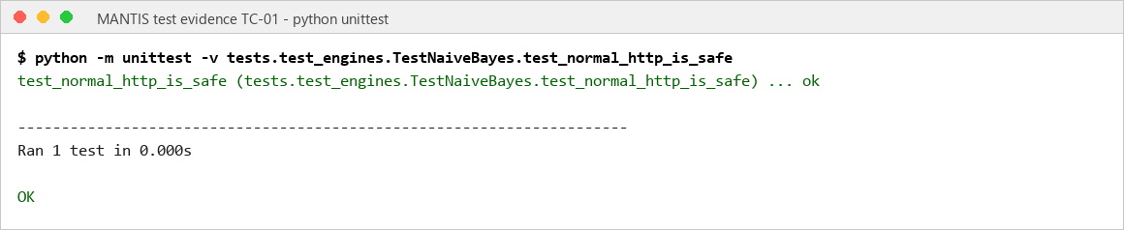
TC-02 | 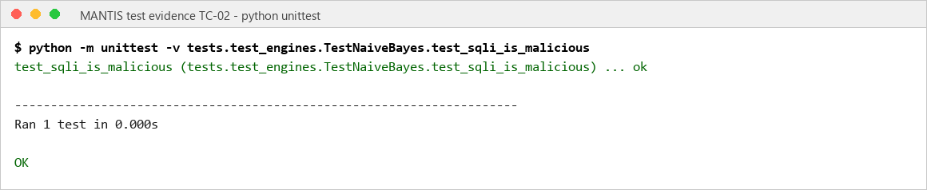
TC-03 | 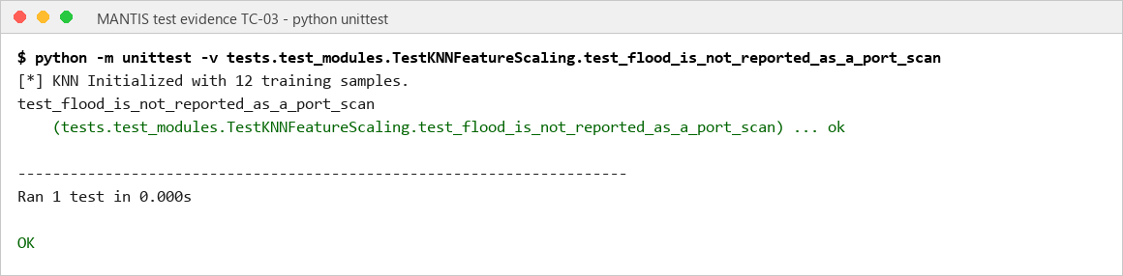
TC-04 | 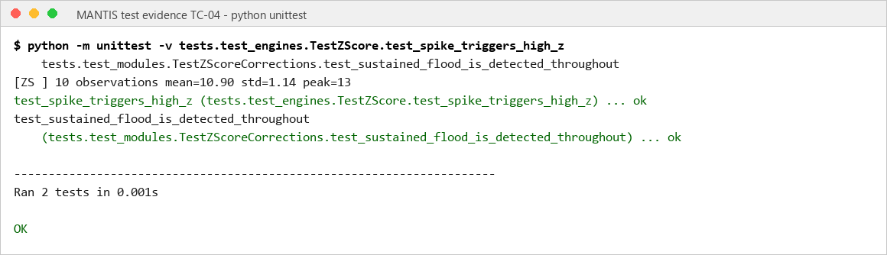
TC-05 | 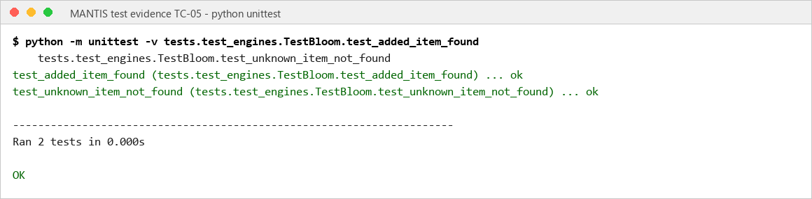
TC-06 | 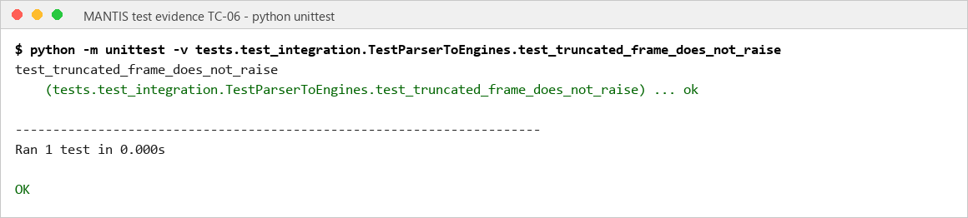
TC-07 | 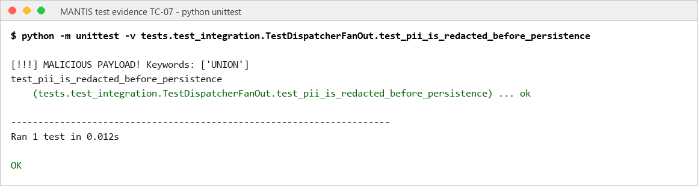
TC-08 | 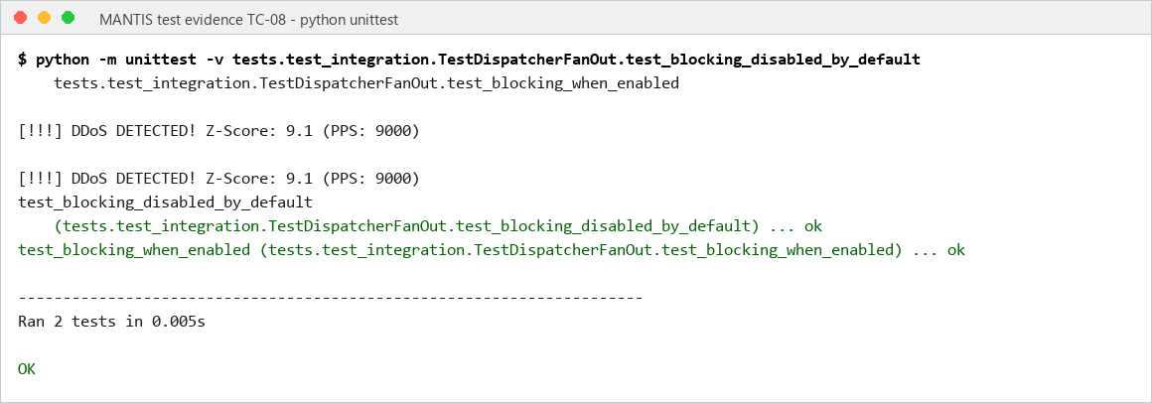
TC-09 | 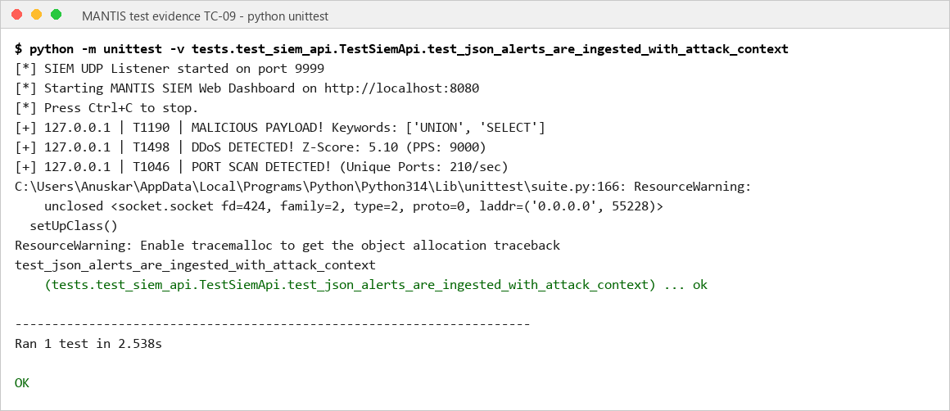
TC-10 | 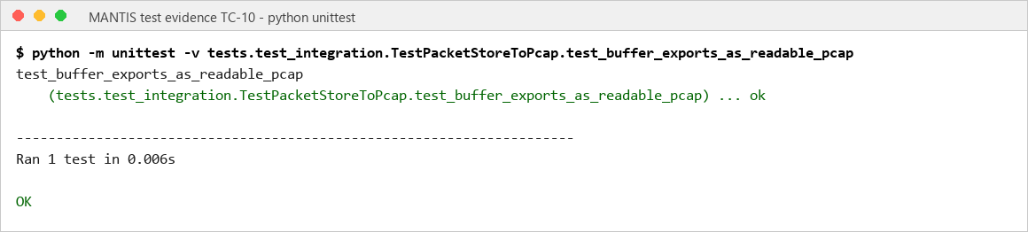
TC-11 | 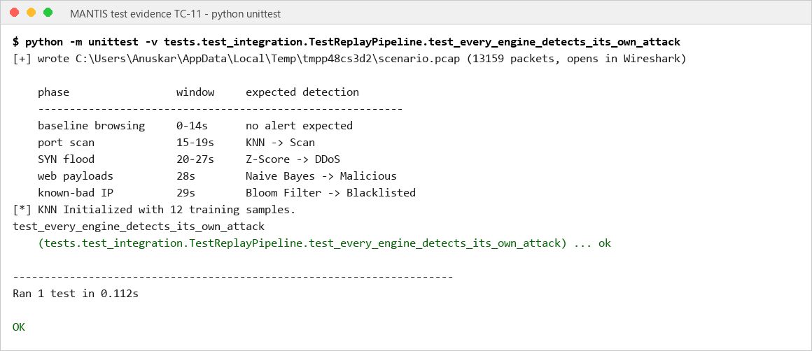
TC-12 | 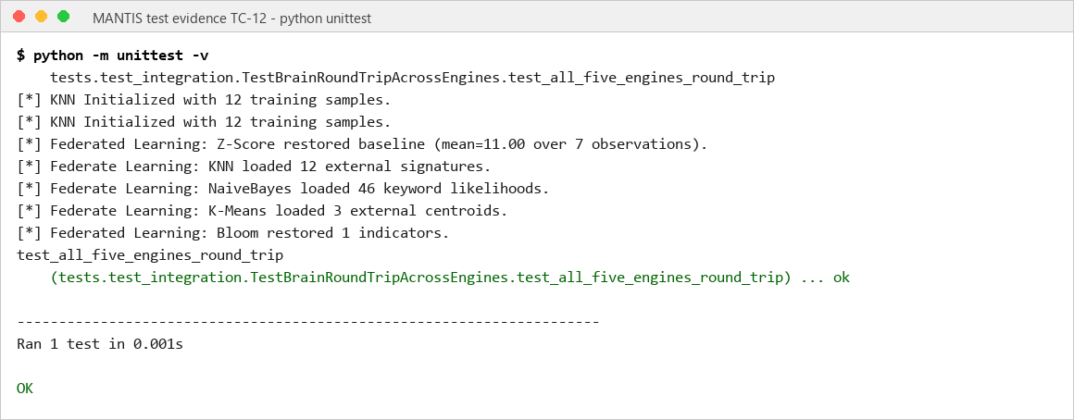
TC-13 | 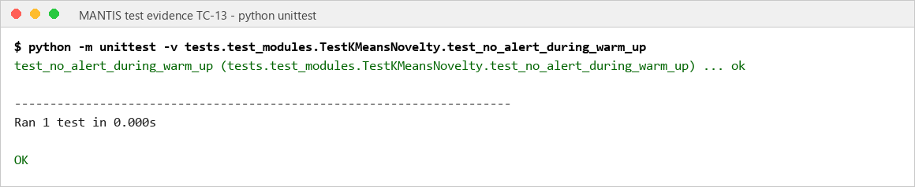
TC-14 | 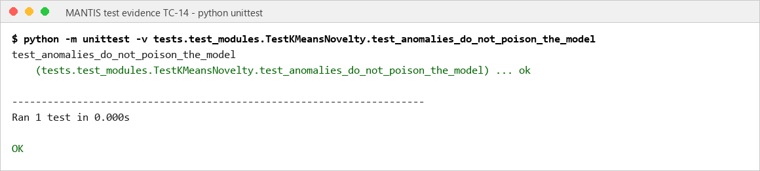
TC-15 | 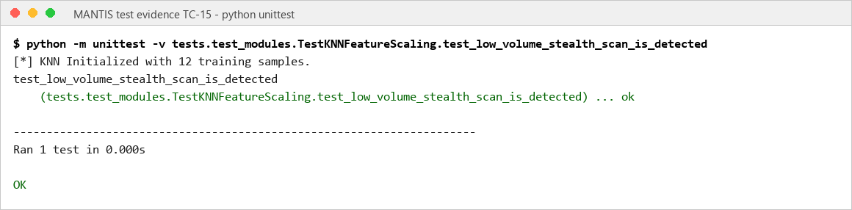
TC-16 | 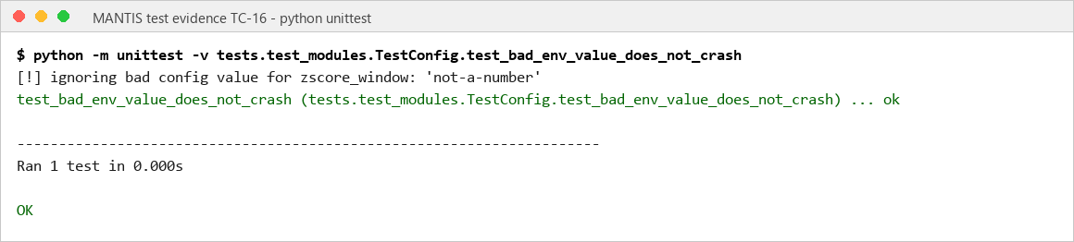
TC-17 | 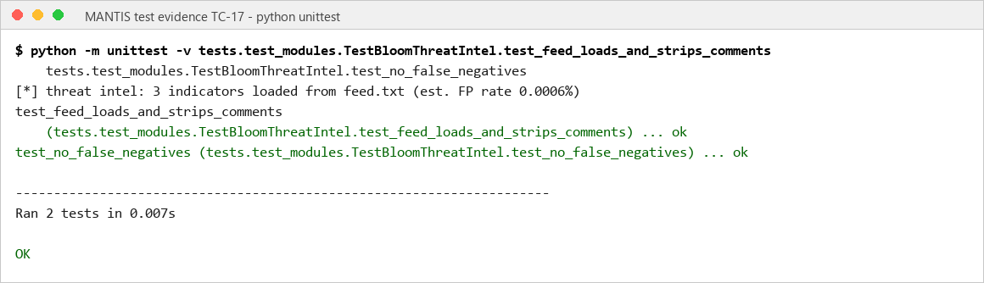
TC-18 | 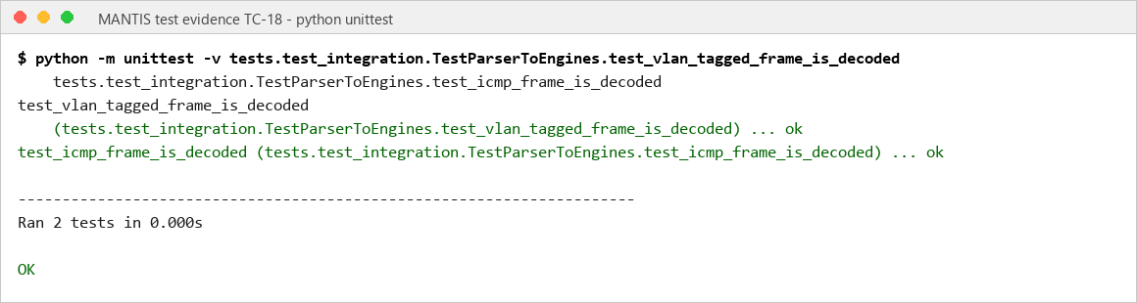
TC-19 | 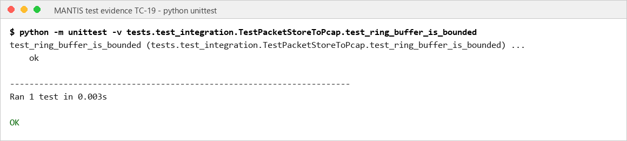
TC-20 | 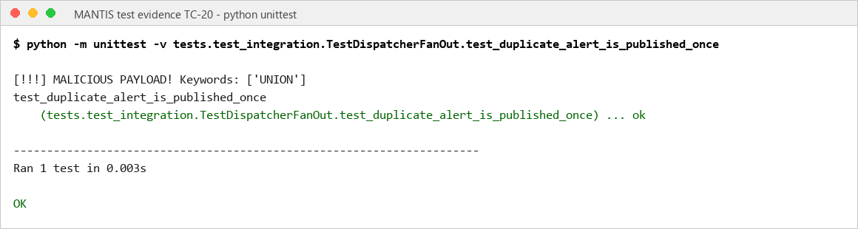
TC-21 | 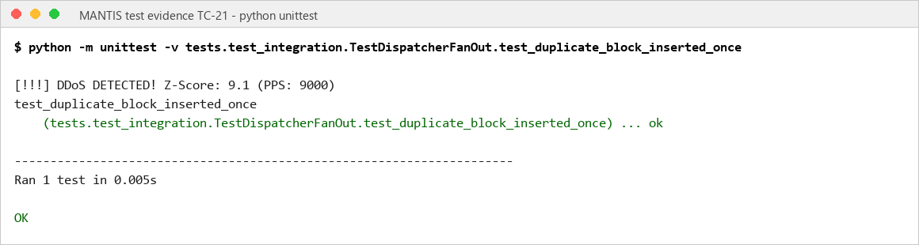
TC-22 | 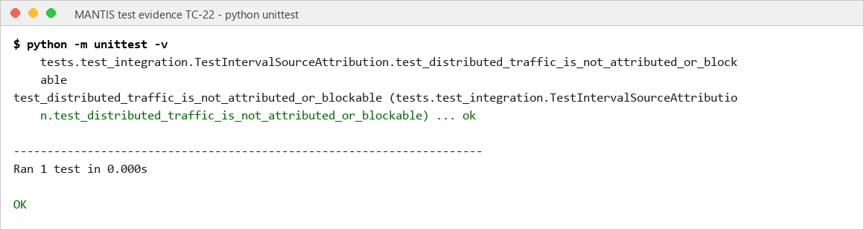
TC-23 | 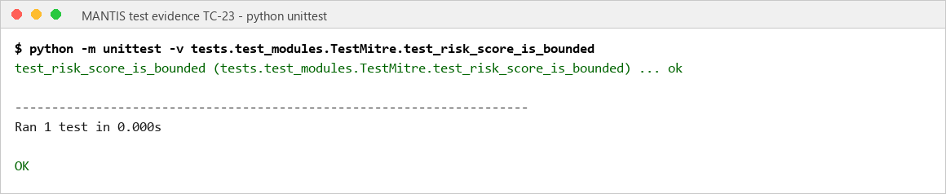
TC-24 | 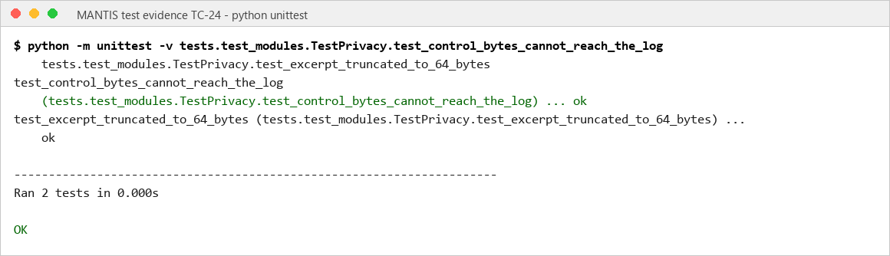
TC-25 | 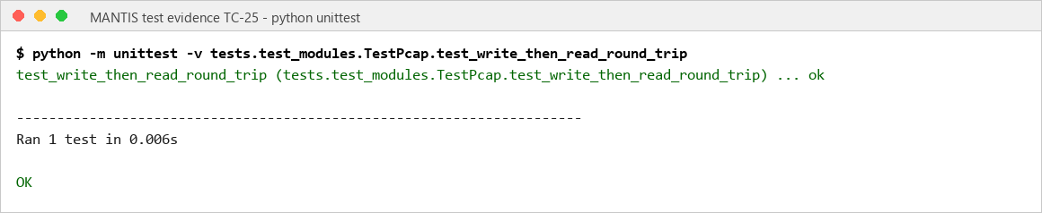
TC-26 | 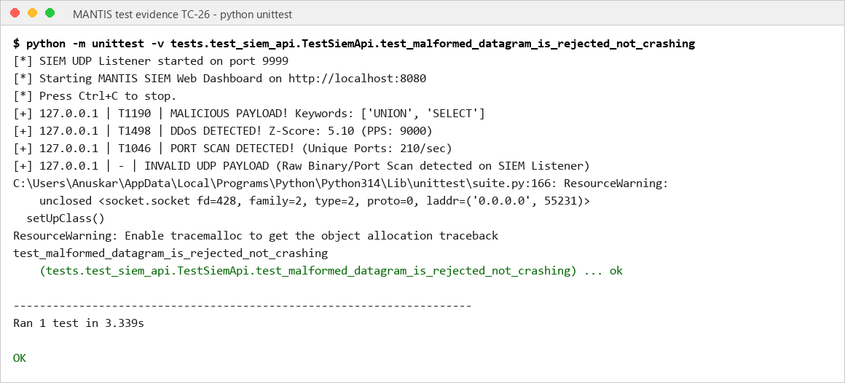
TC-27 | 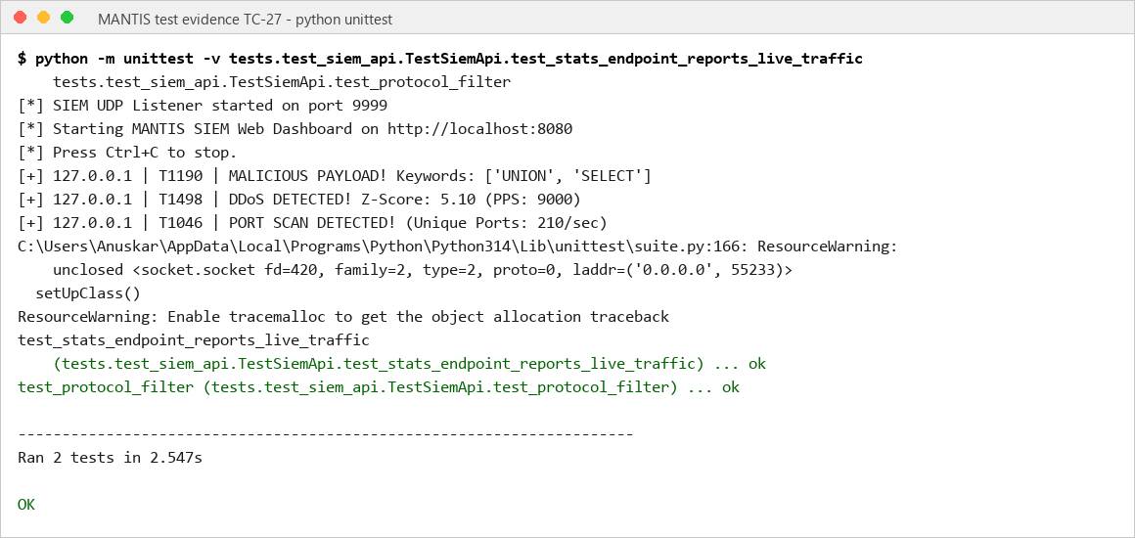
TC-28 | 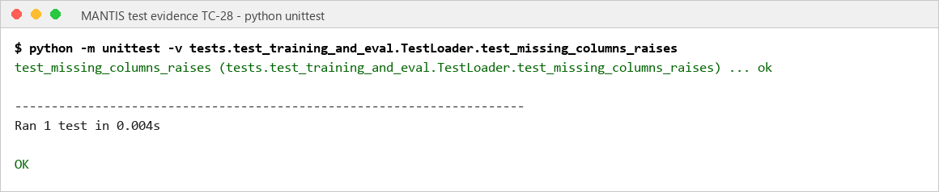

6. Conclusion
MANTIS met its aim by delivering a working and inspectable host detector for commodity Linux. AF_PACKET and PCAP input, five Standard Library engines, bounded evidence, dashboard telemetry, persistent state and optional policy-controlled response form one traceable pipeline. Passing tests demonstrate implemented behaviour in the stated environment, while the report deliberately avoids converting laboratory results into production or unknown-attack claims.

6.1 Technical Difficulties Encountered
The main difficulties were aligning external flow datasets with live sensor features, preventing anomalous traffic from poisoning online baselines, separating flood behaviour from scan behaviour, and testing privileged Linux capture and iptables actions safely. The project also had to control queue growth, preserve evidence without excessive payload retention, handle malformed packets and keep UDP, HTTP and test sockets from affecting repeatability. These issues were addressed through schema validation, semantic guardrails, bounded buffers, privacy redaction, policy checks, controlled PCAP replay and layered automated tests.

6.2 Future Scope
Future work should evaluate longer and more varied workloads, use independent and prevalence-balanced traffic, withhold complete attack families and devices, and compare MANTIS with Snort, Suricata, Zeek and Wazuh under the same hardware and traffic. Technical extensions should include broader IPv6 and application-protocol parsing, authenticated and encrypted dashboard access, durable case storage, improved delivery guarantees, deterministic socket cleanup and centrally managed deployment. Any larger model or automated response policy should retain the current requirements for visible features, reviewable evidence, explicit safeguards and reproducible evaluation.

7. References
- Bloom, B.H. (1970) 'Space/time trade-offs in hash coding with allowable errors', Communications of the ACM, 13(7), pp. 422-426. Available at: https://doi.org/10.1145/362686.362692 (Accessed: 2 September 2026).
- Canadian Institute for Cybersecurity (2023) CIC-IoT2023 Dataset. Available at: https://www.unb.ca/cic/datasets/iotdataset-2023.html (Accessed: 2 September 2026).
- Chandola, V., Banerjee, A. and Kumar, V. (2009) 'Anomaly detection: a survey', ACM Computing Surveys, 41(3), Article 15. Available at: https://doi.org/10.1145/1541880.1541882 (Accessed: 2 September 2026).
- Cisco Talos (2024) Snort Documentation. Available at: https://www.snort.org/documents (Accessed: 2 September 2026).
- Crnkovic, G. (2010) 'Constructive research and info-computational knowledge generation', in Model-Based Reasoning in Science and Technology. Springer, pp. 359-380. Available at: https://doi.org/10.1007/978-3-642-15223-8_20 (Accessed: 2 September 2026).
- Halvorsen, J., Izurieta, C., Cai, H. and Gebremedhin, A. (2024) 'Applying generative machine learning to intrusion detection: a systematic mapping study and review', ACM Computing Surveys, 56(10), Article 257. Available at: https://doi.org/10.1145/3659575 (Accessed: 2 September 2026).
- Hidayat, I., Ali, M.Z. and Arshad, A. (2023) 'Machine learning-based intrusion detection system: an experimental comparison', Journal of Computational and Cognitive Engineering, 2(2), pp. 88-97. Available at: https://doi.org/10.47852/bonviewJCCE2202270 (Accessed: 2 September 2026).
- Kus, D., Wagner, E., Pennekamp, J., Wolsing, K., Fink, I.B., Dahlmanns, M., Wehrle, K. and Henze, M. (2022) 'A false sense of security? Revisiting the state of machine learning-based industrial intrusion detection', Proceedings of CPSS '22, pp. 73-84. Available at: https://doi.org/10.1145/3494107.3522773 (Accessed: 2 September 2026).
- McCallum, A. and Nigam, K. (1998) 'A comparison of event models for Naive Bayes text classification', AAAI Workshop on Learning for Text Categorization, pp. 41-48. Available at: https://aaai.org/papers/041-ws98-05-007/ (Accessed: 2 September 2026).
- Mitzenmacher, M. and Upfal, E. (2017) Probability and Computing. 2nd edn. Cambridge: Cambridge University Press. Available at: https://doi.org/10.1017/CBO9780511813603 (Accessed: 2 September 2026).
- National Institute of Standards and Technology (2007) Guide to Intrusion Detection and Prevention Systems (IDPS), NIST SP 800-94. Available at: https://doi.org/10.6028/NIST.SP.800-94 (Accessed: 2 September 2026).
- Neto, E.C.P., Dadkhah, S., Ferreira, R., Zohourian, A., Lu, R. and Ghorbani, A.A. (2023) 'CICIoT2023: a real-time dataset and benchmark for large-scale attacks in IoT environment', Sensors, 23(13), Article 5941. Available at: https://doi.org/10.3390/s23135941 (Accessed: 2 September 2026).
- Open Information Security Foundation (2024) Suricata User Guide. Available at: https://docs.suricata.io/ (Accessed: 2 September 2026).
- OWASP (2024) OWASP Internet of Things Project. Available at: https://owasp.org/www-project-internet-of-things/ (Accessed: 2 September 2026).
- Python Software Foundation (2026) Python 3 Documentation. Available at: https://docs.python.org/3/ (Accessed: 2 September 2026).
- Roesch, M. (1999) 'Snort: lightweight intrusion detection for networks', Proceedings of LISA '99, pp. 229-238. Available at: https://www.usenix.org/conference/lisa-99/snort-lightweight-intrusion-detection-networks (Accessed: 2 September 2026).
- Sculley, D. (2010) 'Web-scale K-Means clustering', Proceedings of WWW 2010, pp. 1177-1178. Available at: https://doi.org/10.1145/1772690.1772862 (Accessed: 2 September 2026).
- Sommer, R. and Paxson, V. (2010) 'Outside the closed world: on using machine learning for network intrusion detection', IEEE Symposium on Security and Privacy, pp. 305-316. Available at: https://doi.org/10.1109/SP.2010.25 (Accessed: 2 September 2026).
- Wazuh Inc. (2026) Wazuh Documentation. Available at: https://documentation.wazuh.com/current/ (Accessed: 2 September 2026).
- Welford, B.P. (1962) 'Note on a method for calculating corrected sums of squares and products', Technometrics, 4(3), pp. 419-420. Available at: https://doi.org/10.1080/00401706.1962.10490022 (Accessed: 2 September 2026).
- Zeek Project (2026) Zeek Documentation. Available at: https://docs.zeek.org/ (Accessed: 2 September 2026).

Appendix A: Gantt Chart
The Gantt chart retains the interim weekly layout while aligning the schedule to constructive research: problem definition, requirements, design, construction, evaluation, critique and dissertation completion.
Figure A.1: MANTIS constructive research methodology Gantt chart

Appendix B: Project Logs
The signed project diary and log forms below record the supervision meetings held during the project, continuing the log presented in the interim report.
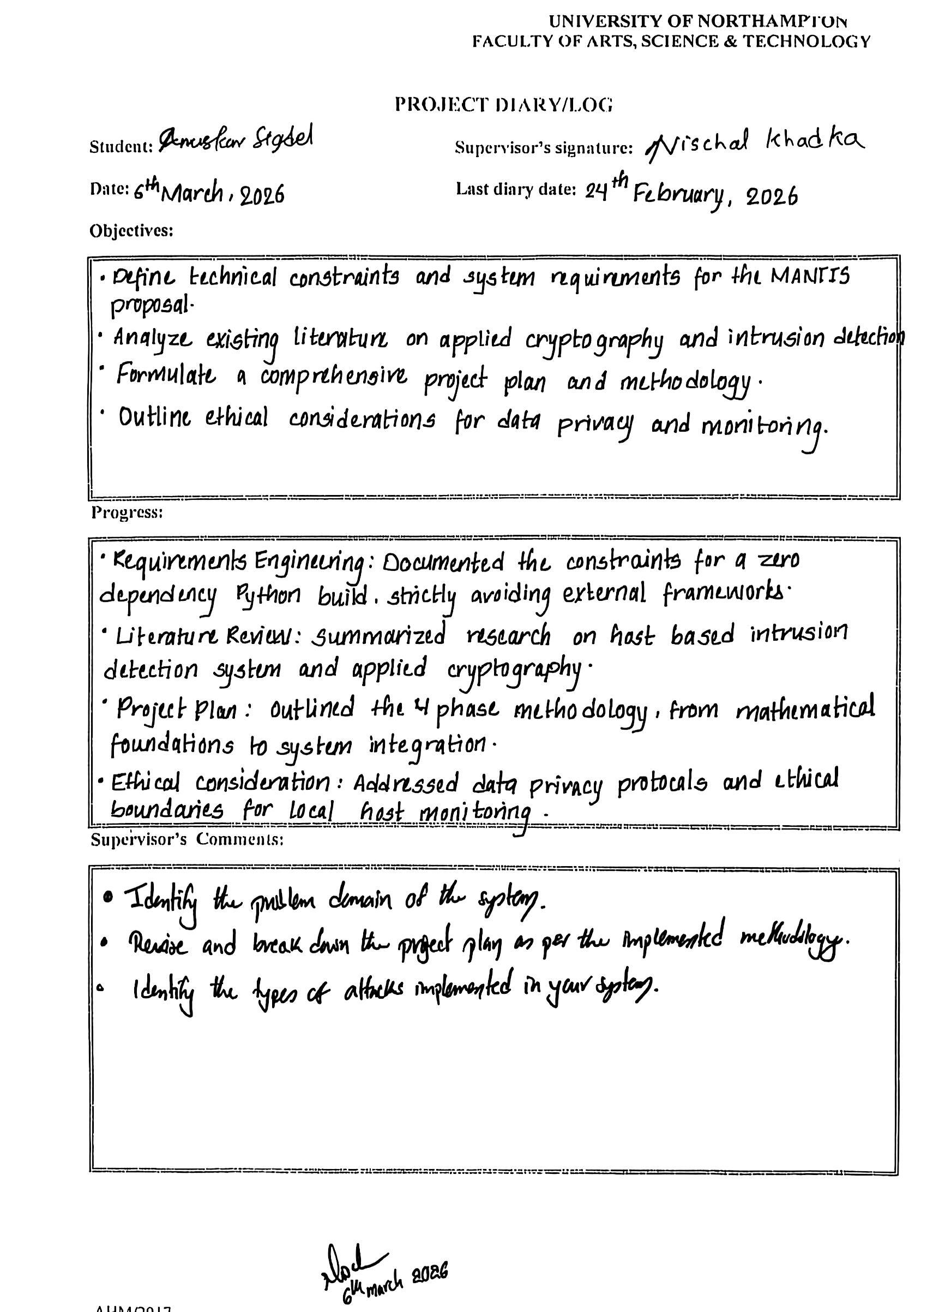




Appendix C: Presentation Slide
