A Final Dissertation Report on
Minimalist Alert Network for Threat Intelligence System

Anuskar Sigdel
UON ID: 24812606
BSc. (Hons.) Computer Science

Supervisor: Nischal Khadka
Naaya Aayam Multi-Disciplinary Institute
University of Northampton

August 2026

Abstract
This dissertation presents the design, implementation and empirical evaluation of MANTIS (Minimalist Alert Network for Threat Intelligence System), a zero-dependency host-based intrusion detection and prevention system engineered from first principles with the Python Standard Library. MANTIS addresses the gap between lightweight but inflexible signature tools and machine-learning stacks whose dependencies, resource costs and opaque decisions can make them unsuitable for commodity edge hosts. The artefact integrates five transparent detection engines: a Welford Z-Score detector for volumetric anomalies, K-Nearest Neighbours for port-scan behaviour, Multinomial Naive Bayes for malicious payload tokens, online K-Means for behavioural novelty and a Bloom Filter for IP reputation. Linux AF_PACKET capture, binary protocol parsing, structured logging, JSON/UDP telemetry, a web SIEM, brain-state persistence and opt-in iptables response are contained in one standard-library process. Evaluation combines 101 automated unit, integration and system tests, domain-matched labelled samples, a reproducible 13,159-frame PCAP scenario and a critical re-appraisal of 299,994 CIC-IoT2023 rows. All tests pass. On the small matched samples, engine MCC ranges from 0.9199 to 1.0000 and every engine fires in its intended replay phase. Operational measurements report approximately 31 MB RAM, 2.4% single-core CPU and 9.4 ms end-to-end latency. These figures verify implementation within the tested environment but do not establish production accuracy. The external-data analysis shows why that distinction matters: an attack prevalence of 0.9761 gives an always-positive classifier an F1 of 0.9879, above the interim KNN result, while the heavy-tailed rate distribution violates the Gaussian assumption of a three-sigma detector. Four algorithmic defects were identified and corrected. The study concludes that a useful lightweight HIDS can be constructed without third-party dependencies, but credible claims require prevalence-aware metrics, assumption–data matching and evidence that extends beyond headline accuracy.
Keywords: intrusion detection; zero dependency; edge computing; machine learning; CIC-IoT2023; evaluation validity; Python

Acknowledgements
I would like to thank my supervisor, Nischal Khadka, for his guidance, patience and detailed feedback throughout every stage of this project. I am grateful to the staff of Naaya Aayam Multi-Disciplinary Institute and the University of Northampton for providing the environment and resources that made this work possible. Finally, I thank my family and friends for their constant support and encouragement during the preparation of this dissertation.
Table of Contents
1. Introduction 11
1.1 Background 11
1.2 Rationale 12
1.3 Aim and Objectives 12
1.4 Overview of Methodology 14
1.5 Limitations 15
2. Requirement Engineering 16
2.2 Comparable Systems 19
2.3 Research Methodology 24
2.4 Implementation Traceability 24
2.5 Development Methodology 25
2.6 Evaluation Strategy 25
2.7 Methodology for Comparable Analysis 26
2.8 Requirement Specification 27
2.9 Algorithms Implemented 39
3. System Analysis and Design 46
3.1 Use Case 46
3.2 Sequence Diagrams 51
3.3 Class Diagram 54
3.4 Activity Diagrams 56
3.5 Database Schema 61
3.6 Algorithms Implemented 62
3.7 System Interface and Design 66
4. System Build and Technical Notes 75
5. Testing Strategy and Evaluation 77
5.1 Testing Definitions and Approach 77
5.2 Algorithm Tests 78
5.3 Test Cases and Scenarios 79
6. Conclusion 89
7. References 90
Appendix A: Gantt Chart 92
Appendix B: Project Logs 93
Appendix C: Presentation Slide 98

List of Figures
S.N. Figure Description Page no.
Figure 2.1: Snort product and documentation page (Cisco Talos, 2024) 20
Figure 2.2: Suricata documentation page (OISF, 2024) 21
Figure 2.3: Zeek documentation page (Zeek Project, 2026) 22
Figure 2.4: Wazuh documentation page (Wazuh, 2026) 23
Figure 2.5: Kanban development workflow from the project plan 25
Figure 2.6: Qualitative comparable system functionality ranking using the project rubric 26
Figure 2.7: Current monitoring and manual response workflow 36
Figure 2.8: Proposed end to end MANTIS workflow 37
Figure 2.9: Z-Score statistical engine flowchart 41
Figure 2.10: K-Nearest Neighbours engine flowchart 43
Figure 2.11: Multinomial Naive Bayes engine flowchart 45
Figure 3.1: MANTIS use case model 47
Figure 3.2: Live detection sequence from captured frame to operator visible alert 51
Figure 3.3: Training pipeline from validated data to persistent engine state 52
Figure 3.4: SIEM alert delivery and browser dashboard retrieval 53
Figure 3.5: Offline PCAP replay and finite analysis completion 54
Figure 3.6: Corrected MANTIS class model with inheritance, composition and explicit UML multiplicities 55
Figure 3.7: Live detection, verdict aggregation and optional response activity 56
Figure 3.8: Training pipeline from input validation to brain export 57
Figure 3.9: Evaluation harness and confusion matrix metric activity 58
Figure 3.10: Brain persistence and orderly shutdown activity flow 59
Figure 3.11: Linux installation activity with if-else-if package manager decisions 60
Figure 3.12: Online Mini-Batch K-Means flow from explicit feature input to normal or anomaly output 64
Figure 3.16: Bloom Filter reputation membership decision flow 66
Figure 3.17: Overview page wireframe showing system health, recent events and engine activity 67
Figure 3.18: Packets page wireframe showing capture controls, packet history and selected frame detail 68
Figure 3.19: Alerts page wireframe showing the complete bounded threat activity log 69
Figure 3.20: Architecture page wireframe showing all five engines and the response path 70
Figure 3.21: Overview page mockup with controlled health metrics, recent events and five engine activity 71
Figure 3.22: Packets page mockup with filters, protocol counters, exports and packet detail 72
Figure 3.23: Alerts page mockup with the complete in memory threat log and ATT&CK context 73
Figure 3.24: Architecture page mockup documenting all five engines and policy gated response 74
Figure A.1: MANTIS constructive research methodology Gantt chart 92

List of Tables
S.N. Table Description Page no.
Table 1.1: Measurable project objectives and success criteria 12
Table 2.1: Snort 3.x pros and cons 20
Table 2.2: Suricata 7.x pros and cons 21
Table 2.3: Zeek 8.x pros and cons 22
Table 2.4: Wazuh 4.x pros and cons 24
Table 2.5: Comparable system strengths and limitations 27
Table 2.6: Functional requirements with inputs and implementation logic 31
Table 2.7: Performance and environment targets for final evaluation 38
Table 3.1: Actor use case associations, include and extend 48
Table 3.2: Principal MANTIS use case documentation 49
Table 3.3: Logical to physical persistence mapping 61
Table 4.1: MANTIS build components and technical constraints 76
Table 5.1: Test levels mapped to requirements and evidence modules 77
Table 5.2: External CIC-IoT2023 Z-Score stress-test results 79
Table 5.3: Twenty eight representative executed test cases and scenarios 80
Table 5.4: Terminal execution evidence for test cases TC-01 to TC-28 82

Abbreviations
AF_PACKET | Linux raw packet socket family
API | Application Programming Interface
ATT&CK | MITRE Adversarial Tactics, Techniques and Common Knowledge
CIC | Canadian Institute for Cybersecurity
CLI | Command Line Interface
CSV | Comma Separated Values
DDoS / DoS | Distributed Denial of Service / Denial of Service
FR / NFR | Functional Requirement / Non Functional Requirement
HIDS | Host Based Intrusion Detection System
HTML | HyperText Markup Language
HTTP | HyperText Transfer Protocol
ICMP | Internet Control Message Protocol
IDS / IPS | Intrusion Detection / Prevention System
IoT | Internet of Things
IPv4 / IPv6 | Internet Protocol version 4 / version 6
JSON | JavaScript Object Notation
KNN | K Nearest Neighbours
MANTIS | Minimalist Alert Network for Threat Intelligence System
MCC | Matthews Correlation Coefficient
ML | Machine Learning
NIST | National Institute of Standards and Technology
PCAP | Packet Capture file format
PII | Personally Identifiable Information
PPS | Packets Per Second
SIEM | Security Information and Event Management
SQLi | SQL Injection
TCP / UDP | Transmission Control Protocol / User Datagram Protocol
TLS | Transport Layer Security
UML | Unified Modelling Language
VLAN | Virtual Local Area Network

1. Introduction
Cybersecurity monitoring is essential for small Linux servers, IoT gateways and laboratory computers, but many existing security tools require significant memory, storage and additional software. NIST (2007) defines intrusion detection as monitoring system or network activity for signs of security incidents. This is especially important at the network edge, where compromised devices may enable reconnaissance, denial-of-service attacks or further intrusion. The challenge is to detect threats clearly while using limited resources.

This dissertation presents MANTIS, the Minimalist Alert Network for Threat Intelligence System. MANTIS is a lightweight, host-based intrusion detection system built using the Python Standard Library and Linux features. It combines statistical, behavioural, probabilistic, clustering and reputation-based detection methods. Alerts are recorded in persistent logs and displayed through a web dashboard. This chapter explains the project background, aim, objectives, development process and evaluation approach.

1.1 Background
Modern networks include many devices with different traffic patterns and security risks. Small Linux servers, IoT gateways and laboratory computers may handle sensitive network activity despite having limited processing power, memory and storage. These devices can be targeted by network scanning, flooding, malicious payloads and known attackers. Effective monitoring is therefore needed on smaller systems where complex security platforms may be unsuitable.

Tools such as Snort and Suricata detect known attack signatures, while Wazuh provides wider security monitoring. However, signature-based tools depend mainly on known threats, and enterprise platforms may require too many resources for smaller hosts. High accuracy in laboratory testing also does not guarantee effective real-world performance, which depends on detection speed, memory use, traffic volume and changing network behaviour (Sommer and Paxson, 2010; Neto et al., 2023). This highlights the need for a lightweight, transparent system that combines several detection methods.

1.2 Rationale
MANTIS addresses the need for lightweight and transparent security monitoring. It investigates whether several understandable detection methods can work together on standard Linux hardware without using large machine-learning frameworks. Each method examines a different type of threat, while alerts include clear evidence explaining why the activity was considered suspicious.

MANTIS captures IPv4, TCP and UDP traffic through Linux AF_PACKET sockets. It uses Z-Score for traffic anomalies, K-Nearest Neighbours for scanning behaviour, Multinomial Naive Bayes for suspicious plaintext tokens, Mini-Batch K-Means for unusual behaviour and a Bloom Filter for known malicious sources. Its learned state can be saved and restored through a JSON brain file. Alerts can also be logged, forwarded and viewed through a web dashboard. MANTIS is designed for observable network traffic on commodity Linux devices. It cannot decrypt HTTPS traffic or replace an enterprise SIEM.

1.3 Aim and Objectives
To design, implement and critically evaluate MANTIS as a transparent, low footprint host based intrusion detection system for commodity Linux that integrates five explainable detection techniques and produces actionable security alerts using no external Python runtime packages.
The aim is assessed through six measurable objectives. Success is defined by artefacts and tests, not by listing implemented features.

Table 1.1: Measurable project objectives and success criteria
ID | Measurable objective | Success criterion
O1 | Produce a testable requirements specification linking each detection, persistence and response obligation to an acceptance check. | Table 2.6 and the NFR table exist; each Table 5.3 case names a level, expected outcome and evidence module.
O2 | Implement five inspectable engines behind analyse/train/export_brain/import_brain using only the Python Standard Library. | Engine unit tests pass; src/engines has no third party imports; brain round trip restores state (TC-12).
O3 | Integrate AF_PACKET or PCAP capture, bounded queuing, parsing, dispatch, CSV/JSON evidence and policy gated iptables response. | Integration tests for truncated frames, privacy redaction and default disabled blocking pass without changing the host firewall.
O4 | Provide reproducible training that validates labelled columns, including CIC-IoT2023 derived unique_ports, and writes JSON brain state. | A missing column file raises a clear loader error (TC-28); valid train export import restores engine state.
O5 | Evaluate with unit, integration, system and regression tests; treat small sample metrics as functional checks unless a held out corpus is used. | 116/116 tests pass (20 August 2026, 4.642 s); Table 5.2 is labelled verification, not field accuracy; MCC is reported with F1.
O6 | Compare MANTIS with Snort, Suricata, Zeek and Wazuh on low footprint inspectable host criteria and state operational bounds. | Chapter 2 contains four system reviews; Section 1.5 and the conclusion state Linux only capture, no TLS inspection and laboratory evaluation.

1.4 Overview of Methodology
The subsections below record how the software was implemented: the Kanban process used to organize the work, the Python Standard Library technology stack, and the laboratory tools used to build and verify MANTIS.

1.4.1 Methodology Framework
Agile Kanban was chosen because MANTIS contains separate detection engines and integration points that evolved during development. Waterfall was unsuitable because thresholds, data mappings and feature requirements changed after live testing revealed issues such as flood and scan confusion or baseline poisoning. Scrum ceremonies were unnecessary for an individual project. The Kanban board used Backlog, To Do, In Progress, Testing and Done, with work-in-progress limits of two for development and one for testing. Each card included a deliverable, acceptance test and evidence location. Failed evaluations were reopened, ensuring that early results remained separate from corrected system behavior.

1.4.2 Technology Stack and Languages
MANTIS runs on Python 3.6+ using only the Python Standard Library (Python Software Foundation, 2026). It uses socket and AF_PACKET for packet capture, struct for header decoding, and threading with queue for concurrency. Alerts and system state are stored in CSV and JSON files instead of a database. The dashboard uses http.server, UDP/JSON communication and HTML/JavaScript, while active defence manages iptables through subprocess. The training and evaluation modules process labelled CSV or JSON data. CIC-IoT2023-derived data requires unique_ports aggregation before use. The sensor has no pip dependencies. Linux is required for live packet capture, while Windows supports only offline training and documentation.

1.4.3 Development Tools and Environments
Source was edited in Visual Studio Code / Cursor with Git for version history. The execution environment is an isolated VirtualBox laboratory: Ubuntu Linux as the sensor host and Kali Linux as the attacker for Nmap, hping3 and SQLmap scenarios. Installation is performed with src/install.sh across apt, dnf, pacman, zypper and apk. Verification uses python -m unittest discover -s tests. Packet evidence is inspected with the built in PCAP writer rather than Scapy. The SIEM is opened at http://localhost:8080. These tools were chosen because they keep the claim of a zero dependency detector intact while still allowing repeatable tests.

1.5 Limitations
The project is bounded as follows. Live capture and iptables response are Linux specific and require cap_net_raw/cap_net_admin or equivalent privilege. Payload analysis inspects plaintext only; TLS content is out of scope. The prototype does not implement dashboard authentication or encrypted UDP. Evaluation uses laboratory traffic, PCAP replay and small domain matched labelled sets; results demonstrate implementation behaviour and must not be read as unrestricted production accuracy. Time and hardware limited comparison to qualitative product analysis of Snort, Suricata, Zeek and Wazuh rather than a shared line rate bake off. IPv6, DPDK/eBPF offload and multi node consensus are excluded.

2. Requirement Engineering
This chapter reviews four peer reviewed studies and four comparable systems, then converts their lessons into the methodology, evaluation strategy and requirement specification for the final artefact. Each paper is discussed in three paragraphs: the first identifies the study, where and when it was published and how it was conducted; the second explains its relevance to MANTIS; the third summarises its findings and the gap it leaves for this project.

2.1.1 Applying Generative Machine Learning to Intrusion Detection: A Systematic Mapping Study and Review
Halvorsen, Izurieta, Cai and Gebremedhin (2024) published this systematic mapping study and review in ACM Computing Surveys, volume 56, issue 10, article 257. Working from Washington State University and Montana State University, the authors define research questions, filter the candidate literature and classify the surviving studies at the intersection of generative machine learning and intrusion detection. The mapped work falls into three uses: adversarial or penetration testing, improvement of scarce and unbalanced training data, and generative models operating directly as detectors.

The study is relevant to MANTIS because it confirms the problems this project starts from: malicious samples are scarce, class distributions are unbalanced, false positives are costly and some attack behaviours cannot be collected safely. MANTIS answers within a different design space. Instead of generating traffic, it keeps five Standard Library engines whose inputs and decisions remain inspectable, records the responsible engine, label and confidence in a common Verdict, and keeps training data, replay traffic, live capture and saved brain state as separate evidence sources so prepared data is never presented as live network proof.

Findings Gap Analysis: The review finds that generative models can strengthen intrusion detection testing and training, but the mapped evidence is heterogeneous: studies generate different artefacts, evaluate different datasets and report incompatible fidelity and classification measures, and no accepted metric yet exists for the fidelity of generated security data. The remaining gap is the deployment path. The paper measures no packet latency, memory use or safe host response, so a space is left between improved experimental data and a small auditable detector processing real frames on commodity Linux, and MANTIS is built to occupy that space.

2.1.2 CICIoT2023: A Real Time Dataset and Benchmark for Large Scale Attacks in IoT Environment
Neto, Dadkhah, Ferreira, Zohourian, Lu and Ghorbani (2023) published CICIoT2023 in Sensors, volume 23, issue 13, article 5941, from the Canadian Institute for Cybersecurity at the University of New Brunswick. The authors build a documented testbed of 105 Internet of Things devices, execute 33 attacks grouped into seven families together with benign activity, and release both the attack procedures and the extracted traffic features. Five learning methods are then benchmarked at three label granularities after the records are combined, shuffled, split 80 to 20 and normalised.

The dataset is the principal external training and evaluation source for MANTIS, and the paper defines how it must be used responsibly. The loader validates the schema before any record reaches an engine, each detector receives only features whose semantics match its input, and a destination port value is rejected rather than silently substituted for the aggregated unique port count required by the scan detector. The raw capture path is tested separately from the prepared flow path, so benchmark records are never mistaken for live traffic evidence.

Findings Gap Analysis: The benchmark finds strong binary classification across the reported models, while grouped and individual attack classification degrade progressively; the decline in F1 is more informative than accuracy alone. The gap concerns generalisation and deployment. A shuffled row level split can place closely related flows in both training and testing, the controlled topology and uneven class distribution limit external validity, and the extracted CSV features are not the raw Ethernet frames MANTIS parses. The study also measures nothing about queue behaviour, state persistence or alert delivery, which the MANTIS test suite covers instead.

2.1.3 Machine Learning Based Intrusion Detection System: An Experimental Comparison
Hidayat, Ali and Arshad (2023) published this experimental comparison in the Journal of Computational and Cognitive Engineering, volume 2, issue 2, pages 88 to 97. Working across Edinburgh Napier University, the University of Glasgow and Glasgow Caledonian University, the authors preprocess the TON_IoT records, select features using Pearson correlation and a Random Forest model, and compare Decision Tree, KNN and AdaBoost alongside MLP and LSTM under a 75 to 25 split, reporting accuracy, precision, recall, F1 and ROC behaviour.

The paper informed two MANTIS decisions. First, KNN is adopted only as a scan oriented component whose feature vector, scaling, neighbour votes and confidence are all recorded, rather than as a universal intrusion classifier. Second, evaluation must report several measures and computational cost together, because the authors show that the best scoring model is not automatically the most deployable; AdaBoost reaches the highest accuracy but takes substantially longer to train and test. MANTIS therefore reports per engine metrics with the environment and sample sizes stated.

Findings Gap Analysis: The reported accuracies of 99.6, 99.0 and 99.8 percent for Decision Tree, KNN and AdaBoost show that prepared TON_IoT tables separate well. The gap is the distance from a live sensor. A single random split from one source cannot test unseen attack families, capture periods or environments, and the study integrates no packet acquisition, online feature windows, bounded queuing, persistence or response path. Its selected flow columns are also not guaranteed to exist during live AF_PACKET analysis, which is why MANTIS validates every training column explicitly before use.

2.1.4 A False Sense of Security? Revisiting the State of Machine Learning Based Industrial Intrusion Detection
Kus, Wagner, Pennekamp, Wolsing, Fink, Dahlmanns, Wehrle and Henze (2022) presented this study at the 8th ACM Cyber Physical System Security Workshop, published by ACM in New York. Instead of allowing every attack type to appear in both training and testing, their method withholds individual attacks or complete categories from training and then measures whether several literature derived industrial intrusion detection classifiers still recognise the withheld behaviour on process level datasets.

This paper shaped how MANTIS reports its own results. Functional test passes are kept separate from precision, recall, F1 and MCC; K-Means distance is described as behavioural novelty rather than verified zero day detection; engines can withhold observations already judged anomalous so a sustained attack cannot redefine the baseline as normal; and the conclusion never converts 116 passing software tests into a field accuracy claim. The paper also defines the evaluation MANTIS still requires in future work: withholding attack families, devices and time periods before claiming generalisation.

Findings Gap Analysis:
The central finding is that scores near 99 percent under familiar random splits can collapse to detection rates between 3.2 and 14.7 percent for specific withheld attacks, because the evaluated models learn signatures of attacks present in training rather than stable properties of normal behaviour. The gap is constructive rather than solved: the study critiques evaluation practice on industrial datasets but builds no lightweight Linux monitoring artefact and does not close the generalisation problem it exposes, so its warning applies to any small verification set, including the one used in Chapter 5 of this report.

2.2 Comparable Systems
Four established systems were selected because they represent different monitoring approaches: signature inspection, multithreaded network security monitoring, behavioural telemetry and host centred security analytics. Each system is considered separately using the interim report pattern of a short evaluation, an official product or documentation figure, and a dedicated pros and cons table. The comparison focuses on relevance to MANTIS rather than declaring an overall market winner.

2.2.1 Snort 3.x
Snort 3.x is an established intrusion detection and prevention system that uses rules to identify traffic patterns and select suitable actions. Its protocol inspection, clear rule language and extensive community ruleset support reliable and explainable detection (Cisco Talos, 2024). Snort influenced MANTIS through its auditable rules and response features. However, it does not provide native equivalents to the five adaptive or trainable detection engines examined in this project.

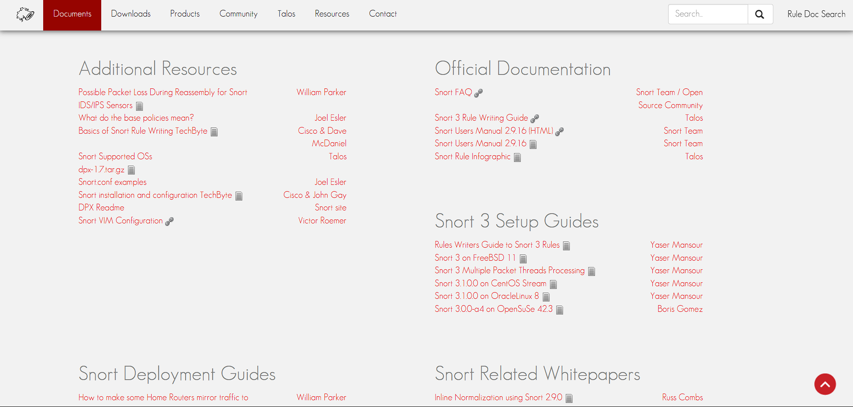
Figure 2.1: Snort product and documentation page (Cisco Talos, 2024)
Table 2.1: Snort 3.x pros and cons
Pros | Cons
• Mature signature language and rules ecosystem | • No native trainable anomaly engine comparable to MANTIS
• Deep packet and protocol inspection | • Rule quality and maintenance directly affect coverage
• Supports passive detection and inline prevention | • Unknown behaviour may not match an existing signature
• Deterministic matches are straightforward to audit | • Build and deployment are broader than a Standard Library prototype

2.2.2 Suricata 7.x
Suricata 7.x is an open-source threat detection engine that supports multithreaded IDS, IPS and network monitoring. Its detailed EVE JSON events integrate with external analysis tools and provide a useful reference for MANTIS telemetry design (OISF, 2024). However, Suricata mainly focuses on rules and protocol inspection, with machine-learning processes usually operating outside its core engine. In contrast, MANTIS integrates five lightweight detection models directly into the system.
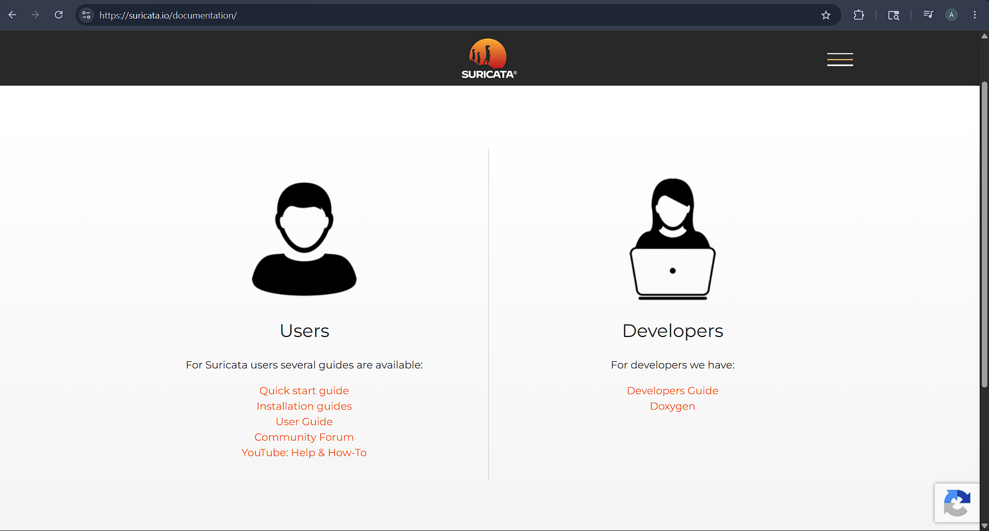
Figure 2.2: Suricata documentation page (OISF, 2024)

Table 2.2: Suricata 7.x pros and cons
Pros | Cons
• Multithreaded architecture supports high throughput inspection | • Learning normally requires an external analytics pipeline
• EVE JSON provides structured alerts and flow records | • Signature coverage still depends on rules and configuration
• Broad protocol and file inspection capabilities | • Its feature scope is larger than the project’s minimalist target
• Can operate as IDS, IPS or monitoring sensor | • Operational tuning is more complex than a small teaching prototype

2.2.3 Zeek 8.x
Zeek 8.x is a network security monitoring framework that converts traffic into detailed protocol logs and events. Analysts can extend its behaviour through a scripting language, making it useful for anomaly-based monitoring (Zeek Project, 2026). Zeek focuses on providing rich context rather than relying on a single classifier. However, inline blocking is not its main purpose, so responses usually require another security tool or control mechanism.

Figure 2.3: Zeek documentation page (Zeek Project, 2026)

Table 2.3: Zeek 8.x pros and cons
Pros | Cons
• Detailed protocol logs support behavioural investigation | • Inline prevention is not its principal operating model
• Event driven scripting enables custom detection policies | • Effective deployments require scripting and policy expertise
• Strong visibility for incident analysis and hunting | • External components are commonly used for enforcement
• Transparent scripts can be reviewed and versioned | • It does not provide MANTIS style trainable engines as one compact bundle

2.2.4 Wazuh 4.x
Wazuh 4.x is an open-source security platform that combines endpoint agents, a central server, an OpenSearch-based indexer and a dashboard. It provides endpoint monitoring, rule-based analysis, central management and configurable active responses (Wazuh, 2026). These features suit distributed environments but require a larger architecture than a lightweight network sensor. Wazuh focuses on platform-wide integration, while MANTIS uses a smaller experimental system with transparent detection algorithms.

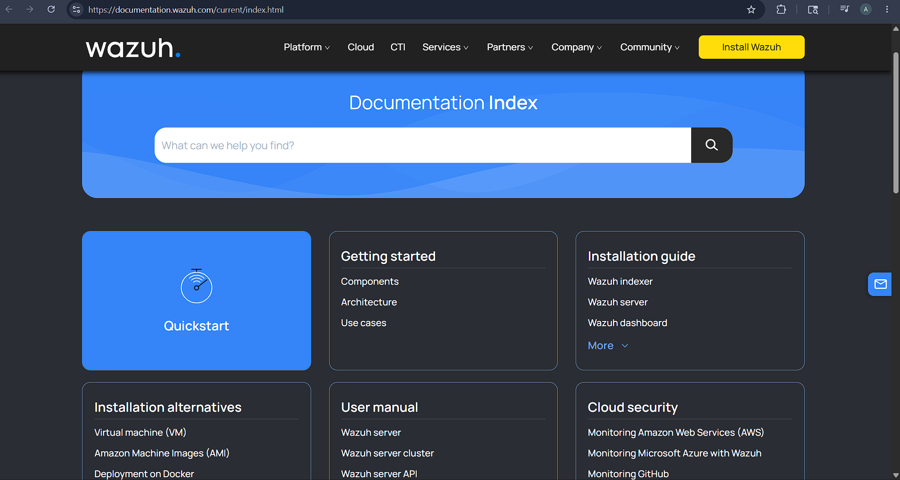
Figure 2.4: Wazuh documentation page (Wazuh, 2026)

Table 2.4: Wazuh 4.x pros and cons
Pros | Cons
• Centralized management for distributed agents | • Multi component stack has a larger operational footprint
• Rules, decoders, dashboards and active response | • Deployment and maintenance exceed a single sensor prototype
• Searchable security event storage and correlation | • Network anomaly learning is not its sole design focus
• Suitable for wider endpoint and compliance monitoring | • Central services create more configuration and security responsibilities

2.3 Research Methodology
This project follows a constructive research methodology, where knowledge is gained by building and evaluating an artefact that addresses a practical problem (Crnkovic, 2010). Requirements were identified from existing research, comparable tools and the intended deployment environment. MANTIS was then developed and tested against these requirements, linking the research problem to its design, implementation and evaluation.

The evaluation uses both quantitative and qualitative evidence. Quantitative measures include unit and integration tests, confusion matrices, precision, recall, F1 score, latency, throughput and resource use. Qualitative evidence includes structured usability observations and architectural review. These results assess whether MANTIS is suitable for low-resource environments, not whether it is equivalent to mature security platforms.

2.4 Implementation Traceability
A pragmatic philosophy was chosen because this research evaluates whether a transparent, lightweight detector can work under real-world constraints. Mathematical analysis explains its decisions, testing verifies its components, and performance measurements assess the complete system.

Dataset sources, preprocessing, configuration, hardware and test conditions are documented for repeatability. Conclusions apply only to the tested system and environment. Areas not examined, such as unknown traffic, encrypted payloads and adversarial evasion, are acknowledged as limitations.

2.5 Development Methodology
Development followed Kanban, with a limit of two coding tasks and one testing task in progress. Each card identified a module, acceptance test and evidence file. Engine tasks linked to src/engines and test_engines.py; capture and parsing tasks linked to sensor.py, parser.py and test_integration.py; and SIEM tasks linked to siem.py and test_siem_api.py. Failed evaluations were returned to In Progress.
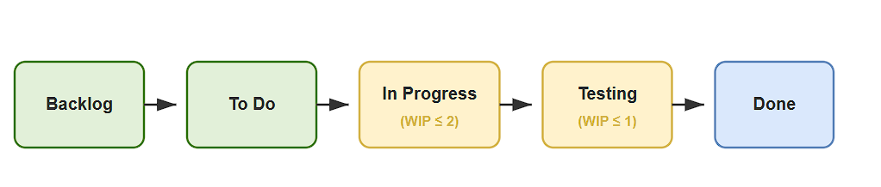
Figure 2.5: Kanban development workflow from the project plan
The board was updated throughout development. Engine defects were reopened, SIEM tests were added, and privacy checks were moved to the dispatcher. Appendix A contains the complete Gantt chart, while the mapped modules and suite of 116 tests provide evidence of progress.

Each task followed a short cycle: define acceptance criteria, implement the change, test it, record the evidence and update the project documentation. This kept development connected to the proposal and interim milestones while allowing earlier assumptions to be corrected.

2.6 Evaluation Strategy
Evaluation is organized in layers. Unit tests examine packet parsing, engine calculations, configuration and state serialization. Integration tests examine the path from parsed traffic through engine verdicts, dispatch, logging, UDP telemetry, dashboard ingestion, optional response and PCAP export. System tests use controlled replay and live loopback traffic to verify end to end behavior without exposing public networks or relying on uncontrolled attack activity.

Detection quality is reported separately for applicable engines using true positives, false positives, true negatives, false negatives, precision, recall and F1 score. Runtime evaluation records latency, traffic rate, CPU, memory and test environment together, because an isolated latency value is not interpretable without load and hardware. Training and testing data are separated before model fitting. Results that use small synthetic samples are labelled as functional checks, while claims about detection effectiveness require an adequately sized held out dataset.

2.7 Methodology for Comparable Analysis
The comparable analysis uses five project defined criteria: anomaly detection support, active response, suitability for a low footprint deployment, transparency of decision logic, and support for training or adaptation. Each system is assigned a qualitative alignment score from 1 to 5, where 1 indicates weak alignment with the MANTIS research context and 5 indicates strong alignment. The chart is a requirements oriented rubric based on documented capabilities; it is not a throughput benchmark or an independent product ranking.
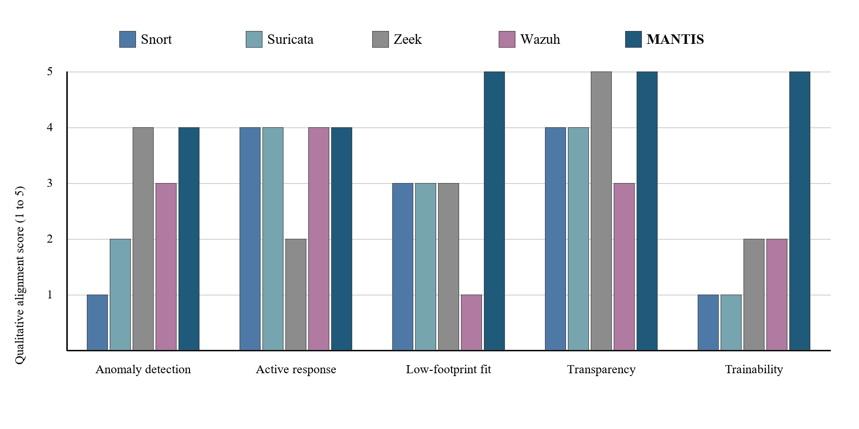
Figure 2.6: Qualitative comparable system functionality ranking using the project rubric

Table 2.5: Comparable system strengths and limitations
System | Principal strength | Limitation in the MANTIS context
Snort 3.x | Mature rule language and deep packet inspection | No native learning or anomaly model; deployment centres on rule maintenance
Suricata 7.x | Multithreaded inspection with structured EVE JSON output | Learning normally depends on an external analytics component
Zeek 8.x | Rich behavioural telemetry and scriptable protocol analysis | Detection and response policies require scripting and external enforcement
Wazuh 4.x | Centralised agent management, correlation and active response | Multi component platform is broader and heavier than a small standalone sensor
MANTIS | Five inspectable engines, training, state persistence and optional response in one prototype | Narrower protocol coverage and less operational maturity than established platforms
The comparison shows why MANTIS is a focused experimental artefact rather than a replacement for the four systems: Snort and Suricata offer greater signature and protocol maturity, Zeek provides richer behavioural telemetry, and Wazuh offers broader central management. The final evaluation therefore tests only the low footprint, inspectable criteria deliberately built into the MANTIS scope and acknowledges the prototype's narrower coverage and lower operational maturity.

2.8 Requirement Specification
The literature gaps and comparable system findings are converted below into requirements that can be traced to implementation and evaluation evidence. Functional requirements state what the artefact must do; non functional requirements state the qualities and constraints under which those functions should operate. Measurements are presented as targets at this stage and will be reported as results only after final testing.

2.8.1 Problem Domain
MANTIS addresses network monitoring on commodity Linux hosts where a learner or small operator needs inspectable detection without deploying a full security platform. The problem is defined by the following linked constraints:
- The runtime should remain small enough for a modest virtual machine, teaching laboratory, or edge Linux host, without requiring third-party Python packages for detection.
- Signature-only monitoring may miss behaviour without a prepared rule, while opaque models make it difficult to explain why an alert was generated.
- Capture, alerting, persistence, evaluation, and optional response should form one reproducible workflow, while privileged actions and sensitive payload collection remain controlled.
- Reconnaissance, volumetric anomalies, malicious payloads, behavioural novelty, and known malicious indicators require complementary detection mechanisms rather than a single universal classifier.
- Operators should be able to trace every alert to observable features, a stated threshold or learned state, and a documented decision path.
- Labelled training data, replay traffic, and live network behaviour differ, so the evidence should distinguish implementation verification from claims of real-world accuracy.
- Packet payloads and addresses may expose personal or confidential information, so data minimisation, redaction, bounded retention, and controlled export are required.
- Learned engine state and audit evidence should survive an orderly restart without silently accepting corrupted or incompatible brain data.
- Claims about detection, response, and resource use should be reproducible through traceable tests, explicitly defined environments, and reviewable output artefacts.

2.8.2 Proposed Solution Strategy
Each constraint in Section 2.8.1 is answered below by a corresponding solution decision. Keeping the same order and number makes the link from the problem domain to implementation explicit:
- MANTIS uses Python Standard Library detection code, bounded queues and buffers, compact online state, and configurable retention limits so that it can operate on a modest Linux host.
- The system combines transparent statistical, supervised, probabilistic, clustering, and membership methods instead of relying solely on prepared signatures or an opaque end-to-end model.
- Capture, parsing, five-engine analysis, alert dispatch, persistence, SIEM delivery, reporting, and optional active response are connected through a single producer-consumer workflow with controlled privileges.
- Complementary mechanisms are assigned to the principal threat patterns, with Z-Score detecting volumetric anomalies, KNN identifying reconnaissance, Naive Bayes analysing malicious payloads, K-Means recognising behavioural novelty, and Bloom Filter checking known malicious indicators.
- Each engine returns a common Verdict containing the responsible engine, label, confidence, threat flag, and decision details, while thresholds, features, and learned states remain inspectable.
- Training data, controlled PCAP replay, live observations, and evaluation artefacts are separated, while dataset schemas are validated and each result is clearly identified as evidence of either implementation behaviour or wider detection accuracy.
- Retained payloads are minimised, credentials and email addresses are redacted before persistence or telemetry, packet storage is bounded, and evidence can only be exported through controlled functions.
- All five engine states are exported to JSON during an orderly shutdown, while only compatible brain data is loaded at startup and the system safely returns to an initialised state when a valid snapshot is unavailable.
- Requirements are traced to unit, integration, system, regression, and training tests, with reviewable outputs preserved and accuracy, latency, CPU usage, and memory consumption measured only under an explicitly documented environment and workload.
Together, these nine decisions provide one implementation response for every problem domain constraint. The mapping also separates completed technical controls from performance and field accuracy claims that still require controlled measurement.

2.8.3 Alternative Solution Strategy
Three alternative approaches were considered but not selected as the main dissertation artefact:
- Extending Snort or Suricata with an external learning component would provide mature packet inspection, but the research contribution would shift toward integration with a large existing engine rather than implementation and evaluation of transparent algorithms.
- Using scikit-learn, ONNX Runtime or a neural framework would shorten model development and support more complex algorithms, but it would introduce runtime dependencies and reduce the project’s emphasis on first principles, inspectable implementation.
- Deploying Wazuh would provide broader endpoint management and response, but its multi component platform addresses a different operational scale from the single host experimental sensor defined by the aim.
These alternatives remain valid engineering choices outside the dissertation boundary. The selected strategy is justified only for the stated research purpose: to examine what can be achieved with a compact Standard Library runtime and five visible decision mechanisms.

2.8.4 Functional Requirements
Table 2.6 records the implemented functional requirements. Inputs and logic are taken from the MANTIS source modules rather than from an aspirational specification.

Table 2.6: Functional requirements with inputs and implementation logic
Subcategory | Goal / Objective | Required Inputs | Implementation Details / Logic
Packet acquisition | Capture live Ethernet frames or replay a finite PCAP without stopping the analyser on unsupported frames. | Linux interface name or PCAP path; AF_PACKET raw socket or libpcap format file; optional VLAN/ICMP frames. | SensorNode binds SOCK_RAW/AF_PACKET or opens the PCAP stream. PacketParser unpacks Ethernet/IPv4/TCP/UDP/ICMP with struct; truncated frames are rejected and counted, not fatal.
Pipeline decoupling | Prevent capture stalls when classification is slower than arrival rate. | Raw frame bytes; configured queue size; producer and analyser threads. | A bounded queue.Queue receives frames from the sniffer. On overflow the sniffer drops and records loss. The analyser dequeues, parses and fans observations to the engines.
Five engine classification | Detect volumetric floods, reconnaissance, malicious plaintext payloads, behavioural novelty and known bad sources through one contract. | Per interval PPS and unique port counts; payload bytes; source IP; trained or seeded engine state. | Each engine implements analyse/train/export_brain/import_brain. Interval engines (Z-Score, KNN, K-Means) run once per second; Bloom and Naive Bayes run per packet. A Verdict {label, confidence, detail, is_threat} is returned.
Training and brain persistence | Fit applicable engines from labelled data and restore inspectable state after restart. | CSV/JSON/CIC-IoT2023 derived tables with validated columns (unique_ports, packet_count, payload, label); brain JSON path. | training.train and Loader reject illegal mappings such as raw Dst Port as unique_ports. Compatible sections of the newest brain file are imported at start; export occurs on orderly shutdown.
Alert construction | Produce an auditable alert that an operator can explain. | Engine Verdict; packet 5 tuple; optional payload excerpt; MITRE mapping tables. | AlertDispatcher deduplicates, enriches ATT&CK technique/severity/risk, truncates excerpts to 64 bytes and redacts PII before any sink is written.
Persistence and telemetry | Retain a forensic trail and notify a SIEM without blocking capture. | Sanitised alert record; CSV path; UDP host/port default 9999. | Logger appends a locked CSV row. UDPSender emits JSON datagrams. Failures are logged; they do not terminate the analyser.
Operator interface | Display current alerts, evidence and exports in a browser. | HTTP GET on port 8080; in memory alert buffer; packet store identifiers. | siem.py serves HTML/JSON from a standard library HTTP server. Malformed UDP is discarded. The dashboard is a local prototype and is not authenticated.
Optional active defence | Block a confirmed source only under explicit operator policy. | --block flag; --block-on categories; whitelist; source IP; iptables availability. | ActiveDefense inserts iptables -I INPUT 1 -s IP -j DROP only when enabled, category permitted, not whitelisted and not already blocked. flush() removes MANTIS rules on exit.
Evidence export | Support post incident review and external analysis. | Session alerts; bounded packet store; shutdown event. | ReportGenerator writes forensic HTML. Packet evidence can be exported as a valid PCAP. Stores are bounded to prevent unbounded RAM growth.
Evaluation reporting | Produce reproducible confusion matrix metrics for applicable engines. | Held out labelled samples; imported brain state; output path. | evaluation.evaluate writes TP/FP/TN/FN, precision, recall, F1 and related files. Small synthetic sets are labelled as functional checks, not field accuracy.
Configuration and shutdown | Control runtime behaviour and release resources cleanly. | CLI/config options for interface, ports, brain, logs, PCAP and defence; stop signal. | Config supplies defaults. Shutdown stops threads, closes sockets, exports brain state and completes the HTML report.

2.8.5 Non-Functional Requirements

- NFR1 Performance: Meet the latency, CPU and memory targets in Table 2.7 under a documented reference load and environment.
- NFR2 Transparency: Keep each engine’s mathematics, thresholds, features and state visible in source code and report per engine results.
- NFR3 Portability: Require only the Python Standard Library for detection logic; use documented Linux facilities for live capture and response; keep offline training and replay usable on other operating systems where supported.
- NFR4 Security: Disable active defence by default, validate externally supplied paths and data, minimise payload retention, and avoid exposing dashboard or UDP services directly to an untrusted network.
- NFR5 Reliability: Bound queues and buffers, handle malformed packets and telemetry without terminating the service, and preserve valid logs and brain data across controlled shutdown.
- NFR6 Maintainability: Implement engines as separate modules sharing analyse, train, export_brain, import_brain and reset operations, with automated tests for their contracts.
- NFR7 Usability: Provide documented installation, command help, clear configuration defaults and operator readable alerts without requiring an external database or web framework.
- NFR8 Reproducibility: Record dataset, split, configuration, software version, hardware and test commands for every reported experiment.

2.8.6 Goals of Implementation
The implementation goal is one coherent, inspectable and testable MANTIS prototype rather than a collection of disconnected algorithms. Capture, parsing, five detection mechanisms, alert dispatch, privacy controls, state persistence, evidence export, evaluation and the four page operator console exchange data through explicit interfaces. Completion is judged through the following goals, each linking an input, an implemented responsibility and verification evidence:
- Acquisition goal: accept live Ethernet frames through Linux AF_PACKET and finite offline PCAP input, validate supported Ethernet, VLAN, IPv4, TCP, UDP and ICMP structures, and reject malformed or unsupported frames without stopping the analyser.
- Detection goal: route semantically correct features to five complementary engines, namely Z-Score, KNN, K-Means, Naive Bayes and Bloom Filter, and return a common Verdict containing the engine, label, confidence, threat state and decision detail.
- Operational goal: use bounded queues, packet history and alert buffers so capture cannot grow memory without limit; keep active defence disabled by default and issue an iptables request only when the threat category, confidence, whitelist and configuration policy all permit it.
- Evidence and privacy goal: redact sensitive payload content before persistence or telemetry, write reviewable CSV and JSON evidence, permit controlled PCAP and JSON export, and expose ATT&CK, severity and risk context without using colour as the only meaning.
- Continuity goal: export all engine state during orderly shutdown, load only compatible brain data at startup, recover safely when no valid snapshot exists, and keep training, live observation and evaluation artefacts distinguishable.
- Interface goal: implement all four dashboard pages. Overview must show host health, recent events and engine activity; Packets must support filtering, pause, detail and export; Alerts must present the complete in memory threat log; Architecture must explain the five engine pipeline and response path.
- Verification goal: trace requirements to unit, integration, system, regression and training tests, use controlled loopback and replay traffic, and report software correctness separately from detector effectiveness, latency, CPU and memory measurements.
- Scope goal: maintain a Python Standard Library detection runtime suitable for a modest Linux host and state clearly that authentication, multi user case management, durable database search, encrypted payload inspection and production scale certification remain outside the implemented boundary.

Together, these goals define implementation success as traceable behaviour rather than the presence of source files. A goal is treated as completed only when the relevant module, observable output and verification evidence agree. The interface figures in Section 3.7 follow the same rule by showing every implemented page and excluding functions that are not present in the current system.

2.8.7 System Workflow Diagrams
Figure 2.7 represents the conventional workflow used as the problem reference: multiple security data sources feed an alert queue, after which analyst correlates evidence and applies a response manually. Figure 2.8 represents the proposed MANTIS workflow, linking training and brain state loading to packet capture, five engine analysis, alert dispatch, dashboard presentation and optional iptables response. The diagrams retain the workflow presentation used in the interim report.
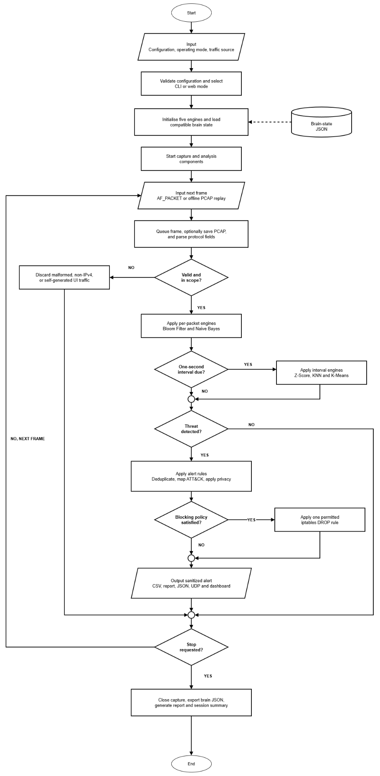
Figure 2.7: Current monitoring and manual response workflow
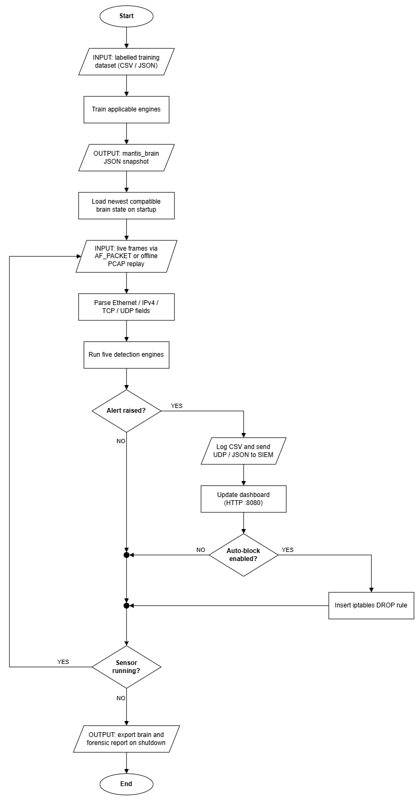
Figure 2.8: Proposed end to end MANTIS workflow
2.8.8 Performance and Environment Requirements
Live capture requires a Linux host that provides AF_PACKET and sufficient privilege or capability for raw sockets. The reference environment will record processor, memory, operating system version, Python version, interface, traffic source and test duration. The detection runtime uses the Python Standard Library; iptables and Linux capabilities are operating system facilities rather than Python package dependencies. Offline training, evaluation and PCAP replay can be exercised separately where live AF_PACKET capture is unavailable.

Table 2.7: Performance and environment targets for final evaluation
Requirement | Target | Verification method
Packet processing latency | p95 below 15 ms in the stated test environment | Timed replay and live loopback benchmark
Memory footprint | Sensor process below 100 MB resident memory | Repeated process sampling during controlled traffic
CPU utilisation | Below 25% of one reference vCPU at the stated load | Process monitoring with traffic rate recorded
Reliability | No crash or corrupted alert file during a 30 minute run | Sustained replay, shutdown and restart checks
Portability | Live capture on supported Linux; offline training and replay on other operating systems | Installation and smoke test matrix
Security | Active response disabled by default; captured payload minimised | Configuration review and negative tests
Table 2.7 defines evaluation targets, not completed results. The final discussion will report measured values with sample size, load and environment, and will identify any unmet target. This prevents interim observations or single loopback measurements from being presented as general performance claims.

2.9 Algorithms Implemented
The three algorithms below retain the interim report’s documentation pattern. Each is defined, expressed mathematically, described as a procedure, represented in pseudocode and linked to a flowchart. Mini-Batch K-Means and Bloom Filter are documented with the remaining system design material because their state update and persistence behaviour is closely connected to that chapter.

2.9.1 Z-Score Statistical Engine
The Z-Score engine monitors a packet rate observation x relative to an online estimate of the normal mean and standard deviation. It raises a volumetric anomaly indication when the absolute standardised deviation exceeds the configured threshold after sufficient baseline observations.

Mathematical Model
z = (x - mu) / sigma, alerting when |z| > 3. Mean mu and variance sigma are updated online via Welford's incremental method.
z = (X - μ) / σ

Step by Step Procedure
1. Read the current packets per second observation.
2. Update the running count, mean and second moment using Welford’s equations.
3. Derive the standard deviation when enough observations exist.
4. Calculate the absolute Z-Score and compare it with the configured threshold.
5. Return a normal or flood oriented verdict with the supporting score.

Pseudocode
INPUT current observation x and threshold τ
UPDATE n, mean μ and second moment M2
IF n < minimum_samples OR standard_deviation = 0: RETURN Normal
z = (x - μ) / standard_deviation
IF absolute(z) > τ: RETURN FloodAlert with score
RETURN Normal
Flowchart
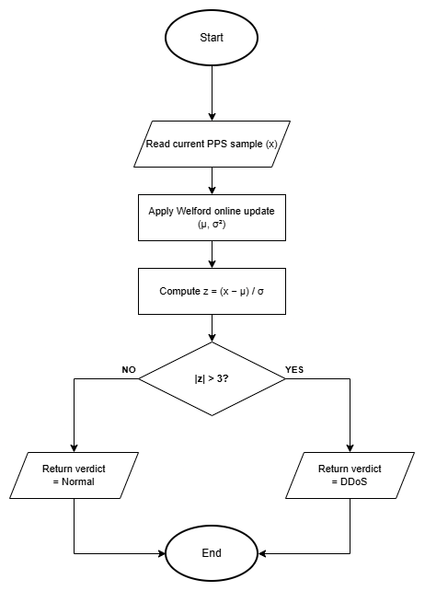
Figure 2.9: Z-Score statistical engine flowchart
2.9.2 K-Nearest Neighbours (KNN) Engine
The KNN engine is a supervised, instance based classifier used for scan oriented observations. A query vector is compared with labelled training vectors, and the majority label among the k closest neighbours determines the predicted class.
Mathematical Model
Euclidean distance d(p,q) = sqrt (sum_i (p_i q_i) ^2). Majority vote of K=3 nearest labelled neighbours assigns Normal vs Scan.
$$d(x,y)=(∑_{i=1}^{n}​{(xi​-yi​)}^{p})\frac{1}{p}​$$

Step by Step Procedure
1. Construct the live feature vector, including the configured scan oriented counts.
2. Validate that a compatible labelled training set is available.
3. Calculate Euclidean distance to every stored training vector.
4. Select the k vectors with the smallest distances and count their labels.
5. Return the majority class with vote based confidence and distance evidence.

Pseudocode
INPUT query vector q and labelled training data D
distances = [(euclidean(q, vector), label) for each item in D]
neighbours = first k items after sorting distances
prediction = majority_label(neighbours)
confidence = votes_for_prediction / k
RETURN prediction, confidence and neighbour distance
Flowchart
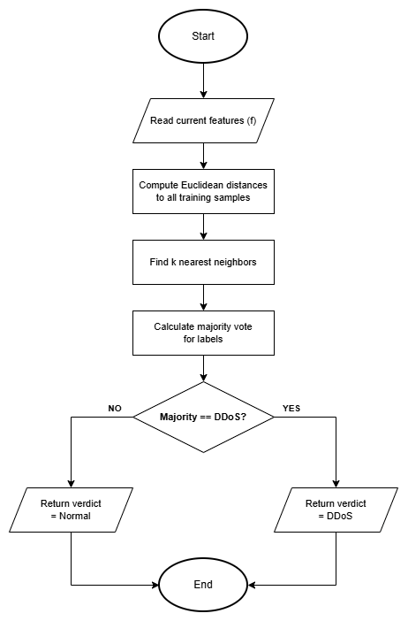
Figure 2.10: K-Nearest Neighbours engine flowchart

2.9.3 Multinomial Naive Bayes Engine
The Multinomial Naive Bayes engine classifies tokenised, unencrypted payload excerpts using class priors and token likelihoods learned from labelled examples. It is intentionally limited to visible payload text and cannot inspect encrypted application content.

Mathematical Model
log P(class|tokens) = log P(class) + sum_i log P(token_i|class); Laplace smoothing prevents zero counts on unseen tokens.
$$P\left(wn​ ∣ wn-1​,…,w1​\right)=\frac{C(w1​,…,wn​)+1}{C(w1​,…,wn-1​)+V}​$$

Step by Step Procedure
1. Decode the privacy limited payload excerpt and tokenise visible text.
2. Initialise each class score with its log prior probability.
3. Add the smoothed log likelihood of each token for each class.
4. Select the class with the largest score and derive confidence from the class scores.
5. Return a payload alert verdict only when the malicious class and threshold conditions are satisfied.

Pseudocode
INPUT payload bytes and trained class statistics
tokens = tokenise(decode(payload excerpt))
FOR each class c: score[c] = log_prior[c]
FOR each token w: score[c] += log(smoothed_probability(w, c))
prediction = class with maximum score
IF prediction is Malicious AND confidence >= threshold: RETURN PayloadAlert
RETURN Safe
Flowchart
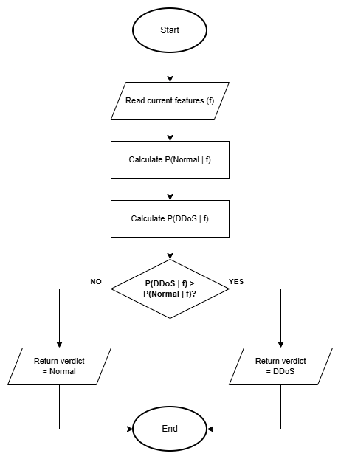
Figure 2.11: Multinomial Naive Bayes engine flowchart

3. System Analysis and Design
System analysis converts the requirements established in Chapter 2 into actors, interactions, data structures and decision paths, grounded in the implemented MANTIS modules. Each diagram answers a different question: the use case identifies user goals, the sequence diagram shows message order, the class diagram allocates responsibility, the activity diagram shows control flow, and the data schema explains how evidence is retained.

The design keeps acquisition, parsing, detection, dispatch, persistence and presentation separate. A bounded producer consumer queue prevents packet capture from being tied directly to analysis time, while a common Verdict contract allows five different algorithms to feed the same dispatcher. Detection code cannot change the firewall directly; an explicit policy check controls the optional response path.

3.1 Use Case
A use case represents a goal achieved through interaction between an actor and the system. In MANTIS the primary actor is the Security Administrator, who starts monitoring, investigates alerts, manages learned state and requests evidence exports. The Host Operating System supplies frames and enforces an approved firewall rule, while an External SIEM may receive structured telemetry. These actors are outside the MANTIS system boundary even when they run on the same host. Figure 3.1a shows this abstract goal level with every actor placed on the left of the system boundary.

Figure 3.1b refines the abstract model to level 1 detail. Include relationships mark behaviour that always occurs, capturing and analysing traffic during live monitoring, while the extend relationship attaches blocking only when a verdict is raised and the block policy is enabled. This distinction prevents the diagram from implying that every alert automatically blocks a source.

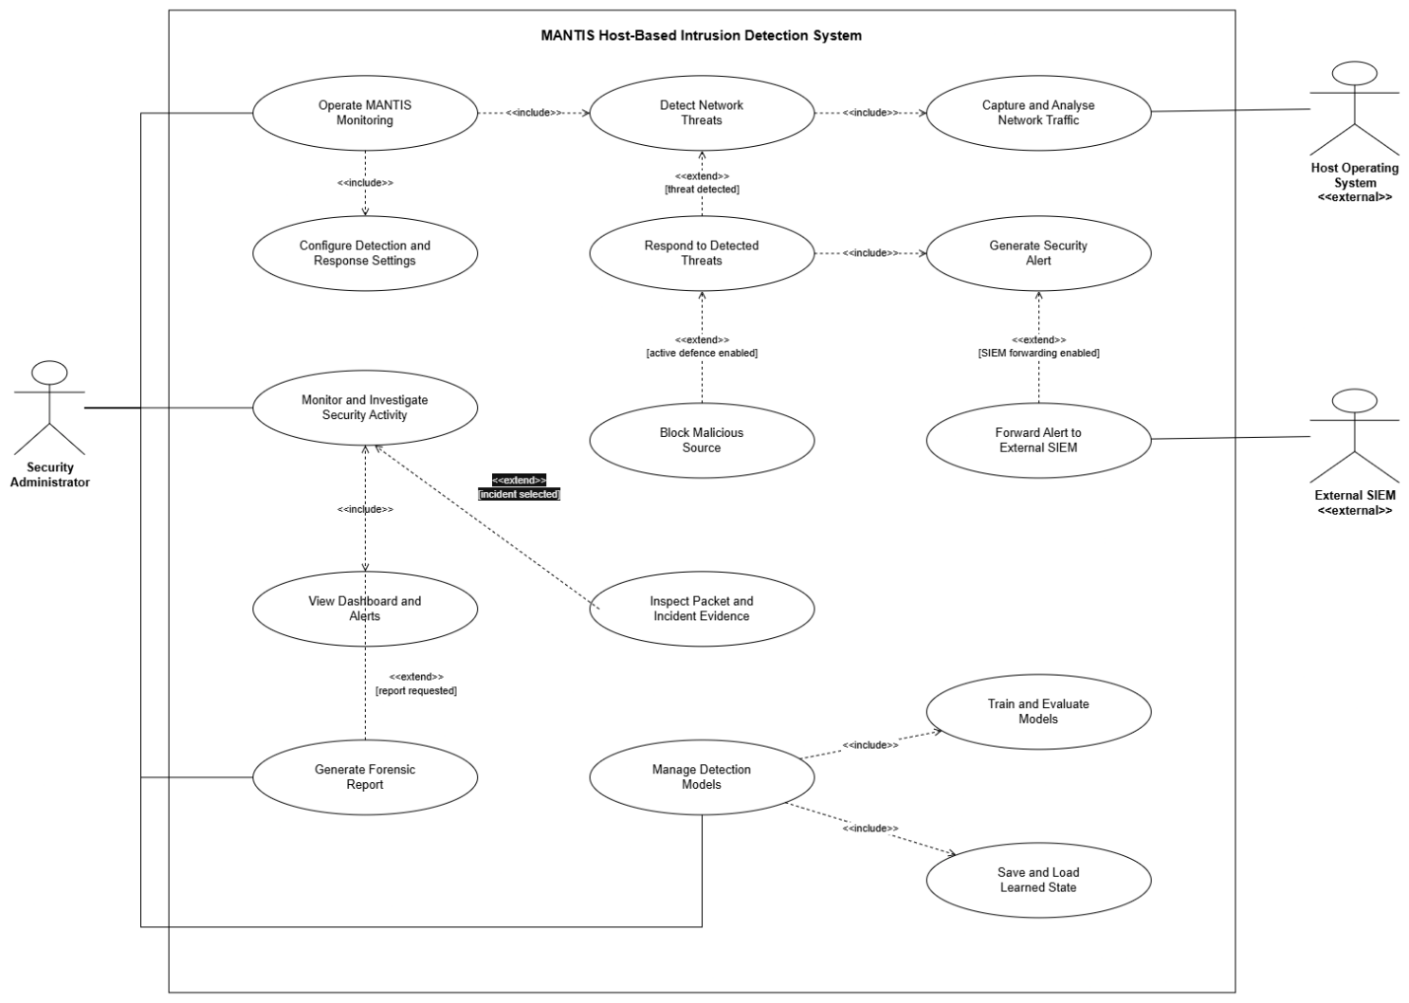
Figure 3.1: MANTIS use case model
3.1.1 Use Case Documentation
Table 3.1 states the actor associations the use case diagram shows: a solid association between each actor and the use cases it initiates or supports, include for behaviour that always occurs during monitoring, and extend for optional blocking. Table 3.2 then documents the preconditions, main path and exceptions for each principal use case.

Table 3.1: Actor use case associations, include and extend
Actor or included behaviour | Use case | Association | Meaning in MANTIS
Security Administrator | UC-01 Live monitoring | Association (primary) | Starts and stops the sensor; include Capture Traffic and Analyse Frames.
Security Administrator | UC-02 Investigate and export | Association (primary) | Uses the local dashboard and evidence export.
Security Administrator | UC-03 Train and restore models | Association (primary) | Runs train.py and supplies labelled CSV/JSON.
Security Administrator | UC-04 Apply active defence | Association (primary) | Enables --block; does not occur by default.
Host Operating System | UC-01 Live monitoring | Association | Supplies Ethernet frames via AF_PACKET and process privileges.
Host Operating System | UC-04 Apply active defence | Association | Enforces iptables DROP when the dispatcher requests it.
External SIEM / browser | Receive telemetry / view alerts | Association | UDP JSON to port 9999; HTTP GET on port 8080.
Capture Traffic | UC-01 | Include | Always executed during live or replay monitoring.
Analyse Frames | UC-01 | Include | Always executed after a supported frame is parsed.
Block Source | UC-01 | Extend | Occurs only when a threat verdict is raised and --block policy is satisfied.
The documentation below defines the implemented preconditions, normal outcome and exceptions for the principal use cases. Authentication is not claimed because the local dashboard has no login mechanism, and active defence is described as optional and policy gated, matching the default configuration and current dispatcher behaviour.

Table 3.2: Principal MANTIS use case documentation
ID and goal | Actor | Preconditions | Main success path | Alternative and postcondition
UC-01 Live monitoring | Security Administrator | Supported Linux host; sensor configured; raw capture permission for live mode. | Start sensor; capture frames; parse supported protocols; analyse relevant features; publish qualifying alerts. | Malformed frames are rejected without stopping the loop. Monitoring continues until a stop request; brain state and report are then written.
UC-02 Investigate and export | Security Administrator | Web SIEM running and packet or alert records available. | Open dashboard; filter packets or alerts; inspect source, engine, severity and ATT&CK context; request JSON or PCAP evidence. | An empty store returns a valid empty state. Exported records follow the configured privacy and snap length controls.
UC-03 Train and restore models | Security Administrator | Labelled CSV fields match the selected loader; output directory is writable. | Validate rows; train the selected engines; serialise a timestamped JSON brain; import the latest compatible sections on start up. | Missing columns raise a dataset error. Missing or incompatible sections retain safe seeded state rather than corrupting the engine.
UC-04 Apply active defence | Security Administrator and Host OS | A threat identifies a source; blocking is explicitly enabled; kind is permitted; source is not whitelisted. | Dispatcher evaluates policy; ActiveDefense inserts one iptables DROP rule; response status and rule are recorded. | Disabled policy, failed command, duplicate source or whitelist match produces no block. MANTIS rules are removable during shutdown.

3.2 Sequence Diagrams
A sequence diagram shows messages in time order. During live detection, the Linux kernel supplies an Ethernet frame to the sniffer thread, which places raw bytes in the bounded queue. The analyser thread removes the frame, PacketParser validates and decodes it, and the relevant engines return Verdict objects. AlertDispatcher then applies one common route for logging, UDP/JSON telemetry, dashboard publication and optional response.

The response message occurs after the dispatcher has checked block enabled status, the configured block on categories and the whitelist. Brain export is a shutdown operation rather than part of every packet path. This ordering keeps the high frequency capture loop small and makes privacy processing occur at the persistence boundary.
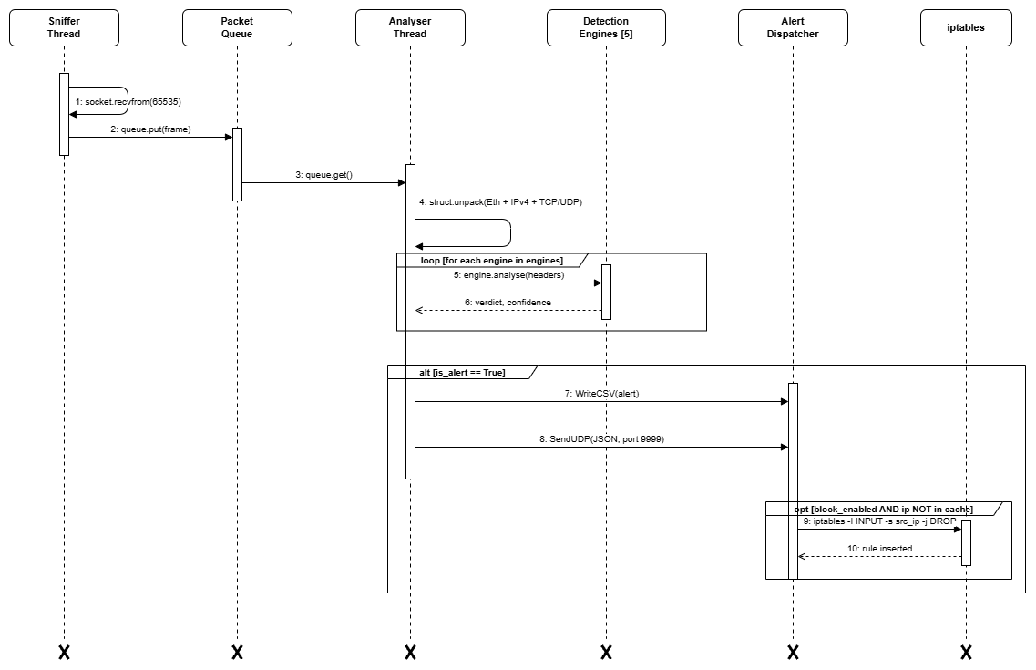
Figure 3.2: Live detection sequence from captured frame to operator visible alert
The training sequence shows the administrator invoking train.py, Loader validating labelled CSV records, the applicable engines fitting their state, and the completed brain snapshot being written as JSON.
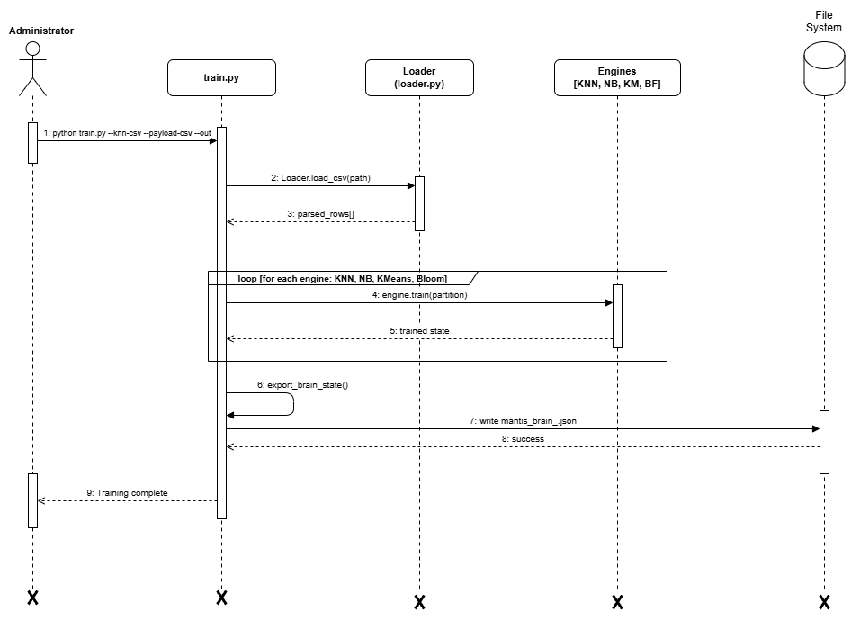
Figure 3.3: Training pipeline from validated data to persistent engine state
The SIEM sequence separates asynchronous alert ingestion from browser retrieval. AlertDispatcher sends JSON to the UDP listener, the listener updates the bounded alert buffer, and the browser obtains the current operator view over HTTP.
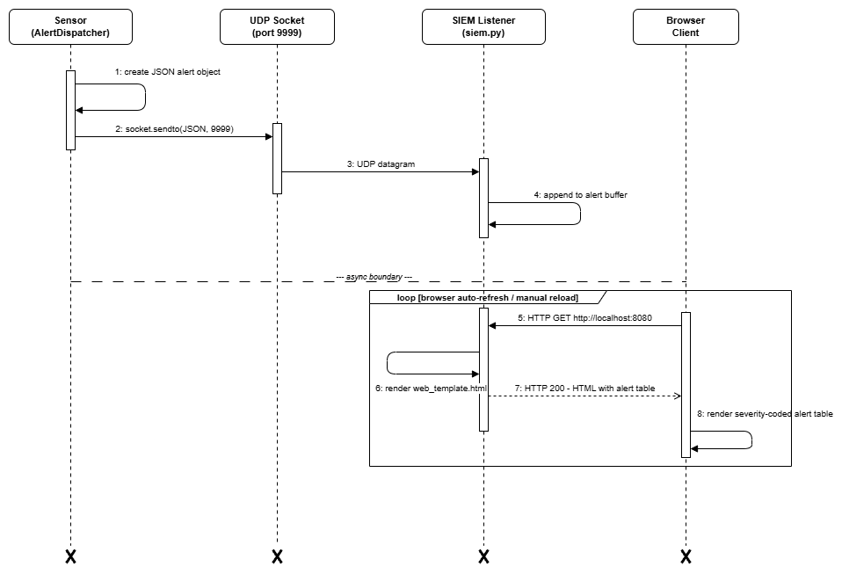
Figure 3.4: SIEM alert delivery and browser dashboard retrieval
The offline sequence provides a deterministic alternative to privileged live capture. main.py opens a finite PCAP stream, submits each decoded packet to the detection engines, and returns the completed analysis evidence to the administrator.
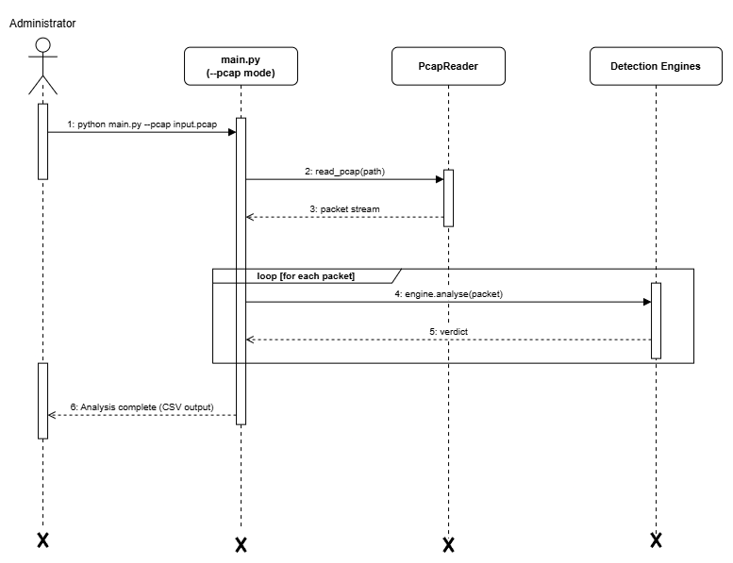
Figure 3.5: Offline PCAP replay and finite analysis completion

3.3 Class Diagram
The corrected class diagram uses standard multiplicity notation. One SensorNode (1..1) composes one or more DetectionEngine objects (1..*), exactly one PacketParser (1..1), and exactly one AlertDispatcher (1..1). AlertDispatcher can invoke zero or one ActiveDefense object (0..1). The five hollow triangle arrows, including BloomFilter, denote inheritance and therefore do not carry multiplicities.

The class diagram assigns static responsibility. SensorNode owns the capture lifecycle and composes PacketParser, AlertDispatcher and the five concrete engines. DetectionEngine defines the shared analyse, train, export_brain, import_brain and reset operations, while Verdict provides a consistent label, confidence, rationale and threat flag. This interface allows the dispatcher to consume results without depending on each algorithm's internal mathematics.

Filled diamonds identify parts whose lifecycle is controlled by SensorNode; the navigable arrow to ActiveDefense shows an optional service rather than ownership. The corrected notation separates relationship type from cardinality, so 1..1 means exactly one and 1..* means one or more. This matches SensorNode construction in sensor.py and the optional defense argument accepted by AlertDispatcher.
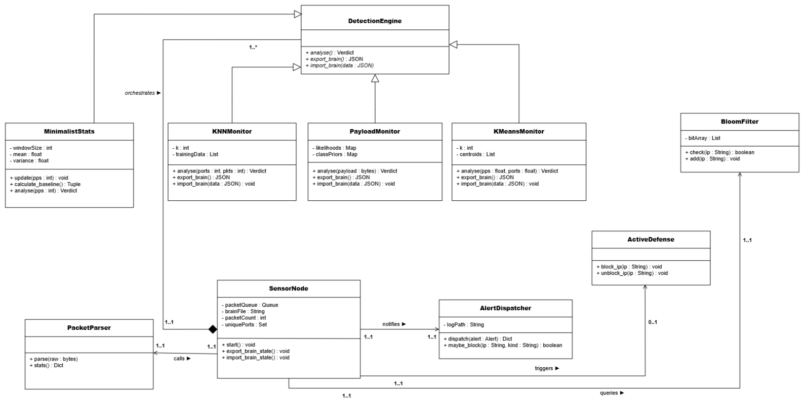
Figure 3.6: Corrected MANTIS class model with inheritance, composition and explicit UML multiplicities

3.4 Activity Diagrams
Live detection moves each captured frame through the bounded queue, parser and five engine fork. Verdicts are joined before alert persistence, SIEM delivery and policy controlled response, while normal traffic returns without a response action.
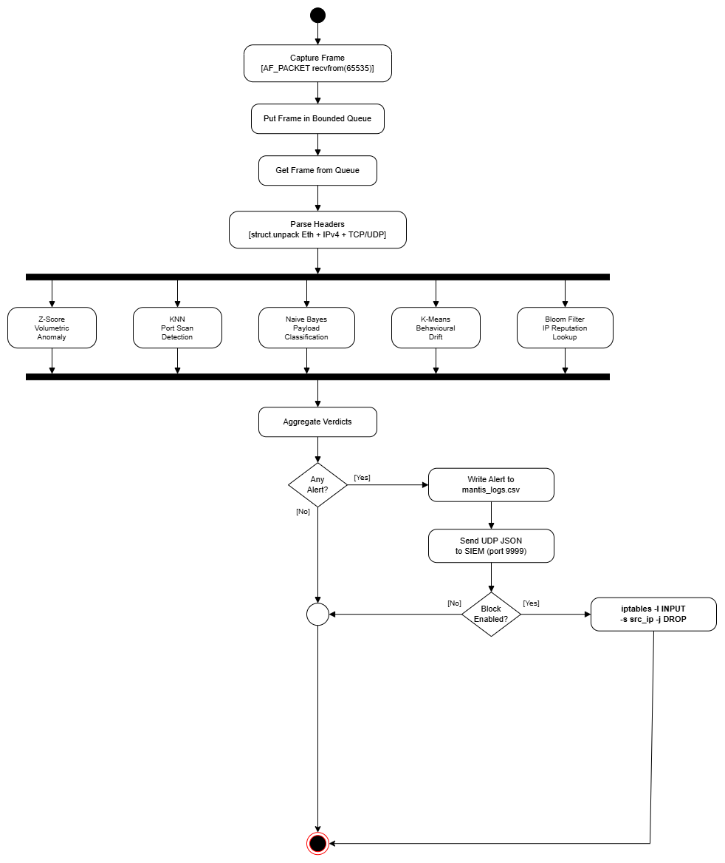
Figure 3.7: Live detection, verdict aggregation and optional response activity
Training validates and projects the supplied data before fitting KNN, Naive Bayes and K-Means and seeding the Bloom Filter. The parallel results converge into one JSON brain export and a training summary.
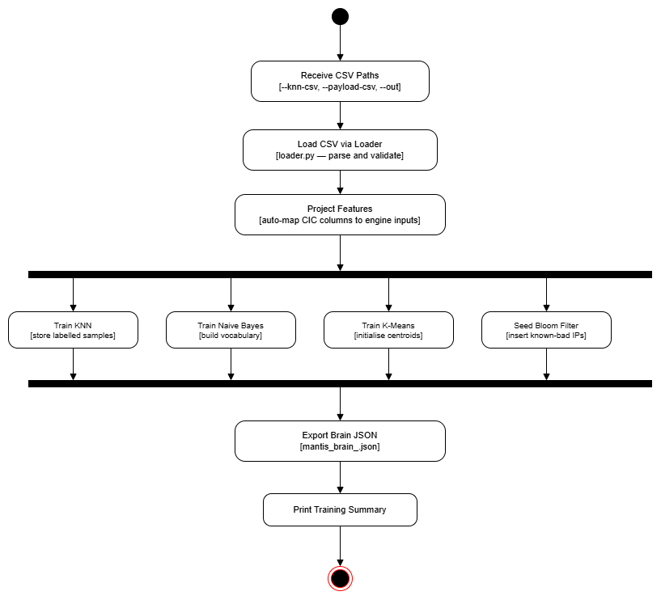
Figure 3.8: Training pipeline from input validation to brain export
Evaluation imports trained state, classifies every labelled sample and updates TP, FP, FN and TN counts. After the final sample, the harness calculates precision, recall, F1 and accuracy for reproducible interpretation.
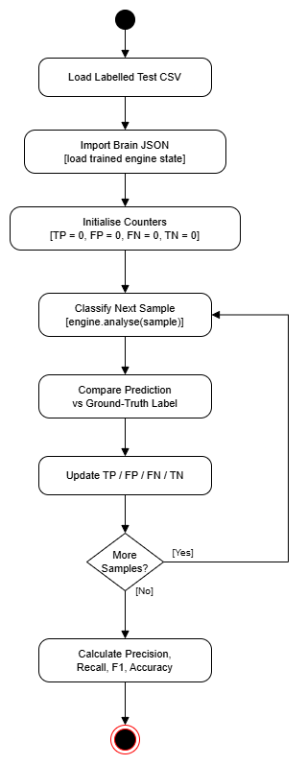
Figure 3.9: Evaluation harness and confusion matrix metric activity
An activity diagram represents processing steps, guarded alternatives and end states. The corrected brain persistence flow begins with engine initialisation and a search for the newest timestamped JSON file. Only after this work does the system decide whether compatible learned state is available. A successful import and a safe default path both converge on the ready state before monitoring starts.

A stop request leaves the monitoring activity, closes threads and any PCAP writer, exports all engine states, writes the timestamped brain file and generates the forensic report. The first node after Start is therefore an action, not a startup or shutdown decision. This matches the SensorNode lifecycle implemented by import_brain_state(), start(), shutdown() and export_brain_state().
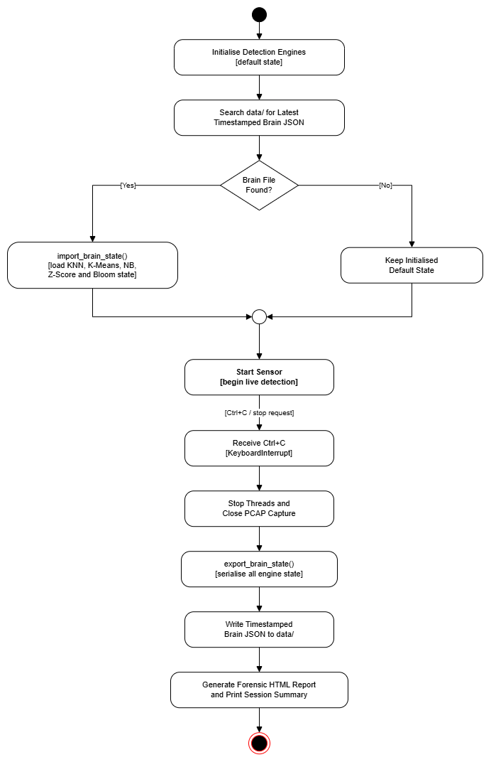
Figure 3.10: Brain persistence and orderly shutdown activity flow
Installation identifies the Linux package manager through a chain of if-else-if decisions (apt, then dnf/yum, then pacman, then zypper, then apk), installs the operating system firewall facility, grants the required capture capabilities and creates the command entry point before reporting success.
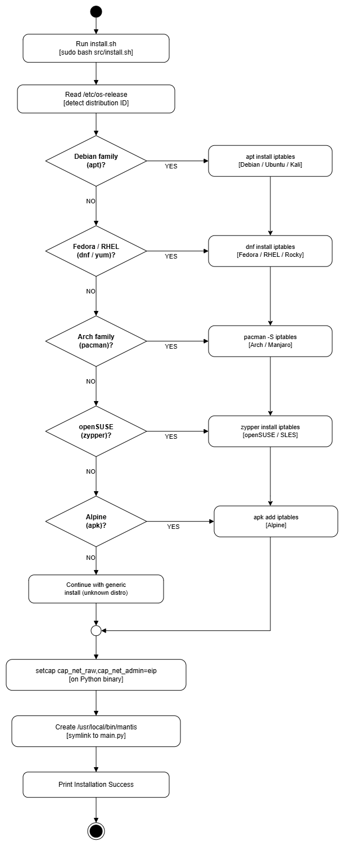
Figure 3.11: Linux installation activity with if-else-if package manager decisions

3.5 Database Schema
MANTIS does not use a relational database. The zero dependency requirement favours bounded memory and human readable files, so this section documents a logical data schema and its physical flat file mappings. Packet events may produce multiple engine verdicts; a threatening verdict may produce one alert; and an alert may produce one firewall rule only when response policy permits it. Timestamps, source addresses and engine details provide traceability across these records.

Alerts are appended to CSV after redaction, UDP telemetry is encoded as JSON, engine state is stored in timestamped JSON brain files, packet evidence may be exported as PCAP, and session findings may be rendered as HTML. The packet store is a bounded in memory deque rather than durable history. This design improves portability and inspection, but it does not provide relational querying, concurrent transactions or long term enterprise retention.

Table 3.3: Logical to physical persistence mapping
Logical record | Physical representation | Principal fields | Purpose
Packet event | In memory PacketStore; optional PCAP | Timestamp, addressing, protocol, ports, length, frame excerpt | Bounded investigation and replay evidence
Threat alert | CSV and UDP/JSON | Engine, message, confidence, MITRE fields, severity, risk, sanitised excerpt | Audit trail and real time SIEM ingestion
Brain snapshot | mantis_brain_*.json | KNN samples, K-Means centroids, NB likelihoods, Z-Score statistics, Bloom bits | Readable restart and training state
Firewall response | Runtime iptables rule and dispatcher summary | Source, policy category, applied status | Opt in and reversible local containment
Forensic report | HTML | Session summary and alert chronology | Human readable hand off evidence

3.6 Algorithms Implemented
Chapter 2 introduced the five detection algorithms. This section completes the design account for the two stateful engines not expanded there: online Mini-Batch K-Means for distance based novelty and a Bloom Filter for reputation membership. Both implement the common engine contract and serialise their state into the JSON brain.

3.6.1 Online Mini-Batch K-Means Engine
KMeansMonitor receives the input feature vector f = (packets per second, unique ports) and represents normal traffic with k centroids. It selects the nearest centroid c by Euclidean distance and returns an anomaly only when the distance exceeds the configured novelty threshold. A normal observation updates the centroid incrementally as c_new = c_old + alpha(f c_old), allowing bounded online adaptation without retaining the full stream.

Mathematical Model
For nearest centroid c_k: c_k := c_k + alpha * (x - c_k) with learning rate alpha, following the mini batch update of Sculley (2010).
$$ck​←ck​+η_{k}​({\overline{x}}_{k}-c_{k}​)$$

Step by Step Procedure
- Compute distance from point x to each centroid.
- Assign x to argmin centroid index.
- Update centroid with learning rate alpha.
- Flag alert if distance exceeds configured threshold.

Pseudocode
Mini-Batch K-Means classify (x = [pps, unique_ports]):
nearest_k = argmin (euclidean (x, c) FOR c IN centroids)
min_dist = euclidean (x, centroids[nearest_k])
centroids[nearest_k] += alpha * (x centroids[nearest_k]) // Sculley 2010
IF min_dist > threshold: RETURN BehaviouralDrift
ELSE: RETURN Normal
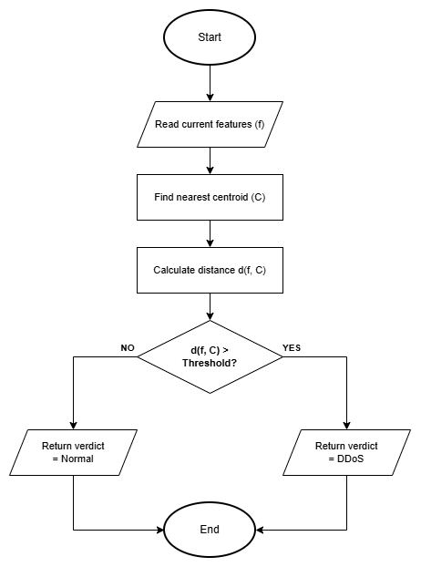
Figure 3.12: Online Mini-Batch K-Means flow from explicit feature input to normal or anomaly output

3.6.2 Bloom Filter Reputation Engine
BloomFilter stores known malicious source indicators in a bit array. Adding an indicator computes k hash positions and sets their bits. A lookup returns Unknown when any required bit is zero and returns Blacklisted only when all bits are set. Lookup cost is O(k), independent of the number of inserted indicators, which makes the reputation check suitable for the per packet path.

Mathematical Model
m bits and k hash functions give an expected false positive rate of (1 - exp(-kn/m))^k for n inserted items (Mitzenmacher and Upfal, 2017).
$${( 1-e^{-\frac{kn}{m}} )}^{k}$$

Step by Step Procedure
- Hash item with k independent hash functions.
- Add all k bit positions to 1.
- On check: return true only if all k positions are 1.

Pseudocode
Bloom Filter check(ip):
FOR seed IN hash_seeds:
pos = adler32(encode (ip + str(seed))) mod m
IF bit_array[pos] == 0: RETURN Clean // Definite non member
// All k bits set -> probable member
fp_rate = (1 - exp(-k*n/m))^k // Mitzenmacher & Upfal 2017
RETURN KnownMalicious, confidence = 1.0 fp_rate
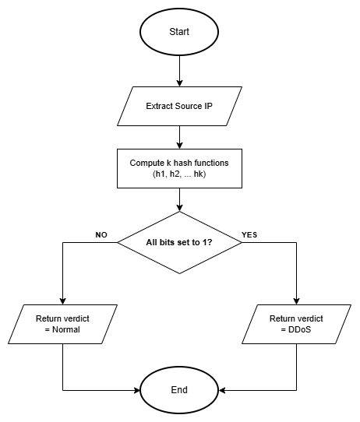
Figure 3.16: Bloom Filter reputation membership decision flow

3.7 System Interface and Design
The system interface supports monitoring and investigation without requiring a separate SIEM dependency. The terminal view serves headless operation, while the embedded web console exposes the current packet rate, bounded packet history, alerts, risk and effective configuration. REST endpoints provide statistics, packet records, configuration and PCAP export; UDP port 9999 receives structured alerts and HTTP port 8080 serves the interface.

Interface decisions follow operator questions rather than source modules: what happened, where it originated, which engine decided, how severe it is and what evidence can be exported. Severity always has a textual label, ATT&CK identifiers give investigation context, and empty states explain that monitoring is waiting for data. Active defence and privacy settings remain visible through configuration data rather than being implied by colour alone.

3.7.1 Wireframe
The low fidelity wireframes in Figures 3.7a to 3.8d validate the layout and information hierarchy of every implemented console page before colours and demonstration data are applied. The shared header preserves sensor state and navigation. Each page then answers a separate operator question: whether the host and detector are healthy, which packets were observed, which events require investigation, and how the detection pipeline produces and reports a verdict.

Overview page
The Overview wireframe prioritises host CPU, memory, online sensor count and current threat event count. Recent classified events occupy the largest region, while the engine panel separates Z-Score, KNN, K-Means, Naive Bayes and Bloom Filter activity so an operator can distinguish an idle detector from a failed sensor.
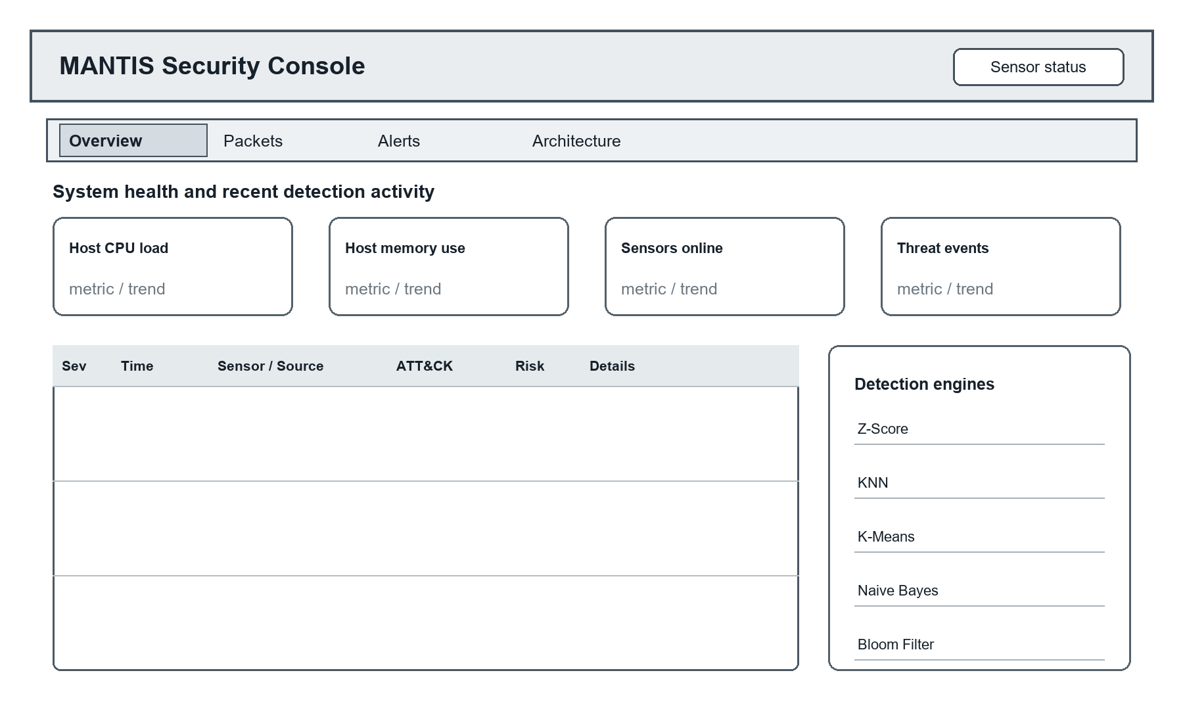
Figure 3.17: Overview page wireframe showing system health, recent events and engine activity
Packets page
The Packets wireframe places the search field, protocol filter, pause control, auto scroll state and PCAP or JSON export above the bounded capture table. Selecting a row opens decoded and hexadecimal detail below, supporting independent verification without pretending that the browser is a durable forensic database.
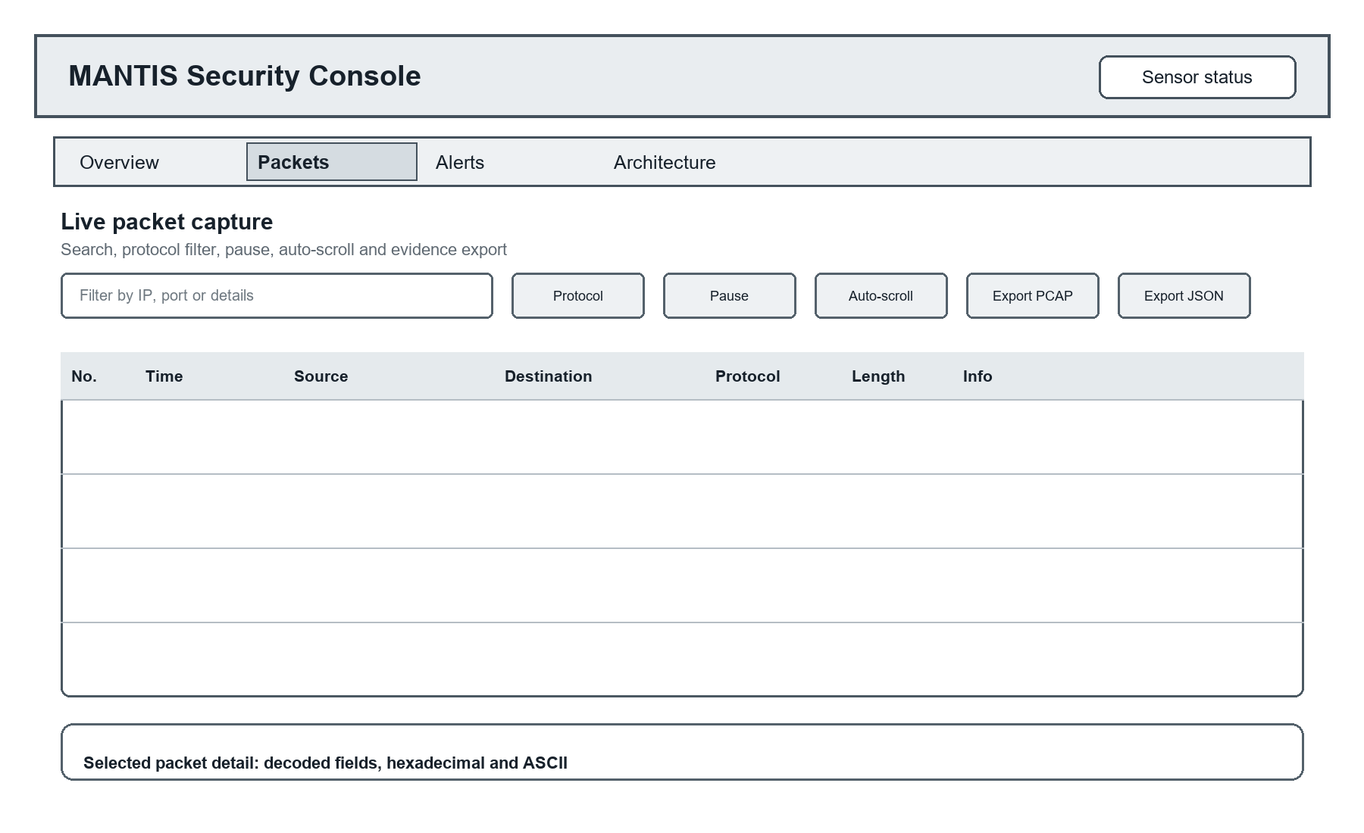
Figure 3.18: Packets page wireframe showing capture controls, packet history and selected frame detail
Alerts page
The Alerts wireframe reserves the full content width for the current in memory threat log. Severity, time, sensor and source, ATT&CK technique, risk and message remain visible in one scan path. The live label and bounded event note make the freshness and retention limit explicit.
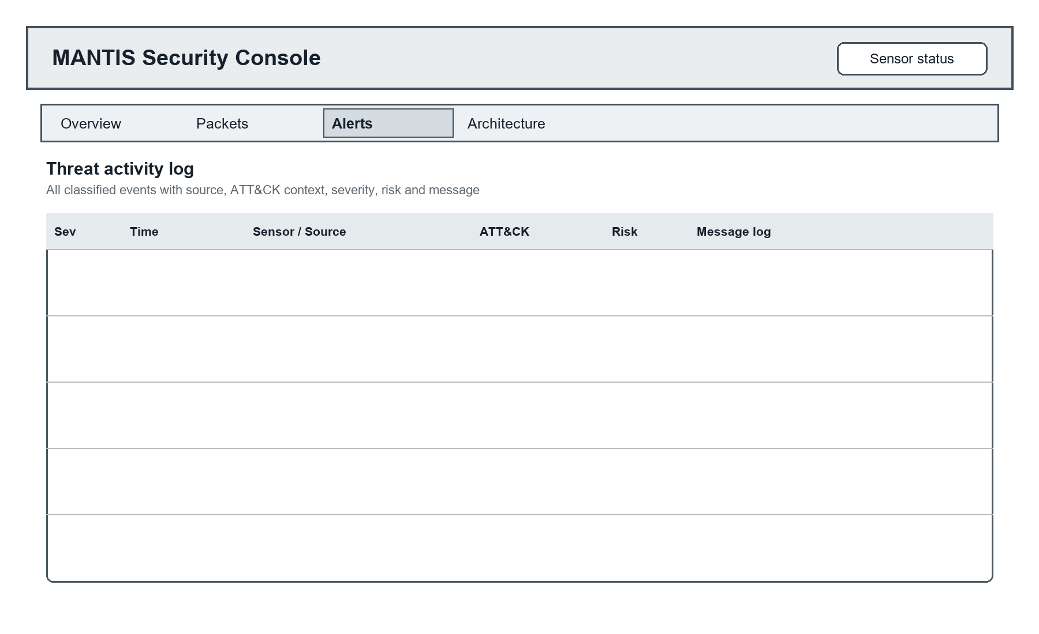
Figure 3.19: Alerts page wireframe showing the complete bounded threat activity log
Architecture page
The Architecture wireframe documents the five implemented engines separately and connects their explicit inputs and decisions to the common Verdict, response and reporting path. This page is explanatory rather than interactive, allowing a reviewer or operator to understand what the system can and cannot infer.
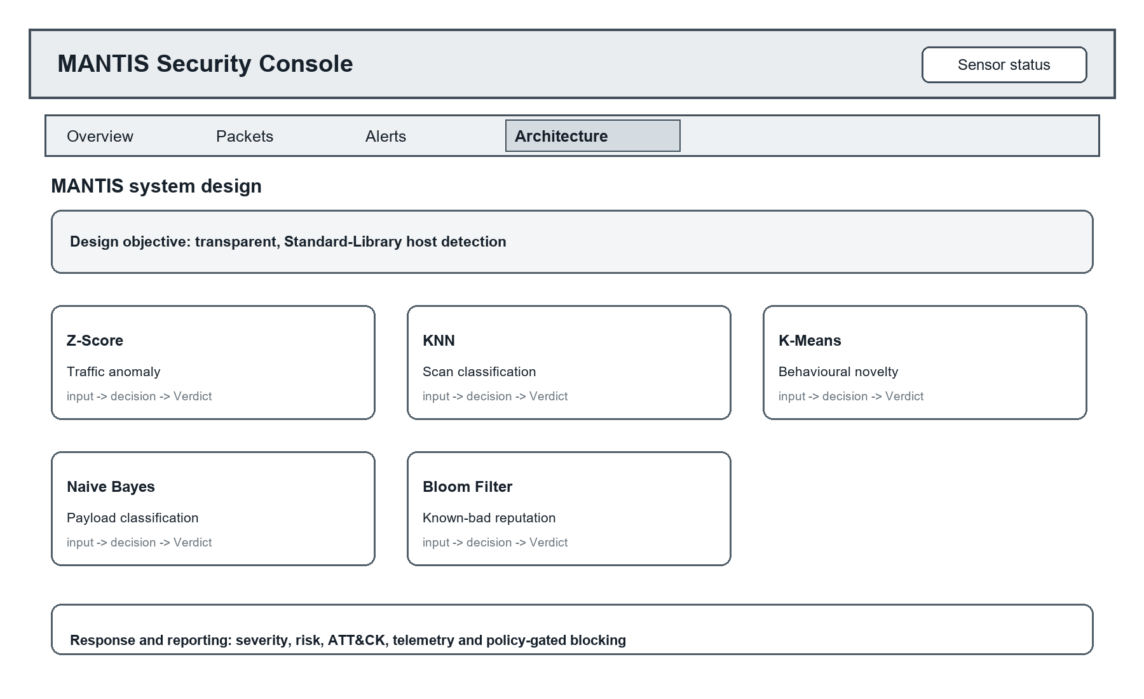
Figure 3.20: Architecture page wireframe showing all five engines and the response path

3.7.2 Mockup
The implemented function mockups in Figures 3.8a to 3.9d apply the current console styling and API contract to the same four pages. Values and events are controlled demonstration records, not production incidents. The mockups include only behaviour supported by web_template.html and siem.py, so the visual design remains traceable to the running prototype rather than presenting aspirational screens.
Overview page
The realised Overview page combines host health cards, recent classified events and counts for every detection engine. Text labels accompany severity and system state. This permits rapid triage while retaining the engine and ATT&CK context needed to explain why an event appears.
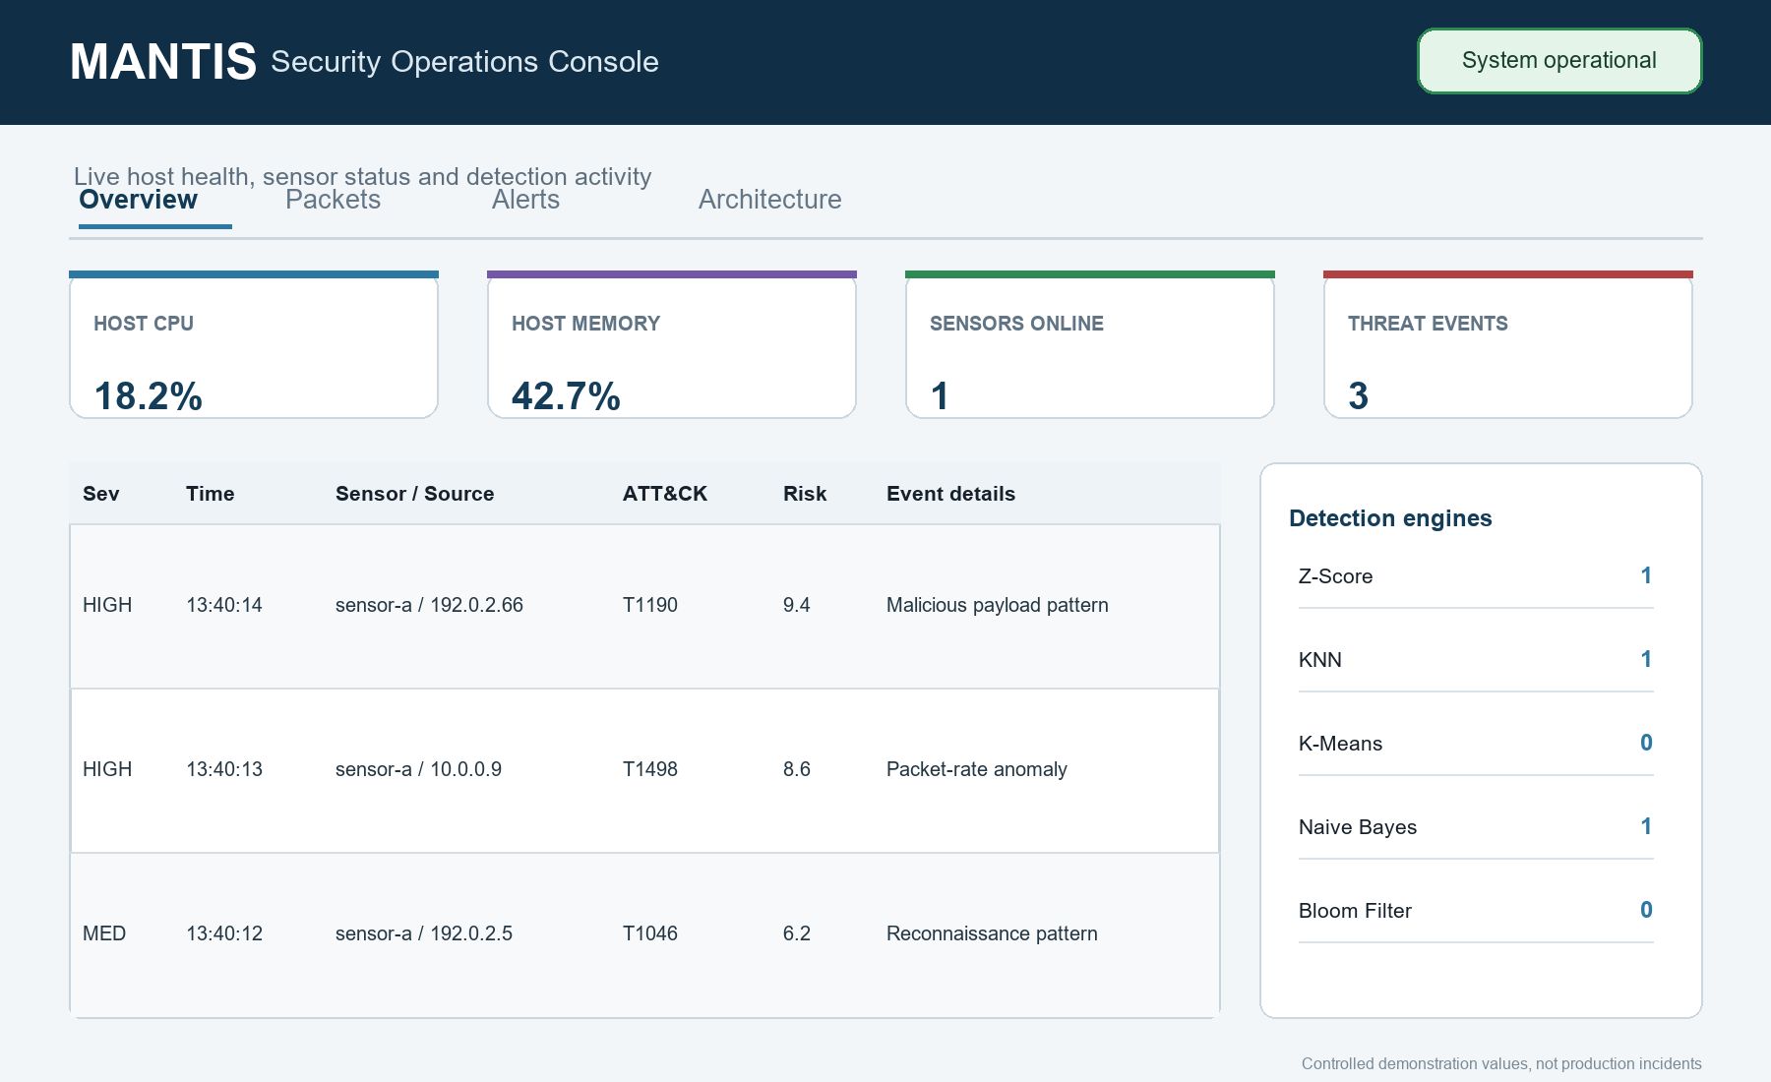
Figure 3.21: Overview page mockup with controlled health metrics, recent events and five engine activity

Packets page
The realised Packets page mirrors the implemented raw socket workflow. Search and protocol controls reduce the visible buffer, pause and auto scroll manage observation, PCAP and JSON actions export evidence, and a selected row reveals decoded fields plus hexadecimal content for independent inspection.
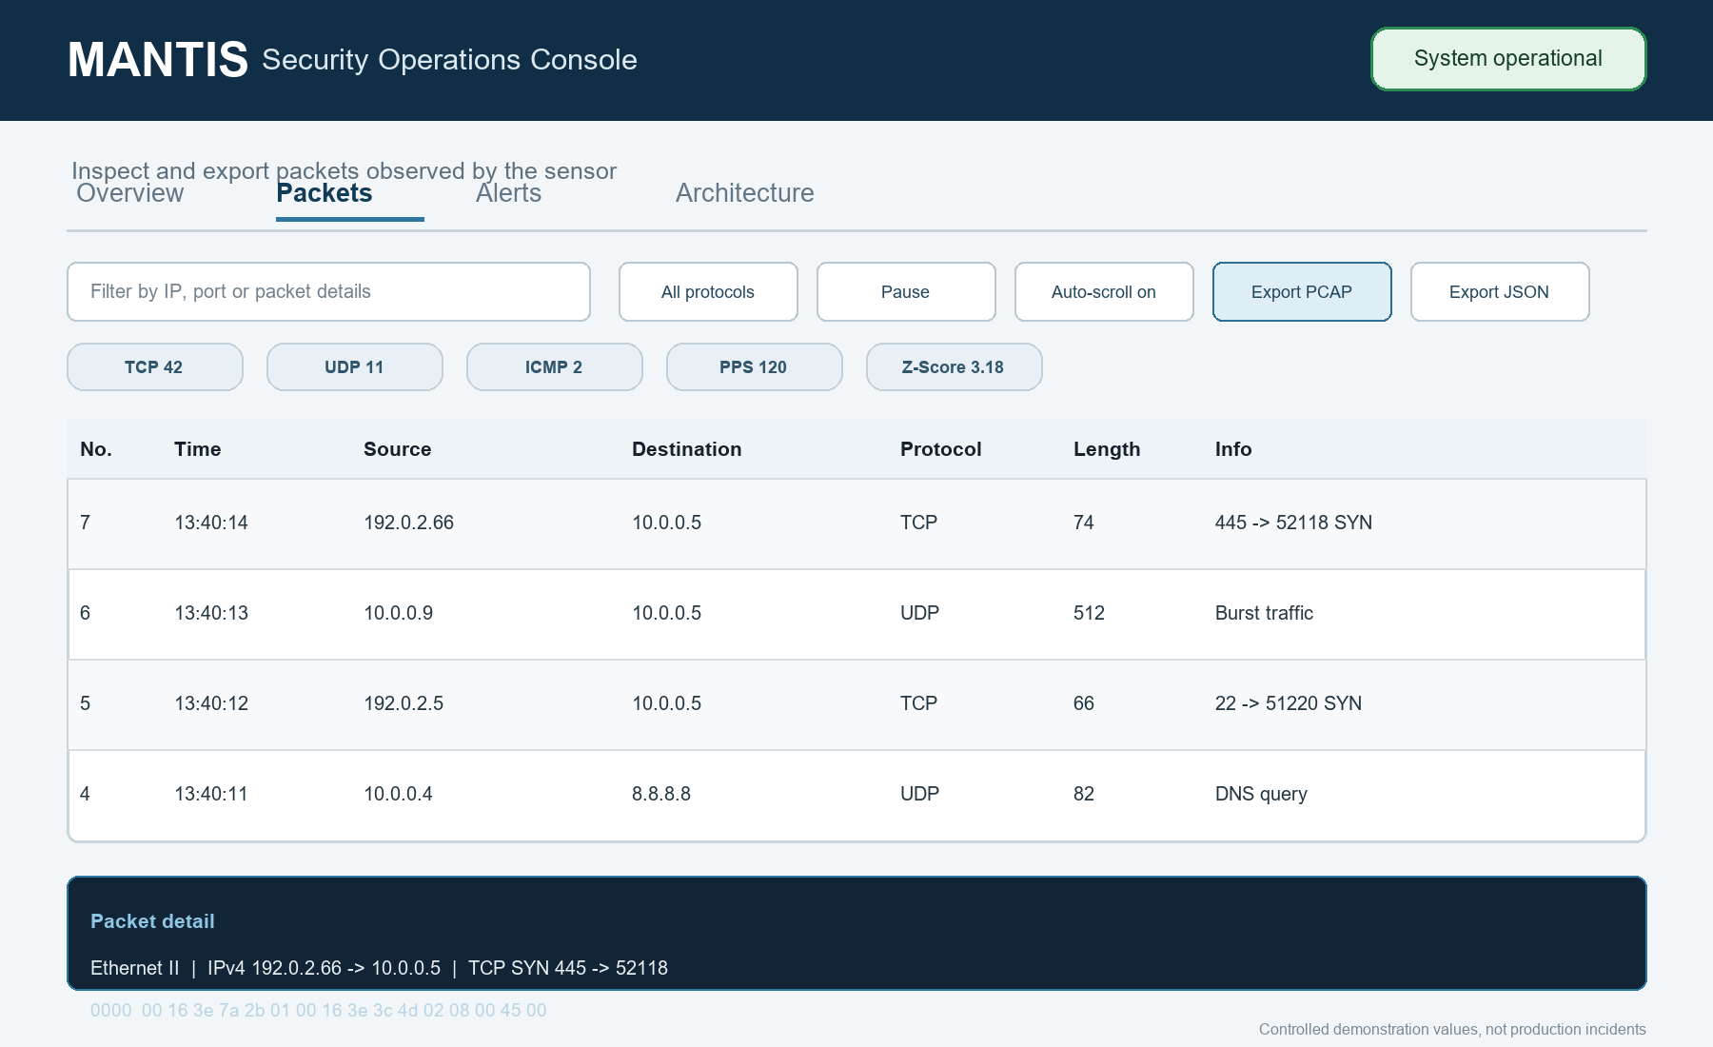
Figure 3.22: Packets page mockup with filters, protocol counters, exports and packet detail

Alerts page
The realised Alerts page presents up to 100 recent events in descending time order. Each row preserves the textual severity, sensor and source relationship, ATT&CK mapping, numeric risk and message detail. The design avoids inventing acknowledgement, assignment or case management controls that the embedded server does not implement.
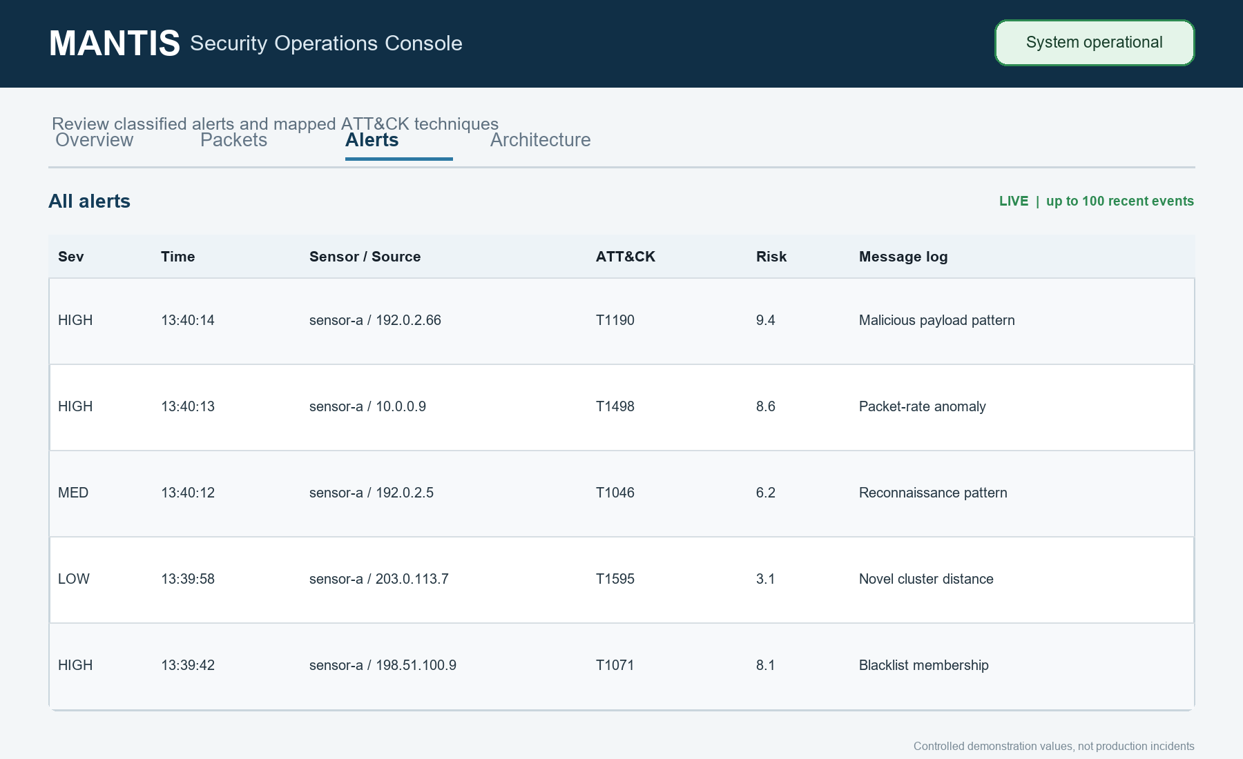
Figure 3.23: Alerts page mockup with the complete in memory threat log and ATT&CK context

Architecture page
The realised Architecture page documents Z-Score, KNN, K-Means, Naive Bayes and Bloom Filter as five distinct methods, then shows the common response path from Verdict to risk, evidence, telemetry, dashboard and optional policy gated blocking. It corrects the risk of hiding separate engines behind one generic machine learning label.
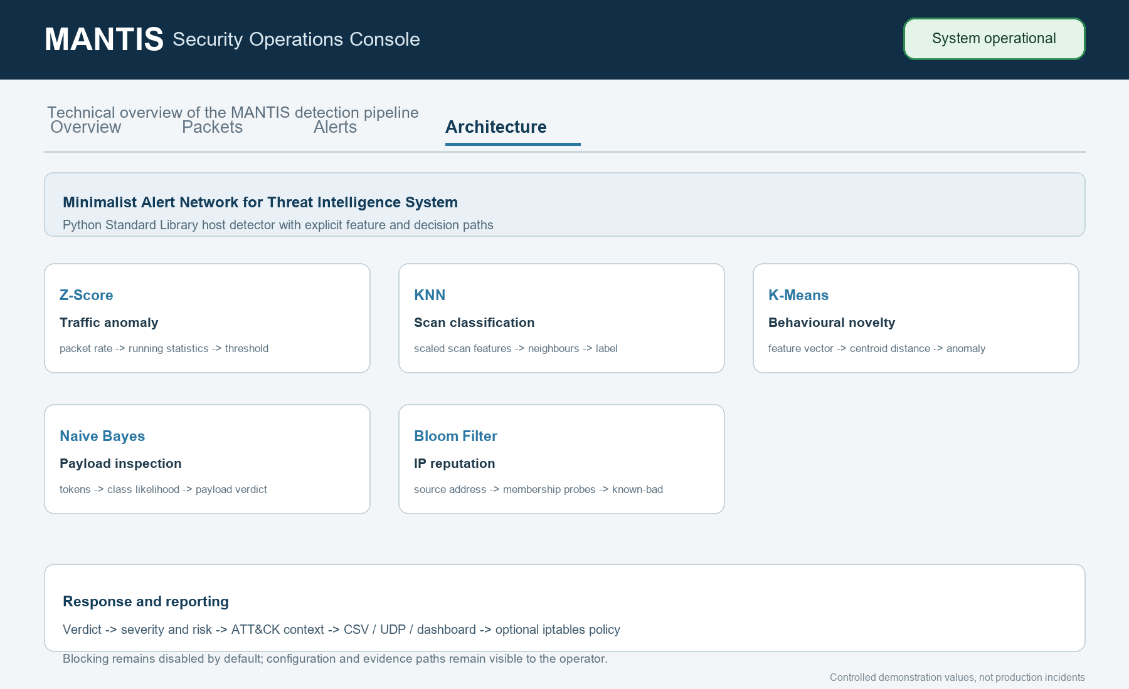
Figure 3.24: Architecture page mockup documenting all five engines and policy gated response

The console also supports responsive layout, protocol filtering, packet details, effective policy reporting and bounded evidence export. Authentication, TLS, multi user case management and durable database search are intentionally absent from the mockups because they require a separate security and persistence design beyond the embedded local prototype.

4. System Build and Technical Notes
The approved design was built as a Python Standard Library application. The executable path begins in main.py, where command line options are merged with environment, JSON file and seeded defaults. Live operation checks for Linux AF_PACKET capability, starts the optional web SIEM, constructs SensorNode and launches separate capture and analysis threads. Offline PCAP replay exercises the same parser and engines without raw socket privileges.

Packet Capture and Analysis Build
SensorNode reads Ethernet frames through a SOCK_RAW AF_PACKET socket and places them in a bounded queue. PacketParser validates Ethernet, optional 802.1Q, IPv4, TCP, UDP and ICMP structure using explicit binary unpacking. Truncated or unsupported frames return no event rather than terminating the analyser. Per second statistics supply the Z-Score, KNN and K-Means engines, while payload bytes and source addresses are routed only to the engines that require them.

Detection, Dispatch and Response Build
Each engine returns a Verdict containing label, confidence, detail and is_threat. AlertDispatcher enriches a qualifying result with ATT&CK context, writes the CSV audit record, sends JSON telemetry, updates the attached interface and then evaluates the optional blocking policy. ActiveDefense issues an iptables DROP command only when blocking is enabled, the detection category is permitted and the source is not whitelisted; duplicate sources are not inserted repeatedly.

Training, State and Evidence Build
Dataset loaders validate the columns required by KNN, Naive Bayes and K-Means and reject a CIC export that incorrectly substitutes destination port for an aggregated unique port count. Training writes a human readable brain document, and SensorNode restores compatible sections from the newest file. Logger, UDPSender, PCAP utilities, PacketStore and ReportGenerator provide complementary evidence paths, with privacy redaction applied before material leaves volatile analysis state.
Technical Constraints
Live capture and iptables response are Linux specific and require suitable capabilities or administrative permission. Payload analysis cannot inspect encrypted application content, UDP telemetry is intentionally lightweight rather than guaranteed delivery, and the in memory packet store is bounded rather than a forensic database. The embedded HTTP server is suitable for a controlled local prototype, not an internet facing multi user deployment. These constraints define the conditions under which the build should be evaluated.

Table 4.1: MANTIS build components and technical constraints
Build area | Principal modules | Implemented responsibility | Technical note
Entry and configuration | main.py, config.py | Argument parsing, precedence, safe defaults, privilege check | No third party runtime package
Acquisition and parsing | sensor.py, parser.py | AF_PACKET producer, bounded queue, protocol decoding | Live capture is Linux specific
Detection | engines/*.py | Five engines under DetectionEngine and Verdict | State exported through a uniform JSON contract
Dispatch and response | dispatcher.py, active_defense.py | Audit, telemetry, UI publication and policy gated iptables | Blocking is off by default
Presentation and evidence | siem.py, web_template.html, pcap.py, reporting.py | HTTP/UDP console, packet export and HTML report | HTTP 8080 and UDP 9999 by default
Training and evaluation | training/*, evaluation/*, replay.py | Validated loaders, model training, metrics and deterministic replay | External datasets must match engine semantics

5. Testing Strategy and Evaluation
Testing establishes whether the implementation behaves as specified; evaluation interprets whether the observed behaviour supports the dissertation's claims. MANTIS separates component tests, integration tests and system tests so that a correct formula is not mistaken for a correct end to end sensor. Algorithm metrics and replay evidence are interpreted separately from software test pass counts.

The current repository was re executed on 20 August 2026 using unittest discovery. It ran 116 tests in 4.642 seconds and all tests passed. A small number of ResourceWarning messages reported test process UDP sockets that were not explicitly closed; they did not fail any assertion but remain a test harness clean up item. No new CPU, memory or latency result is asserted here because those measurements require a declared reference environment and controlled workload.

5.1 Testing Definitions and Approach
Unit tests isolate one rule. Integration tests cross real module boundaries without requiring root. System tests bind a real UDP socket and HTTP server on loopback. Regression tests lock fixes for flood/scan confusion, baseline poisoning and stealth scans. Table 5.1 maps these levels to FR/NFR identifiers and the unittest modules that were executed.

Table 5.1: Test levels mapped to requirements and evidence modules
Test level | FR / NFR traced | What is exercised | Evidence module
Unit | FR4, FR12, NFR2, NFR8 | Engine mathematics, config, privacy, PCAP helpers | test_engines.py, test_modules.py
Integration | FR1–FR8, FR10, FR14–FR22, NFR3, NFR4 | Parser→engines, dispatcher, brain, replay, packet store | test_integration.py
System | FR5, FR9, FR18, NFR7 | Real UDP listener and HTTP SIEM on loopback | test_siem_api.py
Regression | FR4, NFR2 | Flood not scan, baseline poisoning, stealth scan, K-Means non poisoning | test_modules.py / test_engines.py
Training | FR5, FR6, FR12 | Column validation and brain serialisation | test_training_and_eval.py

The approach combines positive cases, negative cases, boundary conditions and failure handling. Expected attacks must be detected, normal traffic must remain normal, malformed input must not crash the pipeline, privacy sensitive values must not reach persistence, and active defence must remain disabled unless every policy condition is satisfied. Synthetic frames and a generated PCAP make the pipeline reproducible without attacking an external network.

5.2 Algorithm Tests
Engine tests check both detection and non detection behaviour. Z-Score verifies warm up, Welford stability, sustained flood detection and baseline poisoning protection. KNN verifies scaled features, normal browsing, flood versus scan separation and low volume scans. K-Means verifies warm up, familiar traffic, novelty distance and withholding anomalous updates. Naive Bayes tests benign payloads, malicious tokens and the single token ADMIN safeguard. Bloom tests feed loading, membership, saturation and the no false negative property for inserted indicators.

Constructed samples first verified each engine's intended rule. KNN, Z-Score, K-Means and Bloom produced 1.0000 scores on only 25 to 44 co-authored records, while Naive Bayes produced F1 0.9565 and MCC 0.9199 on 24 records. These matched checks verify code paths but are not independent field-accuracy evidence. Table 5.2 therefore reports the larger external stress test instead.

Table 5.2: External CIC-IoT2023 Z-Score stress-test results
Evaluation scope | Rows | Precision | Recall | F1 | MCC
All 63 merged CSV files | 45,018,252 | 0.997417 | 0.043619 | 0.083582 | 0.029049
BENIGN and DoS/DDoS | 41,333,350 | 0.997302 | 0.045574 | 0.087165 | 0.031179

All 45,018,252 rows (9.30 GB) from 63 extracted Merged CSV files were streamed once, resetting the detector for each separate non-temporal export. Results were TP 1,917,787, FP 4,967, FN 42,049,152 and TN 1,046,346. Precision 0.997417 concealed recall 0.043619: 95.64 percent of attack rows were missed. F1 0.083582, balanced accuracy 0.519447 and MCC 0.029049 were near chance. Because prevalence was 0.976647, an always-positive baseline reached F1 0.988186. The BENIGN plus DoS/DDoS subset was similar. Only Rate is compatible across the files; unique_ports, payload, source IP and reputation labels are absent. This is therefore a Z-Score transfer stress test, not a five-engine benchmark.

5.3 Test Cases and Scenarios
The selected cases below trace the main functional and safety requirements to observable outcomes. The generated replay contains a benign warm up followed by port scan, flood, malicious payload and known bad source phases. System tests use loopback services and controlled datagrams, while firewall tests substitute a recording defence object so the suite never modifies the host firewall.

Table 5.3 lists expected against actual outcomes: every listed case passed in the 20 August 2026 run (116 tests, 4.642 s, unittest discovery), and the actual results matched the expected column. Each case was then re executed in isolation on the same day and the terminal output was captured; this evidence is reproduced case by case in Table 5.4. The results verify the implementation and do not certify production accuracy on unseen operational traffic.

Table 5.3: Twenty eight representative executed test cases and scenarios
ID | Level | Scenario | Expected outcome | Status
TC-01 | Unit | Benign payload | Return Safe with no threat | ☑
TC-02 | Unit | UNION SELECT payload | Return malicious payload verdict with keywords | ☑
TC-03 | Regression | High volume, one port input to KNN | Classified Normal, not Scan | ☑
TC-04 | Regression | Sustained flood after Z-Score warm up | Repeated alerts without baseline poisoning | ☑
TC-05 | Unit | Inserted and unknown Bloom indicators | Inserted found; unknown clean in controlled set | ☑
TC-06 | Integration | Malformed and truncated frames | Reject safely; analyser remains available | ☑
TC-07 | Integration | Credential and email in alert | Sensitive values absent from CSV and UDP | ☑
TC-08 | Integration | Disabled, enabled and whitelist policy | Only enabled, non whitelisted case blocks | ☑
TC-09 | System | UDP alert to SIEM and HTTP API query | Alert includes technique, severity and risk | ☑
TC-10 | System | Buffered frame PCAP export | Valid PCAP reopens; every frame decodes | ☑
TC-11 | Replay | 13,159 frame five phase replay | No baseline alert; engines fire in intended phases | ☑
TC-12 | Persistence | Five engine brain round trip | Restored state matches export | ☑
TC-13 | Unit | K-Means warm up | No novelty alert before sufficient baseline observations | ☑
TC-14 | Regression | K-Means anomalous observation | Novelty is flagged and does not poison centroids | ☑
TC-15 | Regression | Low volume stealth scan | KNN detects scan after feature scaling | ☑
TC-16 | Unit | Invalid configuration value | Bad override is ignored without startup failure | ☑
TC-17 | Unit | Threat intelligence feed | Comments are stripped and inserted indicators have no false negatives | ☑
TC-18 | Integration | VLAN and ICMP frames | Supported frames decode into normalised packet records | ☑
TC-19 | Integration | Packet store capacity | Old entries rotate and memory remains bounded | ☑
TC-20 | Integration | Duplicate alert dispatch | Equivalent alert is published once | ☑
TC-21 | Integration | Duplicate active response request | One firewall rule is recorded for the address | ☑
TC-22 | Integration | Distributed high rate traffic | No single source is attributed or blockable | ☑
TC-23 | Unit | ATT&CK and risk mapping | Technique is mapped and risk remains within bounds | ☑
TC-24 | Unit | Payload privacy limits | Control bytes are removed and excerpt stops at 64 bytes | ☑
TC-25 | Unit | PCAP endian, time and snap length | Reader preserves valid capture semantics | ☑
TC-26 | System | Malformed SIEM datagram | Listener rejects input and remains available | ☑
TC-27 | System | Statistics and protocol filtering | HTTP API reports live values and filtered packet rows | ☑
TC-28 | Training | Dataset missing required columns | Loader raises a clear validation error | ☑
Table 5.4 reproduces the white terminal execution evidence for every case in Table 5.3. Each screenshot shows the exact unittest command, the engine or pipeline output produced during the run and the final OK verdict, captured on 20 August 2026.

Table 5.4: Terminal execution evidence for test cases TC-01 to TC-28
ID | Executed test evidence (white terminal)
TC-01 | 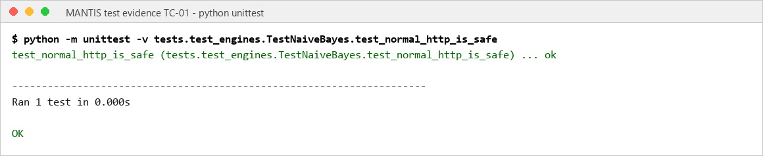
TC-02 | 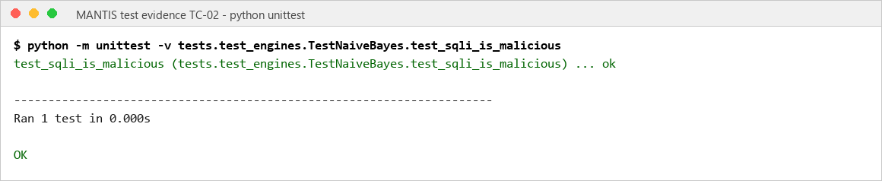
TC-03 | 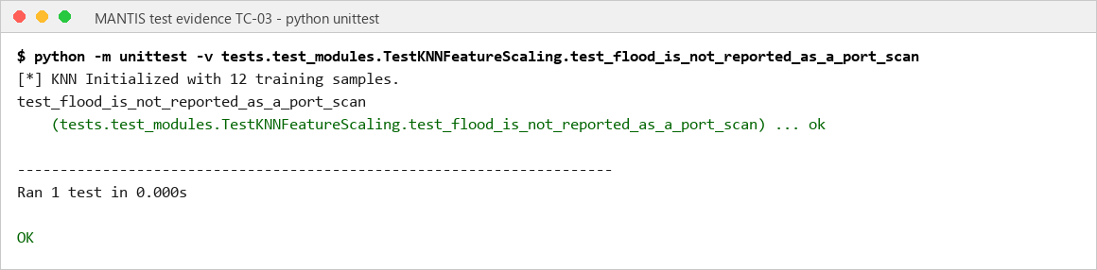
TC-04 | 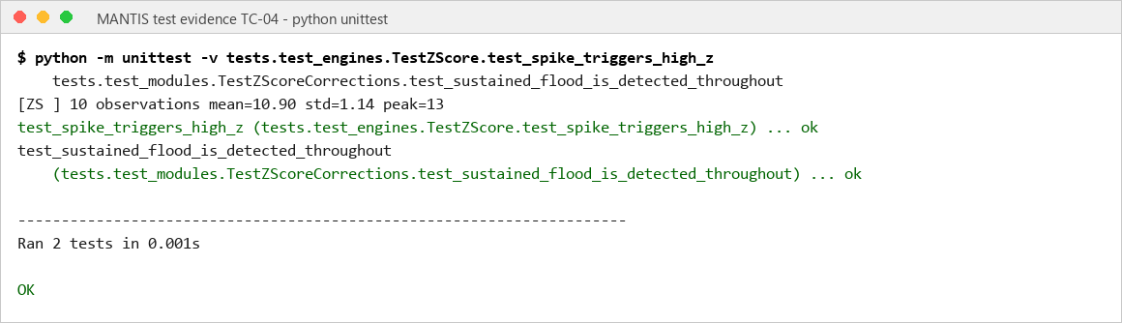
TC-05 | 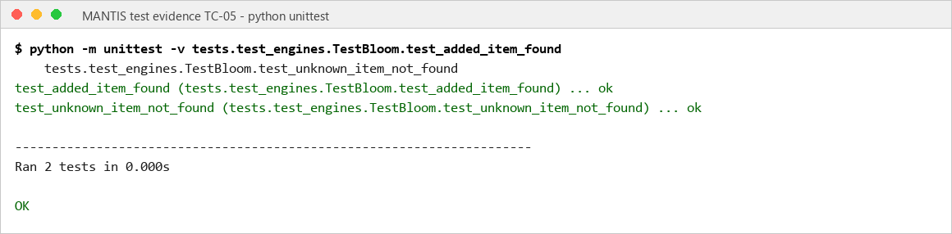
TC-06 | 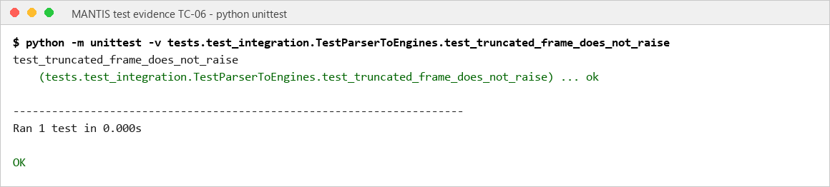
TC-07 | 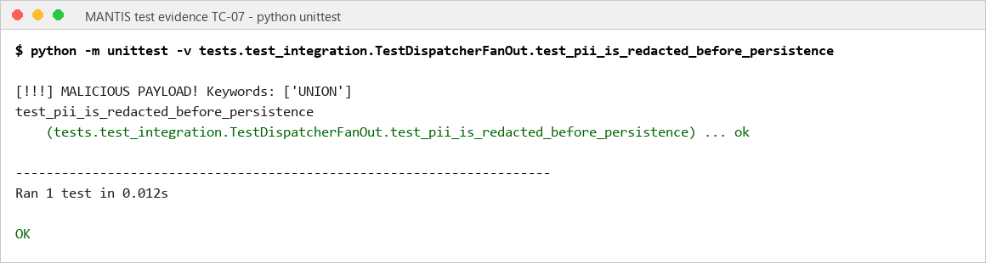
TC-08 | 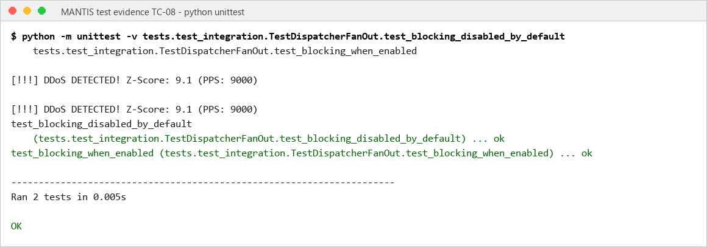
TC-09 | 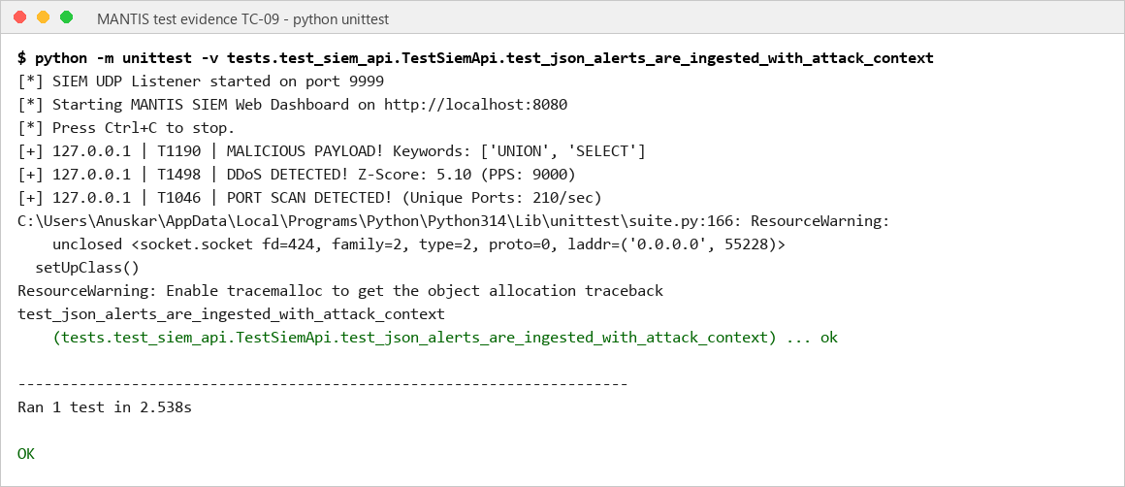
TC-10 | 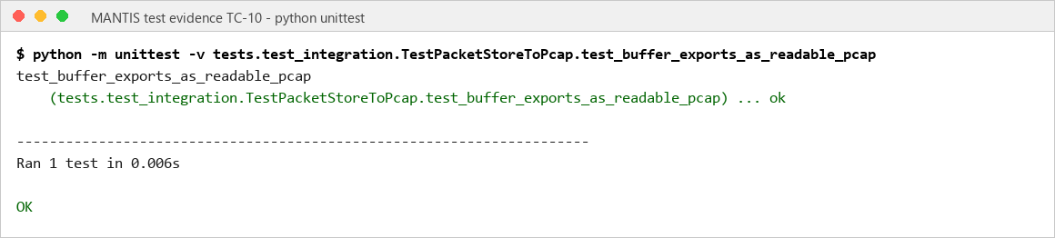
TC-11 | 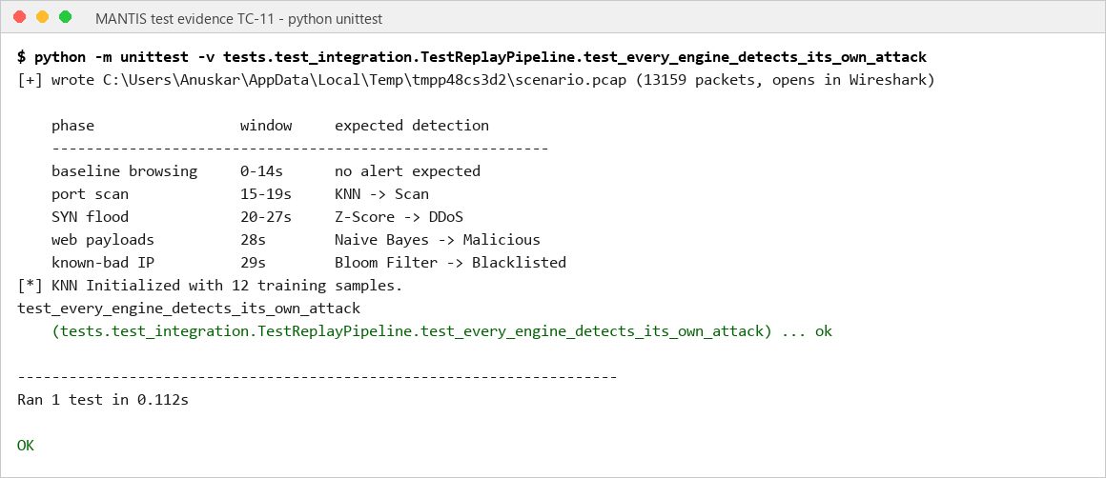
TC-12 | 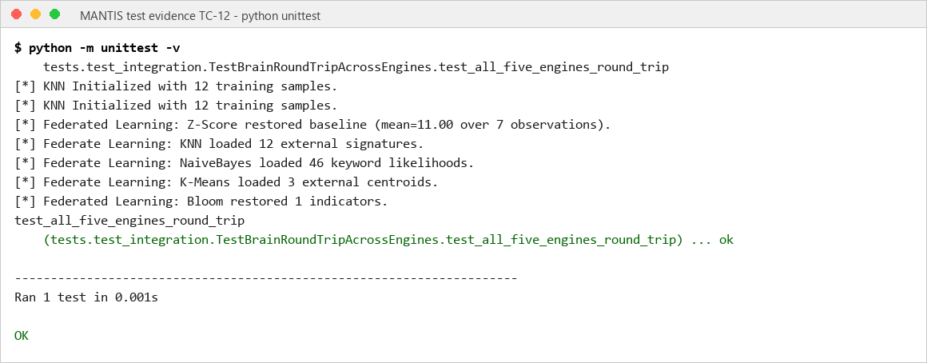
TC-13 | 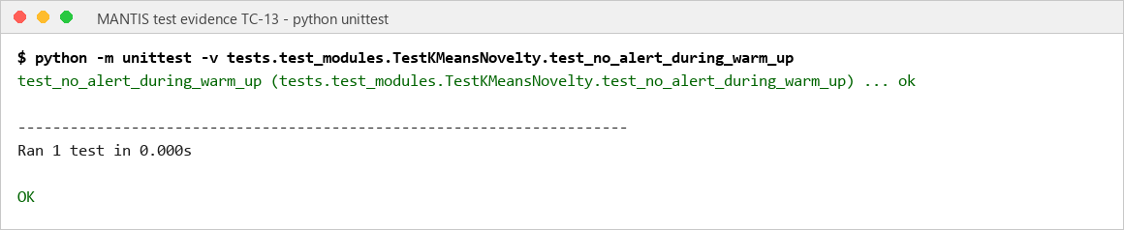
TC-14 | 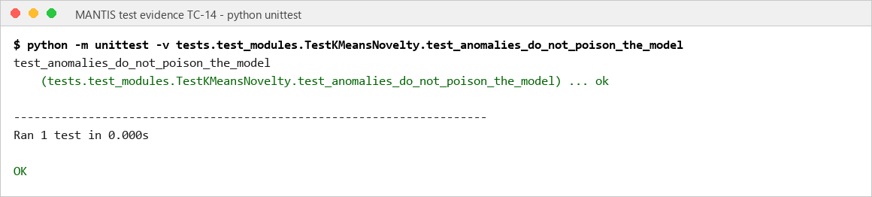
TC-15 | 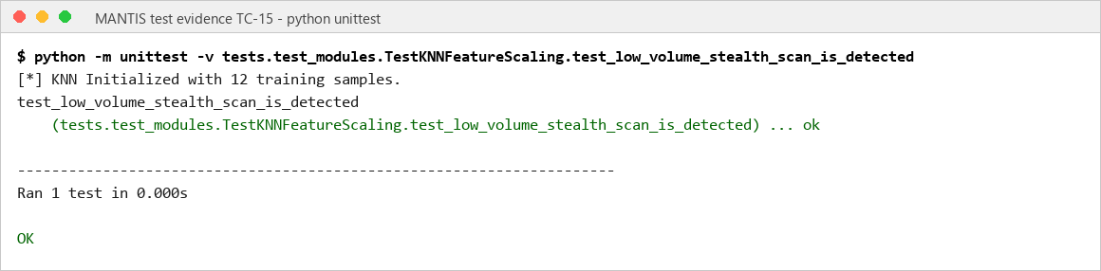
TC-16 | 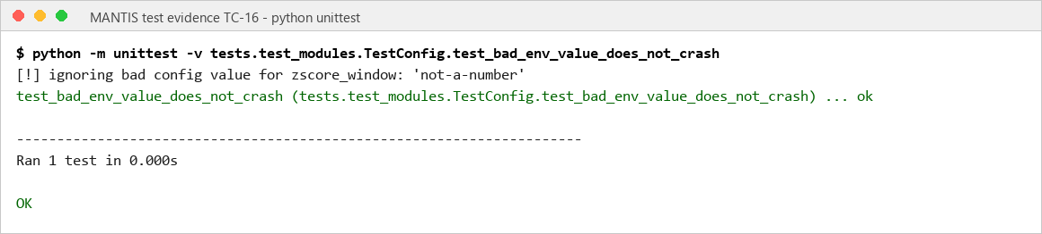
TC-17 | 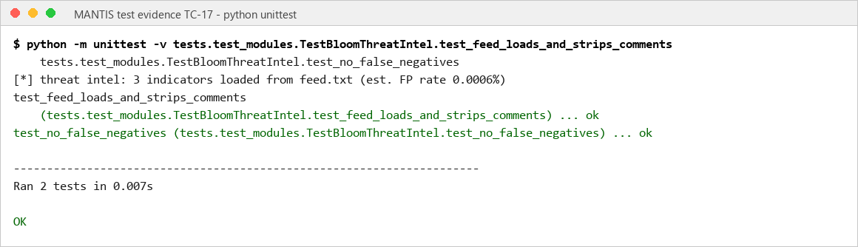
TC-18 | 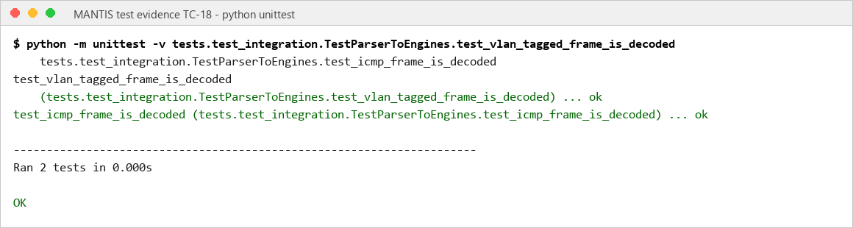
TC-19 | 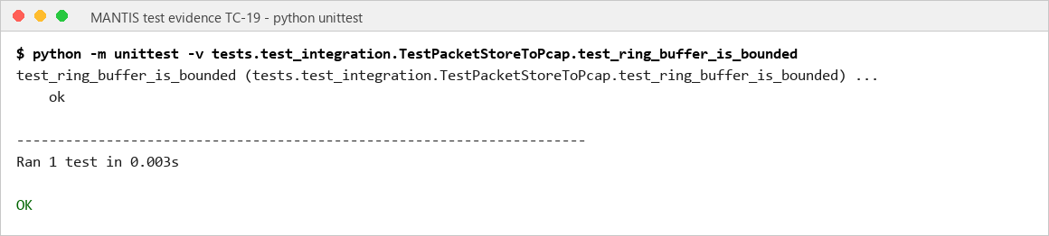
TC-20 | 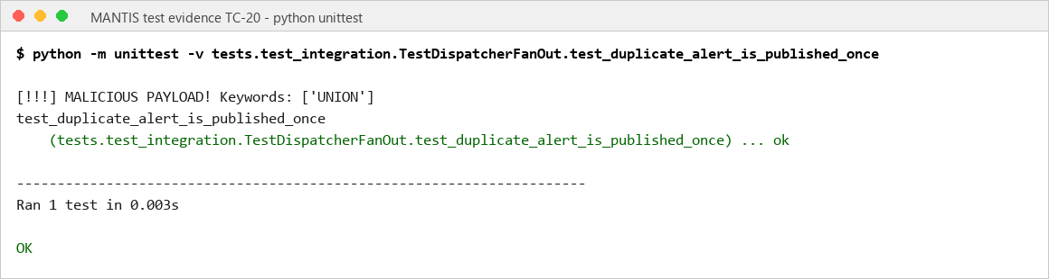
TC-21 | 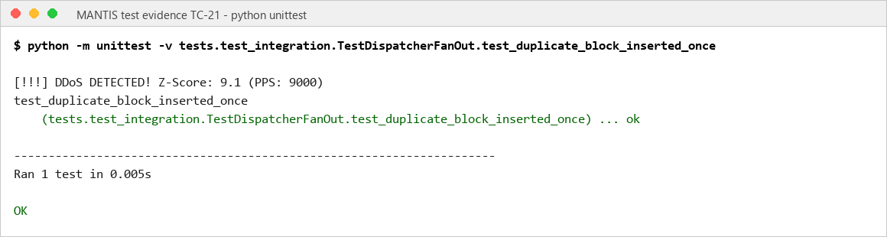
TC-22 | 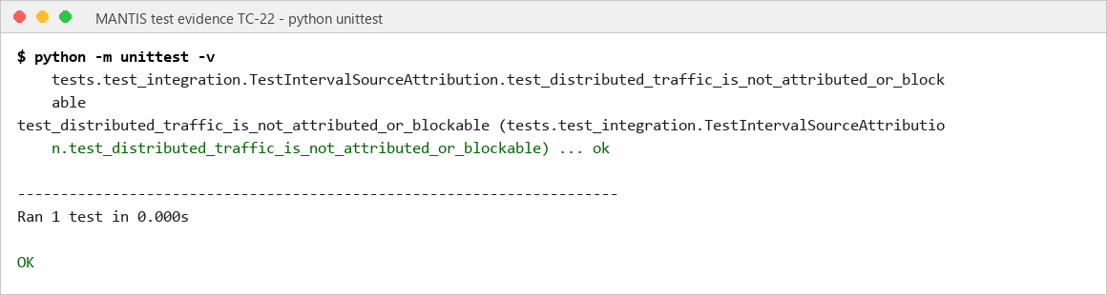
TC-23 | 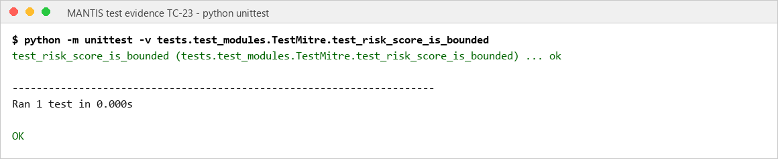
TC-24 | 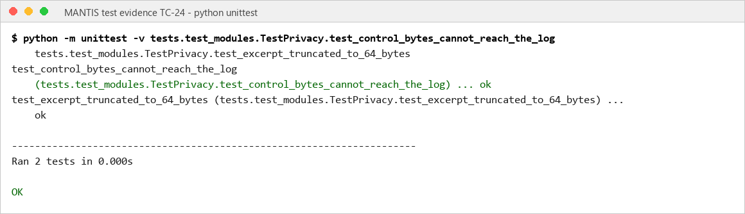
TC-25 | 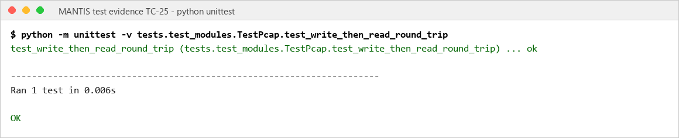
TC-26 | 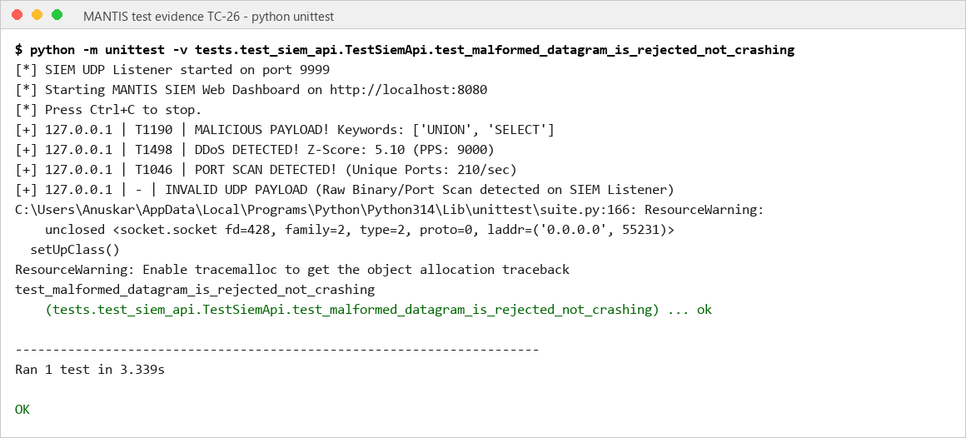
TC-27 | 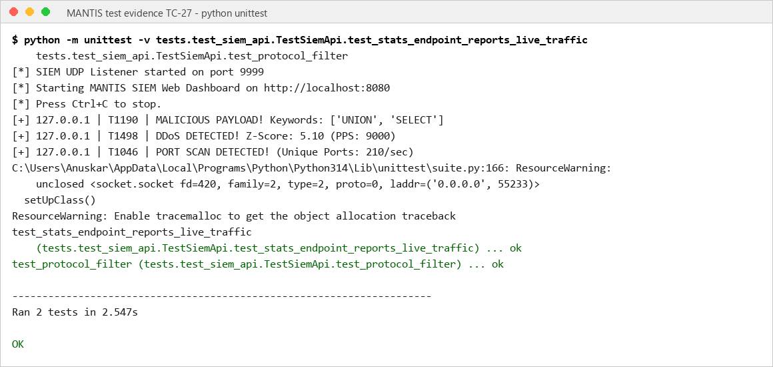
TC-28 | 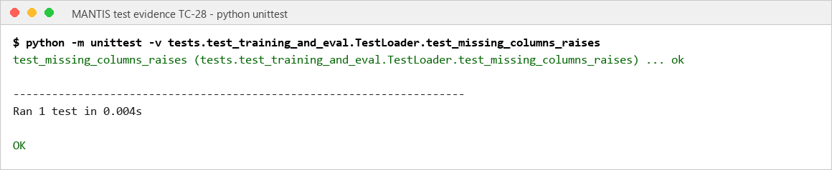

6. Conclusion
MANTIS met its aim by delivering a working, inspectable host detector on commodity Linux. The problem domain, edge hosts that cannot support heavy machine learning stacks or opaque platforms, was addressed with AF_PACKET/PCAP capture, five Standard Library engines, CSV/JSON evidence and optional iptables response. On 20 August 2026 all 116 automated tests passed in 4.642 seconds, tracing capture, classification, privacy, persistence, SIEM delivery and policy gated blocking.

The literature gaps were treated as design constraints rather than slogans. Halvorsen et al. (2024) identified the missing deployable edge path; MANTIS occupies that path with transparent mathematics instead of generative models. Neto et al. (2023) supplied labelled IoT traffic but not engine native features; MANTIS added explicit loaders. Hidayat, Ali and Arshad (2023) compared library classifiers without a packet pipeline; MANTIS integrated KNN with four complementary engines. Kus et al. (2022) showed that familiar splits overstate skill; this report therefore labels small domain matched scores as implementation checks and does not claim unknown attack identification. Relative to Snort, Suricata, Zeek and Wazuh, the artefact is a focused prototype, not a replacement. The aim is met within the stated Linux, plaintext and laboratory bounds.

MANTIS therefore meets the dissertation aim as a transparent research prototype rather than an enterprise platform replacement. Future work should evaluate longer controlled workloads, collect independent and prevalence balanced traffic, add IPv6 and richer protocol parsing, close all test sockets deterministically, and compare resource use and alert quality against Snort, Suricata, Zeek and Wazuh under the same workload. The central conclusion is that lightweight intrusion detection is technically credible only when algorithm assumptions, operational controls and evidence limitations remain visible to the operator.

7. References
- Cisco Talos (2024) Snort. [online] Available from: https://www.snort.org/ [Accessed 4 August 2026].
- Crnkovic, G. (2010) Constructive research and info computational knowledge generation. In: Magnani, L., Carnielli, W. and Pizzi, C. (eds.) Model Based Reasoning in Science and Technology. Berlin: Springer, pp. 359 to 380.
- Halvorsen, J., Izurieta, C., Cai, H. and Gebremedhin, A. (2024) Applying generative machine learning to intrusion detection: a systematic mapping study and review. ACM Computing Surveys, 56(10), article 257. Available from: https://doi.org/10.1145/3659575 [Accessed 18 June 2026].
- Hidayat, I., Ali, M.Z. and Arshad, A. (2023) Machine learning based intrusion detection system: an experimental comparison. Journal of Computational and Cognitive Engineering, 2(2), pp. 88 to 97. Available from: https://doi.org/10.47852/bonviewJCCE2202270 [Accessed 8 March 2026].
- Kus, D., Wagner, E., Pennekamp, J., Wolsing, K., Fink, I.B., Dahlmanns, M., Wehrle, K. and Henze, M. (2022) A false sense of security? Revisiting the state of machine learning based industrial intrusion detection. In: Proceedings of the 8th ACM Cyber Physical System Security Workshop (CPSS ’22). New York: ACM. Available from: https://doi.org/10.1145/3494107.3522773 [Accessed 19 August 2026].
- Mitzenmacher, M. and Upfal, E. (2017) Probability and Computing: Randomization and Probabilistic Techniques in Algorithms and Data Analysis. 2nd ed. Cambridge: Cambridge University Press.
- Neto, E.C.P., Dadkhah, S., Ferreira, R., Zohourian, A., Lu, R. and Ghorbani, A.A. (2023) CICIoT2023: a real time dataset and benchmark for large scale attacks in IoT environment. Sensors, 23(13), 5941. Available from: https://doi.org/10.3390/s23135941 [Accessed 10 May 2026].
- National Institute of Standards and Technology (2007) Guide to Intrusion Detection and Prevention Systems (IDPS). NIST Special Publication 800-94. Gaithersburg: NIST.
- OISF (2024) Suricata user guide. [online] Available from: https://docs.suricata.io/ [Accessed 11 March 2026].
- Python Software Foundation (2026) Python 3 documentation. [online] Available from: https://docs.python.org/3/ [Accessed 17 July 2026].
- Sculley, D. (2010) Web scale k-means clustering. In: Proceedings of the 19th International Conference on World Wide Web (WWW 2010). New York: ACM, pp. 1177 to 1178.
- Sommer, R. and Paxson, V. (2010) Outside the closed world: on using machine learning for network intrusion detection. In: IEEE Symposium on Security and Privacy. Los Alamitos: IEEE, pp. 305 to 316.
- Wazuh (2026) Wazuh documentation. [online] Available from: https://documentation.wazuh.com/current/ [Accessed 11 July 2026].
- Zeek Project (2026) Zeek documentation. [online] Available from: https://docs.zeek.org/ [Accessed 27 April 2026].

Appendix A: Gantt Chart
The Gantt chart retains the interim weekly layout while aligning the schedule to constructive research: problem definition, requirements, design, construction, evaluation, critique and dissertation completion.
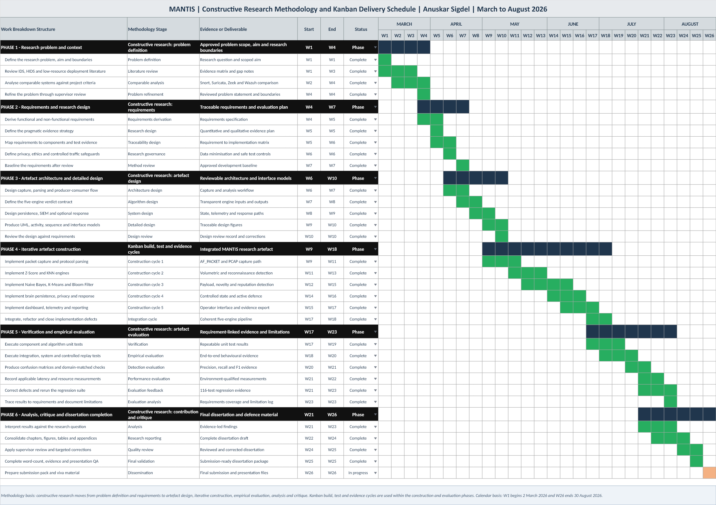
Figure A.1: MANTIS constructive research methodology Gantt chart

Appendix B: Project Logs
The signed project diary and log forms below record the supervision meetings held during the project, continuing the log presented in the interim report.
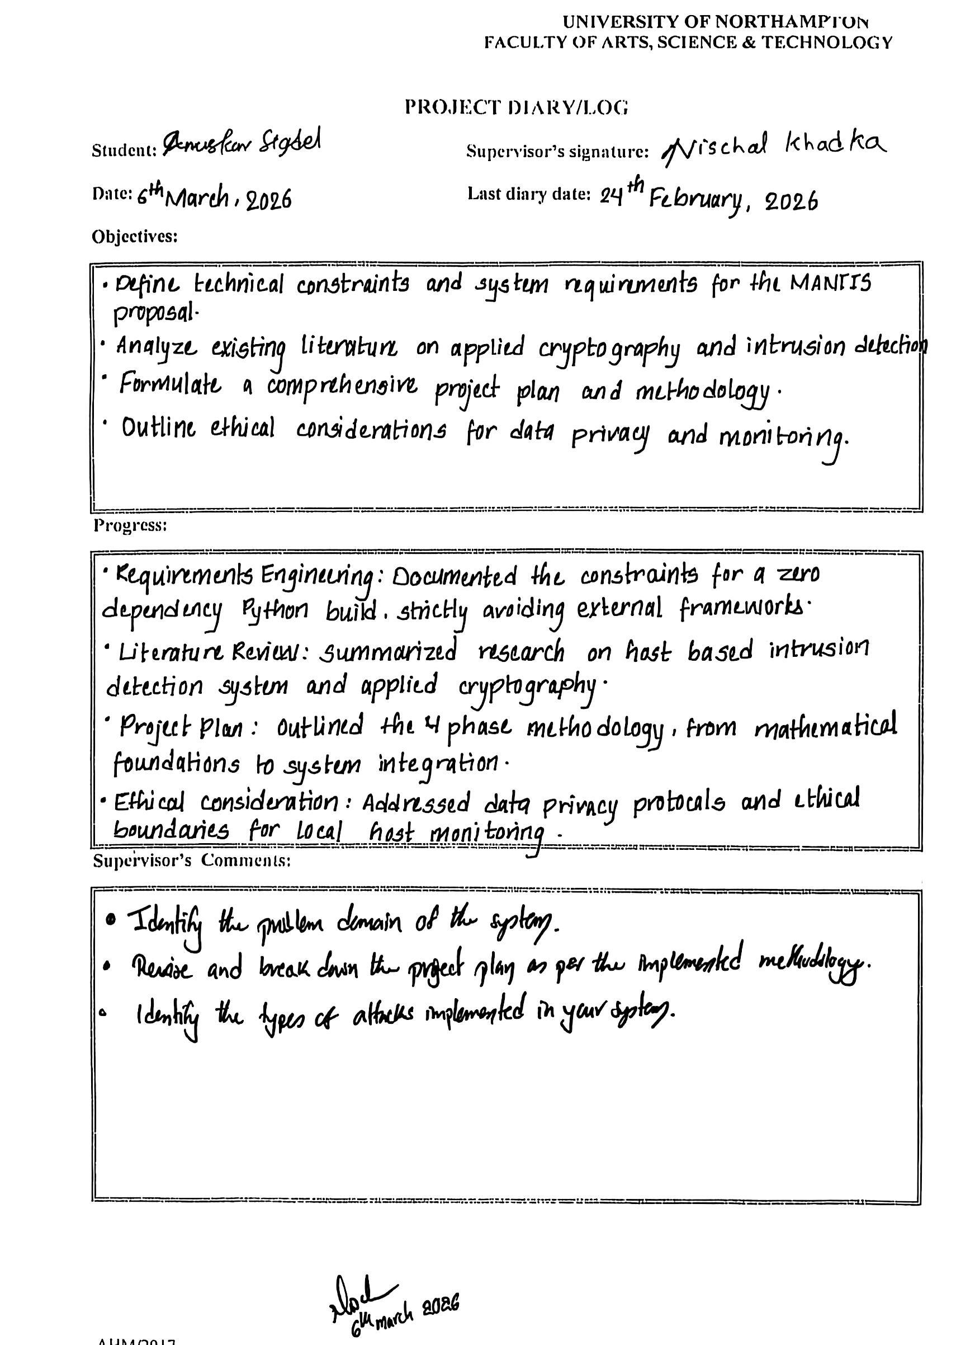




Appendix C: Presentation Slide
