CSY 4022 Computing Dissertation Project Proposal

M.A.N.T.I.S: A STRATEGY FOR THE EFFECTIVE
DEVELOPMENT OF A ZERO DEPENDENCY FIRST
PRINCIPLES HOST BASED INTRUSION DETECTION SYSTEM
USING MACHINE LEARNING

By

Anuskar Sigdel

A proposal submitted in partial fulfillment of the requirements for the degree of

BSc (Hons.) Computing

The University of Northampton

Table of Contents
SN. Page No.
1. Introduction 1
1.1. Background 1
1.2. Rationale 2
2. Aims and Objectives 2
3. Literature Review 3
4. Research Methodology 6
4.1. Project Activity Overview 6
4.2. Problem Domain Investigation 6
4.3. Software Requirements Engineering 6
4.4. System Analysis and Design 7
4.5. System Construction 8
4.6. System Testing 8
4.7. System Evaluation 8
4.8. Algorithm Development 8
5. Professional, Legal and Ethical Considerations 8
References 9
Appendix 9

List of figures
Figure 1 MANTIS Agile Kanban Methodology Diagram ..............................................................7
Figure 2 Gantt Chart .....................................................................................................................10
Figure 3 Comprehensive Architecture and Execution Flow of the MANTIS Intrusion Detection
System ...........................................................................................................................................11
Abbreviations
API: Application Programming Interface
DDoS: Distributed Denial of Service
GDPR: General Data Protection Regulation
HIDS: Host Based Intrusion Detection System
JSON: JavaScript Object Notation
KNN: K-Nearest Neighbours
MANTIS: Minimalist Alert Network for Threat Intelligence System
OSI: Open Systems Interconnection
PII: Personally Identifiable Information
SIEM: Security Information and Event Management
TCP/UDP: Transmission Control Protocol / User Datagram Protocol
VM: Virtual Machine
XSS: Cross Site Scriptin

Introduction
The realm of global cybersecurity operates in an environment defined by relentless escalation. As malicious actors automate the deployment of zero day vulnerabilities and sophisticated ransomware campaigns, targeted organizations must deploy equally sophisticated defense perimeters. The core of this defensive strategy resides in the implementation of Security
Information and Event Management (SIEM) systems and Host Based Intrusion Detection Systems
These systems provide operational visibility by ingesting and analysing security telemetry. Prevention is a separate, policy-controlled capability and is not assumed for every alert.
However, as the velocity of network traffic increases, the foundational engineering behind these defensive systems is being severely tested. Security Operations Centers (SOCs) are demanding faster, intelligently automated responses to novel threats without sacrificing the holistic stability of the underlying operating system. This demand has catalyzed the fusion of low level network engineering with advanced data science, forcing software developers to rethink how network threat telemetry is processed and acted upon.

Background
Within this specific cybersecurity domain, there is an ongoing architectural shift toward integrating complex machine learning methodologies such as K-Nearest Neighbours and Bayesian probability matrices directly into threat detection telemetry. While integrating advanced clustering theoretically improves mitigation rates, the practical implementation has inadvertently birthed abstract dependency bloat.
Many established security platforms, including Zeek and Wazuh, provide broad capabilities but require substantially larger software stacks than a small edge sensor. Machine-learning extensions commonly depend on third-party Python packages. This project investigates whether selected detection mathematics can be implemented transparently using only the Python Standard Library in the runtime detection path.

Rationale
The primary problem this proposed project addresses is the industry over reliance on bloated, imported machine learning libraries and external frameworks in modern cybersecurity tools. Relying on massive dependencies hides the algorithmic decision making process, places a severe computational burden on the host machine, and drastically widens the attack surface for software supply chain vulnerabilities historically evidenced by catastrophic, dependency based breaches like the SolarWinds incident.
The project therefore evaluates a lightweight, host-deployed network IDS prototype. Restricting the runtime detection path to the Python Standard Library reduces third-party Python dependency exposure and makes the algorithms inspectable; it does not remove operating-system dependencies or eliminate all supply-chain risk.

Aims and Objectives
The aim is to design, implement and evaluate MANTIS, a host-deployed network intrusion-detection prototype for Linux whose runtime detection path uses no third-party Python packages.
- Implement and unit-test five transparent detection components: Z-Score, KNN, Naive Bayes, Mini-Batch K-Means and a Bloom Filter, with each component traceable to its mathematical basis.
- Implement an AF_PACKET producer/consumer capture pipeline that manually decodes Ethernet, VLAN, IPv4, TCP, UDP and ICMP traffic, then measure decoded frames, malformed frames and queue drops during controlled Kali Linux tests.
- Evaluate applicable engines using labelled test data and report confusion matrices, precision, recall, F1-score and false-positive rate, while separately evaluating the online statistical and reputation components.
- Implement optional iptables response for explicitly permitted alert categories only when a source IP is available, the operator enables blocking and the address is not whitelisted.
- Deliver alerts through a CSV audit log, structured UDP/JSON telemetry and a browser dashboard, and verify that identical events are suppressed within a configurable deduplication window.
- Use repeatable synthetic PCAP replay and isolated live tests with Nmap, hping3 and curl to measure detection behaviour, normal-traffic false positives, CPU use, memory use and processing latency on researcher-owned systems.

Literature Review
The intersection of low level systems programming and high level data science has been heavily documented in recent cybersecurity literature. A complete understanding of the theoretical work completed by previous researchers is required to properly navigate the challenges of building a reliable network defense mechanism from scratch. The following peer-reviewed papers establish the foundational baseline for this project's mathematical approach.
Machine Learning-Based Intrusion Detection System: An Experimental Comparison Author: Hidayat, I., Ali, M. Z., and Arshad, A.
Date: 2022
This empirical 2022 study conducted a comprehensive examination of contemporary machine learning paradigms against modern network intrusions. The authors established a significant conclusion, which is that isolated, specialized ML mathematical algorithms when tuned distinctly for strict network environments can vastly outperform generalized, heavyweight framework ensembles in pure edge-computing ecosystems. They particularly highlighted that algorithmic models tightly coupled to the data processing layer reduce CPU inference latency significantly compared to heavily abstracted ML libraries.

This research directly validates the core philosophy of MANTIS's Zero-Dependency architecture.
By proving that concisely tuned, standalone ML equations can outpace abstracted libraries,
Hidayat et al. support comparing specialised detection models and their operational cost. Their findings motivate measurement of MANTIS rather than an assumption that dependency reduction alone guarantees accuracy or removes CPU overhead.
A False Sense of Security? Revisiting the State of Machine Learning-Based Industrial
Intrusion Detection
Author: Kus, D., Wagner, E., Pennekamp, J., Wolsing, K., Fink, I. B., Dahlmanns, M., Wehrle, K., and Henze, M.
Date: 2022
Published in the 2022 ACM CPSS Workshop, this foundational paper explored the critical blind spots of modern ML Intrusion Detection systems. The authors proved mathematically that models reliant on massive, pre-calculated generalized training datasets consistently fail to recognize novel, zero day anomalous attacks when operating inside live, continuous runtime environments. The primary reason they fail is that fixed training sets cannot understand dynamic network topography or subtle, gradual shifts in legitimate user behavior over time.
This finding motivates explicit drift testing and retraining. MANTIS KNN uses a labelled training set that changes only when a new brain is trained or imported, while Mini-Batch K-Means updates its normal centroids online. Neither mechanism is claimed to eliminate distribution shift.

Applying Generative Machine Learning to Intrusion Detection: A Systematic Mapping
Study and Review
Author: Halvorsen, J., Izurieta, C., Cai, H., and Gebremedhin, A.
Date: 2024
This 2024 study mapped the absolute leading edge of probabilistic and generative machine learning models. The authors discovered that while advanced generative probability arrays are highly accurate at diagnosing complex text payloads, their immense software latency severely cripples their ability to execute inline TCP blocking on resource constrained systems. Heavy machine learning essentially processes data incredibly accurately but far too slowly to actively block a high speed network attack during a live runtime scenario.
This review motivates testing a smaller probabilistic payload classifier. MANTIS implements Multinomial Naive Bayes with standard-library arithmetic and measures its latency and classification performance rather than assuming immediate packet dropping.
Network Intrusion Detection System Using XGBoost and Random Forest Algorithms Author: Onyebueke, A. E., David, A. A., and Munu, S.
Date: 2023
This recent 2023 study evaluated modern Machine Learning models utilizing XGBoost and
Random Forest algorithms to anticipate and successfully identify dynamic network intrusions, establishing new benchmarks for contemporary classification speeds against novel vectors. The researchers demonstrated that decision-tree style ensembles are particularly adept at identifying the subtle behavioral fingerprints left by sophisticated port scanning and reconnaissance tools before a full attack is launched.
This modern research validates the MANTIS behavioral engine design constraints. Since ensemble algorithms have proven highly effective at predicting modern intrusions through behavioral profiling, MANTIS leverages this mathematical framework to justify utilizing distance based clustering heuristics built entirely from scratch in native Python. By calculating the Euclidean distance between connection attempts, MANTIS captures these exactly identified behavioral patterns without inheriting the massive CPU overhead associated with importing Random Forest libraries.

Research Methodology

Project Activity Overview
The project uses Constructive Research Methodology because its contribution is an evaluated software artefact. Agile Kanban organises implementation into short iterations, while a V-Model trace links requirements to unit, integration, replay and live system tests.

Problem Domain Investigation
The investigation covers Linux AF_PACKET capture, manual protocol parsing, first-principles detection algorithms and comparison with established IDS architectures. Evidence is collected from source tests, labelled evaluation data, deterministic PCAP replay and isolated live traffic.

Software Requirements Engineering
Requirements gathering will concentrate on defining exact packet structures, extracting 14 byte
Ethernet frame identifiers, and developing logical formulations required to parse live traffic arrays into usable analytical variables, ensuring the sensor operates concurrently. System limitations and capabilities must be strictly defined to prevent feature creep.
The core cyclical framework of the MANTIS Agile Kanban methodology is illustrated in Figure
1: -
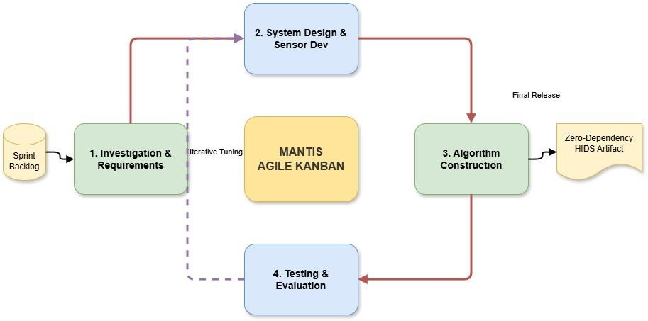
Figure 1 MANTIS Agile Kanban Methodology Diagram
As depicted in Figure 1, development is driven by a continuous Kanban backlog. Rather than a linear approach, the system progresses through iterative loops bridging System Design,
Algorithm Construction, and Evaluation. This cyclical 'Iterative Tuning' ensures constant security refinement before outputting the final zero-dependency artifact

System Analysis and Design
The architectural design will employ a threaded, decoupled flow model. The sensor will act independently from the SIEM UI dashboard, bridging communication asynchronously via JSON structures over UDP ports. This ensures web UI computational rendering delays do not bottleneck real time packet ingestion speeds.

System Construction
The runtime detection path uses Python 3 Standard Library modules on Linux. The installer may use operating-system facilities such as iptables and libcap; therefore 'zero dependency' refers only to third-party Python runtime packages.
The dashboard UI strictly utilizes HTML and vanilla JS over an HTTP socket server.
Code is structured modularly to allow independent algorithm analysis.

System Testing
Testing follows four levels: deterministic engine unit tests; integration tests covering parsing, dispatch, persistence and telemetry; reproducible synthetic PCAP replay; and live Nmap, hping3, curl and blacklist tests inside an isolated environment. Normal traffic is observed before attacks to measure false alerts.

System Evaluation
Evaluation reports confusion matrices and precision, recall and F1-score for supervised components where labelled ground truth is appropriate. It also reports Bloom Filter false-positive behaviour, Z-Score guard behaviour, parser drops, replay throughput, CPU use, resident memory and alert latency. Dataset splits, sample counts, hardware and repetitions are documented.

Algorithm Development
Algorithms will be explicitly constructed from first principles. This involves writing customized standard deviation logic for volumetric attacks, Euclidean distance KNN models for behavioral profiling, and Bayesian calculations for text payload abnormalities precisely by hand.

Professional, Legal and Ethical Considerations
Creating security tools mandates ethical boundary setting. No experimental volunteers are used. There is a duty to ensure the publication of algorithms does not provide malicious actors evasion models. The research maintains impartiality by executing standard, unmodified offensive payloads utilizing standard Nmap flags without tuning attacks to favor the engine.
Legally, the project complies with the UK Computer Misuse Act (1990). The proposal guarantees no active cyber attacks or port scanning sequences will ever traverse public internet infrastructure. All tooling simulations will be isolated entirely within private Virtual Machine boundaries completely owned by the researcher on local hardware.
The sensor can capture raw packet data, which may contain personal or confidential information. Testing is restricted to synthetic traffic and researcher-owned systems; privacy mode truncates and redacts persisted payload excerpts, and PCAP capture is optional.
These controls support data minimisation but do not guarantee absolute GDPR compliance. Test captures and exports must be retained only as long as necessary and handled under the university's research-data requirements.

References
Python Software Foundation (2024) Python 3.12 Documentation. Available at: https://docs.python.org/3/ (Accessed: 15 January 2026).
National Institute of Standards and Technology (NIST) (2024) Intrusion Detection Systems (IDS). Available at: https://csrc.nist.gov/glossary/term/intrusion_detection_system (Accessed: 19 February 2026).
Agile Alliance (2024) What is Agile? Available at: https://www.agilealliance.org/agile101/ (Accessed: 10 February 2026).
Linux Kernel Organization (2024) The Linux Kernel Documentation. Available at: https://kernel.org/doc/ (Accessed: 26 February 2026).

Halvorsen, J., Izurieta, C., Cai, H. and Gebremedhin, A. (2024) 'Applying generative machine learning to intrusion detection: a systematic mapping study and review', IEEE Access, 12, pp. 21314-21345.
Hidayat, I., Ali, M.Z. and Arshad, A. (2022) 'Machine learning-based intrusion detection system: an experimental comparison', Journal of Computational and Cognitive Engineering, 1(2), pp. 1-12.
Kus, D., Wagner, E., Pennekamp, J., Wolsing, K., Fink, I.B., Dahlmanns, M., Wehrle, K. and Henze, M. (2022) 'A false sense of security? Revisiting the state of machine learning-based industrial intrusion detection', Proceedings of CPSS '22, pp. 73-84.
Onyebueke, A.E., David, A.A. and Munu, S. (2023) 'Network Intrusion Detection System Using XGBoost and Random Forest Algorithms', Asian Journal of Pure and Applied Mathematics, 5(1), pp. 321-335.

Appendix
Appendix 1: Project Plan Gantt Chart
The project developmental timeline, broken into five iterative Agile Sprints, is shown in Figure 2:
-

Figure 2 Gantt Chart
Figure 2 illustrates the ten-month schedule from January to October 2026. Rather than leaving all documentation for the end, the project follows strict Agile methodology by requiring a dedicated documentation update period at the conclusion of every single development sprint to continuously track progress.

Appendix 2: Proposed System Flow Diagram
The step-by-step process of how MANTIS actually catches network attacks is shown below in Figure 3: -
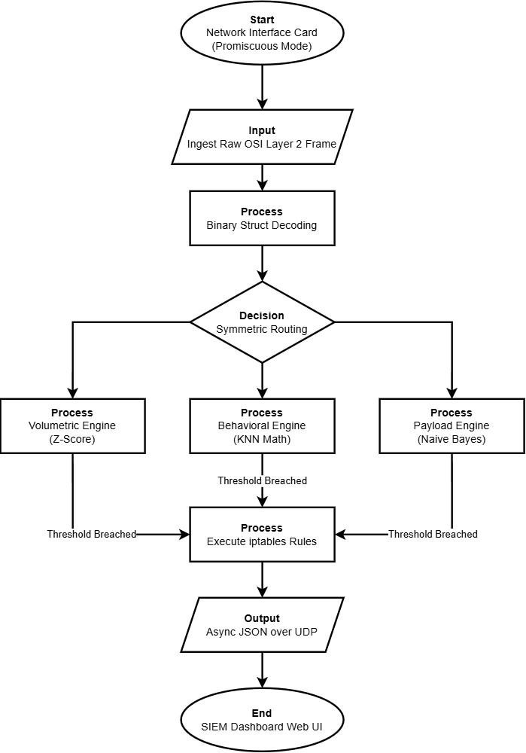
Figure 3 Comprehensive Architecture and Execution Flow of the MANTIS Intrusion Detection System
Figure 3 shows raw traffic entering five detection components. Bloom Filter and Naive Bayes operate per packet; Z-Score, KNN and K-Means operate on one-second aggregates. Each engine may emit an independent alert. CSV, UDP/JSON and dashboard outputs are always available, while iptables blocking is optional and requires an attributed, non-whitelisted source.

