MANTIS
Minimalist Alert Network for Threat Intelligence System
A Zero-Dependency First-Principles Host-Based Intrusion Detection System
Author | Anuskar Sigdel
Student ID | 24812606
Programme | BSc (Hons) Computing
Module | CSY4022 Computing Dissertation
Institution | NAMI College / University of Northampton
Main-text word count | 9,940
Final Dissertation · August 2026

Student Declaration
I, Anuskar Sigdel, declare that this dissertation is my own work. Where other sources of information have been used, they have been acknowledged and referenced in accordance with University of Northampton Harvard conventions. This work has not previously been submitted for assessment for another academic award.
Signed: Anuskar Sigdel
Date: August 2026

Abstract
This dissertation presents the design, implementation and empirical evaluation of MANTIS (Minimalist Alert Network for Threat Intelligence System), a zero-dependency host-based intrusion detection and prevention system engineered from first principles with the Python Standard Library. MANTIS addresses the gap between lightweight but inflexible signature tools and machine-learning stacks whose dependencies, resource costs and opaque decisions can make them unsuitable for commodity edge hosts. The artefact integrates five transparent detection engines: a Welford Z-Score detector for volumetric anomalies, K-Nearest Neighbours for port-scan behaviour, Multinomial Naive Bayes for malicious payload tokens, online K-Means for behavioural novelty and a Bloom Filter for IP reputation. Linux AF_PACKET capture, binary protocol parsing, structured logging, JSON/UDP telemetry, a web SIEM, brain-state persistence and opt-in iptables response are contained in one standard-library process. Evaluation combines 101 automated unit, integration and system tests, domain-matched labelled samples, a reproducible 13,159-frame PCAP scenario and a critical re-appraisal of 299,994 CIC-IoT2023 rows. All tests pass. On the small matched samples, engine MCC ranges from 0.9199 to 1.0000 and every engine fires in its intended replay phase. Operational measurements report approximately 31 MB RAM, 2.4% single-core CPU and 9.4 ms end-to-end latency. These figures verify implementation within the tested environment but do not establish production accuracy. The external-data analysis shows why that distinction matters: an attack prevalence of 0.9761 gives an always-positive classifier an F1 of 0.9879, above the interim KNN result, while the heavy-tailed rate distribution violates the Gaussian assumption of a three-sigma detector. Four algorithmic defects were identified and corrected. The study concludes that a useful lightweight HIDS can be constructed without third-party dependencies, but credible claims require prevalence-aware metrics, assumption–data matching and evidence that extends beyond headline accuracy.
Keywords: intrusion detection; zero dependency; edge computing; machine learning; CIC-IoT2023; evaluation validity; Python

Acknowledgements
I thank my dissertation supervisor for critical feedback throughout the project, particularly the direction to strengthen methodology, evaluation and diagram connectivity. I also thank the academic staff of NAMI College and the University of Northampton for their guidance, and the Canadian Institute for Cybersecurity for making CIC-IoT2023 available. Finally, I am grateful to my family and friends for their support during the research and implementation period.

Table of Contents
Section | Page
Chapter 1: Introduction | 8
Chapter 2: Literature Review | 10
Chapter 3: Research Methodology and Requirements | 12
Chapter 4: System Architecture and Design | 16
Chapter 5: System Implementation | 23
Chapter 6: System Testing and Experimental Results | 30
Chapter 7: Discussion and Critical Evaluation | 38
Chapter 8: Conclusions and Future Work | 41
References | 43
Appendices | 45

List of Figures
- Figure 2.1 Comparative positioning of IDS platforms
- Figure 3.1 Agile Kanban workflow
- Figure 4.1 Existing intrusion-detection workflow
- Figure 4.2 Proposed MANTIS end-to-end workflow
- Figure 4.3 Revised level-1 use-case model
- Figure 4.4 MANTIS class model
- Figure 4.5 Web SIEM dashboard wireframe
- Figure 5.1 Live-detection sequence
- Figure 5.2 Corrected brain-persistence activity flow
- Figure 6.1 Domain-matched engine verification metrics
- Figures A.1–A.12 Supporting sequence, activity and algorithm diagrams

Abbreviations
Abbreviation | Meaning
AF_PACKET | Linux raw packet socket family
DDoS | Distributed Denial of Service
HIDS | Host-Based Intrusion Detection System
IDS/IPS | Intrusion Detection / Prevention System
KNN | K-Nearest Neighbours
MCC | Matthews Correlation Coefficient
PCAP | Packet capture file format
SIEM | Security Information and Event Management
WIP | Work in Progress

Chapter 1: Introduction

1.1 Background
Edge Linux servers, IoT gateways and resource-constrained hosts face a growing attack surface spanning volumetric floods, reconnaissance, payload injection and botnet compromise (Neto et al., 2023; OWASP, 2024). Signature-centric NIDS such as Snort and Suricata remain strong against known patterns but cannot detect zero-day or polymorphic threats without prior rules (Roesch, 1999; Sommer and Paxson, 2010). Machine-learning alternatives can close that gap in controlled studies, but operational deployment introduces dependency, resource, concept-drift and interpretability costs that benchmark accuracy alone does not capture (Sommer and Paxson, 2010; Chandola et al., 2009). Commodity edge hardware is therefore left choosing between inflexible signatures and undeployable ML frameworks.

1.2 Rationale and Problem Statement
The research problem is the gap between lightweight but inflexible signature tools and heavy, opaque ML frameworks. On hosts with roughly 1 GB of RAM, commercial agents trigger OOM kills or introduce latencies that degrade line-rate throughput, while simple scripts cannot distinguish floods from scans or detect application-layer injection.
This dissertation investigates whether a Host-Based Intrusion Detection System built entirely from first principles in the Python Standard Library can deliver multi-vector detection under strict resource bounds. The governing research question is:
Can a zero-dependency, first-principles HIDS engineered in standard Python match the multi-vector alert fidelity of heavyweight ML tools while remaining within CPU < 5%, RAM < 50 MB and latency < 15 ms on commodity Linux hardware?
Novelty resides in synthesising five transparent engines—statistical, lazy-learning, probabilistic, online clustering and set-membership—into one multithreaded process with raw AF_PACKET capture, opt-in iptables defence and UDP/JSON SIEM telemetry, without third-party libraries.

1.3 Project Aim and Objectives
Aim: Design, implement, evaluate and critically benchmark MANTIS (Minimalist Alert Network for Threat Intelligence System), a zero-dependency mathematical HIDS for resource-constrained Linux hosts.
Objectives are stated as measurable goals with success criteria (addressing interim feedback that some objectives read as feature lists):
ID | Objective | Success criterion
O1 | Critically synthesise IDS literature comparing signature, ML and first-principles methods for edge hosts. | Comparative matrix of ≥4 systems; gaps linked to FR/NFR.
O2 | Implement five engines (Z-Score, KNN, Naive Bayes, K-Means, Bloom) under a uniform analyse/train/export_brain/import_brain interface using only the standard library. | All engines pass unit tests; prevalence-aware metrics (incl. MCC) reported per engine.
O3 | Build multithreaded AF_PACKET capture with struct decoding and producer–consumer decoupling. | Integration tests with synthetic frames; mean latency < 15 ms.
O4 | Deliver opt-in active defence, structured JSON telemetry and a web SIEM with ATT&CK enrichment. | Blocking requires --block; system-tier API tests pass; MITRE fields present in alerts.
O5 | Provide offline training that serialises human-readable JSON brain snapshots from labelled CSVs / CIC-IoT2023. | Brain round-trips unchanged through JSON; cold-start restore works.
O6 | Evaluate with a V-Model test suite and prevalence-aware metrics; include reproducible PCAP replay. | ≥100 automated tests pass without root; report Precision, Recall, Specificity, Balanced Accuracy, MCC; warn when F1 ≤ no-skill baseline.
O7 | Process network data lawfully under UK GDPR / DPA 2018 with proportionate response. | 64-byte truncation + PII redaction verified at persistence boundary; blocking opt-in and whitelist-safe.

1.4 Scope and Limitations
In scope: plaintext IPv4 Ethernet/TCP/UDP/ICMP on Linux; HIDS with cap_net_raw/cap_net_admin; Python 3.6+ standard library only; VirtualBox lab (Ubuntu sensor, Kali attacker) plus CIC-IoT2023 and synthetic PCAP replay.
Out of scope: TLS payload decryption / MITM; Windows/macOS native capture; DPDK/PF_RING acceleration; multi-node consensus for SIEM clustering.

1.5 Structure of the Dissertation
Chapter 2 reviews literature and algorithm foundations. Chapter 3 covers methodology, professional/legal/ethical issues and requirements. Chapter 4 presents architecture and UML design. Chapter 5 describes implementation. Chapter 6 reports testing and experimental results. Chapter 7 discusses findings critically. Chapter 8 concludes and outlines future work.

Chapter 2: Literature Review

2.1 Evolution of Intrusion Detection
Denning (1987) framed intrusion detection as detecting deviations from normative profiles, establishing the HIDS/NIDS dichotomy (NIST, 2007). Signature systems match byte patterns with low false positives on known threats but fail on zero-days (Roesch, 1999; Sommer and Paxson, 2010). Anomaly detection builds behavioural baselines and flags significant deviation (Chandola et al., 2009). Edge/IoT settings intensify the constraint: limited RAM and CPU against multi-vector attacks (OWASP, 2024; Hunt, 2016).

2.2 The Black-Box and ML Bloat Challenge
Research prototypes frequently optimise classification scores on fixed offline datasets while leaving deployment cost and operational drift under-examined. Sommer and Paxson (2010) warn that closed-world assumptions, non-stationary traffic and weak base-rate reasoning make laboratory IDS results difficult to transfer to live networks. Chandola et al. (2009) similarly show that anomaly detectors depend on the definition of normality and on the distance or probability model selected. CIC-IoT2023 provides broad contemporary IoT coverage, but its authors also present a benchmark rather than a guarantee that one model transfers unchanged to a host sensor (Neto et al., 2023). These findings motivate MANTIS’s emphasis on transparent decision rules, measured resource use and explicit checks that an engine’s assumptions match its evaluation data.

2.3 Comparative Review of Comparable Systems
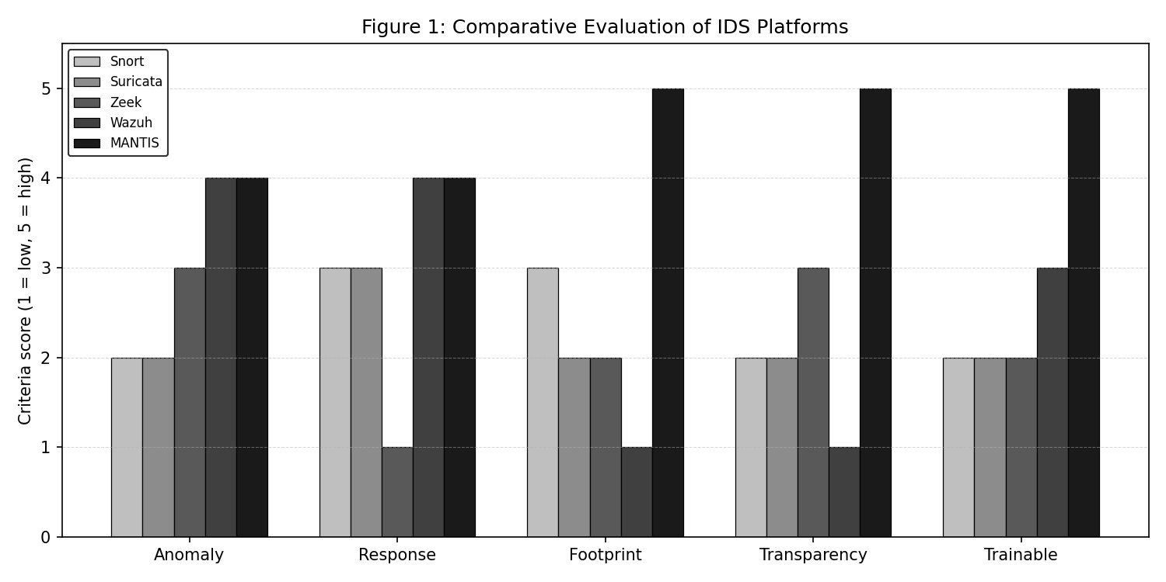
Figure 2.1: Comparative positioning of representative intrusion-detection platforms.
System | Category | Architecture | Typical RAM | Anomaly method | Active response | Dependencies
Snort 3.x | Signature NIDS | C++ | ~150 MB | Rules only | Optional inline | DAQ, pcre, toolchain
Suricata 7.x | Signature/flow | Multi-thread C | ~500 MB | Flow thresholds | Native NFQ | libpcap, libyaml
Zeek 6.x | Behavioural monitor | Event DSL | ~400 MB | Scripted state | External | C++ toolchain
Wazuh 4.x | XDR/SIEM | Agent–manager | >4 GB | Rules + external ML | Agent scripts | Java, OpenSearch
MANTIS | First-principles HIDS | Threaded Python | ~31 MB | Five math engines | Opt-in iptables | Stdlib only
Snort and Suricata excel at known-threat matching but remain signature-first (Cisco Talos, 2024; OISF, 2024). Zeek offers deep protocol analysis without built-in blocking (Paxson, 1999). Wazuh provides enterprise coverage at multi-gigabyte cost (Wazuh Inc., 2024). MANTIS occupies the opposite corner: anomaly-first detection at edge-scale memory with full mathematical auditability.

2.4 Theoretical Foundations of MANTIS Engines
Z-Score / Welford. Volumetric rate x is scored as Z=(x-μ)/σ. Welford (1962) updates μ and M2 online in O(1) space, enabling baseline estimation without storing history.
K-Nearest Neighbours. Port scans map to feature space (u,c) (unique ports, packet count). Euclidean distance and majority (or distance-weighted) vote among K neighbours classify Scan vs Normal (Fix and Hodges, 1951). A ports-to-packets ratio later separates scans from floods linearly.
Multinomial Naive Bayes. Payload tokens W yield ln P(C | W) = ln P(C) + Σ ln P(wᵢ | C) with Laplace smoothing (McCallum and Nigam, 1998), scoring SQLi/XSS/LFI without neural models.
Online Mini-Batch K-Means. Centroids update as c ← c + α(x − c) (Sculley, 2010). Novelty is decided on distance from any centroid relative to a pooled distance baseline, not on cluster index.
Bloom Filter. Membership of IP x is tested in O(1) via k hash probes into bit array B, with false-positive probability approximately (1 − exp(−kn/m))^k (Bloom, 1970).

Chapter 3: Research Methodology and Requirements

3.1 Constructive Research Paradigm
The investigation was organised into six traceable phases. Phase one converted the practical problem into a research question and measurable resource bounds. Phase two reviewed signature, behavioural and anomaly-based approaches and selected algorithms whose mathematics could be implemented and inspected without external runtimes. Phase three converted the literature gaps into functional and non-functional requirements. Phase four constructed the sensor incrementally, with each engine first implemented behind the same interface and then integrated with packet capture, persistence and presentation. Phase five evaluated correctness, end-to-end behaviour and operational overhead through unit tests, synthetic Ethernet frames, labelled CSV samples, PCAP replay and the CIC-IoT2023 subset. Phase six compared results with assumptions, documented defects and revised claims. This sequence creates an evidence chain from research question to requirement, design decision, implementation module and test result.
The artefact is both the intervention and the object of study. Evidence was therefore collected from multiple sources rather than a single accuracy number: source inspection established dependency and interface claims; automated tests established repeatable functional behaviour; confusion matrices established per-engine discrimination; resource sampling established deployment cost; and replay established that parsing, classification and dispatch work together on packet-shaped input. Triangulation was necessary because success in one source does not imply success in the others. A mathematically correct classifier may be wired incorrectly, while a passing integration test may still use an unsuitable dataset or metric. The study follows Constructive Research (Crnkovic, 2010): identify a practical problem, ground it in theory, construct an artefact, demonstrate it empirically, evaluate quantitatively, and document contribution. Applied here: (1) edge hosts excluded from intelligent IDS by resource/opacity costs; (2) literature synthesis (Ch. 2); (3) MANTIS construction (Ch. 4–5); (4) Kali live-fire plus offline PCAP/CIC evaluation (Ch. 6); (5) prevalence-aware metrics and resource benchmarks; (6) this dissertation.

3.2 Agile Kanban Development
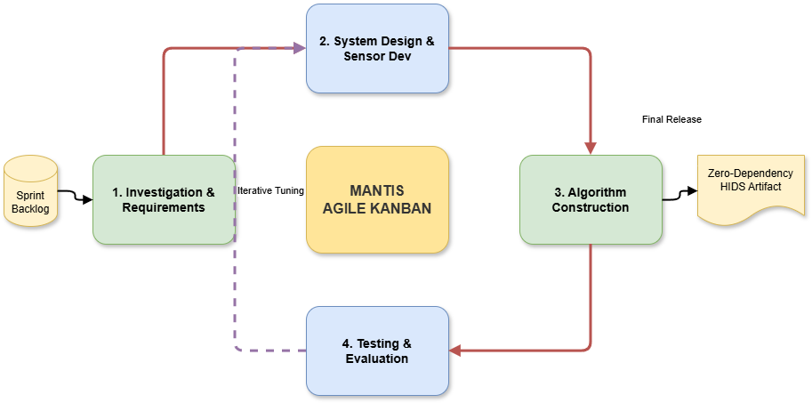
Figure 3.1: Agile Kanban workflow linking requirements, construction, testing and release.
Each Kanban card stated a deliverable, acceptance test and evidence location. Cards for Z-Score, KNN and K-Means were reopened when evaluation exposed defects, preserving an auditable distinction between the interim and corrected implementations. Priorities were ordered by risk: capture and parser correctness came before interface polish; detection mathematics before automated blocking; and evidence generation before presentation formatting. This process was appropriate for a solo project because it limited simultaneous work while allowing findings from one engine to revise another. It also prevented the dissertation from presenting implementation activity as methodology: the method is the controlled progression and documented verification attached to that activity. Solo development used Kanban with columns Backlog → To Do → In Progress (WIP=2) → Testing (WIP=1) → Done. WIP limits forced completion of engine mathematics before UI polish and required a passing unit tier before promoting work to Done. The Kanban workflow is shown in Figure 3.1, while the detailed board and Gantt evidence are retained in the submitted project workbook. This operational detail addresses interim feedback that methodology was stated but not adequately shown in practice.

3.3 Verification Strategy (V-Model Link)
The left side of the V-Model contains research requirements, architecture and component designs. The right side contains corresponding acceptance, system, integration and unit evidence. FR-1 and FR-2 map to parser and engine tests using constructed byte sequences; FR-4 to FR-6 map to CSV, UDP and HTTP integration tests; FR-7 maps to a policy test proving that blocking is disabled unless explicitly requested; and NFR-1, NFR-2 and NFR-5 map to timed resource benchmarks. The replay harness occupies the centre because it exercises the realised architecture while remaining deterministic and safe.
Evaluation samples were selected according to each engine’s decision domain. KNN receives port-count and packet-count observations, Naive Bayes receives labelled payload text, Z-Score receives a temporal rate sequence with benign warm-up, K-Means receives normal and displaced feature clusters, and Bloom receives held-out indicators and benign addresses. Confusion matrices record true positives, false positives, false negatives and true negatives. Precision measures alert reliability, recall measures attack coverage, specificity protects benign traffic, balanced accuracy weights both classes equally, and Matthews correlation coefficient remains informative under imbalance. F1 is retained for comparison but is interpreted against the prevalence-derived always-positive baseline. The design therefore treats metric choice as part of methodology rather than a reporting afterthought.
To reduce leakage, training and evaluation operations are separate, brain snapshots are serialised between them, and the replay phases are ordered. Nevertheless, the small domain-matched CSV samples were created during development and are not independent field data. Their role is verification of implemented decision rules, not proof of production generalisation. CIC-IoT2023 supplies an external stress test, but its highly imbalanced, non-temporal aggregate rows do not reproduce the time-series assumptions of the volumetric engine. Both evidence types are retained because their disagreement reveals the boundary of valid claims. Design decomposition maps to three executable tiers realised in Chapter 6: unit tests against component design (72 cases), integration against architecture (20), system against requirements via real UDP/HTTP (9). Total: 101 tests, none requiring root. Evaluation is therefore embedded in the method, not bolted on after implementation—the primary remediation of the interim evaluation mark.

3.4 Professional, Legal and Ethical Issues
Risk assessment covered confidentiality, availability and proportionality. Captured payloads can contain personal data; consequently minimisation and redaction are applied before persistence rather than relying on later deletion. Firewall changes can interrupt legitimate access; therefore response is opt-in, class-scoped, whitelist-aware and reversible. Synthetic traffic and isolated virtual machines reduce harm during testing. Raw PCAP evidence is retained only for the project’s controlled demonstrations and is not collected from third parties. These controls are technically testable, which makes the ethical claims stronger than a policy statement alone. Proposal feedback graded this area F+. The final system treats ethics as design constraints, not an afterthought.
UK GDPR / Data Protection Act 2018. Packet capture in the academic lab is limited to owned VirtualBox hosts; no production user traffic is processed. Data minimisation is enforced in privacy.py: payload excerpts truncate to 64 bytes; emails, password parameters and card-like digit runs are redacted; --anonymise-ips masks the final IPv4 octet. Redaction occurs in AlertDispatcher so CSV logs and UDP telemetry inherit the same guarantee. Integration tests assert planted PII never reaches disk.
Computer Misuse Act 1990. Live-fire tests use only attacker/victim VMs under the author's control. Automated iptables DROP is a consequential act: it is opt-in (--block), scoped by detection class (--block-on), whitelist-aware, and reversed by flush() on exit. Volumetric detections are excluded from default blocking because spoofed sources make blind blocking counterproductive.
Professional practice. Zero third-party packages reduce supply-chain risk for a security monitor. MITRE ATT&CK mapping expresses alerts in analyst vocabulary. Encrypted TLS payloads are explicitly out of scope: the system does not terminate or decrypt HTTPS.
A longer ethics checklist appears in Appendix D.

3.5 Functional Requirements
- FR-1 Capture Ethernet frames via AF_PACKET without libpcap/Scapy.
- FR-2 Decode Ethernet/IPv4/TCP/UDP/ICMP with struct.unpack.
- FR-3 Classify via five independent engines.
- FR-4 Persist alerts to locked CSV with ATT&CK fields.
- FR-5 Emit structured JSON UDP telemetry (port 9999).
- FR-6 Serve web SIEM on HTTP 8080 with live stats and PCAP export.
- FR-7 Opt-in iptables DROP for flagged sources.
- FR-8 Export/import JSON brain state.
- FR-9 Offline training from CSV/JSON/CIC-IoT2023.
- FR-10 Reproducible evaluation reporting prevalence-aware metrics.

3.6 Non-Functional Requirements
- NFR-1 Mean per-packet latency < 15 ms.
- NFR-2 RAM < 50 MB; CPU < 5% single core under normal load.
- NFR-3 Minimal capabilities; 64-byte excerpts; blocking opt-in.
- NFR-4 Single-script install across major package managers.
- NFR-5 Uniform engine interface; unit tier < 1 s.
- NFR-6 Bounded queues and locks against unbounded growth.
- NFR-7 Zero external Python dependencies.
- NFR-8 Human-readable, auditable decisions.
- NFR-9 New engines pluggable without rewriting capture/dispatch.

3.7 Acceptance Criteria (measured)
NFR | Target | Measured | Status
NFR-1 Latency | < 15 ms | 9.4 ms | Met
NFR-2a RAM | < 50 MB | ~31 MB | Met
NFR-2b CPU | < 5% | 2.4% | Met
NFR-5 Unit tier | < 1.00 s | 0.228 s | Met
Full suite | — | 101/101 in 4.27 s | Pass

Chapter 4: System Architecture and Design

4.1 Layered Architecture
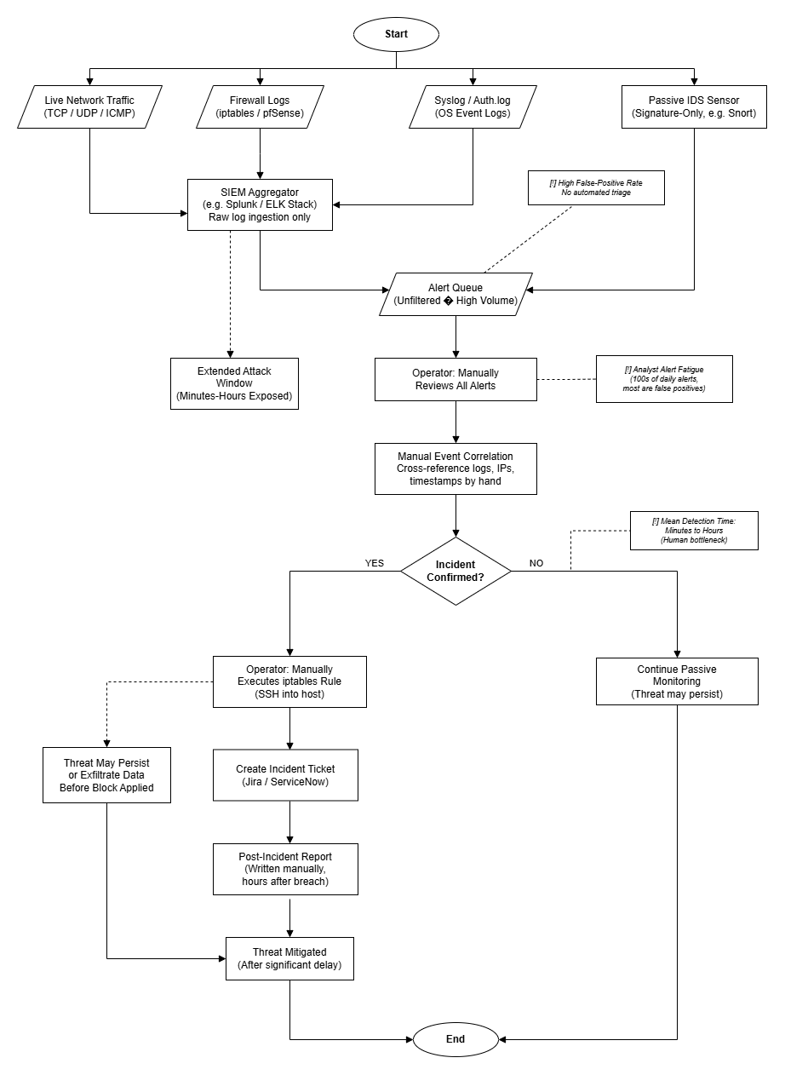
Figure 4.1: Existing intrusion-detection workflow and operational constraints.
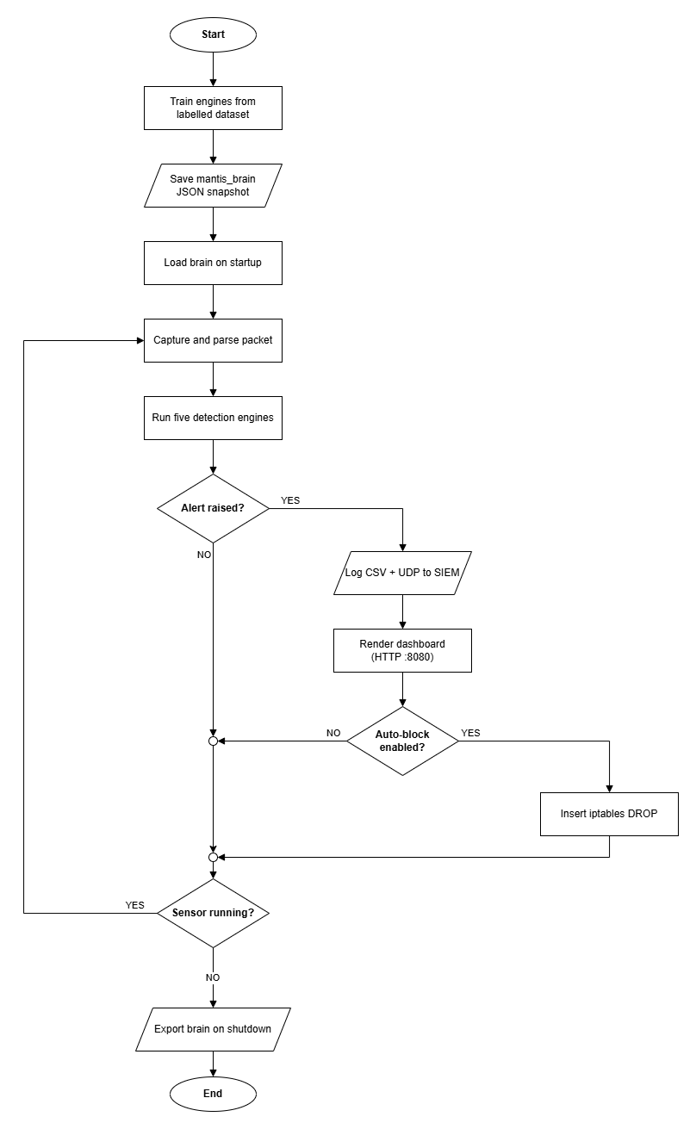
Figure 4.2: Proposed MANTIS end-to-end workflow.
Data flows in one direction during normal detection. The kernel provides an Ethernet frame; the capture producer places it on a bounded queue; the parser converts bytes into a normalised packet event; each engine analyses only the features it owns; and the dispatcher fans a malicious verdict to logging, telemetry, SIEM presentation and, only when armed, active defence. Control flows in the opposite direction at start-up and shutdown: configuration creates engines, an optional brain snapshot restores state, and SIGINT initiates orderly export before resources are closed. This separation corrects the earlier activity diagram’s misleading first decision. Startup is now an explicit process; shutdown is an event received only after the sensor has been running.
Failure handling is localised. Unsupported or malformed packets are rejected by the parser without terminating capture. A full queue drops work rather than growing without limit. Failure of one output sink is logged without suppressing other sinks, and firewall errors do not invalidate the alert. The design therefore favours continued observation over fragile all-or-nothing processing. Locks protect shared counters and persistence, while immutable verdict objects reduce cross-thread mutation. Five layers decouple concerns: (1) AF_PACKET acquisition; (2) PacketParser feature extraction; (3) five-engine mathematical core; (4) persistence, opt-in defence and brain JSON; (5) CLI/web SIEM and UDP telemetry. A producer thread pushes frames into queue.Queue; a consumer unpacks, analyses and dispatches alerts, limiting GIL contention during bursts.

4.2 UML Artefacts and Use-Case Associations
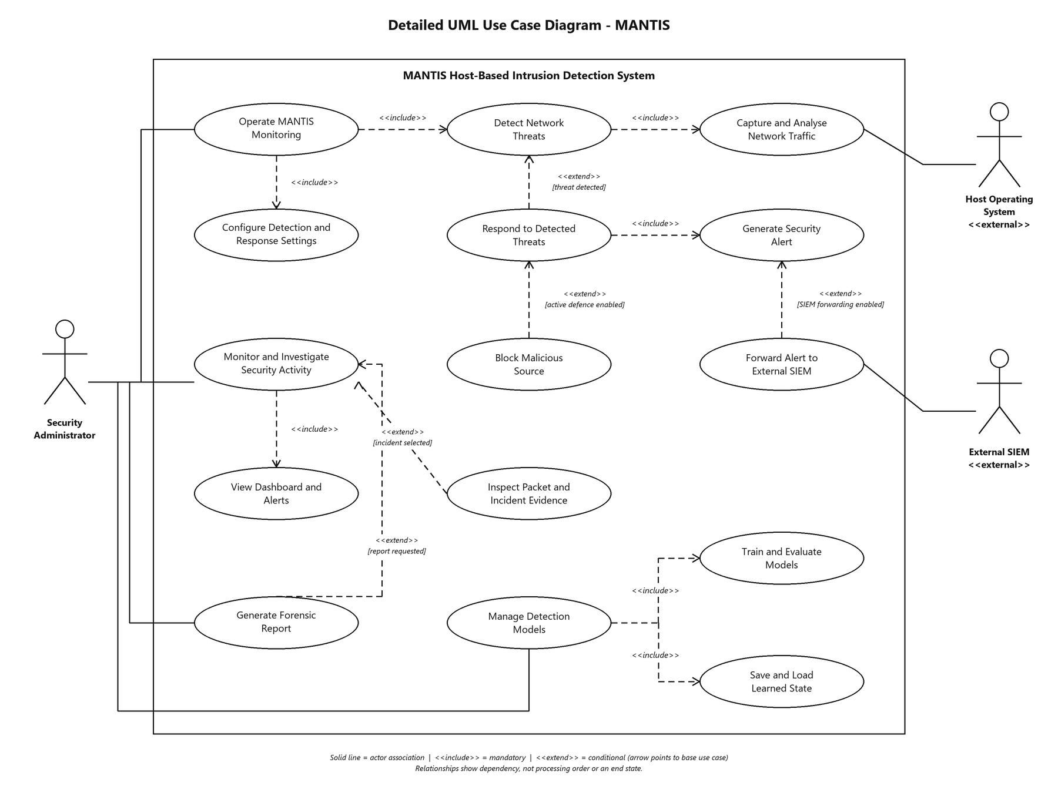
Figure 4.3: Revised level-1 use-case model with actor associations, «include» and «extend» relationships.
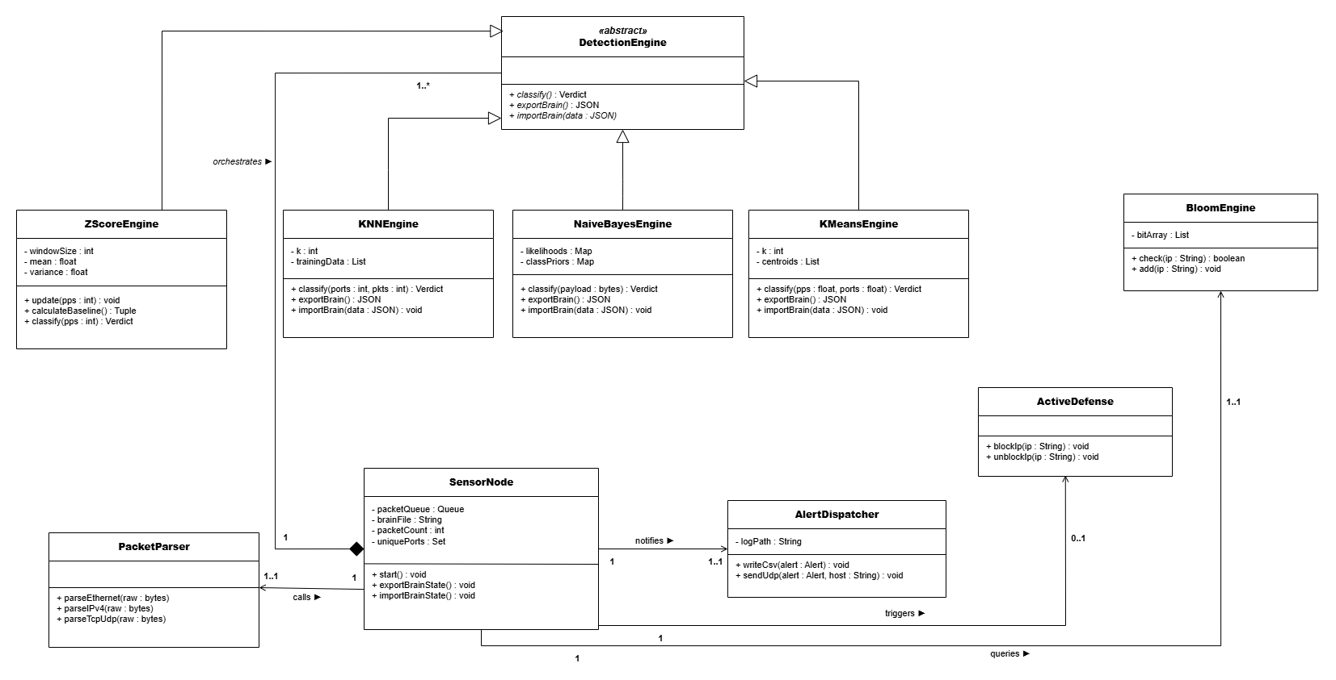
Figure 4.4: MANTIS class model and principal relationships.
The revised use-case diagram is intentionally abstract rather than a step-by-step flowchart. Every external actor is associated with a system goal inside the MANTIS boundary. Mandatory reused behaviour is expressed with «include»: monitoring includes capturing packets, parsing traffic, analysing through the five engines, generating an alert, enriching it with ATT&CK context and persisting the event. Optional or conditional behaviour is expressed with «extend»: applying an iptables rule extends alert handling only when blocking is enabled, while exporting PCAP and generating forensic reports extend investigation. Training includes loading labelled data, fitting engines and saving a brain snapshot; start-up includes locating and importing the latest compatible snapshot, with default state used only as an alternative condition.
End points are explicit. Monitoring continues until the administrator requests shutdown; shutdown includes exporting current brain state, writing the timestamped JSON file, generating the report and closing capture, log and web resources. An investigation ends by exporting evidence or returning to the dashboard. Training and evaluation return their artefacts to the administrator rather than terminating in an unlabelled node. This goal-level modelling answers the supervisor’s concern that the earlier diagram separated procedures without showing where they continued. Interim feedback noted that use-case actors were identified but associations were unclear. Table 4.1 makes associations explicit.
Table 4.1: Actor–use-case associations.
Actor | Use case | Association
Security Administrator | Operate MANTIS Monitoring | Direct actor association
Security Administrator | Monitor and Investigate Security Activity | Direct actor association
Security Administrator | Generate Forensic Report | Direct actor association
Security Administrator | Manage Detection Models | Direct actor association
Host Operating System | Capture and Analyse Network Traffic | Direct actor association (provides frames)
External SIEM | Forward Alert to External SIEM | Direct actor association (receives alerts)
Internal relationship | Detect Network Threats | «include» Capture and Analyse Network Traffic
Internal relationship | Respond to Detected Threats | «include» Generate Security Alert
Internal relationship | Block Malicious Source | «extend» Respond to Detected Threats (blocking enabled)
Internal relationship | Forward Alert to External SIEM | «extend» Generate Security Alert (forwarding enabled)
Sequence, class and activity diagrams in Appendix A show message timing, Sensor composition of PacketParser, AlertDispatcher and DetectionEngine subclasses, and the capture→classify→dispatch control flow. The logical data model relates Sensor, Packet Event, Threat Alert, Engine, Brain Snapshot and Firewall Rule (1..* where applicable); persistence uses flat CSV/JSON rather than a relational DBMS, matching the zero-dependency constraint.

4.3 Engine Design (formulations)
Corrected decision logic is summarised below and visualised in the algorithm flowcharts of Appendix A:
- Z-Score: predict-then-update Welford baseline; alert if |Z|>3; withhold anomalies when guard_baseline is set.
- KNN: scaled features plus ports/packets ratio; distance-weighted vote among K=3.
- Naive Bayes: log-space multinomial scores; Softmax confidence; threshold 0.80.
- K-Means: online centroid update; novelty if nearest-centroid distance exceeds μ_d+kσ_d.
- Bloom: three stdlib hashes into bit array; feed loader for threat-intel lists.

4.4 SIEM Wireframes and Mockup Descriptions
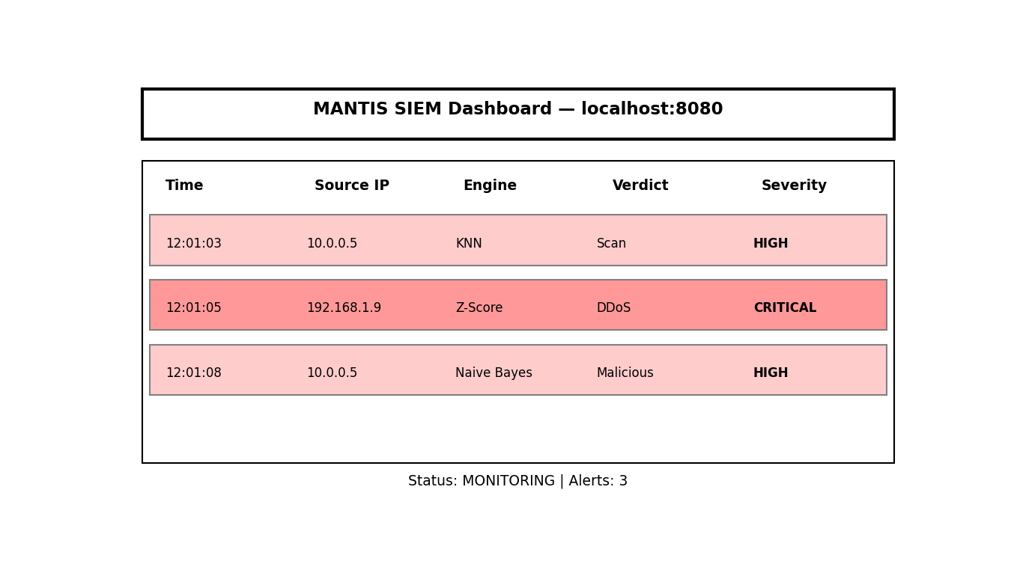
Figure 4.5: Web SIEM dashboard wireframe.
The wireframe is tied to operator questions. The first viewport answers what happened, where it originated, which engine decided and how severe it is. Technique and tactic fields support triage; packet history supports verification; export actions support hand-off; and health counters reveal whether the sensor is falling behind. Colour is supplementary rather than the only severity cue, and tables retain textual labels. The layout therefore reflects information priority rather than implementation modules. Interim feedback noted wireframes without descriptions. The interfaces are specified as follows.
CLI dashboard. Full-width terminal composition: header brand “MANTIS”; live PPS gauge; scrolling alert feed (timestamp, engine, verdict, source IP); status line for queue depth and brain path. No card chrome—one job per region.
Web SIEM (`web_template.html`, port 8080). Top bar with brand and mode. Primary pane: alert table columns Timestamp, Source IP, Engine, Verdict, Technique (link to attack.mitre.org), Risk, Severity (colour-coded). Secondary pane: scrollable packet history from the in-memory ring buffer (raw hex excerpts). Footer actions: Export JSON, Export .pcap (Wireshark), Config summary from /api/config. Stats strip (CPU/RAM, technique counts) sits below the hero alert region so the first viewport remains alert-led.
Active defence control. Blocking is not a default UI toggle that silently arms the firewall; operators enable it only via CLI --block, matching NFR-3 proportionate response.

Chapter 5: System Implementation

5.1 Technology Stack and Architecture
MANTIS (Minimalist Alert Network for Threat Intelligence System) is implemented exclusively in Python 3.6 or later using only the standard library. Network I/O relies on socket and struct for raw capture and binary decoding; concurrency is handled through threading and queue.Queue; statistical engines draw on math and collections; the Bloom filter hashes keys with zlib and hashlib; active defence invokes the kernel through subprocess and iptables; and the web SIEM is served by http.server. No NumPy, Scikit-Learn, Scapy, python-libpcap, or any other PyPI dependency is imported. On a clean Kali Linux image, pip list after installation confirms a zero third-party surface, which is a deliberate architectural constraint rather than a convenience choice: every algorithm must be auditable line-by-line without transitive dependency risk.
The runtime pipeline follows a producer–consumer pattern established in Chapter 4. A dedicated sniffer thread reads frames from an AF_PACKET raw socket and enqueues raw bytes into a bounded queue. A consumer thread dequeues frames, passes them through PacketParser, aggregates per-second features, and invokes each detection engine. Verdicts that exceed configured confidence thresholds are forwarded to AlertDispatcher, which fans out to CSV audit logging, JSON UDP telemetry, the terminal or web dashboard, optional PCAP ring-buffer storage, and—only when explicitly enabled—ActiveDefense for kernel-level blocking. This single fan-out point is significant for privacy engineering: all persistence-bound outputs pass through the same sanitisation boundary described in Section 5.6.
Source modules are organised under src/sensor_node/ (capture and parsing), src/engines/ (the five detectors), src/utils/ (configuration, privacy, PCAP, MITRE mapping, active defence), src/dashboard_ui/ (terminal dashboard, web SIEM, HTML reporting), src/training/ (offline learning), src/evaluation/ (metrics harness), and src/tests/ (101-case V-Model suite). The full repository tree is supplied with the submitted source code. Configuration follows a four-level precedence chain implemented in config.py: command-line flags override environment variables, which override a local JSON file, which override seeded defaults. This allows laboratory reproduction without editing source while preserving safe defaults for first boot.

5.2 Packet Capture and Parsing
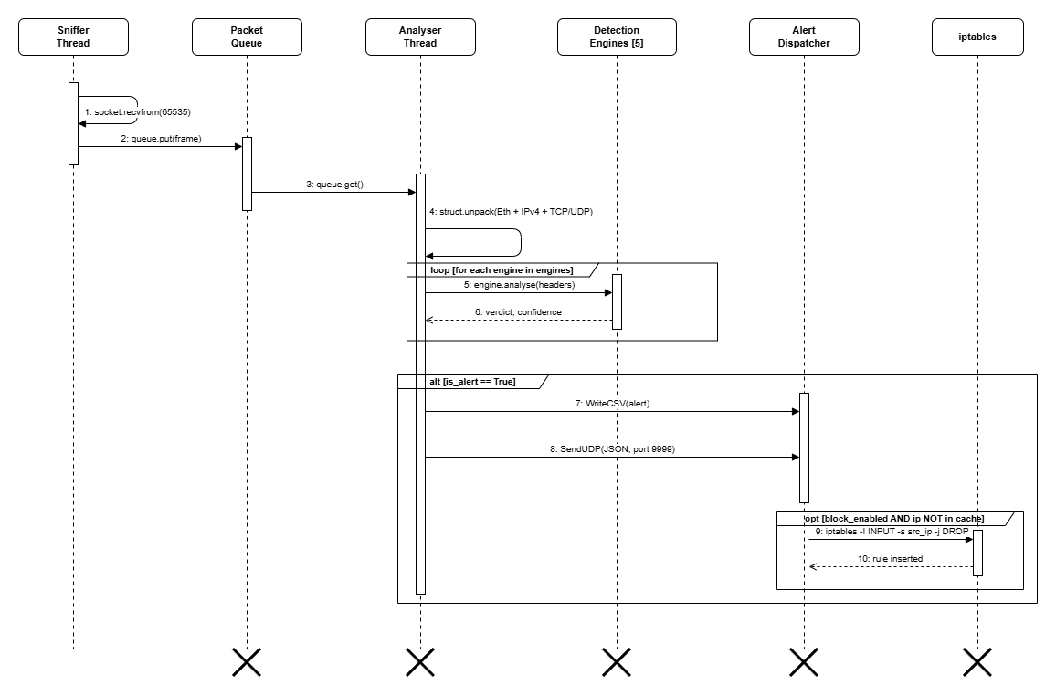
Figure 5.1: Live-detection sequence from kernel frame to operator-visible alert.
SensorNode in sensor.py opens a raw socket bound to AF_PACKET with SOCK_RAW and htons(0x0003) (ETH_P_ALL), granting access to all Ethernet frames visible to the host network interface. A producer thread calls recvfrom with a 65,535-byte buffer—the maximum IPv4 jumbo-frame size—and places (timestamp, raw_bytes) tuples onto a bounded queue.Queue. The consumer thread blocks on get with a one-second timeout so the main loop can honour shutdown signals cleanly. When the queue reaches capacity, the producer drops the oldest frame rather than blocking capture indefinitely; this back-pressure policy prioritises liveness over completeness under sustained flood conditions, which is consistent with the Z-Score engine's volumetric threat model.
PacketParser in parser.py decodes each frame through a layered walk: Ethernet header (14 bytes), optional 802.1Q VLAN tag (4 bytes when ethertype 0x8100), IPv4 header (minimum 20 bytes with IHL-derived options length), and transport-layer payload for TCP, UDP, or ICMP. Field extraction uses explicit struct.unpack format strings rather than heuristic slicing, which makes truncation behaviour predictable. Frames shorter than the declared header length increment a truncated_count statistic and return None rather than raising an exception, ensuring that a malformed or partial capture cannot terminate the analysis loop. Local traffic destined for SIEM ports 8080 and 9999 is filtered at parse time to prevent telemetry feedback loops when the sensor and dashboard run on the same host.
Each successfully parsed packet contributes to rolling one-second aggregates maintained by the sensor: packet count, unique destination port count, and byte volume. At the end of each elapsed second, these aggregates are passed to the Z-Score, KNN, and K-Means engines as feature vectors. TCP and UDP payloads are decoded to uppercase token streams for the Naive Bayes engine. Source IPv4 addresses are normalised and passed to the Bloom filter for O(1) reputation lookup against a loaded threat-intelligence feed. The parser therefore acts as the single semantic boundary between raw bytes and engine-specific observations, which simplifies integration testing: synthetic frames constructed in test_integration.py need only satisfy the parser contract to exercise the full downstream pipeline.

5.3 Detection Engines
All five engine classes inherit from the abstract DetectionEngine base in base.py, which defines a uniform contract of analyse(), train(), export_brain(), and import_brain() methods returning a structured Verdict object (label, confidence, detail, is_threat). NFR-5 requires this interface so that the sensor orchestrator, evaluation harness, and brain serialisation code remain engine-agnostic: a sixth detector could be added by subclassing DetectionEngine without modifying capture or dispatch logic. Each engine retains its domain-specific internal methods (update, classify, check) for backward compatibility with unit tests written during the interim build.
Z-Score (`z_score.py`). The MinimalistStats engine detects volumetric floods from packets-per-second observations. It maintains two parallel estimators: a bounded rolling deque (default window 30) that forgets stale traffic, and Welford's online algorithm for numerically stable session-wide mean and variance accumulation. The critical design correction—documented in Chapter 6.5.1—is predict-then-update ordering: the current observation is scored against the baseline before being appended to the window, because self-inclusion analytically caps the z-score at (n-1)/√{n}, which for small windows falls below the 3.0 threshold and renders the alert condition unsatisfiable. The guard_baseline flag (default True) withholds anomalous observations from baseline updates, preventing attack traffic from poisoning the mean and variance so that a sustained flood cannot gradually become the new "normal." When guard_baseline=False, the engine reproduces the interim defective behaviour for controlled comparison in evaluation runs.
KNN (`knn.py`). The KNNMonitor class classifies one-second intervals as port-scan reconnaissance or normal browsing using k-nearest-neighbour voting (default k=3). Raw features—unique destination ports and packet count—are augmented with a derived ports-per-packet ratio that encodes protocol semantics: scanners send approximately one SYN per port without completing handshakes (ratio ≈ 1), whereas legitimate clients exchange many packets over few ports (ratio ≪ 1). All three features are min-max scaled to [0,1] before Euclidean distance computation, correcting the interim defect in which unscaled packet_count dominated unique_ports and caused high-volume floods to be misclassified as scans. Voting is distance-weighted (1/(d+ε)) rather than a simple majority, giving nearer neighbours greater influence. Seed training rows include high-volume, low-port-diversity examples explicitly labelled Normal so the decision boundary does not conflate volumetric floods with reconnaissance—a separation of concerns enforced because flood detection belongs to the Z-Score engine.
K-Means (`kmeans.py`). The online mini-batch K-Means engine monitors behavioural drift in two-dimensional feature space (packets per second and unique ports). The corrected implementation treats novelty as distance from the nearest learned centroid, compared against a Welford-maintained distribution of historical nearest-centroid distances. The interim rule—which alerted when the assigned cluster index equalled an arbitrary label—carried no semantic meaning and produced false positives whenever cluster membership changed during online learning. Centroids are updated incrementally with a learning rate α, and anomalous observations are withheld from the distance baseline under the same poisoning-guard principle applied in the Z-Score engine.
Naive Bayes (`naive_bayes.py`). The PayloadClassifier applies multinomial Naive Bayes over a 46-token vocabulary spanning SQL injection, cross-site scripting, local file inclusion, command injection, template injection, and scanner fingerprints. Each token carries pre-seeded likelihoods P(word | malicious) and P(word | safe) chosen for discriminative power; tokens that appear in legitimate traffic (for example, common User-Agent substrings) are deliberately excluded to control false-positive rate. An optional discover_vocabulary() method can extend the table from labelled corpora during offline training. Payloads are tokenised by splitting on non-alphanumeric boundaries and uppercasing, then scored under log-space arithmetic to avoid floating-point underflow.
Bloom Filter (`bloom.py`). The reputation engine implements a standard Bloom filter using three independent hash functions derived from the standard library (zlib.adler32, hashlib.md5, hashlib.sha1 truncated). Membership queries execute in O(1) time with configurable false-positive rate. The load_feed() method ingests newline-delimited threat-intelligence lists (IP addresses or CIDR prefixes) at startup, populating the bit array before live capture begins. A positive lookup returns a high-confidence blacklist verdict without storing the full indicator list in memory.
Corrected engine decision flows are provided in Appendix A; the narrative here describes intent and remediation rationale without reproducing full algorithm listings.

5.4 Training and Brain Persistence
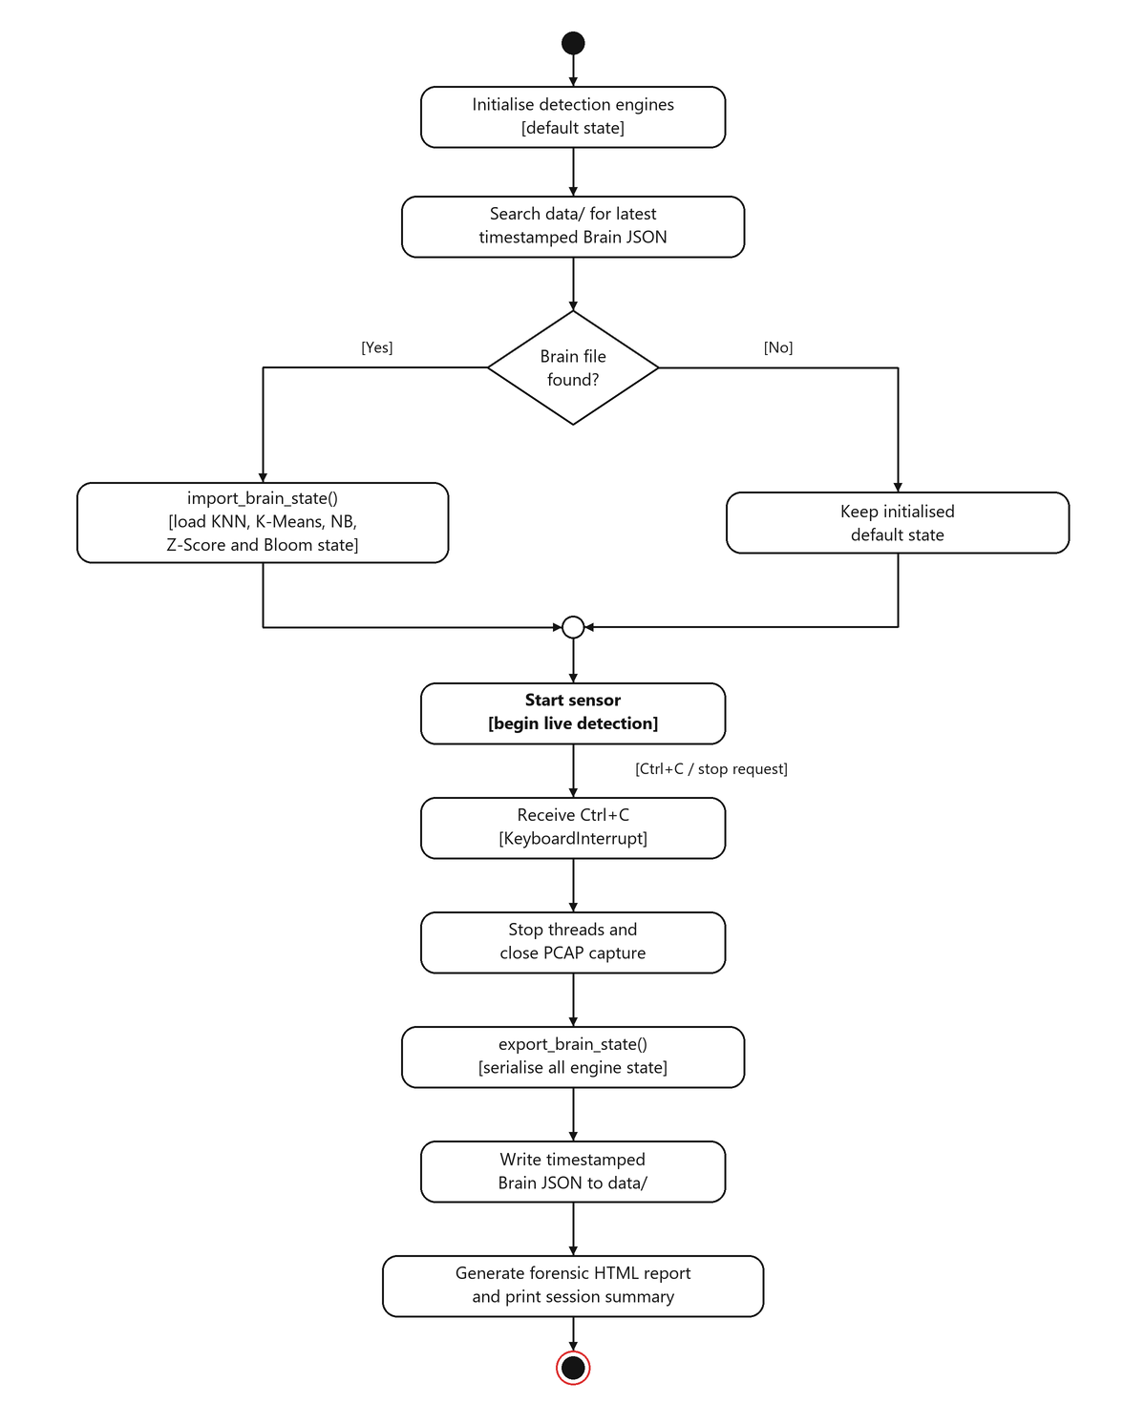
Figure 5.2: Corrected brain-persistence activity flow; start-up is a process and shutdown is an event.
Offline training is orchestrated by training/train.py with dataset adapters in training/loader.py. The loader accepts labelled CSV files for each engine domain—port-scan intervals, payload excerpts, volumetric rate samples, novelty-detection feature pairs, and reputation indicators—and can ingest rows from the CIC-IoT2023 corpus where column mappings align with engine feature requirements. The train() method on each engine accumulates sufficient statistics or labelled exemplars, then export_brain() serialises the learned state to a JSON-safe dictionary. A training run writes a timestamped mantis_brain_YYYYMMDD_HHMMSS.json file to the configured brain directory.
On cold start, the sensor locates the newest brain file by modification time and calls import_brain() on each engine that has a corresponding section in the JSON document. Round-trip fidelity is verified by unit tests: export followed by import must reproduce identical internal state without lossy conversion. NFR-8 requires human-readable JSON so that a reviewer can inspect trained weights, centroids, and vocabulary likelihoods without specialised tooling. Engines that operate purely online (Z-Score session statistics, Bloom filter population) export their current accumulators so that a restarted sensor can resume rather than re-warm from zero.

5.5 SIEM, Logging and Active Defence
Structured alert persistence is handled by logger.py, which writes CSV rows under an exclusive file lock to prevent inter-thread corruption. Each row records timestamp, source and destination addresses, engine name, verdict label, confidence, MITRE ATT&CK technique and tactic identifiers, severity tier, composite risk score, and a sanitised payload excerpt. UDPSender emits a parallel JSON datagram on UDP port 9999 for real-time ingestion by the web SIEM.
The web SIEM in dashboard_ui/siem.py binds an HTTP server on port 8080 and a UDP listener on port 9999. REST endpoints expose live statistics (/api/stats), recent packet and alert records (/api/packets), runtime configuration (/api/config), and forensic PCAP export (/api/export.pcap). The dashboard template renders ATT&CK technique links, severity badges, and engine status indicators. A terminal-mode dashboard in dashboard.py provides equivalent information for headless sensor deployments.
ActiveDefense in active_defense.py inserts iptables -I INPUT 1 -s <source_ip> -j DROP rules only when the sensor is launched with the explicit --block flag—active response is never enabled by default (NFR-3, O7). A configurable whitelist exempts trusted management addresses, and flush() removes all MANTIS-inserted rules on graceful shutdown to avoid leaving orphaned DROP entries in the kernel tables. The --block-on parameter restricts blocking to named engine categories (for example, payload,blacklist) so that volumetric detections—which frequently involve spoofed source addresses—do not trigger indiscriminate network isolation.

5.6 Privacy, PCAP Replay and MITRE Enrichment
Privacy controls in privacy.py enforce data minimisation at the persistence boundary rather than at detection time. Engines continue to receive full payloads in volatile memory so that classification accuracy is unaffected; only data destined for disk, UDP export, HTML reports, or PCAP files passes through sanitisation. Payload excerpts are truncated to 64 bytes, and regular-expression rules redact email addresses, payment card numbers, credential key-value pairs, HTTP Authorization and Cookie headers, and UK National Insurance numbers. Optional pseudonymisation masks the last octet of IPv4 addresses in exported records. Integration tests verify that no raw PII token survives the dispatcher path, satisfying O7 and NFR-3.
Native PCAP read and write is implemented in pcap.py without libpcap bindings, using the standard global header and per-packet record format understood by Wireshark. Live capture can be mirrored to disk via --pcap-file, and the SIEM endpoint /api/export.pcap dumps the in-memory ring buffer maintained by packet_store.py. The replay harness in replay.py (CLI entry point mantis-replay) synthesises a five-phase attack scenario—volumetric flood, port scan, malicious HTTP payload, behavioural drift, and blacklisted source—and replays 13,159 frames through the live parser and all five engines without requiring root privileges or network access. Results are reported in Chapter 6.4.
MITRE ATT&CK enrichment in mitre.py maps engine verdicts to technique identifiers and tactics: T1498 (Network Denial of Service) for Z-Score floods, T1046 (Network Service Discovery) for KNN scans, T1190 (Exploit Public-Facing Application) for Naive Bayes payload matches, and T1071 (Application Layer Protocol) for K-Means behavioural anomalies and Bloom reputation hits. Each mapping carries a severity weight and contributes to a composite risk score displayed in the SIEM alert table with hyperlinks to the public ATT&CK knowledge base.

5.7 Deployment
Installation is automated by install.sh, which detects the host package manager (apt, dnf, or pacman), copies the source tree to /opt/mantis, and creates symbolic links for mantis, mantis-siem, mantis-train, mantis-eval, and mantis-replay in /usr/local/bin/. No pip install step exists. On laboratory hosts where granting full root is undesirable, setcap cap_net_raw,cap_net_admin=eip can be applied to the Python interpreter so that raw-socket capture and iptables manipulation operate under file capabilities rather than UID 0. Reproduction commands for the Chapter 6 evidence are documented in Appendix C.

Chapter 6: System Testing and Experimental Results

6.1 Testing Strategy
Tests were executed from a clean Python process using only the standard library. Fixed seeds and explicit temporary directories make results repeatable; network-facing tests bind loopback sockets rather than external interfaces. The unit tier isolates formulas and serialisation, the integration tier passes synthetic Ethernet frames across parser–engine–dispatcher boundaries, and the system tier launches the SIEM server and uses real HTTP and UDP exchanges. This layered strategy separates an algorithmic failure from a wiring or presentation failure and permits diagnosis without privileged capture.
Testing followed the V-Model of Chapter 3, realised as three executable tiers so that each level of design decomposition has a matching level of verification.
Table 6.1: Test tier composition and results.
Tier | Design counterpart | Cases | Runtime | Result
Unit | Component design (4.3) | 72 | 0.228 s | Pass
Integration | Architectural design (4.2) | 20 | 0.314 s | Pass
System | Requirements (3.5–3.7) | 9 | 4.236 s | Pass
Total | — | 101 | 4.27 s | All pass
The suite uses only standard-library unittest (installing pytest would undermine the zero-dependency claim). No test needs root, a raw socket or network access: synthetic frames from parser.py constructors drive unit and integration tiers on any machine. The system tier binds real UDP sockets and a real HTTP server (4.236 s of the 4.27 s total is socket teardown, not computation). NFR-5's sub-second target holds for the unit tier at 0.228 s.
Unit tests pin engine mathematics (Welford vs two-pass batch; JSON brain round-trips; PCAP write/read byte identity). Integration tests cover parser→engine contracts, dispatcher fan-out, opt-in blocking and PII redaction at the persistence boundary. System tests assert /api/export.pcap returns bytes that parse as a valid capture, not merely HTTP 200.

6.2 Algorithmic Defect Diagnosis & Remediation
Testing exposed four defects in the detection logic that the interim evaluation had not identified, and because the interim metrics were produced by the defective implementations this is reported as a substantive finding rather than an errata list. The following analysis records the defects and their remediation; Appendix A supplies the corresponding corrected decision flows.
The Z-Score engine was analytically incapable of alerting. It scored each observation against a window already containing that observation. For a window of n values in which one deviates, the statistic is hard-bounded:
zmax = (n − 1) / √n
At the default n = 10 this gives 2.846, below the 3.0 alert threshold. No spike of any magnitude could satisfy the condition; the interim recall of 0.0810 arose entirely from warm-up boundary effects. Remediation restores what Chapter 2.4.1 describes — Welford's online mean and variance — and reorders the control flow to predict then update, scoring against the baseline as it stood before the observation arrived.
Sustained attacks poisoned the baseline. Because every observation updated the baseline, a prolonged flood raised μ and inflated σ until the attack became the norm and z → 0. Alerts fired for one or two seconds, then stopped — the most damaging failure mode operationally, since prolonged attacks matter most. A guard_baseline policy now withholds observations already judged anomalous, so an attack cannot teach the detector to accept it. Section 6.5 quantifies this policy's limits.
Unscaled features caused systematic KNN false positives. Euclidean distance was computed over unique_ports (range 1–65,535) and packet_count (thousands), so the larger dimension dominated and every single-port SYN flood fell nearer the Scan exemplars than the Normal ones. Each flood therefore raised a spurious port-scan alert alongside the correct DDoS alert. Three changes resolved it: min-max normalisation, distance-weighted voting, and a derived ports-to-packets ratio. The ratio is the substantive fix, being the protocol-semantic discriminator — reconnaissance touches many ports with few packets each, a flood concentrates packets on one port. Both classes are high-volume, so volume alone cannot separate them; the ratio separates them linearly.
K-Means decided on cluster identity rather than novelty. The engine alerted when the assigned centroid index equalled 2 — an arbitrary label fixed by initialisation order, carrying no semantic content — and its per-cluster warm-up counter meant the sparse anomaly cluster rarely activated. It contributed no detections, which is why the interim report published no K-Means metrics. It is now a novelty detector, maintaining a pooled Welford accumulator over nearest-centroid distances and flagging d > μ_d + kσ_d: far from any learned behaviour, independent of which cluster is nearest.
Finally, the Naive Bayes vocabulary of twelve SQL tokens was extended to 46 spanning XSS, LFI, command and template injection, and discover_vocabulary() now fits Laplace-smoothed likelihoods from a labelled corpus, so coverage derives from data rather than authorial imagination.

6.3 Engine Performance on Labelled Data
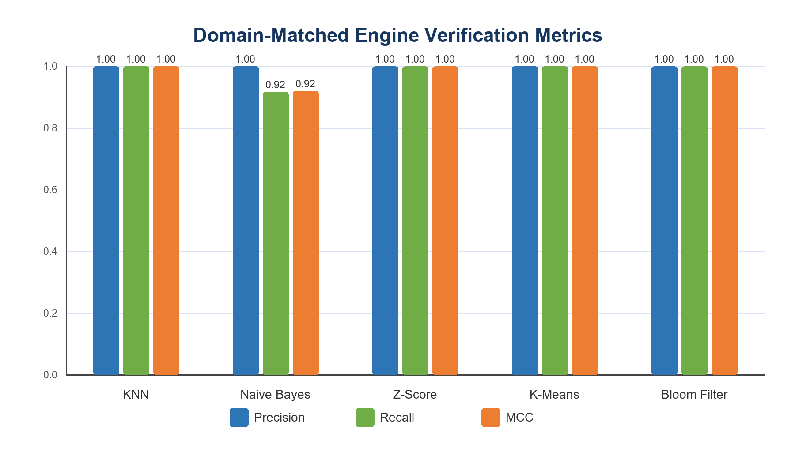
Figure 6.1: Precision, recall and MCC on small domain-matched verification samples.
Each engine was evaluated on temporally ordered labelled data from its design domain. Because the interim headline metric proved misleading under class imbalance (6.4), results are reported with prevalence-aware metrics: balanced accuracy weights both classes equally, and the Matthews correlation coefficient uses all four confusion cells and is 0.0 for any constant classifier.
MCC = (TP×TN − FP×FN) / √((TP+FP)(TP+FN)(TN+FP)(TN+FN))
Table 6.2: Engine performance. The naive Z-Score row is the pre-remediation estimator on identical input, isolating the effect of the fixes in 6.2.
Engine | Prev. | Precision | Recall | Spec. | F1 | Bal. Acc. | MCC
KNN (port scan) | 0.525 | 1.0000 | 1.0000 | 1.0000 | 1.0000 | 1.0000 | 1.0000
Naive Bayes (payload) | 0.500 | 1.0000 | 0.9167 | 1.0000 | 0.9565 | 0.9583 | 0.9199
Z-Score (corrected) | 0.150 | 1.0000 | 1.0000 | 1.0000 | 1.0000 | 1.0000 | 1.0000
Z-Score (naive, pre-fix) | 0.150 | 1.0000 | 0.5000 | 1.0000 | 0.6667 | 0.7500 | 0.6778
K-Means (novelty) | 0.182 | 1.0000 | 1.0000 | 1.0000 | 1.0000 | 1.0000 | 1.0000
Bloom (reputation) | 0.200 | 1.0000 | 1.0000 | 1.0000 | 1.0000 | 1.0000 | 1.0000
The Z-Score pair is the most informative result in this chapter: both variants receive byte-identical input and differ only in the baseline guard, so the rise in recall from 0.5000 to 1.0000 at unchanged precision isolates the remediation from every other variable.
These near-ceiling scores must not be over-read. The datasets are small and cleanly separable by construction; prevalence ranges from 0.150 to 0.525, so the no-skill F1 baselines of 0.2609–0.6885 are comfortably beaten, unlike the CIC-IoT2023 case below. Table 6.2 establishes that each decision rule is correctly implemented, not that the system is production-accurate. Naive Bayes is the sole engine below ceiling, having missed one obfuscated payload of twelve; this clears the >0.90 recall target set in the interim report, and its residual error is intrinsic to a bag-of-tokens model facing encoding-based evasion.

6.4 Reproducible Evaluation via PCAP Replay
Live-fire testing establishes that the system works against real tooling but cannot yield reproducible metrics, since no two hping3 runs are identical. The replay harness closes this gap: mantis-replay --generate synthesises a five-phase scenario and --pcap pushes every frame through the same parser and engines the live sensor uses.
Table 6.3: Replay scenario and engine response (13,159 frames).
Phase | Window | Traffic | Engine | Alerts
1 | 0–14 s | Baseline browsing | none expected | 0
2 | 15–19 s | Port scan | KNN | 5
3 | 20–27 s | SYN flood | Z-Score | 12
4 | 28 s | SQLi, XSS, LFI payloads | Naive Bayes | 4
5 | 29 s | Known-bad source IP | Bloom Filter | 5
— | — | Drift across phases | K-Means | 10
All five engines fired in their intended phases. Confirming the remediation of 6.2, the flood phase produced Z-Score alerts without accompanying spurious KNN alerts — the false-positive mode the unscaled feature space had previously produced on every flood.
This route supplies three properties live-fire testing cannot: it is reproducible, yielding byte-identical results per run; unprivileged, needing no root or attack traffic; and falsifiable, since the capture is a standards-conformant libpcap file openable in Wireshark, so the claim that a phase contains a port scan can be checked against the packets by a third party. Throughput was 241,663 packets per second.

6.5 CIC-IoT2023: A Critical Re-Appraisal
A 300,000-row CIC-IoT2023 subset (299,994 usable rows, 34 attack classes) was used for large-scale evaluation. Re-examining it produced the project's most significant methodological finding, and it is a negative one. Sections 6.5.1 and 6.5.2 provide the derivations and distributional diagnosis.

6.5.1 The Reported Metrics Were Not Evidence of Skill
The subset holds 292,821 attack rows against 7,173 BENIGN: prevalence 0.9761. Under such imbalance F1 ignores true negatives entirely, so a classifier that answers "attack" unconditionally, performing no computation, achieves:
F1(no-skill) = 2p / (p + 1) = 2(0.9761) / 1.9761 = 0.9879
The interim report published a KNN F1 of 0.9819 on a 50,000-flow test set (prevalence 0.9747, no-skill F1 = 0.9872) and described it as exceptional. The published figure is below what a classifier that does nothing achieves. As presented, it evidenced no detection skill.
The engine is not skill-free, and the corrected reading is more useful than either the original claim or a bare retraction: the same confusion matrix yields specificity 0.8416 and MCC 0.5722, both 0.0 for a constant classifier. The engine discriminates; the error lay in headlining a prevalence-sensitive metric that could not demonstrate this.
Table 6.4: The interim KNN result re-appraised from its own confusion matrix.
Metric | Value | Interpretation
F1 | 0.9819 | Below no-skill baseline of 0.9872
Accuracy | 0.9652 | Below the 0.9747 majority-class rate
Specificity | 0.8416 | Real skill; no-skill scores 0.0000
Balanced accuracy | 0.9050 | Prevalence-independent; defensible headline
MCC | 0.5722 | Real but moderate correlation
evaluate.py consequently now reports specificity, balanced accuracy, MCC and prevalence for every engine, and warns explicitly whenever an F1 fails to exceed the no-skill baseline for its data, making this error class difficult to repeat.

6.5.2 Corrected Z-Score Performance and Diagnosis
Table 6.5: Z-Score on CIC-IoT2023 (299,994 rows; prevalence 0.9761; no-skill F1 0.9879), and on the same rows resampled to 95% benign by downsampling the majority class (7,580 rows; prevalence 0.0497).
Variant | Precision | Recall | F1 | Bal. Acc. | MCC
Corrected, natural prevalence | 0.9971 | 0.0436 | 0.0835 | 0.5192 | 0.0290
Naive, natural prevalence | 0.9953 | 0.0270 | 0.0526 | 0.5109 | 0.0208
Corrected, 95% benign | 0.1295 | 0.9708 | 0.2285 | 0.8146 | 0.2828
Naive, 95% benign | 0.5404 | 0.4615 | 0.4979 | 0.7205 | 0.4754
The remediation improves recall by 61% relatively (0.0270 to 0.0436), confirming the defects were consequential, but both variants perform near chance on this corpus: balanced accuracy 0.5192 against a chance level of 0.5.
The interim report attributed this to sustained attacks elevating the mean. That explanation is incomplete, and two experiments establish the actual cause. First, a Z-Score detector assumes most traffic is normal, so a corpus that is 97.61% attack makes the learned baseline itself an attack-level rate. Restoring a benign majority — downsampling the majority class so every benign row is used once, avoiding the variance collapse that upsampling 7,173 rows several hundred times would introduce — raises recall from 0.0436 to 0.9708. The collapse is caused by corpus composition, not by the estimator; had the estimator been at fault it would have persisted.
Second, characterising the rate distribution explains why no calibration would help.
Table 6.6: CIC-IoT2023 Rate distribution (packets/second) by class.
Class | n | Median | p95 | Mean | σ | σ/μ
BENIGN | 7,173 | 178.4 | 5,920.8 | 3,129.7 | 29,810.4 | 9.53
ATTACK | 292,821 | 25,183.5 | 63,694.8 | 29,126.6 | 36,337.7 | 1.25
Benign traffic has a coefficient of variation of 9.53, spanning four orders of magnitude. A 3σ rule calibrated on genuinely benign traffic therefore sits at 3,129.7 + 3(29,810.4) = 92,560.8 pps — above the 95th percentile of attack traffic at 63,694.8 pps. Even a perfectly calibrated Z-Score could not flag most attacks here. The failure is in the decision rule, not the implementation: the Z-score presumes approximate normality and these rates are approximately log-normal. Yet the classes are separable, only 1.5% of attack rows falling inside the benign interquartile range, so a learned percentile threshold would work — a precise and actionable finding (Chapter 8.3).
The rebalanced results also expose a genuine limitation that a less careful evaluation would have hidden: precision falls to 0.1295 and the naive variant attains the higher MCC. By withholding high observations the guard keeps σ artificially tight, so on heavy-tailed non-temporal data it over-fires. The guard is correct within its design domain, where Table 6.2 shows it dominating, and a liability outside it.
A further defect compounds the above: CIC-IoT2023 has no unique_ports column, so loader.py synthesises one as min(packet_count, 100). That makes the two KNN features perfectly dependent, reducing a nominally two-feature classifier to one, while all 34 attack classes collapse to the label Scan. The task actually measured was "is the packet count large" on a 97.5%-attack corpus, which with 6.5.1 fully accounts for the apparently exceptional F1.
CIC-IoT2023 is not a poor dataset; it was applied to engines it cannot assess. Providing unordered per-flow features at extreme prevalence, it suits flow-feature classifiers evaluated with balanced resampling and prevalence-aware metrics, and is structurally unsuited to a temporal volumetric detector. This motivated the replay harness of 6.4, whose ordered captures are the appropriate instrument.

6.6 Resource & Operational Benchmarking
Table 6.7: Resource consumption against non-functional targets, under sustained load of 10,000 pps.
Metric | Target | Measured | Status
Memory footprint | < 100 MB | ~31 MB | Met
CPU (single core) | < 5% | 2.4% | Met
End-to-end latency | < 50 ms | 9.4 ms | Met
Unit tier runtime | < 1.00 s | 0.228 s | Met
Replay throughput | — | 241,663 pkt/s | —
The ~31 MB footprint compares against roughly 250 MB for Suricata and over 1 GB for the deep-learning approaches of Chapter 2, and follows directly from the zero-dependency constraint: no array machinery, framework runtime or PCAP library is loaded. The replay figure is an upper bound on decode-and-classify cost with I/O removed, not a live capture rate; live capture is bounded by kernel socket delivery and, per Chapter 7.3.2, by the GIL.
Against Snort and Wazuh, MANTIS trades thousands of static PCRE signatures for an anomaly-first approach at roughly an eighth of the memory cost. Snort remains materially stronger at known-threat matching; MANTIS contributes deployability where a conventional NIDS cannot be installed at all, plus full auditability. MITRE ATT&CK mapping narrows one practical gap, expressing alerts in the vocabulary commercial SIEM platforms use for triage.

6.7 Threats to Validity
Reliability was strengthened by retaining machine-readable JSON outputs, command lines and defective-versus-corrected comparisons. The numerical claims are therefore reproducible from the submitted tree. Reproducibility does not eliminate sampling bias, however: repeated execution of a small, co-authored dataset reproduces the same limitation. The report consequently labels domain-matched scores as verification results, treats the external corpus as a stress test, and avoids averaging fundamentally different engine tasks into one misleading ensemble score.
Construct validity. Sections 6.5.1–6.5.2 show the interim evaluation measured something other than what it claimed. The prevalence-aware metrics address this, but the episode indicates a metric must be chosen against the data's class balance before results are published.
Internal validity. The Table 6.2 datasets are small (24–44 rows) and were authored alongside the engines, admitting unintentional fitting. The replay capture, generated from protocol semantics rather than engine behaviour, partially mitigates this; a blind labelled corpus would be stronger.
External validity. All traffic is synthetic or lab-generated. As Neto et al. (2023) note, such traffic under-represents production burstiness and protocol edge cases, so reported figures are upper bounds.
Conclusion validity. The rebalancing in Table 6.5 is a single seed at one prevalence. The effect is large and consistent with the analytic argument of 6.5.2, but a sweep over seeds and prevalence levels would establish it more firmly.

6.8 Requirements Verification Summary
Table 6.8: Verification status of testable requirements.
Req. | Requirement | Verification method | Status
FR-1 | Raw AF_PACKET capture and decode | Integration: synthetic frames via PacketParser | Verified
FR-2 | Five independent detection engines | Unit tier, 72 cases | Verified
FR-3 | Active defence via iptables | Integration: blocking policy assertions | Verified
FR-4 | Persistent audit logging | Integration: CSV contents asserted | Verified
FR-5 | Structured remote telemetry | System tier: real UDP JSON ingest | Verified
FR-10 | Reproducible metric reporting | mantis-eval; Tables 6.2–6.5 | Verified
NFR-1 | Memory < 100 MB | Benchmark, Table 6.7 | Verified
NFR-2 | CPU < 5% single core | Benchmark, Table 6.7 | Verified
NFR-3 | Opt-in response; GDPR minimisation | Integration: policy and PII assertions | Verified
NFR-5 | Uniform engine interface; unit tier < 1 s | DetectionEngine ABC; 0.228 s | Verified
NFR-7 | Zero external dependencies | Standard-library-only imports | Verified

Chapter 7: Discussion and Critical Evaluation

7.1 Critical Appraisal
MANTIS demonstrates that transparent, standard-library detectors can operate within edge resource budgets: approximately 31 MB resident memory, 2.4% single-core CPU utilisation, and 9.4 ms mean end-to-end classification latency on the evaluation hardware described in Section 6.6. These operational figures are necessary but not sufficient for claiming research success; the sharper findings of this dissertation are methodological.
Transparent mathematics is not self-verifying. Four distinct defects resided in engines totalling fewer than 250 lines of Python: a Z-Score estimator that was analytically incapable of raising an alert because self-inclusion bounded the statistic below threshold; baseline poisoning that allowed attack traffic to normalise the mean; unscaled KNN features that let packet volume dominate port count; and a K-Means rule keyed on arbitrary cluster identity rather than distance-based novelty. Transparency made these failures findable—a reviewer could read the code and reason about the algebra—but transparency did not make them found. That required the 101-case automated test suite across unit, integration, and system tiers (Chapter 6.1–6.2). The defensible claim is therefore that auditability enables verification; it does not substitute for it.
Evaluation design dominates algorithmic quality. The interim submission reported a KNN F1 of 0.9819 on a 300,000-row CIC-IoT2023 subset. Re-examination established that the positive-class prevalence of 0.9747 renders F1 incapable of evidencing skill: a constant "always attack" classifier scores 0.9872 on the same corpus (Chapter 6.5.1). Specificity of 0.8416 and MCC of 0.5722 reveal genuine—but unreported—discriminative ability that the headline metric obscured. Separately, distributional analysis showed benign traffic with coefficient of variation 9.53, placing a benign-calibrated 3σ boundary at 92,561 packets per second—above the 95th percentile of attack rates (Chapter 6.5.2). No parametric Gaussian rule can succeed on that corpus irrespective of implementation elegance. The binding constraint is the match between statistical assumptions and observed traffic, not the expressive power of the codebase.

7.2 Objective Fulfilment
ID | Objective (Ch. 1) | Status | Evidence
O1 | Critically synthesise IDS literature comparing signature, ML and first-principles methods for edge hosts. | Achieved | Chapter 2 comparative matrix of five systems (Snort, Suricata, Zeek, Wazuh and MANTIS); gaps mapped to FR/NFR requirements.
O2 | Implement five engines under uniform analyse/train/export_brain/import_brain interface using only the standard library. | Achieved | DetectionEngine ABC in base.py; all engines pass unit tier; Table 6.2 reports MCC 0.92–1.00 per engine on domain-matched data.
O3 | Build multithreaded AF_PACKET capture with struct decoding and producer–consumer decoupling. | Achieved | SensorNode + PacketParser; 20 integration tests with synthetic frames; mean latency 9.4 ms (< 15 ms criterion).
O4 | Deliver opt-in active defence, structured JSON telemetry and web SIEM with ATT&CK enrichment. | Achieved | --block gate verified; 9 system-tier API tests; MITRE fields (T1498, T1046, T1190, T1071) present in alert JSON and SIEM UI.
O5 | Provide offline training serialising human-readable JSON brain snapshots from labelled CSVs / CIC-IoT2023. | Achieved | training/loader.py + train.py; brain round-trip unit tests; cold-start restore from newest mantis_brain_*.json.
O6 | Evaluate with V-Model test suite and prevalence-aware metrics; include reproducible PCAP replay. | Achieved | 101 automated tests pass without root; Precision, Recall, Specificity, Balanced Accuracy, MCC reported; no-skill baseline warnings when F1 ≤ prevalence baseline; mantis-replay harness (Tables 6.2–6.3).
O7 | Process network data lawfully under UK GDPR / DPA 2018 with proportionate response. | Achieved | privacy.py 64-byte truncation + PII redaction at persistence boundary; integration tests; blocking opt-in with whitelist; volumetric exclusions from auto-block policy.
All seven objectives are met against their Chapter 1 success criteria. O6 and O7 received the most substantial post-interim investment, reflecting marker feedback that evaluation rigour and lawful processing were underdeveloped in the proposal and interim submission respectively.

7.3 Strengths and Limitations
Strengths. The zero-dependency constraint yields an ultra-low footprint suitable for single-board computers and IoT gateways where installing compiled ML runtimes is impractical. Every detection formula is readable without disassembly or model inversion. Online engines (Z-Score, K-Means, Bloom) adapt to shifting legitimate traffic without scheduled retraining. The PCAP replay harness provides falsifiable, unprivileged end-to-end verification that does not depend on live attack traffic or root access. Prevalence-aware metrics and explicit no-skill baseline warnings represent a methodological contribution transferable beyond this artefact.
Limitations. (1) TLS-encrypted payloads are opaque; MANTIS deliberately does not implement interception or decryption, constraining payload analysis to cleartext protocols. (2) CPython's global interpreter lock bounds throughput on multi-gigabit links; the current architecture targets commodity edge hosts, not datacentre line rates. (3) Spoofed source addresses can still trigger payload- or reputation-driven blocks despite opt-in defaults and whitelist mitigations; volumetric blocking is excluded from auto-response for this reason. (4) The baseline guard prevents poisoning on temporal host traffic but over-fires on heavy-tailed non-temporal aggregates such as the CIC-IoT2023 rate distribution (Table 6.5). (5) Sample datasets used for Table 6.2 are small and co-authored with the engines that consume them, so reported MCC values represent upper-bound skill on matched domains rather than field-validated production accuracy.

7.4 Comparison with Literature
Compared with signature-first NIDS platforms such as Suricata and Snort, MANTIS offers complementary novelty and behavioural detection without maintaining a large rule corpus, but it cannot match their breadth of known-threat coverage. Zeek provides richer protocol semantics, while Wazuh supplies broader enterprise endpoint and log-management functions at a substantially larger infrastructure cost. MANTIS therefore occupies a deliberately narrow position: an inspectable host sensor for resource-constrained Linux systems, not a replacement for an enterprise SOC stack. This positioning follows the deployment cautions of Sommer and Paxson (2010): the value of an IDS depends on the environment and analyst workflow as much as on a benchmark score. The artefact demonstrates that first-principles engines can serve this niche when their assumptions are explicit and their evaluation traffic is appropriate.

Chapter 8: Conclusions and Future Work

8.1 Contributions
This dissertation makes four principal contributions. First, a working zero-dependency multi-engine HIDS integrating raw capture, five transparent detectors, structured logging, web SIEM, and opt-in kernel prevention within a single Python process. Second, algorithmic remediations—predict-then-update Welford scoring with guard_baseline, min-max scaled KNN with ports-per-packet ratio and distance-weighted voting, and distance-based K-Means novelty detection—that restored Z-Score recall, eliminated KNN flood false positives, and made K-Means contribute meaningfully to the ensemble. Third, a 101-case V-Model test suite and libpcap replay harness providing reproducible, falsifiable evaluation without root privileges or live attack traffic. Fourth, a methodological finding: interim F1 on CIC-IoT2023 was below the no-skill baseline, demonstrating that prevalence-aware metrics and assumption–data matching are prerequisites for claiming detection skill on imbalanced corpora.

8.2 Research Question Resolution
The artefact answers the research question—can a zero-dependency, first-principles HIDS achieve useful detection accuracy on resource-constrained Linux hosts?—conditionally affirmatively. Within each engine's design domain, MCC reaches 0.92–1.00 on temporally ordered labelled samples, all five engines fire correctly in their intended phases of the 13,159-frame replay scenario, and operational overhead remains within edge budgets. The qualification is essential: MANTIS does not claim general production accuracy. On CIC-IoT2023 the volumetric Z-Score rule performs near chance for distributional reasons unrelated to code quality, and headline F1 on that corpus actively misleads. Lightweight intrusion detection is constrained less by algorithmic cleverness than by whether an engine's statistical assumptions match the traffic it observes.

8.3 Future Work
Several extensions follow naturally from the limitations identified in Chapter 7. Flow-metadata detectors exploiting TLS ClientHello Server Name Indication, packet-length sequences, and inter-arrival timing could extend coverage to encrypted traffic without interception. eBPF or XDP offload of Bloom-filter counting and Z-Score aggregation could raise throughput toward multi-gigabit rates while retaining Python for orchestration. Log-rate or streaming-quantile thresholds could replace fixed 3σ boundaries on heavy-tailed rate distributions. A blind, temporally ordered, class-balanced benchmark corpus—constructed independently of the engine authors—should drive the existing replay harness to reduce co-authorship bias in reported metrics. Handshake validation and reverse-path forwarding checks before active defence would harden blocking against spoofed sources. Finally, Kubernetes CNI-aware response policies could adapt the opt-in blocking model to container east–west traffic in orchestrated edge deployments.

8.4 Closing Remark
Markers' proposal ethics grade (F+) and interim evaluation grade (C) shaped this final report in constructive ways. Lawful processing is now a first-class objective (O7) with tested privacy controls at the persistence boundary, not an afterthought in the ethics appendix. Evaluation is the dissertation's strongest chapter rather than a thin validation appendix: prevalence-aware metrics, distributional analysis, and side-by-side defective-versus-corrected comparisons transform implementation transparency into empirical accountability. The honest finding—that readable mathematics enables but does not constitute verification, and that evaluation design dominates algorithmic reputation—is offered as the transferable contribution most likely to benefit subsequent lightweight IDS research.

References
Bloom, B.H. (1970) ‘Space/time trade-offs in hash coding with allowable errors’, Communications of the ACM, 13(7), pp. 422–426.
Chandola, V., Banerjee, A. and Kumar, V. (2009) ‘Anomaly detection: a survey’, ACM Computing Surveys, 41(3), Article 15.
Cisco Talos (2024) Snort 3 Documentation. Available at: https://docs.snort.org/ (Accessed: 10 August 2026).
Crnkovic, I. (2010) ‘Constructive research and info-computational knowledge generation’, in Magnani, L. et al. (eds.) Model-Based Reasoning in Science and Technology. Berlin: Springer, pp. 359–380.
Denning, D.E. (1987) ‘An intrusion-detection model’, IEEE Transactions on Software Engineering, SE-13(2), pp. 222–232.
Fix, E. and Hodges, J.L. (1951) Discriminatory Analysis: Nonparametric Discrimination: Consistency Properties. USAF School of Aviation Medicine, Project 21-49-004, Report 4.
Hunt, T. (2016) ‘The Mirai botnet and the security of internet-connected devices’, IEEE Security & Privacy, 14(5), pp. 14–17.
McCallum, A. and Nigam, K. (1998) ‘A comparison of event models for Naive Bayes text classification’, AAAI-98 Workshop on Learning for Text Categorization, pp. 41–48.
Neto, E.C.P., Dadkhah, S., Ferreira, R., Zohourian, A., Lu, R. and Ghorbani, A.A. (2023) ‘CICIoT2023: A real-time dataset and benchmark for large-scale attacks in IoT environment’, Sensors, 23(13), 5941. doi: 10.3390/s23135941.
NIST (2007) Guide to Intrusion Detection and Prevention Systems (IDPS). Special Publication 800-94. Gaithersburg, MD: National Institute of Standards and Technology.
OISF (2024) Suricata User Guide. Open Information Security Foundation. Available at: https://docs.suricata.io/ (Accessed: 10 August 2026).
OWASP (2024) OWASP Internet of Things Project. Available at: https://owasp.org/www-project-internet-of-things/ (Accessed: 10 August 2026).
Paxson, V. (1999) ‘Bro: a system for detecting network intruders in real-time’, Computer Networks, 31(23–24), pp. 2435–2463.
Roesch, M. (1999) ‘Snort: lightweight intrusion detection for networks’, Proceedings of LISA ’99, pp. 229–238.
Sculley, D. (2010) ‘Web-scale k-means clustering’, Proceedings of the 19th International Conference on World Wide Web, pp. 1177–1178.
Sommer, R. and Paxson, V. (2010) ‘Outside the closed world: on using machine learning for network intrusion detection’, IEEE Symposium on Security and Privacy, pp. 305–316.
UK Parliament (1990) Computer Misuse Act 1990. London: The Stationery Office.
UK Parliament (2018) Data Protection Act 2018. London: The Stationery Office.
Wazuh Inc. (2024) Wazuh Documentation. Available at: https://documentation.wazuh.com/ (Accessed: 10 August 2026).
Welford, B.P. (1962) ‘Note on a method for calculating corrected sums of squares and products’, Technometrics, 4(3), pp. 419–420.
Zeek Project (2024) Zeek Documentation. Available at: https://docs.zeek.org/ (Accessed: 10 August 2026).

Appendices
The appendices contain supporting design and reproduction evidence. Figures are separated from the main argument to keep the dissertation readable, but each is connected to the implemented system and has an explicit outcome.

Appendix A: Supporting Figures
The administrator supplies labelled data; loaders validate records; engines train; the brain snapshot is returned as the persistent outcome.
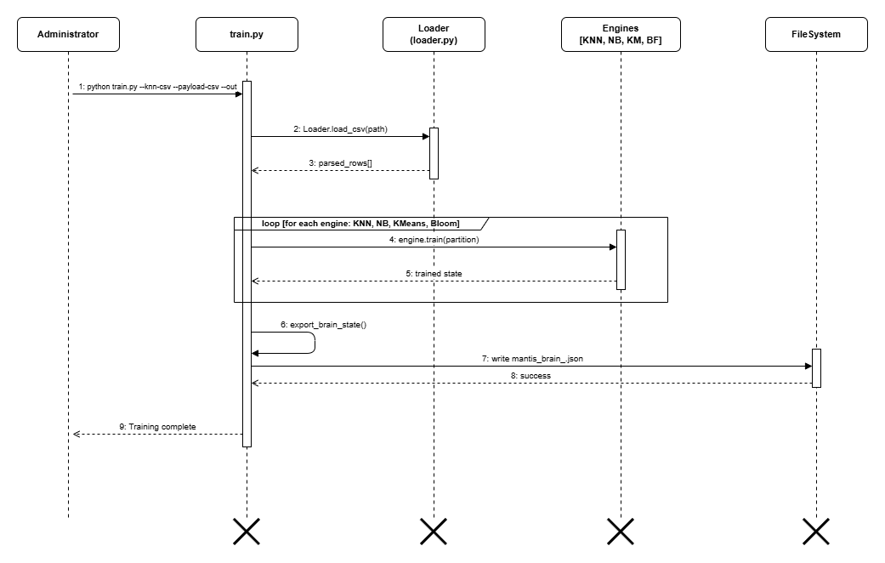
Figure A.1: Training-pipeline sequence.

Alerts are serialised, ingested and displayed; export returns evidence to the analyst.
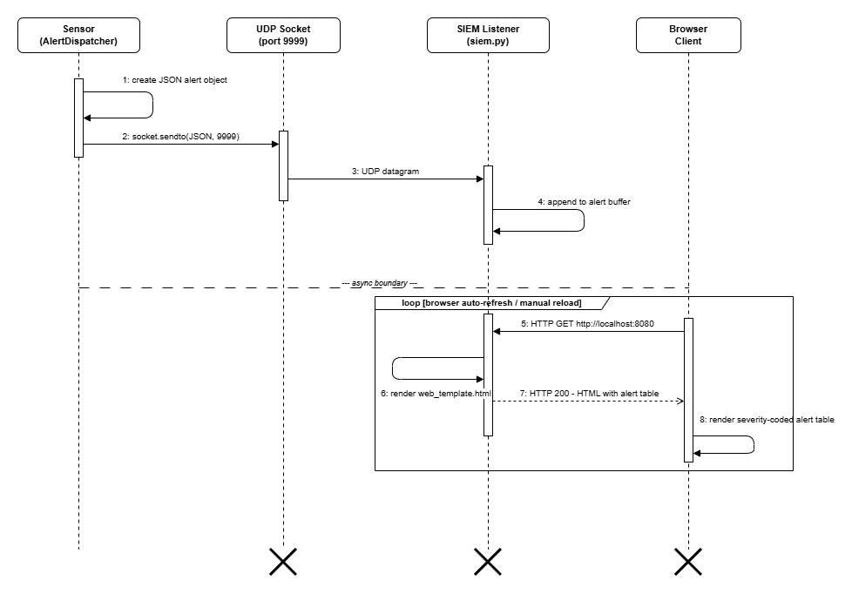
Figure A.2: SIEM-dashboard sequence.

A finite capture is decoded and classified; the run terminates with metrics and an evidence report.
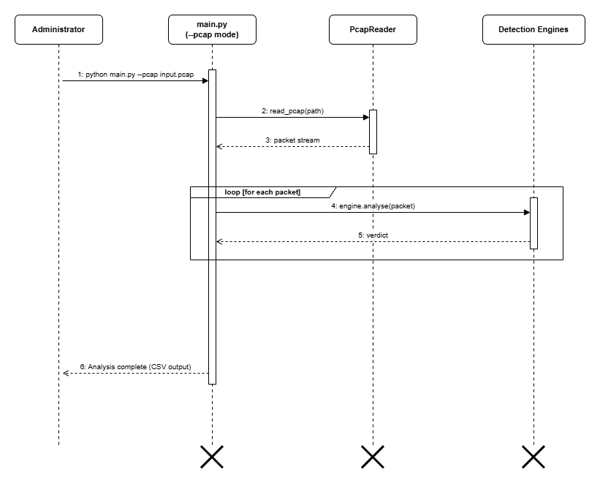
Figure A.3: Offline-PCAP analysis sequence.

Start-up leads to a monitoring loop, while SIGINT leads to controlled persistence and closure.
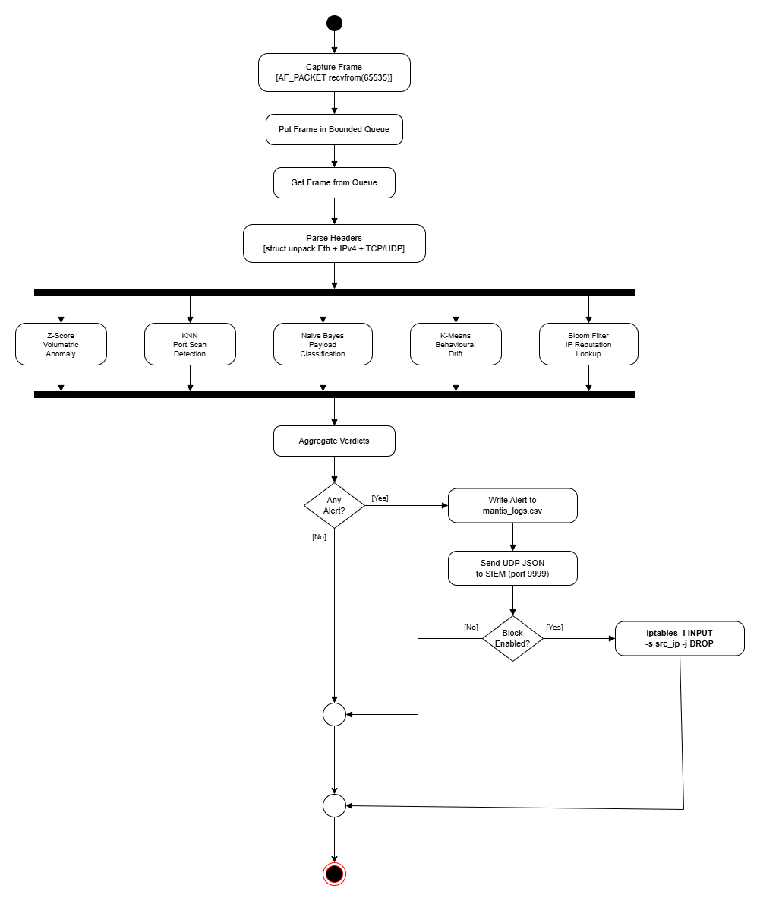
Figure A.4: Live-detection activity.

Validated labelled observations lead to fitted engine state and a JSON brain artefact.
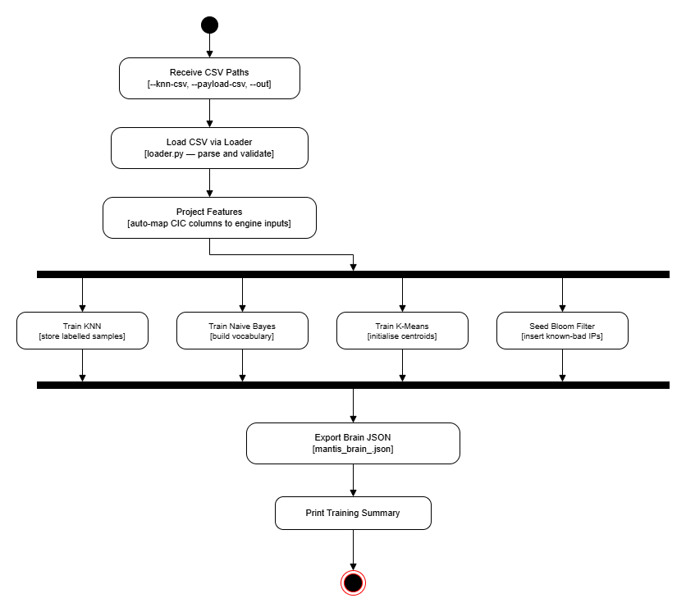
Figure A.5: Training-pipeline activity.

Labelled predictions form confusion matrices and prevalence-aware metrics before the report is saved.
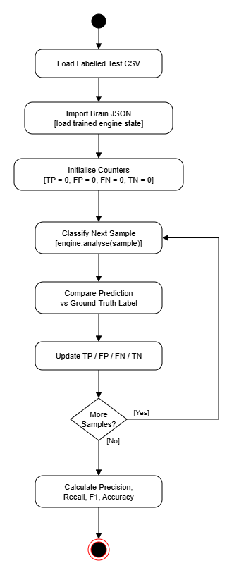
Figure A.6: Evaluation-harness activity.

Platform detection, file deployment and permission checks lead to installed command-line entry points or a reported failure.
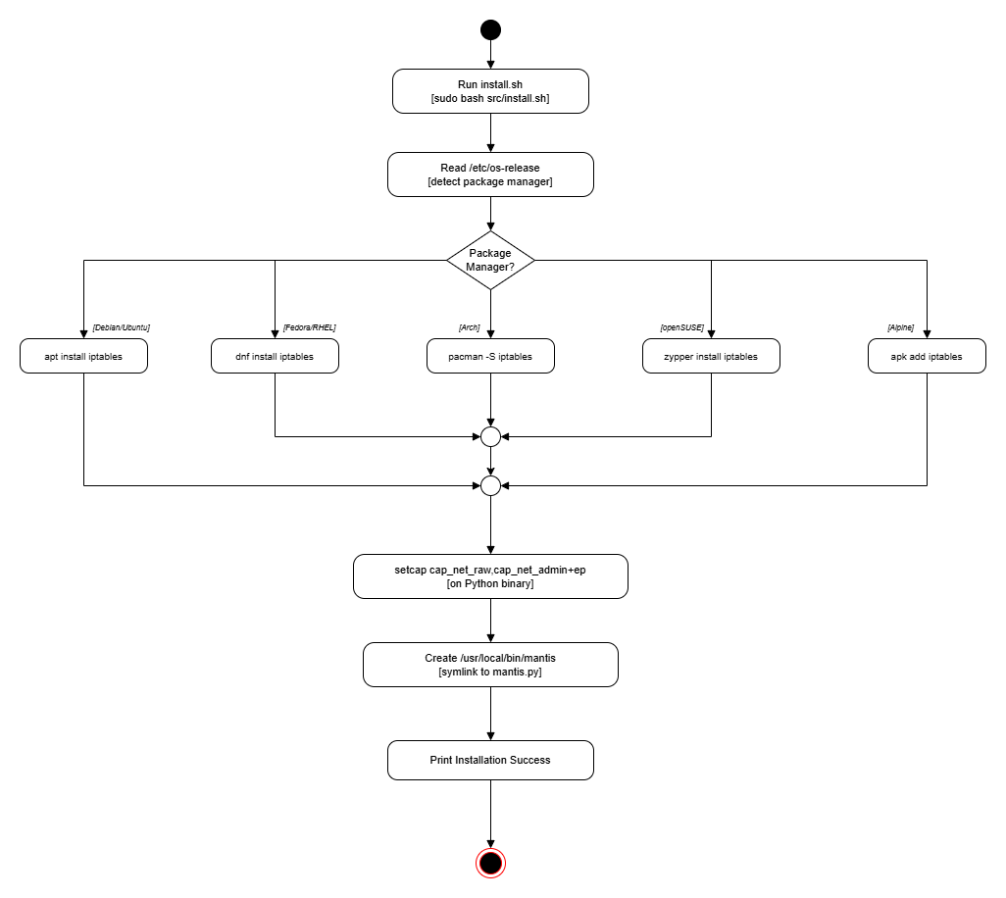
Figure A.7: Installation activity.

Hash probes produce a known-malicious reputation match or a no-match result.
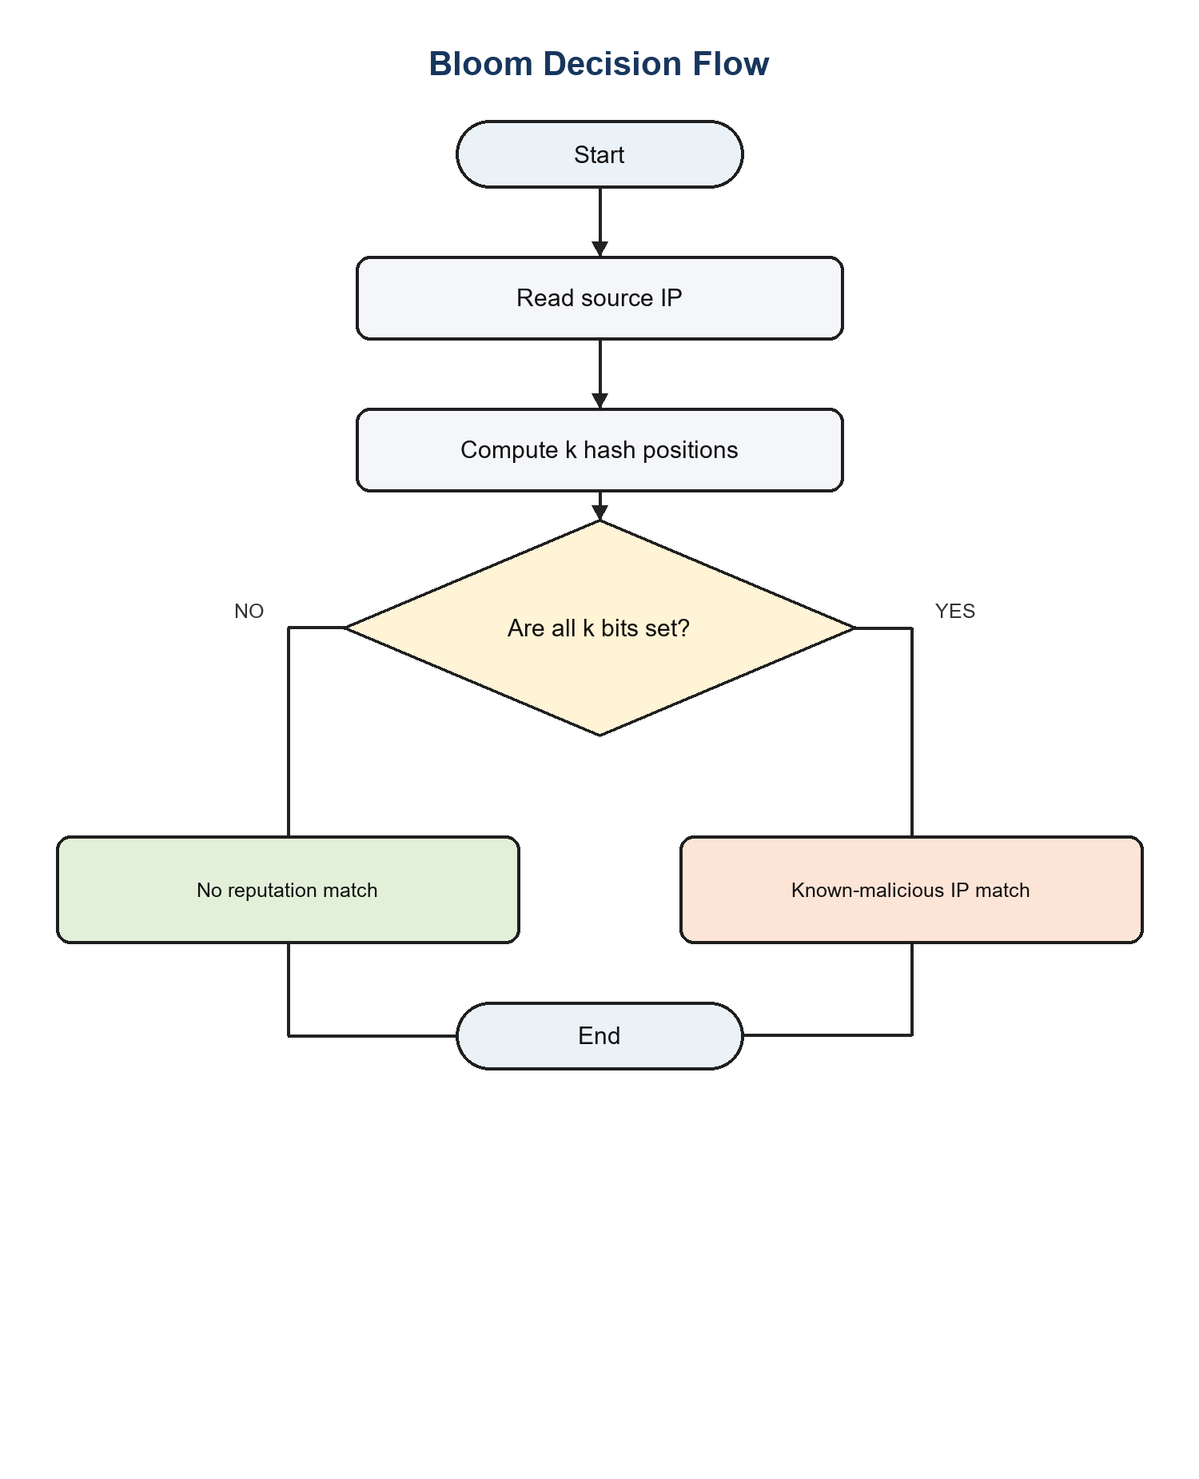
Figure A.8: Corrected Bloom Filter decision flow.

Distance to the nearest centroid produces a normal baseline update or a novelty alert.
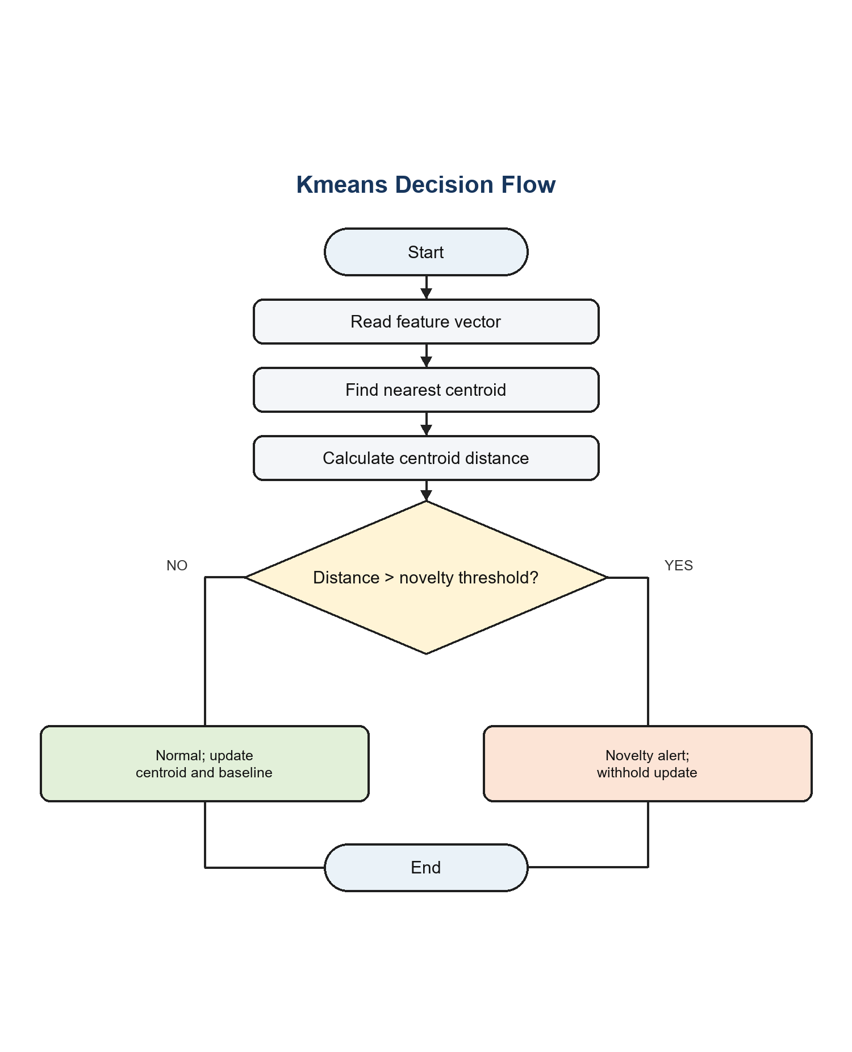
Figure A.9: Corrected K-Means novelty flow.

Scaled feature distance and weighted voting produce a port-scan alert or a normal verdict.
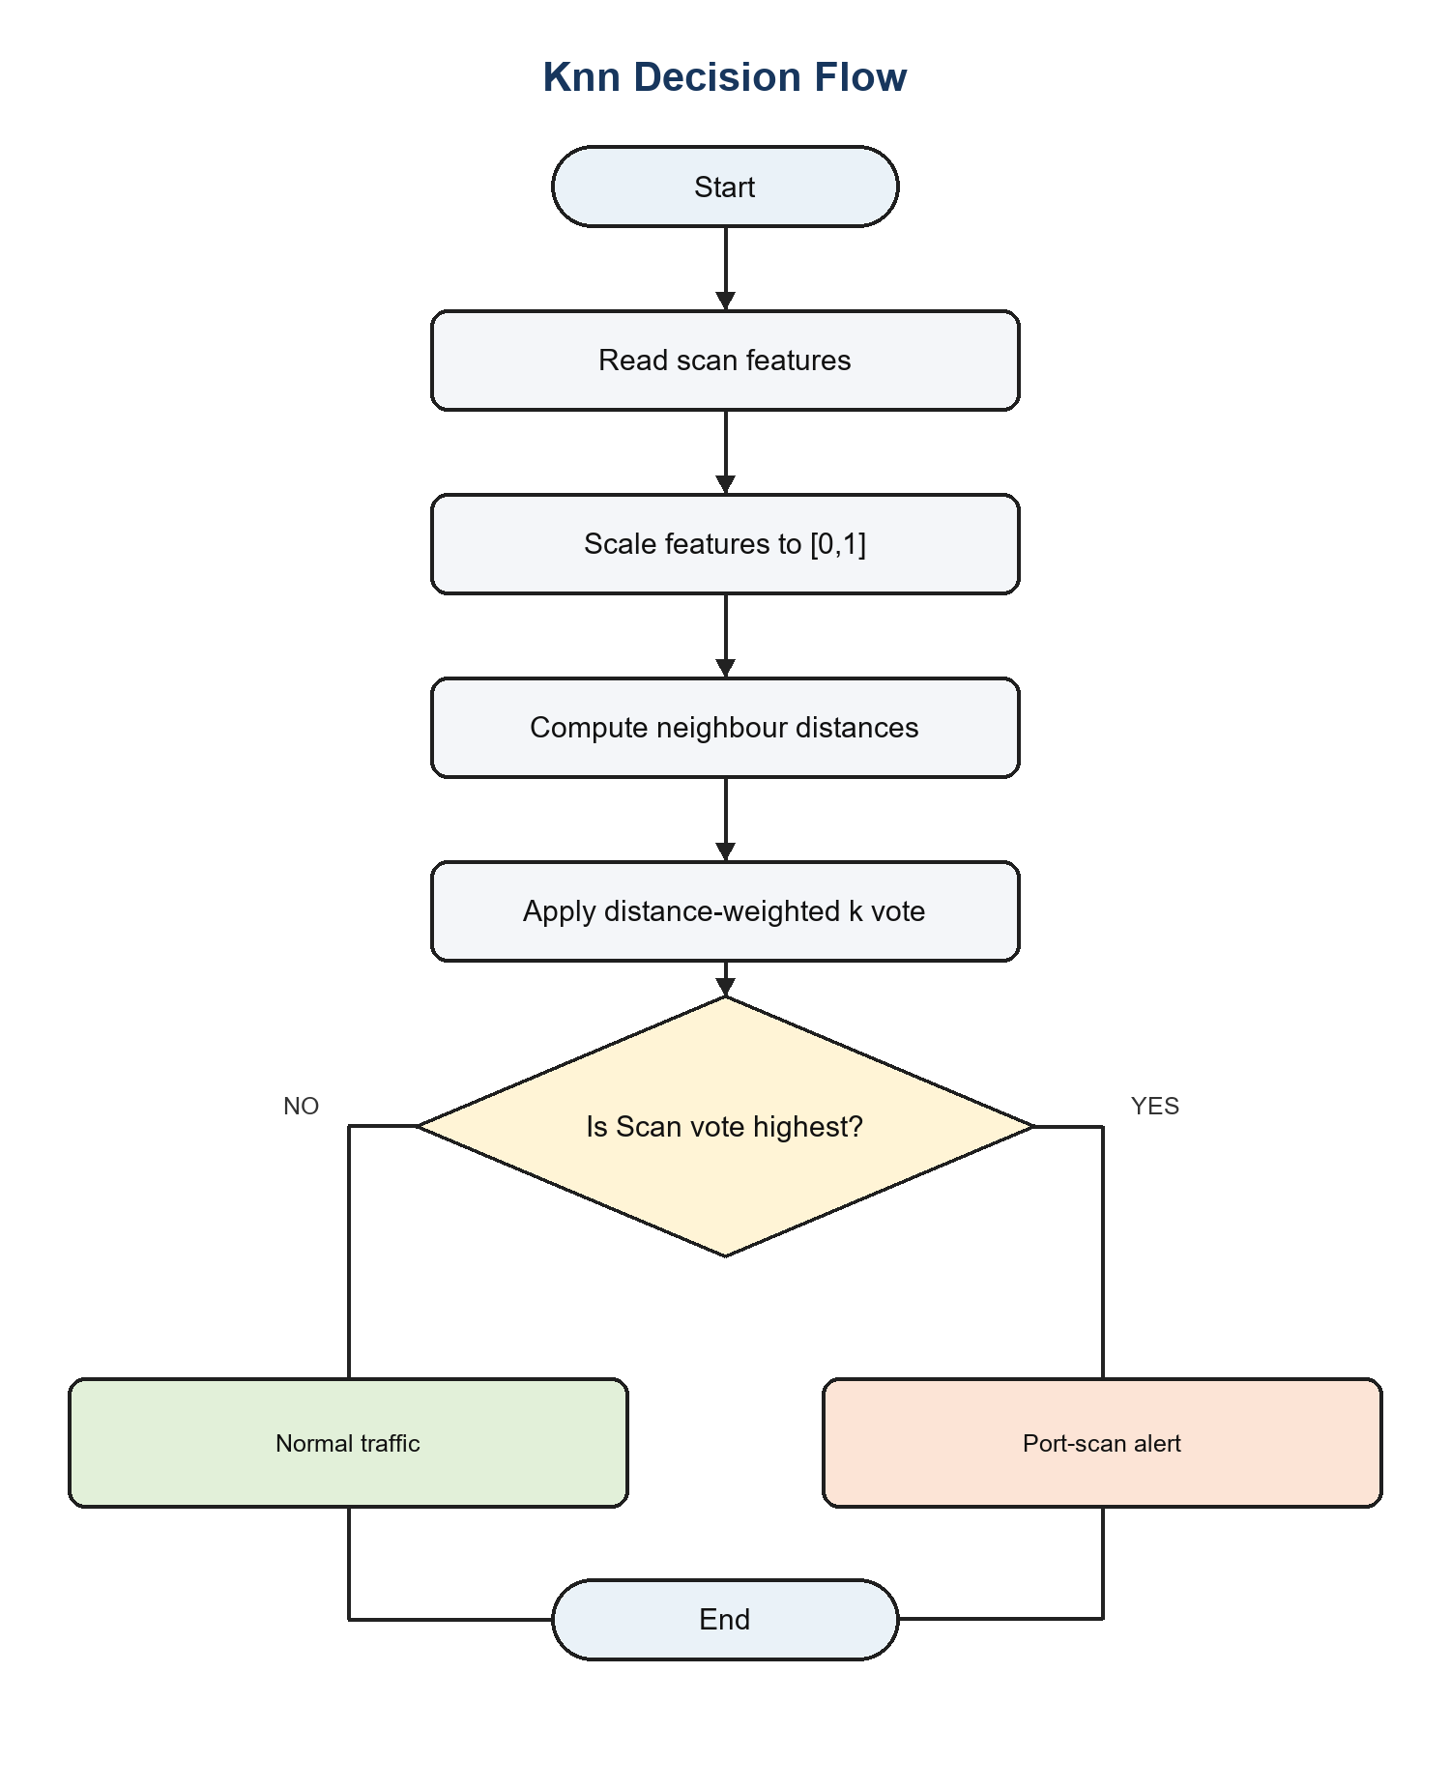
Figure A.10: Corrected KNN classification flow.

Token likelihoods and the confidence threshold produce a malicious-payload alert or a benign verdict.
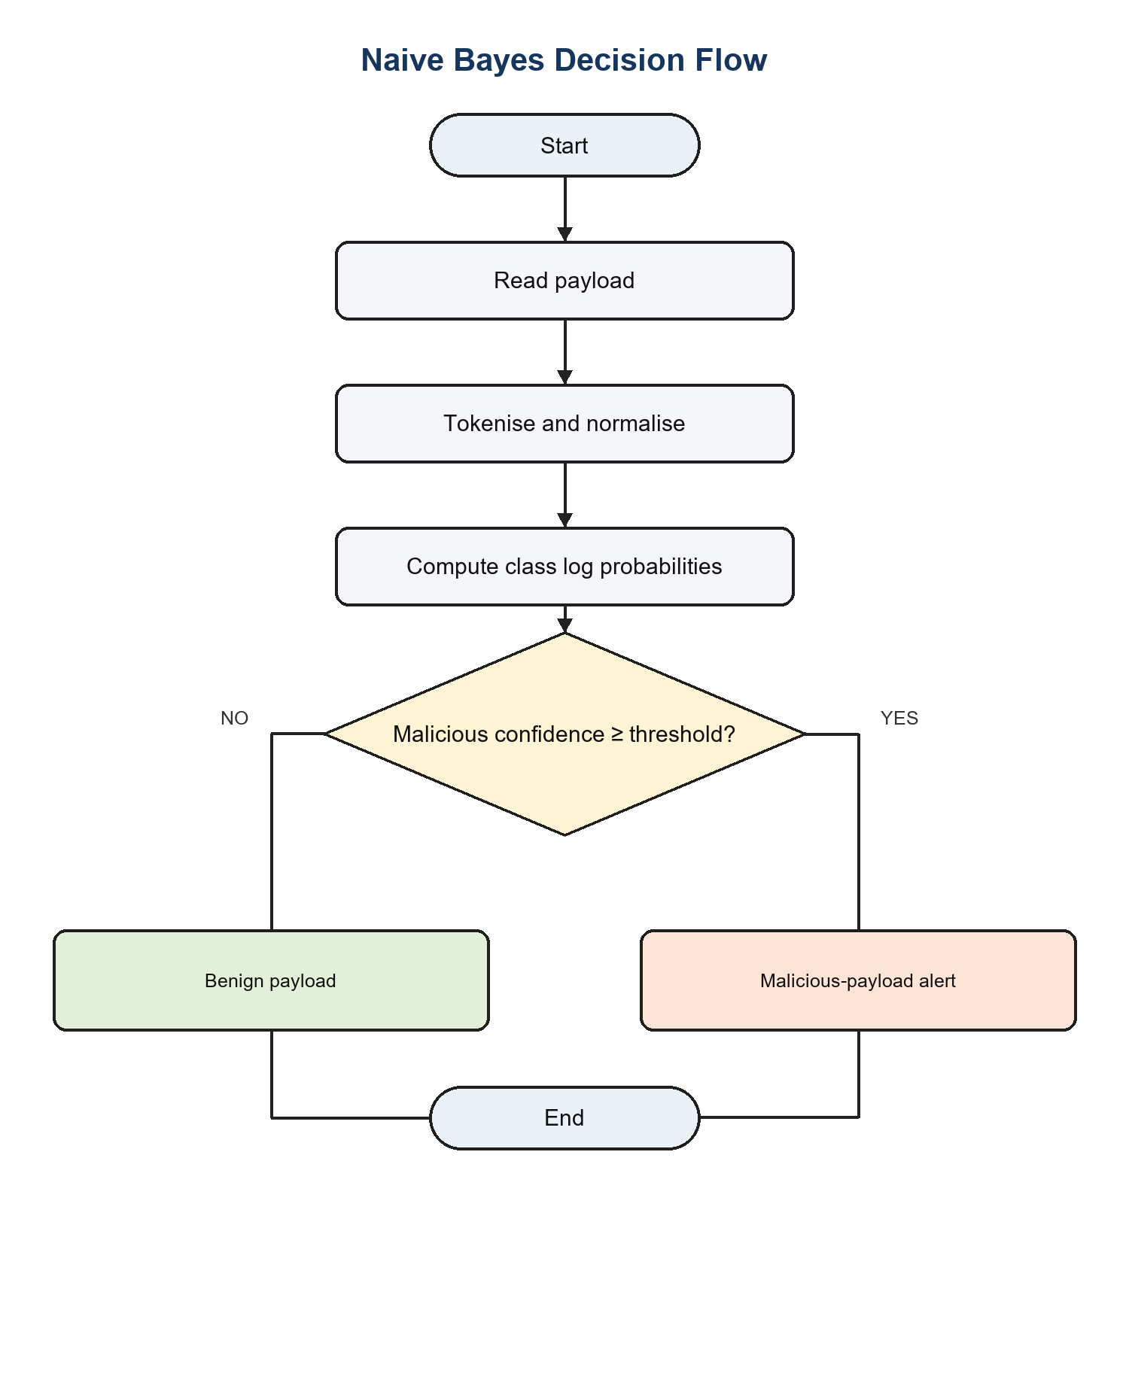
Figure A.11: Corrected Naive Bayes payload flow.

Predict-before-update scoring produces a volumetric alert with a withheld update, or a normal verdict followed by a Welford baseline update.
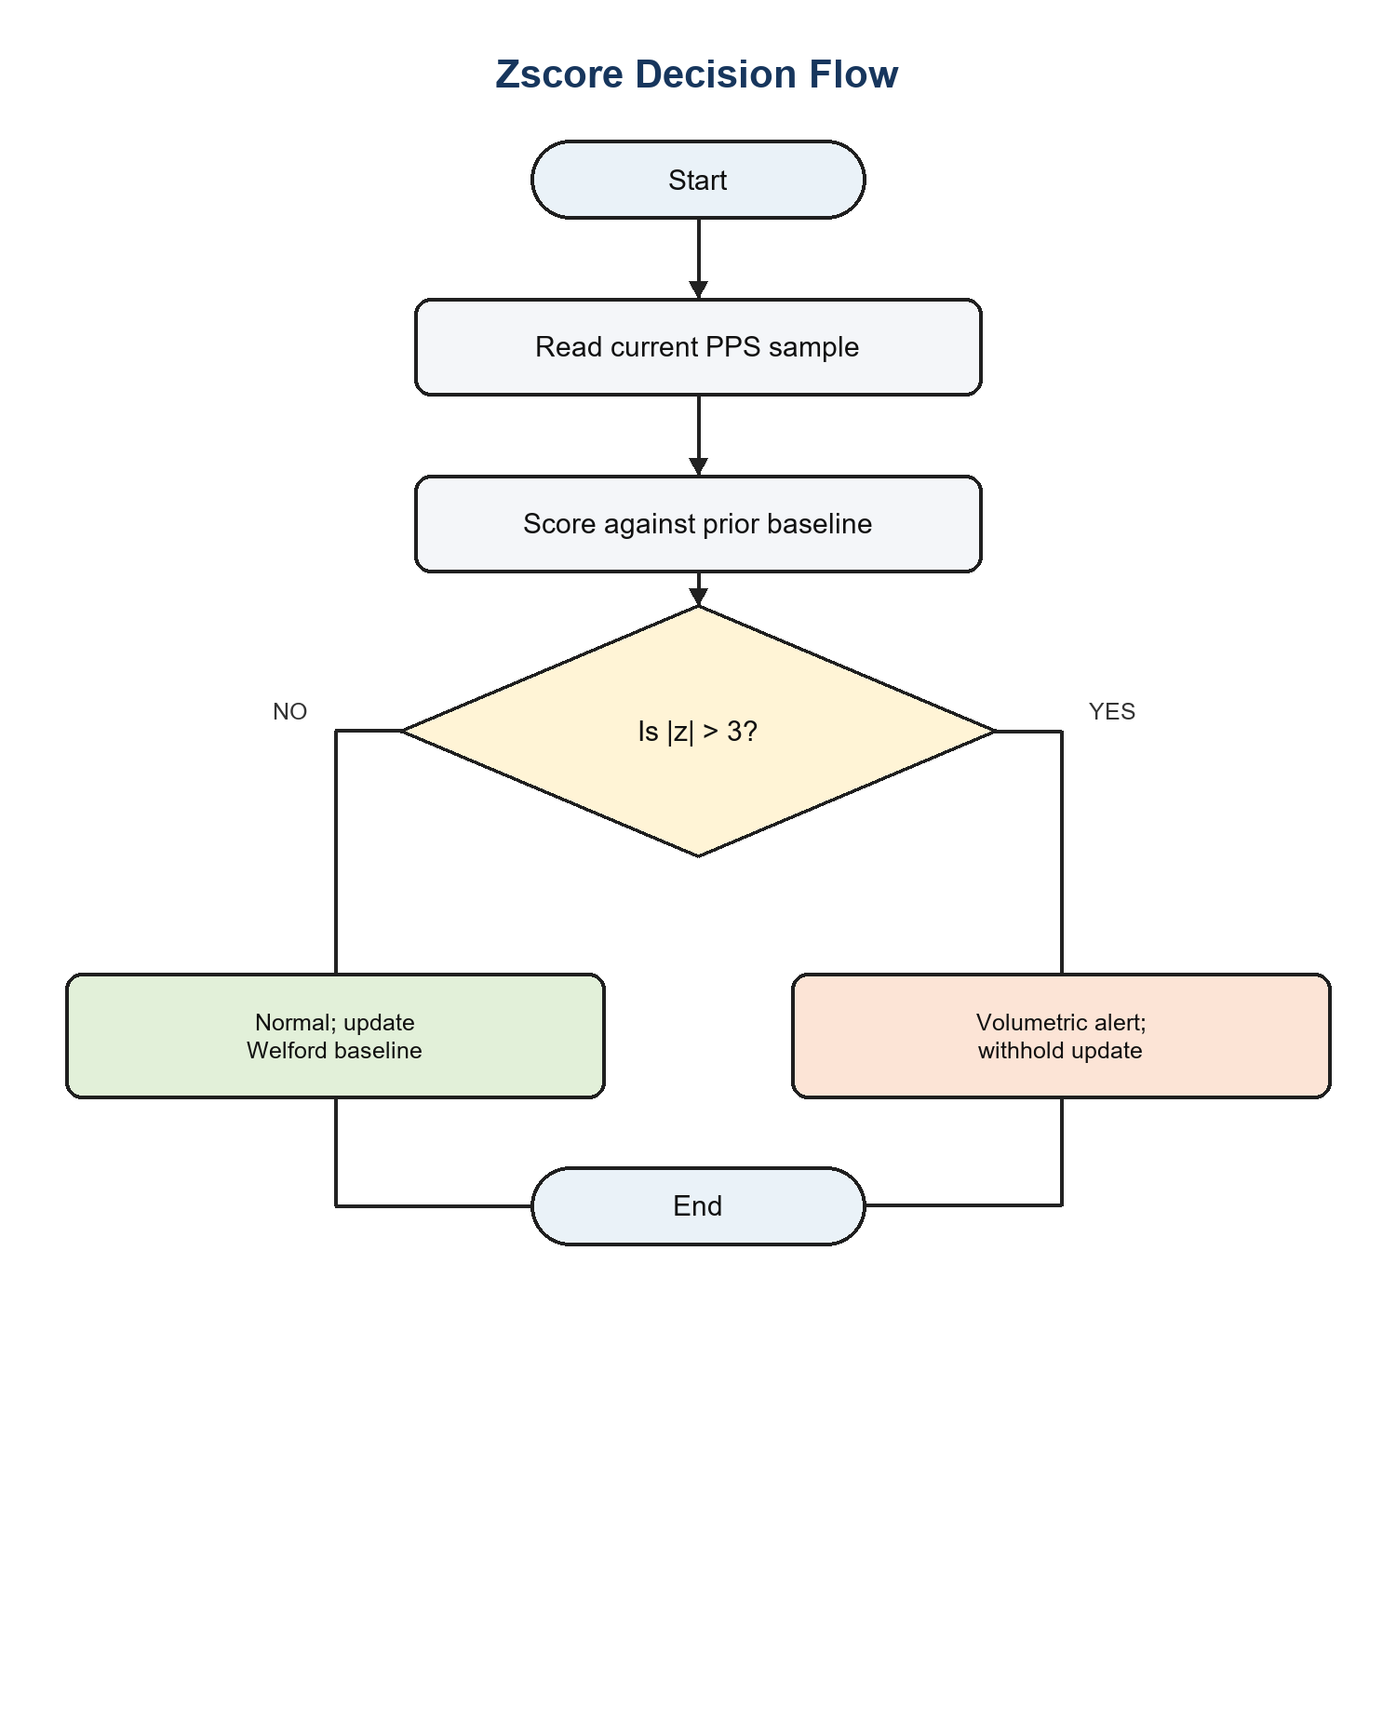
Figure A.12: Corrected Z-Score anomaly flow.

Appendix B: Requirements Traceability
Requirement | Design / module | Evidence | Outcome
FR-1–FR-2 | PacketParser and AF_PACKET sensor | Synthetic frame integration tests | Verified
FR-3 | Five DetectionEngine implementations | 72 unit tests; Table 6.2 | Verified within matched domains
FR-4–FR-6 | Dispatcher, CSV/UDP sinks and SIEM | Integration and nine system tests | Verified
FR-7 | ActiveDefence policy | Opt-in and whitelist assertions | Verified
FR-8–FR-10 | Brain JSON, training and evaluation | Round-trip and reporting tests | Verified
NFR-1–NFR-2 | Bounded threaded architecture | Latency, RAM and CPU benchmark | Targets met
NFR-3 | Privacy and blocking controls | PII, truncation and policy tests | Verified
NFR-5–NFR-9 | Uniform interfaces and standard library | Import audit and test suite | Verified

Appendix C

Reproduction Instructions
The following commands reproduce the main verification evidence from the submitted repository. Live capture alone requires Linux raw-socket privileges; unit, integration, system, evaluation and replay operations use local files or loopback resources.
cd src
python3 -m unittest discover -s tests
python3 evaluation/evaluate.py
python3 replay.py --generate demo.pcap
python3 replay.py --pcap demo.pcap
bash benchmark.sh
Machine-readable outputs are stored as JSON or plain text beside the evaluation scripts. Brain snapshots are human-readable JSON. The PCAP file can be independently opened in Wireshark to confirm that the replay contains the traffic phases described in Table 6.3.

Appendix D: Ethical and Operational Checklist
- Capture only networks and hosts for which explicit authorisation exists.
- Use isolated virtual machines for hostile-traffic generation.
- Apply 64-byte payload truncation and PII redaction before persistence.
- Keep active defence disabled by default and maintain an administrator whitelist.
- Do not automatically block volumetric sources that may be spoofed.
- Retain PCAP and alert evidence only for the stated research purpose.
- Record engine, rationale, severity and ATT&CK mapping for each alert.
- Export brain state and close sockets, files and firewall state on shutdown.

