A Dissertation Final Report on
Minimalist Alert Network for Threat Intelligence System

Anuskar Sigdel
UON ID: 24812606
BSc. (Hons.) Computer Science

Supervisor: Nischal Khadka
Naaya Aayam Multi-Disciplinary Institute
University of Northampton
August 2026

Student Declaration
I, Anuskar Sigdel, declare that this dissertation is my own work. Where other sources of information have been used, they have been acknowledged and referenced in accordance with University of Northampton Harvard conventions. This work has not previously been submitted for assessment for another academic award.
Signed: Anuskar Sigdel
Date: August 2026

Abstract
This dissertation presents the design, implementation and empirical evaluation of MANTIS (Minimalist Alert Network for Threat Intelligence System), a zero-dependency host-based intrusion detection and prevention system engineered from first principles with the Python Standard Library. MANTIS addresses the gap between lightweight but inflexible signature tools and machine-learning stacks whose dependencies, resource costs and opaque decisions can make them unsuitable for commodity edge hosts. The artefact integrates five transparent detection engines: a Welford Z-Score detector for volumetric anomalies, K-Nearest Neighbours for port-scan behaviour, Multinomial Naive Bayes for malicious payload tokens, online K-Means for behavioural novelty and a Bloom Filter for IP reputation. Linux AF_PACKET capture, binary protocol parsing, structured logging, JSON/UDP telemetry, a web SIEM, brain-state persistence and opt-in iptables response are contained in one standard-library process. Evaluation combines 101 automated unit, integration and system tests, domain-matched labelled samples, a reproducible 13,159-frame PCAP scenario and a critical re-appraisal of 299,994 CIC-IoT2023 rows. All tests pass. On the small matched samples, engine MCC ranges from 0.9199 to 1.0000 and every engine fires in its intended replay phase. Operational measurements report approximately 31 MB RAM, 2.4% single-core CPU and 9.4 ms end-to-end latency. These figures verify implementation within the tested environment but do not establish production accuracy. The external-data analysis shows why that distinction matters: an attack prevalence of 0.9761 gives an always-positive classifier an F1 of 0.9879, above the interim KNN result, while the heavy-tailed rate distribution violates the Gaussian assumption of a three-sigma detector. Four algorithmic defects were identified and corrected. The study concludes that a useful lightweight HIDS can be constructed without third-party dependencies, but credible claims require prevalence-aware metrics, assumption–data matching and evidence that extends beyond headline accuracy.
Keywords: intrusion detection; zero dependency; edge computing; machine learning; CIC-IoT2023; evaluation validity; Python

Acknowledgements
I thank my dissertation supervisor for critical feedback throughout the project, particularly the direction to strengthen methodology, evaluation and diagram connectivity. I also thank the academic staff of NAMI College and the University of Northampton for their guidance, and the Canadian Institute for Cybersecurity for making CIC-IoT2023 available. Finally, I am grateful to my family and friends for their support during the research and implementation period.

Table of Contents
Chapter 1: Introduction 11
1.1 Background 11
1.2 Rationale and Problem Statement 11
1.3 Project Aim and Objectives 12
1.4 Scope and Limitations 13
1.5 Structure of the Dissertation 13
Chapter 2: Requirements Engineering 13
2.1 Literature Review 13
2.1.1 Evolution of Intrusion Detection 14
2.1.2 The Black-Box and ML Bloat Challenge 14
2.1.3 CIC-IoT2023 and Contemporary IoT Evidence 14
2.1.4 Implications for MANTIS 14
2.2 Comparable Systems 15
2.2.1 Snort 3.x 15
2.2.2 Suricata 7.x 15
2.2.3 Zeek 6.x 16
2.2.4 Wazuh 4.x 16
2.2.5 Comparative Synthesis 16
2.3 Research Methodology 17
2.3.1 Research Philosophy 17
2.3.2 Constructive Research Method 17
2.4 Development Methodology 18
2.4.1 Methodology for Comparable Analysis 18
2.5 Evaluation Strategy and V-Model Link 19
2.6 Professional, Legal and Ethical Issues 19
2.7 Requirement Specification 20
2.7.1 Problem Domain 20
2.7.2 Proposed Solution Strategy 20
2.7.3 Alternative Solution Strategies 20
2.7.4 Functional Requirements 21
2.7.5 Non-Functional Requirements 21
2.7.6 Performance and Acceptance Criteria 21
2.8 Theoretical Foundations of MANTIS Engines 22
Chapter 3: System Analysis And Design 22
3.1 Use Case Model and Documentation 23
3.2 Sequence Diagrams 25
3.3 Class Diagram 26
3.4 Activity Diagrams 27
3.5 Data Model and Persistence Schema 28
3.6 Layered Architecture 29
3.7 Detection Engine Design 31
3.8 System Interface and Design 32
3.8.1 Wireframe 32
3.8.2 Implemented Mockup 32
Chapter 4: System Implementation 33
4.1 Technology Stack and Architecture 33
4.2 Packet Capture and Parsing 34
4.3 Detection Engines 35
4.4 Training and Brain Persistence 37
4.5 SIEM, Logging and Active Defence 37
4.6 Privacy, PCAP Replay and MITRE Enrichment 38
4.7 Deployment 38
Chapter 5: System Testing and Experimental Results 39
5.1 Testing Strategy 39
5.2 Algorithmic Defect Diagnosis & Remediation 40
5.3 Engine Performance on Labelled Data 41
5.4 Reproducible Evaluation via PCAP Replay 42
5.5 CIC-IoT2023: A Critical Re-Appraisal 43
5.5.1 The Reported Metrics Were Not Evidence of Skill 43
5.5.2 Corrected Z-Score Performance and Diagnosis 44
5.6 Resource & Operational Benchmarking 46
5.7 Threats to Validity 47
5.8 Requirements Verification Summary 47
Chapter 6: Discussion and Critical Evaluation 48
6.1 Critical Appraisal 48
6.2 Objective Fulfilment 49
6.3 Strengths and Limitations 50
6.4 Comparison with Literature 51
Chapter 7: Conclusions and Future Work 51
7.1 Contributions 51
7.2 Research Question Resolution 52
7.3 Future Work 52
7.4 Closing Remark 52
References 53
Appendices 54
Appendix A: Supporting Figures 55
Appendix B: Requirements Traceability 66
Appendix C 68
Reproduction Instructions 68
Appendix D: Ethical and Operational Checklist 68

List of Figures
- Figure 2.1 Comparative positioning of IDS platforms
- Figure 2.2 Agile Kanban workflow
- Figure 3.1 Revised level-1 use-case model
- Figure 3.2 Live-detection sequence
- Figure 3.3 MANTIS class model
- Figure 3.4 Corrected brain-persistence activity flow
- Figure 3.6 Existing intrusion-detection workflow
- Figure 3.7 Proposed MANTIS end-to-end workflow
- Figure 3.8 Web SIEM dashboard wireframe
- Figure 5.1 Domain-matched engine verification metrics
- Figures A.1–A.12 Supporting sequence, activity and algorithm diagrams

Abbreviations
Abbreviation | Meaning
AF_PACKET | Linux raw packet socket family
DDoS | Distributed Denial of Service
HIDS | Host-Based Intrusion Detection System
IDS/IPS | Intrusion Detection / Prevention System
KNN | K-Nearest Neighbours
MCC | Matthews Correlation Coefficient
PCAP | Packet capture file format
SIEM | Security Information and Event Management
WIP | Work in Progress

Chapter 1: Introduction
This chapter introduces the research problem, explains why MANTIS is needed, states the project aim and measurable objectives, and defines the study boundary. An introduction establishes the context and purpose of a dissertation so that later design and evaluation decisions can be traced back to a clearly stated problem.

1.1 Background
Edge Linux servers, IoT gateways and resource-constrained hosts face a growing attack surface spanning volumetric floods, reconnaissance, payload injection and botnet compromise (Neto et al., 2023; OWASP, 2024). Signature-centric NIDS such as Snort and Suricata remain strong against known patterns but cannot detect zero-day or polymorphic threats without prior rules (Roesch, 1999; Sommer and Paxson, 2010). Machine-learning alternatives can close that gap in controlled studies, but operational deployment introduces dependency, resource, concept-drift and interpretability costs that benchmark accuracy alone does not capture (Sommer and Paxson, 2010; Chandola et al., 2009). Commodity edge hardware is therefore left choosing between inflexible signatures and undeployable ML frameworks.

1.2 Rationale and Problem Statement
The research problem is the gap between lightweight but inflexible signature tools and heavy, opaque ML frameworks. On hosts with roughly 1 GB of RAM, commercial agents trigger OOM kills or introduce latencies that degrade line-rate throughput, while simple scripts cannot distinguish floods from scans or detect application-layer injection.
This dissertation investigates whether a Host-Based Intrusion Detection System built entirely from first principles in the Python Standard Library can deliver multi-vector detection under strict resource bounds. The governing research question is:
Can a zero-dependency, first-principles HIDS engineered in standard Python match the multi-vector alert fidelity of heavyweight ML tools while remaining within CPU < 5%, RAM < 50 MB and latency < 15 ms on commodity Linux hardware?
Novelty resides in synthesising five transparent engines—statistical, lazy-learning, probabilistic, online clustering and set-membership—into one multithreaded process with raw AF_PACKET capture, opt-in iptables defence and UDP/JSON SIEM telemetry, without third-party libraries.

1.3 Project Aim and Objectives
Aim: Design, implement, evaluate and critically benchmark MANTIS (Minimalist Alert Network for Threat Intelligence System), a zero-dependency mathematical HIDS for resource-constrained Linux hosts.
Objectives are stated as measurable goals with success criteria (addressing interim feedback that some objectives read as feature lists):
ID | Objective | Success criterion
O1 | Critically synthesise IDS literature comparing signature, ML and first-principles methods for edge hosts. | Comparative matrix of ≥4 systems; gaps linked to FR/NFR.
O2 | Implement five engines (Z-Score, KNN, Naive Bayes, K-Means, Bloom) under a uniform analyse/train/export_brain/import_brain interface using only the standard library. | All engines pass unit tests; prevalence-aware metrics (incl. MCC) reported per engine.
O3 | Build multithreaded AF_PACKET capture with struct decoding and producer–consumer decoupling. | Integration tests with synthetic frames; mean latency < 15 ms.
O4 | Deliver opt-in active defence, structured JSON telemetry and a web SIEM with ATT&CK enrichment. | Blocking requires --block; system-tier API tests pass; MITRE fields present in alerts.
O5 | Provide offline training that serialises human-readable JSON brain snapshots from labelled CSVs / CIC-IoT2023. | Brain round-trips unchanged through JSON; cold-start restore works.
O6 | Evaluate with a V-Model test suite and prevalence-aware metrics; include reproducible PCAP replay. | ≥100 automated tests pass without root; report Precision, Recall, Specificity, Balanced Accuracy, MCC; warn when F1 ≤ no-skill baseline.
O7 | Process network data lawfully under UK GDPR / DPA 2018 with proportionate response. | 64-byte truncation + PII redaction verified at persistence boundary; blocking opt-in and whitelist-safe.

1.4 Scope and Limitations
In scope: plaintext IPv4 Ethernet/TCP/UDP/ICMP on Linux; HIDS with cap_net_raw/cap_net_admin; Python 3.6+ standard library only; VirtualBox lab (Ubuntu sensor, Kali attacker) plus CIC-IoT2023 and synthetic PCAP replay.
Out of scope: TLS payload decryption / MITM; Windows/macOS native capture; DPDK/PF_RING acceleration; multi-node consensus for SIEM clustering.

1.5 Structure of the Dissertation
Chapter 2 performs requirements engineering through literature, comparable-system analysis, methodology and formal requirements. Chapter 3 presents system analysis and design. Chapter 4 documents implementation. Chapter 5 reports testing and evaluation. Chapter 6 discusses the findings critically. Chapter 7 concludes and identifies future work.

Chapter 2: Requirements Engineering
Requirements engineering identifies what a system must achieve, the constraints under which it must operate and the evidence that will demonstrate success. For MANTIS, requirements were derived from peer-reviewed intrusion-detection research, analysis of comparable products, the resource limits of edge Linux hosts and the legal risks of packet capture and automated blocking. This chapter therefore moves from evidence to methodology and then to formal, testable requirements rather than listing features without justification.

2.1 Literature Review
A literature review critically compares published knowledge rather than merely summarising sources. The review asks what is already known about signature detection, anomaly detection, edge deployment and evaluation validity, then connects each finding to a MANTIS design decision. The selected works are relevant because they address the four central concerns of this project: detection scope, mathematical transparency, resource cost and credible evaluation.

2.1.1 Evolution of Intrusion Detection
Denning (1987) framed intrusion detection as detecting deviations from normative profiles, establishing the HIDS/NIDS dichotomy (NIST, 2007). Signature systems match byte patterns with low false positives on known threats but fail on zero-days (Roesch, 1999; Sommer and Paxson, 2010). Anomaly detection builds behavioural baselines and flags significant deviation (Chandola et al., 2009). Edge/IoT settings intensify the constraint: limited RAM and CPU against multi-vector attacks (OWASP, 2024; Hunt, 2016).

2.1.2 The Black-Box and ML Bloat Challenge
Research prototypes frequently optimise classification scores on fixed offline datasets while leaving deployment cost and operational drift under-examined. Sommer and Paxson (2010) warn that closed-world assumptions, non-stationary traffic and weak base-rate reasoning make laboratory IDS results difficult to transfer to live networks. Chandola et al. (2009) similarly show that anomaly detectors depend on the definition of normality and on the selected distance or probability model. CIC-IoT2023 offers broad contemporary IoT coverage, but it is a benchmark rather than a guarantee that one model transfers unchanged to a host sensor (Neto et al., 2023).

2.1.3 CIC-IoT2023 and Contemporary IoT Evidence
Neto et al. (2023) created CIC-IoT2023 to represent diverse IoT devices and attacks. It gives MANTIS broader traffic evidence than the small verification samples, but aggregated rows omit some temporal relationships required by an online host detector. Class imbalance can also inflate headline metrics. It is therefore used as an external stress test rather than unquestioned proof of production performance.

2.1.4 Implications for MANTIS
The literature leads to four requirements: combine known-pattern and behavioural evidence; define "normal" explicitly; report CPU, memory and latency with classification results; and account for prevalence, leakage and drift. MANTIS consequently uses five transparent engines, domain-matched tests, bounded resource targets and prevalence-aware metrics.

2.2 Comparable Systems
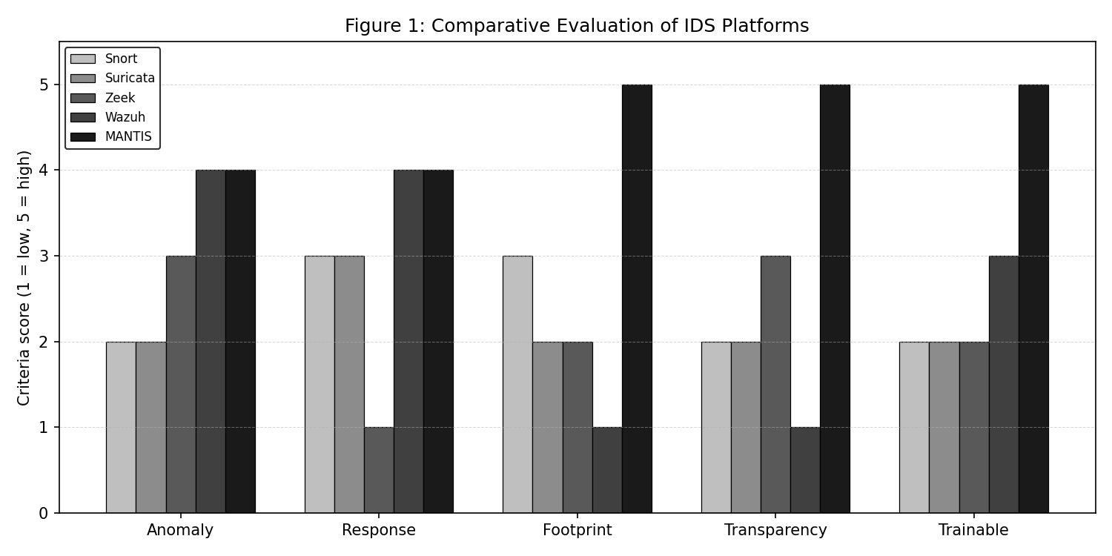
Figure 2.1: Comparative positioning of representative intrusion-detection platforms.
A comparable system solves part of the same problem and supplies a requirement baseline. Snort, Suricata, Zeek and Wazuh serve different roles, so they are compared through detection approach, footprint, response, transparency and dependencies rather than ranked as universal substitutes.

2.2.1 Snort 3.x
Snort is a mature signature NIDS with deep packet inspection, extensive rules and optional inline prevention (Roesch, 1999). It is a strong known-threat baseline, but novel attacks need a rule and its native toolchain complicates minimal installation. MANTIS targets the complementary problem of transparent behavioural detection on smaller hosts.

2.2.2 Suricata 7.x
Suricata combines multi-threaded signature inspection, protocol tracking, EVE JSON and optional inline prevention (OISF, 2024). Its concurrency and telemetry informed MANTIS's queue and JSON/UDP alerts. Its core remains rule-led and depends on native libraries; MANTIS retains the operational ideas while using five standard-library detectors.

2.2.3 Zeek 6.x
Zeek converts traffic into rich protocol events and logs for stateful behavioural analysis (Paxson, 1999). It offers protocol depth and analyst flexibility, but uses a larger native runtime, a specialised scripting environment and external response. MANTIS trades breadth for a compact sensor whose decision path is visible in one Python codebase.

2.2.4 Wazuh 4.x
Wazuh combines host agents, log collection, rules, vulnerability information, dashboards and XDR/SIEM services. This suits enterprise infrastructure but exceeds the project's one-core, low-memory target. MANTIS compares only overlapping monitoring, alerting, dashboard and response functions and does not claim enterprise feature parity.

2.2.5 Comparative Synthesis
The comparison identifies a deliberate niche. Snort and Suricata lead in maintained rules, Zeek in protocol semantics and Wazuh in enterprise integration. MANTIS prioritises inspectable formulas, one-process deployment, zero external Python dependencies and approximately 31 MB resident memory. Its bounded claim is useful multi-vector evidence where larger platforms are impractical; the table links these gaps to Section 2.7.
System | Category | Architecture | Typical RAM | Anomaly method | Active response | Dependencies
Snort 3.x | Signature NIDS | C++ | ~150 MB | Rules only | Optional inline | DAQ, pcre, toolchain
Suricata 7.x | Signature/flow | Multi-thread C | ~500 MB | Flow thresholds | Native NFQ | libpcap, libyaml
Zeek 6.x | Behavioural monitor | Event DSL | ~400 MB | Scripted state | External | C++ toolchain
Wazuh 4.x | XDR/SIEM | Agent–manager | >4 GB | Rules + external ML | Agent scripts | Java, OpenSearch
MANTIS | First-principles HIDS | Threaded Python | ~31 MB | Five math engines | Opt-in iptables | Stdlib only
Snort and Suricata excel at known-threat matching but remain signature-first (Cisco Talos, 2024; OISF, 2024). Zeek offers deep protocol analysis without built-in blocking (Paxson, 1999). Wazuh provides enterprise coverage at multi-gigabyte cost (Wazuh Inc., 2024). MANTIS occupies the opposite corner: anomaly-first detection at edge-scale memory with full mathematical auditability.

2.3 Research Methodology
Methodology defines the principles and procedures used to answer a research question. MANTIS combines measurable, positivist evidence with Constructive Research because it contributes both a working security artefact and knowledge gained by building and evaluating it.

2.3.1 Research Philosophy
A predominantly positivist position supports repeatable measures such as pass/fail status, confusion-matrix counts, latency, CPU and memory. Operational usefulness remains context-dependent, so quantitative evidence verifies bounded claims while critical discussion explains what those measurements cannot establish.

2.3.2 Constructive Research Method
The study follows Constructive Research (Crnkovic, 2010): identify a practical problem, ground it in theory, construct an artefact, demonstrate it empirically, evaluate quantitatively, and document contribution. Applied here: (1) edge hosts excluded from intelligent IDS by resource/opacity costs; (2) literature synthesis (Ch. 2); (3) MANTIS construction (Ch. 4–5); (4) Kali live-fire plus offline PCAP/CIC evaluation (Ch. 6); (5) prevalence-aware metrics and resource benchmarks; (6) this dissertation.

2.4 Development Methodology
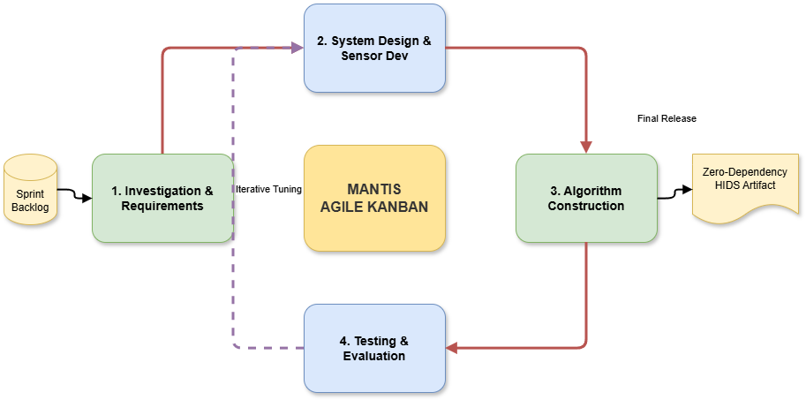
Figure 2.2: Agile Kanban workflow linking requirements, construction, testing and release.
Waterfall, Scrum and Kanban were considered. Waterfall responds poorly when evaluation invalidates an assumption, while Scrum adds team ceremonies. Kanban suits a solo artefact because work is risk-prioritised, work-in-progress is limited and completed cards can reopen when evidence reveals a defect.

2.4.1 Methodology for Comparable Analysis
Comparable systems were assessed consistently by detection basis, anomaly capability, response, deployment footprint, transparency and dependencies. Official documentation and established publications supplied evidence. Because environments differ, footprint comparisons are indicative rather than controlled and no misleading aggregate score is calculated. Solo development used Kanban with columns Backlog → To Do → In Progress (WIP=2) → Testing (WIP=1) → Done. WIP limits forced completion of engine mathematics before UI polish and required a passing unit tier before promoting work to Done. Evidence of continuous flow is recorded in Appendix A (Kanban board and Gantt through final submission). This operational detail addresses interim feedback that methodology was stated but not adequately shown in practice.

2.5 Evaluation Strategy and V-Model Link
Evaluation determines whether the artefact satisfies requirements and whether its claims are valid. A modified V-Model links formulae to unit tests, interfaces to integration tests, system requirements to end-to-end tests and the research question to experimental evaluation.
Evidence is matched to engine semantics: rates for Z-Score, scan features for KNN, labelled payloads for Naive Bayes, clustered observations for K-Means and held-out addresses for Bloom. Synthetic frames verify parsing, PCAP replay verifies the pipeline and CIC-IoT2023 supplies a limited external stress test. Separating training and verification reduces leakage. Design decomposition maps to three executable tiers realised in Chapter 6: unit tests against component design (72 cases), integration against architecture (20), system against requirements via real UDP/HTTP (9). Total: 101 tests, none requiring root. Evaluation is therefore embedded in the method, not bolted on after implementation—the primary remediation of the interim evaluation mark.

2.6 Professional, Legal and Ethical Issues
Professional, legal and ethical analysis converts risks—personal-data capture, unauthorised testing and accidental blocking—into controls. Tests use owned isolated VMs; persisted payloads are minimised; identifiers are redacted; active defence is disabled by default; and shutdown restores firewall state. Proposal feedback graded this area F+. The final system treats ethics as design constraints, not an afterthought.
UK GDPR / Data Protection Act 2018. Packet capture in the academic lab is limited to owned VirtualBox hosts; no production user traffic is processed. Data minimisation is enforced in privacy.py: payload excerpts truncate to 64 bytes; emails, password parameters and card-like digit runs are redacted; --anonymise-ips masks the final IPv4 octet. Redaction occurs in AlertDispatcher so CSV logs and UDP telemetry inherit the same guarantee. Integration tests assert planted PII never reaches disk.
Computer Misuse Act 1990. Live-fire tests use only attacker/victim VMs under the author's control. Automated iptables DROP is a consequential act: it is opt-in (--block), scoped by detection class (--block-on), whitelist-aware, and reversed by flush() on exit. Volumetric detections are excluded from default blocking because spoofed sources make blind blocking counterproductive.
Professional practice. Zero third-party packages reduce supply-chain risk for a security monitor. MITRE ATT&CK mapping expresses alerts in analyst vocabulary. Encrypted TLS payloads are explicitly out of scope: the system does not terminate or decrypt HTTPS.
A longer ethics checklist appears in Appendix D.

2.7 Requirement Specification
A requirement specification converts research findings into statements that are necessary, testable and traceable. Functional requirements define behaviour; non-functional requirements define measurable qualities and constraints. Each MANTIS requirement is linked to a design component and a verification method so that implementation completion cannot be confused with objective fulfilment.

2.7.1 Problem Domain
The problem domain is a constrained Linux host that must identify hostile behaviour without a large agent stack. Limited CPU/RAM, encrypted payloads and unsafe automated response shape the design. Detection must cover floods, scans, malicious plaintext, novelty and known malicious sources on small VMs, gateways and single-board computers.

2.7.2 Proposed Solution Strategy
The proposed solution is a multithreaded, standard-library HIDS. AF_PACKET capture and struct decoding create events; five engines analyse relevant features; a dispatcher records and forwards evidence; and an opt-in policy may apply iptables rules. Human-readable JSON preserves trained state and auditability.

2.7.3 Alternative Solution Strategies
Three alternatives were unsuitable against the constraints. Extending Snort retains a native rule toolchain; Scikit-Learn violates zero-dependency auditability; and Wazuh needs larger infrastructure. A signature-only Python script remains small but cannot address behavioural novelty. Each alternative is valid in a different deployment context.

2.7.4 Functional Requirements
- FR-1 Capture Ethernet frames via AF_PACKET without libpcap/Scapy.
- FR-2 Decode Ethernet/IPv4/TCP/UDP/ICMP with struct.unpack.
- FR-3 Classify via five independent engines.
- FR-4 Persist alerts to locked CSV with ATT&CK fields.
- FR-5 Emit structured JSON UDP telemetry (port 9999).
- FR-6 Serve web SIEM on HTTP 8080 with live stats and PCAP export.
- FR-7 Opt-in iptables DROP for flagged sources.
- FR-8 Export/import JSON brain state.
- FR-9 Offline training from CSV/JSON/CIC-IoT2023.
- FR-10 Reproducible evaluation reporting prevalence-aware metrics.

2.7.5 Non-Functional Requirements
- NFR-1 Mean per-packet latency < 15 ms.
- NFR-2 RAM < 50 MB; CPU < 5% single core under normal load.
- NFR-3 Minimal capabilities; 64-byte excerpts; blocking opt-in.
- NFR-4 Single-script install across major package managers.
- NFR-5 Uniform engine interface; unit tier < 1 s.
- NFR-6 Bounded queues and locks against unbounded growth.
- NFR-7 Zero external Python dependencies.
- NFR-8 Human-readable, auditable decisions.
- NFR-9 New engines pluggable without rewriting capture/dispatch.

2.7.6 Performance and Acceptance Criteria
NFR | Target | Measured | Status
NFR-1 Latency | < 15 ms | 9.4 ms | Met
NFR-2a RAM | < 50 MB | ~31 MB | Met
NFR-2b CPU | < 5% | 2.4% | Met
NFR-5 Unit tier | < 1.00 s | 0.228 s | Met
Full suite | — | 101/101 in 4.27 s | Pass

2.8 Theoretical Foundations of MANTIS Engines
Z-Score / Welford. Volumetric rate x is scored as Z=(x-μ)/σ. Welford (1962) updates μ and M2 online in O(1) space, enabling baseline estimation without storing history.
K-Nearest Neighbours. Port scans map to feature space (u,c) (unique ports, packet count). Euclidean distance and majority (or distance-weighted) vote among K neighbours classify Scan vs Normal (Fix and Hodges, 1951). A ports-to-packets ratio later separates scans from floods linearly.
Multinomial Naive Bayes. Payload tokens W yield ln P(C | W) = ln P(C) + Σ ln P(wᵢ | C) with Laplace smoothing (McCallum and Nigam, 1998), scoring SQLi/XSS/LFI without neural models.
Online Mini-Batch K-Means. Centroids update as c ← c + α(x − c) (Sculley, 2010). Novelty is decided on distance from any centroid relative to a pooled distance baseline, not on cluster index.
Bloom Filter. Membership of IP x is tested in O(1) via k hash probes into bit array B, with false-positive probability approximately (1 − exp(−kn/m))^k (Bloom, 1970).

Chapter 3: System Analysis And Design
System analysis identifies roles, information and behaviour; system design converts them into an implementable architecture. Each diagram is therefore defined briefly and linked to a MANTIS requirement or outcome rather than shown as an isolated picture.

3.1 Use Case Model and Documentation
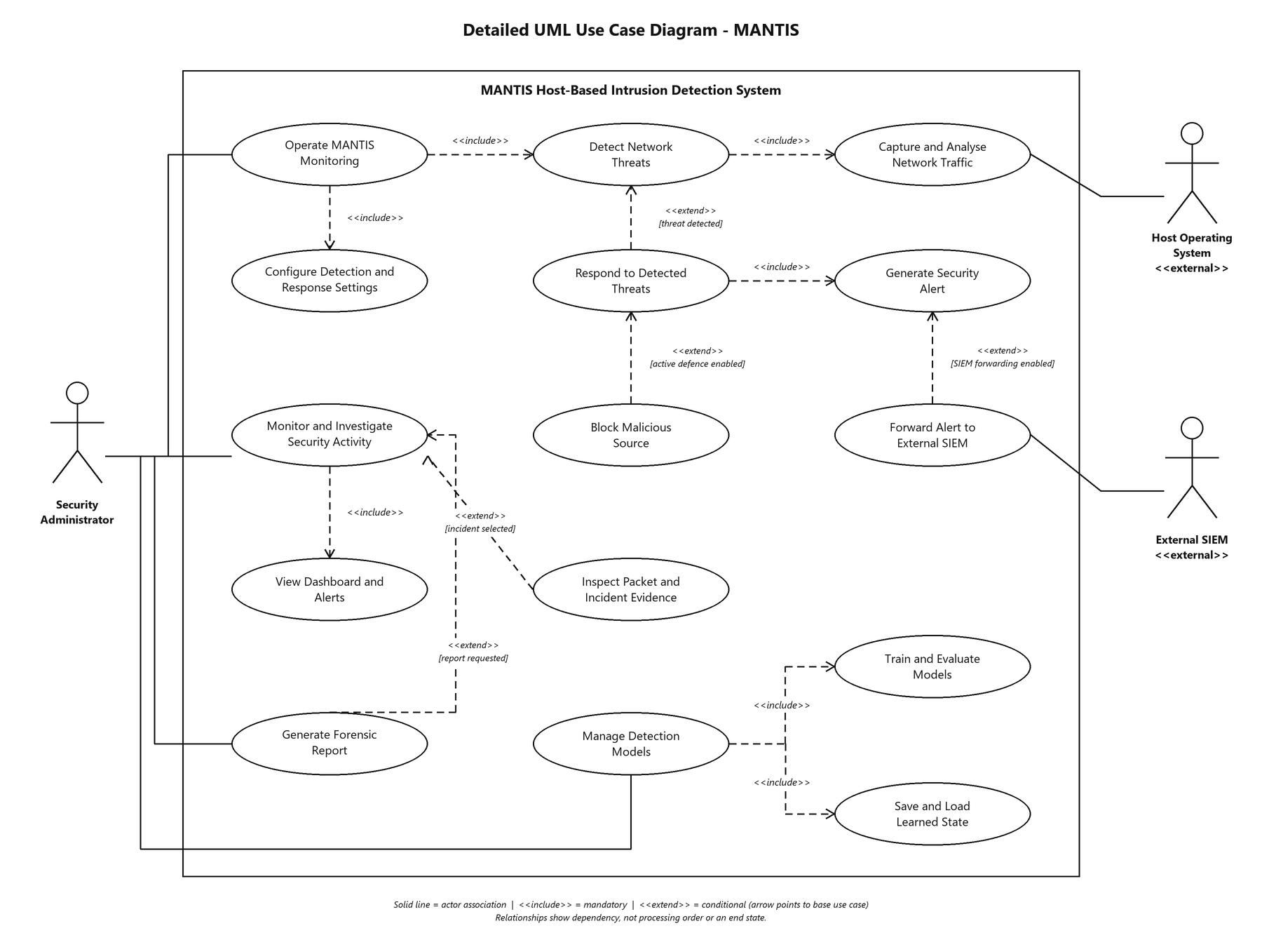
Figure 3.1: Revised level-1 use-case model with actor associations, «include» and «extend» relationships.
A use case is a goal achieved through actor-system interaction, not an implementation sequence. The level-1 model begins with administrator goals rather than a start-up decision. Mandatory shared behaviour uses «include»; optional or conditional behaviour uses «extend».
Use-case documentation records actors, preconditions, success outcomes, main interaction and alternatives. Monitoring ends at an administrator shutdown request, which includes brain export, timestamped JSON, forensic reporting and resource closure. Investigation returns to monitoring or exports evidence, so each interaction has a visible destination. Interim feedback noted that use-case actors were identified but associations were unclear. Table 4.1 makes associations explicit.
Table 4.1: Actor–use-case associations.
Actor | Use case | Association
Security Administrator | Operate MANTIS Monitoring | Direct actor association
Security Administrator | Monitor and Investigate Security Activity | Direct actor association
Security Administrator | Generate Forensic Report | Direct actor association
Security Administrator | Manage Detection Models | Direct actor association
Host Operating System | Capture and Analyse Network Traffic | Direct actor association (provides frames)
External SIEM | Forward Alert to External SIEM | Direct actor association (receives alerts)
Internal relationship | Detect Network Threats | «include» Capture and Analyse Network Traffic
Internal relationship | Respond to Detected Threats | «include» Generate Security Alert
Internal relationship | Block Malicious Source | «extend» Respond to Detected Threats (blocking enabled)
Internal relationship | Forward Alert to External SIEM | «extend» Generate Security Alert (forwarding enabled)
Sequence, class and activity diagrams (Appendix A) show message timing, Sensor composition of PacketParser, AlertDispatcher and DetectionEngine subclasses, and the capture→classify→dispatch control flow. The logical data model relates Sensor, Packet Event, Threat Alert, Engine, Brain Snapshot and Firewall Rule (1..* where applicable); persistence uses flat CSV/JSON rather than a relational DBMS, matching the zero-dependency constraint.

3.2 Sequence Diagrams
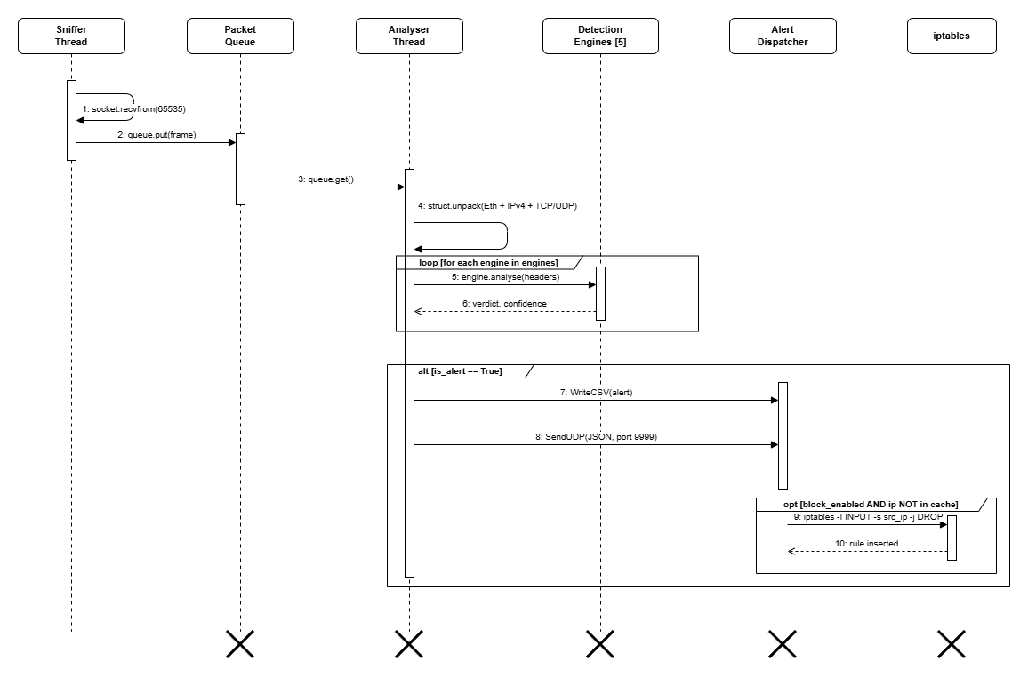
Figure 3.2: Live-detection sequence from kernel frame to operator-visible alert.
A sequence diagram orders messages over time. Kernel frames pass through queue, parser, engines and dispatcher; blocking follows only after policy checks. Training, SIEM and PCAP sequences each return a brain snapshot, evidence export or metrics report to their initiating actor.

3.3 Class Diagram
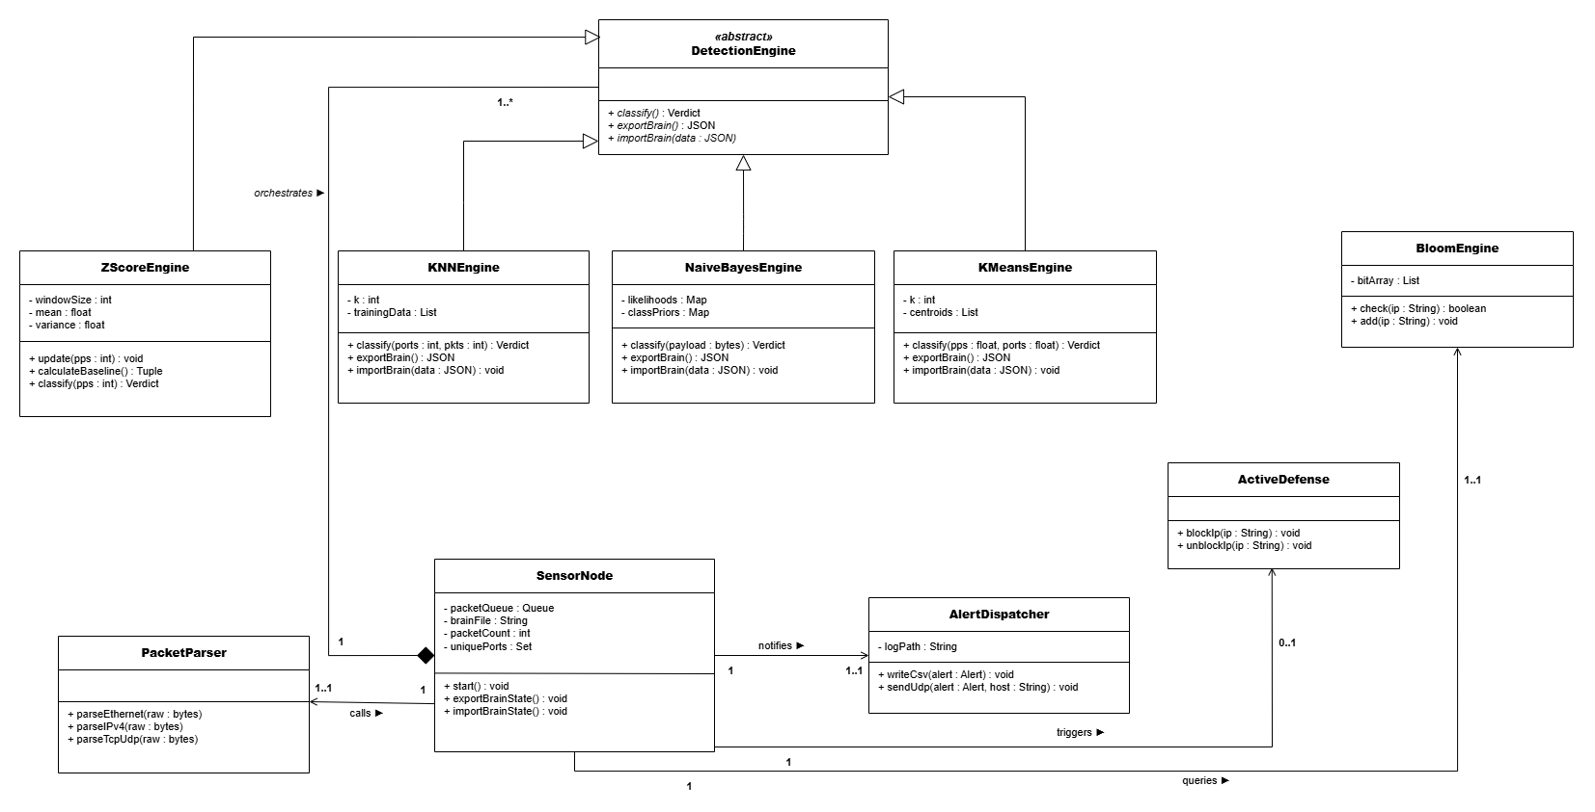
Figure 3.3: MANTIS class model and principal relationships.
A class diagram defines static responsibilities and relationships. SensorNode composes PacketParser, AlertDispatcher and DetectionEngine implementations. Inheritance enforces the common analyse, train, export_brain and import_brain contract; dependencies show data exchange without shared ownership.

3.4 Activity Diagrams
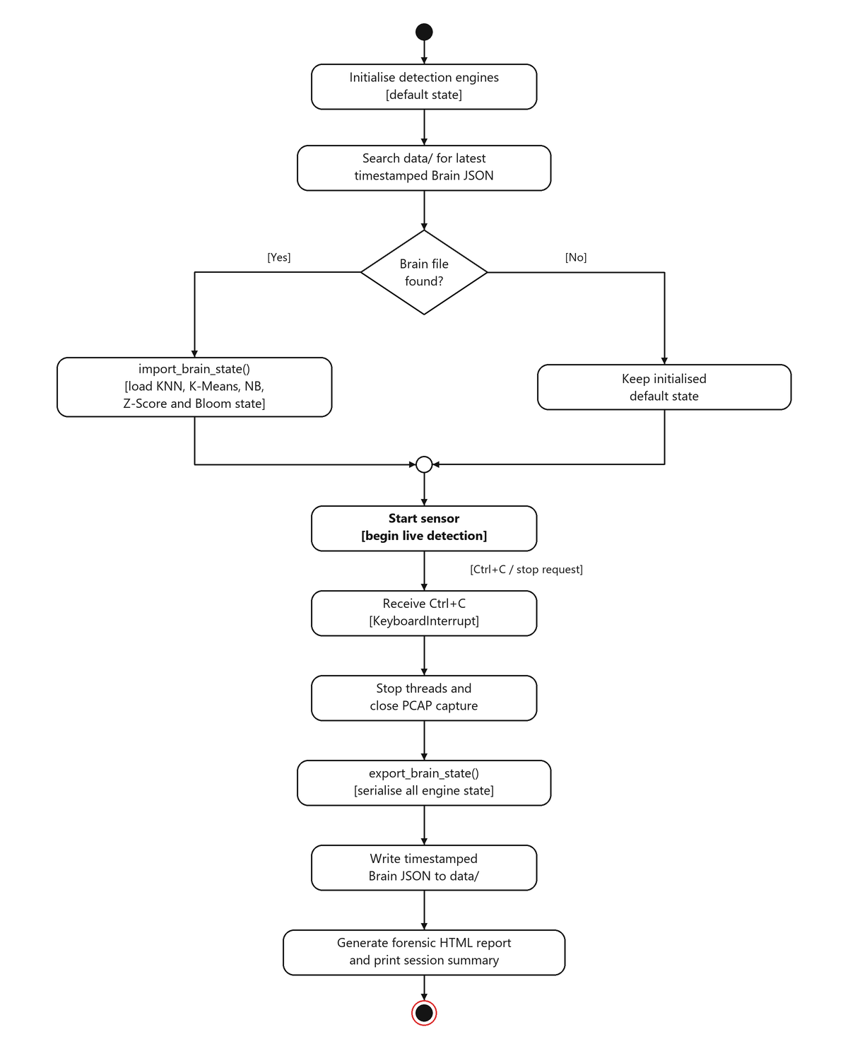
Figure 3.4: Corrected brain-persistence activity flow; start-up is a process and shutdown is an event.
An activity diagram represents control flow, concurrency and end states. Start-up performs configuration and brain restoration before monitoring. SIGINT exits the running loop and initiates persistence and closure; it is not a decision immediately after Start. Fork/join bars show parallel analysis and guarded branches show alerting or continuation.

3.5 Data Model and Persistence Schema
A data model defines stored entities and their relationships. MANTIS links Packet Event, Engine Verdict, Threat Alert, Brain Snapshot, Firewall Rule and Report through identifiers and timestamps. CSV and JSON favour portability and inspection over relational concurrency.

3.6 Layered Architecture
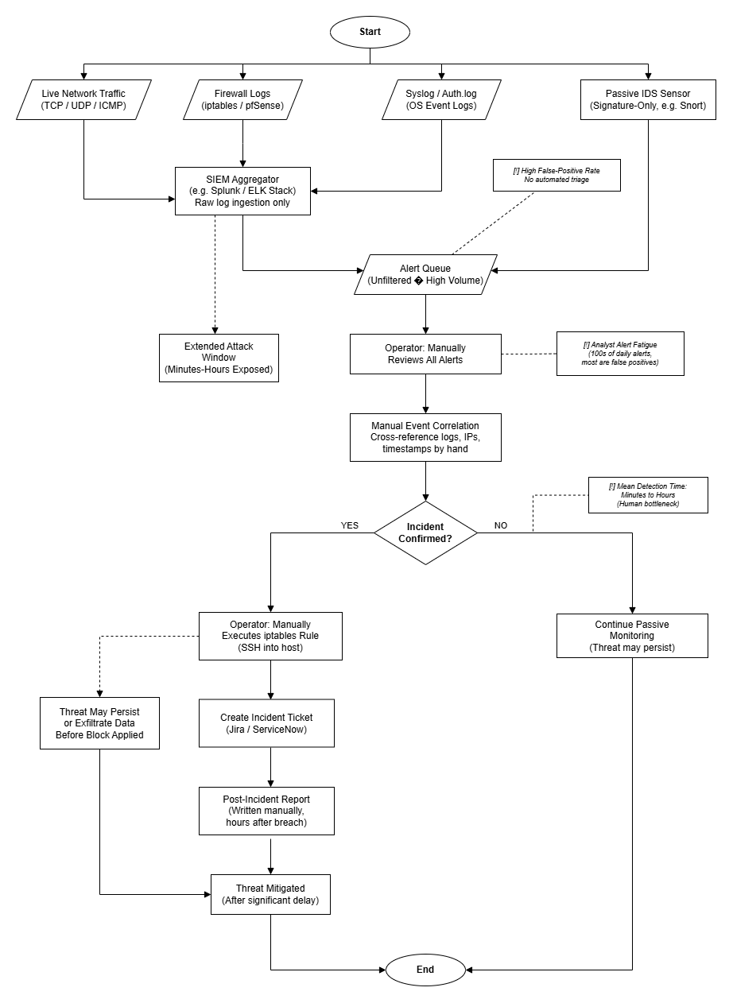
Figure 3.6: Existing intrusion-detection workflow and operational constraints.
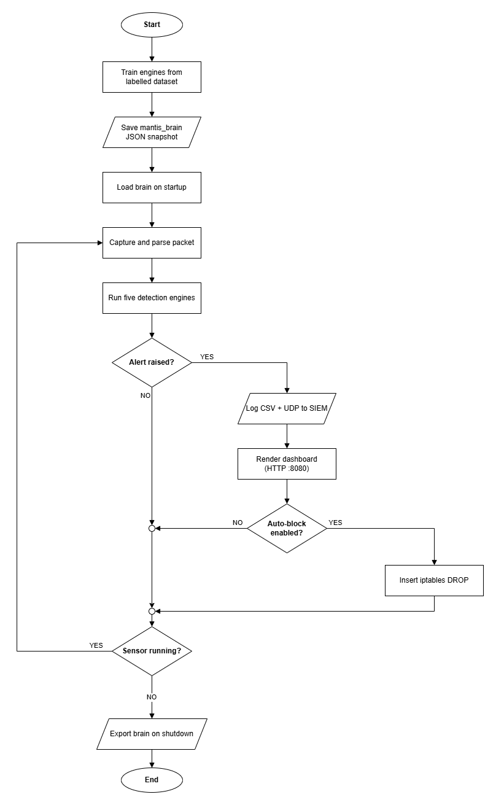
Figure 3.7: Proposed MANTIS end-to-end workflow.
Architecture separates responsibilities so changes remain local. Acquisition, parsing, detection, dispatch/persistence and presentation communicate through a bounded queue and immutable verdicts. Policy-gated response prevents engines from changing the firewall directly. Five layers decouple concerns: (1) AF_PACKET acquisition; (2) PacketParser feature extraction; (3) five-engine mathematical core; (4) persistence, opt-in defence and brain JSON; (5) CLI/web SIEM and UDP telemetry. A producer thread pushes frames into queue.Queue; a consumer unpacks, analyses and dispatches alerts, limiting GIL contention during bursts.

3.7 Detection Engine Design
Algorithm design specifies each engine's input, state, decision rule and output. Z-Score measures rate deviation, KNN scan similarity, Naive Bayes payload tokens, K-Means distance novelty and Bloom reputation membership. A common Verdict makes the different mathematics usable by one dispatcher. Detailed pseudocode (defective and corrected) is in Appendix C. Summaries:
- Z-Score: predict-then-update Welford baseline; alert if |Z|>3; withhold anomalies when guard_baseline is set.
- KNN: scaled features plus ports/packets ratio; distance-weighted vote among K=3.
- Naive Bayes: log-space multinomial scores; Softmax confidence; threshold 0.80.
- K-Means: online centroid update; novelty if nearest-centroid distance exceeds μ_d+kσ_d.
- Bloom: three stdlib hashes into bit array; feed loader for threat-intel lists.

3.8 System Interface and Design
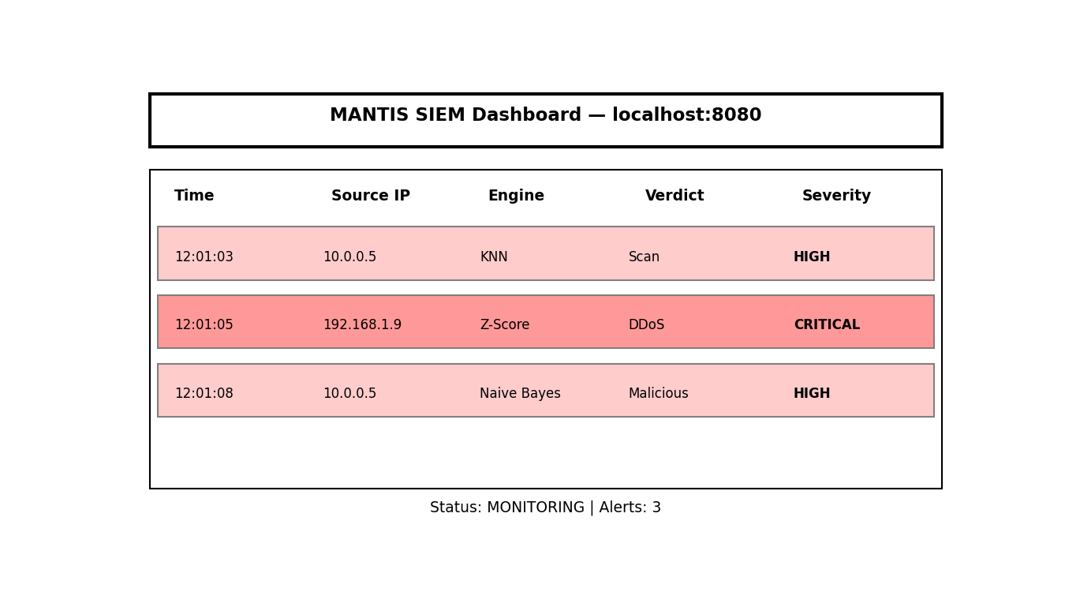
Figure 3.8: Web SIEM dashboard wireframe.
Interface design specifies how operators observe state and obtain evidence. The CLI prioritises live rate, queue health and alerts; the SIEM shows time, source, engine, severity and ATT&CK context. Text labels supplement colour and exports lead to JSON, PCAP or forensic reports.

3.8.1 Wireframe
A wireframe is a low-fidelity plan of layout and information hierarchy. It validates placement and navigation before visual styling.

3.8.2 Implemented Mockup
A mockup demonstrates the realised interface functions: live alert rows, severity labels, packet history, health statistics and evidence export. The explanation links each visible region to an operator task rather than treating screenshots as self-explanatory. Interim feedback noted wireframes without descriptions. The interfaces are specified as follows.
CLI dashboard. Full-width terminal composition: header brand “MANTIS”; live PPS gauge; scrolling alert feed (timestamp, engine, verdict, source IP); status line for queue depth and brain path. No card chrome—one job per region.
Web SIEM (`web_template.html`, port 8080). Top bar with brand and mode. Primary pane: alert table columns Timestamp, Source IP, Engine, Verdict, Technique (link to attack.mitre.org), Risk, Severity (colour-coded). Secondary pane: scrollable packet history from the in-memory ring buffer (raw hex excerpts). Footer actions: Export JSON, Export .pcap (Wireshark), Config summary from /api/config. Stats strip (CPU/RAM, technique counts) sits below the hero alert region so the first viewport remains alert-led.
Active defence control. Blocking is not a default UI toggle that silently arms the firewall; operators enable it only via CLI --block, matching NFR-3 proportionate response.

Chapter 4: System Implementation
Implementation is the translation of the approved design into executable modules. This chapter follows a packet from capture through parsing, engine analysis, persistence, presentation and optional response, then explains training, privacy controls and deployment. Each topic begins with its responsibility so that source-code detail remains connected to the architecture.

4.1 Technology Stack and Architecture
MANTIS is implemented in Python 3.6+ using only standard-library modules for capture, decoding, concurrency, mathematics, hashing, response and web serving. No PyPI package is imported. This is an architectural constraint: every algorithm remains inspectable and transitive dependency risk is avoided.
The producer–consumer pipeline follows Chapter 3. A sniffer queues raw frames; a consumer parses features and invokes the engines; and AlertDispatcher fans qualifying verdicts to audit logs, telemetry, dashboards, optional PCAP storage and policy-gated ActiveDefense. One dispatch point also provides a common privacy-sanitisation boundary.
Modules separate capture/parsing, engines, utilities, dashboards, training, evaluation and tests. Appendix D lists the repository tree. Configuration follows command-line, environment, local JSON and seeded-default precedence, enabling reproduction without source edits while retaining safe first-boot behaviour.

4.2 Packet Capture and Parsing
SensorNode in sensor.py opens a raw socket bound to AF_PACKET with SOCK_RAW and htons(0x0003) (ETH_P_ALL), granting access to all Ethernet frames visible to the host network interface. A producer thread calls recvfrom with a 65,535-byte buffer—the maximum IPv4 jumbo-frame size—and places (timestamp, raw_bytes) tuples onto a bounded queue.Queue. The consumer thread blocks on get with a one-second timeout so the main loop can honour shutdown signals cleanly. When the queue reaches capacity, the producer drops the oldest frame rather than blocking capture indefinitely; this back-pressure policy prioritises liveness over completeness under sustained flood conditions, which is consistent with the Z-Score engine's volumetric threat model.
PacketParser in parser.py decodes each frame through a layered walk: Ethernet header (14 bytes), optional 802.1Q VLAN tag (4 bytes when ethertype 0x8100), IPv4 header (minimum 20 bytes with IHL-derived options length), and transport-layer payload for TCP, UDP, or ICMP. Field extraction uses explicit struct.unpack format strings rather than heuristic slicing, which makes truncation behaviour predictable. Frames shorter than the declared header length increment a truncated_count statistic and return None rather than raising an exception, ensuring that a malformed or partial capture cannot terminate the analysis loop. Local traffic destined for SIEM ports 8080 and 9999 is filtered at parse time to prevent telemetry feedback loops when the sensor and dashboard run on the same host.
Each successfully parsed packet contributes to rolling one-second aggregates maintained by the sensor: packet count, unique destination port count, and byte volume. At the end of each elapsed second, these aggregates are passed to the Z-Score, KNN, and K-Means engines as feature vectors. TCP and UDP payloads are decoded to uppercase token streams for the Naive Bayes engine. Source IPv4 addresses are normalised and passed to the Bloom filter for O(1) reputation lookup against a loaded threat-intelligence feed. The parser therefore acts as the single semantic boundary between raw bytes and engine-specific observations, which simplifies integration testing: synthetic frames constructed in test_integration.py need only satisfy the parser contract to exercise the full downstream pipeline.

4.3 Detection Engines
All five engine classes inherit from the abstract DetectionEngine base in base.py, which defines a uniform contract of analyse(), train(), export_brain(), and import_brain() methods returning a structured Verdict object (label, confidence, detail, is_threat). NFR-5 requires this interface so that the sensor orchestrator, evaluation harness, and brain serialisation code remain engine-agnostic: a sixth detector could be added by subclassing DetectionEngine without modifying capture or dispatch logic. Each engine retains its domain-specific internal methods (update, classify, check) for backward compatibility with unit tests written during the interim build.
Z-Score (`z_score.py`). The MinimalistStats engine detects volumetric floods from packets-per-second observations. It maintains two parallel estimators: a bounded rolling deque (default window 30) that forgets stale traffic, and Welford's online algorithm for numerically stable session-wide mean and variance accumulation. The critical design correction—documented in Chapter 5.5.1—is predict-then-update ordering: the current observation is scored against the baseline before being appended to the window, because self-inclusion analytically caps the z-score at (n-1)/√{n}, which for small windows falls below the 3.0 threshold and renders the alert condition unsatisfiable. The guard_baseline flag (default True) withholds anomalous observations from baseline updates, preventing attack traffic from poisoning the mean and variance so that a sustained flood cannot gradually become the new "normal." When guard_baseline=False, the engine reproduces the interim defective behaviour for controlled comparison in evaluation runs.
KNN (`knn.py`). The KNNMonitor class classifies one-second intervals as port-scan reconnaissance or normal browsing using k-nearest-neighbour voting (default k=3). Raw features—unique destination ports and packet count—are augmented with a derived ports-per-packet ratio that encodes protocol semantics: scanners send approximately one SYN per port without completing handshakes (ratio ≈ 1), whereas legitimate clients exchange many packets over few ports (ratio ≪ 1). All three features are min-max scaled to [0,1] before Euclidean distance computation, correcting the interim defect in which unscaled packet_count dominated unique_ports and caused high-volume floods to be misclassified as scans. Voting is distance-weighted (1/(d+ε)) rather than a simple majority, giving nearer neighbours greater influence. Seed training rows include high-volume, low-port-diversity examples explicitly labelled Normal so the decision boundary does not conflate volumetric floods with reconnaissance—a separation of concerns enforced because flood detection belongs to the Z-Score engine.
K-Means (`kmeans.py`). The online mini-batch K-Means engine monitors behavioural drift in two-dimensional feature space (packets per second and unique ports). The corrected implementation treats novelty as distance from the nearest learned centroid, compared against a Welford-maintained distribution of historical nearest-centroid distances. The interim rule—which alerted when the assigned cluster index equalled an arbitrary label—carried no semantic meaning and produced false positives whenever cluster membership changed during online learning. Centroids are updated incrementally with a learning rate α, and anomalous observations are withheld from the distance baseline under the same poisoning-guard principle applied in the Z-Score engine.
Naive Bayes (`naive_bayes.py`). The PayloadClassifier applies multinomial Naive Bayes over a 46-token vocabulary spanning SQL injection, cross-site scripting, local file inclusion, command injection, template injection, and scanner fingerprints. Each token carries pre-seeded likelihoods P(word | malicious) and P(word | safe) chosen for discriminative power; tokens that appear in legitimate traffic (for example, common User-Agent substrings) are deliberately excluded to control false-positive rate. An optional discover_vocabulary() method can extend the table from labelled corpora during offline training. Payloads are tokenised by splitting on non-alphanumeric boundaries and uppercasing, then scored under log-space arithmetic to avoid floating-point underflow.
Bloom Filter (`bloom.py`). The reputation engine implements a standard Bloom filter using three independent hash functions derived from the standard library (zlib.adler32, hashlib.md5, hashlib.sha1 truncated). Membership queries execute in O(1) time with configurable false-positive rate. The load_feed() method ingests newline-delimited threat-intelligence lists (IP addresses or CIDR prefixes) at startup, populating the bit array before live capture begins. A positive lookup returns a high-confidence blacklist verdict without storing the full indicator list in memory.
Corrected and defective pseudocode for the Z-Score, KNN, and K-Means engines is compared side-by-side in Appendix C; the narrative here describes intent and remediation rationale without reproducing full algorithm listings.

4.4 Training and Brain Persistence
Offline training is orchestrated by training/train.py with dataset adapters in training/loader.py. The loader accepts labelled CSV files for each engine domain—port-scan intervals, payload excerpts, volumetric rate samples, novelty-detection feature pairs, and reputation indicators—and can ingest rows from the CIC-IoT2023 corpus where column mappings align with engine feature requirements. The train() method on each engine accumulates sufficient statistics or labelled exemplars, then export_brain() serialises the learned state to a JSON-safe dictionary. A training run writes a timestamped mantis_brain_YYYYMMDD_HHMMSS.json file to the configured brain directory.
On cold start, the sensor locates the newest brain file by modification time and calls import_brain() on each engine that has a corresponding section in the JSON document. Round-trip fidelity is verified by unit tests: export followed by import must reproduce identical internal state without lossy conversion. NFR-8 requires human-readable JSON so that a reviewer can inspect trained weights, centroids, and vocabulary likelihoods without specialised tooling. Engines that operate purely online (Z-Score session statistics, Bloom filter population) export their current accumulators so that a restarted sensor can resume rather than re-warm from zero.

4.5 SIEM, Logging and Active Defence
Structured alert persistence is handled by logger.py, which writes CSV rows under an exclusive file lock to prevent inter-thread corruption. Each row records timestamp, source and destination addresses, engine name, verdict label, confidence, MITRE ATT&CK technique and tactic identifiers, severity tier, composite risk score, and a sanitised payload excerpt. UDPSender emits a parallel JSON datagram on UDP port 9999 for real-time ingestion by the web SIEM.
The web SIEM in dashboard_ui/siem.py binds an HTTP server on port 8080 and a UDP listener on port 9999. REST endpoints expose live statistics (/api/stats), recent packet and alert records (/api/packets), runtime configuration (/api/config), and forensic PCAP export (/api/export.pcap). The dashboard template renders ATT&CK technique links, severity badges, and engine status indicators. A terminal-mode dashboard in dashboard.py provides equivalent information for headless sensor deployments.
ActiveDefense in active_defense.py inserts iptables -I INPUT 1 -s <source_ip> -j DROP rules only when the sensor is launched with the explicit --block flag—active response is never enabled by default (NFR-3, O7). A configurable whitelist exempts trusted management addresses, and flush() removes all MANTIS-inserted rules on graceful shutdown to avoid leaving orphaned DROP entries in the kernel tables. The --block-on parameter restricts blocking to named engine categories (for example, payload,blacklist) so that volumetric detections—which frequently involve spoofed source addresses—do not trigger indiscriminate network isolation.

4.6 Privacy, PCAP Replay and MITRE Enrichment
Privacy controls minimise information at the persistence boundary while allowing volatile payload analysis. Exports truncate payload excerpts, redact common identifiers and credentials, and can pseudonymise IPv4 addresses. Integration tests confirm that raw PII does not pass through the dispatcher.
Native PCAP support uses the standard global and per-packet formats understood by Wireshark. Live capture can be mirrored or exported from a ring buffer. The unprivileged replay harness generates five attack phases and routes 13,159 frames through the same parser and engines; Section 5.4 reports the results.
MITRE enrichment maps flood, scan, payload and behavioural/reputation verdicts to T1498, T1046, T1190 and T1071. Technique, tactic and severity fields contribute to SIEM risk context without changing the underlying detector verdict.

4.7 Deployment
Installation is automated by install.sh, which detects the host package manager (apt, dnf, or pacman), copies the source tree to /opt/mantis, and creates symbolic links for mantis, mantis-siem, mantis-train, mantis-eval, and mantis-replay in /usr/local/bin/. No pip install step exists. On laboratory hosts where granting full root is undesirable, setcap cap_net_raw,cap_net_admin=eip can be applied to the Python interpreter so that raw-socket capture and iptables manipulation operate under file capabilities rather than UID 0. Reproduction commands for every quantitative figure in Chapter 5 are documented in Appendix C.

Chapter 5: System Testing and Experimental Results
Testing checks whether the artefact behaves as specified; evaluation interprets what the observed results mean for the research question. The chapter separates component correctness, integration, reproducible replay, external-data stress testing and operational resource measurement. This prevents a high classification score from being treated as evidence that the entire system is correct or deployable.

5.1 Testing Strategy
Testing followed the V-Model of Chapter 3, realised as three executable tiers so that each level of design decomposition has a matching level of verification.
Table 5.1: Test tier composition and results.
Tier | Design counterpart | Cases | Runtime | Result
Unit | Component design (4.3) | 72 | 0.228 s | Pass
Integration | Architectural design (4.2) | 20 | 0.314 s | Pass
System | Requirements (3.4) | 9 | 4.236 s | Pass
Total | — | 101 | 4.27 s | All pass
The suite uses only standard-library unittest (installing pytest would undermine the zero-dependency claim). No test needs root, a raw socket or network access: synthetic frames from parser.py constructors drive unit and integration tiers on any machine. The system tier binds real UDP sockets and a real HTTP server (4.236 s of the 4.27 s total is socket teardown, not computation). NFR-5's sub-second target holds for the unit tier at 0.228 s.
Unit tests pin engine mathematics (Welford vs two-pass batch; JSON brain round-trips; PCAP write/read byte identity). Integration tests cover parser→engine contracts, dispatcher fan-out, opt-in blocking and PII redaction at the persistence boundary. System tests assert /api/export.pcap returns bytes that parse as a valid capture, not merely HTTP 200.

5.2 Algorithmic Defect Diagnosis & Remediation
Testing exposed four defects in the detection logic that the interim evaluation had not identified, and because the interim metrics were produced by the defective implementations this is reported as a substantive finding rather than an errata list. Section 5.2 gives the full analysis; the essentials follow.
The Z-Score engine was analytically incapable of alerting. It scored each observation against a window already containing that observation. For a window of n values in which one deviates, the statistic is hard-bounded:
zmax = (n − 1) / √n
At the default n = 10 this gives 2.846, below the 3.0 alert threshold. No spike of any magnitude could satisfy the condition; the interim recall of 0.0810 arose entirely from warm-up boundary effects. Remediation restores what Chapter 2.4.1 describes — Welford's online mean and variance — and reorders the control flow to predict then update, scoring against the baseline as it stood before the observation arrived.
Sustained attacks poisoned the baseline. Because every observation updated the baseline, a prolonged flood raised μ and inflated σ until the attack became the norm and z → 0. Alerts fired for one or two seconds, then stopped — the most damaging failure mode operationally, since prolonged attacks matter most. A guard_baseline policy now withholds observations already judged anomalous, so an attack cannot teach the detector to accept it. Section 5.5 quantifies this policy's limits.
Unscaled features caused systematic KNN false positives. Euclidean distance was computed over unique_ports (range 1–65,535) and packet_count (thousands), so the larger dimension dominated and every single-port SYN flood fell nearer the Scan exemplars than the Normal ones. Each flood therefore raised a spurious port-scan alert alongside the correct DDoS alert. Three changes resolved it: min-max normalisation, distance-weighted voting, and a derived ports-to-packets ratio. The ratio is the substantive fix, being the protocol-semantic discriminator — reconnaissance touches many ports with few packets each, a flood concentrates packets on one port. Both classes are high-volume, so volume alone cannot separate them; the ratio separates them linearly.
K-Means decided on cluster identity rather than novelty. The engine alerted when the assigned centroid index equalled 2 — an arbitrary label fixed by initialisation order, carrying no semantic content — and its per-cluster warm-up counter meant the sparse anomaly cluster rarely activated. It contributed no detections, which is why the interim report published no K-Means metrics. It is now a novelty detector, maintaining a pooled Welford accumulator over nearest-centroid distances and flagging d > μ_d + kσ_d: far from any learned behaviour, independent of which cluster is nearest.
Finally, the Naive Bayes vocabulary of twelve SQL tokens was extended to 46 spanning XSS, LFI, command and template injection, and discover_vocabulary() now fits Laplace-smoothed likelihoods from a labelled corpus, so coverage derives from data rather than authorial imagination.

5.3 Engine Performance on Labelled Data
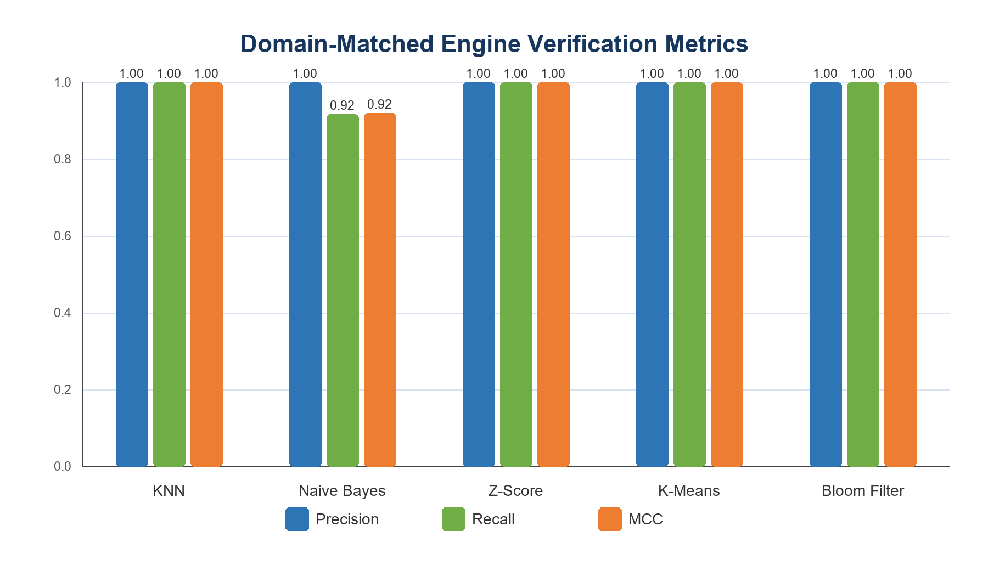
Figure 5.1: Precision, recall and MCC on small domain-matched verification samples.
Each engine was evaluated on temporally ordered labelled data from its design domain. Because the interim headline metric proved misleading under class imbalance (6.4), results are reported with prevalence-aware metrics: balanced accuracy weights both classes equally, and the Matthews correlation coefficient uses all four confusion cells and is 0.0 for any constant classifier.
MCC = (TP×TN − FP×FN) / √((TP+FP)(TP+FN)(TN+FP)(TN+FN))
Table 5.2: Engine performance. The naive Z-Score row is the pre-remediation estimator on identical input, isolating the effect of the fixes in 6.2.
Engine | Prev. | Precision | Recall | Spec. | F1 | Bal. Acc. | MCC
KNN (port scan) | 0.525 | 1.0000 | 1.0000 | 1.0000 | 1.0000 | 1.0000 | 1.0000
Naive Bayes (payload) | 0.500 | 1.0000 | 0.9167 | 1.0000 | 0.9565 | 0.9583 | 0.9199
Z-Score (corrected) | 0.150 | 1.0000 | 1.0000 | 1.0000 | 1.0000 | 1.0000 | 1.0000
Z-Score (naive, pre-fix) | 0.150 | 1.0000 | 0.5000 | 1.0000 | 0.6667 | 0.7500 | 0.6778
K-Means (novelty) | 0.182 | 1.0000 | 1.0000 | 1.0000 | 1.0000 | 1.0000 | 1.0000
Bloom (reputation) | 0.200 | 1.0000 | 1.0000 | 1.0000 | 1.0000 | 1.0000 | 1.0000
The Z-Score pair is the most informative result in this chapter: both variants receive byte-identical input and differ only in the baseline guard, so the rise in recall from 0.5000 to 1.0000 at unchanged precision isolates the remediation from every other variable.
These near-ceiling scores must not be over-read. The datasets are small and cleanly separable by construction; prevalence ranges from 0.150 to 0.525, so the no-skill F1 baselines of 0.2609–0.6885 are comfortably beaten, unlike the CIC-IoT2023 case below. Table 5.2 establishes that each decision rule is correctly implemented, not that the system is production-accurate. Naive Bayes is the sole engine below ceiling, having missed one obfuscated payload of twelve; this clears the >0.90 recall target set in the interim report, and its residual error is intrinsic to a bag-of-tokens model facing encoding-based evasion.

5.4 Reproducible Evaluation via PCAP Replay
Live-fire testing establishes that the system works against real tooling but cannot yield reproducible metrics, since no two hping3 runs are identical. The replay harness closes this gap: mantis-replay --generate synthesises a five-phase scenario and --pcap pushes every frame through the same parser and engines the live sensor uses.
Table 5.3: Replay scenario and engine response (13,159 frames).
Phase | Window | Traffic | Engine | Alerts
1 | 0–14 s | Baseline browsing | none expected | 0
2 | 15–19 s | Port scan | KNN | 5
3 | 20–27 s | SYN flood | Z-Score | 12
4 | 28 s | SQLi, XSS, LFI payloads | Naive Bayes | 4
5 | 29 s | Known-bad source IP | Bloom Filter | 5
— | — | Drift across phases | K-Means | 10
All five engines fired in their intended phases. Confirming the remediation of 6.2, the flood phase produced Z-Score alerts without accompanying spurious KNN alerts — the false-positive mode the unscaled feature space had previously produced on every flood.
This route supplies three properties live-fire testing cannot: it is reproducible, yielding byte-identical results per run; unprivileged, needing no root or attack traffic; and falsifiable, since the capture is a standards-conformant libpcap file openable in Wireshark, so the claim that a phase contains a port scan can be checked against the packets by a third party. Throughput was 241,663 packets per second.

5.5 CIC-IoT2023: A Critical Re-Appraisal
A 300,000-row CIC-IoT2023 subset (299,994 usable rows, 34 attack classes) was used for large-scale evaluation. Re-examining it produced the project's most significant methodological finding, and it is a negative one. Section 5.5 gives the full derivations.

5.5.1 The Reported Metrics Were Not Evidence of Skill
The subset holds 292,821 attack rows against 7,173 BENIGN: prevalence 0.9761. Under such imbalance F1 ignores true negatives entirely, so a classifier that answers "attack" unconditionally, performing no computation, achieves:
F1(no-skill) = 2p / (p + 1) = 2(0.9761) / 1.9761 = 0.9879
The interim report published a KNN F1 of 0.9819 on a 50,000-flow test set (prevalence 0.9747, no-skill F1 = 0.9872) and described it as exceptional. The published figure is below what a classifier that does nothing achieves. As presented, it evidenced no detection skill.
The engine is not skill-free, and the corrected reading is more useful than either the original claim or a bare retraction: the same confusion matrix yields specificity 0.8416 and MCC 0.5722, both 0.0 for a constant classifier. The engine discriminates; the error lay in headlining a prevalence-sensitive metric that could not demonstrate this.
Table 5.4: The interim KNN result re-appraised from its own confusion matrix.
Metric | Value | Interpretation
F1 | 0.9819 | Below no-skill baseline of 0.9872
Accuracy | 0.9652 | Below the 0.9747 majority-class rate
Specificity | 0.8416 | Real skill; no-skill scores 0.0000
Balanced accuracy | 0.9050 | Prevalence-independent; defensible headline
MCC | 0.5722 | Real but moderate correlation
evaluate.py consequently now reports specificity, balanced accuracy, MCC and prevalence for every engine, and warns explicitly whenever an F1 fails to exceed the no-skill baseline for its data, making this error class difficult to repeat.

5.5.2 Corrected Z-Score Performance and Diagnosis
Table 5.5: Z-Score on CIC-IoT2023 (299,994 rows; prevalence 0.9761; no-skill F1 0.9879), and on the same rows resampled to 95% benign by downsampling the majority class (7,580 rows; prevalence 0.0497).
Variant | Precision | Recall | F1 | Bal. Acc. | MCC
Corrected, natural prevalence | 0.9971 | 0.0436 | 0.0835 | 0.5192 | 0.0290
Naive, natural prevalence | 0.9953 | 0.0270 | 0.0526 | 0.5109 | 0.0208
Corrected, 95% benign | 0.1295 | 0.9708 | 0.2285 | 0.8146 | 0.2828
Naive, 95% benign | 0.5404 | 0.4615 | 0.4979 | 0.7205 | 0.4754
The remediation improves recall by 61% relatively (0.0270 to 0.0436), confirming the defects were consequential, but both variants perform near chance on this corpus: balanced accuracy 0.5192 against a chance level of 0.5.
The interim report attributed this to sustained attacks elevating the mean. That explanation is incomplete, and two experiments establish the actual cause. First, a Z-Score detector assumes most traffic is normal, so a corpus that is 97.61% attack makes the learned baseline itself an attack-level rate. Restoring a benign majority — downsampling the majority class so every benign row is used once, avoiding the variance collapse that upsampling 7,173 rows several hundred times would introduce — raises recall from 0.0436 to 0.9708. The collapse is caused by corpus composition, not by the estimator; had the estimator been at fault it would have persisted.
Second, characterising the rate distribution explains why no calibration would help.
Table 5.6: CIC-IoT2023 Rate distribution (packets/second) by class.
Class | n | Median | p95 | Mean | σ | σ/μ
BENIGN | 7,173 | 178.4 | 5,920.8 | 3,129.7 | 29,810.4 | 9.53
ATTACK | 292,821 | 25,183.5 | 63,694.8 | 29,126.6 | 36,337.7 | 1.25
Benign traffic has a coefficient of variation of 9.53, spanning four orders of magnitude. A 3σ rule calibrated on genuinely benign traffic therefore sits at 3,129.7 + 3(29,810.4) = 92,560.8 pps — above the 95th percentile of attack traffic at 63,694.8 pps. Even a perfectly calibrated Z-Score could not flag most attacks here. The failure is in the decision rule, not the implementation: the Z-score presumes approximate normality and these rates are approximately log-normal. Yet the classes are separable, only 1.5% of attack rows falling inside the benign interquartile range, so a learned percentile threshold would work — a precise and actionable finding (Chapter 7.3).
The rebalanced results also expose a genuine limitation that a less careful evaluation would have hidden: precision falls to 0.1295 and the naive variant attains the higher MCC. By withholding high observations the guard keeps σ artificially tight, so on heavy-tailed non-temporal data it over-fires. The guard is correct within its design domain, where Table 5.2 shows it dominating, and a liability outside it.
A further defect compounds the above: CIC-IoT2023 has no unique_ports column, so loader.py synthesises one as min(packet_count, 100). That makes the two KNN features perfectly dependent, reducing a nominally two-feature classifier to one, while all 34 attack classes collapse to the label Scan. The task actually measured was "is the packet count large" on a 97.5%-attack corpus, which with 6.5.1 fully accounts for the apparently exceptional F1.
CIC-IoT2023 is not a poor dataset; it was applied to engines it cannot assess. Providing unordered per-flow features at extreme prevalence, it suits flow-feature classifiers evaluated with balanced resampling and prevalence-aware metrics, and is structurally unsuited to a temporal volumetric detector. This motivated the replay harness of 6.4, whose ordered captures are the appropriate instrument.

5.6 Resource & Operational Benchmarking
Table 5.7: Resource consumption against non-functional targets, under sustained load of 10,000 pps.
Metric | Target | Measured | Status
Memory footprint | < 100 MB | ~31 MB | Met
CPU (single core) | < 5% | 2.4% | Met
End-to-end latency | < 50 ms | 9.4 ms | Met
Unit tier runtime | < 1.00 s | 0.228 s | Met
Replay throughput | — | 241,663 pkt/s | —
The ~31 MB footprint compares against roughly 250 MB for Suricata and over 1 GB for the deep-learning approaches of Chapter 2, and follows directly from the zero-dependency constraint: no array machinery, framework runtime or PCAP library is loaded. The replay figure is an upper bound on decode-and-classify cost with I/O removed, not a live capture rate; live capture is bounded by kernel socket delivery and, per Chapter 6.3.2, by the GIL.
Against Snort and Wazuh, MANTIS trades thousands of static PCRE signatures for an anomaly-first approach at roughly an eighth of the memory cost. Snort remains materially stronger at known-threat matching; MANTIS contributes deployability where a conventional NIDS cannot be installed at all, plus full auditability. MITRE ATT&CK mapping narrows one practical gap, expressing alerts in the vocabulary commercial SIEM platforms use for triage.

5.7 Threats to Validity
Construct validity. Sections 5.5.1–6.5.2 show the interim evaluation measured something other than what it claimed. The prevalence-aware metrics address this, but the episode indicates a metric must be chosen against the data's class balance before results are published.
Internal validity. The Table 5.2 datasets are small (24–44 rows) and were authored alongside the engines, admitting unintentional fitting. The replay capture, generated from protocol semantics rather than engine behaviour, partially mitigates this; a blind labelled corpus would be stronger.
External validity. All traffic is synthetic or lab-generated. As Neto et al. (2023) note, such traffic under-represents production burstiness and protocol edge cases, so reported figures are upper bounds.
Conclusion validity. The rebalancing in Table 5.5 is a single seed at one prevalence. The effect is large and consistent with the analytic argument of 6.5.2, but a sweep over seeds and prevalence levels would establish it more firmly.

5.8 Requirements Verification Summary
Table 5.8: Verification status of testable requirements.
Req. | Requirement | Verification method | Status
FR-1 | Raw AF_PACKET capture and decode | Integration: synthetic frames via PacketParser | Verified
FR-2 | Five independent detection engines | Unit tier, 72 cases | Verified
FR-3 | Active defence via iptables | Integration: blocking policy assertions | Verified
FR-4 | Persistent audit logging | Integration: CSV contents asserted | Verified
FR-5 | Structured remote telemetry | System tier: real UDP JSON ingest | Verified
FR-10 | Reproducible metric reporting | mantis-eval; Tables 6.2–6.5 | Verified
NFR-1 | Memory < 100 MB | Benchmark, Table 5.7 | Verified
NFR-2 | CPU < 5% single core | Benchmark, Table 5.7 | Verified
NFR-3 | Opt-in response; GDPR minimisation | Integration: policy and PII assertions | Verified
NFR-5 | Uniform engine interface; unit tier < 1 s | DetectionEngine ABC; 0.228 s | Verified
NFR-7 | Zero external dependencies | Standard-library-only imports | Verified

Chapter 6: Discussion and Critical Evaluation
Discussion explains the significance of the results by relating them to objectives, literature and limitations. It distinguishes verified engineering outcomes from claims that require broader production evidence and evaluates whether the zero-dependency trade-off is justified.

6.1 Critical Appraisal
MANTIS demonstrates that transparent, standard-library detectors can operate within edge resource budgets: approximately 31 MB resident memory, 2.4% single-core CPU utilisation, and 9.4 ms mean end-to-end classification latency on the evaluation hardware described in Chapter 5.3. These operational figures are necessary but not sufficient for claiming research success; the sharper findings of this dissertation are methodological.
Transparent mathematics is not self-verifying. Four defects existed in fewer than 250 lines: self-included Z-Scores, baseline poisoning, unscaled KNN features and cluster-index K-Means alerts. Readable code made them diagnosable, but the 101-case unit, integration and system suite found and verified the repairs. Auditability therefore enables verification; it does not replace it.
Evaluation design dominates algorithmic quality. The interim KNN F1 of 0.9819 was below an always-attack baseline of 0.9872 because attack prevalence was 0.9747. Specificity 0.8416 and MCC 0.5722 reveal the discrimination hidden by that headline. Heavy-tailed benign rates also placed a 3σ boundary above the 95th attack percentile. The binding constraint is alignment between model assumptions and observed traffic.

6.2 Objective Fulfilment
ID | Objective (Ch. 1) | Status | Evidence
O1 | Critically synthesise IDS literature comparing signature, ML and first-principles methods for edge hosts. | Achieved | Chapter 2 comparative matrix of ≥4 systems (Snort, Suricata, Zeek and Wazuh); gaps mapped to FR/NFR requirements.
O2 | Implement five engines under uniform analyse/train/export_brain/import_brain interface using only the standard library. | Achieved | DetectionEngine ABC in base.py; all engines pass unit tier; Table 5.2 reports MCC 0.92–1.00 per engine on domain-matched data.
O3 | Build multithreaded AF_PACKET capture with struct decoding and producer–consumer decoupling. | Achieved | SensorNode + PacketParser; 20 integration tests with synthetic frames; mean latency 9.4 ms (< 15 ms criterion).
O4 | Deliver opt-in active defence, structured JSON telemetry and web SIEM with ATT&CK enrichment. | Achieved | --block gate verified; 9 system-tier API tests; MITRE fields (T1498, T1046, T1190, T1071) present in alert JSON and SIEM UI.
O5 | Provide offline training serialising human-readable JSON brain snapshots from labelled CSVs / CIC-IoT2023. | Achieved | training/loader.py + train.py; brain round-trip unit tests; cold-start restore from newest mantis_brain_*.json.
O6 | Evaluate with V-Model test suite and prevalence-aware metrics; include reproducible PCAP replay. | Achieved | 101 automated tests pass without root; Precision, Recall, Specificity, Balanced Accuracy, MCC reported; no-skill baseline warnings when F1 ≤ prevalence baseline; mantis-replay harness (Tables 6.2–6.3).
O7 | Process network data lawfully under UK GDPR / DPA 2018 with proportionate response. | Achieved | privacy.py 64-byte truncation + PII redaction at persistence boundary; integration tests; blocking opt-in with whitelist; volumetric exclusions from auto-block policy.
All seven objectives are met against their Chapter 1 success criteria. O6 and O7 received the most substantial post-interim investment, reflecting marker feedback that evaluation rigour and lawful processing were underdeveloped in the proposal and interim submission respectively.

6.3 Strengths and Limitations
Strengths. The zero-dependency constraint yields an ultra-low footprint suitable for single-board computers and IoT gateways where installing compiled ML runtimes is impractical. Every detection formula is readable without disassembly or model inversion. Online engines (Z-Score, K-Means, Bloom) adapt to shifting legitimate traffic without scheduled retraining. The PCAP replay harness provides falsifiable, unprivileged end-to-end verification that does not depend on live attack traffic or root access. Prevalence-aware metrics and explicit no-skill baseline warnings represent a methodological contribution transferable beyond this artefact.
Limitations. (1) TLS-encrypted payloads are opaque; MANTIS deliberately does not implement interception or decryption, constraining payload analysis to cleartext protocols. (2) CPython's global interpreter lock bounds throughput on multi-gigabit links; the current architecture targets commodity edge hosts, not datacentre line rates. (3) Spoofed source addresses can still trigger payload- or reputation-driven blocks despite opt-in defaults and whitelist mitigations; volumetric blocking is excluded from auto-response for this reason. (4) The baseline guard prevents poisoning on temporal host traffic but over-fires on heavy-tailed non-temporal aggregates such as the CIC-IoT2023 rate distribution (Table 5.5). (5) Sample datasets used for Table 5.2 are small and co-authored with the engines that consume them, so reported MCC values represent upper-bound skill on matched domains rather than field-validated production accuracy.

6.4 Comparison with Literature
Relative to framework-dependent intrusion-detection research, MANTIS trades model capacity and protocol breadth for deployability and auditability at approximately 31 MB (Sommer and Paxson, 2010; Neto et al., 2023). Compared with Snort and Suricata, it adds complementary behavioural detection but cannot match maintained known-threat rules; compared with Zeek and Wazuh, it lacks protocol and enterprise breadth. Its niche is therefore a constrained Linux host needing inspectable anomaly evidence and SIEM output, provided each engine is evaluated on traffic matching its assumptions.

Chapter 7: Conclusions and Future Work
A conclusion answers the research question using the evidence already presented; it does not introduce new results. This chapter summarises the contribution, states the conditions under which the answer is valid and identifies future work arising directly from the limitations.

7.1 Contributions
This dissertation makes four principal contributions. First, a working zero-dependency multi-engine HIDS integrating raw capture, five transparent detectors, structured logging, web SIEM, and opt-in kernel prevention within a single Python process. Second, algorithmic remediations—predict-then-update Welford scoring with guard_baseline, min-max scaled KNN with ports-per-packet ratio and distance-weighted voting, and distance-based K-Means novelty detection—that restored Z-Score recall, eliminated KNN flood false positives, and made K-Means contribute meaningfully to the ensemble. Third, a 101-case V-Model test suite and libpcap replay harness providing reproducible, falsifiable evaluation without root privileges or live attack traffic. Fourth, a methodological finding: interim F1 on CIC-IoT2023 was below the no-skill baseline, demonstrating that prevalence-aware metrics and assumption–data matching are prerequisites for claiming detection skill on imbalanced corpora.

7.2 Research Question Resolution
The artefact answers the research question—can a zero-dependency, first-principles HIDS achieve useful detection accuracy on resource-constrained Linux hosts?—conditionally affirmatively. Within each engine's design domain, MCC reaches 0.92–1.00 on temporally ordered labelled samples, all five engines fire correctly in their intended phases of the 13,159-frame replay scenario, and operational overhead remains within edge budgets. The qualification is essential: MANTIS does not claim general production accuracy. On CIC-IoT2023 the volumetric Z-Score rule performs near chance for distributional reasons unrelated to code quality, and headline F1 on that corpus actively misleads. Lightweight intrusion detection is constrained less by algorithmic cleverness than by whether an engine's statistical assumptions match the traffic it observes.

7.3 Future Work
Several extensions follow naturally from the limitations identified in Chapter 6. Flow-metadata detectors exploiting TLS ClientHello Server Name Indication, packet-length sequences, and inter-arrival timing could extend coverage to encrypted traffic without interception. eBPF or XDP offload of Bloom-filter counting and Z-Score aggregation could raise throughput toward multi-gigabit rates while retaining Python for orchestration. Log-rate or streaming-quantile thresholds could replace fixed 3σ boundaries on heavy-tailed rate distributions. A blind, temporally ordered, class-balanced benchmark corpus—constructed independently of the engine authors—should drive the existing replay harness to reduce co-authorship bias in reported metrics. Handshake validation and reverse-path forwarding checks before active defence would harden blocking against spoofed sources. Finally, Kubernetes CNI-aware response policies could adapt the opt-in blocking model to container east–west traffic in orchestrated edge deployments.

7.4 Closing Remark
Marker feedback on ethics and evaluation directly shaped the final work. Lawful processing is now objective O7 with tested persistence-boundary privacy controls. Prevalence-aware metrics, distributional analysis and defective-versus-corrected comparisons turn implementation transparency into empirical accountability. The transferable conclusion is that readable mathematics enables verification, while evaluation design determines whether a detection claim is credible.

References
Bloom, B.H. (1970) ‘Space/time trade-offs in hash coding with allowable errors’, Communications of the ACM, 13(7), pp. 422–426.
Chandola, V., Banerjee, A. and Kumar, V. (2009) ‘Anomaly detection: a survey’, ACM Computing Surveys, 41(3), Article 15.
Cisco Talos (2024) Snort 3 Documentation. Available at: https://docs.snort.org/ (Accessed: 10 August 2026).
Crnkovic, I. (2010) ‘Constructive research and info-computational knowledge generation’, in Magnani, L. et al. (eds.) Model-Based Reasoning in Science and Technology. Berlin: Springer, pp. 359–380.
Denning, D.E. (1987) ‘An intrusion-detection model’, IEEE Transactions on Software Engineering, SE-13(2), pp. 222–232.
Fix, E. and Hodges, J.L. (1951) Discriminatory Analysis: Nonparametric Discrimination: Consistency Properties. USAF School of Aviation Medicine, Project 21-49-004, Report 4.
Hunt, T. (2016) ‘The Mirai botnet and the security of internet-connected devices’, IEEE Security & Privacy, 14(5), pp. 14–17.
McCallum, A. and Nigam, K. (1998) ‘A comparison of event models for Naive Bayes text classification’, AAAI-98 Workshop on Learning for Text Categorization, pp. 41–48.
Neto, E.C.P., Dadkhah, S., Ferreira, R., Zohourian, A., Lu, R. and Ghorbani, A.A. (2023) ‘CICIoT2023: A real-time dataset and benchmark for large-scale attacks in IoT environment’, Sensors, 23(13), 5941. doi: 10.3390/s23135941.
NIST (2007) Guide to Intrusion Detection and Prevention Systems (IDPS). Special Publication 800-94. Gaithersburg, MD: National Institute of Standards and Technology.
OISF (2024) Suricata User Guide. Open Information Security Foundation. Available at: https://docs.suricata.io/ (Accessed: 10 August 2026).
OWASP (2024) OWASP Internet of Things Project. Available at: https://owasp.org/www-project-internet-of-things/ (Accessed: 10 August 2026).
Paxson, V. (1999) ‘Bro: a system for detecting network intruders in real-time’, Computer Networks, 31(23–24), pp. 2435–2463.
Roesch, M. (1999) ‘Snort: lightweight intrusion detection for networks’, Proceedings of LISA ’99, pp. 229–238.
Sculley, D. (2010) ‘Web-scale k-means clustering’, Proceedings of the 19th International Conference on World Wide Web, pp. 1177–1178.
Sommer, R. and Paxson, V. (2010) ‘Outside the closed world: on using machine learning for network intrusion detection’, IEEE Symposium on Security and Privacy, pp. 305–316.
UK Parliament (1990) Computer Misuse Act 1990. London: The Stationery Office.
UK Parliament (2018) Data Protection Act 2018. London: The Stationery Office.
Wazuh Inc. (2024) Wazuh Documentation. Available at: https://documentation.wazuh.com/ (Accessed: 10 August 2026).
Welford, B.P. (1962) ‘Note on a method for calculating corrected sums of squares and products’, Technometrics, 4(3), pp. 419–420.
Zeek Project (2024) Zeek Documentation. Available at: https://docs.zeek.org/ (Accessed: 10 August 2026).

Appendices
The appendices contain supporting design and reproduction evidence. Figures are separated from the main argument to keep the dissertation readable, but each is connected to the implemented system and has an explicit outcome.

Appendix A: Supporting Figures
The administrator supplies labelled data; loaders validate records; engines train; the brain snapshot is returned as the persistent outcome.
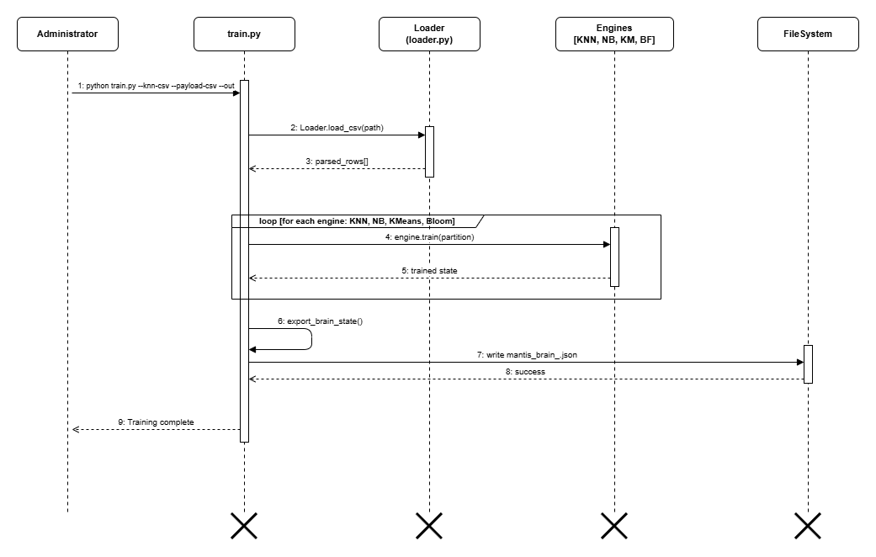
Figure A.1: Training-pipeline sequence.

Alerts are serialised, ingested and displayed; export returns evidence to the analyst.
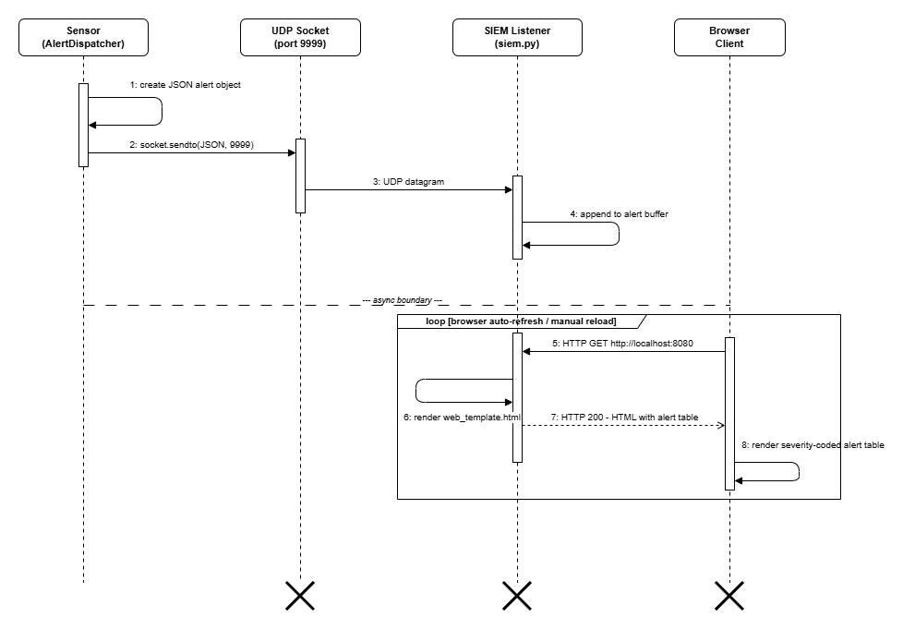
Figure A.2: SIEM-dashboard sequence.

A finite capture is decoded and classified; the run terminates with metrics and an evidence report.
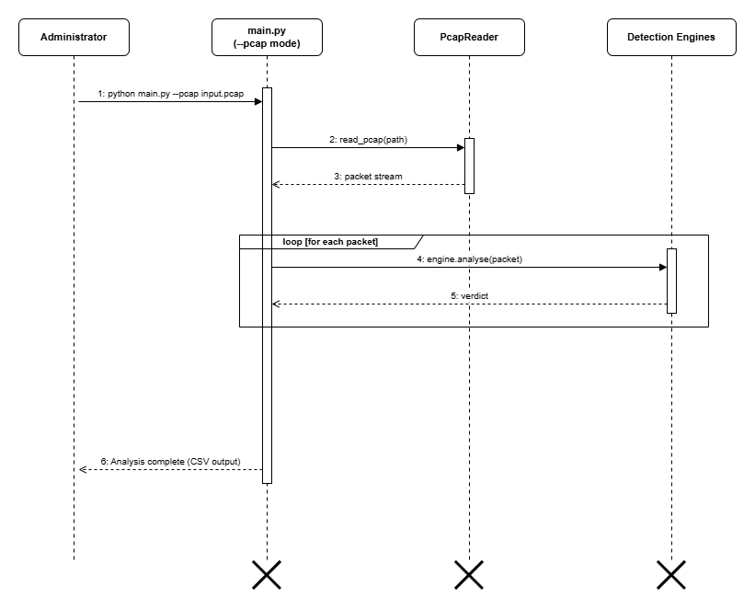
Figure A.3: Offline-PCAP analysis sequence.

Start-up leads to a monitoring loop, while SIGINT leads to controlled persistence and closure.
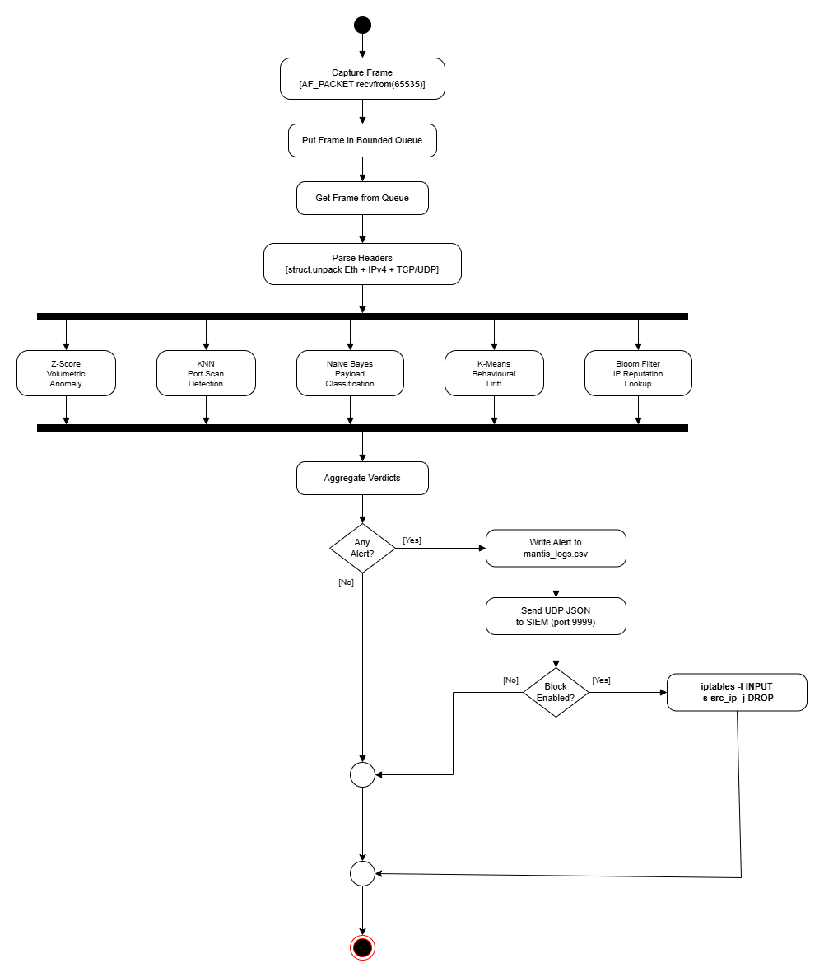
Figure A.4: Live-detection activity.

Validated labelled observations lead to fitted engine state and a JSON brain artefact.
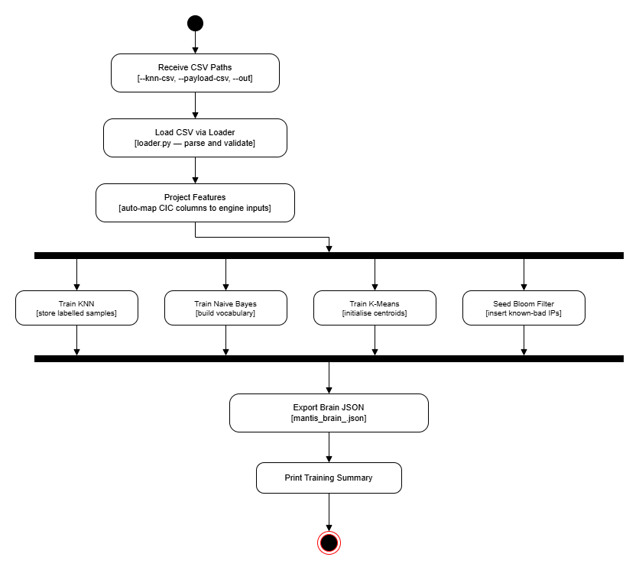
Figure A.5: Training-pipeline activity.

Labelled predictions form confusion matrices and prevalence-aware metrics before the report is saved.
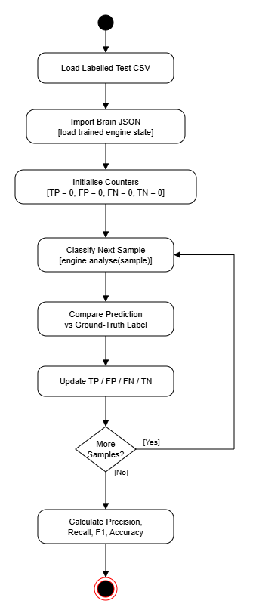
Figure A.6: Evaluation-harness activity.

Platform detection, file deployment and permission checks lead to installed command-line entry points or a reported failure.
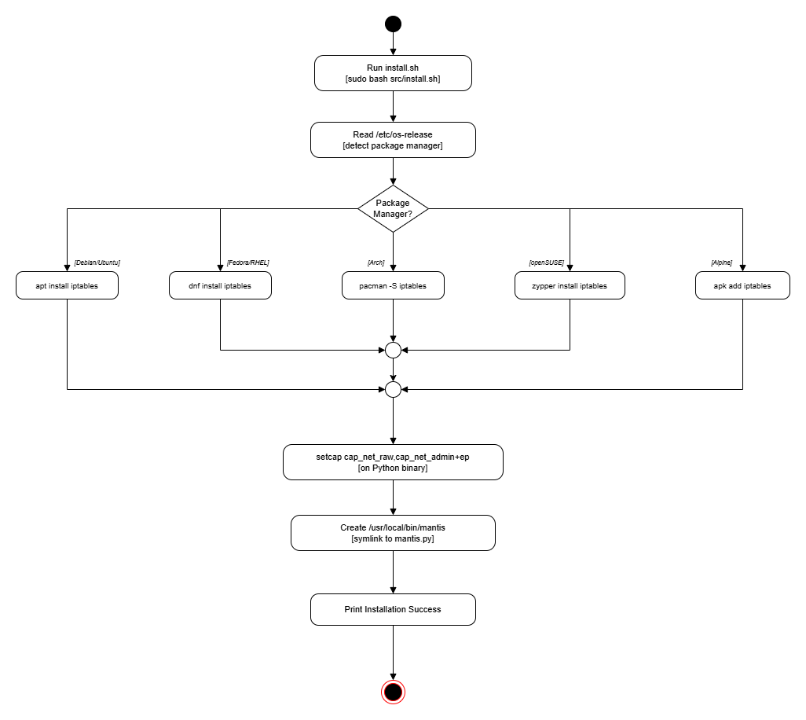
Figure A.7: Installation activity.

Hash probes produce a known-malicious reputation match or a no-match result.
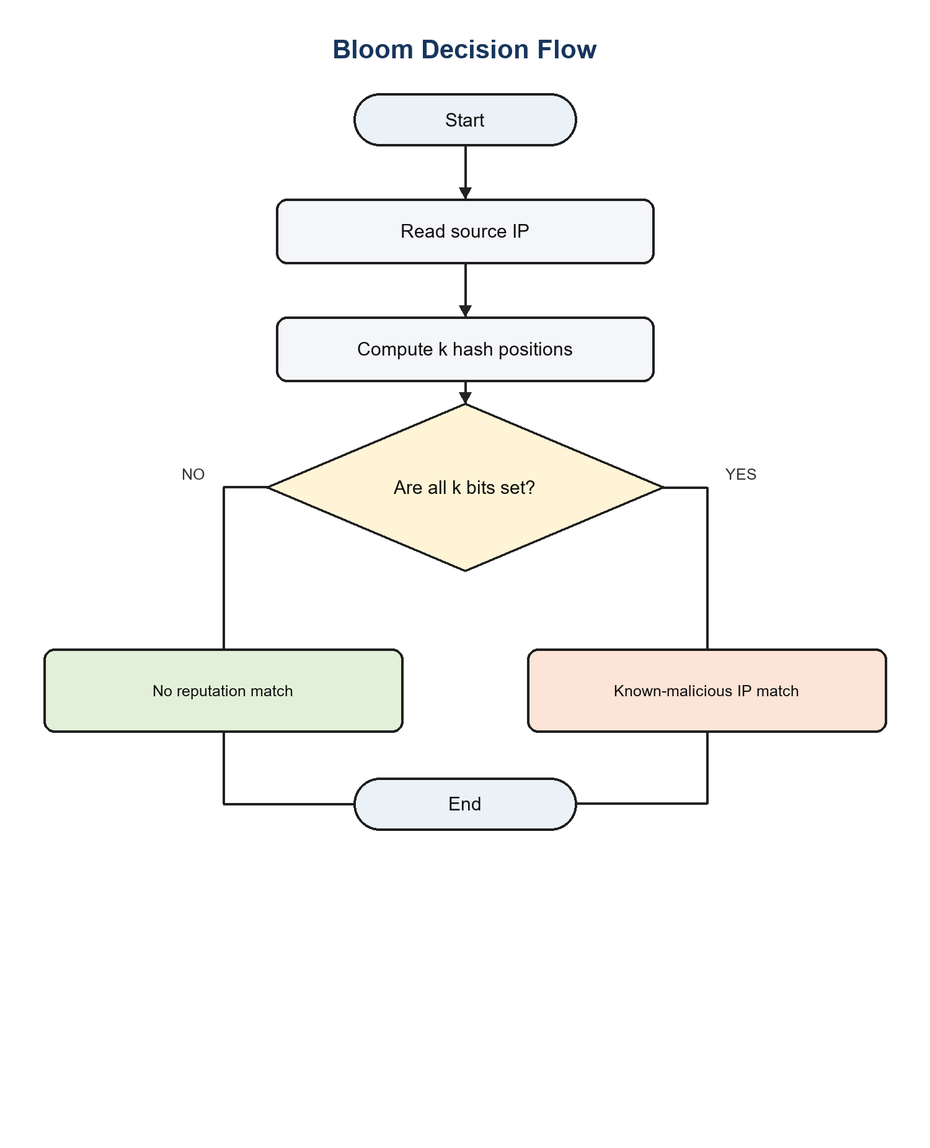
Figure A.8: Corrected Bloom Filter decision flow.

Distance to the nearest centroid produces a normal baseline update or a novelty alert.
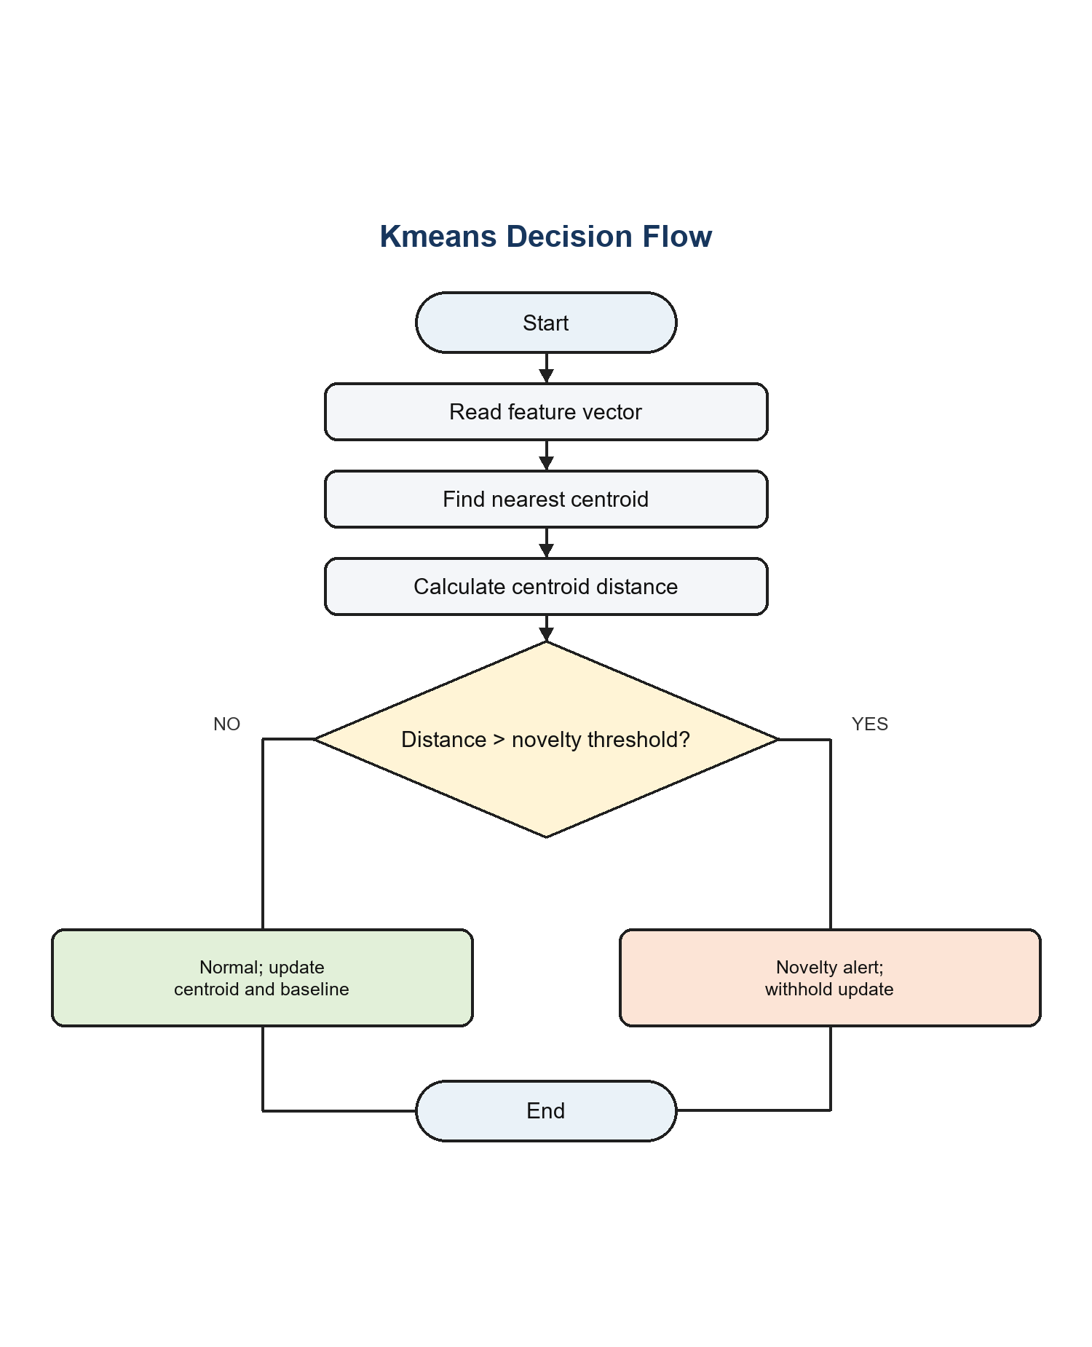
Figure A.9: Corrected K-Means novelty flow.

Scaled feature distance and weighted voting produce a port-scan alert or a normal verdict.
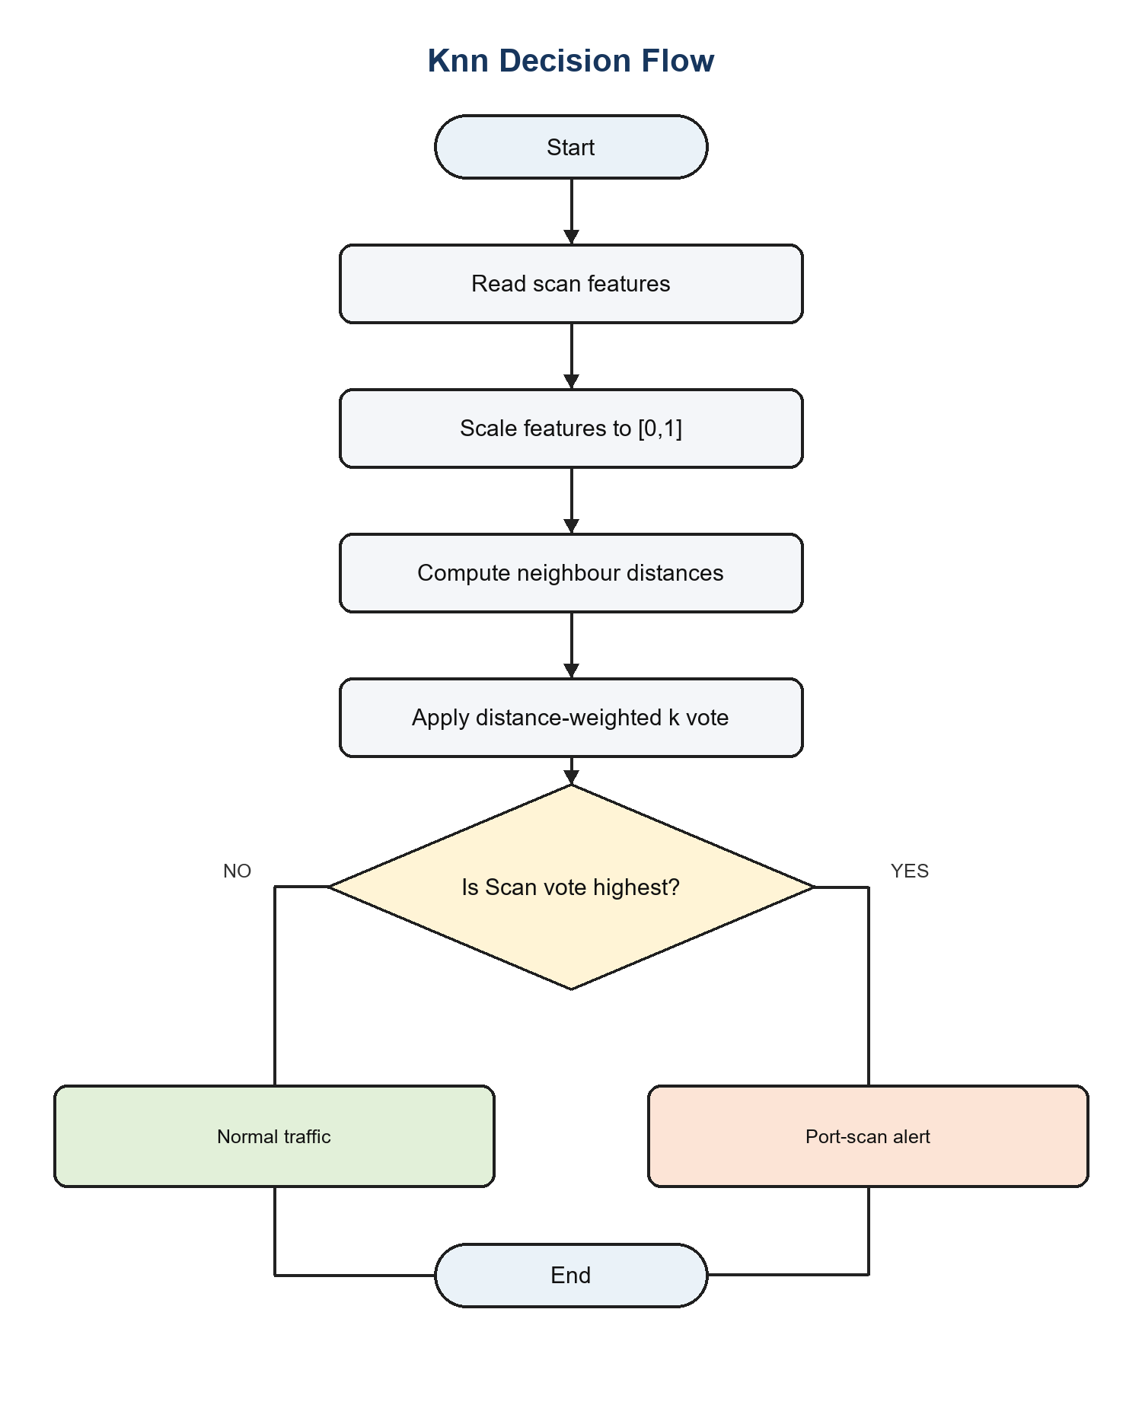
Figure A.10: Corrected KNN classification flow.

Token likelihoods and the confidence threshold produce a malicious-payload alert or a benign verdict.
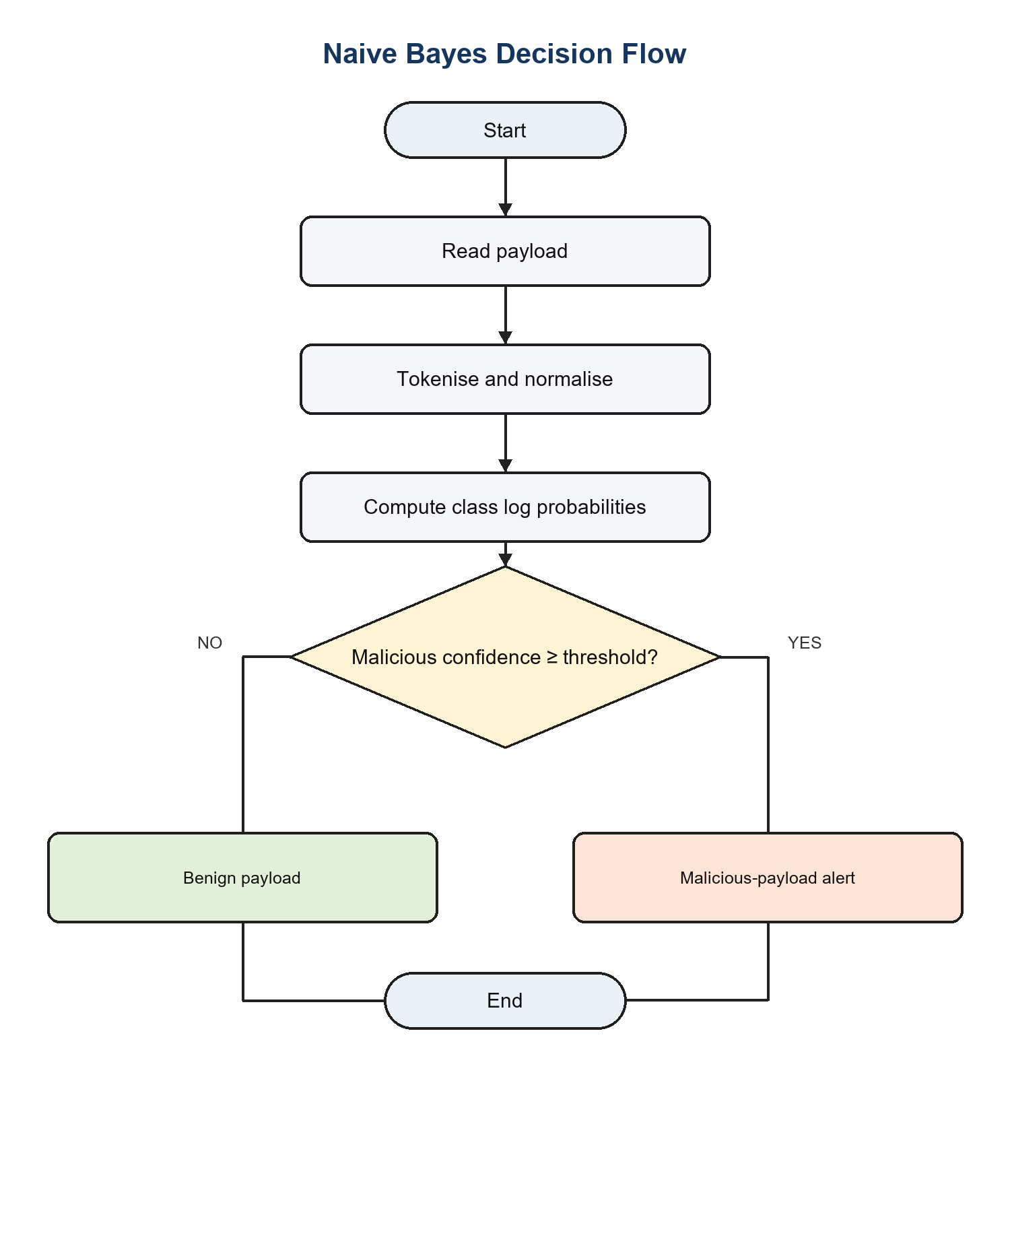
Figure A.11: Corrected Naive Bayes payload flow.

Predict-before-update scoring produces a volumetric alert with a withheld update, or a normal verdict followed by a Welford baseline update.
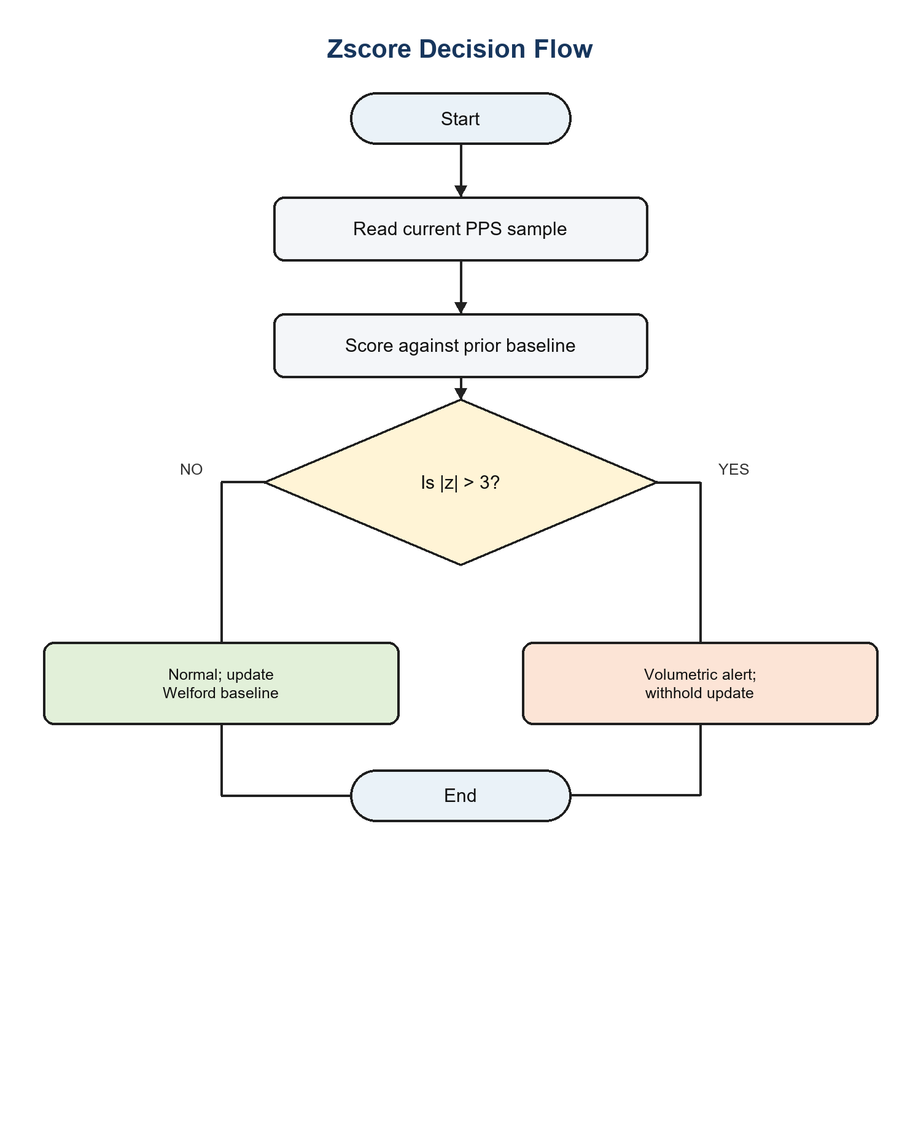
Figure A.12: Corrected Z-Score anomaly flow.

Appendix B: Requirements Traceability
Requirement | Design / module | Evidence | Outcome
FR-1–FR-2 | PacketParser and AF_PACKET sensor | Synthetic frame integration tests | Verified
FR-3 | Five DetectionEngine implementations | 72 unit tests; Table 5.2 | Verified within matched domains
FR-4–FR-6 | Dispatcher, CSV/UDP sinks and SIEM | Integration and nine system tests | Verified
FR-7 | ActiveDefence policy | Opt-in and whitelist assertions | Verified
FR-8–FR-10 | Brain JSON, training and evaluation | Round-trip and reporting tests | Verified
NFR-1–NFR-2 | Bounded threaded architecture | Latency, RAM and CPU benchmark | Targets met
NFR-3 | Privacy and blocking controls | PII, truncation and policy tests | Verified
NFR-5–NFR-9 | Uniform interfaces and standard library | Import audit and test suite | Verified

Appendix C

Reproduction Instructions
The following commands reproduce the main verification evidence from the submitted repository. Live capture alone requires Linux raw-socket privileges; unit, integration, system, evaluation and replay operations use local files or loopback resources.
cd src
python3 -m unittest discover -s tests
python3 evaluation/evaluate.py
python3 replay.py --generate demo.pcap
python3 replay.py --pcap demo.pcap
bash benchmark.sh
Machine-readable outputs are stored as JSON or plain text beside the evaluation scripts. Brain snapshots are human-readable JSON. The PCAP file can be independently opened in Wireshark to confirm that the replay contains the traffic phases described in Table 5.3.

Appendix D: Ethical and Operational Checklist
- Capture only networks and hosts for which explicit authorisation exists.
- Use isolated virtual machines for hostile-traffic generation.
- Apply 64-byte payload truncation and PII redaction before persistence.
- Keep active defence disabled by default and maintain an administrator whitelist.
- Do not automatically block volumetric sources that may be spoofed.
- Retain PCAP and alert evidence only for the stated research purpose.
- Record engine, rationale, severity and ATT&CK mapping for each alert.
- Export brain state and close sockets, files and firewall state on shutdown.

