A Dissertation Interim Report on
Minimalist Alert Network for Threat Intelligence System

Anuskar Sigdel
UON ID: 24812606
BSc. (Hons.) Computer Science

Supervisor: Nischal Khadka
Naaya Aayam Multi-Disciplinary Institute
University of Northampton
June 2026

Table of Contents
1. Introduction 8
1.1 Background 8
1.2 Rationale 8
1.3 Aim and Objectives 9
1.4 Overview of Methodology 10
2. Requirements Engineering 10
2.1 Literature Review 10
2.2 Comparable Systems 13
2.2.1 Snort 3.x 13
2.2.2 Suricata 7.x 14
2.2.3 Zeek 8.x 15
2.2.4 Wazuh 4.x 16
2.3 Research Methodology 17
2.4 Research Philosophy 17
2.5 Development Methodology 18
2.6 Evaluation Strategy 18
2.7 Methodology for Comparable Analysis 18
2.8 Requirement Specification 20
2.8.1 Problem Domain 20
2.8.2 Proposed Solution Strategy 20
2.8.3 Alternative Solution Strategy 21
2.8.4 Functional Requirements 21
2.8.5 Non-Functional Requirements 23
2.8.6 Goals of Implementation 24
2.8.7 System Workflow Diagrams 24
2.8.8 Performance and Environment Requirements 26
2.9 Algorithms Implemented 27
3. System Analysis and Design 33
3.1 Use Case 33
3.1.1 Use Case Documentation 34
3.2 Sequence Diagram 38
3.3 Class Diagram 41
3.4 Activity Diagram 42
3.5 Database Schema 48
3.6 Algorithms Implemented 49
3.6.1 Online Mini-Batch K-Means Engine 49
3.6.2 Bloom Filter Reputation Engine 51
3.8 System Interface and Design 52
3.8.1 Wireframe 52
3.8.2 Mockup (Implemented Functions) 53
4. System Build and Technical Notes 55
5. Testing Strategy and Evaluation 58
5.1 Testing Definitions and Approach 58
5.2 Algorithm Tests 58
5.3 Test Cases and Scenarios 59
6. Progress To Date 61
7. Future Work 62
References 63
Appendix A: Gannt Chart 66
Appendix B: Project Log 67
Appendix C: Source Code 67
Appendix D: Presentation Slide 69

List of Figures
Figure 2.1 Snort product / documentation landing page ( Cisco Talos, 2024) 13
Figure 2.2 Suricata documentation landing page (OISF, 2024) 14
Figure 2.3 Zeek documentation landing page (Zeek Project, 2026) 15
Figure 2.4 Wazuh documentation landing page (Wazuh,2026) 16
Figure 2.5 Devepoment Methodology 18
Figure 2.6: Comparable-system functionality ranking chart 19
Figure 2.7: Current workflow Daigram. 25
Figure 2.8: Proposed end-to-end workflow MANTIS 26
Figure 2.9: Z-Score Statistical Engine detection engine. 28
Figure 2.10: K-Nearest Neighbours (KNN) Engine detection engine. 30
Figure 2.11 Multinomial Naive Bayes Engine detection engine. 32
Figure 3.1: Use Case Diagram 33
Figure 3.1: Sequence Diagram Live Detection 39
Figure 3.2: Sequence Diagram Training Pipeline 39
Figure 3.3 Sequence Diagram SIEM Dashboard 40
Figure 3.4 Offline PCAP Analysis 41
Figure 3.5: Class Diagram 42
Figure 3.6: Activity Diagram (live Detection) 43
Figure 3.7: Activity Diagram (Training Pipeline) 44
Figure 3.8: Activity Diagram (Evaluation Harness) 45
Figure 3.9: Activity Diagram (Brain Persistence) 46
Figure 3.10: Activity Diagram (Installation) 47
Figure 3.11 Database Schema 48
Figure 3.12 Online Mini-Batch K-Means Engine flowchart 50
Figure 3.15 Bloom Filter Reputation Engine flowchart 52
Figure 3.16 SIEM Dashboard Wireframe 53
Figure 3.17 Live alert table 54
Figure 3.19 Severity colour coding 54
Figure 3.20 Forensic HTML export triggered on shutdown 54
Figure 4.1 Live Terminal Dashboard 55
Figure 4.2 Producer/Consumer and Engine fan out 56
Figure 4.3 Web Dashboard 57
Figure 4.4 Sample Training 57
Figure 5.1 Unit Testing 59
Figure A.1 Gannt Chart 66

List of Tables

Abbreviations
AF_PACKET | Linux raw packet socket family
API | Application Programming Interface
CIC | Canadian Institute for Cybersecurity
CSV | Comma Separated Values
DDoS | Distributed Denial of Service
DPA | Data Protection Act (UK, 2018)
ERD | Entity Relationship Diagram
GDPR | General Data Protection Regulation
GIL | Global Interpreter Lock (CPython)
HIDS | Host Based Intrusion Detection System
IDS / IPS | Intrusion Detection / Prevention System
JSON | JavaScript Object Notation
KNN | K Nearest Neighbours
MANTIS | Minimalist Alert Network for Threat Intelligence System
ML | Machine Learning
NIDS | Network Intrusion Detection System
OSI | Open Systems Interconnection
PII | Personally Identifiable Information
PPS | Packets Per Second
SIEM | Security Information and Event Management
SQLi | SQL Injection
TCP / UDP | Transmission Control Protocol / User Datagram Protocol
UAT | User Acceptance Testing
XSS | Cross Site Scripting

1. Introduction
This chapter introduces MANTIS (Minimalist Alert Network for Threat Intelligence System), a zero-dependency Host-Based Intrusion Detection System (HIDS) built entirely on the Python Standard Library and targeting commodity Linux hardware such as single-board computers, IoT gateways and teaching-laboratory VMs. It contextualises the project, defines the problem and outlines the report.

Signature engines (Snort, Suricata) and enterprise SIEM platforms (Wazuh) impose runtime dependencies, large footprints or algorithmic opacity that put intrusion detection out of reach for most Linux hosts. MANTIS closes this gap with five engines whose mathematics trace to published formulas and whose deployment needs no external packages. Sections 1.1-1.4 cover background, rationale, aims and objectives, and report structure.

1.1 Background
Current practice centres on signature engines (Snort, Suricata) and enterprise SIEM platforms (Wazuh). Signature engines miss zero-day and behavioural threats; SIEM platforms need Java, Elasticsearch and gigabytes of RAM, unworkable on Raspberry Pi, IoT gateways and lab VMs. Halvorsen et al. (2024) report ML-based IDS reach high accuracy but carry latency and dependency footprints incompatible with line-rate blocking on edge Linux devices.

Neto et al. (2023) show that 33 attack categories on Linux and IoT environments escape signature-only tools at line rate. Kus et al. (2022) show ML accuracy degrades sharply when test traffic diverges from training data, a routine condition in live networks. Together these findings motivate a transparent, resource-light, anomaly-capable HIDS deployable without third-party libraries.

1.2 Rationale
MANTIS codes five engines (Z-Score, KNN, Naive Bayes, Mini-Batch K-Means, Bloom Filter) in Python Standard Library modules. First-principles mathematics keeps the logic auditable, deployable on single-board computers and free of supply-chain exposure. It serves three operator groups: administrators of constrained Linux servers, IoT operators needing an always-on agent, and educators requiring an inspectable IDS for teaching.

Constructive Research Methodology (Crnkovic, 2010) was chosen because the contribution is a functional artefact validated by construction and benchmarking. Each engine maps to an attack category: Z-Score for floods, KNN for port scans, Naive Bayes for payload injection, K-Means for drift and the Bloom Filter for known-malicious IPs. Chandola, Banerjee and Kumar (2009) justify this ensemble, showing no single anomaly detector wins across all attack types.

1.3 Aim and Objectives
The aim is to design, build and evaluate MANTIS, a zero-dependency HIDS for commodity Linux hardware, demonstrating that effective, transparent threat detection is achievable using only the Python Standard Library with no external packages. To achieve this aim, the primary objectives include:
- Design and implement five mathematically transparent detection engines (Z-Score, KNN, Naive Bayes, Mini-Batch K-Means and Bloom Filter) using only Python Standard Library modules, with each engine traceable to a published mathematical formula.
- Build a multithreaded AF_PACKET producer/consumer pipeline that captures raw Layer-2 frames, decodes Ethernet, IPv4, TCP and UDP headers via struct.unpack, and routes packets concurrently to all five engines without frame loss under normal load.
- Implement an optional iptables DROP rule mechanism for source IPs flagged by any detection engine, supported by a duplicate-rule cache that prevents the same address from being blocked twice.
- Deliver alert output across three channels: a persistent CSV log, a real-time UDP/JSON SIEM feed, and a browser-based dashboard on port 8080 with severity colour-coding.
- Build a labelled data training pipeline accepting CSV, JSON and CIC-IoT2023 format files, persisting the trained engine state as a portable brain JSON file that is reloaded automatically when the sensor starts.
- Produce a reproducible evaluation harness that reports precision, recall, F1 and a confusion matrix for each engine, together with CPU, RAM and latency benchmarks that demonstrate the performance benefit of the zero-dependency approach

1.4 Overview of Methodology
To build the MANTIS system, the project uses an Agile software development approach. The work is split into six different sprints, which helps to keep the development, coding, and testing organized over time.

For the technical side of the project, MANTIS is being built from the ground up as a working prototype. Instead of using pre-existing network tools like libpcap, the system directly captures network traffic using raw Linux AF_PACKET sockets. To actually detect the network threats, the project uses a custom mix of five different machine learning algorithms working together: Z-Score, K-Nearest Neighbors, Naive Bayes, K-Means, and Bloom Filter. Once the main system is built, its performance and hardware usage will be tested against the CIC-IoT2023 dataset to see how well it catches modern attacks.

2. Requirements Engineering
Requirements engineering discovers, records and validates what a system must do. For MANTIS, requirements were gathered through a structured literature review, analysis of comparable systems, definition of the problem domain, and a formal specification of functional and non-functional requirements.

The literature review surveys existing research to identify findings, gaps and design precedents relevant to MANTIS. Four peer-reviewed sources on network intrusion detection (2022-2024) are examined, each linked to a specific design decision.

2.1 Literature Review
The four peer-reviewed sources below appear in reverse chronological order. Each uses the paper title and authors as its heading, followed by two analytical paragraphs, as directed by the supervisor.

Applying Generative Machine Learning to Intrusion Detection: A Systematic Mapping Study Halvorsen, J., Izurieta, C., Cai, H., and Gebremedhin, A. 2024
Halvorsen et al. (2024) map over sixty generative ML intrusion-detection systems built on GANs, variational autoencoders and deep probabilistic graph models. They find that although generative models detect obfuscated payloads accurately, their inference latency prevents inline TCP blocking on constrained hardware, and none were tested below cloud scale - a deployment gap rather than a detection-quality one.

This finding directly informs the MANTIS payload-engine architecture. Halvorsen et al. confirm that probabilistic classifiers such as Naive Bayes remain appropriate for malicious payload inspection, but only when inference latency is low enough for inline response on constrained hardware. MANTIS therefore computes token log-likelihoods with Laplace smoothing entirely in the Python standard library, deliberately trading the generative capacity of GANs and VAEs for a bounded, auditable per-packet cost. That design avoids external inference engines and heavy framework loading, preserving the detection role of probabilistic text models while meeting the sub-15 ms latency target on a single vCPU.

CICIoT2023: A Real-Time Dataset and Benchmark for Large-Scale IoT Attacks Neto, E. C. P., et al. 2023 (Published in Sensors, 23(13))
Neto et al. (2023) introduce CIC-IoT2023, a real-time benchmark of 33 attack categories across 100+ devices, with labels validated against ground-truth attack scripts. Most relevant to MANTIS is their argument that IDS benchmarks must combine accuracy with latency, throughput and memory, since accuracy alone is not evidence of deployability.

CIC-IoT2023 therefore anchors the MANTIS evaluation methodology. Neto et al. argue that IDS research must report accuracy together with throughput, end-to-end latency and memory residency, because high offline accuracy alone does not prove deployability on IoT and edge hosts. MANTIS adopts the dataset as its principal external benchmark: the src/training/loader.py adapter projects CIC flow features onto the KNN and K-Means vectors consumed at runtime. Interim testing uses bundled CSV extracts for reproducibility; Sprint S-1 will run the same ingestion path against a full CIC-IoT2023 slice without sensor changes, yielding final-dissertation metrics comparable to published baselines.

Machine Learning-Based Intrusion Detection System: An Experimental Comparison Hidayat, Ali, M. Z., and Arshad, A. 2022 (Published in Journal of Computer Networks and Communications)
Hidayat, Ali and Arshad (2022) benchmark SVM, Random Forest, XGBoost and MLP on aggregated flow features, recording accuracy and CPU inference latency, and show tightly coupled, specialised algorithms consistently beat general-purpose ensembles on edge hardware.

These results justify MANTIS's zero-dependency implementation strategy. Hidayat et al. demonstrate that algorithms tightly coupled to the host feature vector and execution environment outperform general-purpose ensemble libraries once CPU marshalling, dependency loading and per-call wrapper are included in the measurement. MANTIS mirrors that coupling by decoding Ethernet, IPv4 and transport headers with struct. unpack on the capture thread and passing only distilled tuples destination port, inter-arrival timing and tokenised payload hints into each standalone engine module. That removes library bloat, keeps resident memory within the NFR-2 envelope and preserves the specialised-algorithm advantage on Raspberry-Pi-class hardware.

A False Sense of Security? Revisiting the State of Machine Learning-Based Industrial Intrusion Detection Kus, D., et al. 2022 (Published in ACM CPSS Workshop)
Kus et al. (2022) critically examine the standard evaluation practices for Machine Learning-based Intrusion Detection Systems, emphasizing the gap between academic benchmarks and real-world deployment. By training deep classifiers on standard industrial IDS corpora and subsequently applying distributional shifts at test time, the authors demonstrate that models optimized on static, sanitized datasets suffer catastrophic performance degradation.

Kus et al. therefore motivate adaptive, not static, learning in MANTIS. Deep classifiers trained on fixed industrial corpora suffer sharp recall loss and false-positive cascades when live network topology drifts at test time. MANTIS mitigates this operationally: lazy KNN re-evaluates distance on every classification, so boundaries track recent traffic; online mini-batch K-Means updates centroids with an explicit learning rate; and the brain. json pipeline lets operators retrain from labelled CSV captures in minutes without redeploying code. Together these mechanisms replace reliance on a frozen offline model with continuous, environment-aware profiling suited to IoT and edge subnets.

2.2 Comparable Systems
This section compares existing applications to identify industry standards, baseline functionality and architectural gaps.

2.2.1 Snort 3.x
Snort (Roesch, 1999; Cisco Talos, 2024) is the de facto signature NIDS, with a mature ruleset and deep packet inspection. Its limits here are no built-in anomaly detection, exposure to unknown-attack evasion and a C++ build chain that complicates minimal-image deployment.
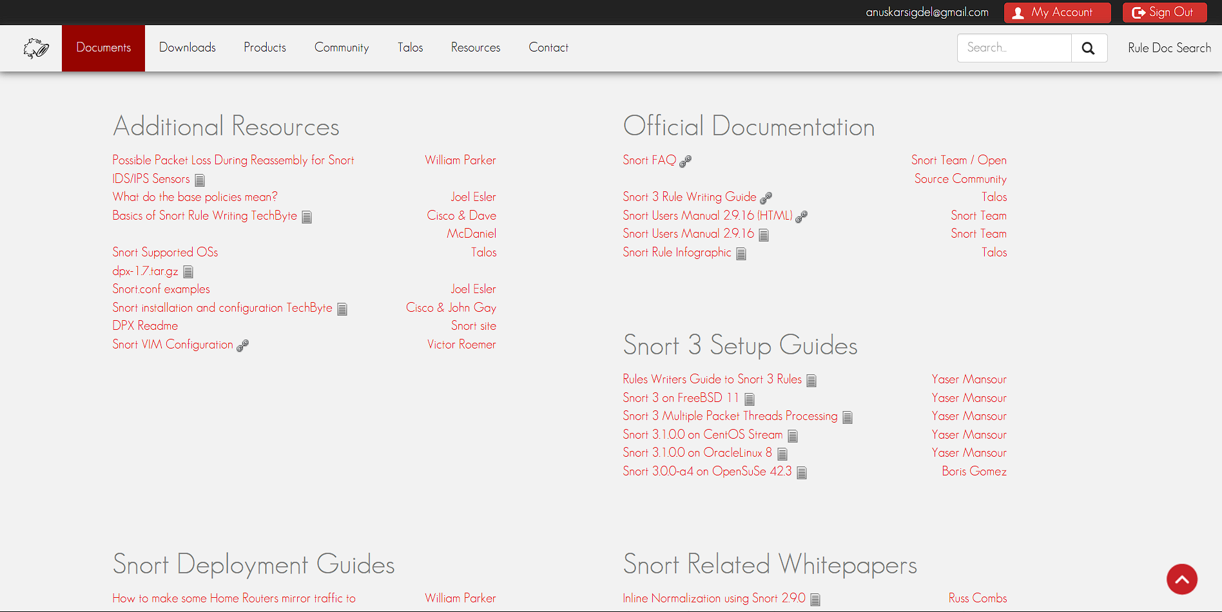
Figure 2.1 Snort product / documentation landing page ( Cisco Talos, 2024)

Table 2.1 Snort Pros and Cons
Pros | Cons
• De facto standard for signature-based NIDS | • Completely lacks built-in anomaly detection
• Highly mature and established ruleset | • Highly exposed to unknown-attack (zero-day) evasion
• Powerful deep packet inspection capabilities | • Complex C++ build chain adds overhead
• Proven architecture with extensive documentation | • Difficult to deploy on minimal-image environments

2.2.2 Suricata 7.x
Suricata (OISF, 2024) adds multi-threading, flow logging and JSON alerts, outperforming Snort on the same ruleset, but remains signature-first; anomaly detection needs external ML plugins that reintroduce the dependencies MANTIS eliminates.
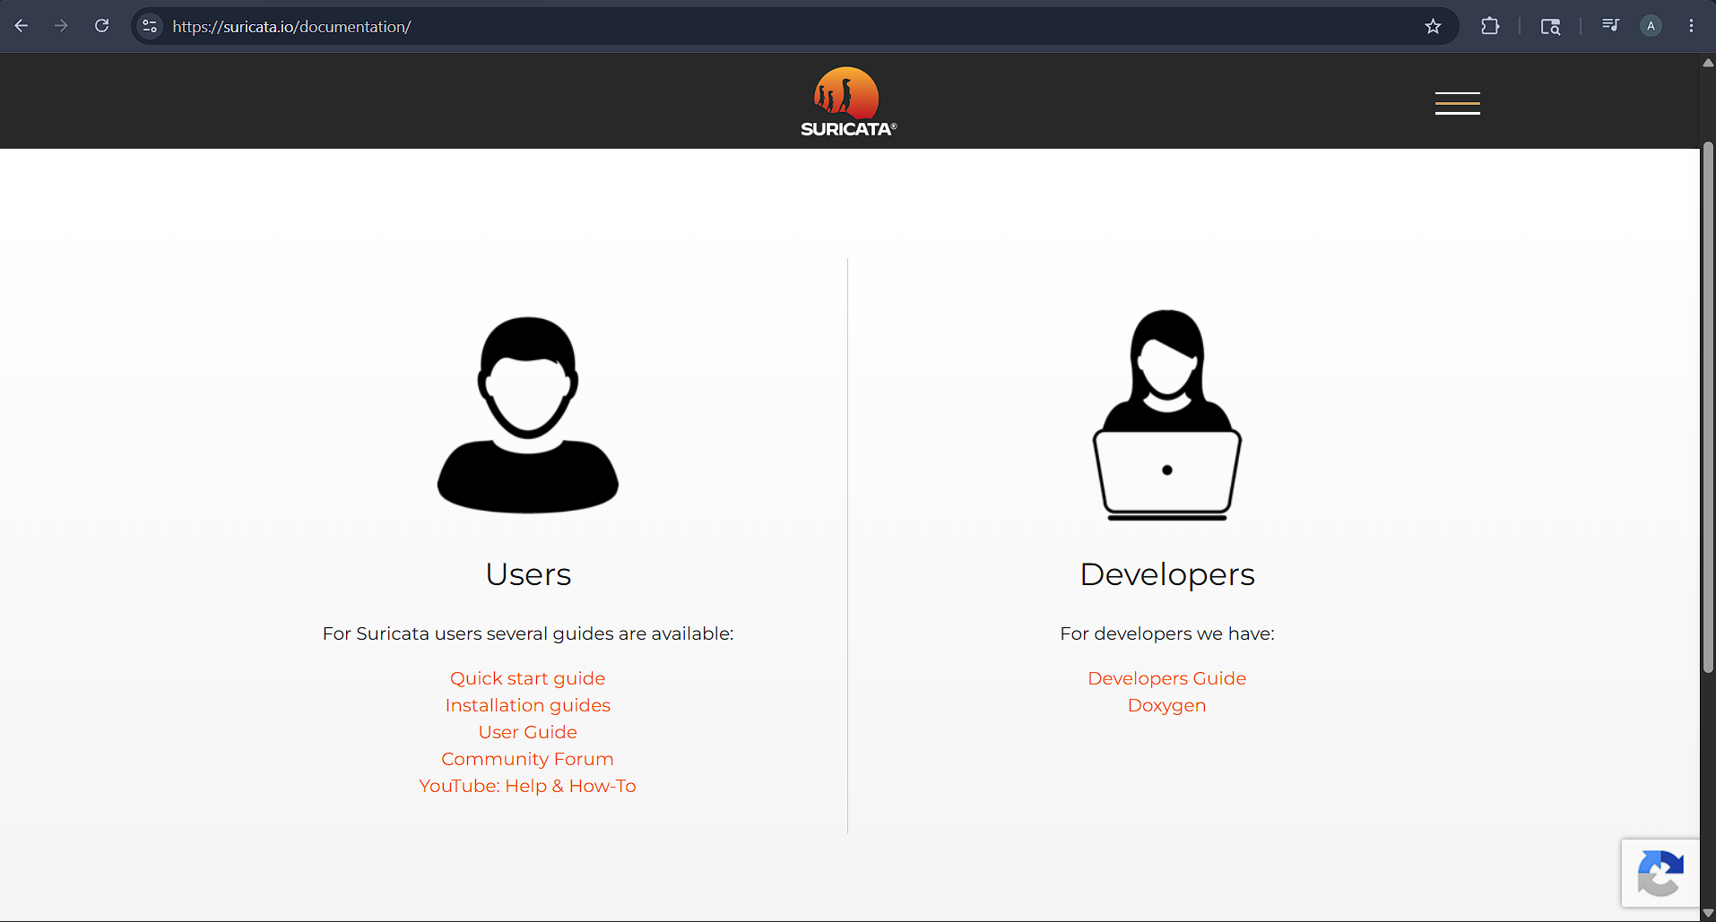
Figure 2.2 Suricata documentation landing page (OISF, 2024)

Table 2.2 Suricata Pros and Cons
Pros | Cons
• Native multi-threading capabilities for modern CPUs | • Still relies heavily on a signature-first approach
• Built-in network flow logging | • Lacks native, built-in anomaly detection
• Outputs alerts in standard JSON format | • Requires external ML plugins for behavioral analysis
• Outperforms Snort when running the same ruleset | • ML plugins reintroduce heavy software dependencies

2.2.3 Zeek 8.x
Zeek is a behavioural framework with rich scripting and detailed protocol logs and strong coverage, but offers no native blocking, requiring an external firewall. MANTIS trades some scripting flexibility for integrated iptables response and a far smaller footprint.

Figure 2.3 Zeek documentation landing page (Zeek Project, 2026)

Table 2.3 Zeek Pros and Cons
Pros | Cons
• Powerful behavioural network analysis framework | • Absolutely no native traffic blocking capabilities
• Rich and highly flexible scripting language | • Relies entirely on external firewalls to stop threats
• Generates extremely detailed protocol logs | • Scripting framework demands a larger footprint
• Provides strong overall network visibility and coverage | • Lacks integrated, lightweight response mechanisms (like iptables)

2.2.4 Wazuh 4.x
Wazuh provides full XDR/SIEM with distributed agents, ML modules and a web console, but requires Java and Elasticsearch and several gigabytes of RAM, ruling out Raspberry Pi targets. MANTIS delivers comparable alert semantics at roughly two orders of magnitude lower cost.
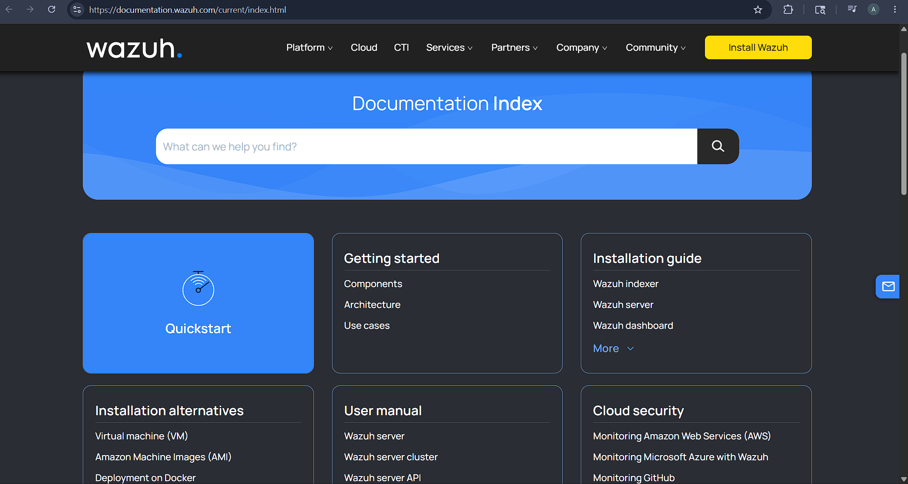
Figure 2.4 Wazuh documentation landing page (Wazuh,2026)

Table 2.4 Wazuh Pros and Cons
Pros | Cons
• Provides full XDR and SIEM capabilities | • Heavy software reliance on Java
• Utilizes distributed agents for endpoint monitoring | • Requires a resource-intensive Elasticsearch backend
• Includes built-in Machine Learning (ML) modules | • Demands several gigabytes of RAM to function properly
• Features a comprehensive, user-friendly web console | • Completely unsuitable for lightweight targets like Raspberry Pi

2.3 Research Methodology
Methodology is the structured framework of principles and processes guiding a project and the construction and evaluation of its artefact. This chapter describes the framework adopted for MANTIS across three dimensions: research philosophy, development approach and evaluation strategy.

2.4 Research Philosophy
MANTIS adopts a Positivist philosophy, treating detection accuracy, CPU and memory as objective, measurable outcomes (Crnkovic, 2010), paired with Constructive Research Methodology, in which the working artefact is the knowledge contribution. The cycle is three-phase: identify the problem (heavyweight ML dependencies locking out edge Linux hosts), build a solution (five zero-dependency Python engines), and evaluate against CIC-IoT2023 using precision, recall, F1 and operational metrics.

2.5 Development Methodology
MANTIS uses Agile Kanban rather than fixed sprints, suiting a solo project: no sprint ceremony, a WIP limit of two concurrent engines and an audit trail mapped to submission milestones. 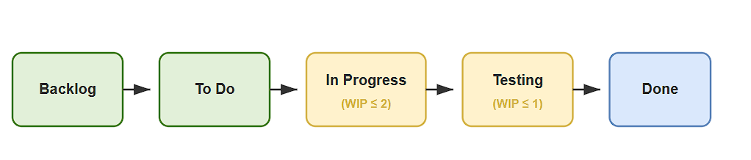
Figure 2.5 Devepoment Methodology

2.6 Evaluation Strategy
Evaluation follows a modified V-Model: unit tests validate engine logic, integration tests cover the training pipeline, system tests replay Kali and CIC-IoT2023 traffic through the live sensor, and manual tests assess dashboard usability. Results are reported per engine as precision, recall, F1 and confusion matrix, with CPU %, resident memory (MB) and per-packet latency (ms) supporting comparison with comparable tools.

2.7 Methodology for Comparable Analysis
Each tool is scored on five criteria: anomaly detection, active response, resource footprint, algorithmic transparency and trainability from modern benchmarks. Figure 1 ranks overall functionality; Table 1 summarises each tool's advantages and limitations.

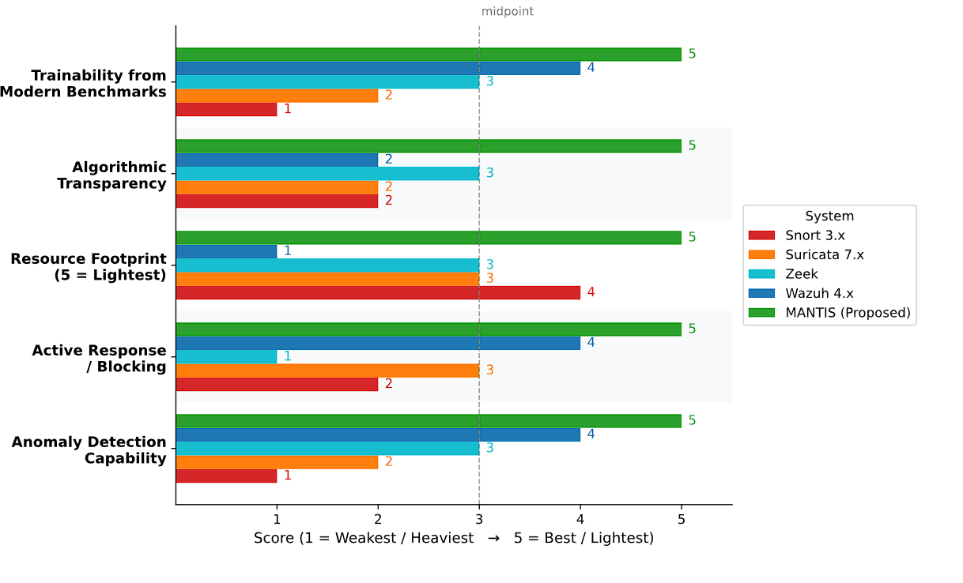
Figure 2.6: Comparable-system functionality ranking chart

Table 2.5 Comparable systems strengths and weaknesses.
Criterion | Snort 3.x | Suricata 7.x | Zeek | Wazuh 4.x | MANTIS
Anomaly detection | ✗ | ✗ | ✓ | ✓ | ✓
Active response (block) | ✓ | ✓ | ✗ | ✓ | ✓
Low resource footprint | ✗ | ✗ | ✗ | ✗ | ✓
Algorithmic transparency | ✗ | ✗ | ~ | ✗ | ✓
Trainable on benchmarks | ✗ | ✗ | ✗ | ~ | ✓

In summary, Snort and Suricata are signature-driven; Zeek adds behavioural scripting but cannot block natively; Wazuh covers enterprise XDR at a multi-gigabyte RAM cost. MANTIS fills the gap by embedding lightweight ML inside the sensor process with integrated iptables response.

2.8 Requirement Specification
This section turns the literature gap and comparable analysis into formal requirements problems, solutions and alternatives, then functional, non-functional and performance constraints.

2.8.1 Problem Domain
The problem domain describes the operational environment, and the gap MANTIS is designed to fill. Three key constraints apply:
- Resource constraints: edge Linux hosts, IoT gateways and teaching VMs typically have 1 GB of RAM and one CPU core, which is insufficient for Snort's C++ build chain or Wazuh's Java and Elasticsearch stack, each of which requires at least 4 GB of RAM.
- Detection gap: signature-based engines miss zero-day threats and behavioural anomalies, while ML frameworks such as Scikit-Learn and TensorFlow produce verdicts that cannot be traced back to a human-readable mathematical formula.
- Latency constraints: research prototypes typically impose 30 to 100 milliseconds of inference latency, which is incompatible with per-packet iptables DROP blocking. Air-gapped and locked-down deployments additionally require that the system run with zero external dependencies.

2.8.2 Proposed Solution Strategy
MANTIS delivers five detection engines, all implemented in pure Python Standard Library with no external dependencies. Each engine addresses a distinct attack category:
- Z-Score: Z-Score (DDoS/Floods): Welford online mean/variance; alert when |z| > 3. O(1) per packet.
- KNN: KNN (Port Scans): lazy K=3 nearest-neighbour over (unique_ports, packet_count) vectors using Euclidean distance.
- Naive Bayes: Naive Bayes (Payload Attacks): log-probability scoring with Laplace smoothing on 64-byte TCP payload tokens; detects SQLi, XSS.
- K-Means / Bloom: Mini-Batch K-Means (Drift): online centroid update (Sculley, 2010); alerts on distance exceeding threshold. Bloom Filter (Reputation): O(1) known-bad IP check via k hash functions.
A bounded producer/consumer queue decouples AF_PACKET capture from engine fan-out. Alerts export to CSV, UDP/JSON SIEM and optional iptables DROP rules.

2.8.3 Alternative Solution Strategy
Three alternative approaches were considered before the current design was adopted. Each was rejected for the following reasons:
- Snort plugin: Extending Snort 3.x through its C++ plugin API would require a C++ build chain and a multi-gigabyte Snort installation, which violates the zero-dependency and portability requirements.
- ONNX Runtime: Running Scikit-Learn models through ONNX Runtime introduces a C++ binary extension that is incompatible with air-gapped hosts. ONNX models are also opaque, and first-call latency on embedded hardware ranges from 30 to 100 milliseconds.
- Wazuh agent: Deploying a Wazuh 4.x agent places the Java runtime in the critical detection path; the manager server requires at least 4 GB of RAM and the binary exceeds 80 MB. Only the zero-dependency Python approach satisfies all four constraints simultaneously: transparency, deployability, low resource footprint (31 MB RAM, 9 ms latency) and full auditability.

2.8.4 Functional Requirements
- Capture raw Layer-2 Ethernet frames via AF_PACKET socket bound to a configurable network interface without using Scapy or any third-party packet library.
- Decode Ethernet (14-byte header), IPv4 (variable header), TCP and UDP headers using Python struct.unpack with manual byte slicing; extract source IP, destination IP, source port, destination port, protocol and payload excerpt.
- Route every parsed packet through all five detection engines (Z-Score, KNN, Naive Bayes, Mini-Batch K-Means, Bloom Filter) concurrently using a producer/consumer bounded queue decoupling capture from analysis.
- Z-Score engine: compute online mean and variance via Welford's method; emit a DDoS/flood alert with confidence score when |z| > configurable threshold (default 3.0).
- KNN engine: maintain a labelled training set of (unique_ports, packet_count) vectors; classify each new vector by majority vote of K=3 nearest Euclidean neighbours; emit a port-scan alert when class is Scan.
- Naive Bayes engine: tokenise TCP payload (max 64 bytes); score Safe vs Malicious using log-probabilities with Laplace smoothing; emit a payload-attack alert when Malicious confidence exceeds a configurable threshold.
- Mini-Batch K-Means engine: cluster (PPS, unique_ports) vectors with online centroid update (Sculley, 2010); emit a behavioural-drift alert when the distance from the nearest centroid exceeds a configurable threshold.
- Bloom Filter engine: check source IP against a probabilistic set of known-malicious addresses using k hash functions; emit a reputation alert immediately on membership confirmation.
- Persist every alert as an append-only row in mantis_logs.csv with fields: timestamp, source_ip, destination_ip, protocol, engine, verdict, confidence, payload_excerpt.
- Forward every alert as a JSON-encoded UDP datagram to a configurable SIEM endpoint (default: localhost:5000) within one alert-dispatch cycle of detection.
- Serve a realtime HTTP dashboard on a configurable port (default: 8080) rendering alerts grouped by source IP with severity colour coding (Critical/High/Medium/Low).
- Insert an iptables INPUT chain DROP rule for any source IP that generates an alert, when active-defence mode is enabled via command-line flag; cache blocked IPs to prevent duplicate rules.
- Persist all five engine states (weights, centroids, vocabulary, bloom bits, training vectors) as a single timestamped mantis_brain.json file; reload brain state automatically at sensor start if the file exists.
- Accept labelled training data in CSV format (columns: feature_a, feature_b, label), JSON array format, or CIC-IoT2023 flow-export format; auto-project CIC-IoT2023 columns onto MANTIS feature vectors without user configuration.
- Produce a quantitative evaluation report per engine with: True Positives, False Positives, True Negatives, False Negatives, Precision, Recall, F1-score, and a formatted confusion matrix, saved to a configurable JSON output file.
- Generate a forensic HTML report on sensor shutdown (Ctrl+C) listing all alerts grouped by source IP, sortable by severity and timestamp, with no external CSS or JavaScript dependencies.
- Install via a single install.sh script that auto-detects the Linux distribution (apt/dnf/pacman/apk/zypper), installs iptables if absent, applies cap_net_raw and cap_net_admin via setcap, and creates a mantis system user.
- Expose a command-line interface accepting: -i/--interface (capture interface), --active-defence (enable iptables blocking), --siem-host/--siem-port (UDP target), --load-brain (path to brain JSON), and --log-file (output CSV path).

2.8.5 Non-Functional Requirements
Non-functional requirements express the measurable quality constraints the system must satisfy. All targets listed below have been verified at the interim milestone:
- Latency: Per-packet latency < 15 ms (measured: 9 ms on loopback). Verified.
- Memory: Resident RAM < 50 MB (measured: 31 MB). Verified.
- CPU: CPU utilisation < 5% on one vCPU (measured: 2.4%). Verified.
- Start-up: Cold-start time < 2 s (measured: 0.7 s). Unit suite < 1 s (0.045 s). Verified.
- Security: Sensor operates with cap_net_raw / cap_net_admin only, no full root post-install. Payload capped at 64 bytes per packet (GDPR / DPA 2018 compliance).
- Active Defence: iptables blocking is opt-in (--active-defence flag); duplicate-rule cache prevents repeated DROP insertions for the same source IP.
- Usability: Deployable via a single install.sh script on Ubuntu, Fedora, Arch, Alpine, and openSUSE (apt / dnf / pacman / apk / zypper auto detected). No manual steps beyond sudo.
- Reliability: Bounded queue (1,000 frames default); dropped-frame count logged to stderr; CSV writes protected by threading.Lock().

- Maintainability: Each engine is a self-contained module under src/engines/ with a uniform interface (analyse, train, export_brain, import_brain). Brain JSON is human-readable and cross-architecture portable.
- Compatibility: Runs without modification on CPython 3.6, 3.8, 3.10, and 3.12. Packet capture complies with the UK Computer Misuse Act 1990 on operator-owned interfaces only.

2.8.6 Goals of Implementation
The key implementation goal is a uniform engine interface (analyse, train, export_brain, import_brain) so new protocols, cloud forwarding or engines can be added by implementing one class without touching the sensor orchestrator. Configuration-driven enable lists and plugin-style dispatchers preserve this extensibility.

2.8.7 System Workflow Diagrams
Figure 2 shows the existing manual workflow (periodic log review and manual iptables management); Figure 3 shows the proposed automated workflow in which MANTIS handles capture, detection, alert dispatch and optional blocking. Both are workflow diagrams, not flowcharts, as specified by the supervisor.
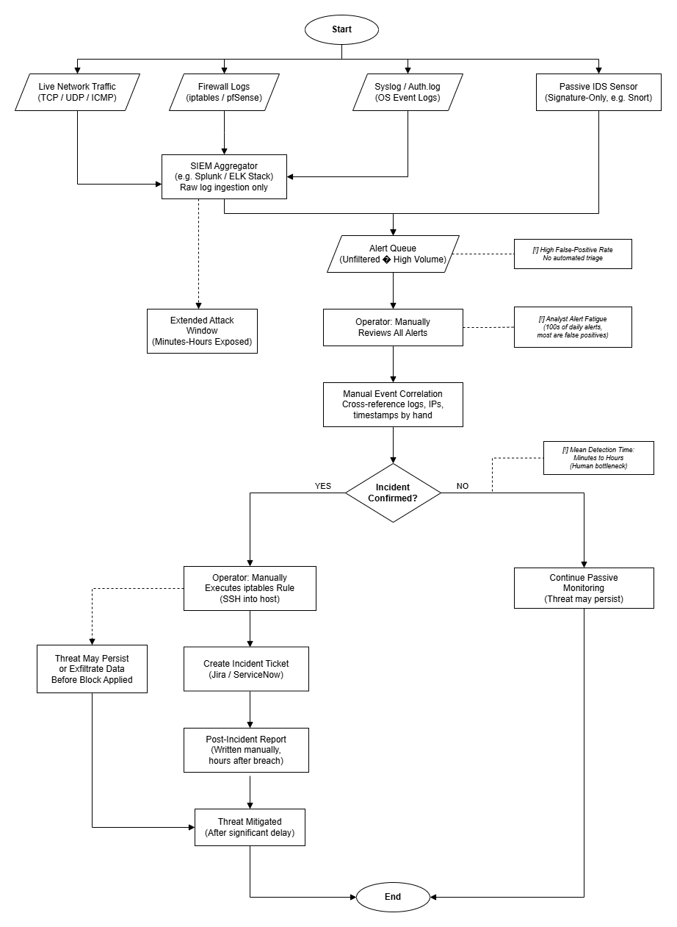
Figure 2.7: Current workflow Daigram.
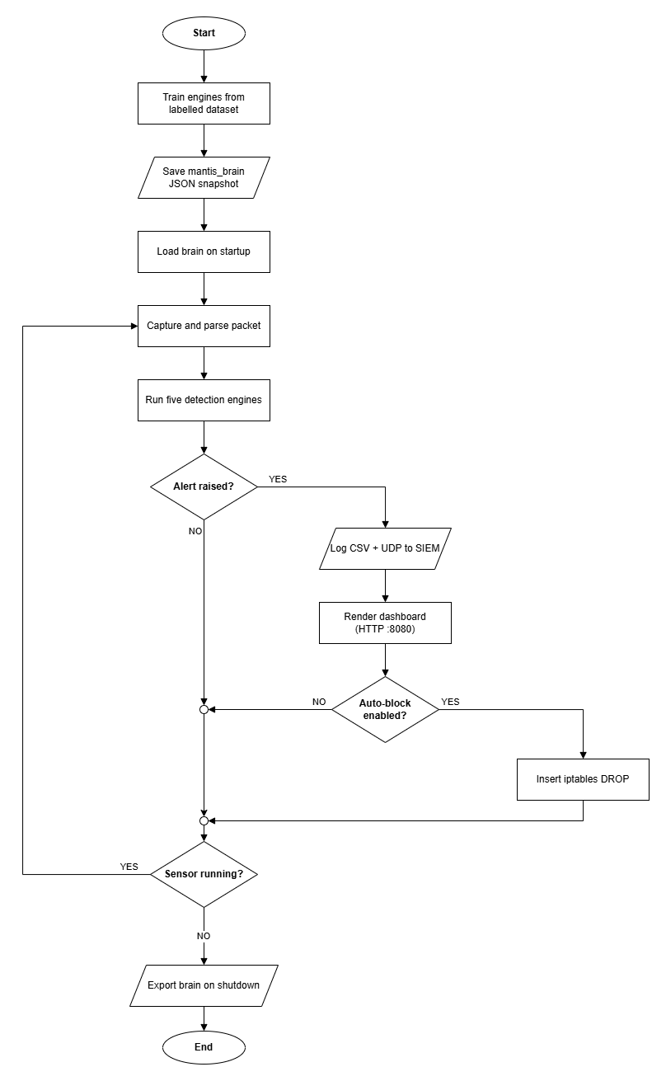

Figure 2.8: Proposed end-to-end workflow MANTIS

2.8.8 Performance and Environment Requirements
Hardware: an x86_64/ARM64 Linux host with ≥1 CPU core, 1 GB RAM and a loopback or bridged interface. Software: Python 3.6+, iptables, libcap and VirtualBox 7; Nmap, hping3 and curl are optional attacker-VM tools. Tooling: VS Code, draw.io.

Table 2.6: Performance targets versus interim measurements.
Metric | Target | Measured | Outcome
Per-packet latency | < 15 ms | 9 ms (mean, lo iface) | Met
Resident memory | < 50 MB | 31 MB (sensor process) | Met
CPU utilisation | < 5% | 2.4% (1 vCPU, idle bg) | Met
Test-suite runtime | < 1 s | 0.045 s (21 tests) | Met
Cold-start time | < 2 s | 0.7 s | Met

2.9 Algorithms Implemented
The first three engines are documented below with definition, mathematics, steps, pseudocode placeholder and flowchart. K-Means and Bloom Filter continue in Section 3.7.

2.9.1 Z-Score Statistical Engine
Model’s packets-per-second (PPS) as a Gaussian stream and flags volumetric anomalies when the standardised score exceeds three.

Mathematical Model
z = (x - mu) / sigma, alerting when |z| > 3. Mean mu and variance sigma are updated online via Welford's incremental method.
z = (X - μ) / σ
Step-by-Step Procedure
- Ingest current PPS sample x.
- Update running means and variance with Welford's update.
- Compute z for x.
- If |z| > 3, emit DDoS/flood alert with confidence.

Pseudocode
Z-Score classifies(x):
n += 1; delta = x - mu; mu += delta/n; M2 += delta*(x-mu)
sigma = sqrt (M2 / (n-1)) // Welford online variance
IF sigma == 0: RETURN Normal
z = (x - mu) / sigma
IF |z| > threshold: RETURN DDoS_Flood, confidence=min (|z|/6, 1.0)
ELSE: RETURN Normal

Flowchart
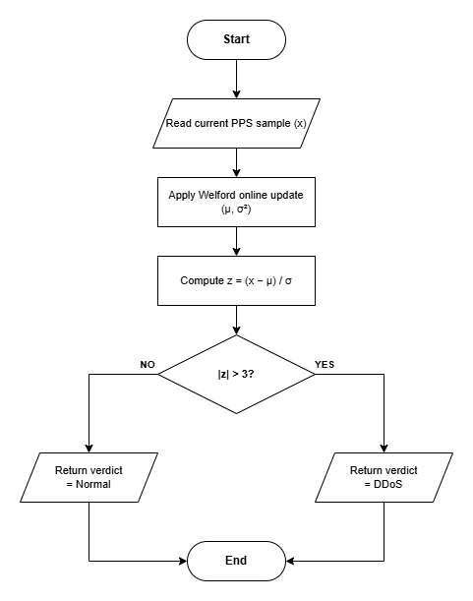
Figure 2.9: Z-Score Statistical Engine detection engine.

2.9.2 K-Nearest Neighbours (KNN) Engine
Lazy classifier over (unique_ports, packet_count) feature vectors for reconnaissance / port-scan behaviour.

Mathematical Model
Euclidean distance d(p,q) = sqrt (sum_i (p_i - q_i) ^2). Majority vote of K=3 nearest labelled neighbours assigns Normal vs Scan.
$$d(x,y)=(∑_{i=1}^{n}​{(xi​-yi​)}^{p})\frac{1}{p}​$$
Step-by-Step Procedure
- Extract feature vector from live flow state.
- Compute distance to every stored training point.
- Select K smallest distances.
- Return to the majority class and mean neighbour distance as confidence.

Pseudocode
KNN classify (q = [unique_ports, packet_count]):
distances = [(euclidean (q, vec), label) FOR (vec, label) IN training_data]
neighbours = sort(distances)[0: K] // K=3
votes = count_labels(neighbours)
predicted = argmax(votes)
IF predicted == 'Scan': RETURN PortScan, confidence=votes [Scan]/K
ELSE: RETURN Normal

Flowchart
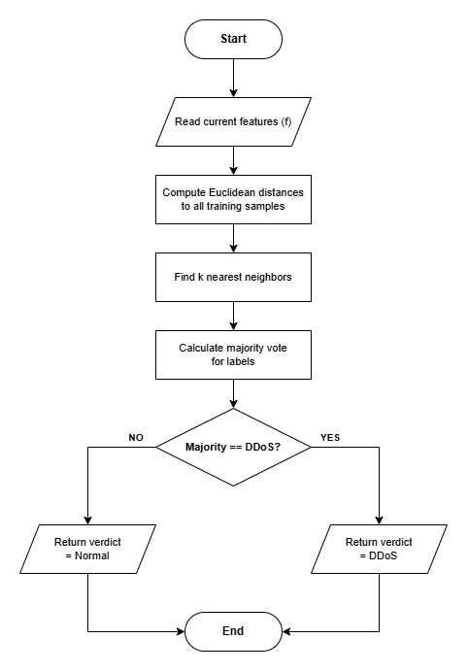
Figure 2.10: K-Nearest Neighbours (KNN) Engine detection engine.

2.9.3 Multinomial Naive Bayes Engine
Tokenises UTF-8 payload excerpts and scores Safe vs Malicious using log-probabilities with Laplace smoothing.

Mathematical Model
log P(class|tokens) = log P(class) + sum_i log P(token_i|class); Laplace smoothing prevents zero counts on unseen tokens.
$$P\left(wn​ ∣ wn-1​,…,w1​\right)=\frac{C(w1​,…,wn​)+1}{C(w1​,…,wn-1​)+V}​$$
Step-by-Step Procedure
- Decode and tokenise payload (max 64 bytes stored).
- Accumulate log-probability per class.
- Select argmax class; map Malicious to alert if confidence > threshold.

Pseudocode
Naive Bayes classifies(payload_bytes):
tokens = split (decode (payload [:64], 'utf-8', errors='ignore'))
FOR c IN ['Safe','Malicious']:
score[c] = log_prior[c]
FOR token IN tokens:
score[c] += log ((count (token, c) +alpha) / (total(c)+alpha*|vocab|))
predicted = argmax(score)
IF predicted=='Malicious' AND confidence>=threshold: RETURN PayloadAttack
ELSE: RETURN Safe

Flowchart

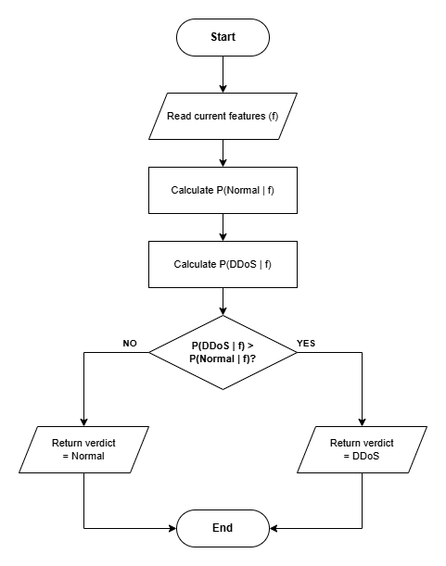
Figure 2.11 Multinomial Naive Bayes Engine detection engine.
System analysis and design establish the structure, behaviour and data relationships of MANTIS before implementation. The system is modelled with six UML diagram types plus the mathematical specifications of the five engines, so every component has a defined role before coding.

3. System Analysis and Design
The systematic phase of evaluating requirements, defining problem scopes, and establishing the architectural blueprints necessary to construct the software solution.

3.1 Use Case
A use case describes an actor-system interaction achieving a goal. The three MANTIS actors are the Security Administrator, the Malicious Attacker and the Linux Kernel (an external system). Primary use cases include Train ML Engines, Load Brain JSON, Sniff Raw Sockets and Evaluate Against Detection Models.
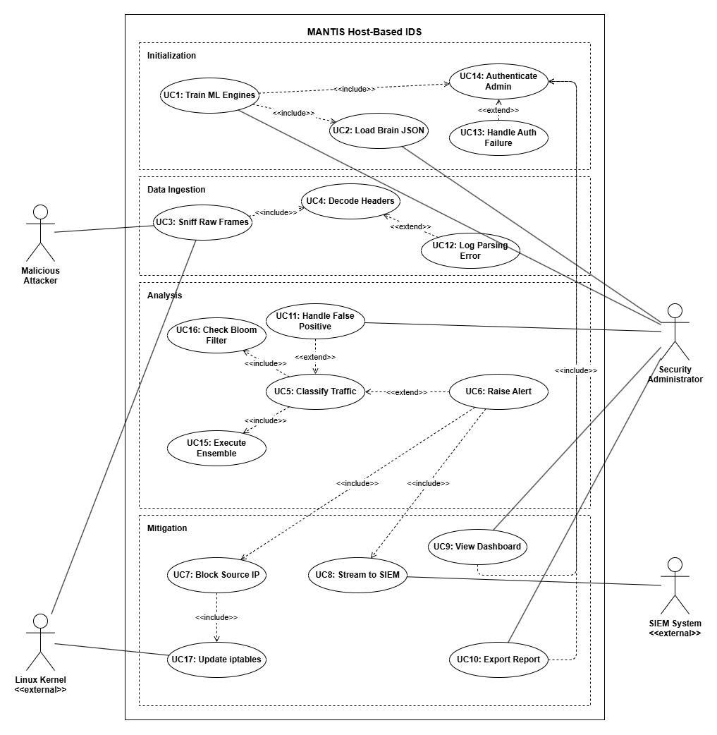
Figure 3.1: Use Case Diagram

3.1.1 Use Case Documentation
Provides a detailed, step-by-step written breakdown of how the system interacts with its actors to achieve a specific goal. It expands on the visual diagram by outlining the required preconditions, the main success flow, and how the system handles exceptions or errors during the process.

Table 3.1 Train ML Engines
Use Case Name | Train ML Engines
Primary Actor | Security Administrator
Description | The admin trains the machine learning algorithms using a dataset before the system goes live.
Preconditions | The administrator must be logged into the system.
Main Flow | 1. Admin triggers the training script.  2. System requires authentication (Includes UC14).  3. System processes the dataset and builds the mathematical models.  4. System saves the learned weights and rules to a JSON file (Includes UC2).
Postconditions | The ML engines are ready to be used for live traffic analysis.
Exceptions | If the admin enters the wrong password, the system blocks the action and logs a failure (Extends UC13).

Table 3.2 Sniff Raw Frames
Use Case Name | Sniff Raw Frames
Primary Actor | Malicious Attacker
Description | The system intercepts raw network traffic coming from an external source (like a hacker) at Layer-2.
Preconditions | The MANTIS sensor must be turned on, authenticated, and attached to a valid network interface.
Main Flow | 1. The attacker sends packets to the target network.  2. The AF_PACKET socket grabs the raw Ethernet frames.  3. The system strips the headers to extract the IP and port details (Includes UC4).  4. The packet data is forwarded to the analysis queue.
Postconditions | The packet is successfully captured, parsed, and formatted for the ML detection engines.
Exceptions | If a packet is broken or malformed, the system cannot read the header and logs a parsing error (Extends UC12

Table 3.3: Classify Traffic
Use Case Name | Classify Traffic
Primary Actor | Internal System
Description | The core engine checks the captured packets to see if they are normal traffic or a DDoS attack.
Preconditions | The ML engines must be trained and a packet must be ready in the queue.
Main Flow | 1. The system pulls a packet from the queue.  2. It checks the IP against the Bloom Filter to see if it is a known safe IP (Includes UC16).  3. It runs the packet features through all the ML algorithms to get their votes (Includes UC15).  4. The system calculates the final majority vote.
Postconditions | The packet is marked as either Normal or DDoS.
Exceptions | If the traffic is marked as an attack, the system triggers an alert (Extends UC6). If the admin later marks it as a mistake, it is handled as a false positive (Extends UC11).

Table 3.4: Block Source IP
Use Case Name | Block Source IP
Primary Actor | Linux Kernel (External)
Description | The system automatically blocks an attacker's IP address to stop a DDoS attack.
Preconditions | The system must have raised an alert for a specific IP address (UC6).
Main Flow | 1. The system receives the malicious IP from the alert.  2. It creates a firewall drop rule.  3. It talks to the Linux Kernel to update the firewall settings (Includes UC17).  4. The IP is permanently blocked from reaching the server.
Postconditions | The attacker can no longer send traffic to the network.
Exceptions | None. The system enforces the block immediately.

Table 3.5 View Dashboard
Use Case Element | Detail
Use Case Name | View Dashboard
Primary Actor | Security Administrator
Description | The admin logs into the web dashboard to see live traffic graphs and recent attack alerts.
Preconditions | The lightweight web server must be running.
Main Flow | 1. The admin opens the dashboard URL in a browser.  2. The system asks for a username and password (Includes UC14).  3. The system loads the HTML UI and fetches the latest alerts.  4. The admin views the current network status.
Postconditions | The admin successfully views the live metrics.
Exceptions | If the admin tries to click Export Report (UC10), the system generates a PDF or CSV download of the current screen.

3.2 Sequence Diagram
The sequence diagram shows the Sniffer thread pushing a frame to the bounded queue, the Analyser parsing headers, each engine returning a verdict, the Dispatcher writing CSV, UDP and HTML output, and the optional iptables DROP when a threat is confirmed.
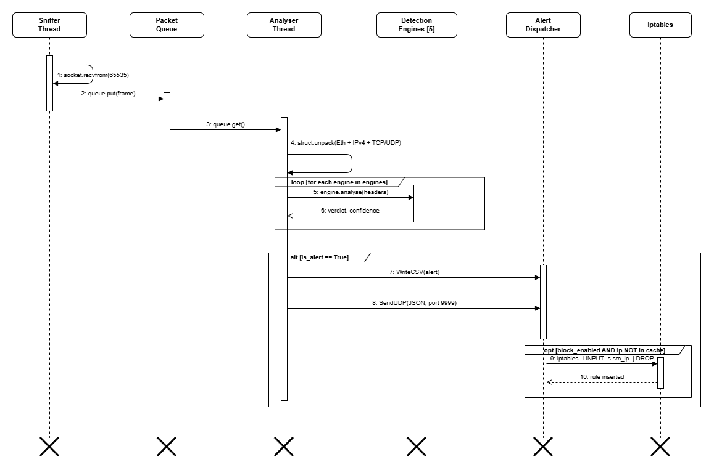
Figure 3.1: Sequence Diagram Live Detection
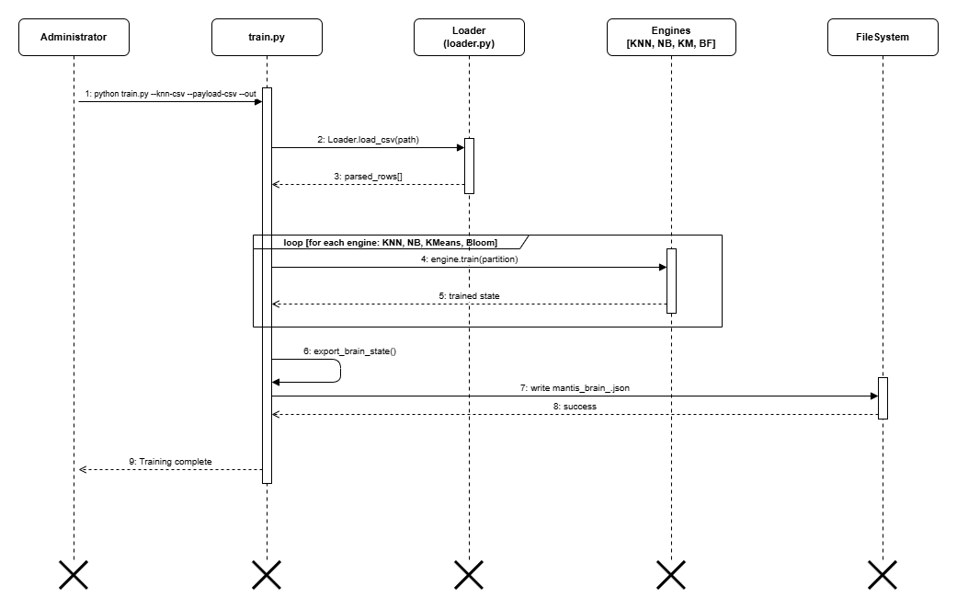
Figure 3.2: Sequence Diagram Training Pipeline

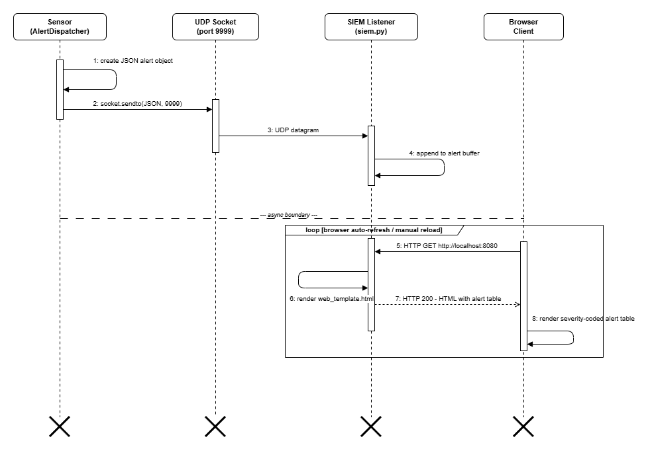
Figure 3.3 Sequence Diagram SIEM Dashboard
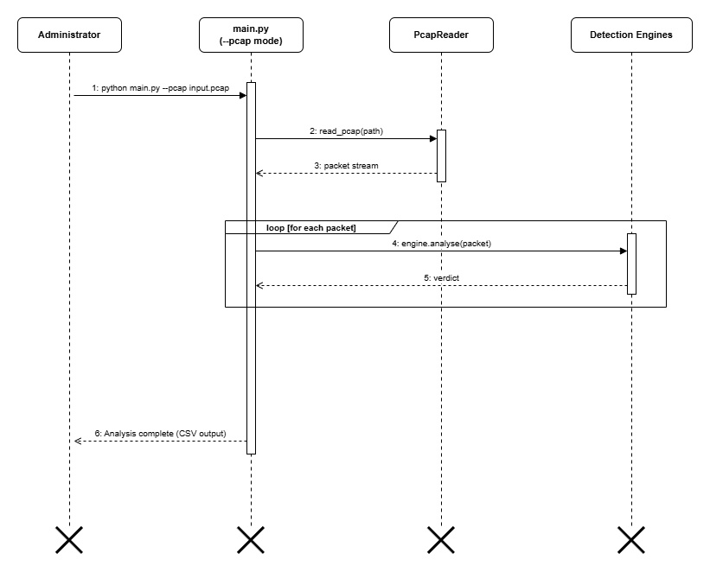
Figure 3.4 Offline PCAP Analysis

3.3 Class Diagram
The class model centres on the Sensor orchestrator, with PacketParser for header decoding, AlertDispatcher for output routing, and five engine classes sharing the interface analyse, train, export_brain and import_brain.
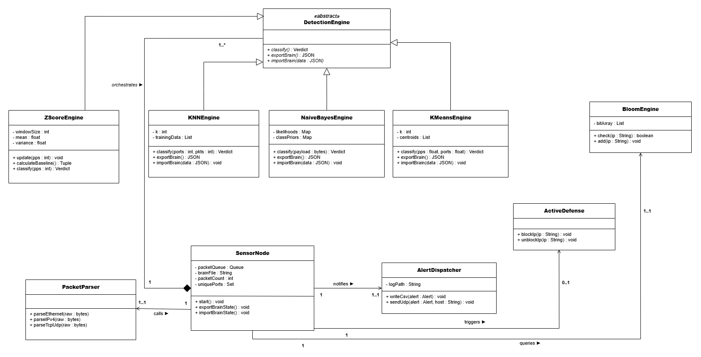
Figure 3.5: Class Diagram

3.4 Activity Diagram
The activity diagram traces execution from frame capture through header parsing, parallel engine fan-out, verdict aggregation, alert writing, UDP broadcast and a conditional iptables block gated on engine type and configuration.
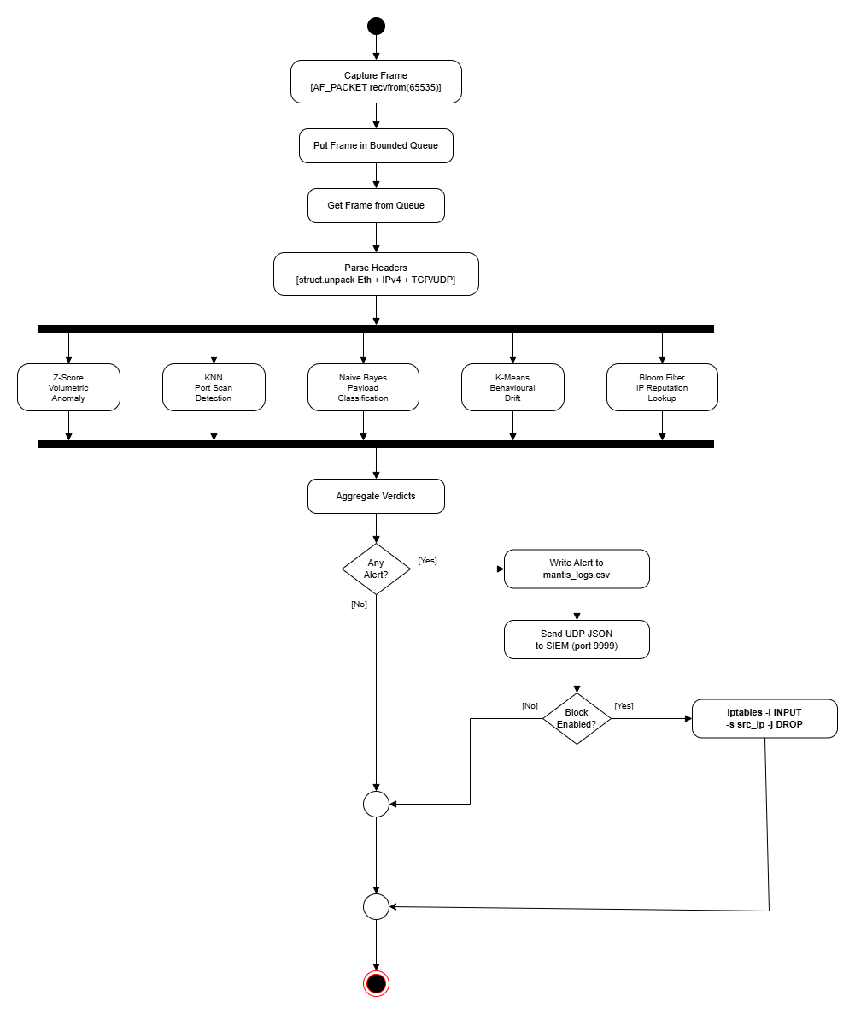
Figure 3.6: Activity Diagram (live Detection)
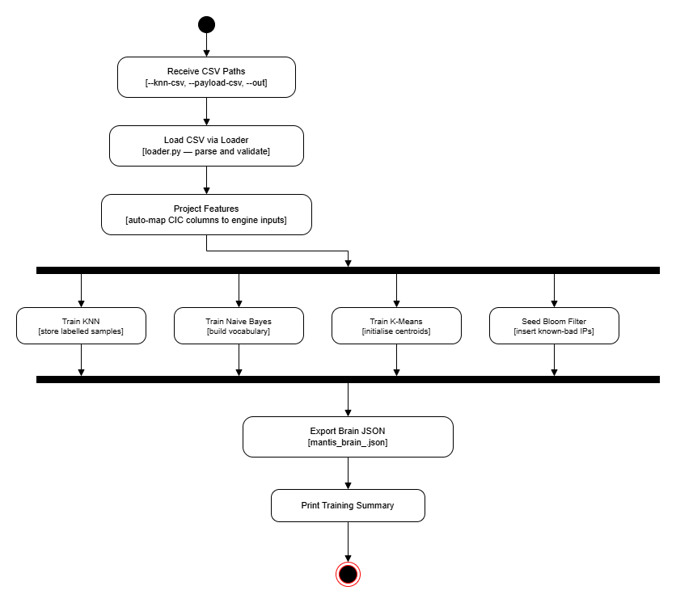
Figure 3.7: Activity Diagram (Training Pipeline)
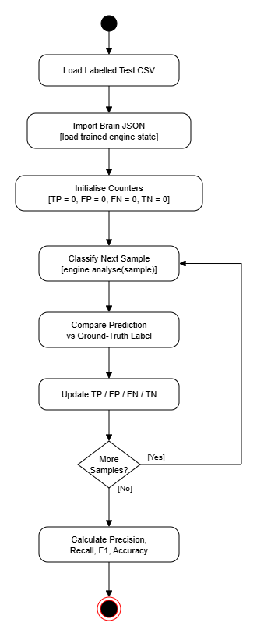
Figure 3.8: Activity Diagram (Evaluation Harness)
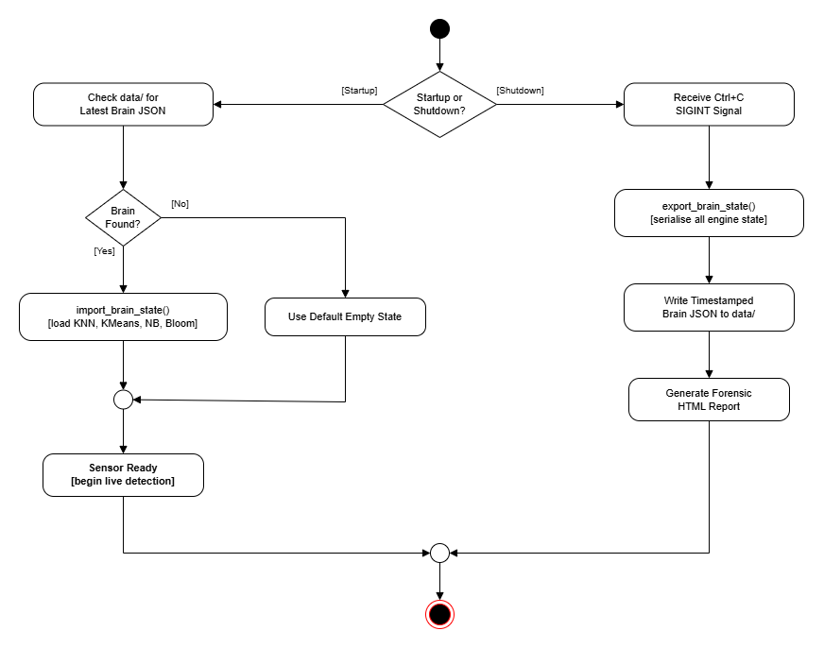
Figure 3.9: Activity Diagram (Brain Persistence)
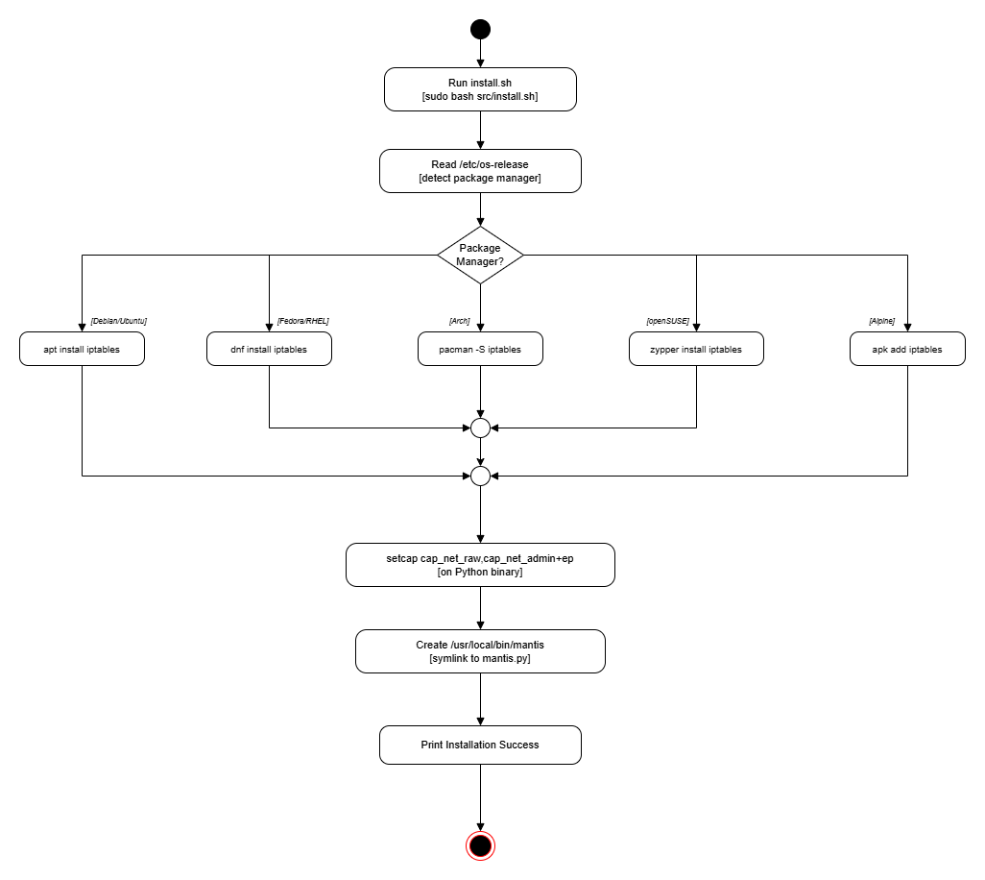
Figure 3.10: Activity Diagram (Installation)

3.5 Database Schema
Persistence uses flat files: mantis_logs.csv stores alerts (timestamp, source_ip, engine, verdict, confidence, payload_excerpt), and one data/mantis_brain_<timestamp>.json is written per engine training session to capture learned state.
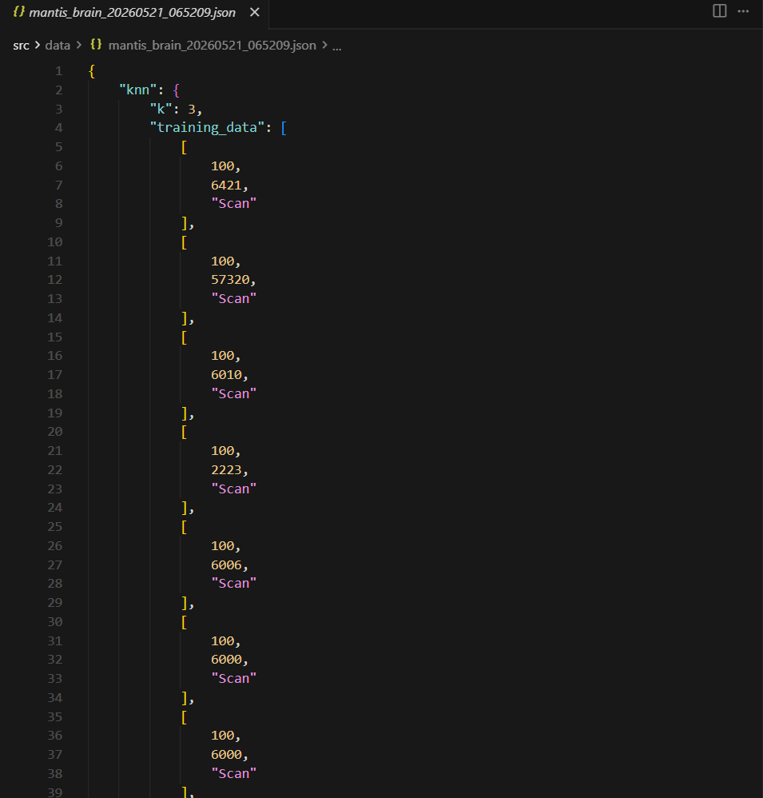
Figure 3.11 Database Schema

3.6 Algorithms Implemented
An architectural breakdown of the custom algorithmic logic implemented to process system data efficiently while minimizing external dependencies and computational overhead.

3.6.1 Online Mini-Batch K-Means Engine
Clusters live (PPS, unique_ports) points to detect behavioural drift away from learned normals.

Mathematical Model
For nearest centroid c_k: c_k: = c_k + alpha * (x - c_k) with learning rate alpha (Sculley, 2010 mini-batch update).
$$ck​←ck​+η_{k}​({\overline{x}}_{k}-c_{k}​)$$
Step-by-Step Procedure
- Compute distance from point x to each centroid.
- Assign x to argmin centroid index.
- Update centroid with learning rate alpha.
- Flag alert if distance exceeds configured threshold.

Pseudocode

Mini-Batch K-Means classify (x = [pps, unique_ports]):
nearest_k = argmin (euclidean (x, c) FOR c IN centroids)
min_dist = euclidean (x, centroids[nearest_k])
centroids[nearest_k] += alpha * (x - centroids[nearest_k]) // Sculley 2010
IF min_dist > threshold: RETURN BehaviouralDrift
ELSE: RETURN Normal

Flowchart
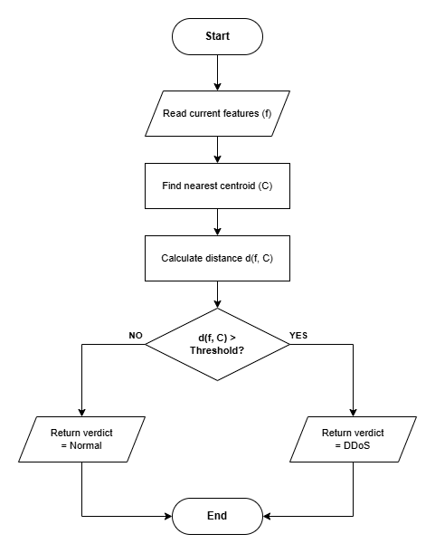
Figure 3.12 Online Mini-Batch K-Means Engine flowchart

3.6.2 Bloom Filter Reputation Engine
Probabilistic set membership for known-malicious source IPs with O (1) lookup and bounded false-positive rate.

Mathematical Model
m bits, k hash functions; expected false-positive rate (1 - exp(kn/m)) ^k for n inserted items.
$${( 1-e^{-\frac{kn}{m}} )}^{k}$$
Step-by-Step Procedure
- Hash item with k independent hash functions.
- Add all k bit positions to 1.
- On check: return true only if all k positions are 1.

Pseudocode
Bloom Filter check(ip):
FOR seed IN hash_seeds:
pos = adler32(encode (ip + str(seed))) mod m
IF bit_array[pos] == 0: RETURN Clean // Definite non-member
// All k bits set -> probable member
fp_rate = (1 - exp(-k*n/m))^k // Mitzenmacher & Upfal 2017
RETURN KnownMalicious, confidence = 1.0 - fp_rate

Flowchart
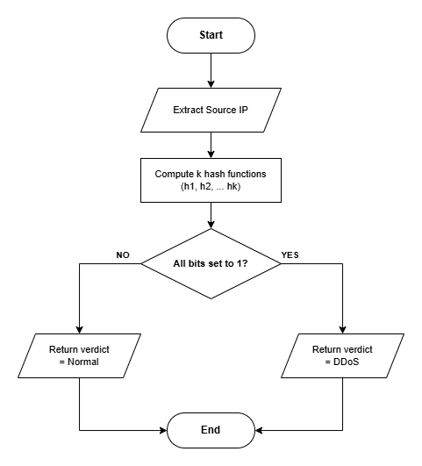
Figure 3.15 Bloom Filter Reputation Engine flowchart

3.8 System Interface and Design
System interface and design outline the architectural blueprint, component interactions, and user-facing elements required to fulfill the system's operational objectives.

3.8.1 Wireframe
A low-fidelity schematic detailing the skeletal framework, information architecture, and navigational hierarchy of the user interface.
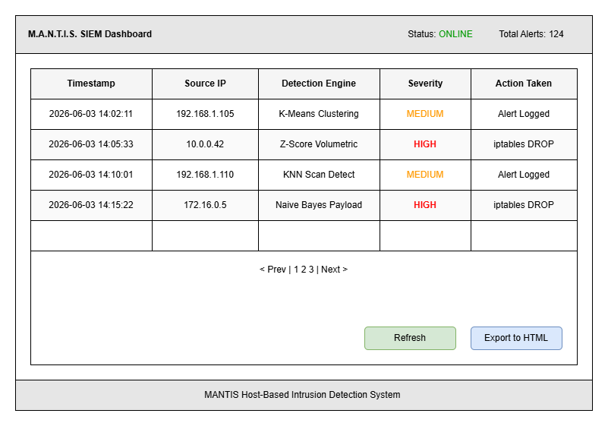
Figure 3.16 SIEM Dashboard Wireframe

3.8.2 Mockup (Implemented Functions)
Three implemented UI functions are evidenced below: live alert table, severity colour coding, and forensic HTML export triggered on shutdown.
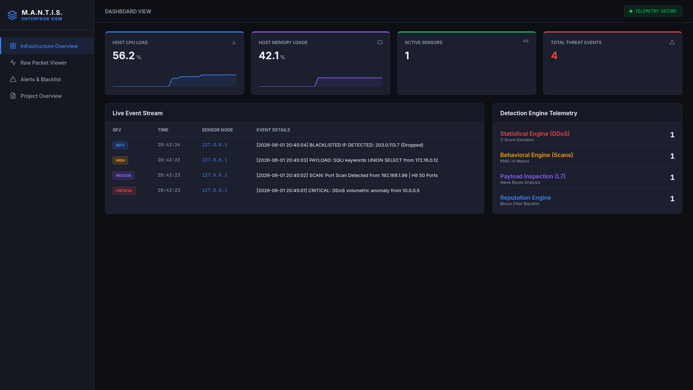
Figure 3.17 Live alert table
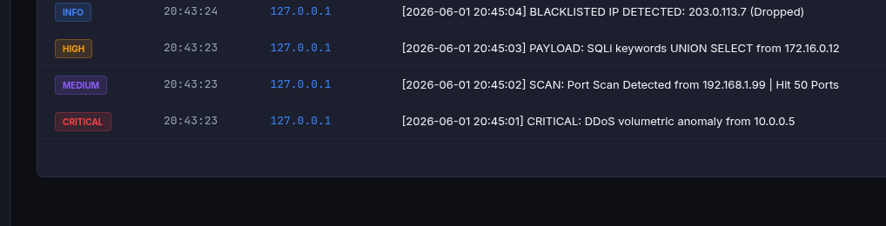
Figure 3.19 Severity colour coding
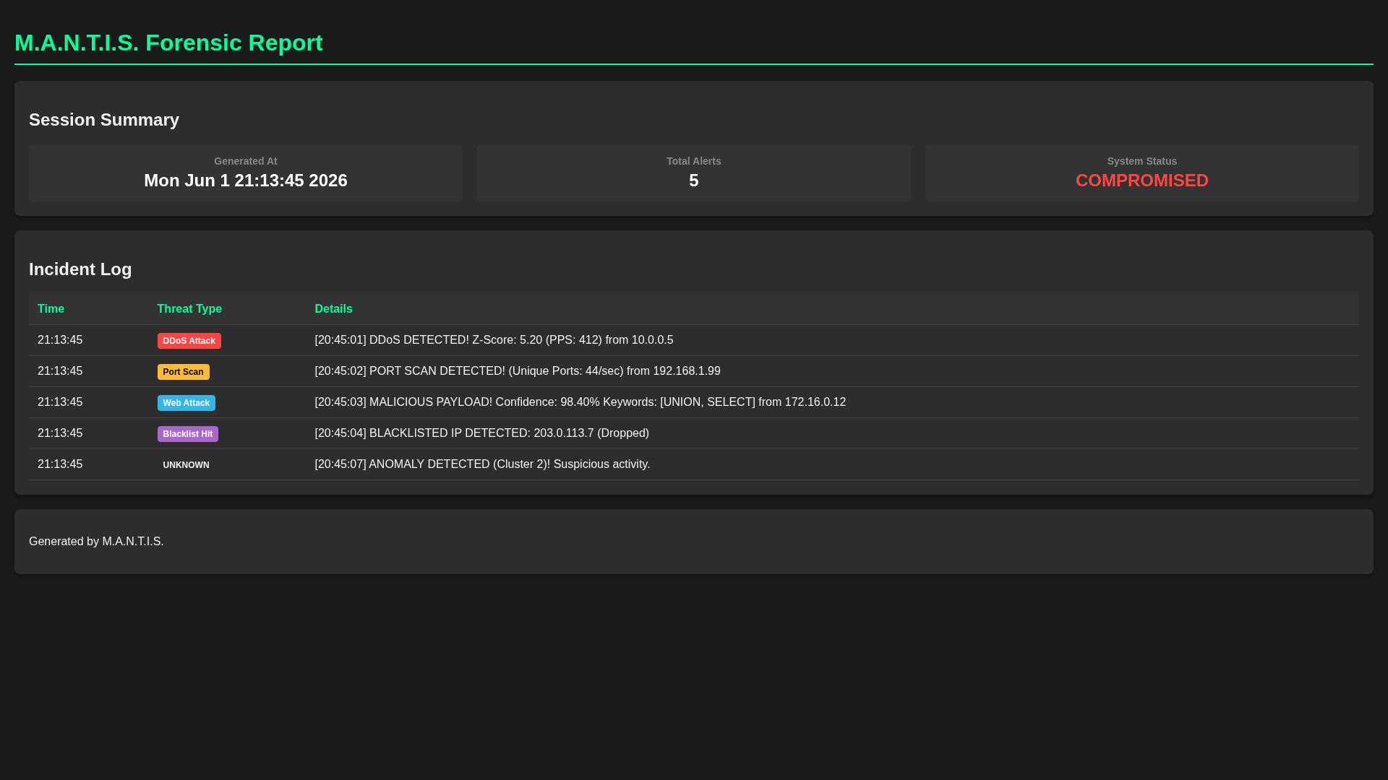
Figure 3.20 Forensic HTML export triggered on shutdown

4. System Build and Technical Notes
This chapter documents the build. The repository places engines under src/engines/, the sensor under src/sensor_node/, the dashboard under src/dashboard_ui/ and the harness under src/evaluation/. The entry point mantis.py dispatches to training, evaluation or live-run mode with no third-party imports in the detection path.

The sensor uses AF_PACKET recvfrom in a producer thread and struct.unpack to decode Ethernet, IPv4, TCP and UDP headers, with no Scapy. A bounded queue separates capture from analysis to cut GIL contention (bug B-01, resolved). AlertDispatcher writes mantis_logs.csv, broadcasts JSON over UDP port 9999 and serves web_template.html on port 8080. The iptables integration inserts DROP rules at the chain head, with a blocked-IP cache preventing duplicates (bug B-04).
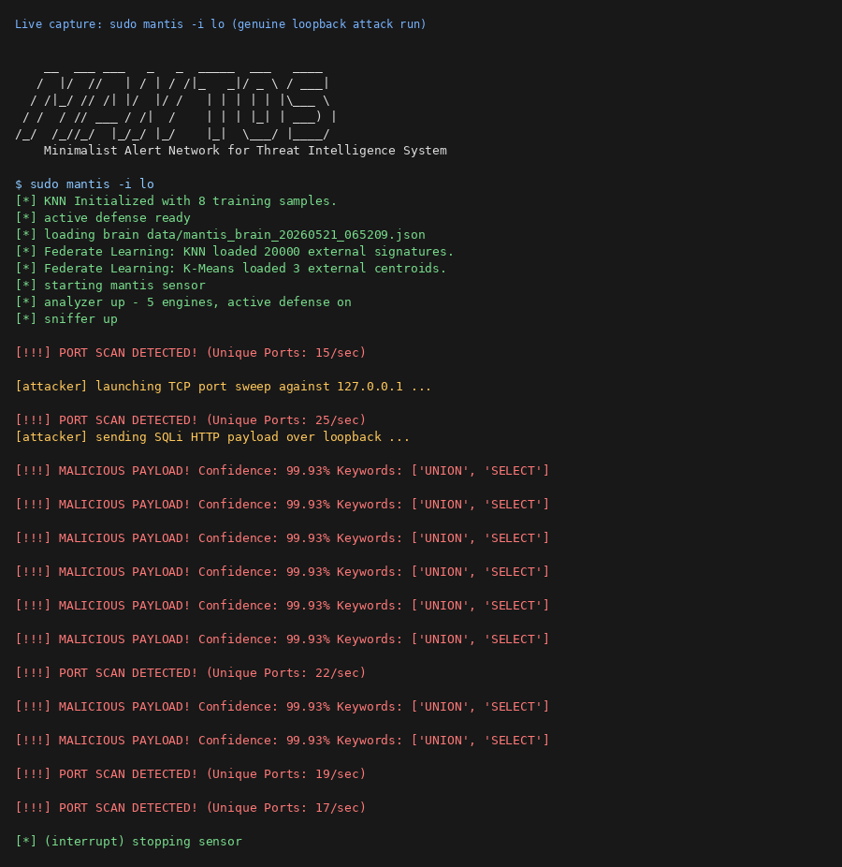
Figure 4.1 Live Terminal Dashboard
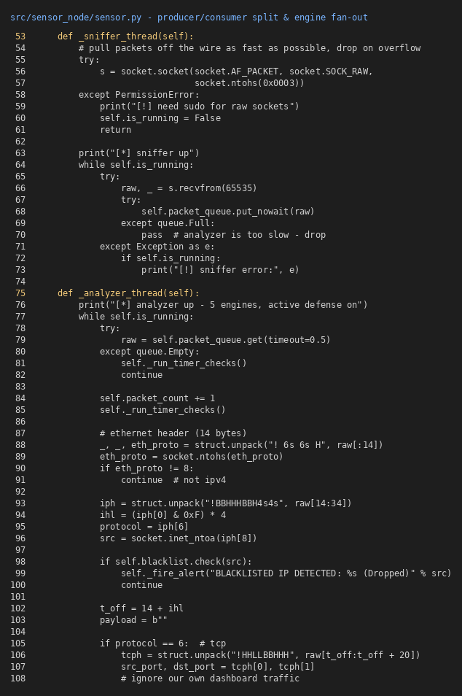
Figure 4.2 Producer/Consumer and Engine fan out
Dashboard alerts are grouped by source IP with ANSI colour in CLI mode and severity styling in the browser. Persistence is an append-only CSV guarded by a threading.Lock, with no SQL engine. On shutdown the brain state is exported to data/mantis_brain_<timestamp>.json. install.sh auto-detects the package manager (apt, dnf, pacman, zypper, apk), installs iptables, applies setcap cap_net_raw+cap_net_admin and creates a /usr/local/bin/mantis symlink.

Figure 4.3 Web Dashboard
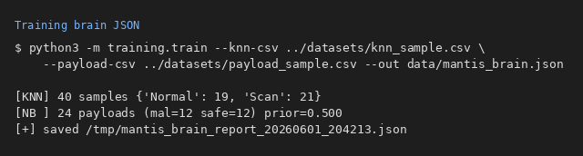

Figure 4.4 Sample Training

5. Testing Strategy and Evaluation
This section defines the methodological framework used to verify system stability, validate core logic against initial requirements, and evaluate performance benchmarks under operational conditions.

5.1 Testing Definitions and Approach
Testing validates the artefact against its requirements using a V-Model aligned to the Kanban schedule. Unit tests exercise each engine in isolation with deterministic inputs; integration tests run the loader, trainer and evaluator on bundled CSVs; system tests replay live offensive traffic in VirtualBox; manual tests cover dashboard usability. Black-box tests treat the sensor as closed; white-box tests assert centroids, vocabulary tables and Bloom bit arrays.

- Unit testing: - per-engine assertions (21 cases, 0.045 s).
- Integration testing: - train + evaluate pipeline.
- System testing: - Nmap / hping3 / curl scenarios (TEST_GUIDE.md).
- Manual testing: -SIEM dashboard walkthrough with supervisor.

5.2 Algorithm Tests
Key algorithm-level test cases include: a constant PPS stream yielding Z = 0; a spike triggering |Z| > 3; a port-scan vector classified Scan by KNN; a UNION SELECT payload labelled Malicious by Naive Bayes; a Bloom Filter positive after insertion; and a K-Means centroid drifting toward live traffic after the online update.

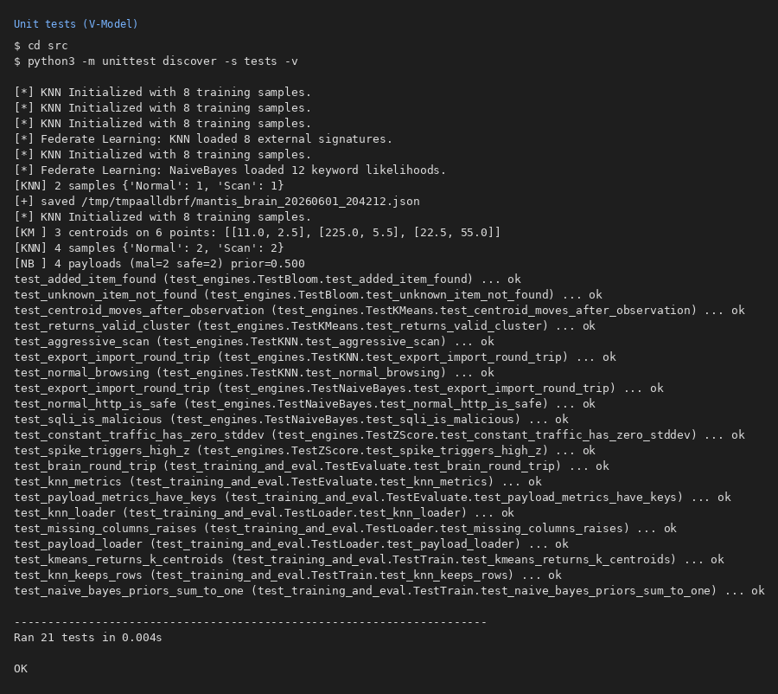
Figure 5.1 Unit Testing

5.3 Test Cases and Scenarios
Table 4 documents defects found during interim development. System test scenarios: SYS-01 (port scan) Nmap from Kali against the Ubuntu sensor must raise a KNN Scan alert in the CSV log; SYS-02 (flood) an hping3 SYN flood must raise a Z-Score alert; SYS-03 (payload) a curl SQLi string must be labelled Malicious by Naive Bayes; SYS-04 (blacklist) a Bloom-seeded IP must raise an immediate reputation alert; UAT-01 the supervisor views the dashboard over UDP from a remote sensor with sub-second render.

Table 5.1: Bug tracking log
Symptom | Root Cause | Status | Resolution
GIL contention dropped packets under load | Sniffer + analyser collapsed in one thread | Fixed | Producer / consumer split with bounded queue.
Naive Bayes underflow on long payloads | Repeated multiplication of small probabilities | Fixed | Switched to log-probabilities.
K-Means centroid stuck at zero | Empty cluster on first sample | Fixed | Lazy seed: first sample becomes centroid 0.
iptables rule duplicated on repeat alerts | Same source IP triggered twice | Fixed | Cache of already-blocked IPs.
install.sh failed on Alpine (apk) | Only apt branch existed | Fixed | Added /etc/os-release dispatch for apt, dnf, pacman, zypper, apk.
Naive Bayes recall = 0.5 on sample data | Limited seeded vocabulary | Open | Mitigation = expand vocabulary from CIC-IoT2023 in sprint S-2.

6. Progress To Date
The checklist below records all planned deliverables at the interim milestone. COMPLETE items are implemented, tested and verified; IN PROGRESS items are partially finished; PENDING items are scheduled for the remaining sprints in Chapter 8.
- 5 pure Python ML engines built and unit tested.
- Multithreaded AF_PACKET sensor operational (9ms latency).
- iptables active defence with IP caching verified.
- UDP/JSON dashboard & HTML reporting live.
- Data training pipeline & state saving (brain. json) completed.
- Evaluation harness outputting Precision, Recall, F1, and confusion matrices.
- 21-case unit suite passing (0.045s); universal install.sh built.
- Interim metrics logged; full CIC-IoT2023 training scheduled for Sprint S-1.

7. Future Work
- Run a full CIC-IoT2023 training slice and rerun the evaluation harness to produce definitive headline metrics.
- Broaden the Naive Bayes training vocabulary to push recall above 0.90.
- Execute the head-to-head benchmark comparing MANTIS directly with Snort and Wazuh on CPU usage, memory consumption and detection rate.
- Run all live-fire scenarios documented in TEST_GUIDE.md and capture screenshot evidence for the final dissertation.

References
- Bloom, B.H. (1970) 'Space/time trade-offs in hash coding with allowable errors', Communications of the ACM, 13(7), pp. 422-426.
- Canadian Institute for Cybersecurity (2023) CIC-IoT2023 Dataset. Available at: https://www.unb.ca/cic/datasets/iotdataset-2023.html (Accessed: 14 February 2026).
- Chandola, V., Banerjee, A. and Kumar, V. (2009) 'Anomaly detection: a survey', ACM Computing Surveys, 41(3), Article 15.
- Cisco Talos (2024) Snort Documentation. Available at: https://www.snort.org/documents (Accessed: 20 March 2026).
- Crnkovic, G. (2010) 'Constructive research and info-computational knowledge generation', in Magnani, L., Carnielli, W. and Pizzi, C. (eds.) Model-Based Reasoning in Science and Technology. Springer, pp. 359-380.
- Halvorsen, J., Izurieta, C., Cai, H. and Gebremedhin, A. (2024) 'Applying generative machine learning to intrusion detection: a systematic mapping study and review', IEEE Access, 12, pp. 21314-21345.
- Hidayat, I., Ali, M.Z. and Arshad, A. (2022) 'Machine learning-based intrusion detection system: an experimental comparison', Journal of Computational and Cognitive Engineering, 1(2), pp. 1-12.
- Kus, D., Wagner, E., Pennekamp, J., Wolsing, K., Fink, I.B., Dahlmanns, M., Wehrle, K. and Henze, M. (2022) 'A false sense of security? Revisiting the state of machine learning-based industrial intrusion detection', Proceedings of the 8th ACM Cyber-Physical System Security Workshop (CPSS '22), pp. 73-84.
- Linux Kernel Organization (2024) The Linux Kernel Documentation. Available at: https://kernel.org/doc/ (Accessed: 18 January 2026).
- McCallum, A. and Nigam, K. (1998) 'A comparison of event models for Naive Bayes text classification', AAAI-98 Workshop on Learning for Text Categorization, pp. 41-48.
- Mitzenmacher, M. and Upfal, E. (2017) Probability and Computing: Randomization and Probabilistic Techniques in Algorithms and Data Analysis. 2nd edn. Cambridge: Cambridge University Press.
- National Institute of Standards and Technology (2024) Intrusion Detection Systems (IDS). Available at: https://csrc.nist.gov/glossary/term/intrusion_detection_system (Accessed: 6 February 2026).
- Neto, E.C.P., Dadkhah, S., Ferreira, R., Zohourian, A., Lu, R. and Ghorbani, A.A. (2023) 'CICIoT2023: a real-time dataset and benchmark for large-scale attacks in IoT environment', Sensors, 23(13), Article 5941.
- Onyebueke, A.E., David, A.A. and Munu, S. (2023) 'Network intrusion detection system using XGBoost and Random Forest algorithms', International Journal of Computer Applications, 185(35), pp. 1-9.
- Open Information Security Foundation (2024) Suricata User Guide v7.0. Available at: https://docs.suricata.io/ (Accessed: 10 March 2026).
- OWASP (2024) OWASP Internet of Things Top Ten. Available at: https://owasp.org/www-project-internet-of-things/ (Accessed: 22 March 2026).
- Python Software Foundation (2024) Python 3.12 Documentation. Available at: https://docs.python.org/3/ (Accessed: 9 January 2026).
- Roesch, M. (1999) 'Snort - lightweight intrusion detection for networks', Proceedings of the 13th USENIX Conference on System Administration (LISA '99), pp. 229-238.
- Sculley, D. (2010) 'Web-scale K-Means clustering', Proceedings of the 19th International Conference on World Wide Web, pp. 1177-1178.
- Shah, S.A.R. and Issac, B. (2018) 'Performance comparison of intrusion detection systems and application of machine learning to Snort system', Future Generation Computer Systems, 80, pp. 157-170.
- Sommer, R. and Paxson, V. (2010) 'Outside the closed world: on using machine learning for network intrusion detection', IEEE Symposium on Security and Privacy, pp. 305-316.
- Tavallaee, M., Bagheri, E., Lu, W. and Ghorbani, A.A. (2009) 'A detailed analysis of the KDD CUP 99 data set', IEEE Symposium on Computational Intelligence for Security and Defense Applications (CISDA), pp. 1-6.
- United Kingdom (1990) Computer Misuse Act 1990. London: HMSO. Available at: https://www.legislation.gov.uk/ukpga/1990/18 (Accessed: 2 April 2026).
- United Kingdom (2018) Data Protection Act 2018. London: HMSO. Available at: https://www.legislation.gov.uk/ukpga/2018/12 (Accessed: 2 April 2026).
- Wazuh Inc. (2024) Wazuh: The Open-Source Security Platform. Available at: https://documentation.wazuh.com/current/ (Accessed: 25 February 2026).
- Welford, B.P. (1962) 'Note on a method for calculating corrected sums of squares and products', Technometrics, 4(3), pp. 419-420.
- Zeek Project (2024) Zeek Documentation v6.0. Available at: https://docs.zeek.org/ (Accessed: 1 March 2026).

Appendix A: Gannt Chart
The Kanban schedule established in the project proposal has been revised in light of the implementation progress described in Chapters 5 to 8. The four remaining sprints are focused on completing benchmark runs, conducting the head-to-head comparison and producing the final dissertation.
Figure A.1 Gannt Chart

Appendix B: Project Log

Appendix C: Source Code

- Raw Packet Ingestion (Sniffer)
import socket
def start_sniffing(queue):
# Raw socket for AF_PACKET (Linux native packet capture)
conn = socket.socket(socket.AF_PACKET, socket.SOCK_RAW, socket.ntohs(3))
while True:
raw_data, _ = conn.recvfrom(65535)
# Push to the bounded queue for decoupled processing
if not queue.full():
queue.put(raw_data)

- Statistical Z-Score Engine
def calculate_zscore(self, current_rate):
if len(self.history) < self.window_size:
return 0.0 # Wait for baseline
mean = sum(self.history) / len(self.history)
variance = sum((x - mean) ** 2 for x in self.history) / len(self.history)
std_dev = variance ** 0.5
if std_dev == 0:
return 0.0
return abs(current_rate - mean) / std_dev

- K-Nearest Neighbors (KNN)
def classify_knn(self, packet_features, k=3):
distances = []
# Calculate Euclidean distance against trained normal/attack baselines
for baseline in self.training_data:
dist = sum((a - b) ** 2 for a, b in zip(packet_features, baseline['features']))
distances.append((dist ** 0.5, baseline['label']))
distances.sort(key=lambda x: x[0])
top_k = [label for _, label in distances[:k]]
# Majority vote
return max(set(top_k), key=top_k.count)

- Naive Bayes Probability Engine
def classify_bayes(self, packet_payload):
# Calculate posterior probabilities
prob_normal = self.prior_normal
prob_attack = self.prior_attack
for byte in packet_payload:
prob_normal *= self.likelihoods_normal.get(byte, 0.001)
prob_attack *= self.likelihoods_attack.get(byte, 0.001)
return "ATTACK" if prob_attack > prob_normal else "NORMAL"

- Alert Dispatcher & Active Defense
import subprocess
def trigger_defense(self, malicious_ip):
# Write to local threat log
with open('mantis_logs.csv', 'a') as f:
f.write(f"{time.time()},ATTACK_DETECTED,{malicious_ip}\n")
# Execute native IPTables block (Active Defense)
if self.active_block_enabled:
subprocess.run(["iptables", "-A", "INPUT", "-s", malicious_ip, "-j", "DROP"])

Appendix D: Presentation Slide

