Developing an Operating System using a Strictly Typed Language

Christopher James Sadler
14410366

Table of Contents
Introduction 3
Comparable Systems 4
Aim and objectives 5
Methodology 5
Memory Safety 5
Process Safety 5
Design Methodology 6
Implementation 7
Kernel Design 7
Software Isolated Tasks 8
Kernel 8
Hardware 8
Testing and Evaluation 9
Professional, Social, Economic and Legal Issues 10
Resource Requirements 10
Software 10
Hardware 10
References 10

Introduction

Modern-day computer systems (e.g. PC’s, Mobile Phones, Tablets) are widely utilized within society and have become an indispensable infrastructure for society. Therefore, safety within these computer programs is become a recognized issue. For example, many programs running on a system are written in strictly types languages (e.g. C#, Java and so on), due to the design of strictly typed languages there is no change of unexpected errors to be raised (Such as segmentation faults and stack overflows). At the time of writing, per SorceForge.net, which is one of the largest open source software development sites, 7 out of 10 programs are written in strictly typed languages (SorceForge.net, 2016).

However, there is one type of program in which strictly typed languages are not utilized, Operating Systems (OS). Modern OS’s, such as Windows, Mac, Linux and Android are written in weakly typed languages, such as ASM and C. Similarly, runtime library and network devices (e.g. Routers and Hubs) are also written in these weakly typed languages. Therefore, it seems difficult to ensure type safety and stability within the OS. One approach to ensuring safety is the use of a model checker. Model Checking or Property Checking (Model checking, 2016) refers to the process in which a program automatically checks to see whether a model meets a specific specification laid out for the programming language. However model checking causes problems with scaling due to growing complexity of models due to the state explosion problem. Thus, ensuring safety of the OS with model checking to be a complex task.
Another method for ensuring type safety within the OS is through the utilization of Interactive Theorem Provider (Proof assistant, 2016). Interactive Theorem Provider systems involves developing a system which searches for mathematical proofs within the application. However due to the complexity of such systems Interactive Theorem Provider are unutilized by average programmers. In addition, upon modification off the program, we would need to verify the safety of the entire system, thereby increasing the complexity of such systems.

In comparison to the above approaches, utilizing strictly typed languages is more effective and efficient in development of an OS. If the OS were to be written using a strong typed language the type safety will be validated using the languages inbuilt type checking specification automatically. Thus, ensuring more time is utilized on the development of the OS and less time on developing a type validation system.

However, one of the major reasons for an OS to not be written in a type safe language is that it is believed that important OS modules cannot be implemented in the strictly typed languages. Modules such as Memory Management, Multi-threading, Device managers and the File System. This is because strictly typed languages usually depend on external memory management system such as garbage collection.

To solve such a problem, internal .NET system calls to these memory mechanisms will be plugged and reimplemented within our own OS. Inline assembly will also be used for specific instructions which are not normally accessible within the chosen .NET language. Due to utilities, such as memory management and multi-thread management are considered as the core of all kinds of OSes, and other modules such as user interface and audio management are developed on top of the core system. Thus, writing the core utilities of the OS utilizing the strictly typed languages would be a significant step in ensuring the safety of the OS.

Comparable Systems

The following table describes comparable systems that relate to this project.
Software | Description
Microsoft’s Singularity (Singularity (operating system), 2016) | Singularity was a multi-year research project focused on the construction of dependable systems through innovation in the areas of systems, languages, and tools. Singularity uses type-safe languages and an abstract instruction set to enable what we call Software Isolated Processes.  Singularity provides a good base In which to build upon by researching how they were able overcome the original limitations of the higher languages when doing lower level instruction’s which are not supported natively.
Sun Microsystems’ Java OS (JavaOS, 2016) | Java OS is an Operating System with a Java VM as its core component. The system is based on a hardware architecture native microkernel. The Java virtual machine runs on top of the microkernel. This project will be used to further develop device drivers to develop generic drivers for standard hardware.
Managed Operating System Alliance (MOSA) (Managed operation system alliance, 2016) | MOSA is an open source software project aiming to create a high quality, cross-platform, optimizing .NET compiler designed specifically to support a managed operating system based on the .NET framework. MOSA will be analyzed to help develop the device driver framework.
C# Open Source Managed Operating System (Cosmos) (Cosmos (operating system), 2016) | Cosmos is a toolkit to be used for building an OS. Cosmos uses a custom assembly language called X# to implement inline assembly within C# source code. The project utilizes the IL2CPU compiler to convert the .NET source code into raw x86 Assembly before passing to the NASM. This project will be used as a basis on which to build our own kernel due to its ease of use and active development team. The main tool to be used from this project is the IL2CPU compiler as to avoid having to write our own.

Aim and objectives

The aims and objectives of the project are follows:
- This project breaks the mistaken believes about types and operating systems by showing how to write an OS kernel in a strictly-typed programming language.
- The outcome will be an OS kernel written in C# using the Open-Source Cosmos project which will be runnable on both real hardware and in a VM.
- The Kernel will allow for the user to create multiple instances of processes and threads which will run concurrently using a pre-emptive scheduler.
- Provide Memory management infrastructure (e.g. Heap, Paging and Page Protection).
- Guarantee type safety within the kernel to avoid unknown errors being raised.
- Provide spinlocks to used to ensure orderly access to a resource (e.g. Drivers, Memory, Resources).

Methodology

To clarify the workings of the project, we explain what degree of safety will be ensured within the project. The type safety mechanisms of C# will be able to ensure memory management and process control safeties upon a single CPU virtual machine. Mechanisms such as paging and semaphores will be implemented using inline assembly due to the limitations of the C# language.

Memory Safety – Memory safety involves ensuring that programs never perform illegal memory access, such as writing to protected memory bounds and executing data segments of memory. One strong point of C# is that the language provides access to pointer which are needed to implement mechanisms such as malloc and free, as well as he internal mechanisms of the heap. C# by default prohibits pointer access without enabling unsafe compiling which will be required within this project. One poor assumption to memory safety is to prohibit access to specific memory bounds. For example, developing an OS in a language that which does not have pointers would be considered memory safe, however this type of language would be unsuitable for writing the OS because memory management would not be able to be implemented. One way to ensure memory safety is to validate the data types used within procedures. This approach works well with our OS as the source language compiler does type checking prior to compiling the source material. The compiler will also ensure that all data types are initialized to a valid pointer further solidifying the memory safety.

Process Safety – Process safety involves ensuring that the programs never perform an illegal instruction. More specifically, flow safe processes never perform an instruction or execute a memory region which is prohibited to the process. Process safety and Memory safety (to see why, substitute “access” for “execute” and “memory regions” for “operations”). Unlike memory safety however, it is easy to ensure process safety as program code cannot be overwritten during runtime by any process other than the program loader. One way in which process safety is ensured is through the validation of the existence of labels and the type of data that label represents (e.g. a jump instruction cannot jump to a string label). This is validated by the .NET compiler prior to compiling.

Design Methodology
The waterfall model (Waterfall model, 2016) will be used to ensure that the previous stages of development will be complete before moving to the next stage. By using the waterfall method, time management can be monitored as each section will have an allocated period in which the section must be complete.
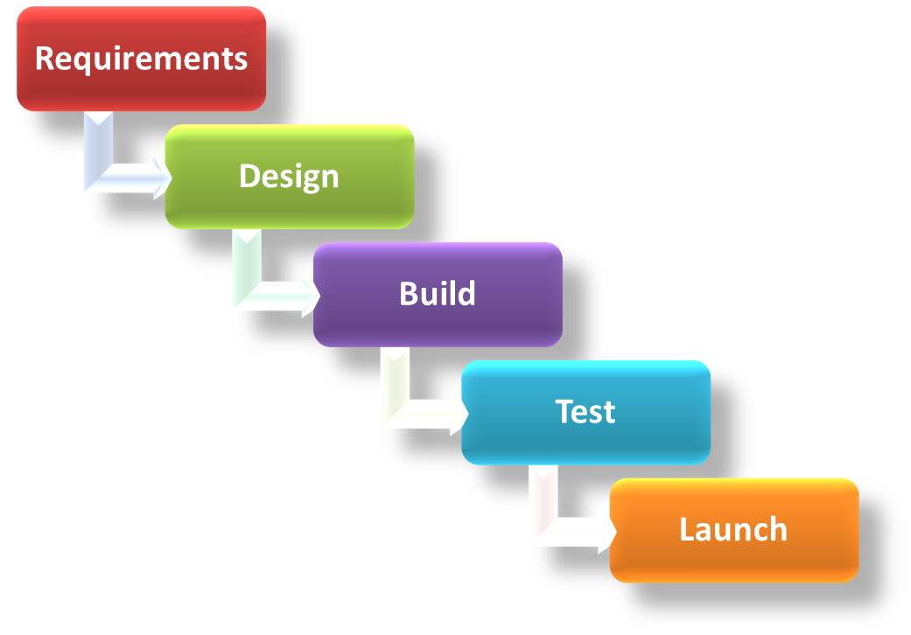

This model works like this:
- The project is divided into multiple steps, the steps include Requirements Determination, Design, Implementation, Verification, and Maintenance.
- Allows for slight overlapping within stages.
- Clearly defines the next logical step in the programs development.

The Waterfall method does have certain advantages, including:
- Design errors are captured before any software is written saving time during the implementation phase.
- Excellent technical documentation is part of the deliverables and it is easier for new programmers to get up to speed during the maintenance phase.
- The approach is very structured and it is easier to measure progress by reference to clearly defined milestones.

Unfortunately, the Waterfall method carries with it quite a few disadvantages, such as:
- The model does not cater for the possibility of requirements changing during the development cycle.
- A project can often take substantially longer to deliver than when developed with an iterative methodology such as the agile development method.

Agile (Agile Manifesto (2016)) was considered as the alternative development cycle. However, while with agile requirements can emerge and evolve throughout the development, this created the potential for scope creep, which could greatly extend the duration of the development process. Scope creep will also create less predictability with the final deliverables making no clear vision as to the outcome of the project. Agile requirements are barely sufficient. This eliminates wasted effort on deliverables that don’t last, however this can mean less information is available during development to peers and project inspectors.

Implementation
This project breaks the mistaken believes about types and operating systems by showing how to write an OS kernel in a strictly-typed programming language. To achieve this the Kernel will be written in C# using Microsoft’s IDE Visual Studio Community (VS) and using a compiler called IL2CPU. The source code for the project will be written using in VS and then compiled using the inbuilt .NET compiler featured in Windows 10, the now IL opcodes will then be passed to the IL2CPU compiler which converts the IL opcodes to raw x86 assembly. Finally, the complete x86 Assembly will be passed to NASM to output the compiled opcodes into a disk image to be run in VM Ware. Research into existing kernel architectures will be required to gain knowledge on how to implement some of the core kernel features such as paging and process creation and API design. To enable testing of the process and memory systems a filesystem must also be created to enable loading of user written programs from hard storage into system memory.

Kernel Design
The kernel will be designed using a monolithic design architecture. Below shows the intended design architecture of the kernel.

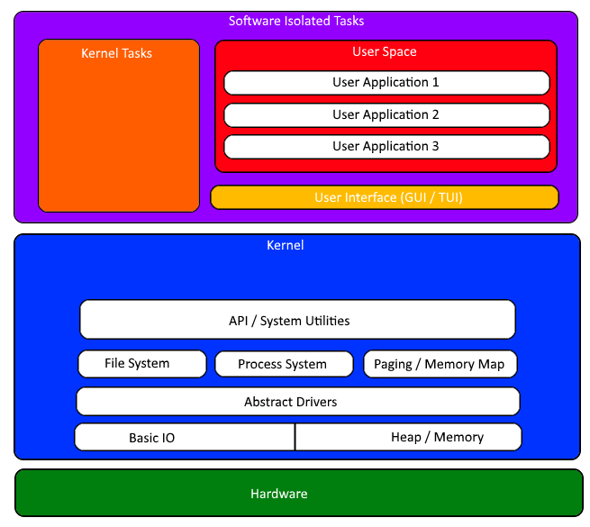

Software Isolated Tasks
This layer will do the following:
- Provide pipes in which processes and process groups can communicate.
- Isolate tasks into groups and by user.

Kernel
This layer will do the following:
- Provide an Application programming interface to the above Kernel and user tasks.
- Provide a filesystem will store information on mounted storage devices and waiting file IO related tasks.
- Provide a process system will contain the scheduler and the active process pool, this module will also provide the base inter process communication system and signaling system.
- Provide a paging / Memory module will contain utilities for managing the heap and the mapped memory.
- Provide an abstract driver interface which will allow for the loading of device specific drivers.
- Provide basic IO functions such as writing and reading from IO ports.
- Provide utilities to access the memory heap and to block access to reserved memory rejoins.

Hardware
- This will be the host system components (e.g. mouse, keyboard, screen and storage).
- For this project this will be the emulated components in VM Ware or VM Virtual Box.

Testing and Evaluation
While testing will be present throughout the entirety of the development, the project will still require thorough testing upon its completion to ensure the final product has met its requirements. This project will go through black-box and white-box testing.

Black-Box testing involves the testing of software without the knowledge of internals by using software to interface with the program. For example, one such test to be carried out will involve loading multiple programs to test the scheduling algorithm. Using black box testing we will not care as to how the processes are loaded but rather to visually see that they are running.
Some of the advantages of black-box testing are:
- Efficient for large segments of code
- Code access is not required
White-box testing looks inside the software that is being tested and uses that knowledge as part of the testing process. For example, one such test to be carried out will involve testing throwing application errors to see if the kernel manages them appropriately.
Some of the advantages of white-box testing are:
- Efficient in finding errors and problems
- Required knowledge of internals of the software under test is beneficial for thorough testing
- Allows finding hidden errors
- Helps optimizing the code

Professional, Social, Economic and Legal Issues
Most of the legal issues to do with this project are for intellectual rights protection and monetary factors. This project will be built to comply with the following regulations:

- Copyright, Designs and Patents Act 1988 [http://www.legislation.gov.uk/ukpga/1988/48/contents] This is one of the most important legislations to consider during the development process. The project will be utilizing an open source compiler which at the time of writing can only be used for academic work per the terms and conditions stated in the project.

Resource Requirements

Software
- Visual Studio Community
- .NET runtime services
- Cosmos Project (Contains IL2CPU compiler)
- VM Ware or Virtual Box

Hardware
- Windows 7/8/10 compatible computer
- Second Computer for real hardware testing

References
- SorceForge.net (2016) Available at: http://SorceForge.net (Accessed: 28 October 2016).
- Model checking (2016) in Wikipedia. Available at: https://en.wikipedia.org/wiki/Model_checking (Accessed: 28 October 2016).
- Proof assistant (2016) in Wikipedia. Available at: https://en.wikipedia.org/wiki/Proof_assistant (Accessed: 28 October 2016).
- OSDev Wiki (no date) Available at: http://wiki.osdev.org/Main_Page (Accessed: 28 October 2016).
- Singularity (operating system) (2016) in Wikipedia. Available at: https://en.wikipedia.org/wiki/Singularity_(operating_system) (Accessed: 28 October 2016).
- Java OS (2016) in Wikipedia. Available at: https://en.wikipedia.org/wiki/JavaOS (Accessed: 28 October 2016).
- Managed operation system alliance (2016) in Wikipedia. Available at: https://en.wikipedia.org/wiki/Managed_Operation_System_Alliance (Accessed: 28 October 2016).
- Cosmos (operating system) (2016) in Wikipedia. Available at: https://en.wikipedia.org/wiki/Cosmos_(operating_system) (Accessed: 28 October 2016).
- Waterfall model (2016) in Wikipedia. Available at: https://en.wikipedia.org/wiki/Waterfall_model (Accessed: 28 October 2016).
- Agile Manifesto (2016) ‘Agile software development’, in Wikipedia. Available at: https://en.wikipedia.org/wiki/Agile_software_development (Accessed: 28 October 2016).

