**SE_Lab**

**Library System**

**Anus khan 32**

**Bilal Hassan 37**

**Lab Task 1: Setting Up the Project:**

**1**: mkdir library_system

**2**: PS C:\Users\This PC\OneDrive\Desktop\git_library_system\liabrary_system> git init

Initialized empty Git repository in C:/Users/This PC/OneDrive/Desktop/git_library_system/liabrary_system/.git/

**3**: PS C:\Users\This PC\OneDrive\Desktop\git_library_system\liabrary_system> git remote add origin <https://github.com/Anuskhancoding/library.git>

**4**: PS C:\Users\This PC\OneDrive\Desktop\git_library_system\liabrary_system> git add .

**5**: PS C:\Users\This PC\OneDrive\Desktop\git_library_system\liabrary_system> git commit -m "commit"

[main 4dfee97] commit

1 file changed, 1 insertion(+)

**6**:PS C:\Users\This PC\OneDrive\Desktop\git_library_system\liabrary_system> git push origin main

Enumerating objects: 5, done.

Counting objects: 100% (5/5), done.

Writing objects: 100% (3/3), 265 bytes | 132.00 KiB/s, done.

Total 3 (delta 0), reused 0 (delta 0), pack-reused 0

To <https://github.com/Anuskhancoding/library.git>



**Lab task 2: Branching and Development**

**1:**PS C:\Users\This PC\OneDrive\Desktop\git_library_system\liabrary_system> git checkout -b f1

**2:**PS C:\Users\This PC\OneDrive\Desktop\git_library_system\liabrary_system> git checkout f1

Already on 'f1'

**3:**PS C:\Users\This PC\OneDrive\Desktop\git_library_system\liabrary_system> git branch

* f1

main

**4**: PS C:\Users\This PC\OneDrive\Desktop\git_library_system\liabrary_system> git commit -m "branch"

[f1 9f5ec68] branch

1 file changed, 1 insertion(+), 1 deletion(-)

Enumerating objects: 5, done.

Writing objects: 100% (3/3), 269 bytes | 134.00 KiB/s, done.

Total 3 (delta 0), reused 0 (delta 0), pack-reused 0

remote:

remote: Create a pull request for 'f1' on GitHub by visiting:

remote: https://github.com/Anuskhancoding/library/pull/new/f1

remote:

To https://github.com/Anuskhancoding/library.git

* [new branch] f1 -> f1

**5**:git push origin f1

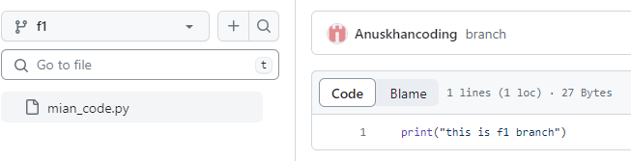

**Lab Task 3-4: Collaborative Work,** **Conflict Resolution Objective: Learn how to resolve merge conflicts.**

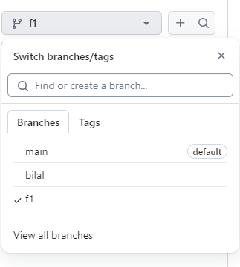

These are three branches

F1: branch is of my branch(Anus)

Bilal branch: it is a branch of Bilal.

Bilal branch process to create it:

1:PS C:\Users\This PC\OneDrive\Desktop\partner_b\library> git checkout -b bilal

Switched to a new branch 'bilal'

2:PS C:\Users\This PC\OneDrive\Desktop\partner_b\library> git add .

3:PS C:\Users\This PC\OneDrive\Desktop\partner_b\library> git commit -m "bilal"

[bilal 70f790a] bilal

1 file changed, 1 insertion(+), 1 deletion(-)

4:PS C:\Users\This PC\OneDrive\Desktop\partner_b\library> git push origin bilal

Enumerating objects: 5, done.

Counting objects: 100% (5/5), done.

Writing objects: 100% (3/3), 274 bytes | 137.00 KiB/s, done.

Total 3 (delta 0), reused 0 (delta 0), pack-reused 0

remote:

remote: Create a pull request for 'bilal' on GitHub by visiting:

remote: https://github.com/Anuskhancoding/library/pull/new/bilal

remote:

To https://github.com/Anuskhancoding/library.git

* [new branch] bilal -> bilal

In both branches there are some files which are uploaded.

And we both add our own piece of code in our own branches and push it on our branches so we both can see.

Bilal code(just a small screenshot for clear picture):

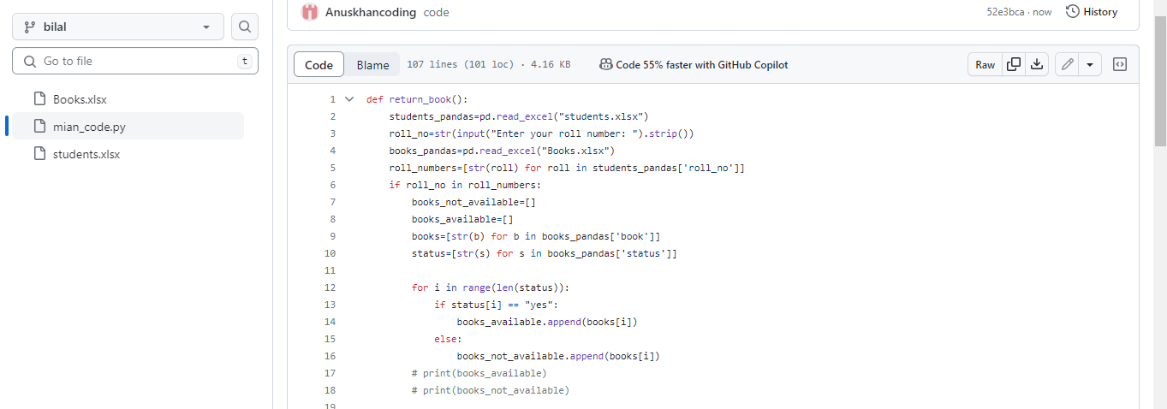

My(anus piece of code screenshot )

I create a pull request to merge my f1 branch into mian. So I sent a request and it was accepted by Bilal Hassan. That all we did on GitHub not on command line interface(terminal). We also communicte during pull-resquest on git-hub to whteher make that request or not but finally we agree bilal approved my request.

I aslo received mail when bilal accpet pull request.

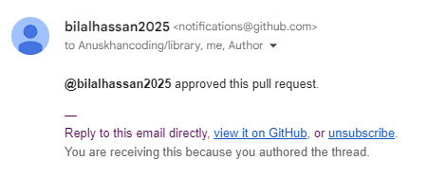

After that I merge f1 branch into the main branch but a conflict occurred.

Same process Bilal Hassan did for the pull request and after that, we merged it.

I working on some different functions of my code and he is working on different functions of the code

There are some like spacing tabbing etc, not an issue like he writes different code and I write different code for the same function.

Wereslove these errors and how these are explained in Lab4 task

*******************************************************

First, when I merge an f1 branch with the main after getting an accepted response from my collaborator I get a conflict and the same situation faced when merging Bilal branch into main so we resolve these issues.

We came to know that   
The conflict/problem is represented by the **<<<<<<<** and **=======** symbols, which are commonly used in Git to identify the conflicting sections.

For example:

The **<<<<<<< f1** marker signifies the beginning of the conflicting section from the "f1" branch, while the **>>>>>>> main** marker indicates the start of the conflicting section from the "main" branch.

To handle these problems, you'll need to decide which changes to keep and how to combine/merge them with each other. You can edit the code manually to ensure it functions as intended and doesn't result in any errors. Accoring to our code me make some adjustment to remove those conflicts and at the end we merge our branches into main and complete code is available at git hub.

**Demo:**

**\*\*\*\*\*\*\*\*\*\*\*\*\*\*\*\*\*\*\*\*\*\*\*\*\*\*\***

**The readme file is available on the git-hub main branch**

**THE END**