CAPSTONE PROJECT REPORT

SAP ERP Blueprint Design with
Sales Analytics Integration using SAP Analytics Cloud

Submitted By | Anusmita Dutta
Roll Number | 23052308
Programme | B.Tech
Institution | KIIT DU
Academic Year | 2024 – 2025
Date of Submission | April 2025

1. Company Overview
VidyutKraft Industries Limited is a fictitious, mid-sized Indian manufacturing company headquartered in Pune, Maharashtra. The company was incorporated in 2005 and has grown to become a trusted supplier of industrial motors, control panels, and electrical switchgear components to customers across India and select export markets in South-East Asia.
The company operates two state-of-the-art manufacturing facilities — one in Pune (the primary plant) and one in Chennai (the assembly unit). It serves over 450 corporate clients, employs approximately 3,200 professionals, and records an annual turnover of roughly INR 620 crore.

Key Business Facts
Parameter | Detail
Industry | Electrical Equipment Manufacturing
Headquarters | Pune, Maharashtra, India
Founded | 2005
Annual Revenue | INR 620 Crore (approx.)
Employees | ~3,200
Customers | 450+ B2B clients across India & South-East Asia
SAP Go-Live Target | April 2025

2. Problem Statement
Before this SAP implementation project, VidyutKraft Industries was running its core operations on a combination of legacy software and manual spreadsheets. This created several persistent operational challenges:
- Financial data was scattered across multiple Excel files, leading to delayed and inconsistent MIS reports.
- The procurement team had no real-time visibility into inventory levels, often resulting in either over-ordering or stock shortages.
- The sales team was managing customer orders manually through emails and phone calls, with no single system of record.
- There was no integration between Finance, Materials, and Sales — making month-end reconciliation a time-consuming and error-prone process.
- Senior management lacked a centralised analytics dashboard to monitor business KPIs such as revenue trends, outstanding receivables, or inventory turnover.
The management recognised that to scale the business and improve operational efficiency, a robust, integrated ERP system was essential. After a thorough evaluation, SAP S/4HANA was selected as the ERP platform, and SAP Analytics Cloud (SAC) was chosen for advanced reporting and analytics.

3. Project Objectives
The primary aim of this capstone project is to design a detailed SAP ERP Blueprint for VidyutKraft Industries, covering the three most critical SAP functional modules and integrating an analytics layer for data-driven decision-making.

Specific Objectives
- Design the complete enterprise structure for VidyutKraft in SAP (Company Code, Plants, Sales Organisation, etc.).
- Configure the Financial Accounting (FI) module to handle general ledger, accounts payable, accounts receivable, and Indian GST compliance.
- Set up the Materials Management (MM) module to streamline the Procure-to-Pay (P2P) process, including purchase orders, goods receipt, and invoice verification.
- Implement the Sales & Distribution (SD) module to manage the full Order-to-Cash (O2C) cycle from sales order creation to billing.
- Integrate SAP Analytics Cloud with SAP S/4HANA for real-time dashboards that display sales performance, inventory levels, and financial health.
- Identify process improvements and future roadmap recommendations based on the blueprint design.

4. Enterprise Structure
The enterprise structure in SAP forms the backbone of the entire system. It defines how the company is organised within SAP and how different business processes are linked together. The following table outlines the complete enterprise structure designed for VidyutKraft Industries.
SAP Object | Value | Description
Company Code | IN01 | VidyutKraft Industries Ltd – India
Plant | PL01 | Pune Manufacturing Plant
Plant | PL02 | Chennai Assembly Unit
Sales Organisation | SO01 | India Sales Organisation
Distribution Channel | DC01 | Wholesale / Direct Sales
Division | D01 | Industrial Equipment
Purchasing Organisation | PO01 | Central Procurement
Storage Location | SL01 | Raw Materials Store
Storage Location | SL02 | Finished Goods Store
Credit Control Area | CC01 | India Credit Control
Chart of Accounts | CAIN | Indian Chart of Accounts
Fiscal Year Variant | V3 | April – March (Indian FY)

Note: The fiscal year follows the Indian financial year from April to March, and all statutory filings are aligned with Indian GST regulations under the company code IN01.

5. SAP Modules Explanation

5.1 Financial Accounting (FI)
The SAP Financial Accounting module is the backbone of the financial operations at VidyutKraft. It records every financial transaction in real time and ensures that the company's books of accounts are always accurate, compliant, and audit-ready.
Key components configured for VidyutKraft:
- General Ledger (G/L): All journal entries, accruals, and inter-company transactions are posted here. The chart of accounts CAIN has been configured with all relevant accounts.
- Accounts Payable (AP): Manages vendor invoices, payment runs, and ageing reports. Vendor master data is maintained centrally.
- Accounts Receivable (AR): Tracks customer invoices, incoming payments, and outstanding dues. Integrated with the SD module for automatic billing document posting.
- Asset Accounting (AA): Manages company assets such as machinery and office equipment, with depreciation calculation as per the Companies Act 2013.
- Indian GST Configuration: CGST, SGST, IGST, and CESS tax codes have been created. The system is configured to generate GST returns (GSTR-1, GSTR-3B) compatible data.
- Controlling Integration (CO-FI): Profit centre and cost centre accounting is enabled for internal management reporting.

5.2 Materials Management (MM)
The SAP Materials Management module handles all procurement and inventory-related activities. For VidyutKraft, this module is critical because raw material procurement directly impacts production planning and cost control.
Key components configured:
- Material Master: A unified record for every raw material, semi-finished good, and finished product, containing details like unit of measure, storage conditions, valuation class, and procurement type.
- Vendor Master: Centralised vendor data that is shared between purchasing (MM) and accounts payable (FI), ensuring consistency.
- Purchase Requisition (PR) & Purchase Order (PO): The system supports both MRP-driven and manual requisitions, with multi-level approval workflows.
- Goods Receipt (GR): When materials arrive at the plant, the GR posting in SAP creates a material document and updates inventory in real time.
- Invoice Verification (MIRO): Vendor invoices are matched with the PO and GR (3-way match) before approval and payment.
- Inventory Management: Supports stock transfers, physical inventory, and automatic reorder point planning.

5.3 Sales & Distribution (SD)
The SAP Sales & Distribution module manages everything from the time a customer places an order to the moment payment is received. For VidyutKraft, this module connects the commercial team with the warehouse and finance teams seamlessly.
Key components configured:
- Customer Master: Contains complete information about each customer, including payment terms, credit limit, pricing conditions, and delivery addresses.
- Sales Order (VA01): When a customer order is received, a sales order is created that drives all downstream processes like delivery and billing.
- Availability Check: The system automatically checks if the ordered quantity is available before confirming the delivery date to the customer.
- Delivery Processing (VL01N): The outbound delivery document triggers the picking and packing process in the warehouse.
- Billing (VF01): After delivery confirmation, the billing document is automatically created and posted to the FI module as an accounting entry.
- Credit Management: Customers are assigned credit limits. If an order exceeds the limit, it is automatically blocked for approval by the finance team.

6. Business Process Flows

6.1 Order-to-Cash (O2C) – SD Process
The Order-to-Cash cycle is the most important business process for VidyutKraft as it directly drives revenue. Below is the step-by-step flow:
Step | Activity | SAP Transaction | Department
1 | Customer places order (email/phone) | VA01 – Create Sales Order | Sales Team
2 | Credit check & availability check | Automatic (SD Config) | Finance / Warehouse
3 | Sales order confirmation to customer | VA05 – Order List | Sales Team
4 | Outbound delivery document created | VL01N – Create Delivery | Logistics Team
5 | Goods picked, packed & dispatched | LT0A – Transfer Order | Warehouse Team
6 | Post Goods Issue (reduces inventory) | VL02N – Post GI | Warehouse Team
7 | Customer invoice (billing doc) created | VF01 – Create Billing | Finance Team
8 | Invoice sent to customer | VF02 / Email Output | Finance Team
9 | Payment received & cleared | F-28 – Incoming Payment | Accounts Team

6.2 Procure-to-Pay (P2P) – MM + FI Process
The Procure-to-Pay cycle governs how VidyutKraft sources raw materials and makes payments to vendors:
- Step 1 – Purchase Requisition (PR): Production planning team raises a material requirement via ME51N.
- Step 2 – Request for Quotation (RFQ): Purchasing team sends RFQs to shortlisted vendors (ME41).
- Step 3 – Vendor Comparison & Selection: Quotations compared using ME49 (Price Comparison Report).
- Step 4 – Purchase Order (PO): Approved PO created and sent to vendor (ME21N).
- Step 5 – Goods Receipt (GR): Materials received at plant and posted in SAP (MIGO – GR against PO).
- Step 6 – Invoice Verification: Vendor invoice matched against PO and GR quantities and values (MIRO – 3-way match).
- Step 7 – Payment Run: Automatic payment programme (F110) generates payment batch, subject to due dates and cash planning.

7. Analytics Integration – SAP Analytics Cloud

7.1 Overview of SAP Analytics Cloud (SAC)
SAP Analytics Cloud (SAC) is a cloud-based analytics platform that connects directly to SAP S/4HANA using a live HANA connection. For VidyutKraft, SAC has been configured to pull real-time data from the FI, MM, and SD modules and present it in interactive dashboards for the management team.
SAC is used here for three purposes: Business Intelligence (BI) for reporting, Planning & Budgeting, and Predictive Analytics for sales forecasting.

7.2 Dashboard 1: Sales Performance Overview
This dashboard provides the management team with a real-time view of the company's sales health. It is accessible to the Sales Head, Regional Managers, and the CFO.
- Chart 1 – Monthly Revenue vs. Target (Bar Chart): Compares actual monthly revenue against the annual sales target, broken down by month.
- Chart 2 – Top 10 Customers by Revenue (Horizontal Bar): Ranks the top customers, allowing the sales team to focus retention efforts.
- Chart 3 – Sales by Product Category (Donut Chart): Shows revenue contribution from Industrial Motors, Control Panels, and Switchgear.
- Chart 4 – Region-wise Sales Heatmap: A geographic heat map showing sales density across Indian states.
- KPI Tiles: Current Month Revenue | Orders Pending Delivery | Overdue Invoices Value

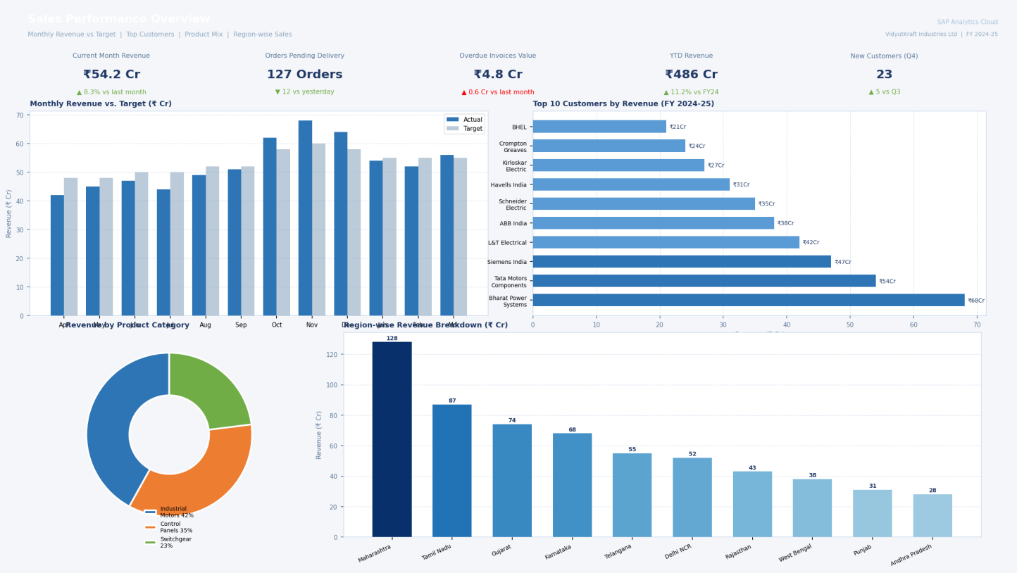
Figure 1: SAP Analytics Cloud – Sales Performance Dashboard (Monthly Revenue vs. Target, Top Customers, Product Mix)

7.3 Dashboard 2: Inventory & Procurement Analytics
This dashboard is designed for the Procurement Manager and the Plant Heads to monitor material availability and procurement efficiency.
- Chart 1 – Stock Availability by Material (Stacked Bar): Shows current stock vs. minimum re-order level for top 15 raw materials.
- Chart 2 – Purchase Order Cycle Time (Line Chart): Tracks average days from PR creation to GR posting over the past 12 months.
- Chart 3 – Vendor Spend Analysis (Treemap): Visualises total spend per vendor, helping in supplier negotiation.
- Chart 4 – Goods Receipt vs. Invoice Discrepancy (Scatter Plot): Highlights vendors where GR quantities frequently differ from invoiced quantities.
- KPI Tiles: Open POs Value | Materials Below Reorder Level | Pending Invoice Verification Count

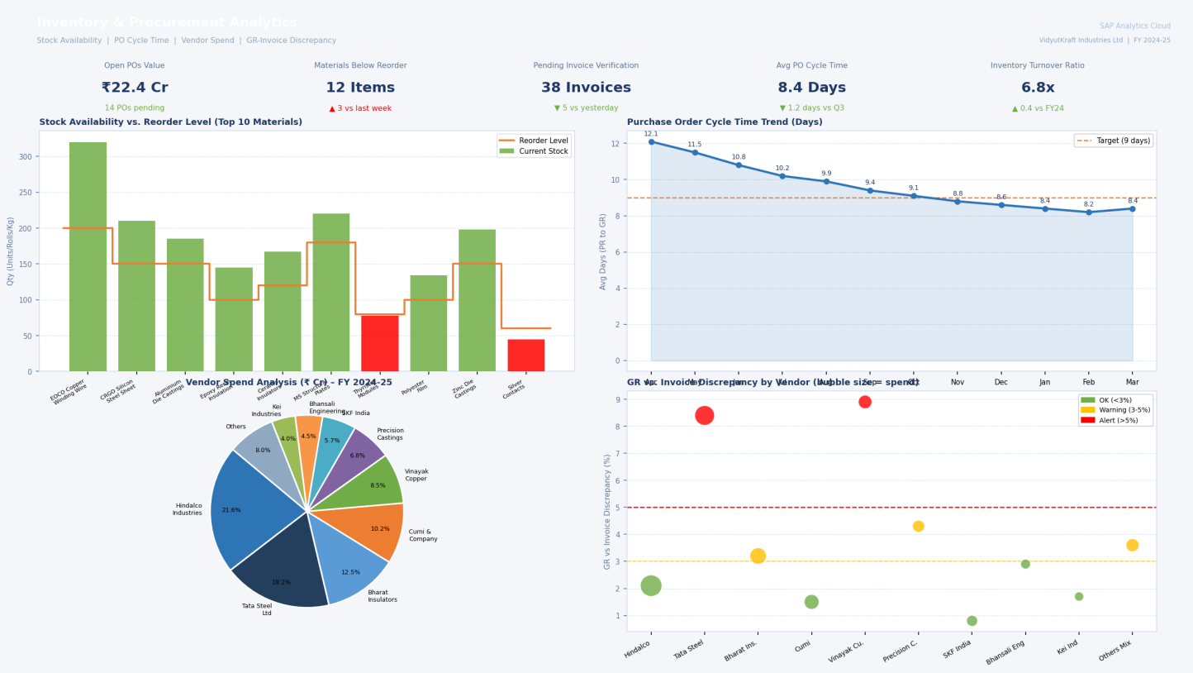
Figure 2: SAP Analytics Cloud – Inventory & Procurement Dashboard (Stock Levels, Vendor Spend, PO Cycle Time)

7.4 Dashboard 3: Financial Health & Receivables
This dashboard is exclusively for the Finance team and CFO, providing a real-time view of the company's financial position.
- Chart 1 – Ageing Analysis of Receivables (Stacked Bar): Groups outstanding customer invoices by ageing buckets: 0-30 days, 31-60 days, 61-90 days, 90+ days.
- Chart 2 – Cash Flow Trend (Area Chart): Monthly cash inflows vs. outflows over the current fiscal year.
- Chart 3 – Month-wise P&L Summary (Waterfall Chart): Displays revenue, cost of goods sold, gross profit, and operating expenses.
- Chart 4 – GST Liability vs. Input Tax Credit (Dual-Axis Chart): Monitors monthly GST payable against available ITC for tax planning.
- KPI Tiles: Total Overdue Receivables | Days Sales Outstanding (DSO) | Current Ratio

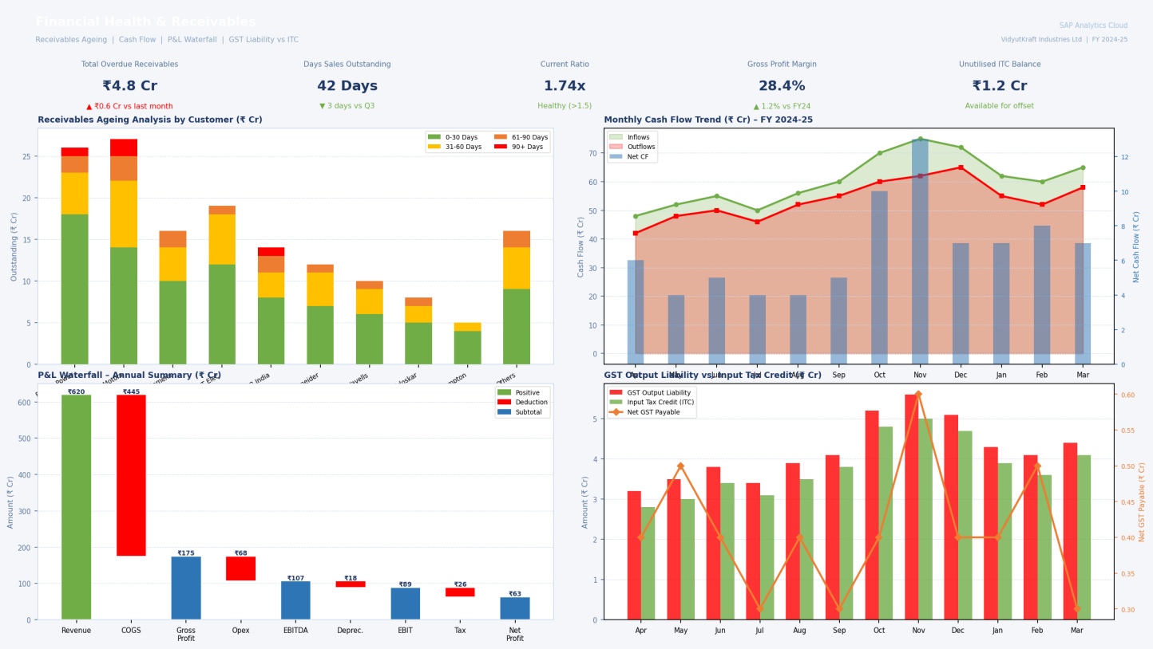
Figure 3: SAP Analytics Cloud – Financial Health Dashboard (Receivables Ageing, Cash Flow, P&L Waterfall)

8. Key Insights from Dashboards
Based on the analytical dashboards configured in SAP Analytics Cloud, the following important business insights were identified for VidyutKraft Industries:
- Revenue Concentration Risk: The top 3 customers contribute nearly 38% of total revenue, indicating a dependency risk. The sales team has been advised to diversify the customer portfolio.
- Inventory Inefficiency: 12 raw materials were consistently held at stock levels more than 40% above the minimum reorder level, resulting in excess working capital being blocked. A revised MRP re-order policy has been recommended.
- Vendor Performance: Two key vendors had a GR-to-Invoice discrepancy of more than 8% consistently over 6 months, suggesting billing irregularities that require renegotiation of purchase agreements.
- Receivables Health: Approximately INR 4.8 crore of customer dues have crossed the 90-day overdue mark. The finance team initiated targeted collection campaigns after this insight was surfaced via the SAC dashboard.
- Sales Seasonality: Dashboard analysis confirmed a consistent Q3 (October–December) spike in revenue due to year-end capital expenditure cycles of industrial customers. This insight was used to pre-plan higher inventory and logistics capacity for Q3.
- GST Compliance: The ITC vs. GST payable chart revealed that VidyutKraft had accumulated INR 1.2 crore in unutilised Input Tax Credit. The accounts team used this to offset future GST liabilities, improving cash flow.

9. Technology Stack
Component | Details
SAP ERP Version | SAP S/4HANA 2023 (On-Premise)
Database | SAP HANA 2.0 (In-Memory DB)
SAP Analytics Cloud | SAP Analytics Cloud (SaaS) – Enterprise Edition
Integration Middleware | SAP Integration Suite (Cloud)
User Interface | SAP Fiori 3.0 / SAP GUI 7.70
Reporting Tool | SAP Analytics Cloud Stories & Dashboards
Operating System (Server) | SUSE Linux Enterprise Server 15 SP4
Development Environment | SAP Business Application Studio (BAS)
Data Connectivity | SAP HANA Live Connection to SAC

The integration between SAP S/4HANA and SAP Analytics Cloud is achieved using a Live HANA Connection, which means the dashboards always display current data without any batch extraction or data warehousing delay. The SAP Integration Suite handles data flow between the ERP system and external stakeholders such as customers and government portals (GST Network).

10. Module Summary
Module | Core Transactions | Business Outcome
FI | FB60, FB70, F110, FS10N | Real-time financial ledger, tax compliance, MIS reports
MM | ME21N, MIGO, MIRO, MB52 | Efficient procurement cycle, inventory optimisation
SD | VA01, VL01N, VF01, ME2M | End-to-end order fulfilment, revenue tracking
SAC | Story, Dashboard, Predictive | Visual insights, KPI monitoring, forecasting

11. Unique Points of This Blueprint
- Indian Localisation: The entire blueprint has been designed keeping Indian statutory requirements in mind – Indian Chart of Accounts, April-March fiscal year, GST tax codes (CGST, SGST, IGST, CESS), and TDS/TCS configurations.
- Fiori-First UI Strategy: Rather than using the traditional SAP GUI for all transactions, the blueprint recommends deploying SAP Fiori apps for end-users, providing a modern, mobile-friendly interface that reduces training time.
- Live Analytics Without a Data Warehouse: Most companies build a separate data warehouse before connecting analytics. This blueprint uses SAP Analytics Cloud's Live HANA Connection to provide real-time analytics without any ETL infrastructure, significantly reducing implementation cost.
- Automated 3-Way Match: The P2P process is configured to automatically validate vendor invoices against both the Purchase Order and Goods Receipt. Any discrepancy beyond a defined tolerance triggers an automatic workflow alert.
- Predictive Sales Forecasting: Using SAC's built-in machine learning capability (Smart Predict), a predictive model has been trained on 3 years of historical sales data to forecast revenue for the next quarter, enabling proactive planning.

12. Future Improvements
- SAP Production Planning (PP) Module: As a natural next step, integrating the PP module will connect procurement and sales data with actual production schedules, enabling end-to-end supply chain visibility.
- SAP Quality Management (QM) Module: Implementing QM will allow VidyutKraft to track quality inspection results at the time of goods receipt, reducing defective material from entering the production line.
- Customer Portal Integration: Developing an SAP Fiori-based customer self-service portal where clients can track their orders, download invoices, and raise disputes will improve customer satisfaction.
- AI-Powered Demand Sensing: Expanding the current predictive model in SAC to include external factors such as commodity price indices, macroeconomic indicators, and customer financial health data for smarter demand forecasting.
- SAP Extended Warehouse Management (EWM): As warehouse complexity grows, upgrading from basic Inventory Management to SAP EWM will provide better control over bin-level storage, picking strategies, and labour management.
- ESG Reporting Dashboard: Building an SAC dashboard dedicated to Environmental, Social, and Governance (ESG) metrics will prepare VidyutKraft for upcoming sustainability reporting requirements under SEBI's BRSR framework.

13. Conclusion
This capstone project presents a comprehensive SAP ERP Blueprint for VidyutKraft Industries Limited, a fictitious Indian electrical equipment manufacturer. The blueprint covers the three foundational SAP modules — Financial Accounting (FI), Materials Management (MM), and Sales & Distribution (SD) — and integrates them with a powerful analytics layer through SAP Analytics Cloud.
The Order-to-Cash and Procure-to-Pay process flows designed in this report demonstrate how SAP can unify disconnected business operations into a single, integrated system. The analytics dashboards highlight how data that was previously buried in spreadsheets and legacy systems can be transformed into actionable business intelligence that directly supports decision-making.
Key business benefits expected from this implementation include a significant reduction in order processing time, improved financial visibility, better inventory management, and enhanced customer service. The Indian localisation features — GST configuration, Indian Chart of Accounts, and April–March fiscal year — ensure that VidyutKraft remains fully compliant with statutory requirements.
From an academic standpoint, this project demonstrates a practical understanding of SAP S/4HANA enterprise architecture, configuration principles, and the role of cloud analytics in modern ERP ecosystems. The insights drawn from the SAC dashboards validate the real-world value of investing in both a well-designed ERP system and a robust analytics platform.
Going forward, the addition of Production Planning, Quality Management, and AI-based demand sensing modules will enable VidyutKraft to evolve from a transactional ERP user to a truly intelligent enterprise powered by SAP.

— End of Report —

Project ZIP Link:
https://drive.google.com/file/d/1M0zPRZHwbDYFc7g2F2wYtIf8TX5JZpdm/view?usp=sharing

