1.

echo -e "1-Current User\n2-User Details\n3-Present Working Directory\n4-Current Date\n5-Exit"

while true;

do

echo "ENTER YOUR CHOICE"

read ch

case $ch in

1)

echo "Current User : $USER";;

2)

echo "User Details : $HOSTNAME";;

3)

echo "Present Working Directory : $PWD";;

4)

now=`date`

echo "Current Date : $now";;

5)

exit 1;;

\*)

echo "Invalid Choice"

exit 1;;

esac

done

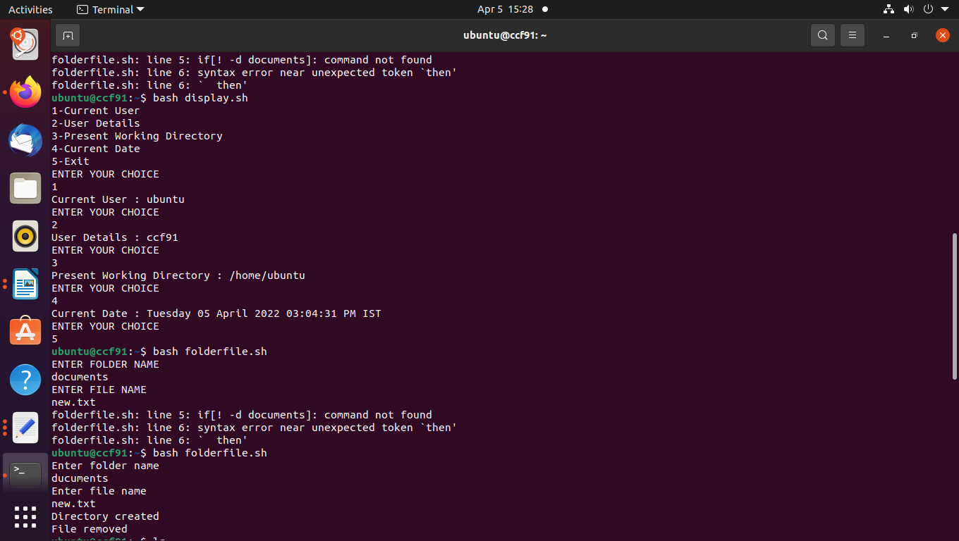

2.

echo "Enter folder name"

read dir

echo "Enter file name "

read file

if [ ! -d $dir ]

then

mkdir $dir

echo "Directory created"

else

echo "Directory exists"

fi

if [ -f "$file" ]

then

rm "$file"

echo "File removed"

else

echo "File doesnot exist so create it"

cat >$file

fi

