ANUSREE. P. R

AM. SC. P2CSC19011

**COMPETATIVE PROGRAMMING LAB SET – 2**

MERGE SORT

#include<iostream>

using namespace std;

void swapping(int &a, int &b)

{

int temp;

temp = a;

a = b;

b = temp;

}

void display(int *array, int size)

{

for(int i = 0; i<size; i++)

cout << array[i] << " ";

cout << endl;

}

void merge(int *array, int l, int m, int r)

{

int i, j, k, nl, nr;

nl = m-l+1; nr = r-m;

int larr[nl], rarr[nr];

for(i = 0; i<nl; i++)

larr[i] = array[l+i];

for(j = 0; j<nr; j++)

rarr[j] = array[m+1+j];

i = 0; j = 0; k = l;

while(i < nl && j<nr)

{

if(larr[i] <= rarr[j])

{

array[k] = larr[i];

i++;

}

Else

{

array[k] = rarr[j];

j++;

}

k++;

}

while(i<nl)

{

array[k] = larr[i];

i++;

k++;

}

while(j<nr)

{

array[k] = rarr[j];

j++;

k++;

}

}

void mergeSort(int *array, int l, int r)

{

int m;

if(l < r)

{

int m = l+(r-l)/2;

mergeSort(array, l, m);

mergeSort(array, m+1, r);

merge(array, l, m, r);

}

}

int main()

{

int n;

cout << "Enter the number of elements: ";

cin >> n;

int arr[n];

cout << "Enter elements:" << endl;

for(int i = 0; i<n; i++)

{

cin >> arr[i];

}

cout << "Array before Sorting: ";

display(arr, n);

mergeSort(arr, 0, n-1);

cout << "Array after Sorting: ";

display(arr, n);

}

OUTPUT

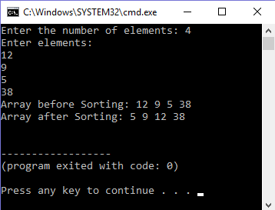

QUICK SORT

#include <iostream>

using namespace std;

void quick_sort(int[],int,int);

int partition(int[],int,int);

int main()

{

int a[50],n,i;

cout<<"Number of elements:";

cin>>n;

cout<<"\nEnter the elements:";

for(i=0;i<n;i++)

cin>>a[i];

quick_sort(a,0,n-1);

cout<<"\nArray after sorting:";

for(i=0;i<n;i++)

cout<<a[i]<<" ";

return 0;

}

void quick_sort(int a[],int l,int u)

{

int j;

if(l<u)

{

j=partition(a,l,u);

quick_sort(a,l,j-1);

quick_sort(a,j+1,u);

}

}

int partition(int a[],int l,int u)

{

int v,i,j,temp;

v=a[l];

i=l;

j=u+1;

do

{

do

i++;

while(a[i]<v&&i<=u);

do

j--;

while(v<a[j]);

if(i<j)

{

temp=a[i];

a[i]=a[j];

a[j]=temp;

}

}while(i<j);

a[l]=a[j];

a[j]=v;

return(j);

}

OUTPUT

