**Week 6 hands-on outputs**

* **RreactJS-HOL 1 (myfirstreact)**

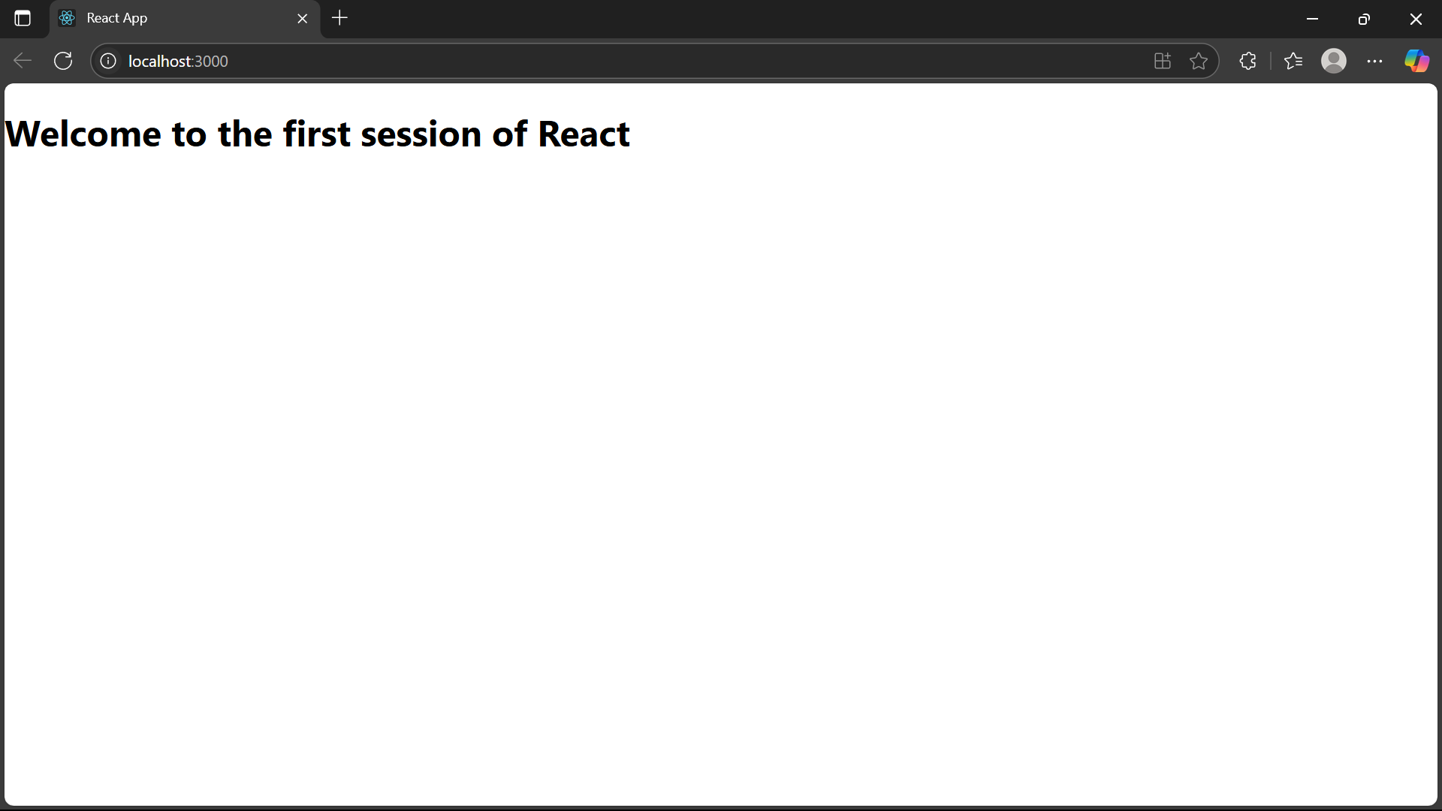

* **RreactJS-HOL 2 (studentapp)**

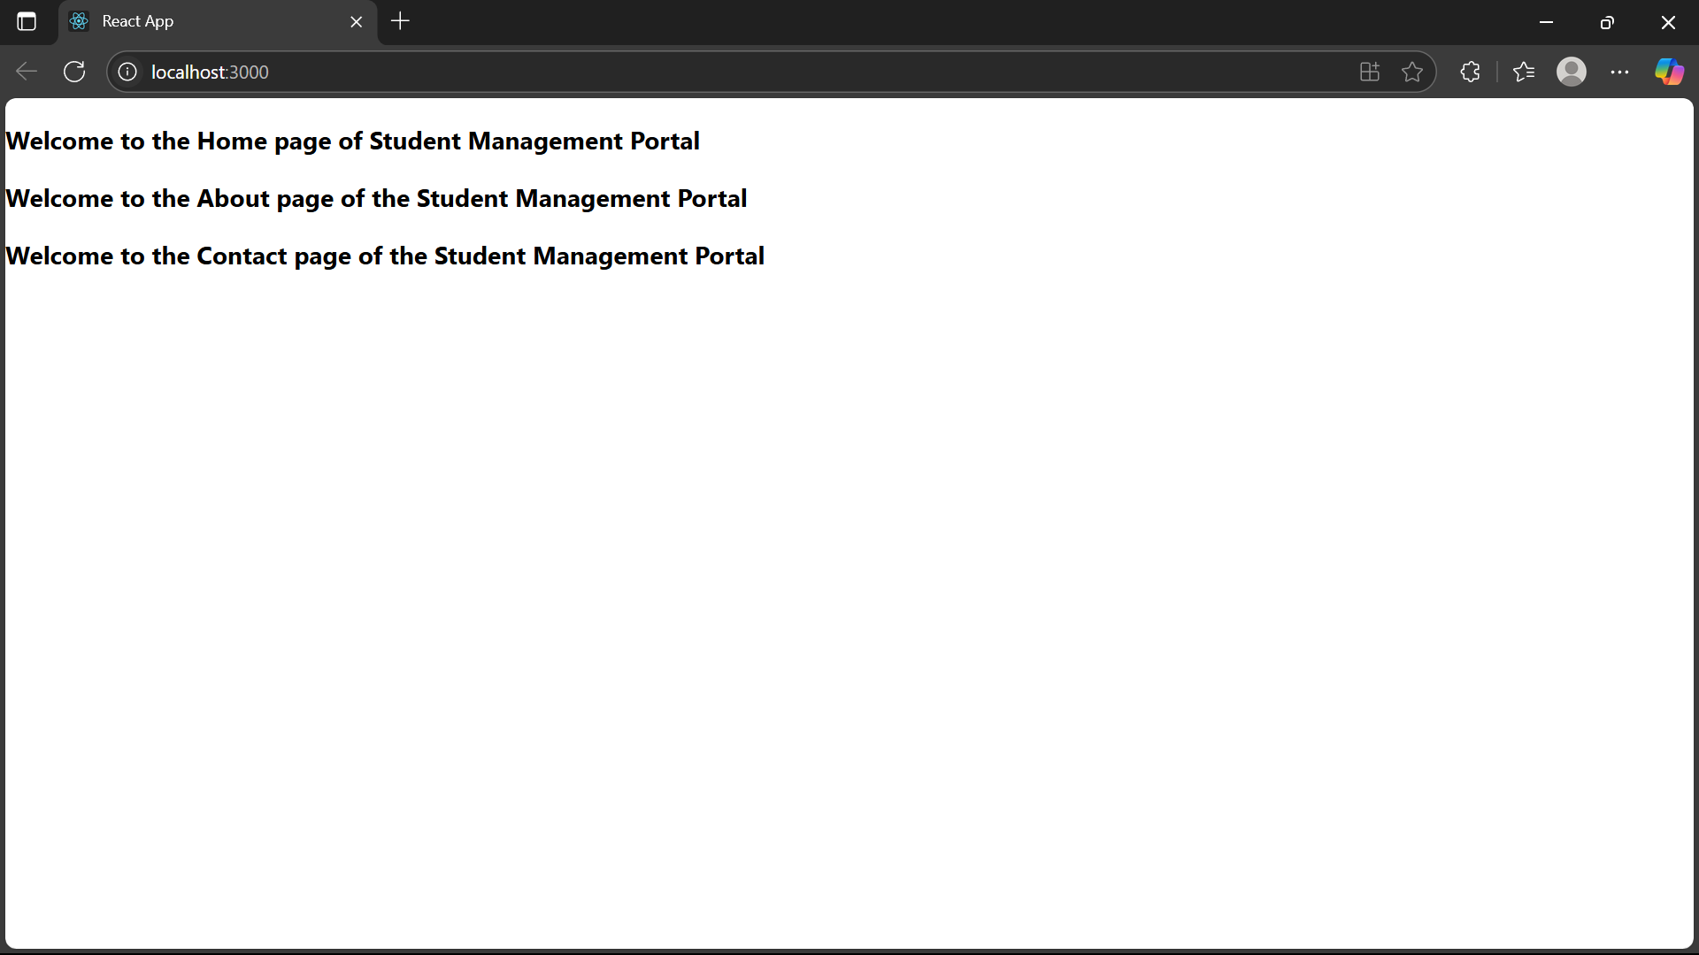

* **RreactJS-HOL 3 (scorecalculatorapp)**

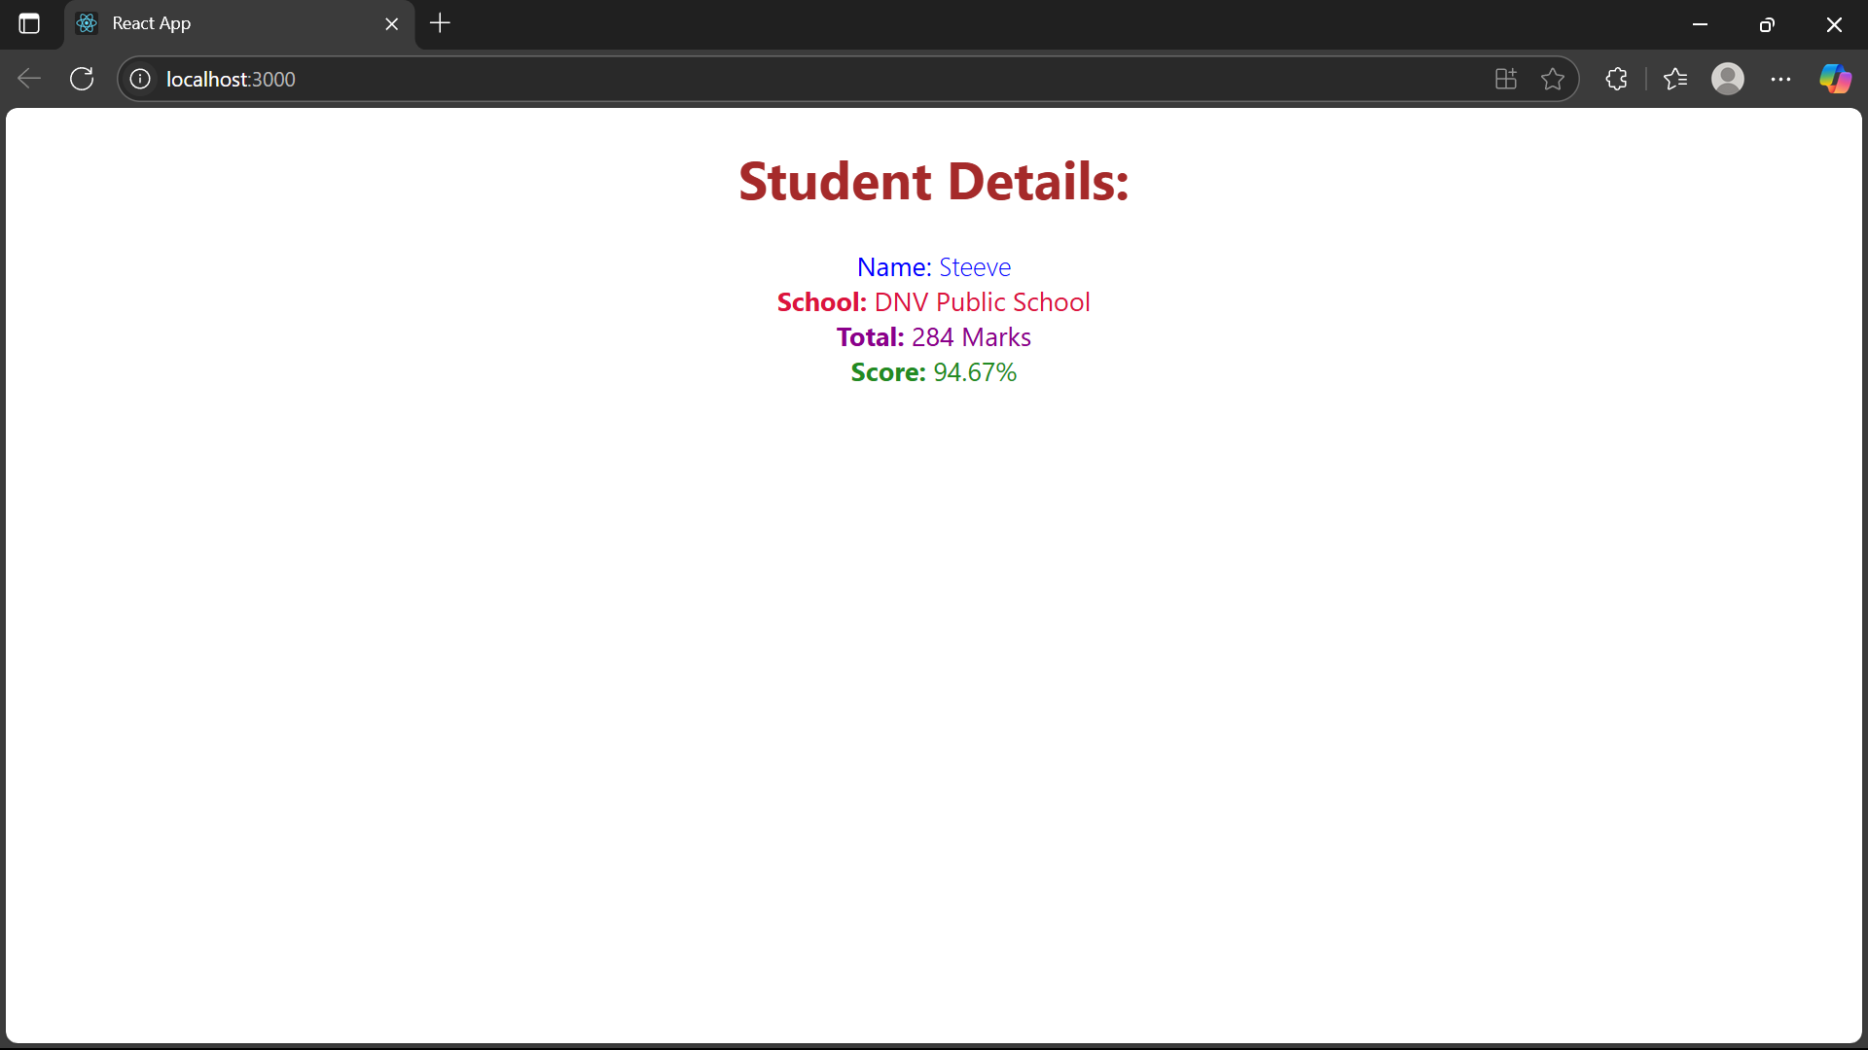

* **RreactJS-HOL 4 (blogapp)**

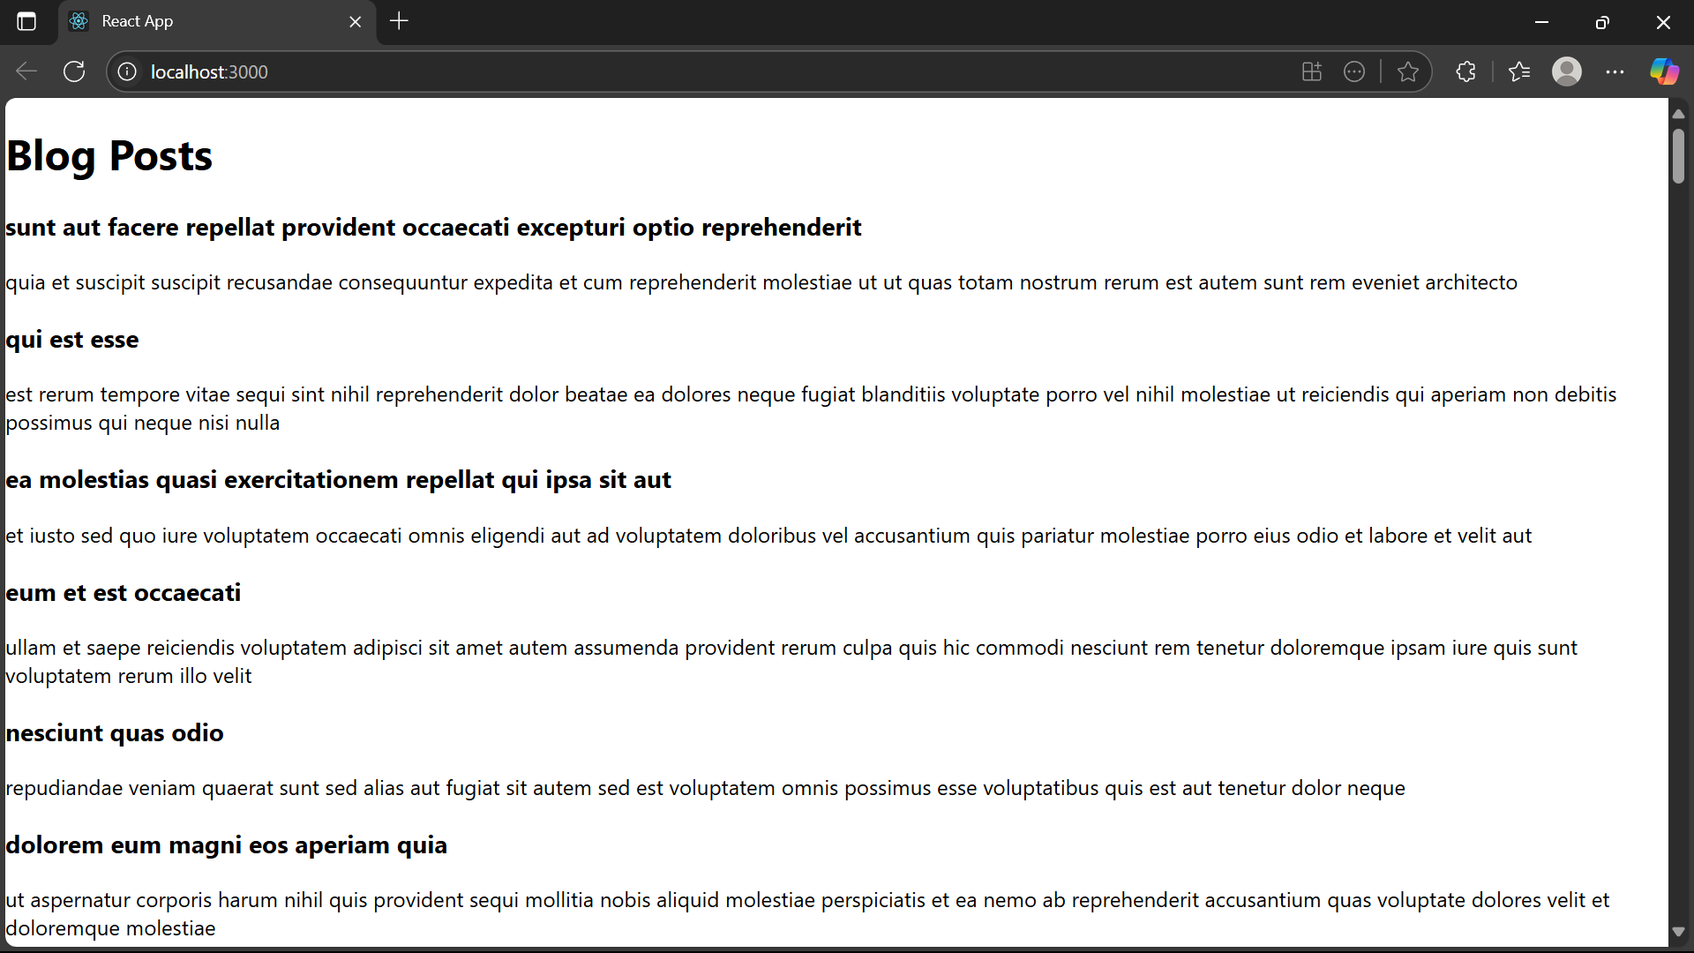

* **RreactJS-HOL 5 (myfirstreact)**

