**Day 10 SQL Bootcamp Assignment**

**1.Write a function to Calculate the total stock value for a given category:**

**(Stock value=ROUND(SUM(unit_price * units_in_stock)::DECIMAL, 2)**

**Return data type is DECIMAL(10,2)**

**QUERY**

**CREATE FUNCTION calculate_stock_value(category_id_param INT)**

**RETURNS DECIMAL(10,2) AS**

**$$**

**DECLARE stock_value DECIMAL(10,2);**

**BEGIN**

**SELECT ROUND(SUM(unit_price * units_in_stock)::DECIMAL, 2)**

**INTO stock_value**

**FROM products**

**WHERE category_id = category_id_param;**

**RETURN stock_value;**

**END;**

**$$ LANGUAGE plpgsql;**

**SELECT calculate_stock_value(1);**

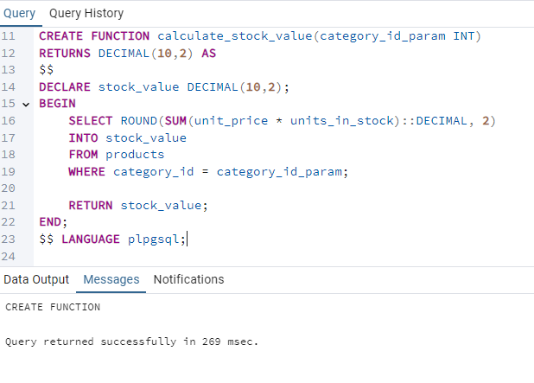

**2.Cursor Query**

**QUERY**

**CREATE**

**create or replace procedure update_prices_with_cursor()**

**language plpgsql**

**as $$**

**declare**

**product_cursor cursor for**

**select product_id,product_name,unit_price,units_in_stock from products where discontinued=0;**

**product_record record;**

**v_new_price decimal(10,2);**

**Begin**

**open product_cursor;**

**loop**

**fetch product_cursor into product_record;**

**exit when not found;**

**---new price calculation**

**if product_record.units_in_stock < 10 THEN**

**v_new_price:=product_record.unit_price * 1.1;**

**else**

**v_new_price:=product_record.unit_price * 0.95;**

**end if;**

**UPDATE products**

**SET unit_price=Round(v_new_price,2)**

**WHERE product_id = product_record.product_id;**

**raise notice 'Updated price % from % to %',**

**product_record.product_name,**

**product_record.unit_price,**

**v_new_price;**

**end loop;**

**close product_cursor;**

**end ;**

**$$;**

**Call update_prices_with_cursor();**

