1. Write a function to Calculate the total stock value for a given category:

(Stock value=ROUND(SUM(unit_price * units_in_stock)::DECIMAL, 2)

Return data type is DECIMAL(10,2)

select * from products;

create function calculate_stockvalue(p_category_id INT)

returns decimal (10,2)as $$

declare

stock_value decimal(10,2);

begin

select round(SUM(unit_price * units_in_stock)::decimal, 2)

into stock_value

from products

where category_id = p_category_id;

return stock_value;

end;

$$ language plpgsql;

SELECT calculate_stockvalue(1);

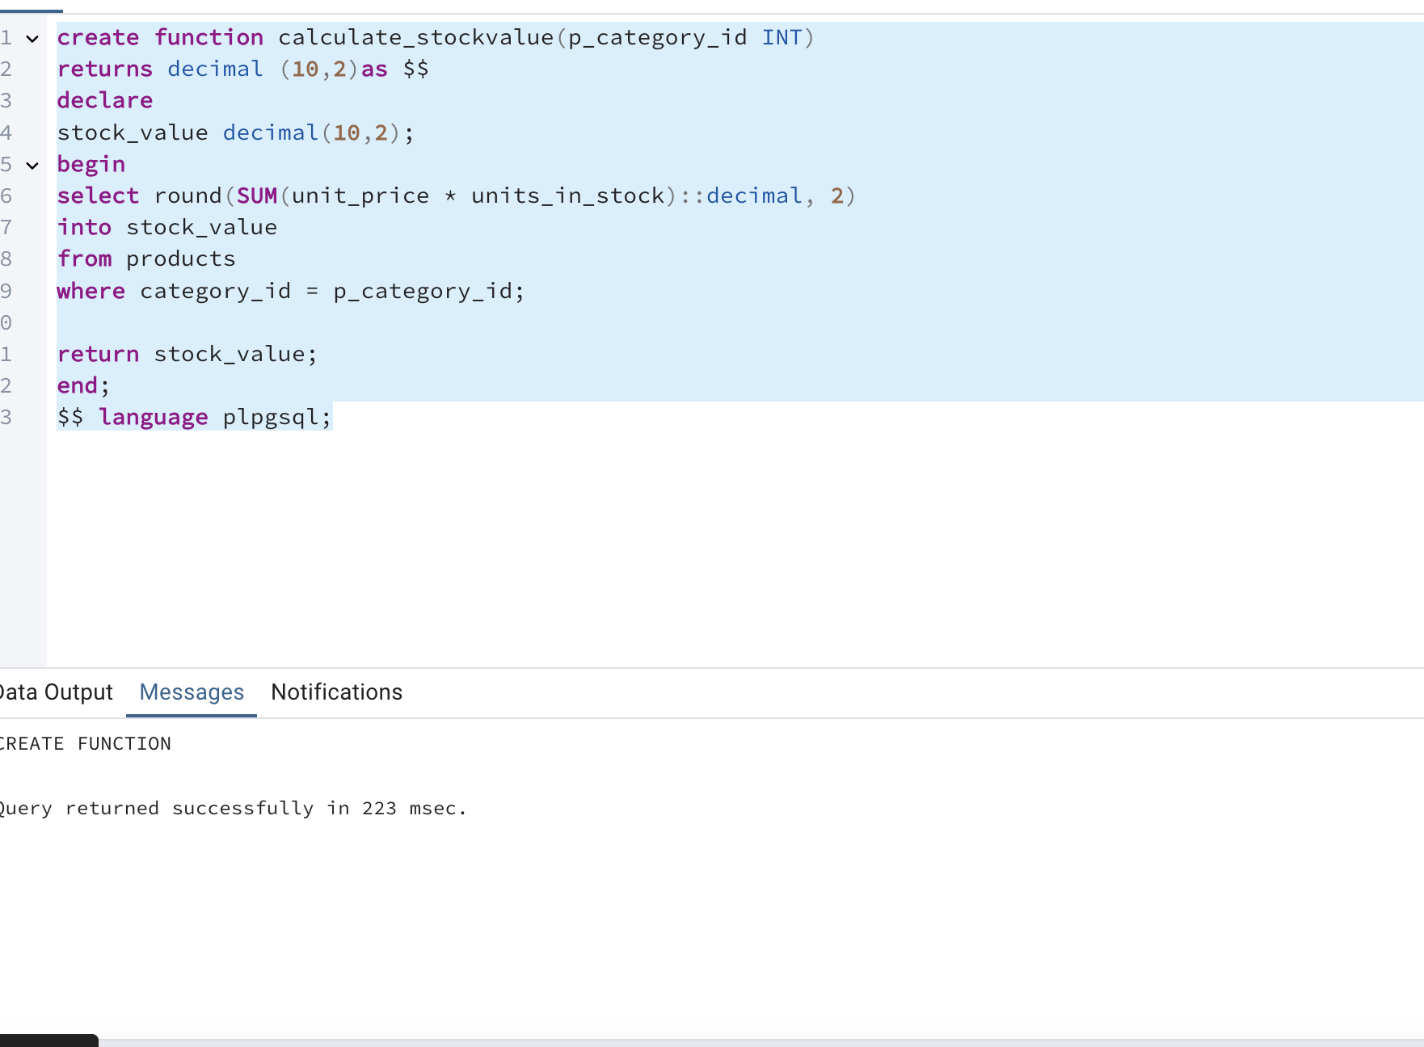

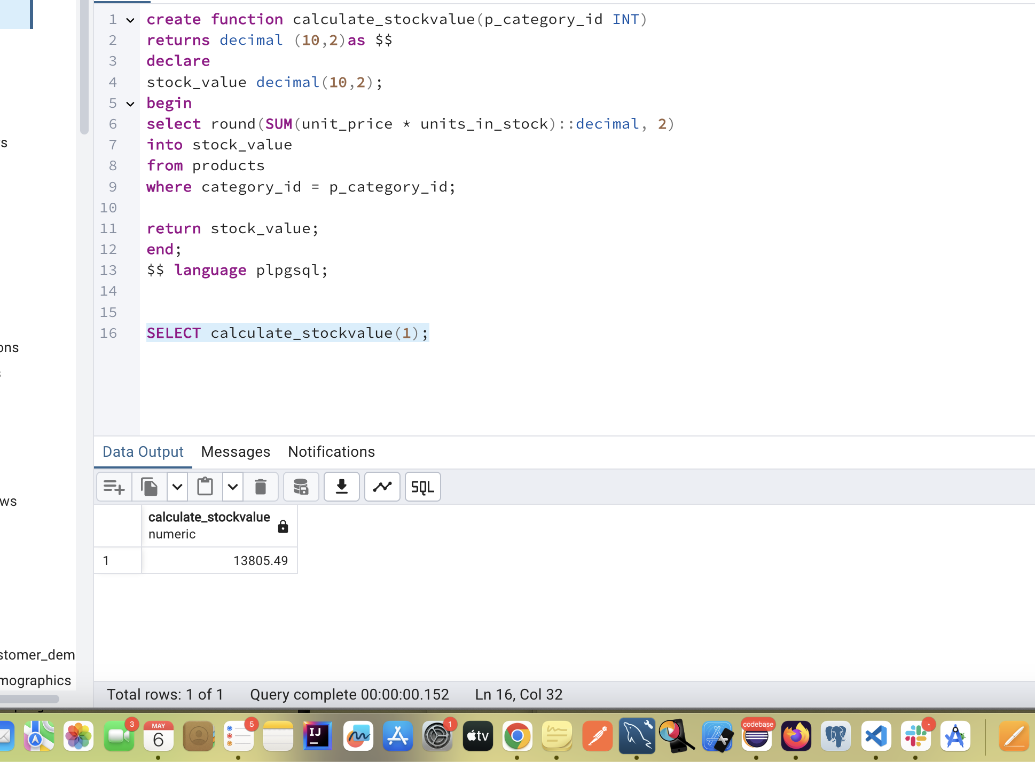

2. Try writing a cursor query which I executed in the training.

So based on the video, the question is The cursor will iterate through the products and adjust prices based on units in stock

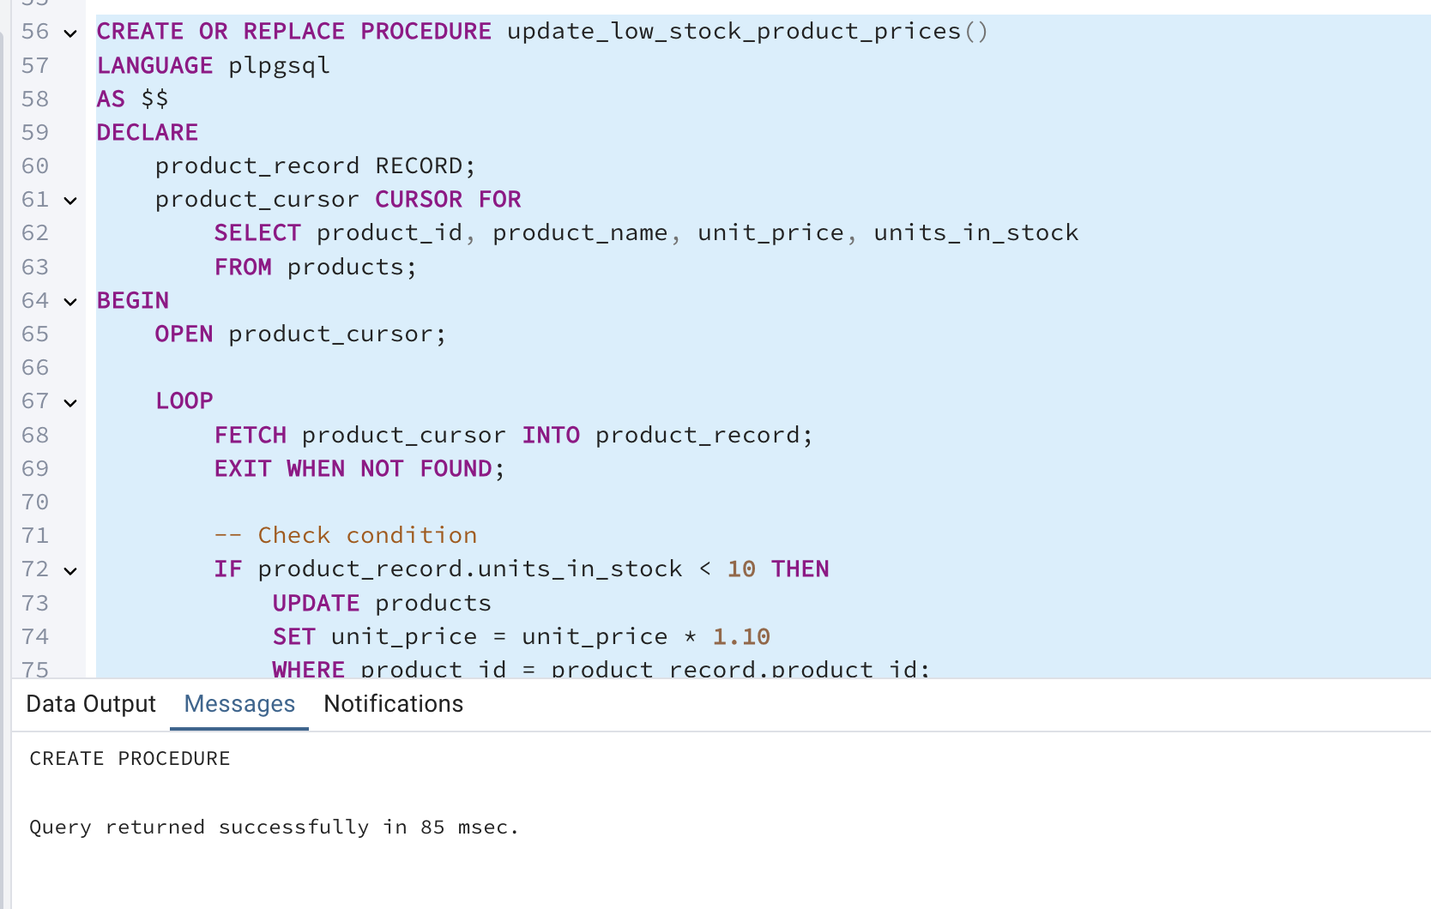

CREATE OR REPLACE PROCEDURE update_low_stock_product_prices()

LANGUAGE plpgsql

AS $$

DECLARE

product_record RECORD;

product_cursor CURSOR FOR

SELECT product_id, product_name, unit_price, units_in_stock

FROM products;

BEGIN

OPEN product_cursor;

LOOP

FETCH product_cursor INTO product_record;

EXIT WHEN NOT FOUND;

-- Check condition

IF product_record.units_in_stock < 10 THEN

UPDATE products

SET unit_price = unit_price * 1.10

WHERE product_id = product_record.product_id;

RAISE NOTICE 'Updated product % - new price: %',

product_record.product_name,

(product_record.unit_price * 1.10);

END IF;

END LOOP;

CLOSE product_cursor;

END;

$$;

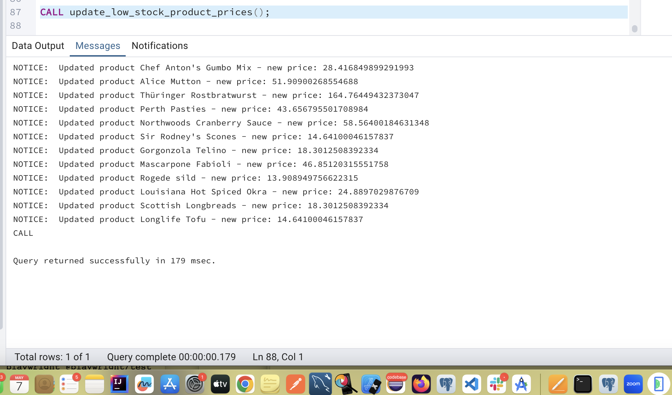

CALL update_low_stock_product_prices();