1)      Alter Table:

* Add a new column linkedin_profile to employees table to store LinkedIn URLs as varchar.

**Query:**

ALTER TABLE employees

ADD COLUMN linkedin_profile varchar;

**Screenshot:**

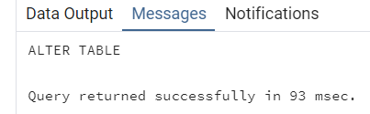

* Change the linkedin_profile column data type from VARCHAR to TEXT.

**Query:**

ALTER TABLE employees

ALTER COLUMN linkedin_profile

SET DATA TYPE text;

**Screenshot:**

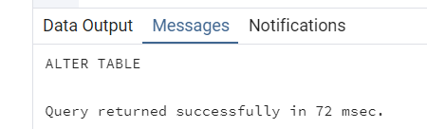

* Add unique, not null constraint to linkedin_profile

**Query:**

UPDATE employees

SET linkedin_profile = ' '

WHERE linkedin_profile IS NULL;

ALTER TABLE employees

ALTER COLUMN linkedin_profile SET NOT NULL;

**Screenshot:**

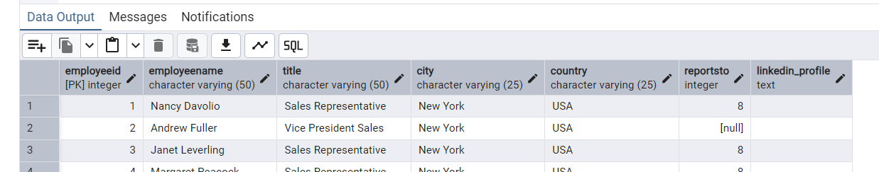

* Drop column linkedin_profile

**Query**:

ALTER TABLE employees

DROP COLUMN linkedin_profile;

**Screenshot**:

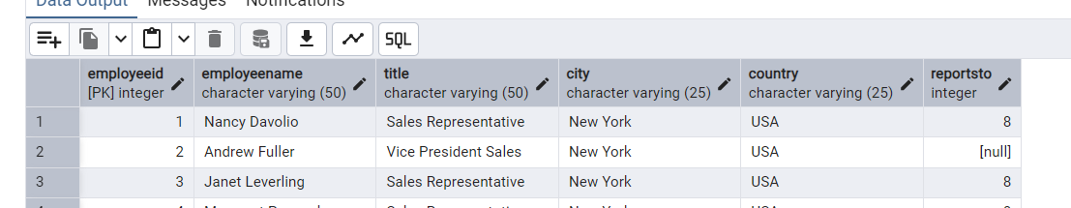

2)      Querying (Select)

* Retrieve the employeeName, and title of all employees

**Query**:

SELECT employeeID, employeeName, title FROM employees;

**Screenshot**:

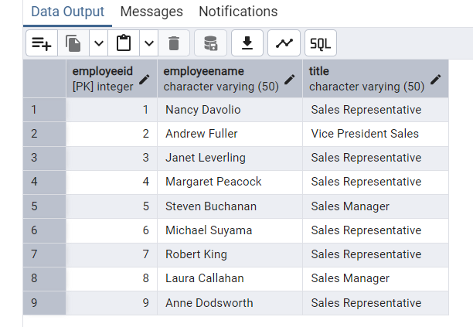

* Find all unique unit prices of products

**Query**:

SELECT DISTINCT unitPrice

FROM products;

**Screenshot**:

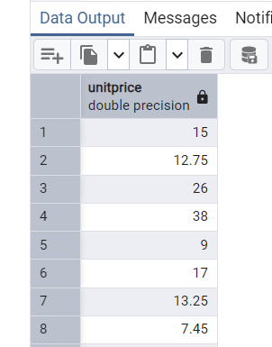

* List all customers sorted by company name in ascending order

**Query**:

SELECT contactName FROM customers

ORDER BY companyName ASC;

**Screenshot**:

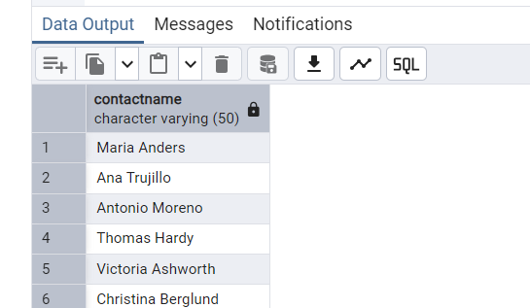

* Display product name and unit price, but rename the unit_price column as price_in_usd

**Query**:

SELECT

productName,

unitPrice AS price_in_usd

FROM products;

**Screenshot**:

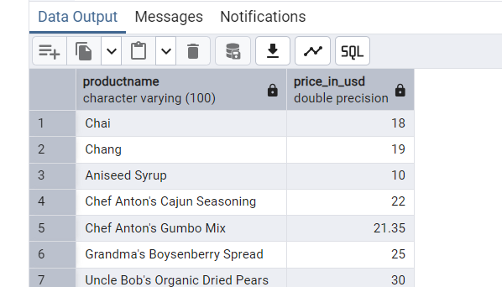

3)      Filtering

* Get all customers from Germany.

**Query**:

SELECT *

FROM customers

WHERE country = 'Germany';

**Screenshot**:

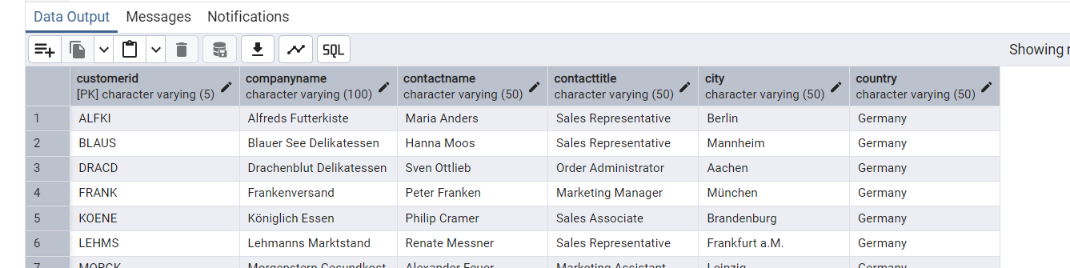

* Find all customers from France or Spain

**Query**:

SELECT *

FROM customers

WHERE country IN ('Spain', 'France');

**Screenshot**:

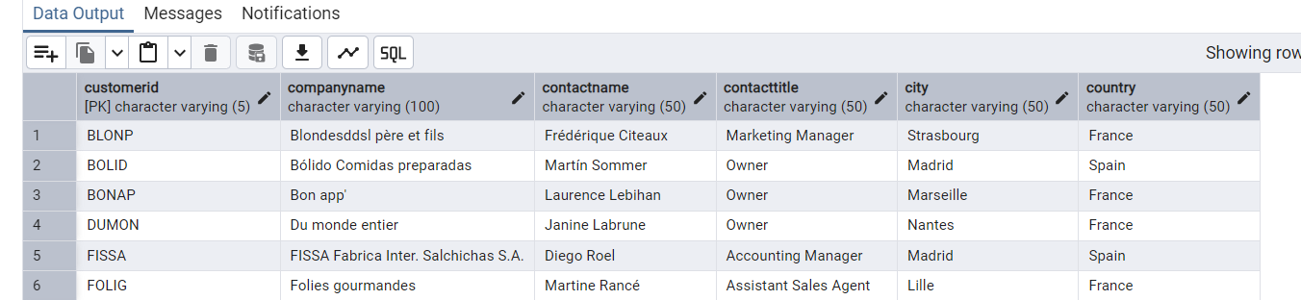

* Retrieve all orders placed in 2014 (based on order_date), and either have freight greater than 50 or the shipped date available (i.e., non-NULL)  (Hint: EXTRACT(YEAR FROM order_date))

**Query**:

SELECT *

FROM orders

WHERE EXTRACT(YEAR FROM orderDate) = 2014

AND (freight > 50 OR shippedDate IS NOT NULL);

**Screenshot**:

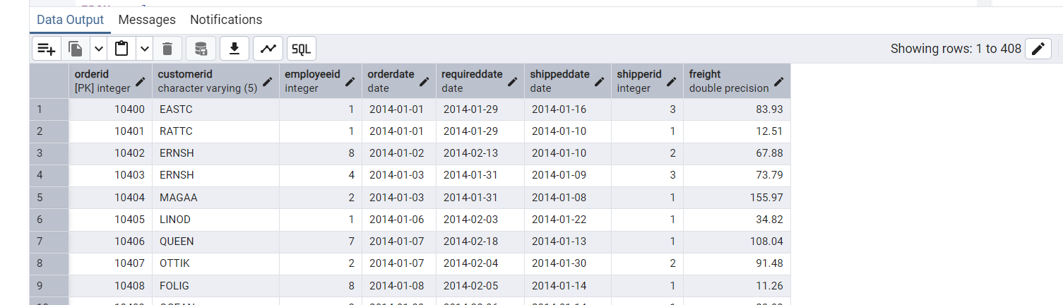

4)      Filtering

* Retrieve the product_id, product_name, and unit_price of products where the unit_price is greater than 15.

**Query**:

SELECT productid, productname, unitPrice

FROM products

WHERE unitPrice > 15;

**Screenshot**:

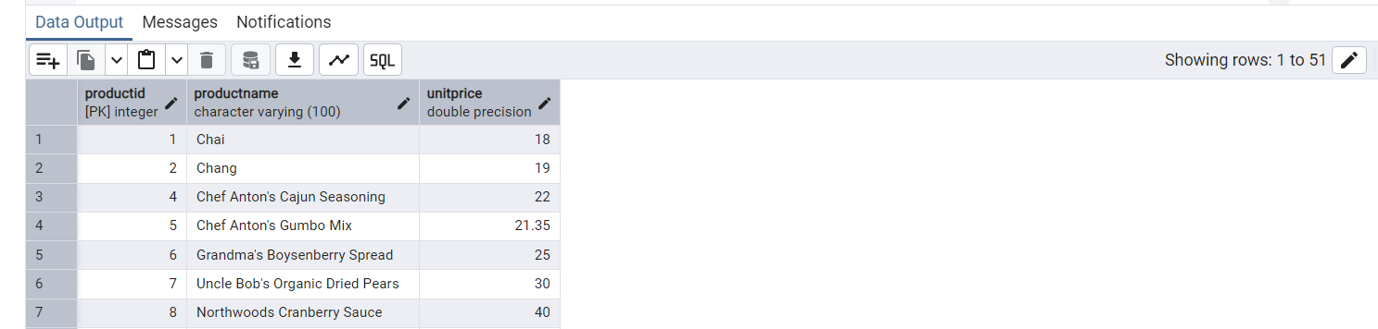

* List all employees who are located in the USA and have the title "Sales Representative".

**Query**:

SELECT *

FROM employees

WHERE country LIKE 'USA'

AND title LIKE 'Sales Representative';

**Screenshot**:

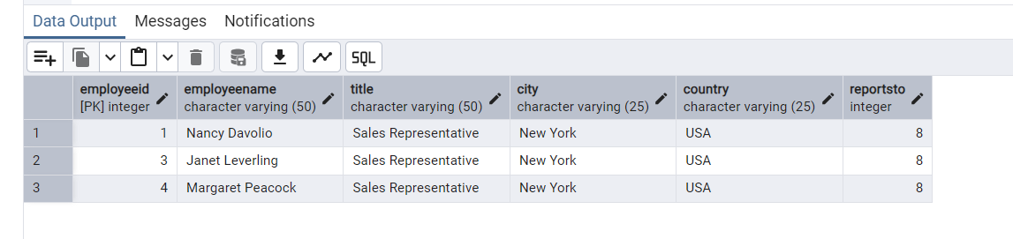

* Retrieve all products that are not discontinued and priced greater than 30.

**Query**:

SELECT *

FROM products

WHERE discontinued = 0

AND unitPrice > 30;

**Screenshot**:

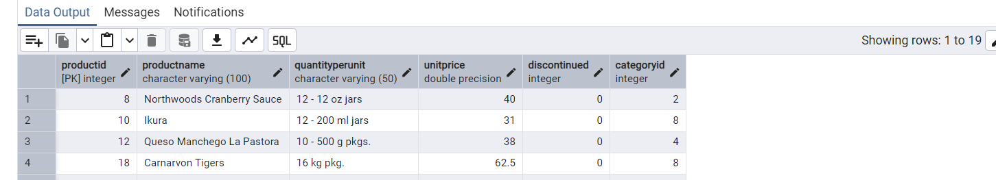

5)      LIMIT/FETCH

* Retrieve the first 10 orders from the orders table.

**Query**:

SELECT *

FROM orders

LIMIT 10;

**Screenshot**:

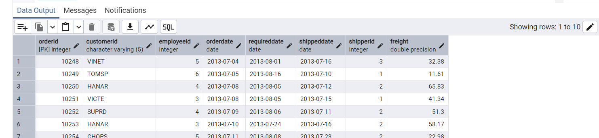

* Retrieve orders starting from the 11th order, fetching 10 rows (i.e., fetch rows 11-20).

**Query**:

SELECT *

FROM orders

LIMIT 10

OFFSET 10;

**Screenshot**:

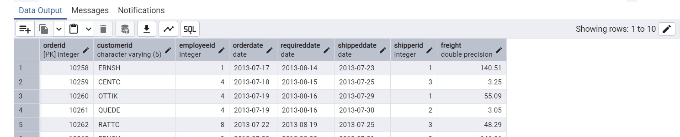

6)      Filtering (IN, BETWEEN)

* List all customers who are either Sales Representative, Owner

**Query**:

SELECT *

FROM customers

WHERE contactTitle IN ('Owner', 'Sales Representative');

**Screenshot**:

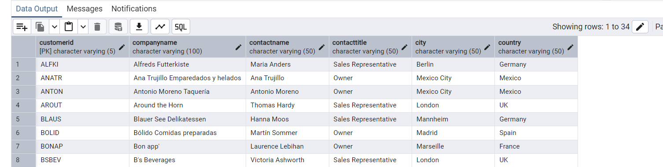

* Retrieve orders placed between January 1, 2013, and December 31, 2013.

**Query**:

SELECT *

FROM orders

WHERE orderDate BETWEEN '2013-01-01' AND '2013-12-31';

**Screenshot**:

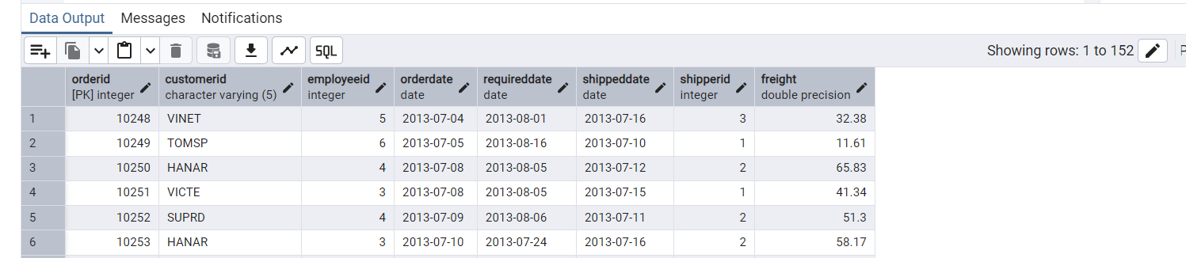

7)      Filtering

* List all products whose category_id is not 1, 2, or 3.

**Query**:

SELECT *

FROM products

WHERE categoryID NOT IN (1, 2, 3);

**Screenshot**:

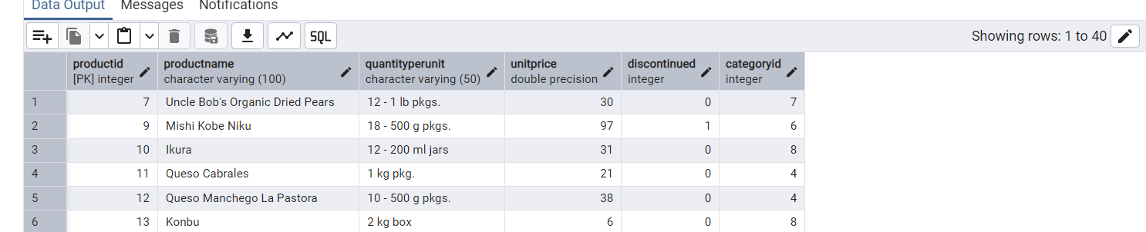

* Find customers whose company name starts with "A".

**Query**:

SELECT *

FROM customers

WHERE companyName like 'A%';

**Screenshot**:

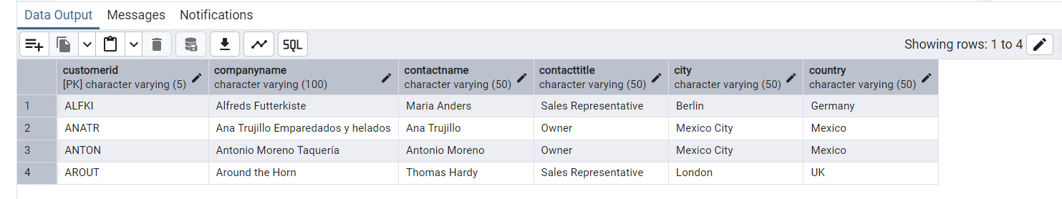

8)       INSERT into orders table:

 Task: Add a new order to the orders table with the following details:

Order ID: 11078

Customer ID: ALFKI

Employee ID: 5

Order Date: 2025-04-23

Required Date: 2025-04-30

Shipped Date: 2025-04-25

shipperID:2

Freight: 45.50

**Query**:

INSERT INTO orders (orderID, customerID, employeeID, orderDate, requiredDate, shippedDate, shipperID, freight)

VALUES

(11078, 'ALFKI', 5, '2025-04-23', '2025-04-30', '2025-04-25', 2, 45.50);

**Screenshot**:

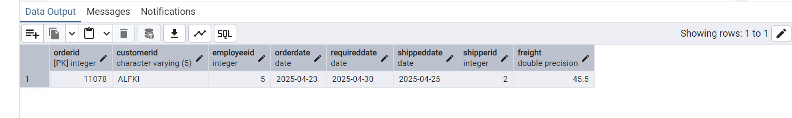

9)      Increase(Update)  the unit price of all products in category_id =2 by 10%.

(HINT: unit_price =unit_price * 1.10)

**Query**:

UPDATE products

SET unitPrice = unitPrice * 1.10

WHERE categoryID = 2;

**Screenshot**:

