--1.Add a new column linkedin_profile to employees table to store LinkedIn URLs as varchar.

ALTER TABLE employees

ADD linkedin_profile VARCHAR

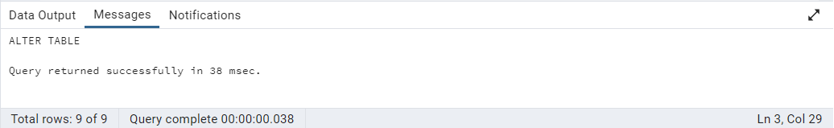

--2.Change the linkedin_profile column data type from VARCHAR to TEXT.

ALTER TABLE employees

ALTER COLUMN linkedin_profile

SET DATA TYPE TEXT

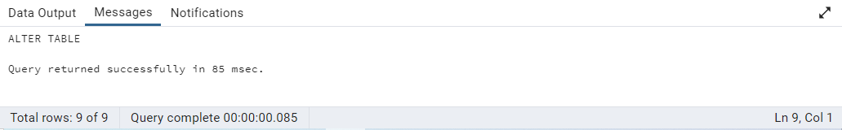

--3. Add unique, not null constraint to linkedin_profile

ALTER TABLE employees

ADD CONSTRAINT linkedin_profile_uni_name UNIQUE (linkedin_profile)

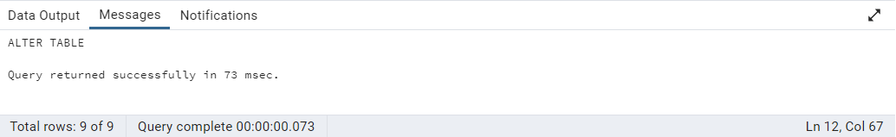

UPDATE employees

SET linkedin_profile = 'https://www.linkedin.com/in/'|| employeename

WHERE linkedin_profile IS NULL

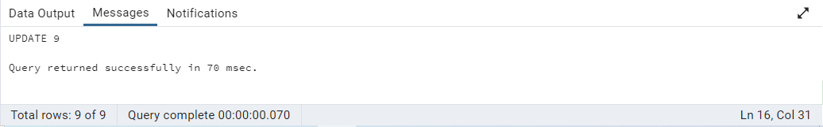

ALTER TABLE employees

ALTER COLUMN linkedin_profile SET NOT NULL

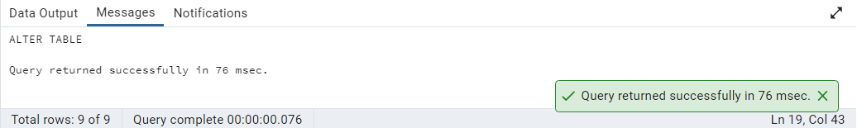

--4.Drop column linkedin_profile

ALTER TABLE employees

DROP COLUMN linkedin_profile

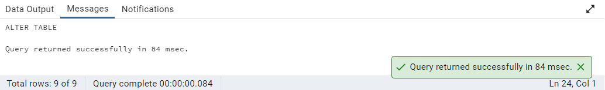

--5. Retrieve the employee name and title of all employees

SELECT employeename, title

FROM employees

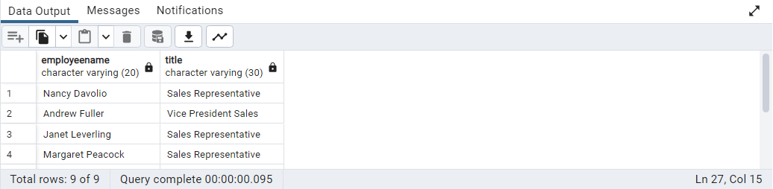

--6.Find all unique unit prices of products

SELECT DISTINCT unitprice

FROM products

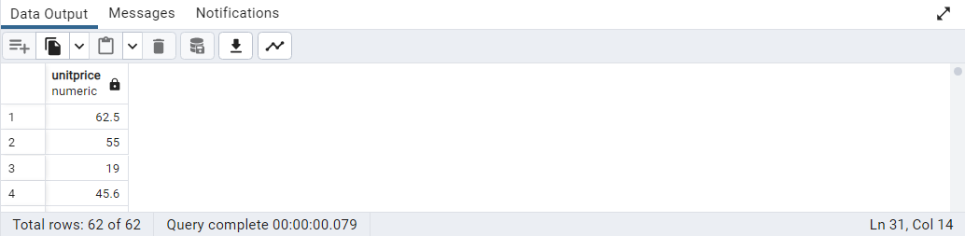

--7. List all customers sorted by company name in ascending order

SELECT customerid, companyname

FROM customers

ORDER BY companyname

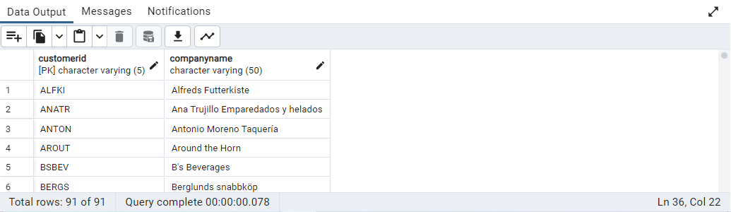

--8.Display product name and unit price, but rename the unit_price column as price_in_usd

SELECT productname, unitprice AS price_in_usd

FROM products

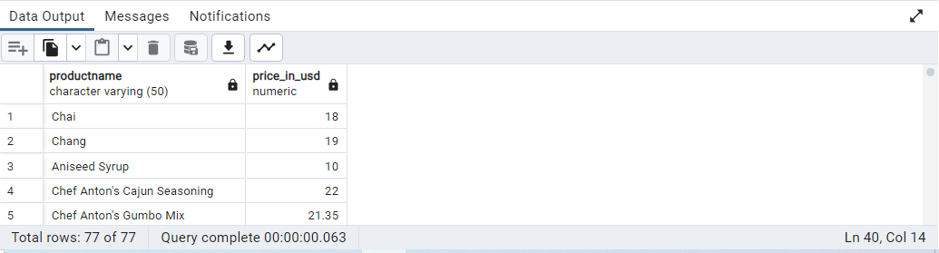

--9.Get all customers from Germany.

SELECT customerid, country

FROM customers

WHERE country = 'Germany'

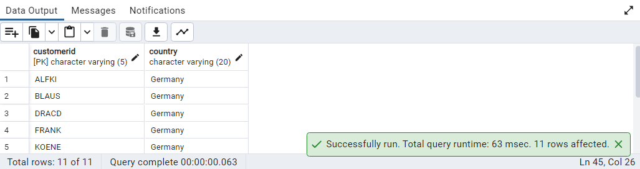

--10.Find all customers from France or Spain

SELECT customerid, country

FROM customers

WHERE country = 'France' OR

country = 'Spain'

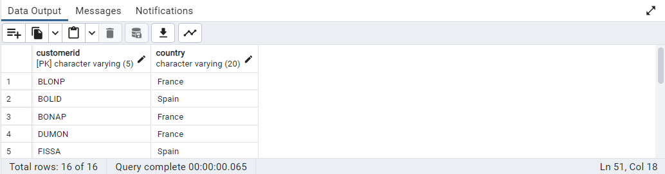

--11.Retrieve all orders placed in 2014(based on order_date), and either have freight greater than 50 or the shipped date available (i.e., non-NULL) (Hint: EXTRACT(YEAR FROM order_date))

SELECT orderid, orderdate, freight, shippeddate

FROM orders

WHERE EXTRACT (YEAR FROM orderdate) = 2014 AND

(freight > 50 OR shippeddate IS NOT NULL)

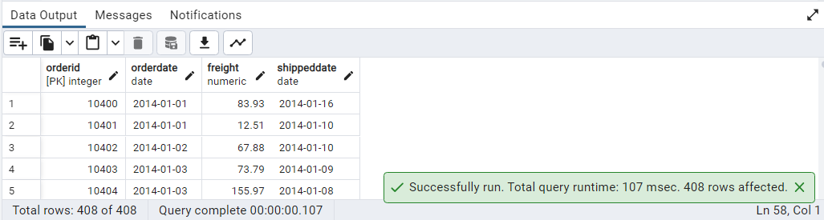

--12.Retrieve the product_id, product_name, and unit_price of products where the unit_price is greater than 15.

SELECT productid, productname, unitprice

FROM products

WHERE unitprice > 15

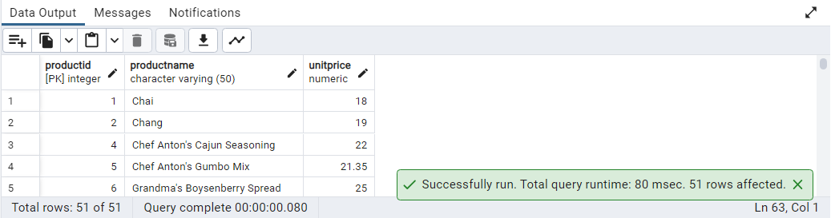

--13.List all employees who are located in the USA and have the title "Sales Representative".

SELECT employeename, title, country

FROM employees

WHERE country = 'USA' AND

title = 'Sales Representative'

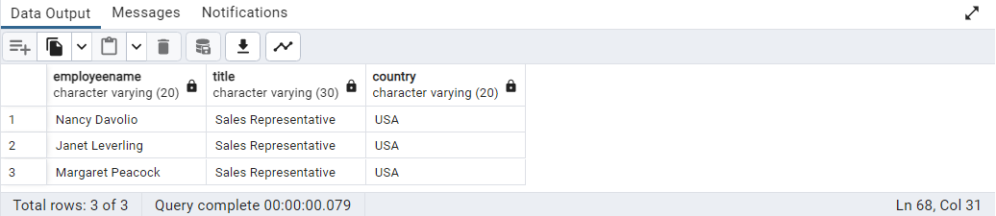

--14.Retrieve all products that are not discontinued and priced greater than 30.

SELECT productname, unitprice, discontinued

FROM products

WHERE discontinued = 0 AND

unitprice > 30

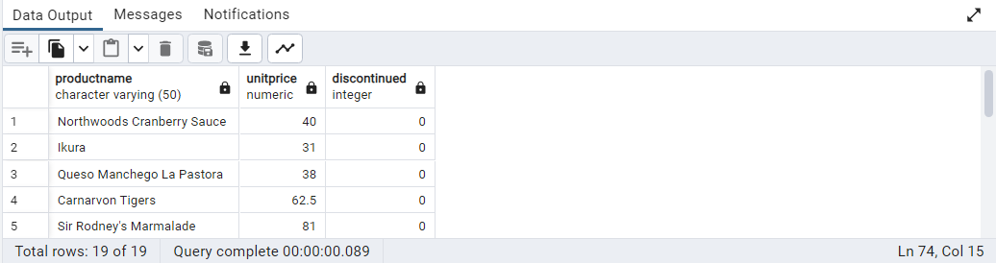

--15. Retrieve the first 10 orders from the orders table.

SELECT * FROM orders

LIMIT 10

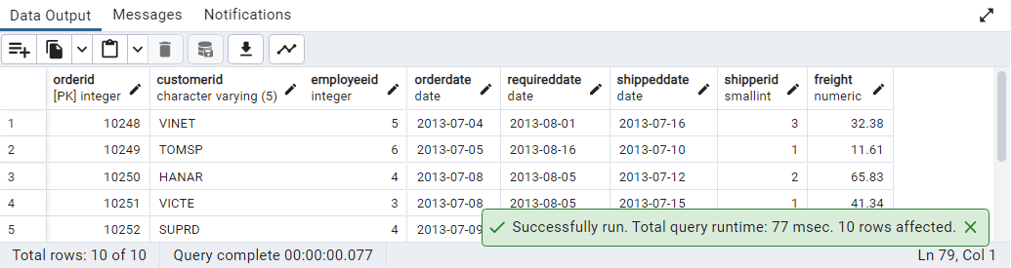

--16.Retrieve orders starting from the 11th order, fetching 10 rows (i.e., fetch rows 11-20).

SELECT * FROM orders

OFFSET 10 ROWS

FETCH NEXT 10 ROWS ONLY

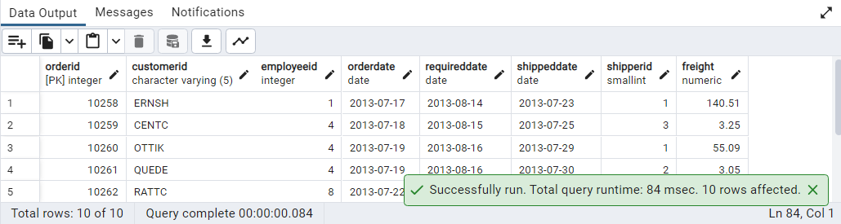

--17.List all customers who are either Sales Representative, Owner

SELECT customerid, contacttitle

FROM customers

WHERE contacttitle IN ('Sales Representative', 'Owner')

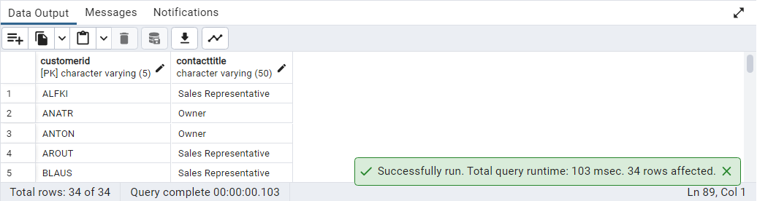

--18.Retrieve orders placed between January 1, 2013, and December 31, 2013.

SELECT orderid, orderdate

FROM orders

WHERE orderdate BETWEEN '2013-01-01' AND '2013-12-31'

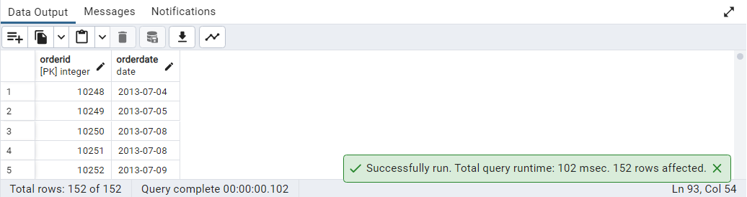

--19.List all products whose category_id is not 1, 2, or 3.

SELECT productname, categoryid

FROM products

WHERE categoryid NOT IN (1, 2, 3)

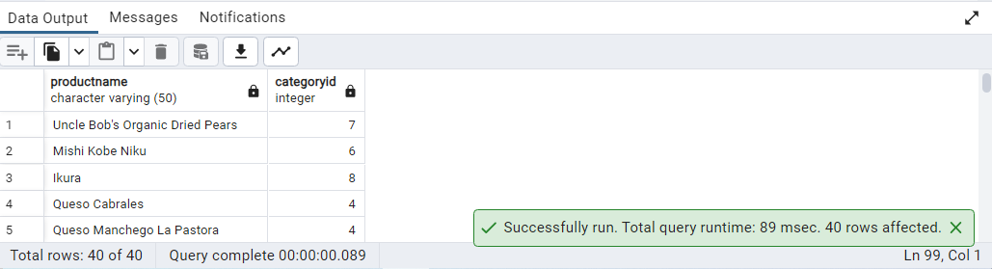

--20.Find customers whose company name starts with "A".

SELECT customerid, companyname

FROM customers

WHERE companyname LIKE 'A%'

