1)      Update the categoryName from “Beverages” to "Drinks" in the categories table.

**QUERY:**

UPDATE categories

SET categoryName = 'Drinks'

WHERE categoryName = 'Beverages';

**SCREENSHOT:**

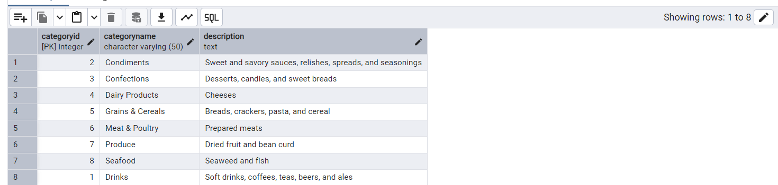

2)      Insert into shipper new record (give any values) Delete that new record from shippers table.

**QUERY:**

INSERT INTO shippers (shipperID, companyName)

VALUES (8,'UPS');

**SCREENSHOT:**

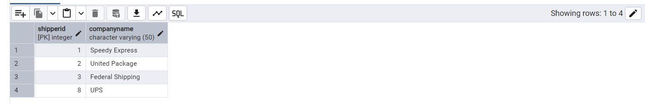

**QUERY:**

DELETE FROM shippers

WHERE shipperID = 8;

**SCREENSHOT:**

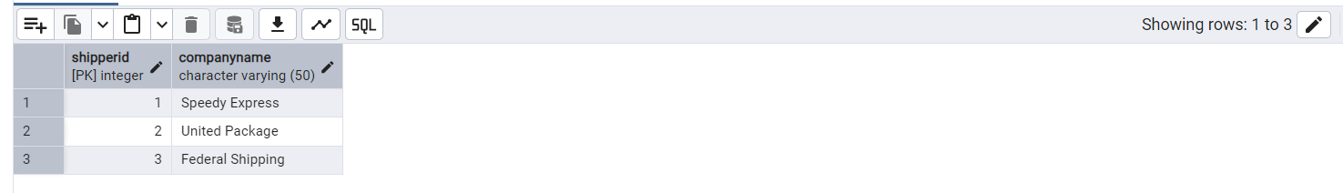

3)      Update categoryID=1 to categoryID=1001. Make sure related products update their categoryID too. Display both category and products table to show the cascade.

**QUERY:**

UPDATE categories

SET categoryID = 1001

WHERE categoryID = 1;

**SCREENSHOT:**

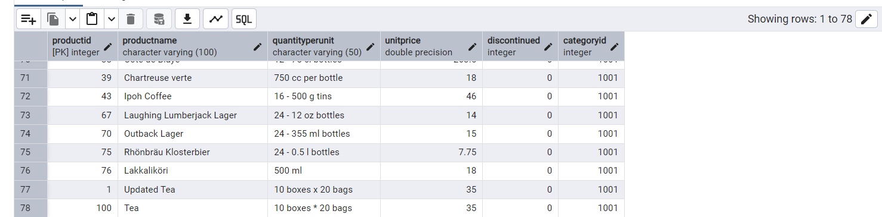

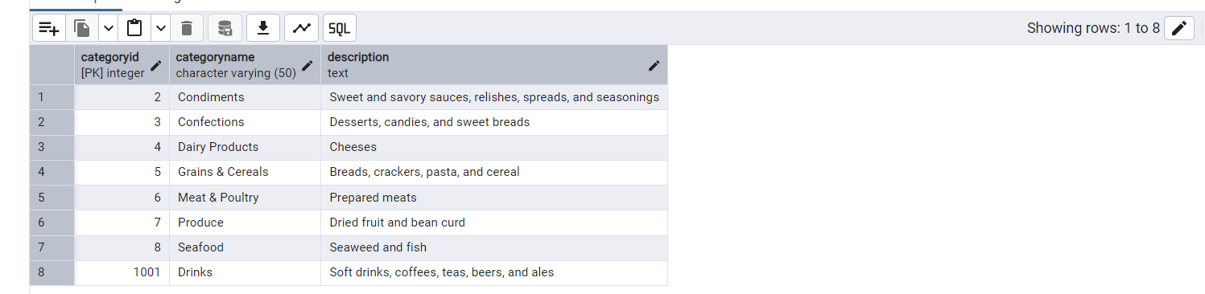

 Delete the categoryID= “3” from categories. Verify that the corresponding records are deleted automatically from products.

 (HINT: Alter the foreign key on products(categoryID) to add ON UPDATE CASCADE, ON DELETE CASCADE, add ON DELETE CASCADE from order_details(productid)

**QUERY:**

DELETE FROM categories

WHERE categoryID = 3;

**SCREENSHOT:**

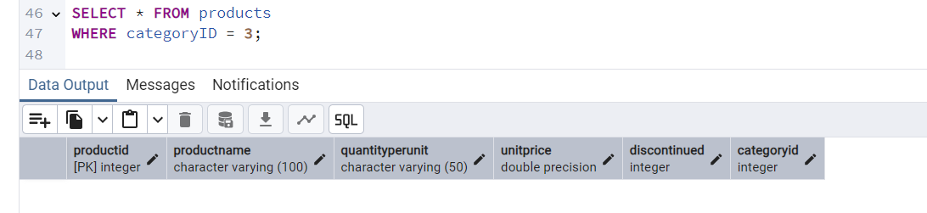

4)      Delete the customer = “VINET” from customers. Corresponding customers in orders table should be set to null (HINT: Alter the foreign key on orders(customerID) to use ON DELETE SET NULL)

**QUERY:**

ALTER TABLE orders

ADD CONSTRAINT orders_customerid_fkey

FOREIGN KEY (customerID)

REFERENCES customers(customerID)

ON DELETE SET NULL;

DELETE FROM customers

WHERE customerID = 'VINET';

**SCREENSHOT:**

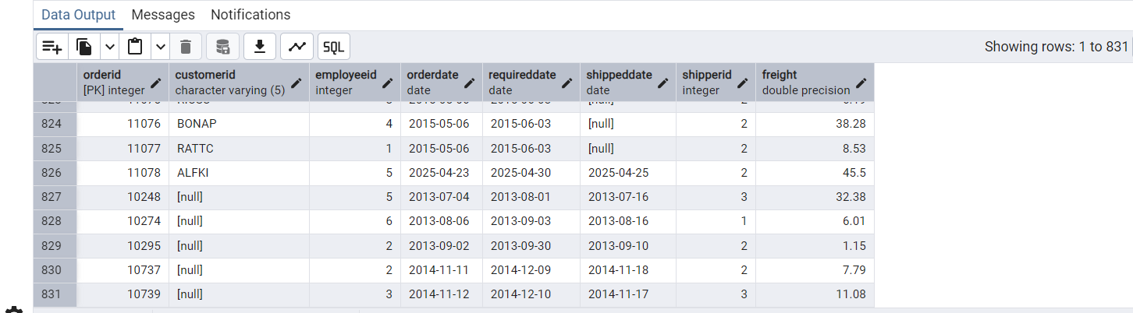

5)      Insert the following data to Products using UPSERT:

product_id = 100, product_name = Wheat bread, quantityperunit=1, unitprice = 13, discontinued = 0, categoryID=5

product_id = 101, product_name = White bread, quantityperunit=5 boxes, unitprice = 13, discontinued = 0, categoryID=5

**SCREENSHOT:**

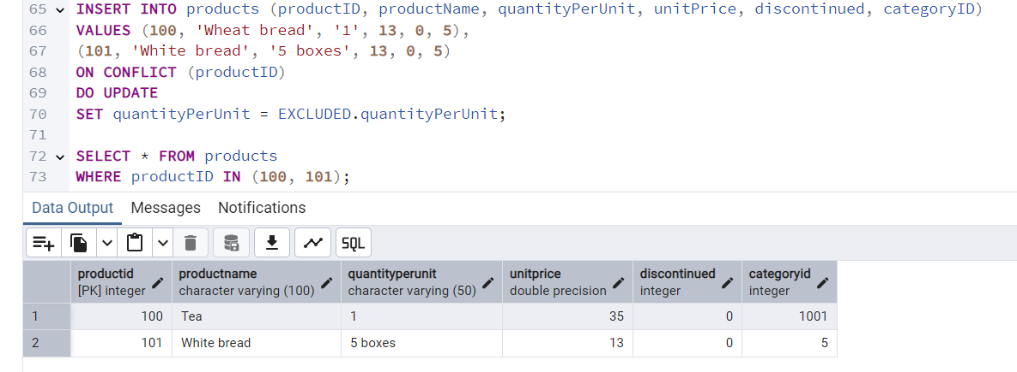

product_id = 100, product_name = Wheat bread, quantityperunit=10 boxes, unitprice = 13, discontinued = 0, categoryID=5

(this should update the quantityperunit for product_id = 100)

**QUERY:**

INSERT INTO products (productID, productName, quantityPerUnit, unitPrice, discontinued, categoryID)

VALUES (100, 'Wheat bread', '10 boxes', 13, 0, 5)

ON CONFLICT (productID)

DO UPDATE

SET quantityPerUnit = EXCLUDED.quantityPerUnit;

**SCREENSHOT:**

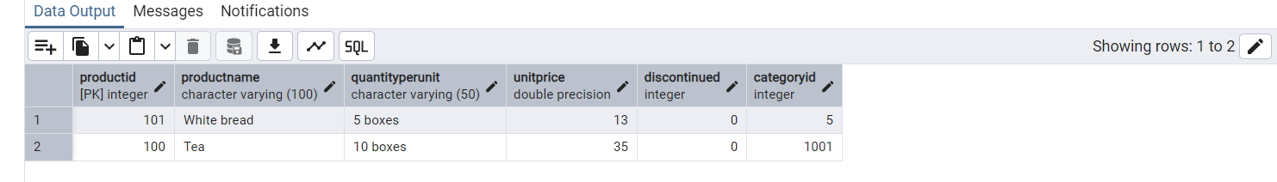

6)      Write a **MERGE query**:

Create **temp table with name:** ‘updated_products’ and insert values as below:

|  |  |  |  |  |  |
| --- | --- | --- | --- | --- | --- |
| productID | productName | quantityPerUnit | unitPrice | discontinued | categoryID |
| 100 | Wheat bread | 10 | 20 | 1 | 5 |
| 101 | White bread | 5 boxes | 19.99 | 0 | 5 |
| 102 | Midnight Mango Fizz | 24 - 12 oz bottles | 19 | 0 | 1 |
| 103 | Savory Fire Sauce | 12 - 550 ml bottles | 10 | 0 | 2 |

* Update the price and discontinued status for from below table ‘updated_products’ only if there are matching products and updated_products. discontinued =0
* If there are matching products and updated_products. discontinued =1 then delete

 Insert any new products from updated_products that don’t exist in products only if updated_products. discontinued =0.

**QUERY:**

MERGE INTO products p

USING updated_products u (productid, productname, quantityperunit, unitprice, discontinued, categoryid)

ON p.productid = u.productid

WHEN MATCHED AND u.discontinued = 1 THEN

DELETE

WHEN MATCHED AND u.discontinued = 0 THEN

UPDATE SET

discontinued = u.discontinued,

unitprice = u.unitprice

WHEN NOT MATCHED AND u.discontinued = 0 THEN

INSERT (productid, productname, quantityperunit, unitprice, discontinued, categoryid)

VALUES (u.productid, u.productname, u.quantityperunit, u.unitprice, u.discontinued, u.categoryid);

**SCREENSHOT:**

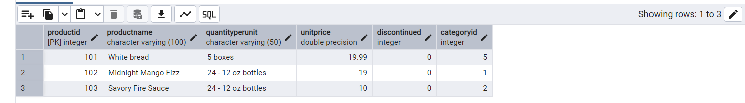

7)      List all orders with employee full names. (Inner join)

**QUERY:**

SELECT e.first_Name || e.last_Name as full_Name

FROM orders o

INNER JOIN employees e ON e.employee_ID = o.employee_ID;

**SCREENSHOT:**

