--1.Update the categoryName From “Beverages” to "Drinks" in the categories table.

UPDATE categories

SET categoryName = 'Drinks'

WHERE categoryName = 'Beverages'

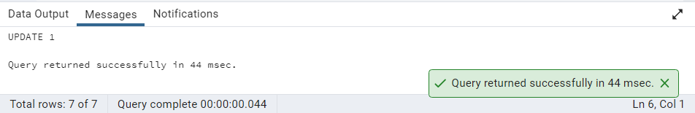

SELECT categoryName FROM categories

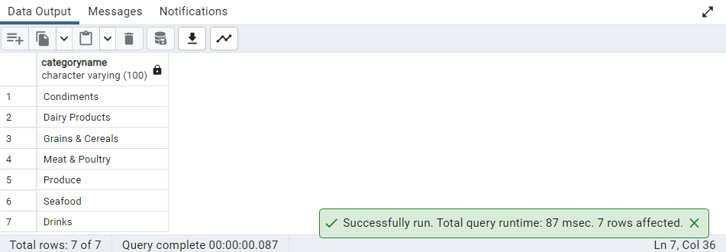

--2.Insert into shipper new record (give any values) Delete that new record from shippers table.

INSERT INTO shippers

(shipperid, companyname)

VALUES (4, 'International Shipping')

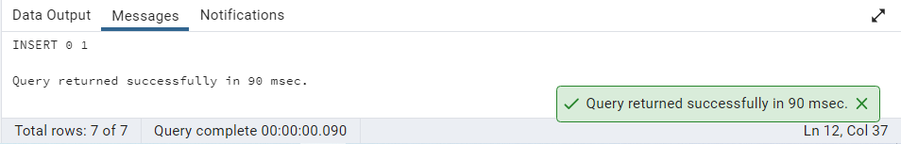

SELECT * FROM shippers

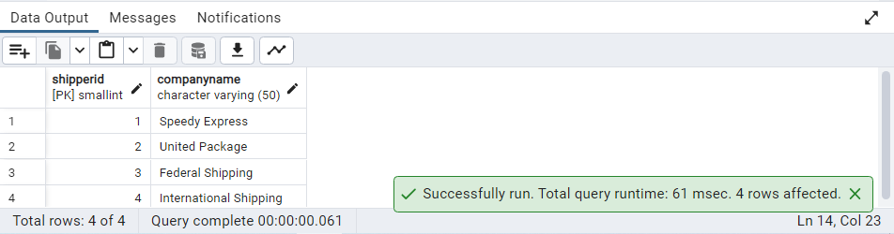

DELETE FROM shippers

WHERE shipperid = 4

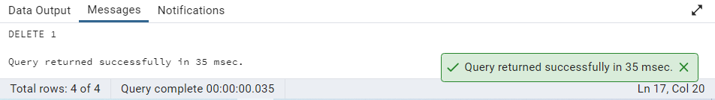

--3.Update categoryID=1 to categoryID=1001. Make sure related products update their categoryID too. Display the both category and products table to show the cascade.

ALTER TABLE products

DROP CONSTRAINT IF EXISTS products_categoryid_fkey

ALTER TABLE products

ADD CONSTRAINT products_categoryid_fkey

FOREIGN KEY (categoryid)

REFERENCES categories (categoryid)

ON UPDATE CASCADE

ON DELETE CASCADE

UPDATE categories

SET categoryid = 1001

WHERE categoryid = 1

SELECT * FROM products

WHERE categoryid = 1001

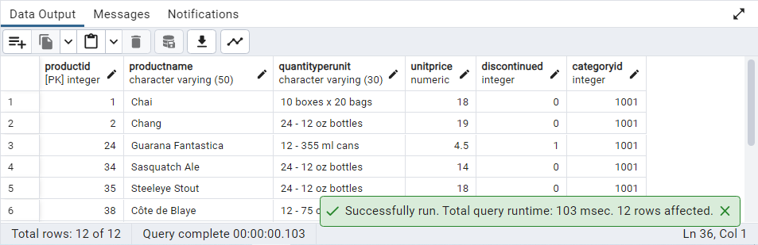

SELECT * FROM categories

WHERE categoryid = 1001

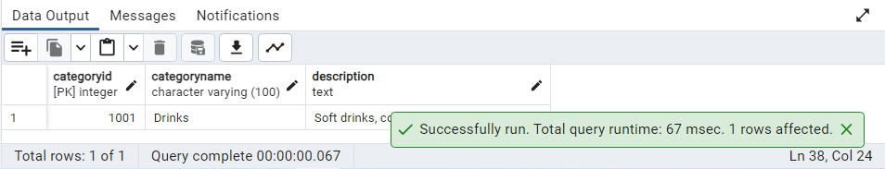

--Delete the categoryID= “3” from categories. Verify that the corresponding records are deleted automatically from products.

ALTER TABLE order_details

DROP CONSTRAINT IF EXISTS order_details_productid_fkey

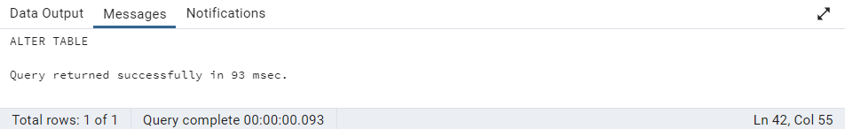

ALTER TABLE order_details

ADD CONSTRAINT order_details_productid_fkey

FOREIGN KEY (productid)

REFERENCES products (productid)

ON UPDATE CASCADE

ON DELETE CASCADE

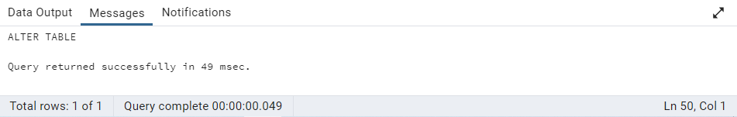

DELETE FROM categories

WHERE categoryID = 3

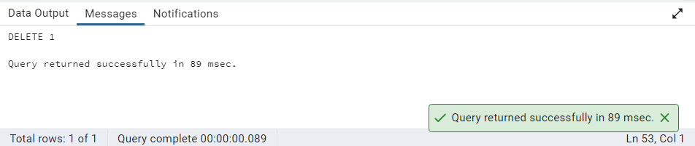

SELECT * FROM categories

WHERE categoryid = 3

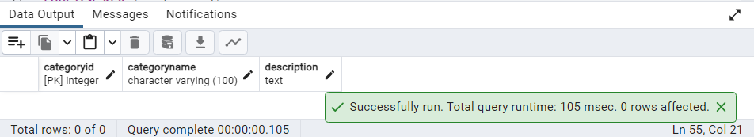

SELECT * FROM products

WHERE categoryid = 3

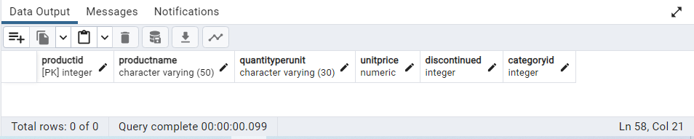

--5.Insert the following data to Products using UPSERT:

INSERT INTO products

(productid, productname, quantityperunit, unitprice, discontinued, categoryid)

VALUES (100, 'Wheat bread', '1 boxes', 13, 0, 5),

(101, 'Wheat bread', '5 boxes', 13, 0, 5),

(100, 'Wheat bread', '10 boxes', 13, 0, 5)

ON CONFLICT (productid)

DO UPDATE

SET productname = Excluded.productname,

quantityperunit = Excluded.quantityperunit,

unitprice = Excluded.unitprice,

discontinued = Excluded.discontinued,

categoryid = Excluded.categoryid

SELECT * FROM products

WHERE productid IN (100, 101)

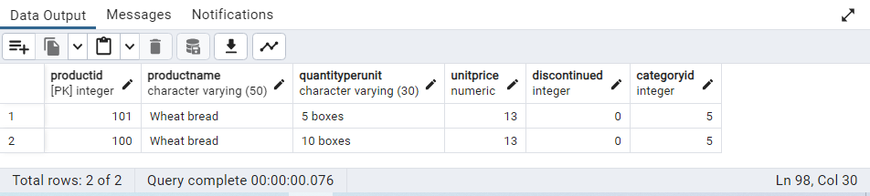

--Write a MERGE query:

--Create temp table

CREATE TEMP TABLE updated_products

(productID INT, productName VARCHAR(25), quantityPerUnit VARCHAR(25), unitprice NUMERIC,

discontinued SMALLINT, categoryID INT)

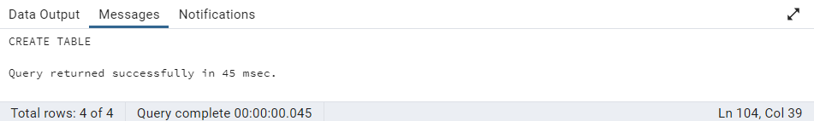

INSERT INTO updated_products

VALUES

(100, 'Wheat bread', '10', 20, 1, 5),

(101, 'Wheat bread', '5 boxes', 19.99, 0, 5),

(102, 'Midnight Mango Fizz', '24 - 12 oz bottles', 19, 0, 1),

(103, 'Savory Fire Sauce', '12 - 550 ml bottles', 10, 0, 2)

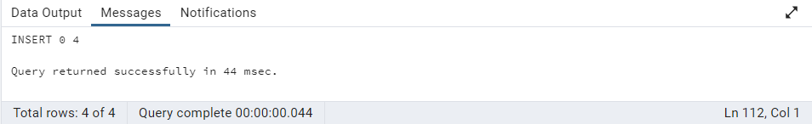

SELECT * FROM updated_products

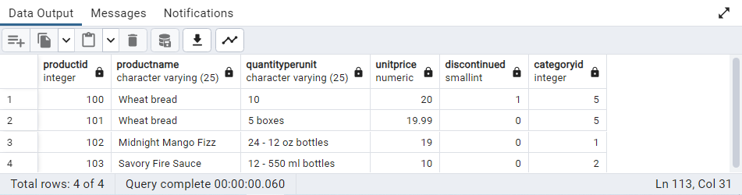

MERGE INTO products p

USING updated_products AS u

ON p.productid = u.productid

WHEN MATCHED AND u.discontinued = 1

THEN DELETE

WHEN NOT MATCHED AND u.discontinued = 0

THEN INSERT (productid, productName, quantityPerUNIT, unitPrice, discontinued, categoryID)

VALUES (u.productid, u.productName, u.quantityPerUNIT, u.unitPrice, u.discontinued, u.categoryID)

WHEN MATCHED AND u.discontinued = 0

THEN UPDATE SET

unitPrice = u.unitPrice,

discontinued = u.discontinued

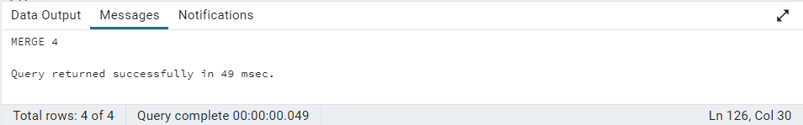

SELECT * FROM products

WHERE productid IN (100, 101, 102, 103)

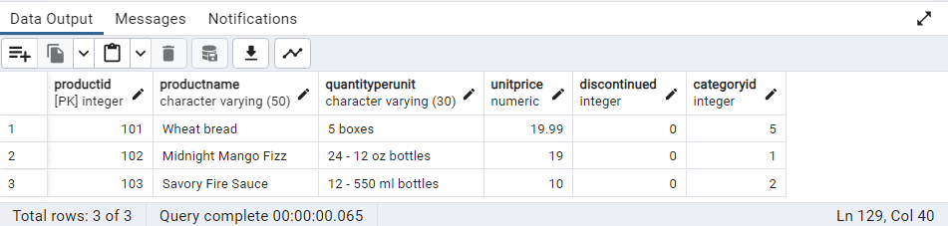

--7.List all orders with employee full names. (Inner join)

SELECT o.order_id, e.first_name ||' '|| e.last_name AS full_name

FROM orders o

INNER JOIN employees e

ON o.employee_id = e.employee_id

