1. List all customers and the products they ordered with the order date. (Inner join)

**Tables used:** customers, orders, order_details, products

**Output should have below columns:**

companyname AS customer,

orderid,

productname,

quantity,

Orderdate

select * from customers;

select * from products;

select * from order_details;

select * from orders;

select c.customer_id,c.company_name as customer,

p.product_name,od.quantity,o.order_id,o.order_date

from customers c

inner join

orders o on c.customer_id=o.customer_id

inner join

order_details od on o.order_id=od.order_id

inner join

products p on p.product_id=od.product_id;

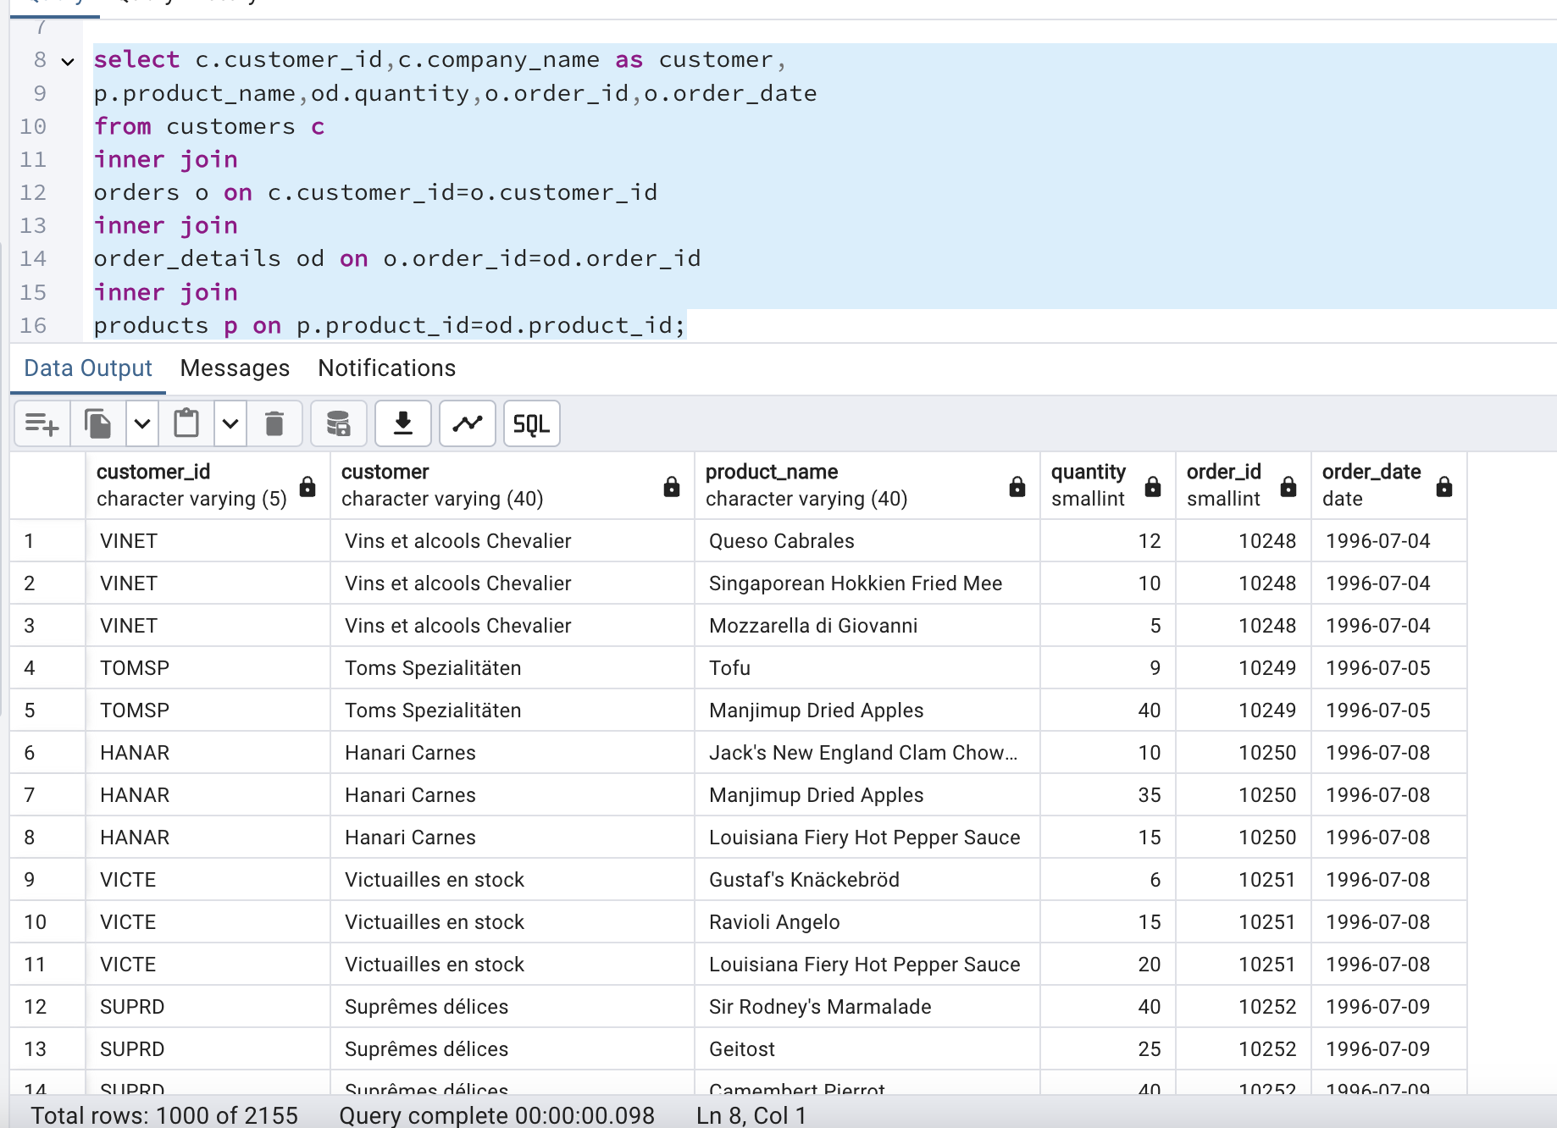

2. Show each order with customer, employee, shipper, and product info — even if some parts are missing. (Left Join)

**Tables used: orders, customers, employees, shippers, order_details, products**

**select o.order_id as ordersplaced,**

**o.order_date,o.customer_id as customer,**

**c.company_name,e.employee_id,e.first_name || '' || e.last_name as employeename,**

**s.shipper_id,s.company_name as shipperscompanyname,**

**p.product_id,p.product_name,od.quantity**

**from orders o**

**left join order_details od on od.order_id=o.order_id**

**left join customers c on c.customer_id=o.customer_id**

**left join employees e on o.employee_id = e.employee_id**

**left join shippers s on s.shipper_id=o.ship_via**

**left join products p on p.product_id=od.product_id;**

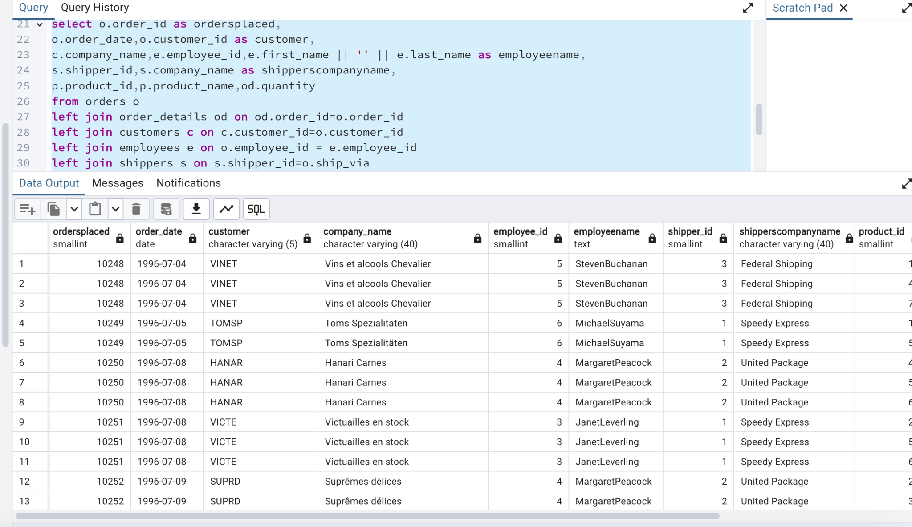

3. Show all order details and products (include all products even if they were never ordered). (Right Join)

**Tables used: order_details, products**

**Output should have below columns:**

orderid,

productid,

quantity,

productname

select od.order_id,od.quantity,od.product_id,

p.product_name,p.product_id

from order_details od

right join products p on od.product_id=p.product_id;

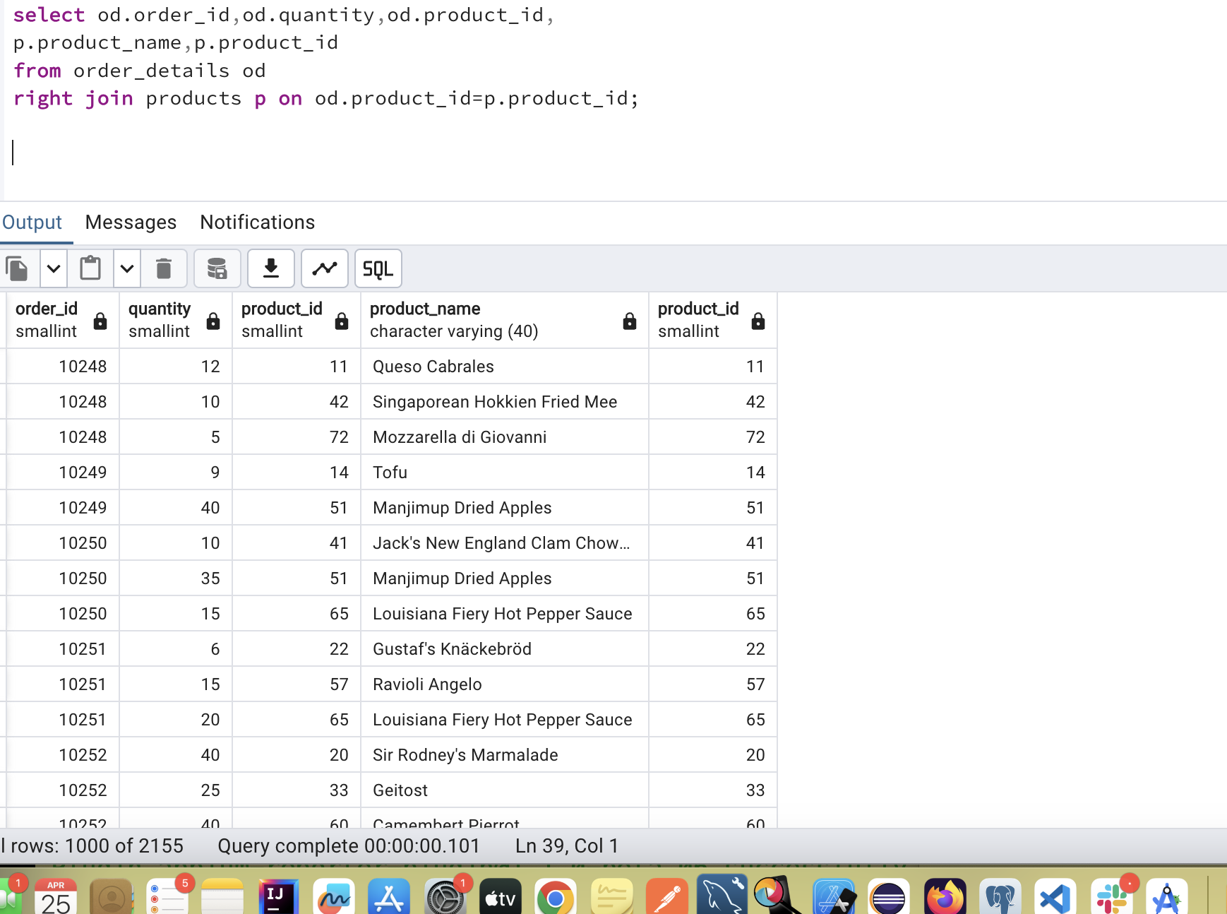

4. List all product categories and their products — including categories that have no products, and products that are not assigned to any category.(Outer Join)

**Tables used: categories, products**

**select c.category_id,c.category_name,p.product_id,p.product_name**

**from categories c**

**full outer join products p on c.category_id=p.category_id;**

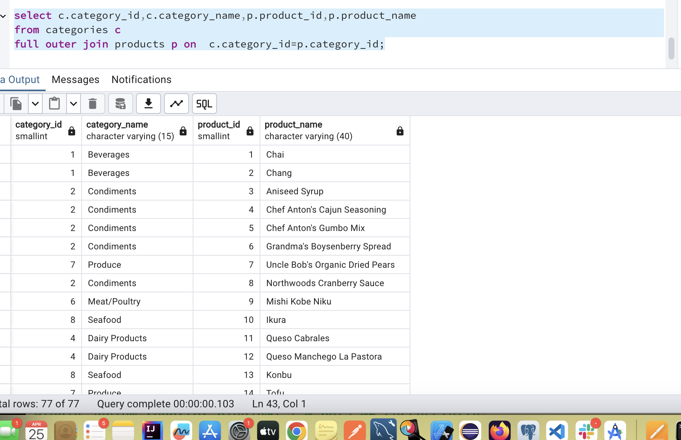

5. Show all possible product and category combinations (Cross join).

select p.product_id,p.product_name,c.category_id,c.category_name

from products p

cross join categories c ;

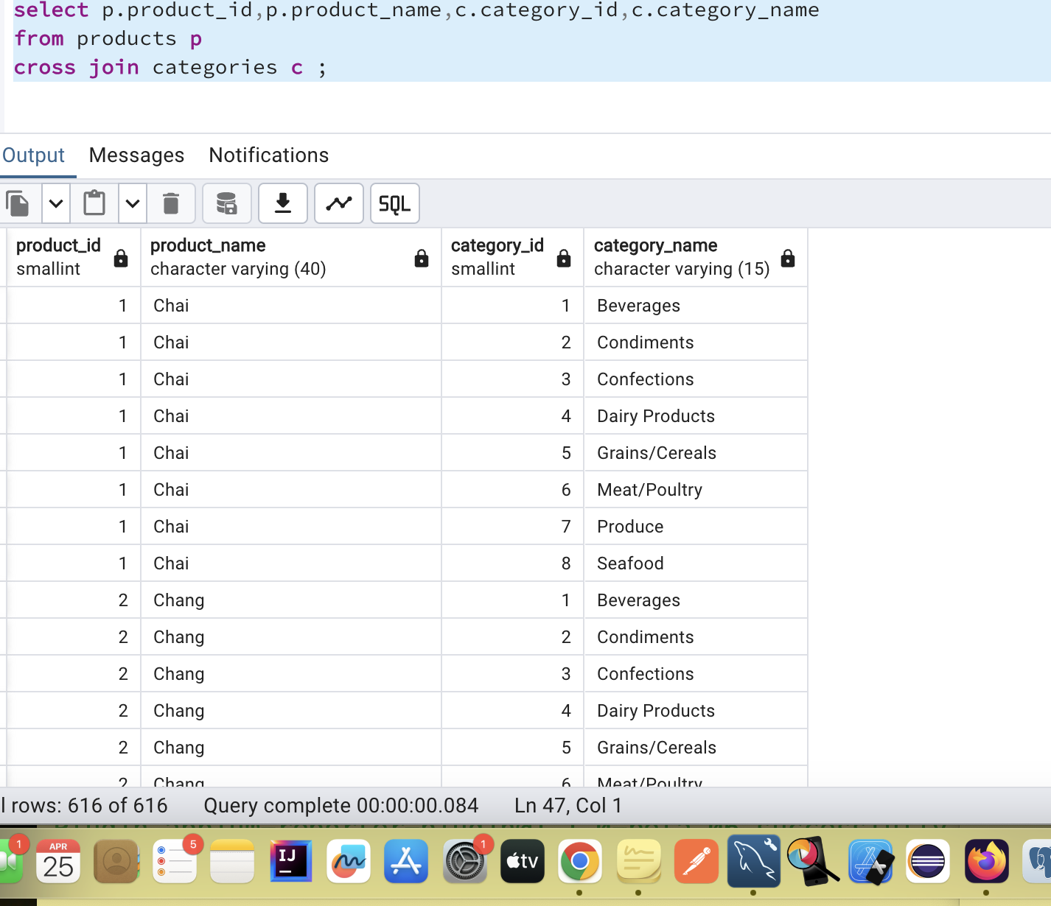

6. Show all employees who have the same manager(Self join)

select e.employee_id , e.first_name || '' || e.last_name as employeename,e.reports_to as manager

from employees e

join employees e1 on e.employee_id=e1.reports_to;

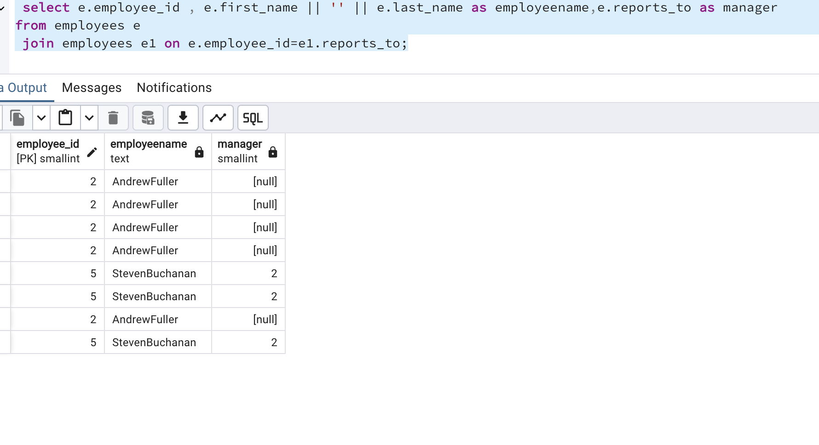

Another way –

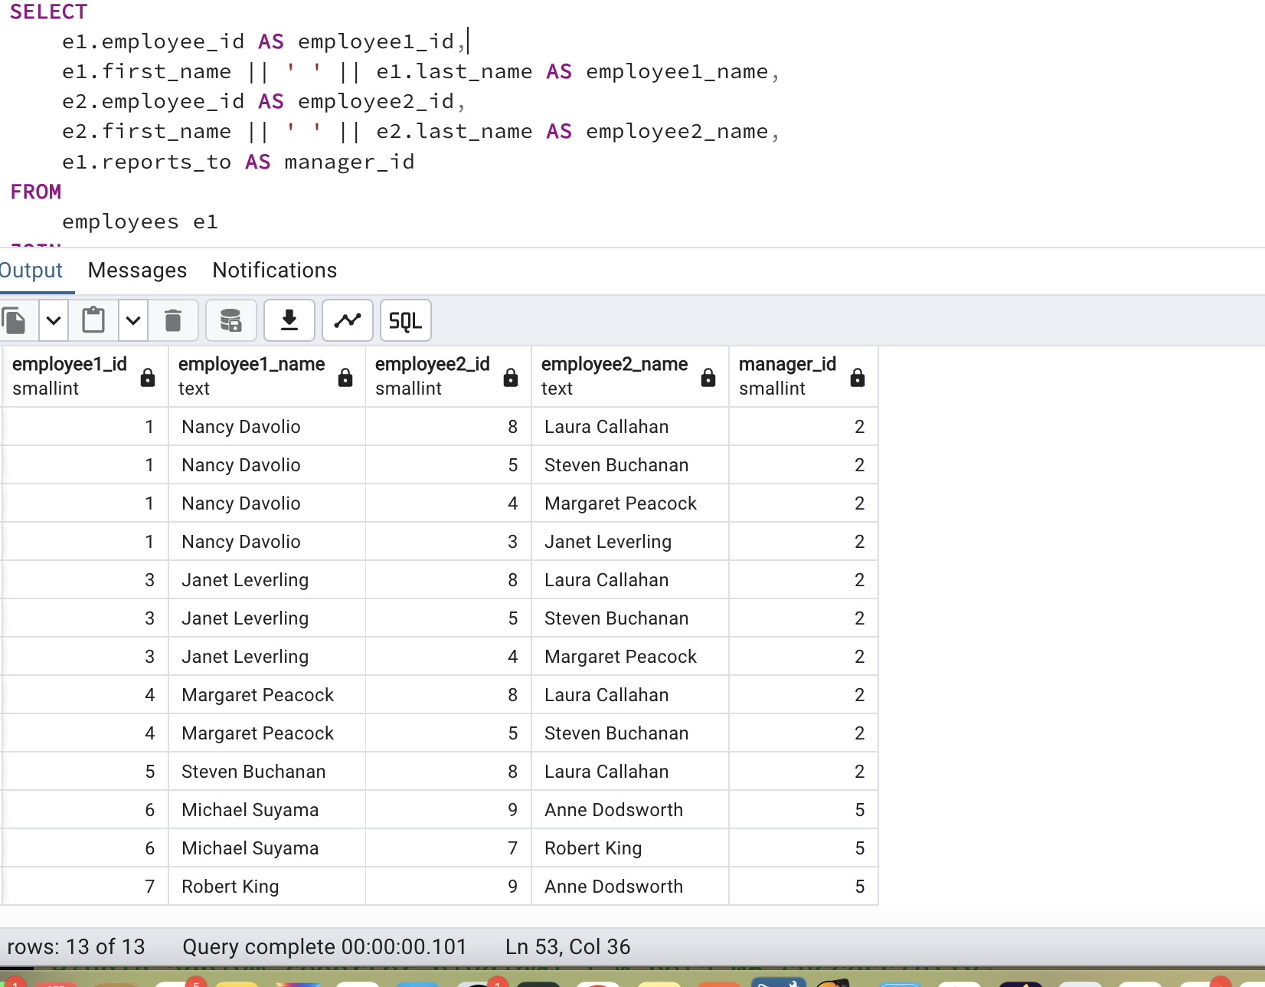

SELECT

e1.employee_id AS employee1_id,

e1.first_name || ' ' || e1.last_name AS employee1_name,

e2.employee_id AS employee2_id,

e2.first_name || ' ' || e2.last_name AS employee2_name,

e1.reports_to AS manager_id

FROM

employees e1

JOIN

employees e2 ON e1.reports_to = e2.reports_to

WHERE

e1.employee_id < e2.employee_id

AND e1.reports_to IS NOT NULL;

7. List all customers who have not selected a shipping method.

**Tables used:** customers, orders

**(Left Join, WHERE o.shipvia IS NULL)**

**select c.customer_id,c.company_name as customer,**

**o.order_id,o.customer_id,o.order_date**

**from customers c**

**left join orders o on c.customer_id=o.customer_id**

**where o.ship_via is null;**

