--1.List all customers and the products they ordered with the order date.

SELECT C.COMPANY_NAME AS CUSTOMER,

O.ORDER_ID,

P.PRODUCT_NAME,

OD.QUANTITY,

O.ORDER_DATE

FROM CUSTOMERS C

INNER JOIN ORDERS O ON C.CUSTOMER_ID = O.CUSTOMER_ID

INNER JOIN ORDER_DETAILS OD ON O.ORDER_ID = OD.ORDER_ID

INNER JOIN PRODUCTS P ON OD.PRODUCT_ID = P.PRODUCT_ID

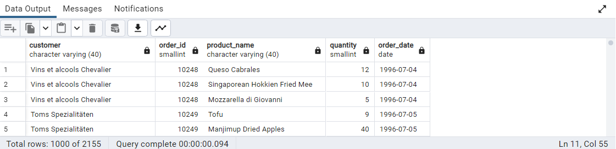

--2.Show each order with customer, employee, shipper, and product info — even if some parts are missing. (Left Join)

SELECT O.ORDER_ID,

C.CUSTOMER_ID,

E.EMPLOYEE_ID,

S.SHIPPER_ID,

P.PRODUCT_NAME

FROM ORDERS O

LEFT JOIN CUSTOMERS C ON O.CUSTOMER_ID = C.CUSTOMER_ID

LEFT JOIN EMPLOYEES E ON O.EMPLOYEE_ID = E.EMPLOYEE_ID

LEFT JOIN SHIPPERS S ON O.SHIP_VIA = S.SHIPPER_ID

LEFT JOIN ORDER_DETAILS OD ON O.ORDER_ID = OD.ORDER_ID

LEFT JOIN PRODUCTS P ON OD.PRODUCT_ID = P.PRODUCT_ID

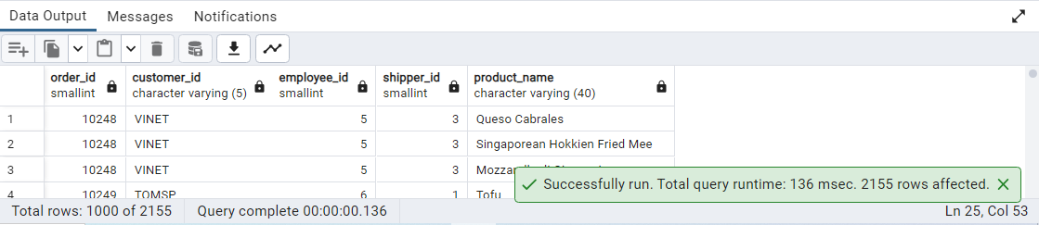

--3.Show all order details and products (include all products even if they were never ordered).

SELECT OD.ORDER_ID,

P.PRODUCT_ID,

OD.QUANTITY,

P.PRODUCT_NAME

FROM ORDER_DETAILS OD

RIGHT JOIN PRODUCTS P ON OD.PRODUCT_ID = P.PRODUCT_ID

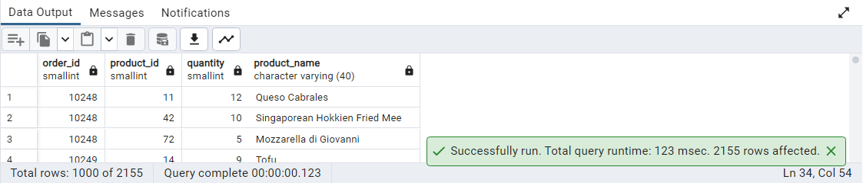

--4.List all product categories and their products — including categories that have no products, and products that are not assigned to any category

SELECT C.CATEGORY_NAME,

P.PRODUCT_NAME

FROM CATEGORIES C

FULL JOIN PRODUCTS P ON C.CATEGORY_ID = P.CATEGORY_ID

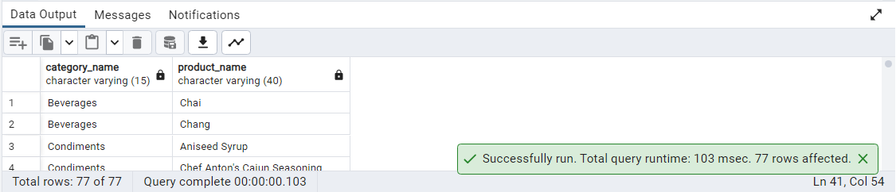

--5.Show all possible product and category combinations

SELECT C.CATEGORY_NAME,

P.PRODUCT_NAME

FROM PRODUCTS P

CROSS JOIN CATEGORIES C

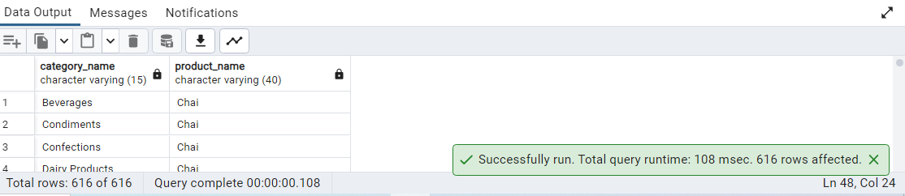

--6.Show all employees and their manager(Self join(left join))

SELECT E.FIRST_NAME || ' ' || E.LAST_NAME AS EMPLOYEES_FULL_NAME,

M.FIRST_NAME || ' ' || M.LAST_NAME AS MANAGER

FROM EMPLOYEES E

LEFT JOIN EMPLOYEES M ON E.EMPLOYEE_ID = M.REPORTS_TO

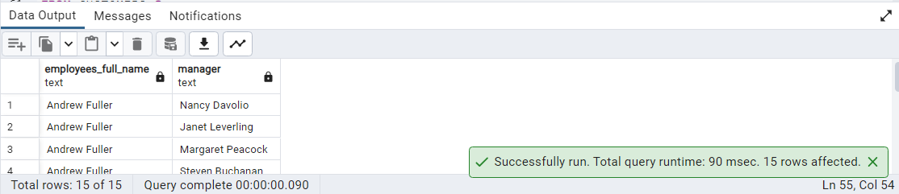

--7.List all customers who have not selected a shipping method.

SELECT C.CUSTOMER_ID,

O.SHIP_VIA

FROM CUSTOMERS C

LEFT JOIN ORDERS O ON C.CUSTOMER_ID = O.CUSTOMER_ID

WHERE O.SHIP_VIA IS NULL

