1. GROUP BY with WHERE - Orders by Year and Quarter

Display, order year, quarter, order count, avg freight cost only for those orders where freight cost > 100

select

extract (year from order_date) as order_year ,

extract (quarter from order_date) as order_quarter,

count (*) as order_count,

avg(freight) as avg_freight from orders

where freight > 100

group by

extract (year from order_date),

extract (quarter from order_date) ;

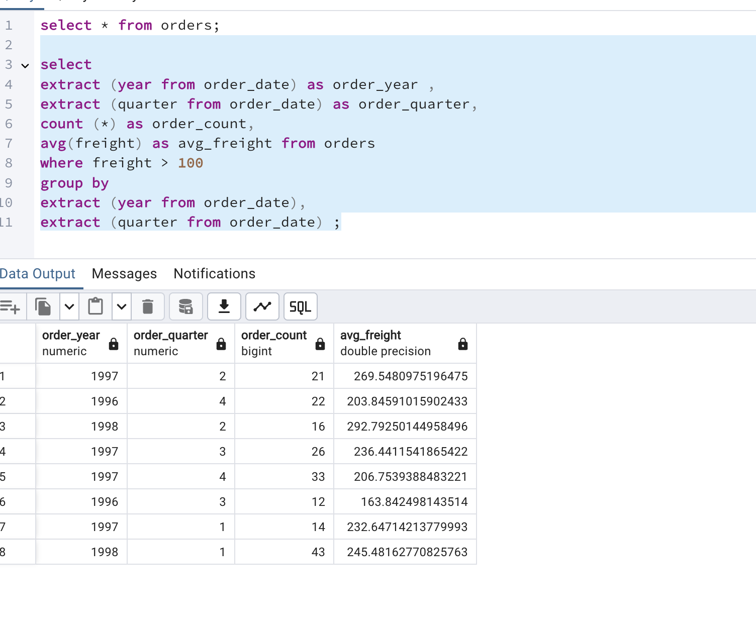

2. GROUP BY with HAVING - High Volume Ship Regions

Display, ship region, no of orders in each region, min and max freight cost  
 Filter regions where no of orders >= 5

select

ship_region,

count(*) as order_count,

min(freight) as minfreight,

max(freight) as maxfreight

from orders

group by ship_region

having count(*)>=5;

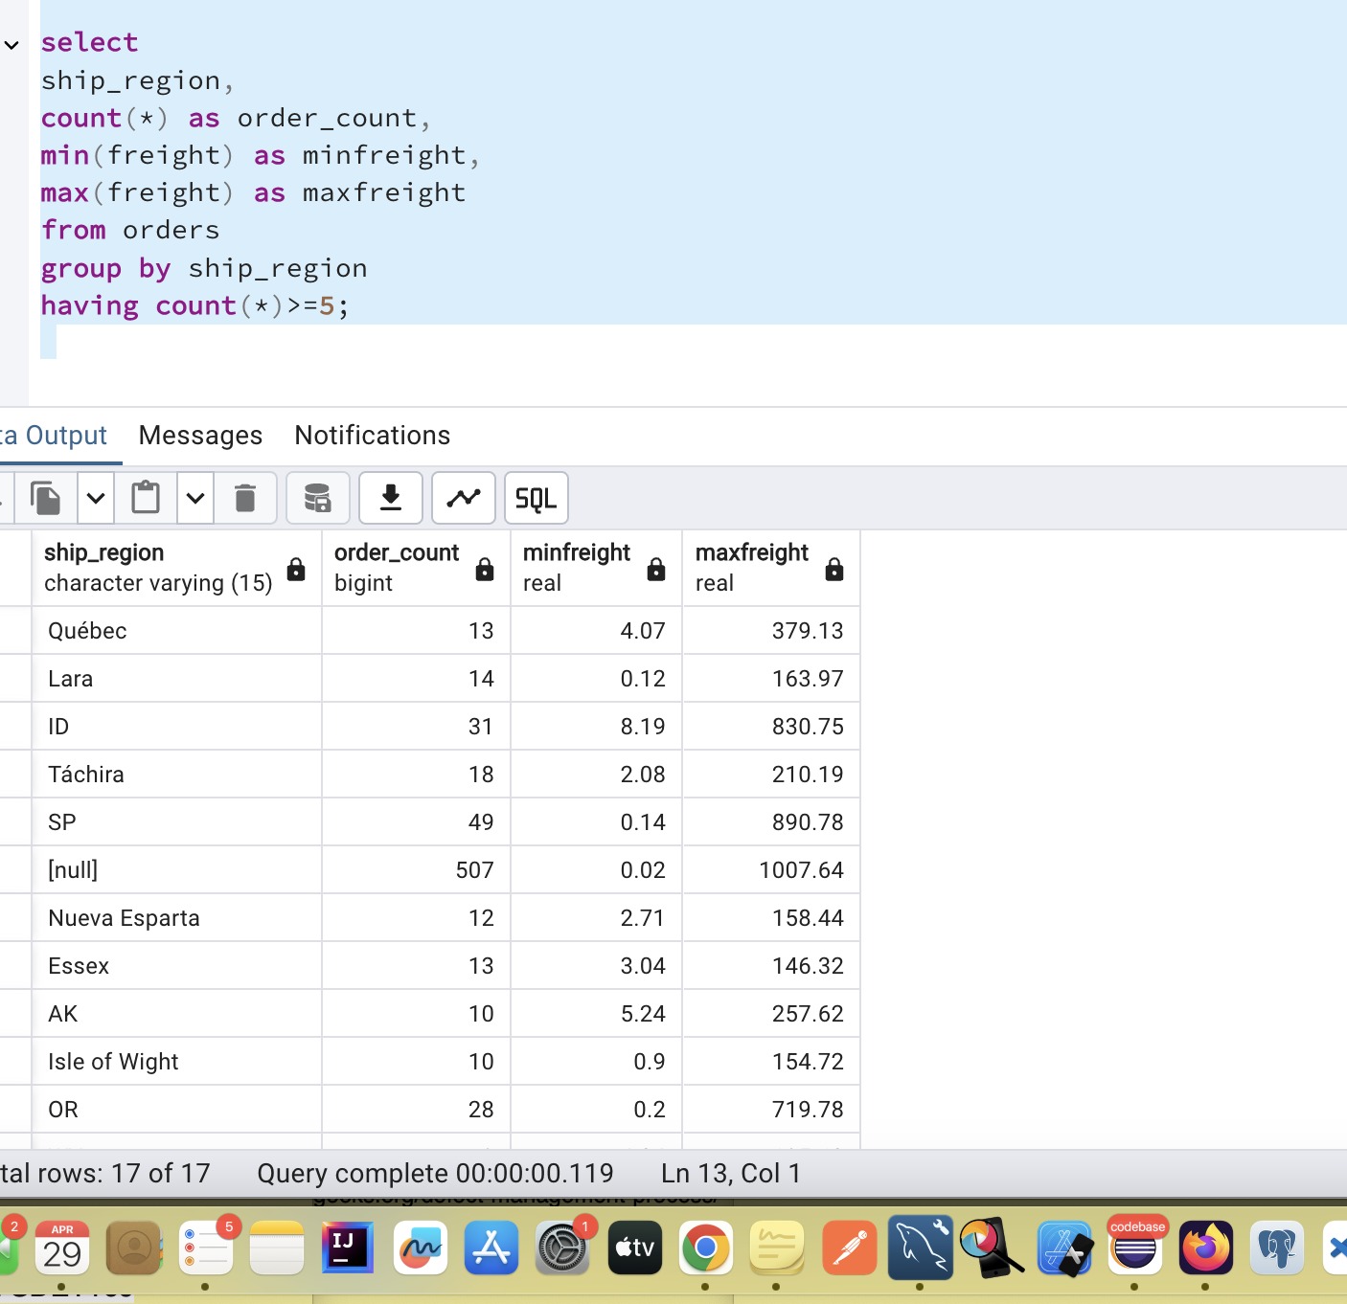

3. Get all title designations across employees and customers ( Try UNION & UNION ALL)

select contact_title as customer_designation from customers

union

select title as employee_designation from employees;

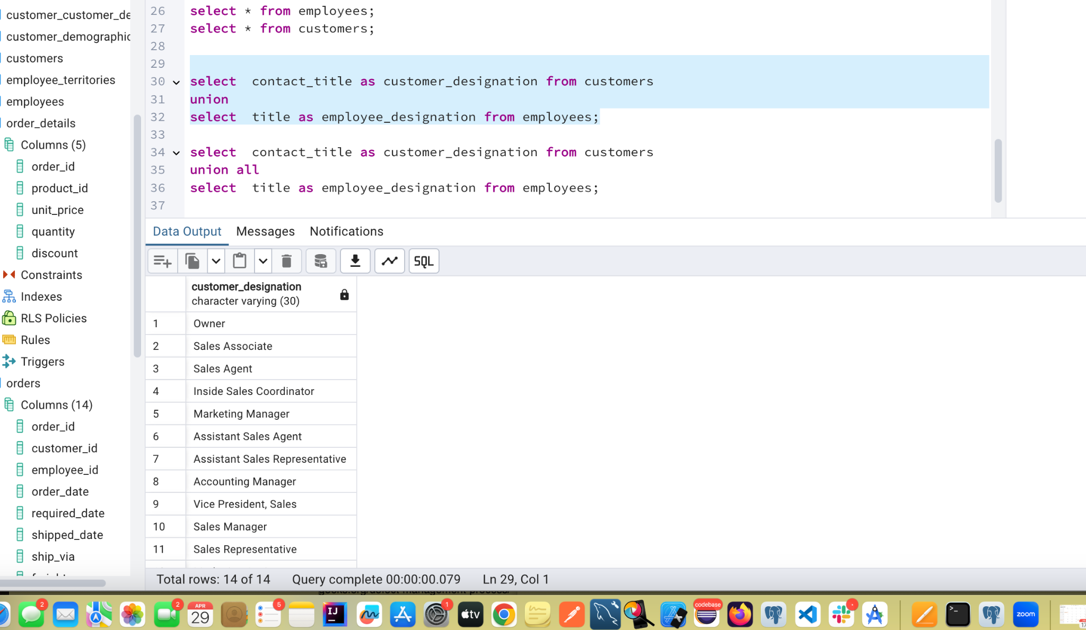

select contact_title as customer_designation from customers

union all

select title as employee_designation from employees;

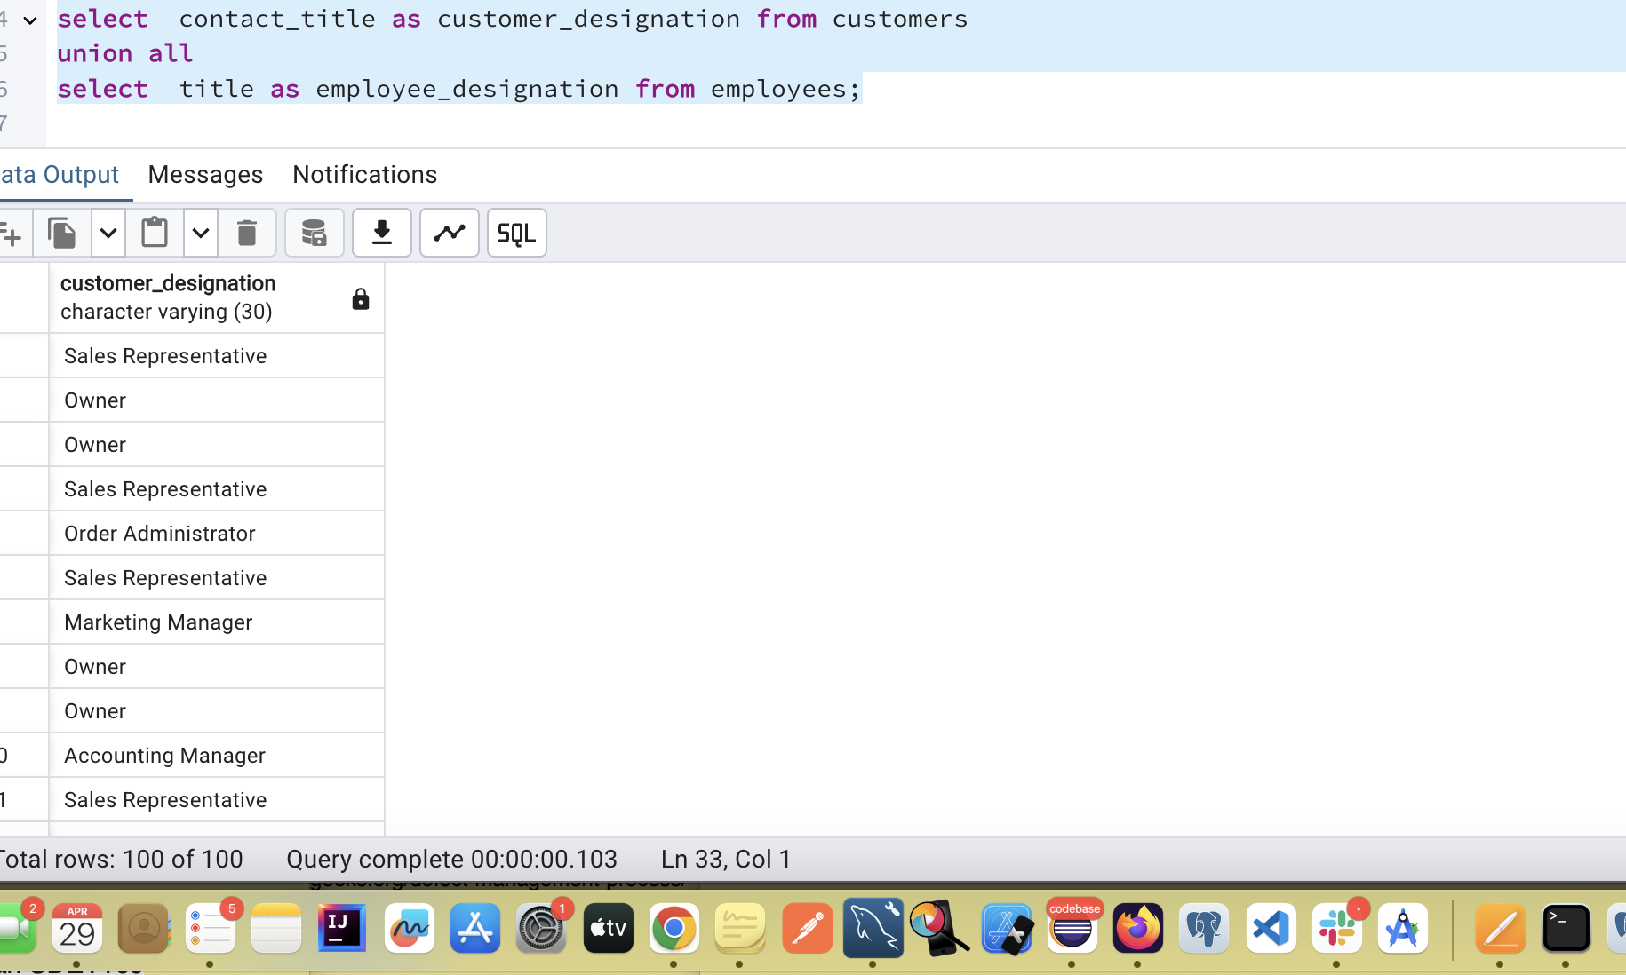

4. Find categories that have both discontinued and in-stock products

(Display category_id, instock means units_in_stock > 0, Intersect)

select category_id from products where discontinued=1

intersect

select category_id from products where units_in_stock >0;

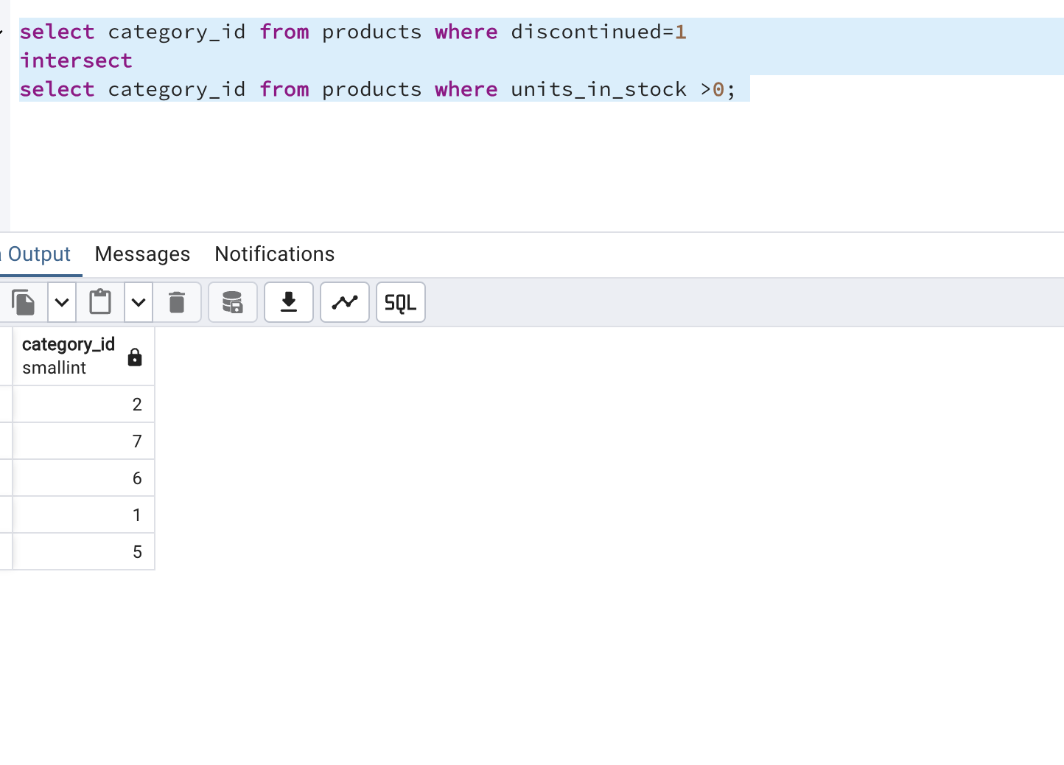

5. Find orders that have no discounted items (Display the order_id, EXCEPT)

select distinct order_id from order_details

except

select distinct order_id from order_details where discount <0;

