--1.GROUP BY with WHERE - Orders by Year and Quarter

--Display, order year, quarter, order count, avg freight cost only for those orders where freight cost > 100

SELECT EXTRACT (YEAR FROM ORDER_DATE) AS ORDER_YEAR,

EXTRACT (QUARTER FROM ORDER_DATE) AS QUARTER,

COUNT (*) AS ORDER_COUNT,

AVG (FREIGHT) AS AVG_FREIGHT_COST

FROM ORDERS

WHERE FREIGHT > 100

GROUP BY ORDER_YEAR,

QUARTER

ORDER BY ORDER_YEAR,

QUARTER

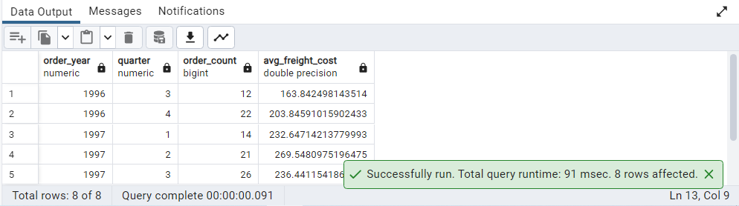

--2.GROUP BY with HAVING - High Volume Ship Regions

--Display, ship region, no of orders in each region, min and max freight cost Filter regions where no of orders >= 5

SELECT SHIP_REGION,

COUNT(*) AS NO_OF_ORDERS,

MIN (FREIGHT) AS MIN_FREIGHT_COST,

MAX (FREIGHT) AS MAX_FREIGHT_COST

FROM ORDERS

GROUP BY SHIP_REGION

HAVING COUNT(*) >= 5

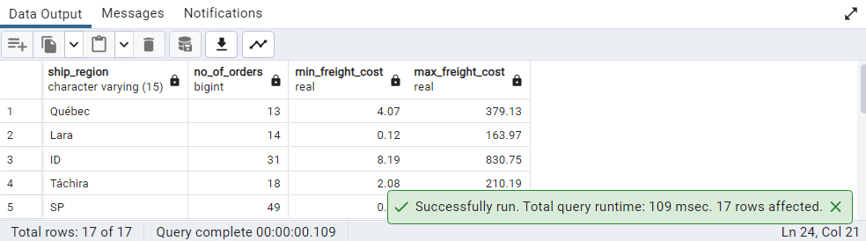

--3.Get all title designations across employees and customers ( Try UNION & UNION ALL)

--UNION

SELECT TITLE

FROM EMPLOYEES

UNION

SELECT CONTACT_TITLE

FROM CUSTOMERS

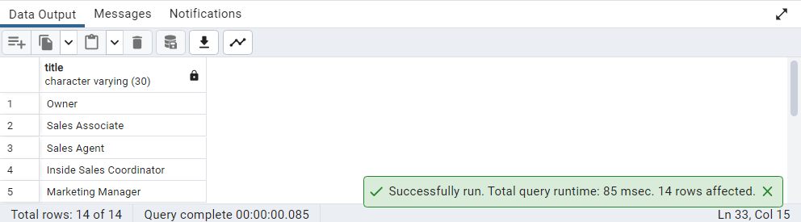

--UNION ALL

SELECT TITLE

FROM EMPLOYEES

UNION ALL

SELECT CONTACT_TITLE

FROM CUSTOMERS

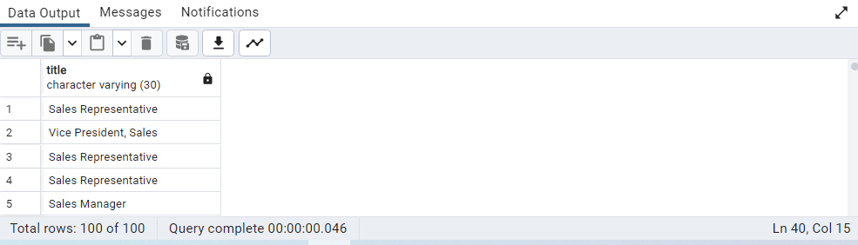

--4.Find categories that have both discontinued and in-stock products

--(Display category_id, instock means units_in_stock > 0, Intersect)

SELECT CATEGORY_ID,

UNITS_IN_STOCK AS IN_STOCK,

DISCONTINUED

FROM PRODUCTS

WHERE UNITS_IN_STOCK > 0 INTERSECT

SELECT CATEGORY_ID,

UNITS_IN_STOCK AS IN_STOCK,

DISCONTINUED

FROM PRODUCTS WHERE DISCONTINUED = 1

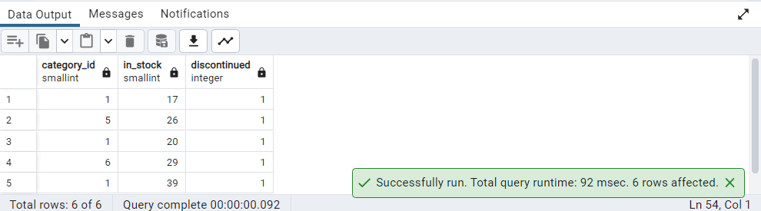

--5.Find orders that have no discounted items (Display the order_id, EXCEPT)

SELECT DISTINCT ORDER_ID

FROM ORDER_DETAILS

EXCEPT

SELECT DISTINCT ORDER_ID

FROM ORDER_DETAILS

WHERE DISCOUNT > 0

