**Day 6 SQL Bootcamp Assignment**

**1. Categorize products by stock status**

**Query:**

**SELECT product_name,**

**units_in_stock,**

**CASE**

**WHEN units_in_stock = 0 THEN 'Out of Stock'**

**WHEN units_in_stock < 20 THEN 'Low Stock'**

**ELSE 'In Stock'**

**END AS stock_status**

**FROM products;**

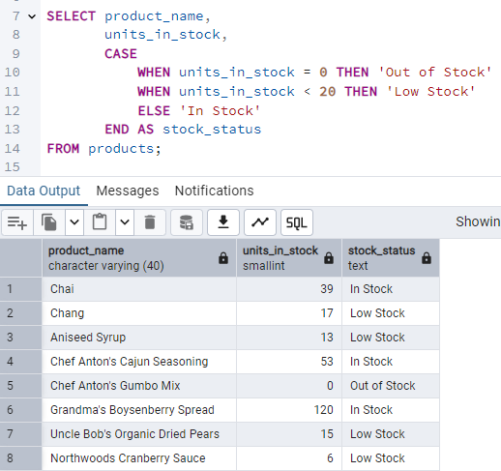

**2.** **Find All Products in Beverages Category**

**Query:**

**SELECT product_name, unit_price**

**FROM products**

**WHERE category_id = (**

**SELECT category_id**

**FROM categories**

**WHERE category_name = 'Drinks'**

**);**

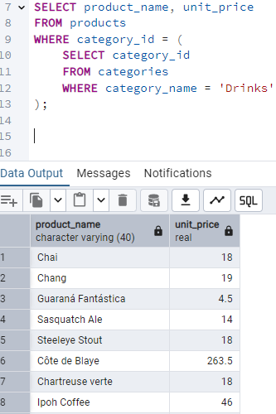

**3.Find Orders by Employee with Most Sales**

**Query:**

**SELECT order_id, order_date, freight, employee_id**

**FROM orders**

**WHERE employee_id = (**

**SELECT employee_id**

**FROM orders**

**GROUP BY employee_id**

**ORDER BY COUNT(order_id) DESC**

**LIMIT 1**

**);**

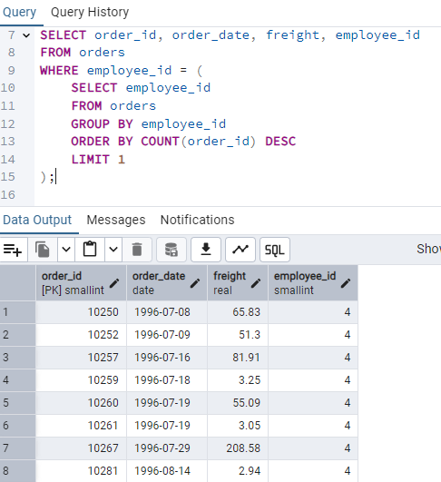

**4.Find orders where for country!= ‘USA’ with freight costs higher than any order from USA. (Subquery, Try with ANY, ALL operators)**

**Query:**

**SELECT order_id, order_date, freight, ship_country**

**FROM orders**

**WHERE ship_country != 'USA'**

**AND freight > ANY (**

**SELECT freight**

**FROM orders**

**WHERE ship_country = 'USA'**

**);**

