1. Categorize products by stock status

(Display product_name, a new column stock_status whose values are based on below condition

units_in_stock = 0 is 'Out of Stock'

units_in_stock < 20 is 'Low Stock')

Select product_name, product_id,unit_price,units_in_stock,

case

when units_in_stock =0 then 'outofstock'

when units_in_stock <20 then 'Low stock'

end as stock_status

From products;

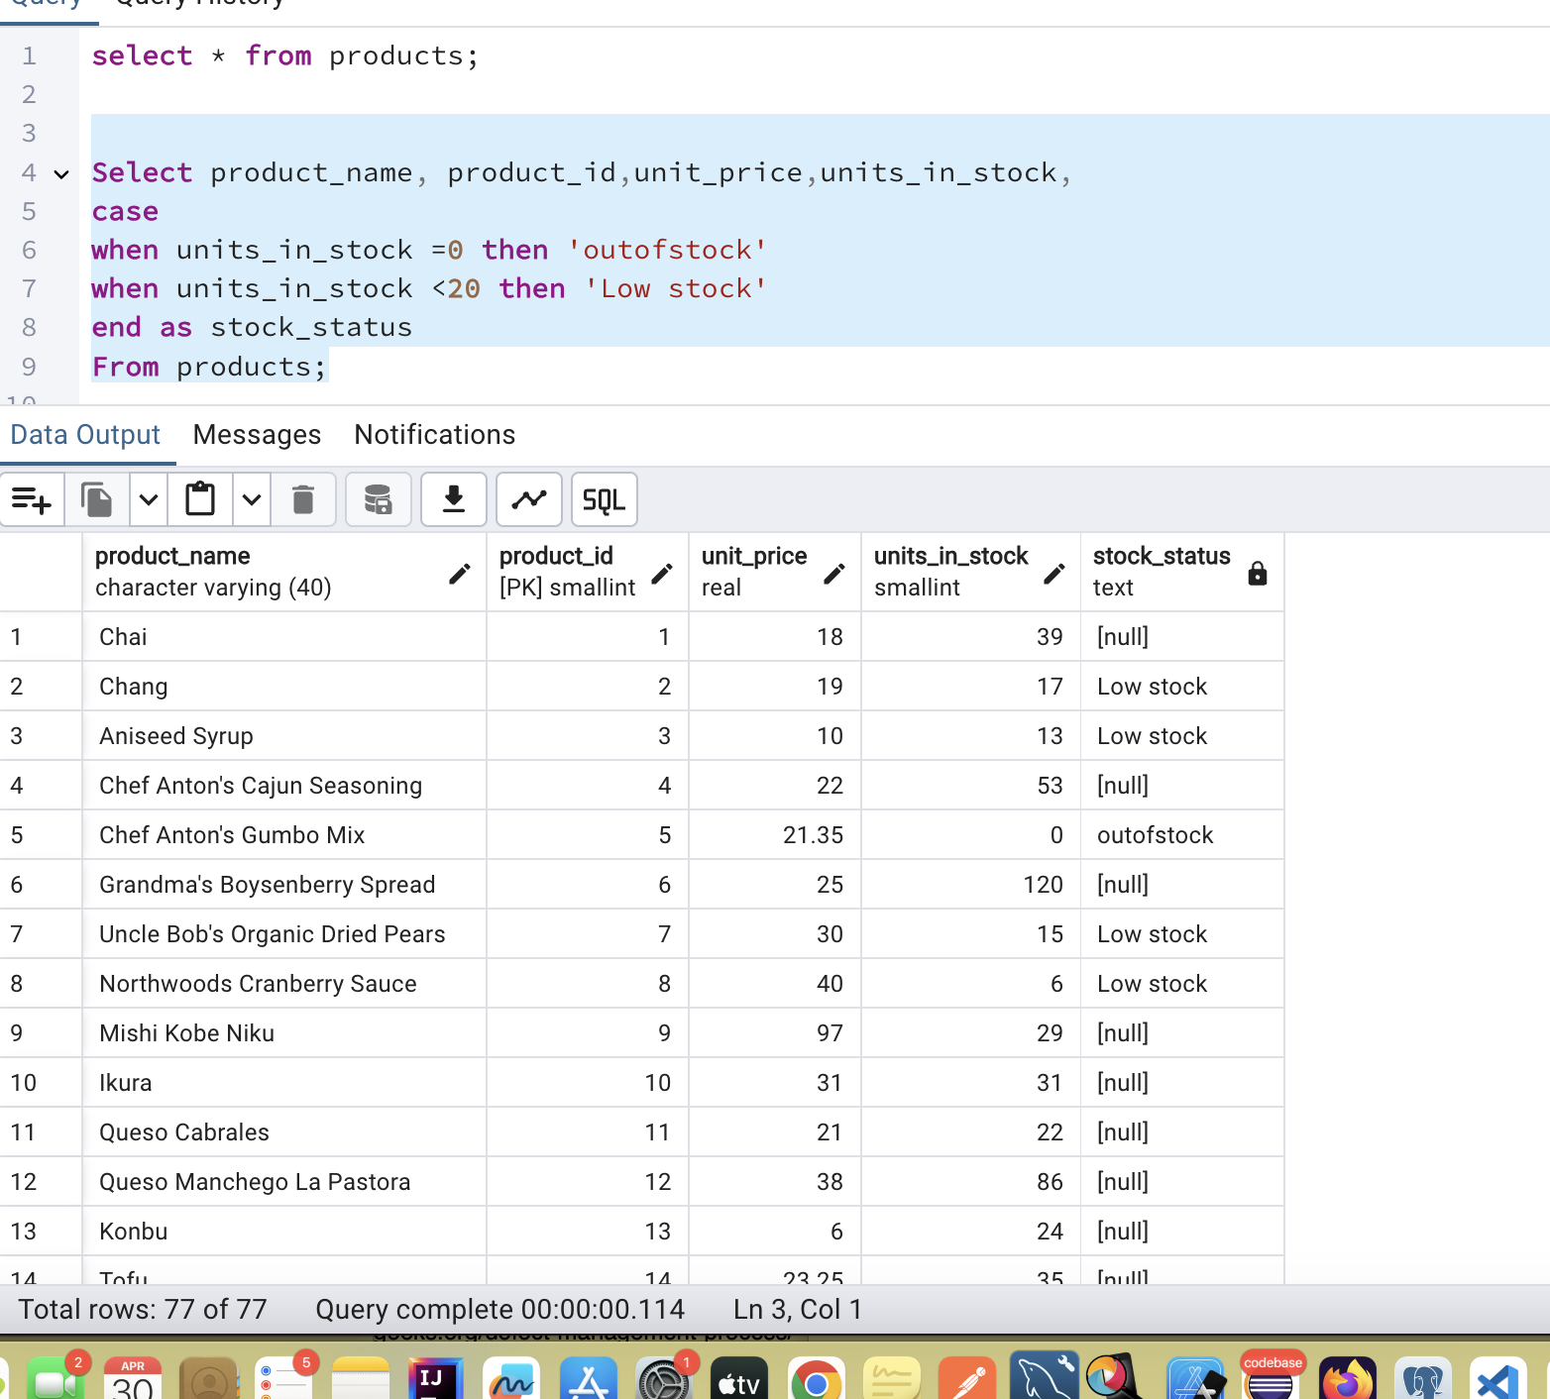

2. Find All Products in Beverages Category

(Subquery, Display product_name,unitprice)

Select product_id,product_name,category_id,unit_price

from products

where

category_id=(select category_id from categories where category_name= 'Beverages');

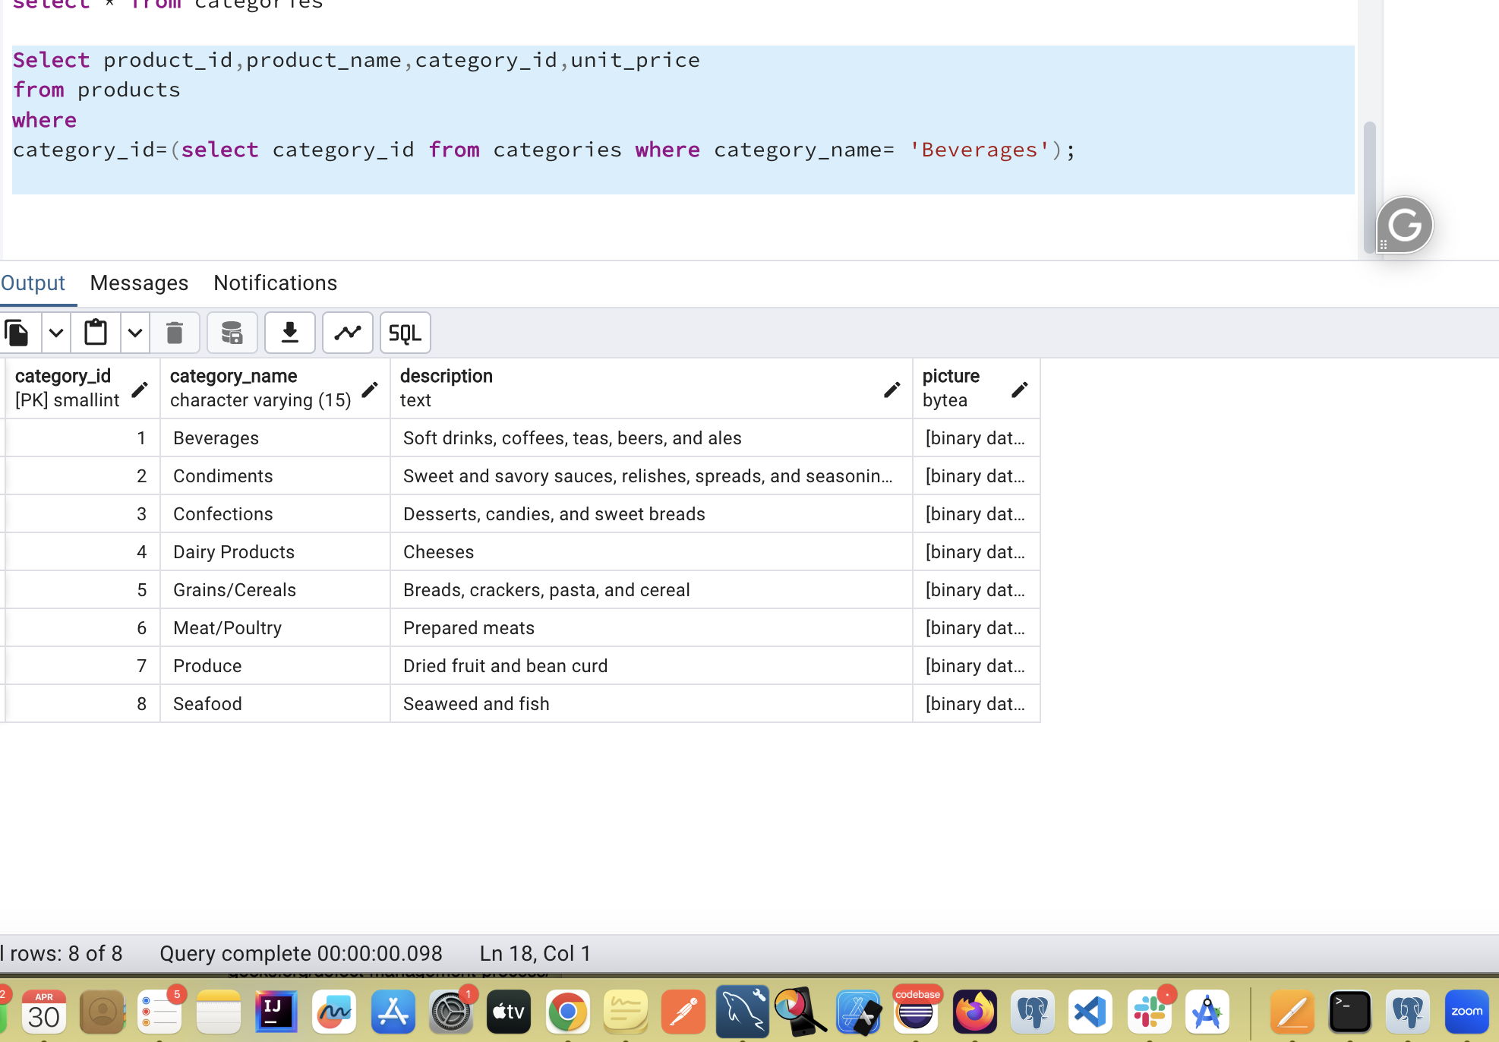

3. Find Orders by Employee with Most Sales

(Display order_id, order_date, freight, employee_id.

Employee with Most Sales=Get the total no.of of orders for each employee then order by DESC and limit 1. Use Subquery)

select order_id, order_date,freight, employee_id

from orders

where employee_id=(select employee_id from orders

Group by employee_id

order by count(order_id) desc

limit 1);

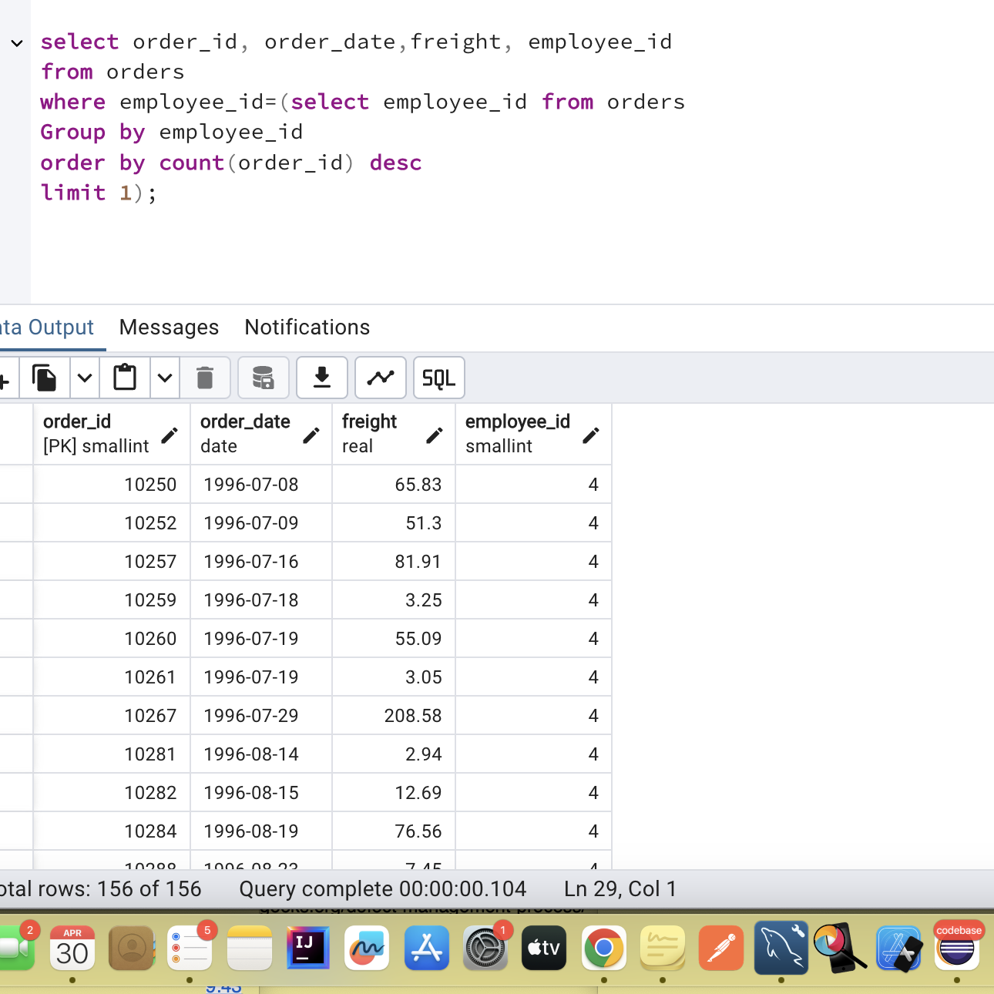

4. Find orders where for country!= ‘USA’ with freight costs higher than any order from USA. (Subquery, Try with ANY, ALL operators)

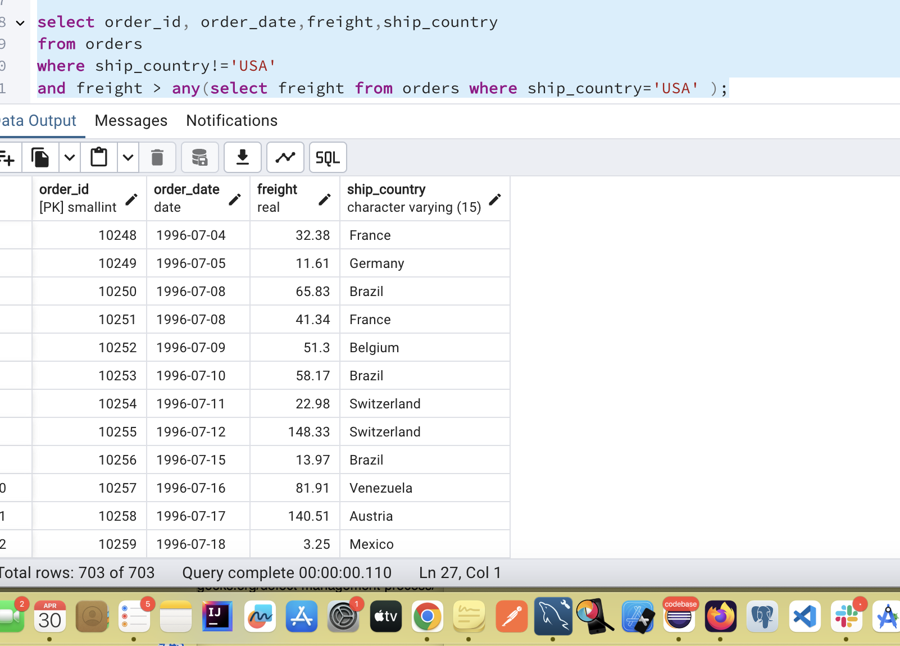

select order_id, order_date,freight,ship_country

from orders

where ship_country!='USA'

and freight > all(select freight from orders where ship_country='USA' );

