--1.Categorize products by stock status

--(Display product_name, a new column stock_status whose values are based on below condition

--units_in_stock = 0 is 'Out of Stock', units_in_stock < 20 is 'Low Stock')

SELECT PRODUCT_NAME,

UNITS_IN_STOCK,

CASE

WHEN UNITS_IN_STOCK = 0 THEN 'Out of Stock'

WHEN UNITS_IN_STOCK < 20 THEN 'Low Stock'

ELSE 'High Stock'

END AS STOCK_STATUS

FROM PRODUCTS

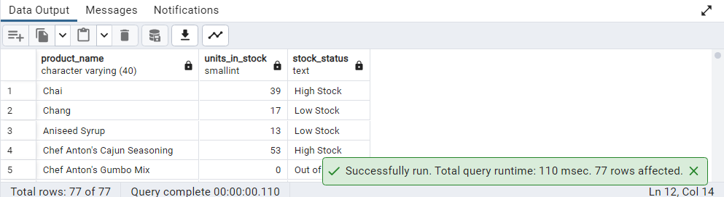

--2.Find All Products in Beverages Category

--(Subquery, Display product_name,unitprice)

SELECT PRODUCT_NAME,

UNIT_PRICE

FROM PRODUCTS

WHERE CATEGORY_ID =

(SELECT CATEGORY_ID

FROM CATEGORIES

WHERE CATEGORY_NAME = 'Beverages')

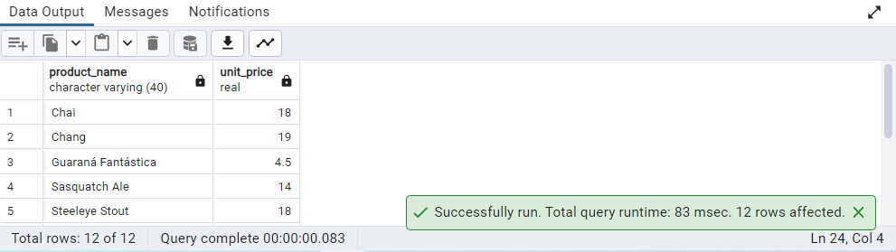

--3.Find Orders by Employee with Most Sales

--(Display order_id, order_date, freight, employee_id. Employee with Most Sales=Get the

--total no.of of orders for each employee then order by DESC and limit 1. Use Subquery)

SELECT ORDER_ID,

ORDER_DATE,

FREIGHT,

EMPLOYEE_ID

FROM ORDERS

WHERE EMPLOYEE_ID =

(SELECT EMPLOYEE_ID

FROM ORDERS

GROUP BY EMPLOYEE_ID

ORDER BY COUNT (*) DESC

LIMIT 1)

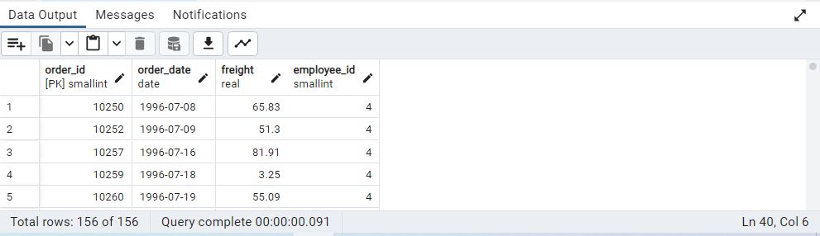

--4.Find orders where for country != ‘USA’ with freight costs higher than any order from USA.

--(Subquery, Try with ANY, ALL operators)

--ANY

SELECT ORDER_ID

FROM ORDERS

WHERE SHIP_COUNTRY != 'USA'

AND FREIGHT > ANY

(SELECT FREIGHT

FROM ORDERS

WHERE SHIP_COUNTRY = 'USA')

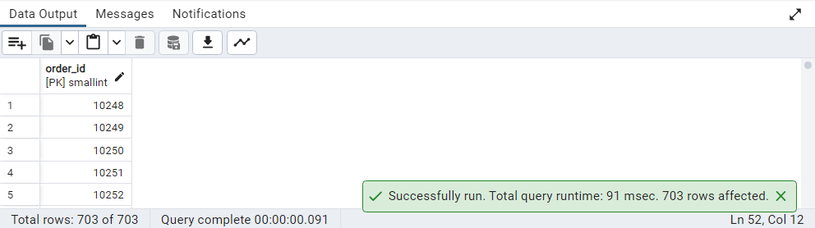

--Sub Query

SELECT ORDER_ID

FROM ORDERS

WHERE SHIP_COUNTRY != 'USA'

AND FREIGHT >

(SELECT MIN(FREIGHT)

FROM ORDERS

WHERE SHIP_COUNTRY = 'USA')

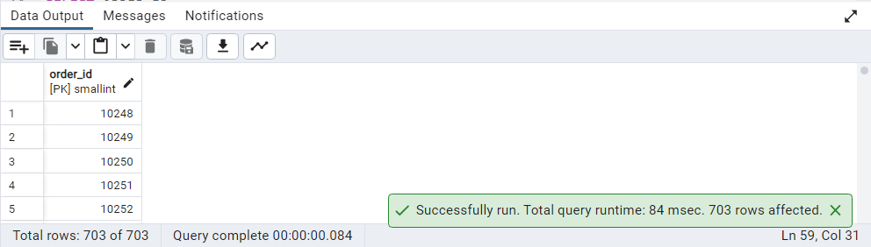

--ALL

SELECT ORDER_ID

FROM ORDERS

WHERE SHIP_COUNTRY != 'USA'

AND FREIGHT > ALL

(SELECT FREIGHT

FROM ORDERS

WHERE SHIP_COUNTRY = 'USA')

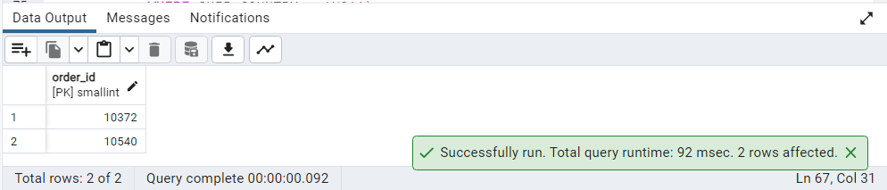

--Sub Query

SELECT ORDER_ID

FROM ORDERS

WHERE SHIP_COUNTRY != 'USA'

AND FREIGHT >

(SELECT MAX(FREIGHT)

FROM ORDERS

WHERE SHIP_COUNTRY = 'USA')

