**Day 7 SQL Bootcamp Assignment**

**1.** **Rank employees by their total sales**

**(Total sales = Total no of orders handled, JOIN employees and orders table)**

**QUERY**

**SELECT e.employee_id, e.first_name || ' ' || e.last_name AS employee_name, COUNT(o.order_id) AS total_sales,**

**RANK() OVER (ORDER BY COUNT(o.order_id) DESC) AS sales_rank**

**FROM employees e**

**JOIN orders o ON e.employee_id = o.employee_id**

**GROUP BY e.employee_id, employee_name**

**ORDER BY total_sales;**

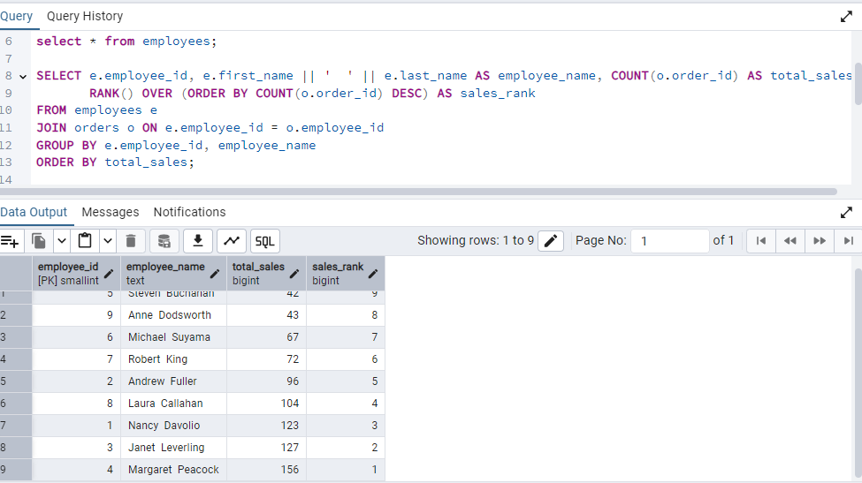

**2. Compare current order's freight with previous and next order for each customer.**

**(Display order_id, customer_id, order_date, freight,**

**Use lead(freight) and lag(freight).**

**QUERY**

**SELECT order_id, customer_id, order_date, freight,**

**LAG(freight) OVER (PARTITION BY customer_id ORDER BY order_date) AS previous_freight,**

**LEAD(freight) OVER (PARTITION BY customer_id ORDER BY order_date) AS next_freight**

**FROM orders**

**ORDER BY customer_id, order_date;**

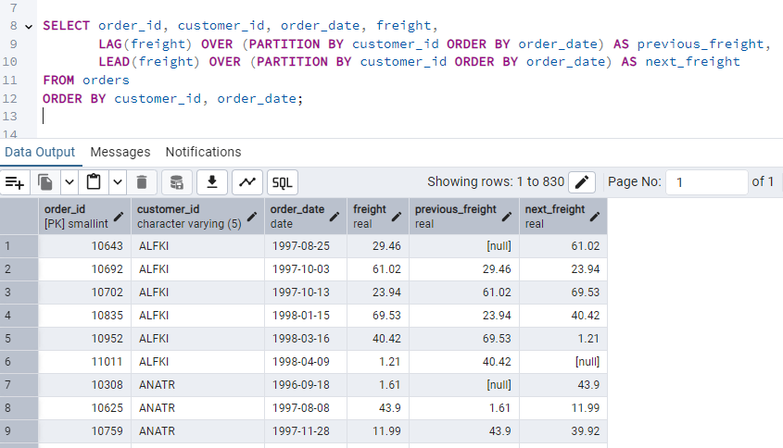

**3. Show products and their price categories, product count in each category, avg price:**

**(HINT:**

**· Create a CTE which should have price_category definition:**

**WHEN unit_price < 20 THEN 'Low Price'**

**WHEN unit_price < 50 THEN 'Medium Price'**

**ELSE 'High Price'**

**· In the main query display: price_category, product_count in each price_category, ROUND(AVG(unit_price)::numeric, 2) as avg_price)**

**QUERY**

**WITH price_cte AS (**

**SELECT product_id, product_name, unit_price,**

**CASE**

**WHEN unit_price < 20 THEN 'Low Price'**

**WHEN unit_price < 50 THEN 'Medium Price'**

**ELSE 'High Price'**

**END AS price_category**

**FROM products**

**)**

**SELECT price_category,**

**COUNT(*) AS product_count,**

**ROUND(AVG(unit_price)::numeric, 2) AS avg_price**

**FROM price_cte**

**GROUP BY price_category**

**ORDER BY avg_price;**

