1. Rank employees by their total sales

(Total sales = Total no of orders handled, JOIN employees and orders table)

select e.employee_id, e.first_name || '' || e.last_name as employeename,

count (o.order_id) as ordersplaced,

rank() over(order by count(o.order_id)desc) as TotalSales

from employees e

inner join orders o

on e.employee_id=o.employee_id

group by e.employee_id, e.first_name,e.last_name

order by TotalSales desc;

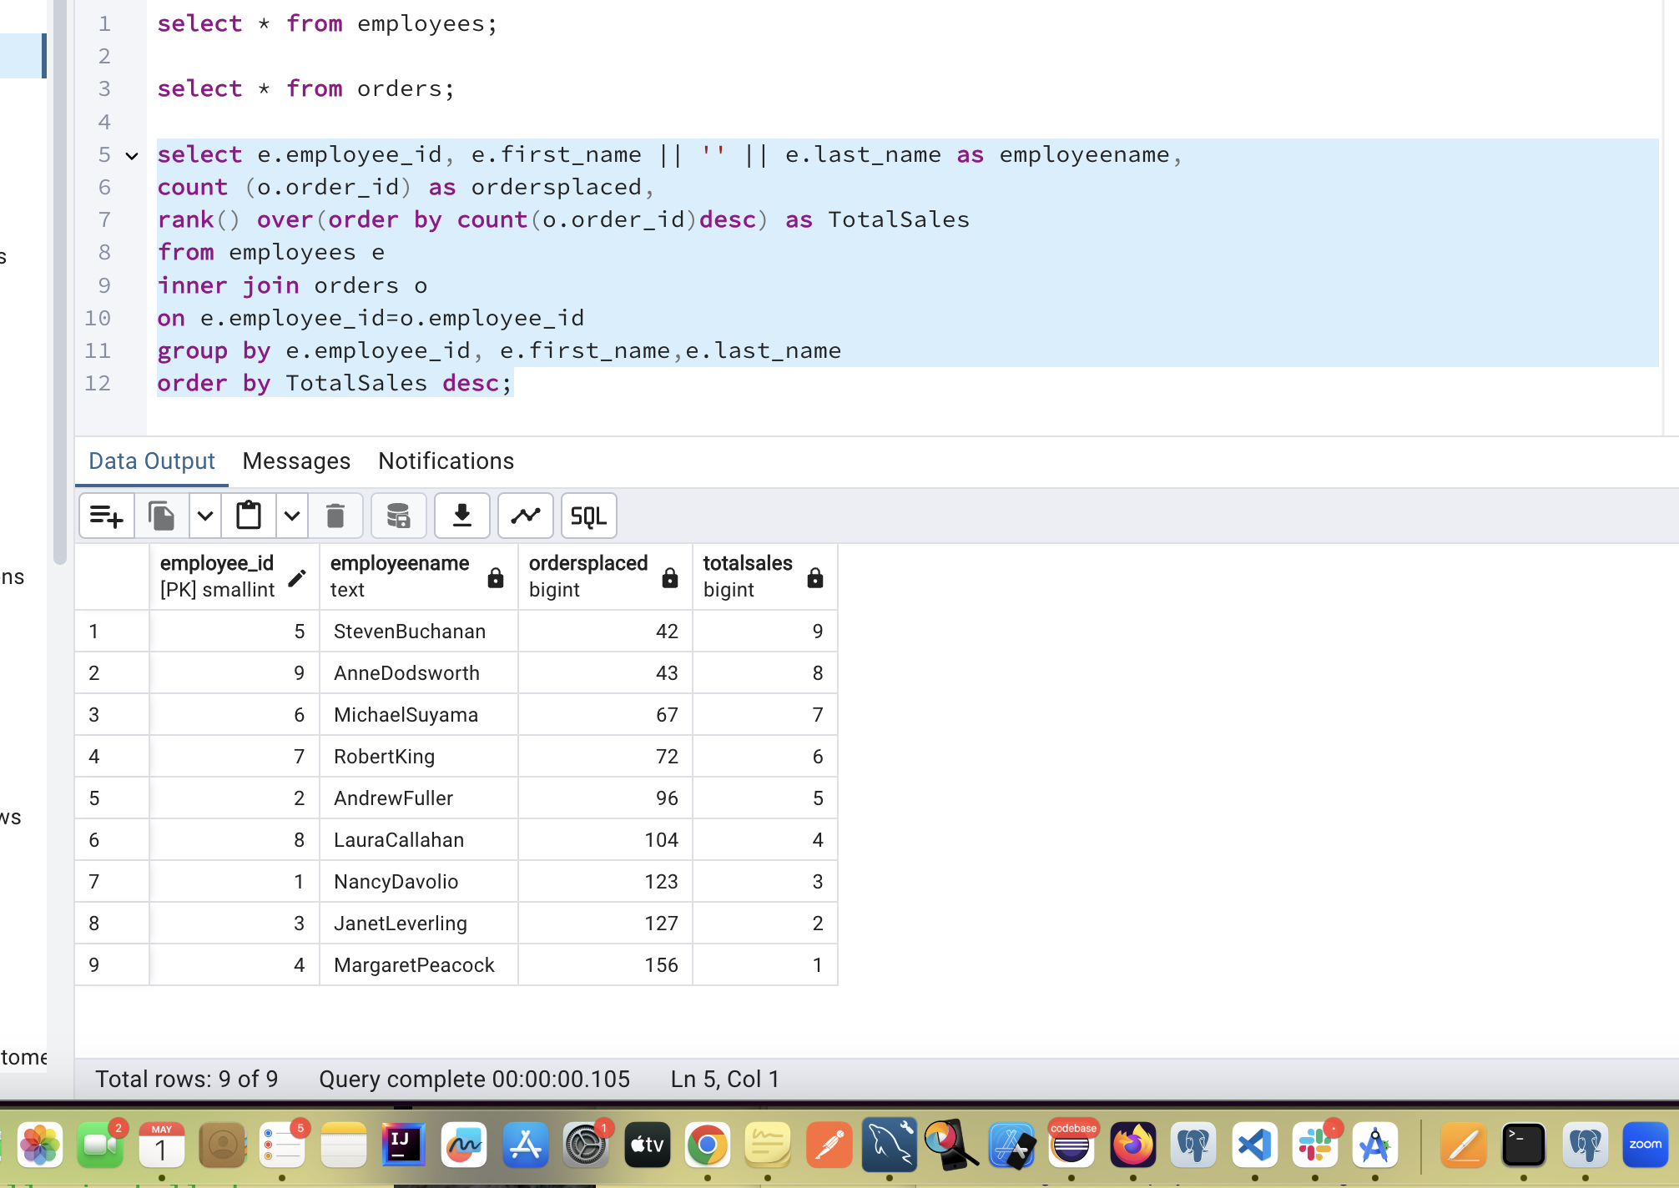

2. Compare current order's freight with previous and next order for each customer.

(Display order_id, customer_id, order_date, freight,

Use lead(freight) and lag(freight).

Select order_id,customer_id,order_date,freight,

lag(freight) over (partition by customer_id order by order_date) as previous_freight ,

LEAD(freight) OVER (PARTITION BY customer_id ORDER BY order_date) AS next_freight

from

orders;

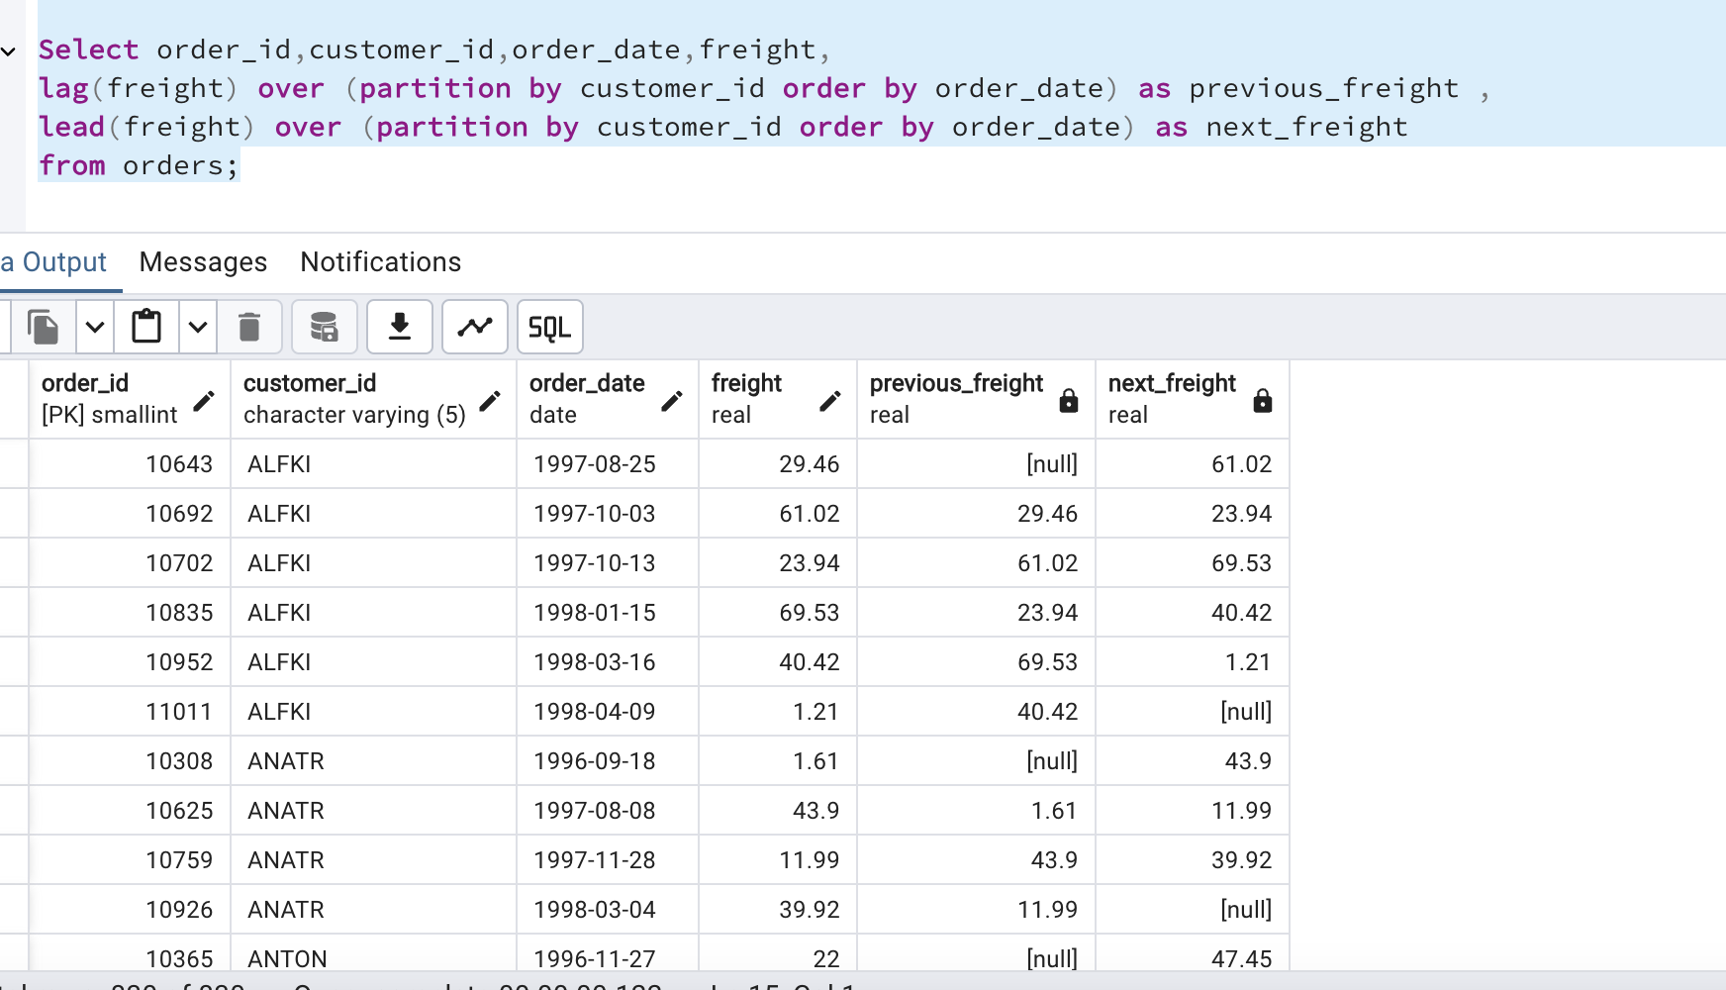

3. Show products and their price categories, product count in each category, avg price:

(HINT:

· Create a CTE which should have price_category definition:

WHEN unit_price < 20 THEN 'Low Price'

WHEN unit_price < 50 THEN 'Medium Price'

ELSE 'High Price'

· In the main query display: price_category, product_count in each price_category, ROUND(AVG(unit_price)::numeric, 2) as avg_price)

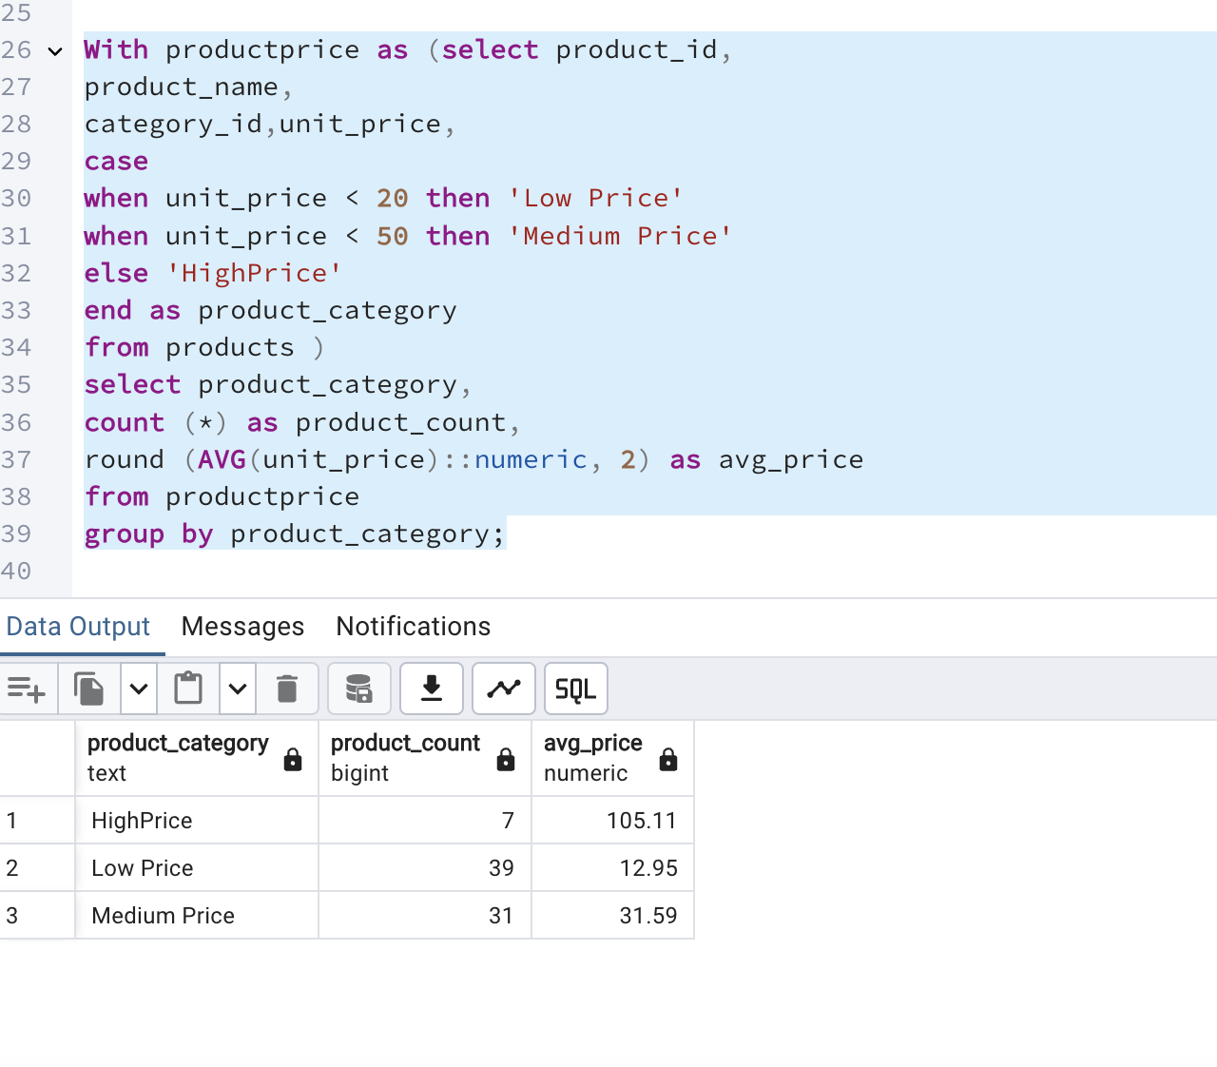

With productprice as (select product_id,

product_name,

category_id,unit_price,

case

when unit_price < 20 then 'Low Price'

when unit_price < 50 then 'Medium Price'

else 'HighPrice'

end as product_category

from products )

select product_category,

count (*) as product_count,

round (AVG(unit_price)::numeric, 2) as avg_price

from productprice

group by product_category;