--1.Rank employees by their total sales

--(Total sales = Total no of orders handled, JOIN employees and orders table)

SELECT E.EMPLOYEE_ID,

E.FIRST_NAME || ' ' || E.LAST_NAME AS EMPLOYEE_NAME,

COUNT (O.ORDER_ID) AS NUMBER_OF_ORDERS,

RANK() OVER (ORDER BY COUNT (O.ORDER_ID) DESC)

AS EMPLOYEE_RANK

FROM ORDERS O

JOIN EMPLOYEES E ON O.EMPLOYEE_ID = E.EMPLOYEE_ID

GROUP BY E.EMPLOYEE_ID

ORDER BY EMPLOYEE_RANK;

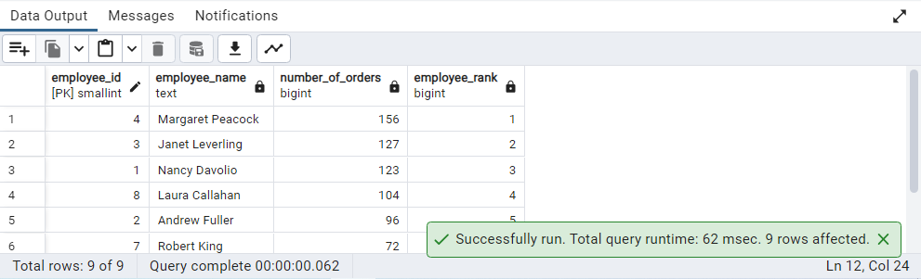

--2.Compare current order's freight with previous and next order for each customer.

--(Display order_id, customer_id, order_date, freight, Use lead(freight) and lag(freight).

--Lag()

SELECT ORDER_ID,

CUSTOMER_ID,

ORDER_DATE,

FREIGHT,

LAG (FREIGHT, 1, FREIGHT)

OVER (PARTITION BY CUSTOMER_ID ORDER BY ORDER_DATE) AS PREVIOUS_FREIGHT,

FREIGHT - LAG (FREIGHT, 1, FREIGHT)

OVER (PARTITION BY CUSTOMER_ID ORDER BY ORDER_DATE) AS FREIGHT_DIFF

FROM ORDERS

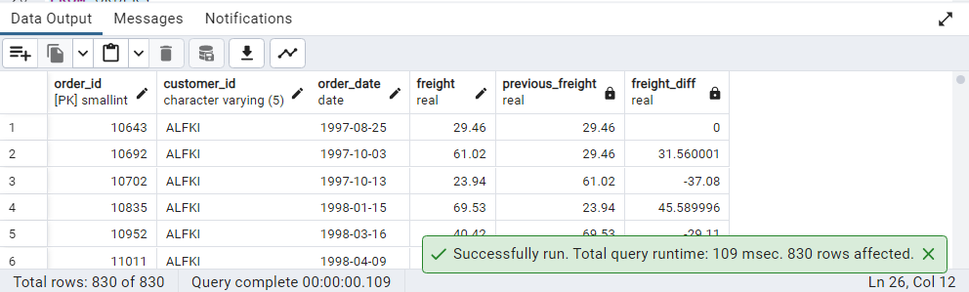

--Lead()

SELECT ORDER_ID,

CUSTOMER_ID,

ORDER_DATE,

FREIGHT,

LEAD (FREIGHT, 1, FREIGHT)

OVER (PARTITION BY CUSTOMER_ID ORDER BY ORDER_DATE) AS NEXT_FREIGHT,

FREIGHT - LEAD (FREIGHT, 1, FREIGHT)

OVER (PARTITION BY CUSTOMER_ID ORDER BY ORDER_DATE) AS FREIGHT_DIFF

FROM ORDERS

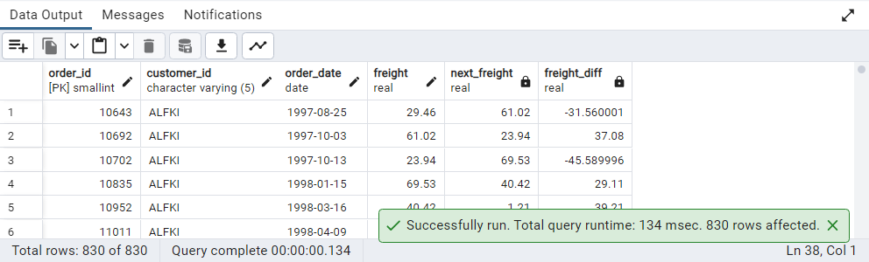

--3.Show products and their price categories, product count in each category, avg price:

-- (HINT: Create a CTE which should have price_category definition:

--WHEN unit_price < 20 THEN 'Low Price'

--WHEN unit_price < 50 THEN 'Medium Price'

--ELSE 'High Price'

--In the main query display: price_category, product_count in each price_category,

--ROUND(AVG(unit_price)::numeric, 2) as avg_price)

WITH price_category_cte AS (

SELECT product_id, unit_price,

CASE

WHEN unit_price < 20 THEN 'Low Price'

WHEN unit_price <50 THEN 'Medium Price'

ELSE

'High Price'

END AS price_category

FROM products

)

SELECT price_category, COUNT (product_id) AS product_count,

ROUND (AVG (unit_price) :: numeric, 2) AS avg_price

FROM price_category_cte

GROUP BY price_category

