**Day 8 SQL Bootcamp Assignment**

**1. Create view vw_updatable_products (use same query whatever I used in the training)**

**Try updating view with below query and see if the product table also gets updated.**

**Update query:**

**UPDATE updatable_products SET unit_price = unit_price * 1.1 WHERE units_in_stock < 10;**

**QUERY**

**CREATE VIEW vw_updatable_products AS**

**SELECT product_id, product_name, unit_price, units_in_stock**

**FROM products**

**WHERE units_in_stock < 10;**

**UPDATE products**

**SET unit_price = unit_price * 1.1**

**WHERE units_in_stock < 10;**

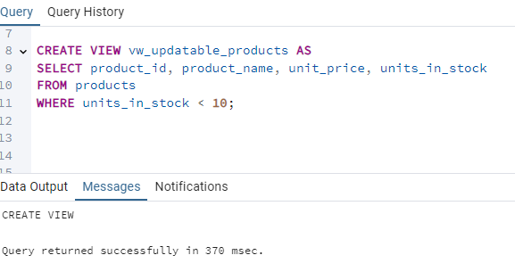

**2. Transaction:**

**Update the product price for products by 10% in category id=1**

**Try COMMIT and ROLLBACK and observe what happens.**

**QUERY**

**BEGIN TRANSACTION;**

**UPDATE products**

**SET unit_price = unit_price * 1.1**

**WHERE category_id = 1;**

**-- Check the updated data before committing**

**SELECT * FROM products WHERE category_id = 1;**

**COMMIT;**

**ROLLBACK;**

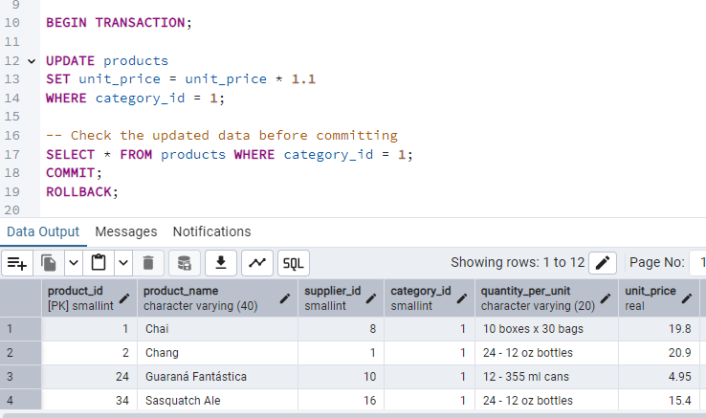

**3. Create a regular view which will have below details (Need to do joins):**

**Employee_id,**

**Employee_full_name,**

**Title,**

**Territory_id,**

**territory_description,**

**region_description**

**QUERY**

**CREATE VIEW vw_employee_territories AS**

**SELECT e.employee_id,**

**CONCAT(e.first_name, ' ', e.last_name) AS employee_full_name,**

**e.title,**

**t.territory_id,**

**t.territory_description,**

**r.region_description**

**FROM employees e**

**JOIN employee_territories et ON e.employee_id = et.employee_id**

**JOIN territories t ON et.territory_id = t.territory_id**

**JOIN region r ON t.region_id = r.region_id;**

**select * from vw_employee_territories;**

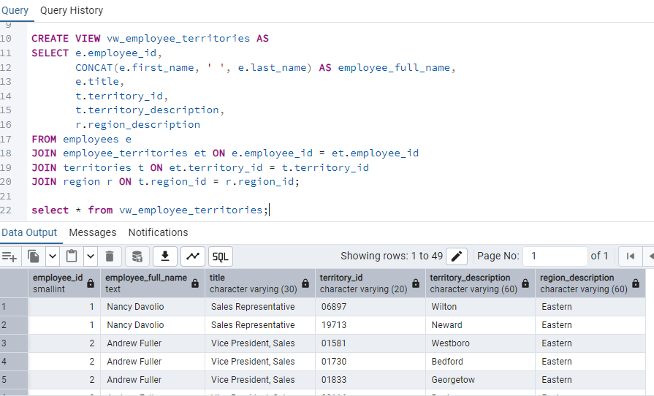

**4.**  **Create a recursive CTE based on Employee Hierarchy**

**QUERY**

**with recursive cte_employees_hierarchy as**

**( select employee_id,**

**first_name || '' || last_name as employee_name,**

**reports_to,**

**1 as level**

**from employees**

**where reports_to is NULL**

**UNION ALL**

**select e.employee_id,**

**e.first_name || '' || e.last_name as employee_name,**

**e.reports_to,eh.level +1**

**from employees e**

**INNER JOIN cte_employees_hierarchy eh ON e.reports_to = eh.employee_id**

**)**

**SELECT * FROM cte_employees_hierarchy**

**ORDER BY level, reports_to, employee_id;**

