--1.Create view vw_updatable_products (use same query whatever I used in the training)

--Try updating the view with the below query and see if the product table also gets updated.

--Update query:

--UPDATE updatable_products SET unit_price = unit_price * 1.1 WHERE units_in_stock < 10;

CREATE OR REPLACE VIEW VW_UPDATABLE_PRODUCTS AS

SELECT PRODUCT_ID,

PRODUCT_NAME,

UNIT_PRICE,

UNITS_IN_STOCK,

DISCONTINUED

FROM PRODUCTS

WHERE DISCONTINUED = 0 WITH CHECK OPTION

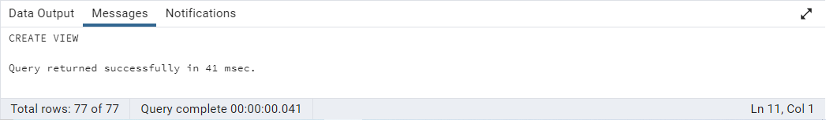

UPDATE VW_UPDATABLE_PRODUCTS

SET UNIT_PRICE = UNIT_PRICE * 1.1

WHERE UNITS_IN_STOCK < 10

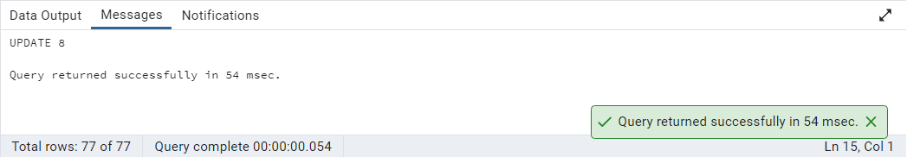

SELECT PRODUCT_ID,

UNIT_PRICE,

UNITS_IN_STOCK

FROM PRODUCTS

WHERE UNITS_IN_STOCK < 10

AND DISCONTINUED = 0

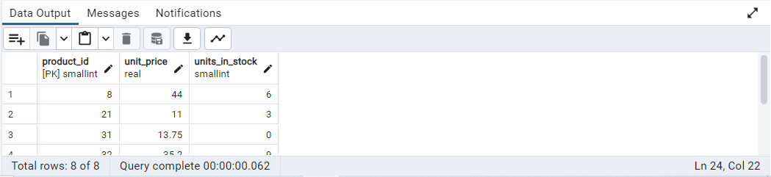

--2.Transaction:

--Update the product price for products by 10% in category id=1

--Try COMMIT and ROLLBACK and observe what happens.

BEGIN;

UPDATE PRODUCTS

SET UNIT_PRICE = UNIT_PRICE * 1.1

WHERE CATEGORY_ID = 1

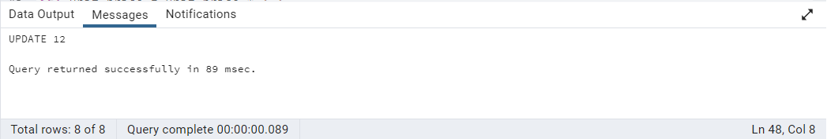

SELECT *

FROM PRODUCTS

WHERE CATEGORY_ID = 1

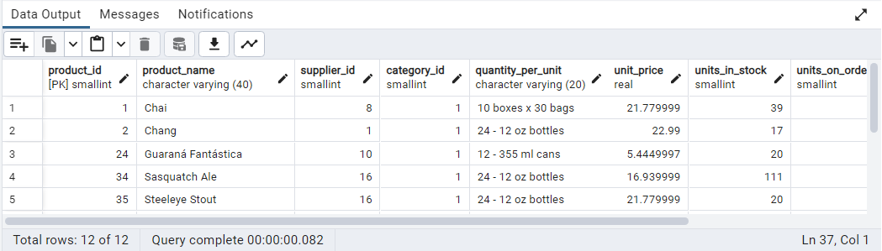

ROLLBACK;

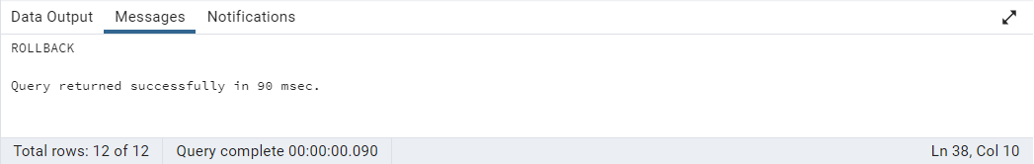

SELECT *

FROM PRODUCTS

WHERE CATEGORY_ID = 1

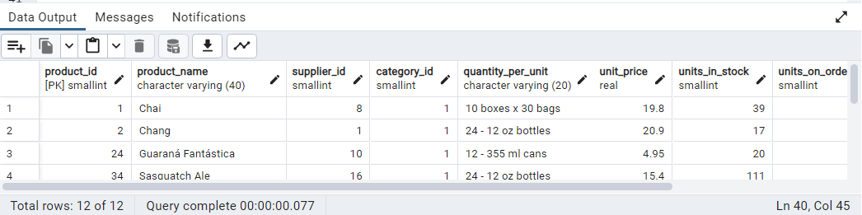

BEGIN;

UPDATE PRODUCTS

SET UNIT_PRICE = UNIT_PRICE * 1.1

WHERE CATEGORY_ID = 1

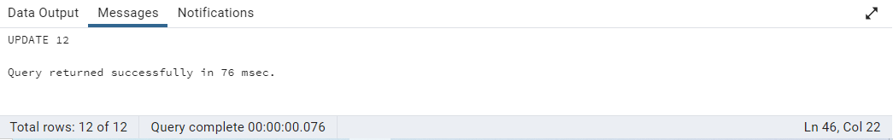

COMMIT;

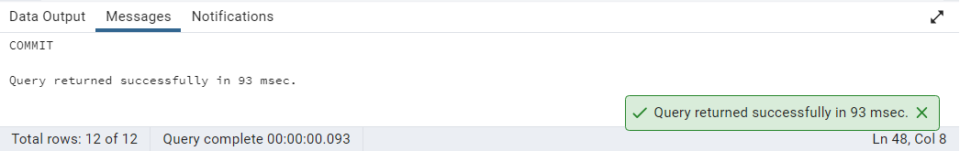

SELECT *

FROM PRODUCTS

WHERE CATEGORY_ID = 1

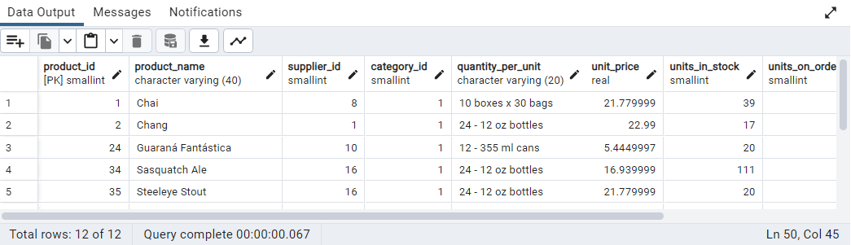

--3.Create a regular view which will have below details (Need to do joins):

--Employee_id, Employee_full_name, Title, Territory_id, territory_description, region_description

CREATE VIEW VW_EMPLOYEE_DETAILS AS

SELECT E.EMPLOYEE_ID,

E.FIRST_NAME || ' ' || E.LAST_NAME AS EMPLOYEE_FULL_NAME,

E.TITLE,

ET.TERRITORY_ID,

T.TERRITORY_DESCRIPTION,

R.REGION_DESCRIPTION

FROM EMPLOYEES E

JOIN EMPLOYEE_TERRITORIES ET ON E.EMPLOYEE_ID = ET.EMPLOYEE_ID

JOIN TERRITORIES T ON ET.TERRITORY_ID = T.TERRITORY_ID

JOIN REGION R ON T.REGION_ID = R.REGION_ID

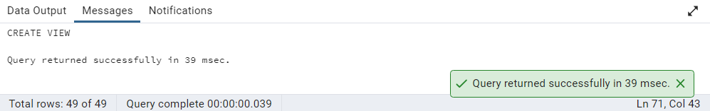

SELECT *

FROM VW_EMPLOYEE_DETAILS

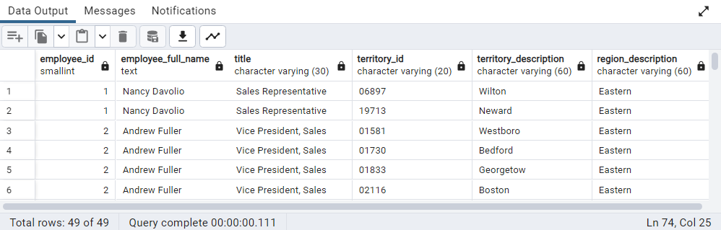

--4.Create a recursive CTE based on Employee Hierarchy

WITH RECURSIVE CTE_EMPLOYEE_HIERARCHY AS

(SELECT EMPLOYEE_ID,

FIRST_NAME,

LAST_NAME,

REPORTS_TO,

0 AS LEVEL

FROM EMPLOYEES E

WHERE REPORTS_TO IS NULL

UNION ALL SELECT E.EMPLOYEE_ID,

E.FIRST_NAME,

E.LAST_NAME,

E.REPORTS_TO,

EH.LEVEL + 1

FROM EMPLOYEES E

JOIN CTE_EMPLOYEE_HIERARCHY EH ON EH.EMPLOYEE_ID = E.REPORTS_TO)

SELECT LEVEL,

EMPLOYEE_ID,

FIRST_NAME || ' ' || LAST_NAME AS EMPLOYEE_NAME

FROM CTE_EMPLOYEE_HIERARCHY

ORDER BY LEVEL

