--1.Create AFTER UPDATE trigger to track product price changes

CREATE TABLE PRODUCT_PRICE_AUDIT (

AUDIT_ID SERIAL PRIMARY KEY,

PRODUCT_ID INT,

PRODUCT_NAME VARCHAR (40),

OLD_PRICE DECIMAL (10,2),

NEW_PRICE DECIMAL (10,2),

CHANGE_DATE TIMESTAMP DEFAULT CURRENT_TIMESTAMP,

USER_NAME VARCHAR (50) DEFAULT CURRENT_USER

)

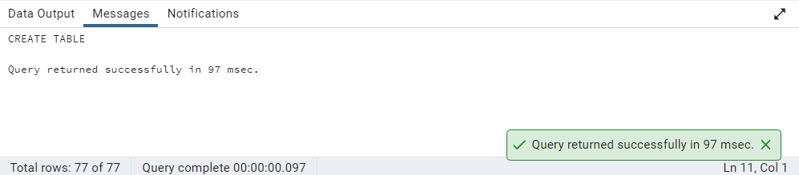

--Define the Trigger Function

CREATE OR REPLACE FUNCTION AFTER_UPDATE_PRODUCT() RETURNS TRIGGER AS $$

BEGIN

INSERT INTO product_price_audit (

product_id,

product_name,

old_price,

new_price

) VALUES (

OLD.product_id,

OLD.product_name,

OLD.unit_price,

NEW.unit_price

);

RETURN NEW;

END;

$$ LANGUAGE PLPGSQL

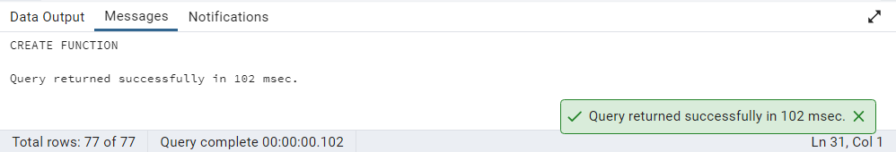

--Create the Trigger

CREATE TRIGGER AFTER_UPDATE_TRIGGER AFTER

UPDATE ON PRODUCTS

FOR EACH ROW EXECUTE FUNCTION AFTER_UPDATE_PRODUCT()

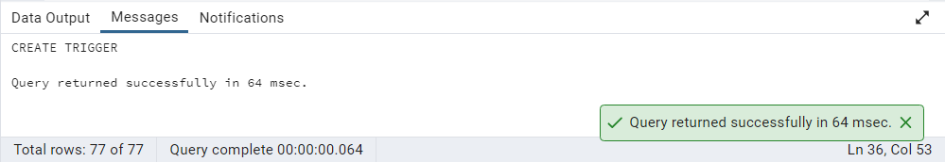

--Test the trigger

UPDATE PRODUCTS

SET UNIT_PRICE = UNIT_PRICE * 1.10

WHERE PRODUCT_ID = 58

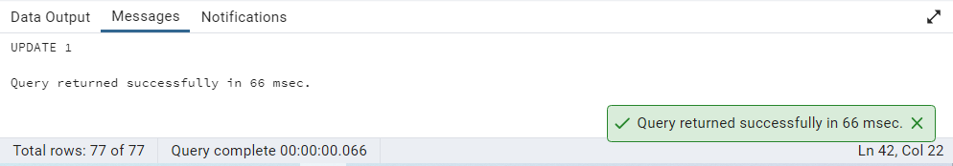

SELECT *

FROM PRODUCT_PRICE_AUDIT

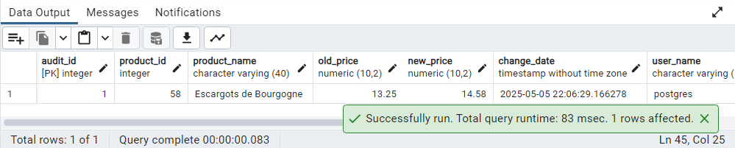

--2.Create stored procedure using IN and INOUT parameters to assign tasks to employees

CREATE TABLE IF NOT EXISTS EMPLOYEE_TASKS (

TASK_ID SERIAL PRIMARY KEY,

EMPLOYEE_ID INT,

TASK_NAME VARCHAR(50),

ASSIGNED_DATE DATE DEFAULT CURRENT_DATE

);

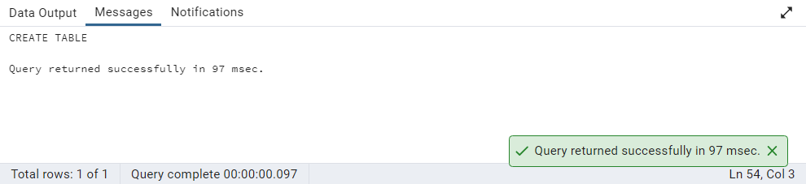

--Create the Stored Procedure

CREATE OR REPLACE PROCEDURE ASSIGN_TASK (

IN P_EMPLOYEE_ID INT,

IN P_TASK_NAME VARCHAR(50),

INOUT P_TASK_COUNT INT DEFAULT 0

)

LANGUAGE PLPGSQL AS $$

BEGIN

INSERT INTO EMPLOYEE_TASKS (

EMPLOYEE_ID, TASK_NAME

) VALUES (

p_employee_id, p_task_name

);

SELECT COUNT (*)

INTO p_task_count

FROM EMPLOYEE_TASKS

WHERE EMPLOYEE_ID = p_employee_id;

RAISE NOTICE 'Task "%" assigned to employee %. Total tasks: %',

p_task_name, p_employee_id, p_task_count;

END;

$$

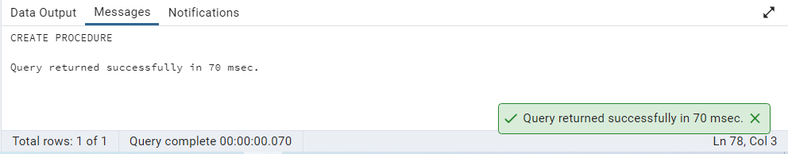

CALL ASSIGN_TASK(

1,'Review Reports'

);

