**y**

**mean**

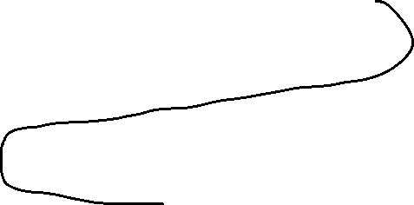

train

train

train

train

**model**

**model**

**model**

**SVR**

**KNNR**

**DNNR**

**GBR**



**X**

**model**

**Train**

**Test**