Exercise 3

- Create Database

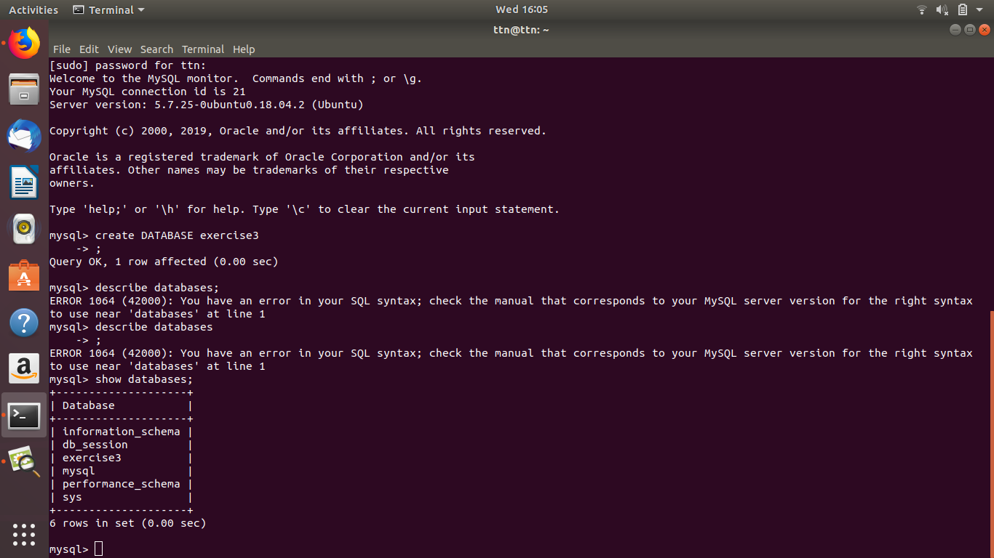

- Design Schema :
In schema:
database: Exercise3

table1: customer table2: sales table3: order
(order_id primary key, (Sales_id primary key, (order_id primary key
cust_name, and cust_id ) s_name) sales_id)

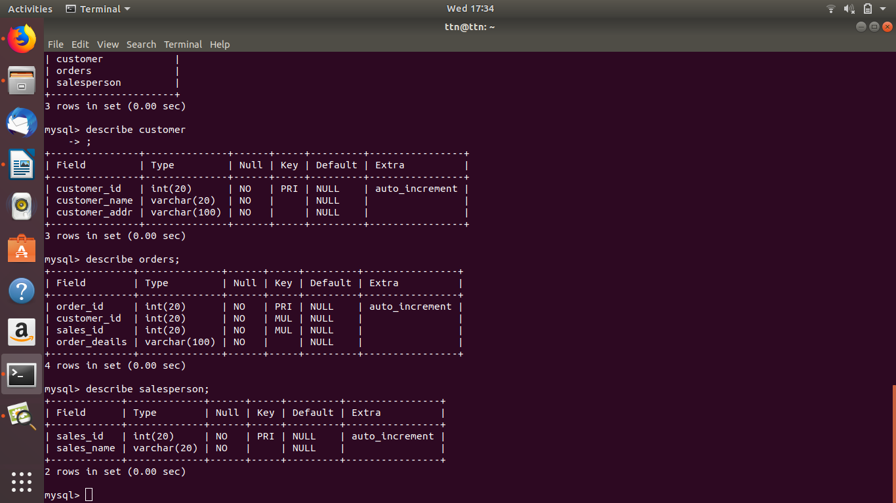
the schema will look like like this and will uphold for further assignment questions.

- Create tables

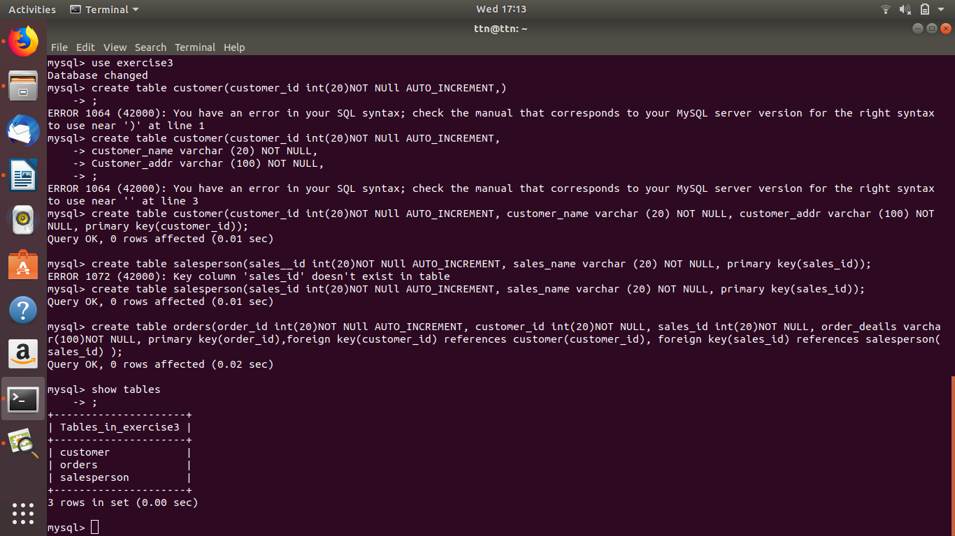

- Insert sample data

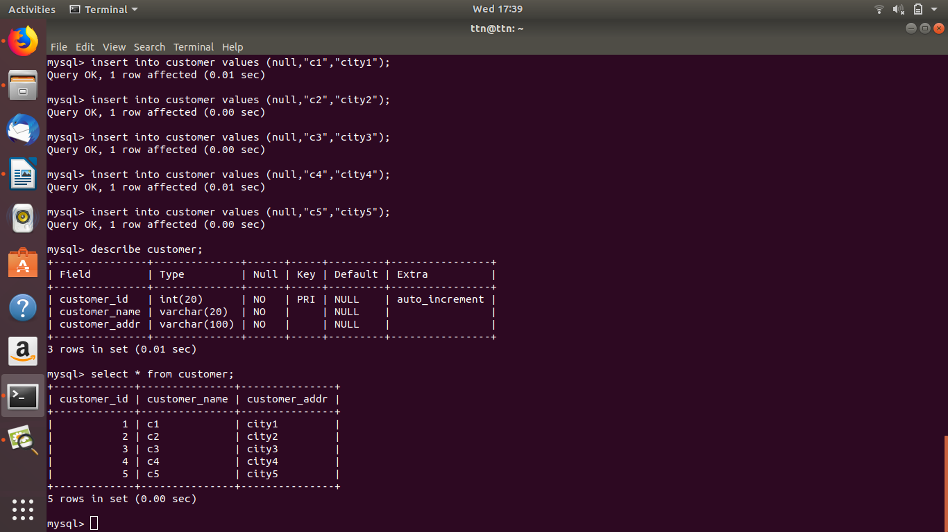
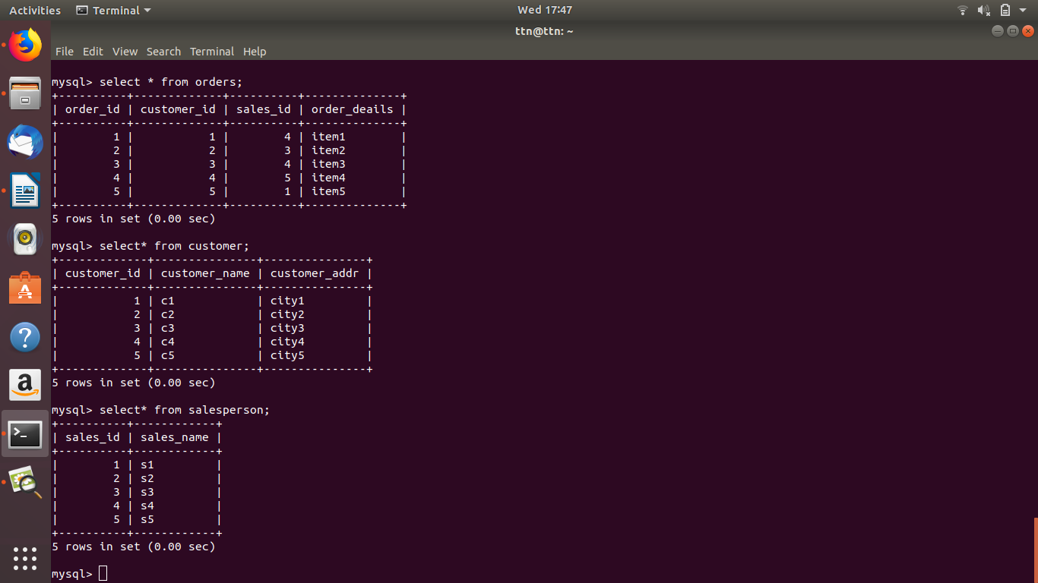

- Find the sales person have multiple orders.

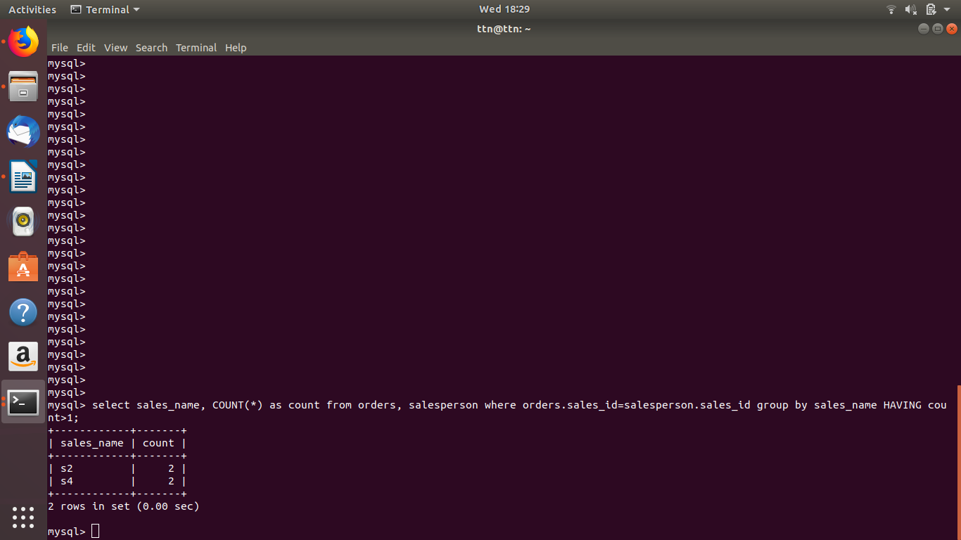

- Find the all sales person details along with order details
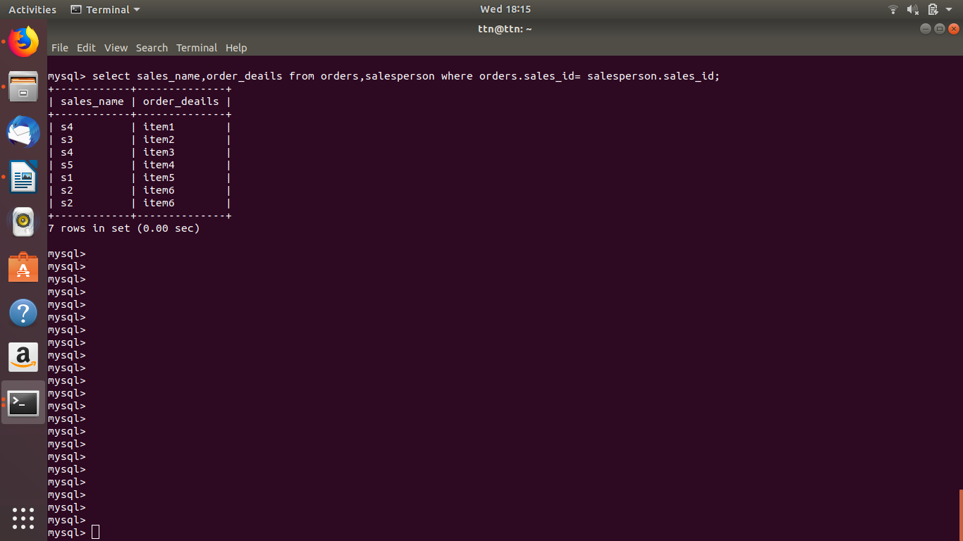

- Create index

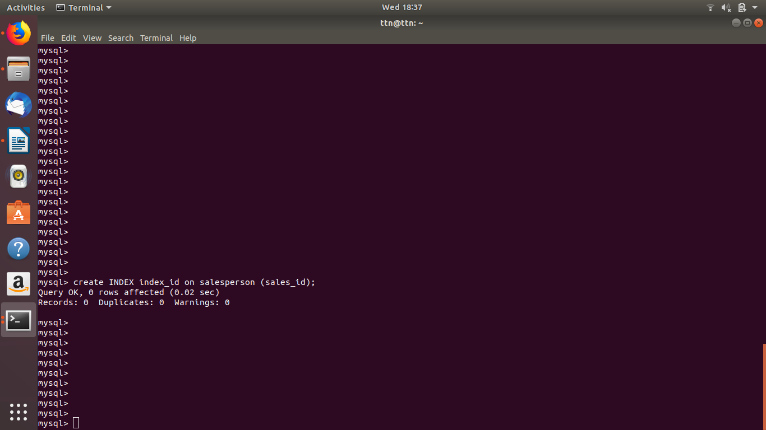

- How to show index on a table

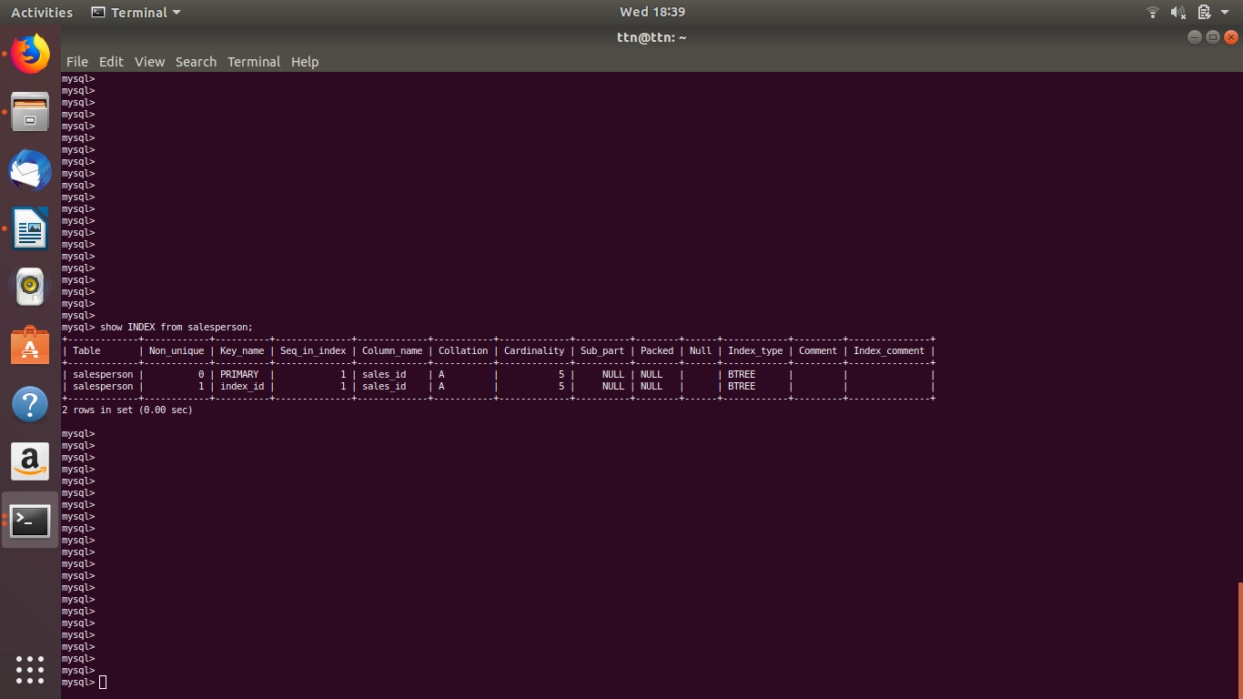

- Find the order number, sale person name, along with the customer to whom that order belongs to

