Cd **TERM– WINTER 2022 **

| **Course & Section Code:** | **DBS311NCC** |
| --- | --- |
| **Course Name:** | **Advance Database Services** |
|  | **Assigment 2** |
| **Q&A / Virtual Office Hour:** | **6:30 PM – 9:30 PM** |
| **Instructor Name & Email:** | **Slavica O’Connor: slavica.oconnor@senecacollege.ca** |

**Assignment Due**: Wednesday, April 20th, 2022, 11:59pm.

**Submission**

Your submission can be a single Word-based with appropriate header and commenting. Please ensure your file has SQL commands and also as well as screen shots executed in SQL Developer. For MongoDB, submit commands.

TASKS

* First question PL/SQL 40 points
* Second question, MongoDB, each task worth 10 points total 60.

**PL/SQL**

1. Create a new table from the existing HR_EMPLOYEES table, using CTAS:

create table a2_employees as select * from hr_employees;

Create a PL/SQL procedure to display some information from the newly created table A2_EMPLOYEES and also to update salary, for a specific department ID. The procedure should read row by row using explicit cursor and calculate average salary for the job id that the employee performs. If the salary is lower that the average tor that job ID, then update the employee’s salary to the average and display old salary, new salary, and the difference. If the salary is higher than the average, display the salary and the difference from the average salary for that job id. Calculate the total amount of money that the department will need for the salary increase for all its employees.

Provide an anonymous block that will call this procedure for several values of department ID.

You can use the following SQL statements for testing:

select distinct department_id, count(1) from a2_employees group by department_id;

select * from a2_employees where department_id = 50 order by job_id, employee_id;

An example of the output is displayed bellow:

**********************************************************************************************************************************************

Department ID = 50

**********************************************************************************************************************************************

**********************************************************************************************************************************************

Job ID = SH_CLERK - the average salary for this job id is $3215

**********************************************************************************************************************************************

Employee ID 180, Name = Winston Taylor, the salary has been updated from $3200 to $3215 (added $15).

Employee ID 181, Name = Jean Fleaur, the salary has been updated from $3100 to $3215 (added $115).

Employee ID 182, Name = Martha Sullivan, the salary has been updated from $2500 to $3215 (added $715).

Employee ID 183, Name = Girard Geoni, the salary has been updated from $2800 to $3215 (added $415).

Employee ID 184, Name = Nandita Sarchand, the salary $4200 is higher than average $3215 no update (the difference is $985).

Employee ID 185, Name = Alexis Bull, the salary $4100 is higher than average $3215 no update (the difference is $885).

Employee ID 186, Name = Julia Dellinger, the salary $3400 is higher than average $3215 no update (the difference is $185).

Employee ID 187, Name = Anthony Cabrio, the salary has been updated from $3000 to $3215 (added $215).

Employee ID 188, Name = Kelly Chung, the salary $3800 is higher than average $3215 no update (the difference is $585).

Employee ID 189, Name = Jennifer Dilly, the salary $3600 is higher than average $3215 no update (the difference is $385).

Employee ID 190, Name = Timothy Gates, the salary has been updated from $2900 to $3215 (added $315).

Employee ID 191, Name = Randall Perkins, the salary has been updated from $2500 to $3215 (added $715).

Employee ID 192, Name = Sarah Bell, the salary $4000 is higher than average $3215 no update (the difference is $785).

Employee ID 193, Name = Britney Everett, the salary $3900 is higher than average $3215 no update (the difference is $685).

Employee ID 194, Name = Samuel McCain, the salary has been updated from $3200 to $3215 (added $15).

Employee ID 195, Name = Vance Jones, the salary has been updated from $2800 to $3215 (added $415).

Employee ID 196, Name = Alana Walsh, the salary has been updated from $3100 to $3215 (added $115).

Employee ID 197, Name = Kevin Feeney, the salary has been updated from $3000 to $3215 (added $215).

Employee ID 198, Name = Donald OConnell, the salary has been updated from $2600 to $3215 (added $615).

Employee ID 199, Name = Douglas Grant, the salary has been updated from $2600 to $3215 (added $615).

**********************************************************************************************************************************************

Job ID = ST_CLERK - the average salary for this job id is $2785

**********************************************************************************************************************************************

Employee ID 125, Name = Julia Nayer, the salary $3200 is higher than average $2785 no update (the difference is $415).

Employee ID 126, Name = Irene Mikkilineni, the salary has been updated from $2700 to $2785 (added $85).

Employee ID 127, Name = James Landry, the salary has been updated from $2400 to $2785 (added $385).

Employee ID 128, Name = Steven Markle, the salary has been updated from $2200 to $2785 (added $585).

Employee ID 129, Name = Laura Bissot, the salary $3300 is higher than average $2785 no update (the difference is $515).

Employee ID 130, Name = Mozhe Atkinson, the salary $2800 is higher than average $2785 no update (the difference is $15).

Employee ID 131, Name = James Marlow, the salary has been updated from $2500 to $2785 (added $285).

Employee ID 132, Name = TJ Olson, the salary has been updated from $2100 to $2785 (added $685).

Employee ID 133, Name = Jason Mallin, the salary $3300 is higher than average $2785 no update (the difference is $515).

Employee ID 134, Name = Michael Rogers, the salary $2900 is higher than average $2785 no update (the difference is $115).

Employee ID 135, Name = Ki Gee, the salary has been updated from $2400 to $2785 (added $385).

Employee ID 136, Name = Hazel Philtanker, the salary has been updated from $2200 to $2785 (added $585).

Employee ID 137, Name = Renske Ladwig, the salary $3600 is higher than average $2785 no update (the difference is $815).

Employee ID 138, Name = Stephen Stiles, the salary $3200 is higher than average $2785 no update (the difference is $415).

Employee ID 139, Name = John Seo, the salary has been updated from $2700 to $2785 (added $85).

Employee ID 140, Name = Joshua Patel, the salary has been updated from $2500 to $2785 (added $285).

Employee ID 141, Name = Trenna Rajs, the salary $3500 is higher than average $2785 no update (the difference is $715).

Employee ID 142, Name = Curtis Davies, the salary $3100 is higher than average $2785 no update (the difference is $315).

Employee ID 143, Name = Randall Matos, the salary has been updated from $2600 to $2785 (added $185).

Employee ID 144, Name = Peter Vargas, the salary has been updated from $2500 to $2785 (added $285).

**********************************************************************************************************************************************

Job ID = ST_MAN - the average salary for this job id is $7280

**********************************************************************************************************************************************

Employee ID 120, Name = Matthew Weiss, the salary $8000 is higher than average $7280 no update (the difference is $720).

Employee ID 121, Name = Adam Fripp, the salary $8200 is higher than average $7280 no update (the difference is $920).

Employee ID 122, Name = Payam Kaufling, the salary $7900 is higher than average $7280 no update (the difference is $620).

Employee ID 123, Name = Shanta Vollman, the salary has been updated from $6500 to $7280 (added $780).

Employee ID 124, Name = Kevin Mourgos, the salary has been updated from $5800 to $7280 (added $1480).

**********************************************************************************************************************************************

Department ID 50 needs $10590 more for the salary increase.

**********************************************************************************************************************************************

PL/SQL procedure successfully completed.

**MongoDB**

Run the following statements

-- Create database "assignment2":

use assignment2

-- Create collection hr_employees:

db,createCollection("hr_employees")

-- Insert documents in collection hr_employees:

db.hr_employees.insertMany([

{"employee_id": 1, "first_name": "Jennifer", "last_name": "Whalen", "hire_date" : ISODate("1987-09-01T00:00:00Z"), "job_id": "AD_ASST", "salary": 4400, "department_id": 10},

{"employee_id": 2, "first_name": "Michael", "last_name": "Hartstein", "hire_date" : ISODate("1996-02-07T00:00:00Z"), "job_id": "MK_MAN", "salary": 13000, "department_id": 20},

{"employee_id": 3, "first_name": "Pat", "last_name": "Fay", "hire_date" : ISODate("1997-08-17T00:00:00Z"), "job_id": "MK_REP", "salary": 6000, "department_id": 20},

{"employee_id": 4, "first_name": "Karen", "last_name": "Colmenares", "hire_date" : ISODate("1999-08-10T00:00:00Z"), "job_id": "PU_CLERK", "salary": 2500, "department_id": 30},

{"employee_id": 5, "first_name": "Guy", "last_name": "Himuro", "hire_date" : ISODate("1998-11-15T00:00:00Z"), "job_id": "PU_CLERK", "salary": 2600, "department_id": 30},

{"employee_id": 6, "first_name": "Sigal", "last_name": "Tobias", "hire_date" : ISODate("1997-07-24T00:00:00Z"), "job_id": "PU_CLERK", "salary": 2800, "department_id": 30},

{"employee_id": 7, "first_name": "Shelli", "last_name": "Baida", "hire_date" : ISODate("1997-12-24T00:00:00Z"), "job_id": "PU_CLERK", "salary": 2900, "department_id": 30},

{"employee_id": 8, "first_name": "Alexander", "last_name": "Khoo", "hire_date" : ISODate("1995-05-18T00:00:00Z"), "job_id": "PU_CLERK", "salary": 3100, "department_id": 30},

{"employee_id": 9, "first_name": "Den", "last_name": "Raphaely", "hire_date" : ISODate("1994-12-07T00:00:00Z"), "job_id": "PU_MAN", "salary": 11000, "department_id": 30},

{"employee_id": 10, "first_name": "Susan", "last_name": "Mavris", "hire_date" : ISODate("1994-06-07T00:00:00Z"), "job_id": "HR_REP", "salary": 6500, "department_id": 40},

{"employee_id": 11, "first_name": "Randall", "last_name": "Perkins", "hire_date" : ISODate("1999-12-19T00:00:00Z"), "job_id": "SH_CLERK", "salary": 2500, "department_id": 50},

{"employee_id": 12, "first_name": "Martha", "last_name": "Sullivan", "hire_date" : ISODate("1999-06-21T00:00:00Z"), "job_id": "SH_CLERK", "salary": 2500, "department_id": 50},

{"employee_id": 13, "first_name": "Douglas", "last_name": "Grant", "hire_date" : ISODate("2000-01-13T00:00:00Z"), "job_id": "SH_CLERK", "salary": 2600, "department_id": 50},

{"employee_id": 14, "first_name": "Donald", "last_name": "OConnell", "hire_date" : ISODate("2010-06-21T00:00:00Z"), "job_id": "SH_CLERK", "salary": 2600, "department_id": 50},

{"employee_id": 15, "first_name": "Vance", "last_name": "Jones", "hire_date" : ISODate("2015-03-17T00:00:00Z"), "job_id": "SH_CLERK", "salary": 2800, "department_id": 50},

{"employee_id": 16, "first_name": "Girard", "last_name": "Geoni", "hire_date" : ISODate("2017-02-12T00:00:00Z"), "job_id": "SH_CLERK", "salary": 2800, "department_id": 50}

])

-- List documents from collection hr_employees:

db.hr_employees.find().forEach(printjson)

1. Write MongoDB commands to answer the following questions: 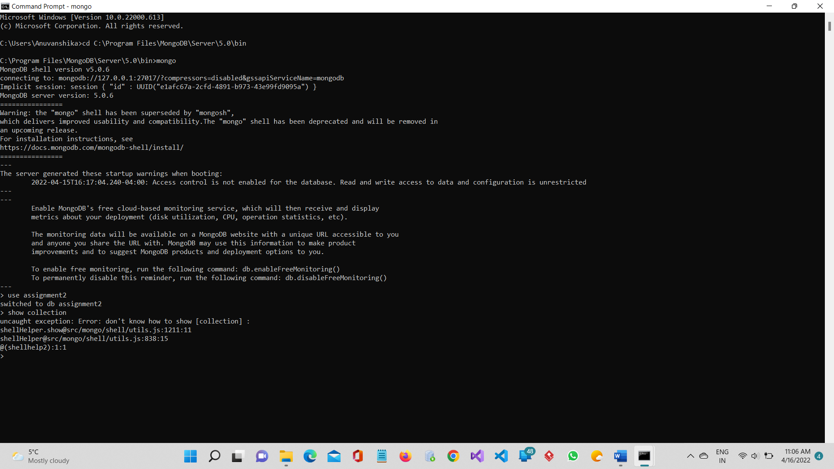
2. Rename key “hire_date**" to “**start_date” in collection hr_employees.

db.hr_employees.updateMany({},{$rename:{"hire_date":"start_date"}})



1. Find the lowest, the average, and the maximum salary in each department.

db.hr_employees.aggregate({"$group":{"_id":"$department_id","average_salary":{"$avg":"$salary"},"lower_salary":{"$min":"$salary"},"maximum_salary":{"$max":"$salary"}}})

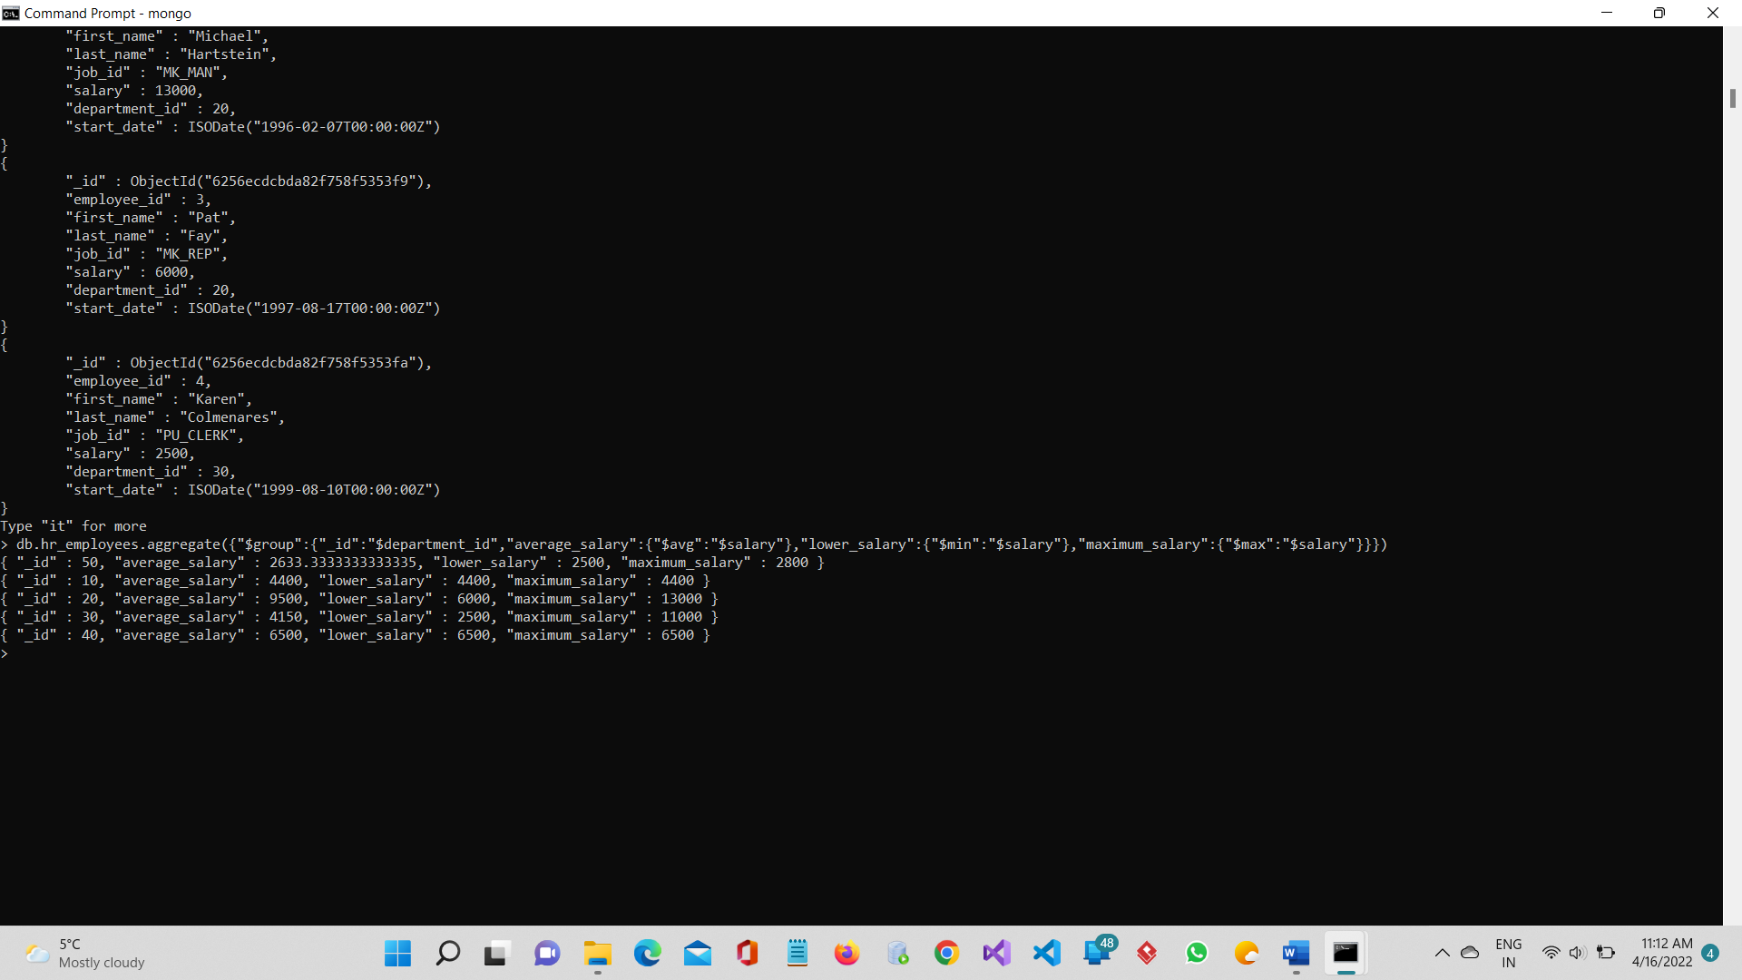

1. Find the lowest, the average, and the maximum salary for each Job ID.

db.hr_employees.aggregate({"$group":{"_id":"$job_id","average_salary":{"$avg":"$salary"},"lower_salary":{"$min":"$salary"},"maximum_salary":{"$max":"$salary"}}})

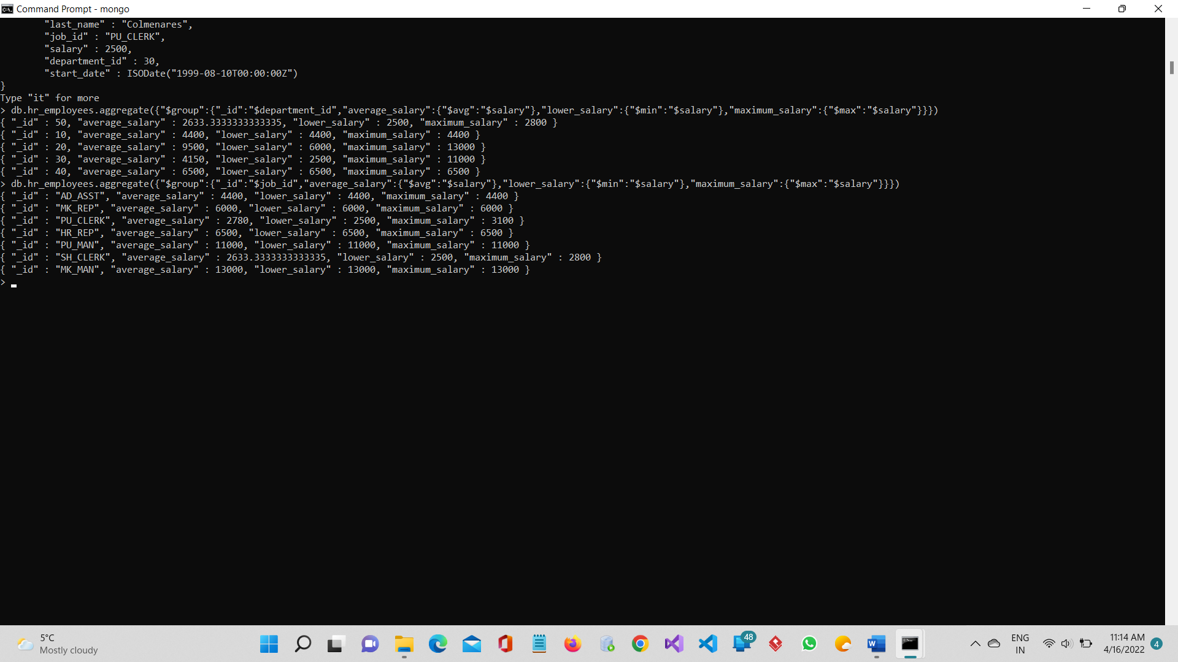

1. Calculate how many years each employee has been with the company.

db.hr_employees.aggregate({"$project":{start_date:1,"_id":0,"how many years":{ "$subtract":[{"$year":new Date()},{"$year":"$start_date"}]}}})

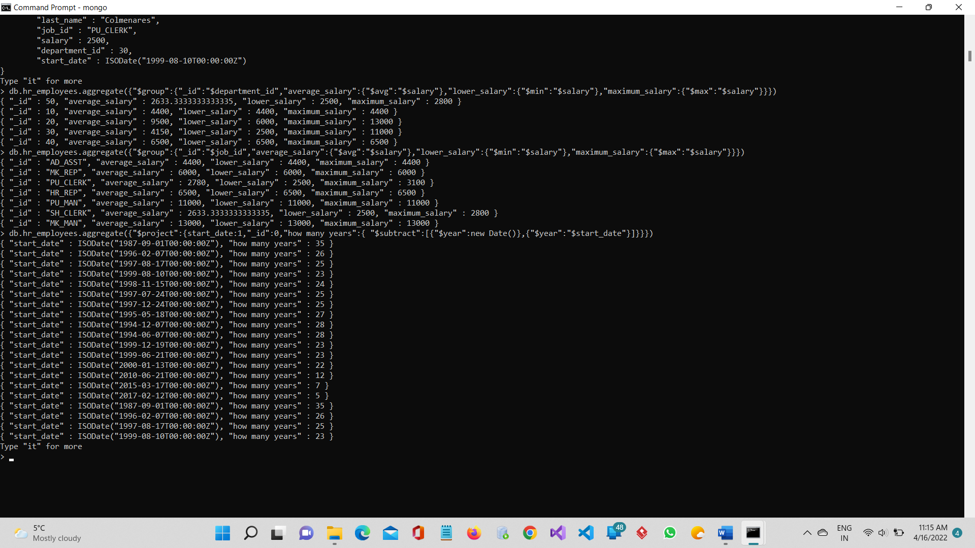

1. For each employee, display first name, last name, and if salary is greater or equal than $3000 “Good”, otherwise “Low”.

db.hr_employees.aggregate([{$project:{"_id":0,"first_name":1,"last_name":1,salary:{$cond:{if:{$gte:["$salary",3000]},then:"Good",else:"Low"}}}}])



1. For each employee, display the employee id, first name, last name, job_id, salary, and new salary increased by 20%. Sort documents on job_id.

db.hr_employees.aggregate({"$sort":{"job_id":1}}, {"$project":{"employee_id":1,"first_name":1,"last_name":1,"job_id":1,"salary":1,"_id":0,"NewSalary":{ "$multiply":["$salary",1.2]}}})

