Multimodal and Regime-Aware Deep Learning for Next Day
SET Index Direction Forecasting
Arsanchai Sukkuea^{1,2}, Tanawat Rungwallapa³

¹ School of Engineering and Technology, Walailak University, 222 Thaiburi, Thasala District, Nakhon Si Thammarat 80160, Thailand.
² Research Center for Intelligent Technology and Integration, School of Engineering and Technology, Walailak University, Nakhon Si Thammarat 80160, Thailand.
³ Faculty of Engineering, Kasetsart University, Bangkok, 10900 Thailand.
* Correspondence: tanawat.run@ku.th
Abstract
Market-direction studies often emphasize the best-performing configuration but whether reported gains persist under strict point-in-time evaluation and robustness checks remain unclear. We conduct a point-in-time reliability audit of numerical denoising, predicted financial-news sentiment, role-structured large-language-model inference, regime-aware feature selection and neural complexity. The study uses daily SET50 price index data from 2012-2025, expanding pre-2022 model selection, four outer test years (2022-2025; 962 sessions), five fixed seeds and five architectures: LSTM, CNN, LSTM-CNN, LSTM-Attention and LSTM-CNN-Attention. Labels are purged by observation date, transformations are fitted on training data only and balanced accuracy is the primary endpoint. Causal rolling variational mode decomposition changed balanced accuracy by -0.60 to +0.35 percentage points across architectures, with no conclusive effect. Predicted news produced no multiplicity-adjusted gain over market-only and falsification controls. In a locked 2023 sentiment benchmark, a Bull/Bear/Leader large-language-model system exceeded equal-call and near-cost self-consistency controls by 5.93 and 6.00 points, respectively. Regime-specific SHAP selection improved CNN by 1.46 points but produced mixed or negative effects elsewhere without Holm-adjusted significance. Partial-2026 testing exposed one-sided prediction collapse while frozen SET100 transfer was uniformly weaker, indicating that the observed gains were configuration-specific rather than generalizable.
Keywords: point-in-time evaluation; stock-market direction; SET50; balanced accuracy; multimodal learning; financial sentiment; variational mode decomposition; market regime; SHAP; reliability audit
1. Introduction
Predicting whether a market index will rise or fall on the next trading day is an unusually compact statement of a difficult forecasting problem. The target is binary, but the data-generating process is non-stationary, the usable signal is weak relative to market noise and small implementation choices can alter the apparent outcome (Fama, 1970; Olorunnimbe & Viktor, 2023) Deep recurrent networks, convolutional networks and attention mechanisms offer flexible representations of sequential financial data (Hochreiter & Schmidhuber, 1997; Qin et al., 2017; Vaswani et al., 2017) Representative financial applications have reported gains from LSTM and CNN architectures (Fischer & Krauss, 2018; Hoseinzade & Haratizadeh, 2019) That flexibility also increases the number of choices available to a researcher: feature families, lookback windows, decomposition settings, text encoders, fusion mechanisms, random seeds, thresholds, regimes and post-hoc explanations. A result selected from many such choices can look stronger than the underlying signal.
The financial forecasting literature contains increasingly elaborate hybrid systems. Reviews document extensive use of LSTM, CNN and hybrid deep-learning models for price and direction prediction, while also identifying continuing gaps in backtesting, reproducibility and practical evaluation (Olorunnimbe & Viktor, 2023; Sezer et al., 2020) Earlier multimodal systems combined text and market signals through attention, graph structure, expert-opinion aggregation and cross-modal interaction (Luo et al., 2023; Sawhney et al., 2020; H. Wang et al., 2020) More recent work models interactions among news items or uses sentiment-attention mechanisms for index prediction (W.-J. Liu et al., 2024; M. Wang et al., 2024) Signal-decomposition methods offer a second route: separate a price process into frequency components and expose a denoised representation to the predictor. Yet a component can improve squared-price error without improving the sign of the next movement and a text model can classify sentiment well without adding conditional information to an already strong market-data feature set. These distinctions are often blurred when performance is summarized by a single best accuracy.
This study treats these distinctions as the object of analysis. Rather than selecting the best-performing configuration, we examine whether five audit dimensions remain informative under a common point-in-time and inferential protocol
- Point-in-time data reliability: Are features, labels, scalers and sequence boundaries consistent with the information available at the prediction time?
- Numerical and denoising reliability: Does causal rolling VMD provide a repeatable directional benefit beyond a comprehensive technical-analysis feature set?
- Multimodal and LLM reliability: Does out-of-sample predicted news add incremental forecasting information and does a role-structured LLM system retain an intrinsic sentiment advantage over compute-matched controls?
- Regime-aware explainability reliability: Do causal Bull/Sideway/Bear routing and SHAP-selected feature subsets generalize across architectures, or are their benefits architecture-specific?
- Forward and transfer reliability: Do the conclusions persist in a later source-contingent period and under frozen transfer from SET50 to the broader SET100 index?
The five registered neural architectures provide a common benchmark panel across these audit dimensions. They are not presented as separate contributions and the study does not claim a new state-of-the-art forecasting model. Instead, the contribution is an integrated reliability-audit framework combining point-in-time reconstruction, architecture-paired ablations, negative-control falsification, compute-matched LLM evaluation, capacity-aware regime analysis, local-explanation diagnostics, serial-dependence sensitivity and frozen same-exchange transfer. The results are heterogeneous: selected enhancements improve particular architectures or intrinsic endpoints, but none of the completed primary forecasting contrasts survive the registered multiplicity controls. This lack of generalizable superiority is a substantive finding of the audit.
2. Related works
2.1 Deep Sequence models for financial direction
LSTM networks were designed to retain information over long sequences while controlling vanishing gradients (Hochreiter & Schmidhuber, 1997) Their use in financial prediction is motivated by delayed dependencies, while CNNs provide local filters that can extract short-range temporal patterns. Attention adds a learned mechanism for weighting representations across a sequence (Qin et al., 2017; Vaswani et al., 2017) Large empirical studies have reported advantages for LSTM-based financial prediction (Fischer & Krauss, 2018) and CNN-based systems have combined diverse market variables for next-day index direction (Hoseinzade & Haratizadeh, 2019) However, the existence of a flexible mapping does not imply a stable signal. Market dynamics change across years and a high-capacity hybrid can magnify optimization variance or collapse to a majority-side decision while retaining superficially acceptable raw accuracy. Recent review evidence likewise treats architecture choice as only one part of a credible, backtested, reproducible financial-learning pipeline (Olorunnimbe & Viktor, 2023)
The present benchmark therefore keeps training budgets deliberately compact and constant, repeats each outer cell across five seeds and treats the year not the seed as the temporal inferential unit. This design distinguishes stochastic fit variability from independent evidence over time.
2.2 Denoising and multimodal financial information
Variational mode decomposition separates a signal into band limited intrinsic mode functions through a constrained variational formulation (Dragomiretskiy & Zosso, 2014) In financial applications, decomposition can reduce high-frequency variation or provide additional frequency-domain features and recent stock-forecasting systems have paired VMD with LSTM, meta-learning and attention-based networks (T. Liu et al., 2022; Y. Liu et al., 2024) The key causal requirement is that decomposition at date (t) must use only observations available through (t). A full-series decomposition, even when followed by a temporal train/test split, can transmit future information into past components; windowed decomposition has been proposed specifically to address this problem (T. Liu et al., 2022) We therefore use a rolling past-only implementation and test VMD as a feature addition rather than assuming it is beneficial denoising.
Financial text offers a different information channel. Prior work has used social media, analyst or expert opinions and news to enrich stock-movement models (Luo et al., 2023; Sawhney et al., 2020; H. Wang et al., 2020). Recent systems further model interactions among news items or sentiment-attention mechanisms for index prediction (W.-J. Liu et al., 2024; M. Wang et al., 2024) An intrinsic sentiment score and an incremental forecasting signal are nevertheless different estimands. Text may be labelled accurately but arrive too late, be redundant with price adjustment, be diluted during daily aggregation, or exhibit source and length shift. A credible multimodal test therefore needs date-aware prediction of text labels, equal forecasting cohorts and controls that distinguish chronology from generic extra dimensions.
2.3 LLM role systems and compute matching
Multi-agent debate and judge-style LLM systems can improve reasoning by eliciting divergent intermediate positions before a final decision (Du et al., 2024; Liang et al., 2024) Self-consistency provides a strong alternative explanation: repeated sampling itself can improve a result by aggregating several reasoning paths (X. Wang et al., 2023) Comparing a three-call role system only with one call therefore confounds role structure with inference budget. Our intrinsic benchmark uses both an equal-call three-pass control and a four-pass near-cost control. Even then, the comparison is system-level: all roles use the same underlying proprietary model, so the result cannot identify abstract “debate reasoning” as the sole causal mechanism. A recent survey of financial LLM agents similarly identifies prompt sensitivity, real-time adaptation and institutional deployment constraints as open evaluation problems (Dong et al., 2025)
2.4 Market regimes and explanation reliability
Bull and bear phases have long been analyses as persistent market states (Pagan & Sossounov, 2003) Trend-following evidence motivates using returns across several horizons (Moskowitz et al., 2012) while the Average Directional Index (ADX) provides a conventional measure of trend strength (Wilder, 1978) A regime router used for next-day forecasting must be fitted without future labels and should produce semantically valid states in both training and test periods.
SHAP unifies feature attribution through Shapley values (Lundberg & Lee, 2017) LIME fits local surrogate explanations around individual predictions (Ribeiro et al., 2016) Neither method converts model association into causal market evidence and an explanation is useful only if it is sufficiently faithful to the fitted model. Sanity checks are consequently part of the explanation audit rather than an optional visualization exercise (Adebayo et al., 2018) Finance-specific review evidence also emphasizes that explanation methods must be assessed with domain, transparency and adoption constraints in view (Yeo et al., 2025) We use SHAP for a train-only selector and LIME only as a post-selection diagnostic; LIME never determines a feature subset.
2.5 Evaluation reliability
Time-series evaluation must respect order and dependence (Bergmeir et al., 2018) Financial machine-learning back tests additionally require explicit information boundaries, pre-specified choices and separation of development from evaluation (Arnott et al., 2019; Olorunnimbe & Viktor, 2023) We use expanding annual folds and a label-observation purge instead of random cross-validation. Balanced accuracy, the mean of class-wise recalls, is the primary directional metric because raw accuracy can reward a one-sided classifier when Up and Down frequencies differ (Brodersen et al., 2010) Families of related comparisons are adjusted by the Holm procedure (Holm, 1979) Economic summaries are explicitly exploratory; the Deflated Sharpe Ratio is retained to reveal selection and short-sample risk rather than to certify deployment (Bailey & López de Prado, 2014)
3. Materials and Methods
3.1 Study design, data governance and evidence hierarchy
Figure 1 summarizes a five-pillar reliability audit in which point-in-time market-data governance supports numerical denoising, multimodal news, regime-aware explanation and later robustness tests. The numerical stream spans the full historical period; news enters only on dates with defensible out-of-sample sentiment estimates; and causal regime labels and train-only explanation rankings act only on the numerical feature pool. The corrected numerical ablation is the primary architecture-paired experiment. Multimodal negative controls are frozen retrospective falsification tests, the integrated regime-news and explanation analyses are post-hoc robustness evidence, the partial-2026 module is source-contingent forward evidence and SET100 is a frozen same-exchange transfer audit rather than independent-market replication.
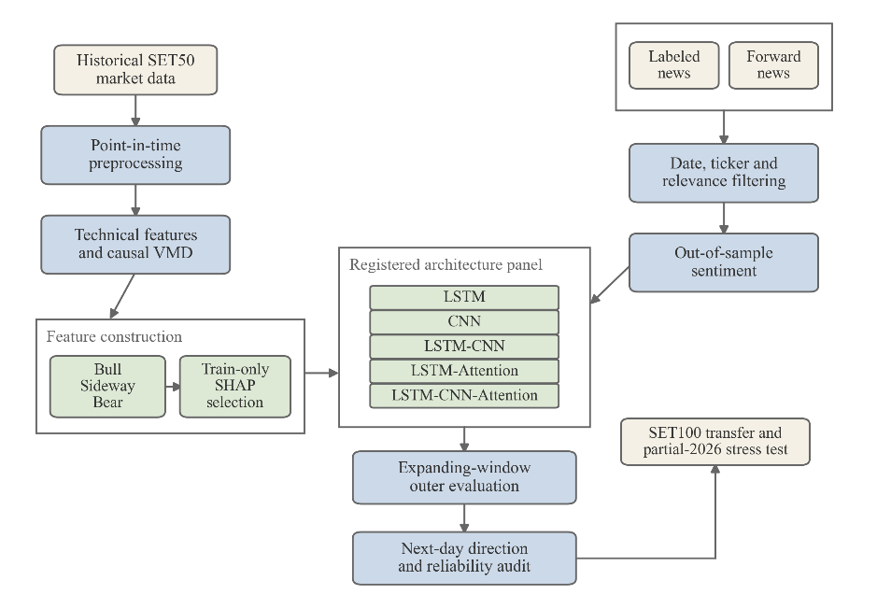
Figure 1. Five-pillar reliability-audit pipeline. Market-data governance and point-in-time reconstruction support the causal VMD, out-of-sample Local-NLP forecasting and intrinsic Bull/Bear/Leader evaluation, causal Bull/Sideway/Bear routing with train-only SHAP, partial-2026 and frozen SET100 modules. Solid arrows denote data or forecasting flow; evaluation-only links are shown separately.
Daily, weekly and monthly SET50 and SET100 price-index observations were manually downloaded from the publicly accessible Investing.com historical-data pages (Investing.com, n.d.-a, n.d.-b) The provenance manifest records source URLs, acquisition evidence, file sizes, SHA-256 digests, row counts, date ranges and processing method. Public accessibility is not treated as an open-data license, provider terms continue to apply and raw rows are not redistributed. Date-only observations were interpreted as Stock Exchange of Thailand sessions in Asia/Bangkok, with features available at 17:00 after the normal close. Weekly and monthly bars were shifted by one completed period before forward filling. The study uses provider-published price-index levels and applies no researcher-side split, dividend, constituent, or corporate-action adjustment.
Forty of 42 raw-file integrity checks passed. Two OHLC-containment warnings on 11 December 2025, present in both daily index files, were retained and disclosed; no critical check failed. The aligned SET100 cohort contained 3,360 of 3,381 required SET50 reference dates (99.3789%); 21 leading dates were excluded rather than backfilled. After the 60-day indicator warm-up, SET50 features begin on 3 May 2012. The four outer SET50 tests end on 18 December 2025 and contain 241, 243, 244 and 234 rows for 2022-2025.
3.2 News data and out-of-sample sentiment construction
The labelled Bilingual StockTBSA snapshot spans 3 January 2018 to 28 December 2023 and contains 10,295 articles, 15,949 article-ticker labels and 12,706 valid positive, neutral, or negative pairs (Uthayopas et al., 2025) Exclude, not-stock and ambiguous labels were not relabeled as neutral. The locked 2023 intrinsic cohort contains 1,333 pairs from 738 articles: 92 negative, 585 neutral and 656 positives. For 2024-2025, 69,824 deduplicated official SET headlines yielded 4,619 point-in-time article-symbol pairs under six non-overlapping SET50 membership versions, including the March-April 2025 transition. These headlines are unlabeled and are evaluated only through downstream forecasting. The 2015-2017 corpus lacked comparable ticker and sentiment labels and no defensible free 2012-2014 source was identified; homogeneous news coverage over 2012-2025 is therefore not claimed.
The operational sentiment model is balanced logistic regression over character TF-IDF features with the target ticker prepended. Annual expanding predictions trained on 2018 to predict 2019 and then expanded one year at a time through a 2018-2022 fit predicting 2023. For 2024-2025, the model was fitted once on labelled 2018-2023 data and frozen; pseudo-label retraining and Optuna tuning were not used. Because reliable intraday timestamps were unavailable in the labelled source, each item dated d was assigned conservatively to the first trading session strictly after d. Eight daily variables were constructed: sentiment mean and standard deviation; positive, negative and neutral ratios; article count; ticker-mention count; and news availability. The forecasting cohort begins in 2019, the first year with out-of-sample sentiment predictions. The complete news-to-session construction is summarized in Figure 2.
For each article-ticker pair, the scalar sentiment score and its session-level aggregation are defined in Eq. (1). Here, N_t is the set of pairs assigned to session t, n_t is its size, and c denotes the positive, neutral, or negative class. Article count, ticker-mention count, and news availability follow directly from N_t.
$s_{i}=p_{i}^{+}-p_{i}^{-}, μ_{s,t}=\frac{1}{n_{t}\sum_{\left(i∈N_{t}\right)s_{i}}{}}, q_{t,c}=\frac{1}{n_{t}\sum_{\left(i∈N_{t}\right)I\left({\hat{c}}_{i}=c\right)}{}}$ (1)
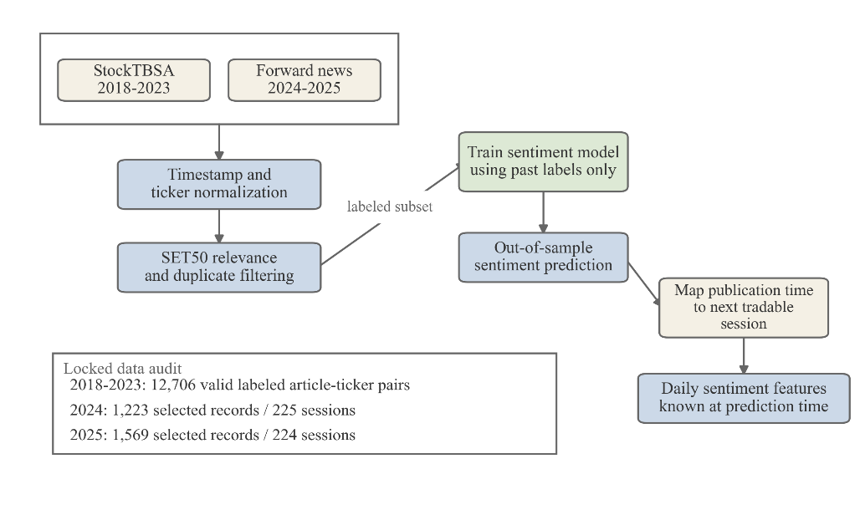
Figure 2. Point-in-time financial-news and sentiment construction. Dated StockTBSA labels from 2018-2023 and forward news from 2024-2025 are normalized, filtered for SET50 relevance and processed using only previously observed labels. Predicted sentiment is mapped from publication time to the next tradable session before daily aggregation.
3.3 Point-in-time contract, temporal splits and frozen windows
For feature date t, market variables use only information available through the close at t. The point-in-time regression target and the realized and predicted directions are defined in Eq. (2). Each row records both its feature Date and the next-session Label_Date on which C_(t+1) becomes observable. At every boundary, a supervised training row is retained only when Label_Date_t is earlier than the first Date in the evaluation split. The final pre-evaluation row may supply sequence context, but it is excluded from fitting and scaler estimation, transformed with the training-fitted scaler and never contributes a target. Zero-return observations remain available to price regression but are excluded from binary metrics; a predicted exact-zero move is treated as an abstention and coverage is reported.
$y_{t}=C_{t+1}, d_{t}=I\left(C_{t+1}>C_{t}\right), {\hat{d}}_{t}=I\left({\hat{C}}_{t+1}>C_{t}\right)$ (2)
Candidate sequence lengths were 1, 3, 5, 10 and 20 trading days. Expanding validation folds trained on 2012-2017, 2012-2018, 2012-2019 and 2012-2020 and validated on 2018-2021. Selection prioritized balanced accuracy, followed by direction accuracy, RMSE and the shorter-window tiebreaker and was symmetric across Full-TA and Full-TA+VMD. Frozen windows were 5 days for LSTM, 20 for CNN, 20 for LSTM-CNN, 10 for LSTM-Attention and 20 for LSTM-CNN-Attention. Outer folds trained through 2021, 2022, 2023 and 2024 and tested 2022, 2023, 2024 and 2025 using seeds 42, 123, 456, 789 and 2025. All dates use Asia/Bangkok and the 17:00 information cutoff. Figure 3 illustrates the point-in-time label boundary and expanding outer folds, while Table 1 summarizes the frozen model windows and common evaluation settings.
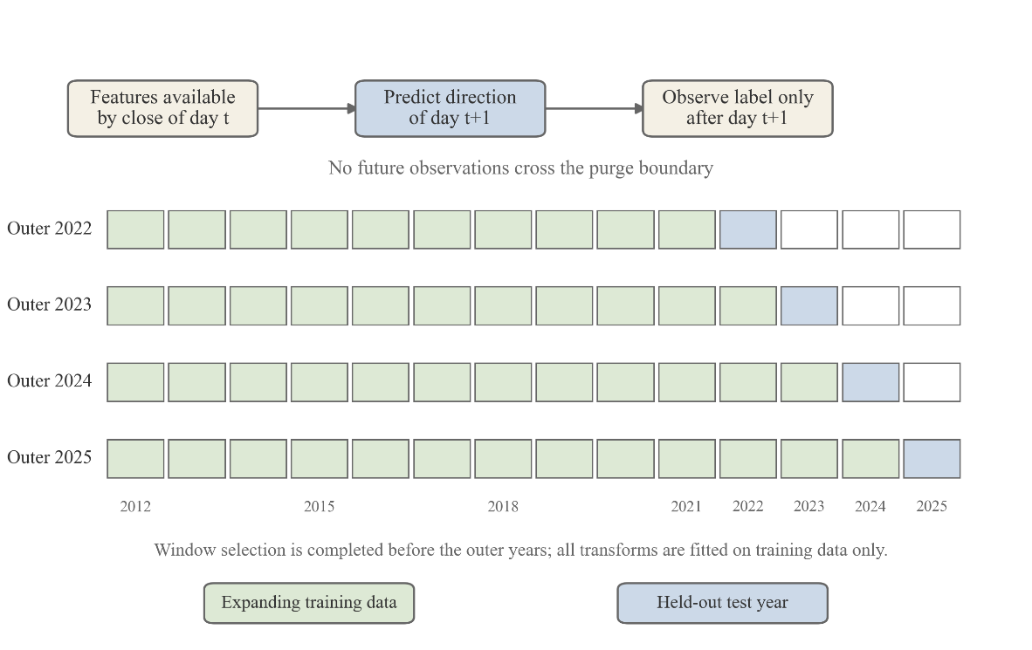
Figure 3. Point-in-time target contract and expanding window evaluation. Features known by the close of day t predict the direction of day t+1, whose label is observed only after t+1. Training data expand through time, while 2022, 2023, 2024 and 2025 remain separate held-out outer years. All transforms are fitted on training data only.
Table 1. Frozen architecture windows and common experimental settings. The table reports the registered sequence window for each architecture, five fixed seeds, expanding outer folds, common SET50 cohort and primary evaluation endpoint.
Architecture | Window | Test years | Outer folds | Seeds / fold | Features Num. / News | Primary endpoint | Time zone / cutoff
LSTM | 5 | 2022-2025 | 4 | 5 | 122 / 8 | Balanced accuracy | Asia/Bangkok / 17:00
CNN | 20 | 2022-2025 | 4 | 5 | 122 / 8 | Balanced accuracy | Asia/Bangkok / 17:00
LSTM-CNN | 20 | 2022-2025 | 4 | 5 | 122 / 8 | Balanced accuracy | Asia/Bangkok / 17:00
LSTM-Attention | 10 | 2022-2025 | 4 | 5 | 122 / 8 | Balanced accuracy | Asia/Bangkok / 17:00
LSTM-CNN-Attention | 20 | 2022-2025 | 4 | 5 | 122 / 8 | Balanced accuracy | Asia/Bangkok / 17:00
3.4 Numerical features and causal VMD
The Full-TA control contains 116 variables constructed from daily and previously completed weekly/monthly OHLCV information: price and volume lags; 1-, 3-, 5-, 10-, 20- and 60-day returns; moving averages; volatility, momentum, rate-of-change, candlestick, cross-timeframe and volume-ratio features; direction lags; and Stochastic, RSI, MACD, Williams %R, CCI, ADX and directional indicators.
Causal rolling VMD adds six variables. At each t, only the 60 closes from t-59 through t are decomposed using five modes, alpha = 1000, dual-ascent step tau = 0, a DC mode, tolerance 10^-7 and at most 500 iterations. The mode with the highest final centre frequency is treated as noise. Four retained intrinsic mode functions, the denoised close and removed-mode energy ratio produce 122 numerical inputs. VMD is tested as a causal auxiliary representation rather than assumed to improve direction.
Equations (3a)-(3c) formalize the trailing decomposition window, highest-frequency noise-mode rule, denoised close, and removed-mode energy ratio. The quantities u_(k,t) and omega_(k,t) denote mode k estimated at date t and its final centre frequency, respectively.
${\left(u_{k,t},ω_{k,t}\right)}_{k=1}^{5}=VMD\left(C_{t-59}:C_{t}\right), k_{t}^{*}=\arg{\max_{k}{ω_{k,t}}}$ (3a)
${\tilde{C}}_{t}=\sum_{\left(k≠k_{t}^{*}\right)u_{\left(k,t\right)\left(60\right)}}{}$ (3b)
$ρ_{t}=\frac{\sum_{τ=1}^{60}{u_{k_{t}^{*},t}^{2\left(τ\right)}}}{\sum_{τ=1}^{60}{C_{t-60+τ}^{2}}}$ (3c)
3.5 Neural architectures and training
Historical numerical, news and regime modules predict the next close and derive direction from predicted next close minus current close. The compact architectures were: LSTM, LSTM(16) followed by Dense(8, ReLU); CNN, causal Conv1D(32, kernel 3) followed by global-average pooling and Dense(8, ReLU); LSTM-CNN, sequence-output LSTM(16) followed by the causal convolution and pooling stack; LSTM-Attention, sequence-output LSTM(16) followed by causal two-head attention (key dimension 8), pooling and Dense(8, ReLU); and LSTM-CNN-Attention, LSTM followed by causal convolution, causal two-head attention, pooling and Dense(8, ReLU). Every architecture uses a linear output.
All five architectures minimize the mean squared error objective in Eq. (4), where n is the number of supervised training sequences.
$L_{MSE}=\frac{1}{n}\sum_{t=1}^{n{\left(y_{t}-{\hat{y}}_{t}\right)}^{2}}{}$ (4)
All fits used Adam, mean squared error, 20 epochs, batch size 32 and shuffle = false. Random states were reset for every cell, deterministic TensorFlow operations were enabled, the Keras session was cleared between fits and min-max scaling was fitted only on the supervised training portion of each fold. Figure 4 summarizes the numerical feature construction, causal VMD arm and five fixed neural architectures.
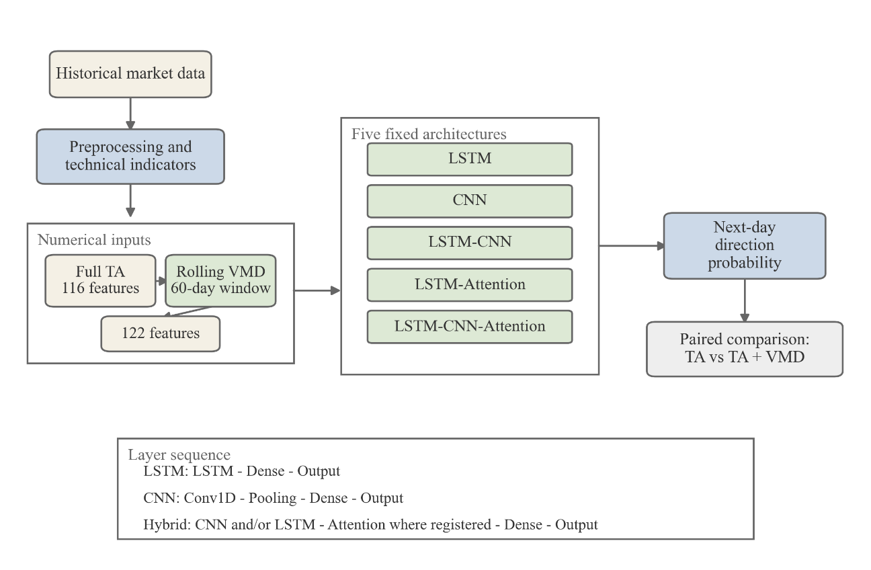
Figure 4. Numerical inputs, causal VMD and registered architectures. The 116-feature technical-analysis representation is compared with a 122-feature representation obtained by adding six variables from causal rolling VMD fitted to a trailing 60-day window. Both representations are evaluated through the same five-model panel.
3.6 Multimodal falsification and Bull/Bear/Leader evaluation
Observed predicted news features were compared with a date-matched Market-Only arm and four falsification controls: News-Only, date-shuffled news, news lagged by five rows and matched random features. All arms retained the frozen architecture, window, cohort, seeds and training budget. The registered family comprised 100 model-control cells and 400 fits. Primary contrasts were Observed-News minus Market-Only and Observed-News minus Shuffled-News; the remaining controls are retained in the complete evidence bundle.
Local relevance and sentiment pipelines were evaluated annually on out-of-sample pairs, while the LLM benchmark used a separate locked design. A class-stratified set of 60 pairs from 2022 was used once to validate prompts before the 2023 cohort was opened. The Bull worker, Bear worker and Leader used the same proprietary model under distinct prompts; the Leader returned positive, neutral and negative probabilities and a scalar sentiment score. Controls were one pass, three identical-prompt self-consistency passes matching the role-system call count and four passes within the frozen +/-15% cost band. Accuracy was the primary intrinsic endpoint, Macro-F1 was supporting evidence, uncertainty was clustered by article and the two Leader contrasts were Holm-adjusted.
The audited downstream forecasting route uses expanding out-of-sample Local-NLP daily features together with the registered Market-Only, News-Only, shuffled-news, lagged-news and random-feature controls. The Bull/Bear/Leader system is evaluated separately on the locked 2023 intrinsic sentiment cohort, and its sentiment accuracy is not interpreted as evidence of downstream forecasting value. Figure 5 summarizes these two distinct audit components.
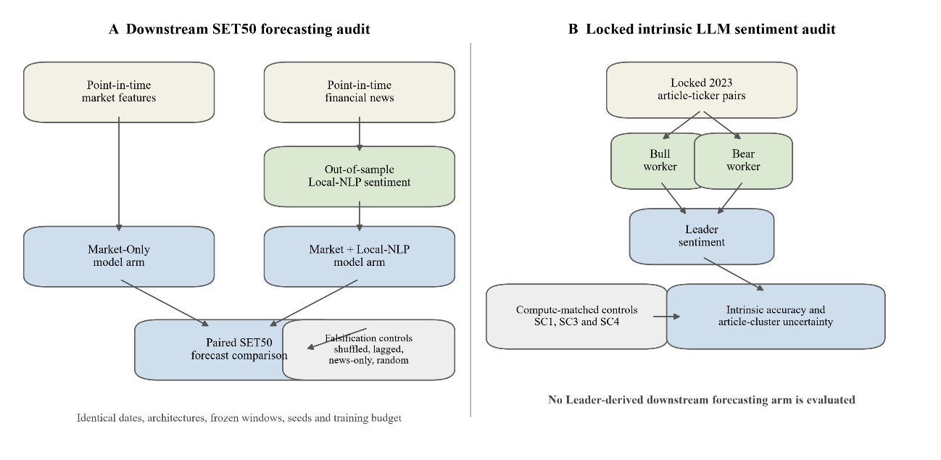
Figure 5. Separate multimodal forecasting and role-structured sentiment audits. The forecasting experiment compares Market-Only with point-in-time Local-NLP predicted news and its falsification controls. The locked 2023 Bull/Bear/Leader benchmark is evaluated only against compute-matched sentiment controls and is not used as a downstream forecasting arm.
3.7 Causal market regimes and SHAP selection
Daily regimes are assigned without future information using the causal trend score in Eq. (5a). H contains the six return horizons in Eq. (5b); sigma_(t,v(h)) is trailing volatility, with v(h)=20 sessions for h up to 20 and 60 sessions for h=60. ADX_(14,t) scales trend strength and EWMA_3 smooths the composite score.
$z_{t}=EWMA_{3\left[\left(\frac{ADX_{14,t}}{100}\right)\sum_{h∈H}{\frac{w_{h}R_{t,h}}{σ_{t,v\left(h\right)}sqrt\left(h\right)}}\right]}$ (5a)
$H=\left\{1,3,5,10,20,60\right\}, w=\left(0.05,0.10,0.15,0.20,0.25,0.25\right)$ (5b)
For outer fold f, the symmetric deadband lambda_f in Eq. (5c) is the 35th percentile of absolute training-fold scores only. Date t is Bull when z_t exceeds lambda_f, Bear when z_t is below -lambda_f, and Sideway otherwise. The state at t routes the prediction for t+1; targets and future columns are never used in regime construction.
$λ_{f}=Q_{\left(0.35\right)\left(\left\{\left|z_{t}\right|:t∈T_{f}\right\}\right)}$ (5c)
SHAP rankings used Gradient Explainer with 100 training-only background sequences, at most 128 evenly spaced training ranking sequences, 200 samples, deterministic cell seeds and float32 tensors. Candidate feature counts were 10, 20, 30, 40, 60, 80, 100 and 122. A one-standard-error rule with balanced-accuracy, model-error, RMSE and temporal-Jaccard guardrails selected the smallest stable subset. Frozen counts were 122 globally, 30 for Bull, 122 for Sideway and 80 for Bear; a Spearman selector used the same counts as a size-matched comparator.
Within regime r, feature j is ranked by the mean absolute SHAP value in Eq. (6), computed only from the training ranking set T_r. The selected set S_r(k) contains the k highest-ranked features.
$I_{r,j}=\frac{1}{\left|T_{r}\right|\sum_{i∈T_{r}\left|ϕ_{i,j}\right|}{}}, S_{r\left(k\right)}=TopK_{j\left(I_{r,j}\right)}$ (6)
Seven outer arms separated routing, capacity and selector effects: Global-All, Global3-All, Global-SHAP, Global-Spearman, Regime-All, Regime-SHAP and Regime-Spearman. Because the global selector retained all 122 features, Global-SHAP and Global-Spearman are identity controls; the primary selector contrast is Regime-SHAP minus Regime-All. LIME was an explanation-fidelity diagnostic only: 1,800 instance-repeat explanations used an R^2 < 0.70 threshold for low fidelity, failed repeats remained in the denominator and LIME did not affect training or selection.
3.8 Metrics and statistical inference
Balanced accuracy is the primary forecasting endpoint. Direction accuracy, MCC, coverage, RMSE and MAE are secondary where applicable; AUC and Brier score are reported for probabilistic 2026 objectives. Seeds are averaged within each model-year cell before temporal inference and are not treated as independent market samples.
Balanced accuracy is defined in Eq. (7), giving equal weight to sensitivity and specificity.
$BAcc=\frac{1}{2\left(\frac{TP}{TP+FN}+\frac{TN}{TN+FP}\right)}$ (7)
Historical paired contrasts use exact two-sided sign-flip tests over four outer-year effects; the minimum attainable two-sided p-value is 0.125. Descriptive t intervals communicate uncertainty but do not override the exact test and Holm adjustment controls the registered familywise error rate. A 10-day circular moving-block bootstrap provides a serial-dependence sensitivity (Politis & Romano, 1992) Intrinsic LLM intervals use 5,000 article-cluster bootstrap replicates, article-cluster sign-flip sensitivity and Holm adjustment across the two accuracy contrasts. Economic summaries are exploratory and are not used to certify deployment. Figure 6 summarizes causal regime routing, train-only SHAP selection and the temporal inference hierarchy.
For paired arms A and B, Eq. (8a) first averages the five seed-level balanced-accuracy differences within each architecture m and outer year y, and then averages the four year effects. Equations (8b)-(8c) define the 16 sign-flipped test statistics and their exact two-sided probability.
$Δ_{m,y}=\frac{1}{5}\sum_{s=1}^{5\left(BAcc_{m,y,s}^{A}-BAcc_{m,y,s}^{B}\right)}{}, Δmean_{m}=\frac{1}{4}\sum_{y=2022}^{2025}{Δ_{m,y}}$ (8a)
$T_{j}=\frac{1}{4}\sum_{y=1}^{4}{ε_{\left(j,y\right)Δ_{m,y}}}, ε_{j,y}∈\left\{-1,+1\right\}, j=1,…,16$ (8b)
$p_{exact}=\frac{1}{16}\sum_{j=1}^{16}{I\left(\left|T_{j}\right|≥\left|Δmean_{m}\right|\right)}$ (8c)

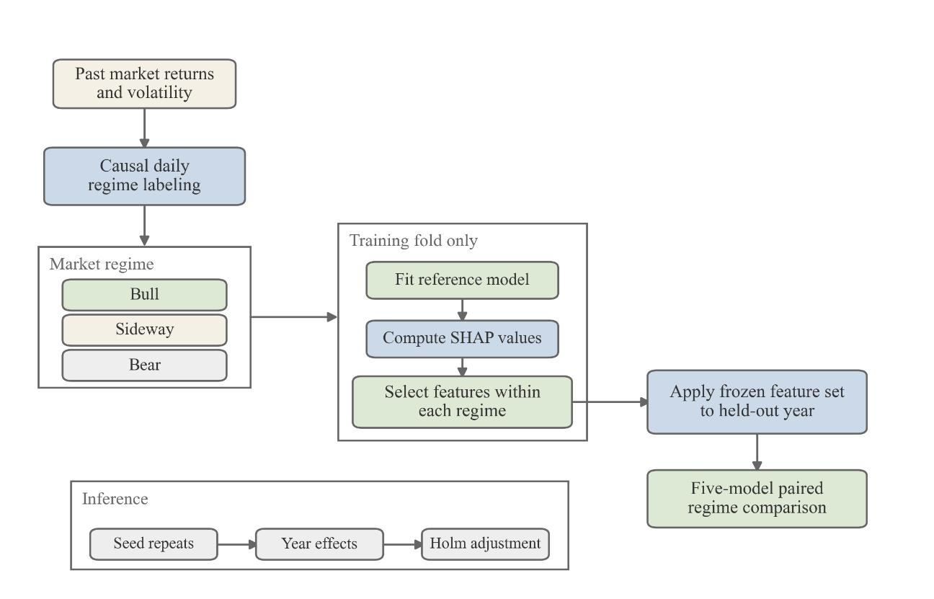
Figure 6. Causal regime-aware SHAP selection and inference. Past returns and volatility define daily Bull, Sideway and Bear states. The reference model, SHAP values and regime-specific feature subsets are fitted within each training fold, frozen and applied to the held-out year. Paired effects are aggregated across seeds and years before Holm adjustment.
4. Results and Discussion
4.1 Numerical denoising was architecture dependent
Table 2 reports the corrected point-in-time numerical ablation. VMD increased mean balanced accuracy only for LSTM–CNN (+0.35 percentage points) and reduced it for the other four architectures (−0.30 to −0.60 points). Every interval crossed zero and the smallest exact p-value was 0.375. VMD therefore cannot be described as a generally beneficial denoiser for next-day direction.
Table 2. Corrected point-in-time numerical ablation for Full-TA versus Full-TA plus causal rolling VMD, 2022-2025. Balanced accuracy effects are based on four outer years after within-fold seed aggregation; runtime is reported per seed-fold cell.
Architecture | W | Full-TA BAcc (%) | +VMD BAcc (%) | Delta pp [95% CI] | Exact p | Runtime s Full / VMD
LSTM | 5 | 53.49 | 53.16 | -0.33 [-1.74, +1.07] | 0.500 | 7.84 / 7.71
CNN | 20 | 52.14 | 51.84 | -0.30 [-1.38, +0.79] | 0.625 | 6.55 / 6.57
LSTM-CNN | 20 | 52.08 | 52.43 | +0.35 [-1.61, +2.32] | 0.625 | 14.26 / 14.55
LSTM-Attention | 10 | 52.51 | 52.01 | -0.50 [-3.48, +2.49] | 0.750 | 14.21 / 15.55
LSTM-CNN-Attention | 20 | 51.58 | 50.98 | -0.60 [-1.98, +0.78] | 0.375 | 20.38 / 19.64
Note: BAcc is balanced accuracy. Values are means over four outer years after within-fold seed aggregation. Runtime is mean model build, fit and evaluation inference time per seed–fold cell; VMD feature generation is not included. The complete selection plus outer numerical protocol recorded 4,158.40 seconds of model fit/inference time
The error and direction endpoints also diverged. In the corrected numerical run, VMD reduced RMSE for LSTM and CNN but reduced their balanced accuracy. Conversely, the small LSTM–CNN balanced-accuracy gain did not imply a universal price-error gain. This is exactly the distinction that a direction-focused audit must preserve.
4.2 Predicted news did not add reliable directional information
The observed-news effect relative to the market-only arm was negative for all five architectures in the serial-dependence sensitivity, ranging from −0.009 points for CNN to −1.895 points for LSTM–Attention (Table 3A). None survived Holm adjustment. Observed news also failed to beat the shuffled-news control after adjustment. Although the unadjusted moving-block intervals for LSTM and LSTM–CNN–Attention versus shuffled news excluded zero in the negative direction, both Holm-adjusted p-values were 0.098. The news-only, five-row lagged-news and random-feature controls likewise produced no adjusted balanced-accuracy superiority. Across the registered exact fold-level families, zero of 30 primary balanced-accuracy contrasts survived Holm correction.
Table 3A. Moving-block bootstrap sensitivity for observed-news effects relative to Market-Only and Shuffled-News controls. Contrasts use the same eligible dates, frozen windows, architectures, seeds and training budgets.
Architecture | Contrast | Delta BAcc pp [95% CI] | Raw p | Holm p | Daily n
LSTM | Observed News - Market-Only | -1.58 [-5.31, +2.11] | 0.404 | 1.000 | 960
LSTM | Observed News - Shuffled News | -3.24 [-5.95, -0.47] | 0.022 | 0.098 | 960
CNN | Observed News - Market-Only | -0.01 [-2.11, +1.99] | 0.993 | 1.000 | 960
CNN | Observed News - Shuffled News | -1.72 [-3.68, +0.05] | 0.057 | 0.171 | 960
LSTM-CNN | Observed News - Market-Only | -0.17 [-1.78, +1.39] | 0.839 | 1.000 | 960
LSTM-CNN | Observed News - Shuffled News | +1.02 [-0.88, +3.08] | 0.308 | 0.616 | 960
LSTM-Attention | Observed News - Market-Only | -1.89 [-4.75, +0.84] | 0.175 | 0.701 | 960
LSTM-Attention | Observed News - Shuffled News | +0.13 [-1.37, +1.56] | 0.853 | 0.853 | 960
LSTM-CNN-Attention | Observed News - Market-Only | -1.22 [-2.80, +0.22] | 0.096 | 0.481 | 960
LSTM-CNN-Attention | Observed News - Shuffled News | -1.78 [-3.42, -0.27] | 0.020 | 0.098 | 960
Note: Each contrast uses 960 paired eligible daily directional rows. The moving-block analysis is a serial-dependence sensitivity; registered fold-level exact tests govern the primary historical inference.
The negative-control result should not be interpreted as proof that news has no financial information. It shows that this dated, aggregated, out-of-sample sentiment representation did not provide a robust conditional increment beyond the numerical pipeline. The 2024–2025 official headlines were also much shorter than the labelled headline proxies (approximately 65 versus 260 characters on average) and sentiment confidence fell from 0.756 in 2023 to about 0.495, documenting a material source shift.
4.3 The LLM role system improved intrinsic sentiment
The local sentiment classifier achieved out-of-sample accuracies of 81.24%, 81.55%, 83.43%, 79.85% and 82.82% for 2019–2023, respectively; 2023 Macro-F1 was 78.44%. The 2023 relevance classifier achieved 88.85% accuracy and 85.91% Macro-F1.
On the locked 2023 intrinsic cohort, a one-call LLM scored 69.84% accuracy, the three-pass self-consistency control 70.67%, the four-pass control 70.59% and the Bull/Bear/Leader system 76.59%. Table 3B shows that the Leader retained an advantage of 5.93–6.00 points under equal-call and near-cost controls. Both article-cluster intervals excluded zero and both comparisons remained significant after Holm adjustment.
Table 3B. Locked 2023 intrinsic sentiment benchmark for single-pass, compute-matched self-consistency and Bull/Bear/Leader systems. Accuracy is the primary endpoint; uncertainty is clustered by article and the two Leader contrasts are Holm-adjusted.
Comparison | Pairs | Articles | Control accuracy (%) | Leader accuracy (%) | Delta pp [95% CI] | Holm p
Leader - SC3 (equal calls) | 1333 | 738 | 70.67 | 76.59 | +5.93 [+3.49, +8.49] | <0.001
Leader - SC4 (near cost) | 1333 | 738 | 70.59 | 76.59 | +6.00 [+3.61, +8.48] | <0.001
Note: Table 3B reports intrinsic sentiment performance on the locked 2023 cohort. These results must not be interpreted as evidence of downstream SET50 forecasting value.
4.4 Regime-SHAP selection helped one architecture but did not generalize
The primary Regime-SHAP minus Regime-All contrast is reported in Table 4.
Table 4. Primary regime-specific SHAP reduction contrast by architecture. The contrast is Regime-SHAP minus Regime-All after seeds are averaged within each outer year; SHAP values are fitted-model attributions rather than causal effects.
Architecture | Delta BAcc (pp) | 95% CI | Exact p | Holm p
LSTM | -0.10 | [-1.75, +1.55] | 1.000 | 1.000
CNN | +1.46 | [-0.09, +3.01] | 0.125 | 0.625
LSTM-CNN | +0.05 | [-2.45, +2.55] | 1.000 | 1.000
LSTM-Attention | -1.03 | [-2.19, +0.12] | 0.125 | 0.625
LSTM-CNN-Attention | -0.74 | [-3.10, +1.62] | 0.500 | 1.000
Note: The contrast is Regime-SHAP minus Regime-All. Seeds are averaged within outer years before inference. SHAP values are fitted-model attributions, not causal effects of market variables.
Separately, the post-hoc integrated 2×2 robustness analysis crossed global versus Regime-SHAP numerical inputs with absence versus presence of Local-NLP predicted news on the 2019–2025 common cohort. The highest mean balanced accuracy was 54.07% for LSTM–CNN with Regime-SHAP numerical inputs without news. Adding news within the regime-selected arm improved mean balanced accuracy for two of five models (LSTM +0.13 and LSTM–Attention +1.03 points) and reduced it for the other three. No balanced-accuracy contrast survived Holm adjustment. The complete factorial is retained as post-hoc integrated evidence in Table S5 rather than promoted as a success claim.
LIME did not provide an independent validation of SHAP. Of 1,800 registered instance–repeat explanations, 1,293 (71.83%) had local surrogate (R^2<0.70). Low-fidelity repeats were retained and disclosed. Because the diagnostic failed for most repetitions, complete LIME agreement and stability tables are placed in the Supplement and no feature-level causal narrative is built from them.
4.5 Partial-2026 performance exposed majority-side collapse
Before opening the 2026 observations, the five architectures, windows, features, seeds, objectives, thresholds and economic rules were frozen. The registered Yahoo Finance source failed its overlap and availability gate, after which a dated deviation accepted the Investing.com historical interface; the 138-row sample from 5 January to 30 July 2026 is therefore source-contingent. Direct models predicted Up with sigmoid binary cross-entropy. Multitask models added a standardized next-day log-return head with direction BCE weight 1.0 and return MSE weight 0.25, using train-only return scaling. Threshold candidates 0.50, 0.55, 0.60 and 0.65 were evaluated on 2019-2021 validation data; all ten model-objective cells failed the registered gate and reverted to 0.50.
The same frozen extension evaluated an exploratory next-session open-to-close proxy for long/flat and long/short rules at 5, 10 and 20 basis points per active round trip. The full grid is retained in the Supplement. These short-sample economic outputs are descriptive diagnostics, not evidence of profitability or deployment readiness.
The 138-row partial-2026 stress test provided weak and objective-dependent evidence (Table 5A). Direct LSTM had the highest balanced accuracy at 54.42% and MCC 0.088, but its direction accuracy was only 52.90%. LSTM multitask had the highest raw direction accuracy, 59.42%, but balanced accuracy fell to 51.40%. Several CNN and LSTM–CNN–Attention cells obtained 58.70% raw accuracy, exactly matching the Up-class share, while balanced accuracy was 50% and MCC was zero. These cells predicted only the majority side. The apparent accuracy was therefore not directional discrimination.
Table 5A. Source-contingent partial-2026 forward robustness across five architectures and two registered objectives. Direction accuracy, balanced accuracy, MCC, AUC, Brier score and prediction-side prevalence are reported using the validation-gate fallback threshold of 0.50.
Architecture | Objective | n | Accuracy (%) | BAcc (%) | MCC | AUC | Brier
LSTM | Multitask | 138 | 59.42 | 51.40 | 0.074 | 0.502 | 0.249
LSTM | Direct | 138 | 52.90 | 54.42 | 0.088 | 0.533 | 0.250
CNN | Multitask | 138 | 58.70 | 50.00 | 0.000 | 0.494 | 0.249
CNN | Direct | 138 | 58.70 | 50.00 | 0.000 | 0.496 | 0.249
LSTM-CNN | Multitask | 138 | 58.70 | 50.00 | 0.000 | 0.517 | 0.249
LSTM-CNN | Direct | 138 | 49.28 | 52.11 | 0.044 | 0.485 | 0.250
LSTM-Attention | Multitask | 138 | 57.97 | 51.20 | 0.038 | 0.512 | 0.249
LSTM-Attention | Direct | 138 | 55.80 | 49.61 | -0.011 | 0.507 | 0.249
LSTM-CNN-Attention | Multitask | 138 | 58.70 | 50.00 | 0.000 | 0.515 | 0.249
LSTM-CNN-Attention | Direct | 138 | 58.70 | 50.00 | 0.000 | 0.484 | 0.249
Note: All objectives used the validation-gate fallback threshold 0.50. The positive-class share was 58.70%. This is a source-contingent partial year, not a full-year or live deployment result.
The complete 10-basis-point economic grid is exploratory. Its best observed cell direct LSTM–CNN, long/flat—had 34.31% coverage, 8.55% net cumulative return, annualized Sharpe 1.75, maximum drawdown −3.54% and break-even cost 27.91 basis points over 137 executable rows. Its Deflated-Sharpe probability was only 0.441, below 0.5. This short, selected result is therefore reported as a diagnostic sensitivity, not evidence of profitability or deployment readiness
4.6 Frozen SET100 transfer was uniformly weaker
SET100 transfer retained the same 122 numerical features, frozen windows, seeds, epochs and 2022-2025 outer years as the matched SET50 global numerical comparator. Features, VMD and scaling were reconstructed within each SET100 fold; no SET100 retuning, Optuna search, early stopping, or model exclusion was allowed. All 100 planned fits (five models x four years x five seeds) completed.
SET100 news was excluded because a historically point-in-time constituent and news universe was unavailable; adding SET50-oriented news would have made the comparison asymmetric. The matched SET50 arm is therefore the Full-TA+VMD global numerical comparator rather than the later integrated regime-news arm. Because SET50 is nested within SET100 and both share the exchange, macro regimes, period and many constituents, this is a same-exchange breadth transfer rather than external-market validation (The Stock Exchange of Thailand, n.d.-a, n.d.-b)
Mean balanced accuracy declined on SET100 for all five architectures by 0.95 to 2.17 percentage points (Table 5B). CNN had the highest SET100 balanced accuracy at 51.89%, followed by LSTM at 51.63%; LSTM–CNN–Attention was close to chance at 50.03%. No paired cross-index difference survived Holm adjustment. Although CNN was lower on SET100 in all four years and its descriptive interval excluded zero, the exact p-value was 0.125 and the Holm p-value was 0.625. It is not a statistically established degradation.
Table 5B. Frozen SET100 same-exchange numerical transfer. SET100 uses the same 122 numerical features, architecture-specific windows, seeds, epochs and 2022-2025 outer years as the matched SET50 comparator, without SET100 retuning.
Architecture | W | SET50 BAcc (%) | SET100 BAcc (%) | Delta pp [95% CI] | Holm p
LSTM | 5 | 53.12 | 51.63 | -1.50 [-6.14, +3.15] | 1.000
CNN | 20 | 53.08 | 51.89 | -1.19 [-2.08, -0.31] | 0.625
LSTM-CNN | 20 | 52.68 | 50.51 | -2.17 [-6.56, +2.23] | 1.000
LSTM-Attention | 10 | 52.37 | 51.42 | -0.95 [-2.99, +1.08] | 1.000
LSTM-CNN-Attention | 20 | 51.10 | 50.03 | -1.07 [-6.85, +4.71] | 1.000
Note: Matched SET50 is the frozen 122-feature global numerical comparator, not the final post-hoc integrated regime–news arm. SET100 is a broader, overlapping index on the same exchange and is not an external-market replication.
Figure 7 summarizes architecture-wise point estimates across the completed audit pillars, while corresponding uncertainty and multiplicity-adjusted results remain in Tables 2, 3A, 4 and 5B.

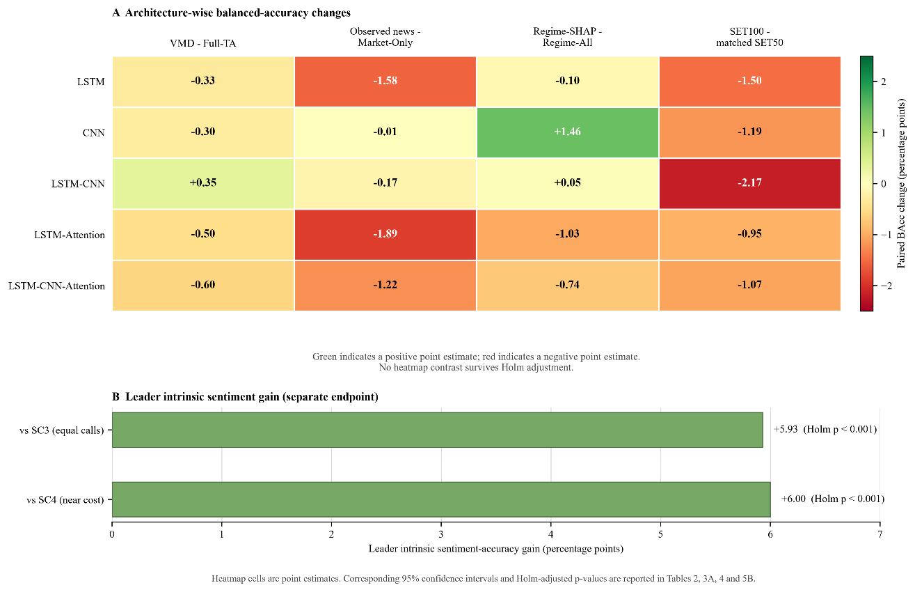
Figure 7. Architecture-wise point-estimate summary across completed audit pillars. Heatmap cells report paired balanced-accuracy changes in percentage points for VMD, Observed-News versus Market-Only, Regime-SHAP versus Regime-All and SET100 minus matched SET50; green denotes positive and red denotes negative point estimates. The lower panel reports the Leader's intrinsic sentiment-accuracy gains over compute-matched controls as a separate endpoint. Confidence intervals and Holm-adjusted p-values are reported in Tables 2, 3A, 4 and 5B.
5. Conclusion
Under a common point-in-time protocol, the five frozen architectures showed modest but architecture-dependent next-day SET50 directional structure rather than a universally superior configuration. Causal rolling VMD changed balanced accuracy by only -0.60 to +0.35 percentage points, predicted Local-NLP news did not survive the registered falsification and multiplicity controls and regime-specific SHAP improved CNN while producing mixed or negative effects elsewhere. The Bull/Bear/Leader system delivered a clear intrinsic sentiment advantage over compute-matched self-consistency, but that endpoint is distinct from downstream forecasting value. Partial-2026 testing exposed majority-side collapse in several objectives and frozen SET100 transfer weakened all five models. Collectively, the findings support the paper's central contribution: a reproducible audit framework that distinguishes selected component gains from improvements that remain reliable across time, architectures, controls and transfer settings.
Limitations: Temporal inference is based on four outer test years, so the exact sign-flip design has limited power and cannot establish small but consistent effects below its attainable p-value resolution. The 2026 sample is partial-year and source-contingent, SET100 is an overlapping same-exchange index rather than an independent market and news coverage varies in source, length, labelling and timestamp precision across periods. The LLM roles share one proprietary base model and intrinsic sentiment gains do not isolate debate as the unique mechanism or guarantee forecasting value. SHAP describes fitted-model attribution rather than causal market effects, while the low-fidelity LIME diagnostic limits feature-level interpretation. These constraints bound the claims to reliability under the audited SET setting rather than universal market predictability or deployment readiness.
Future work: The next study should preregister the complete protocol before opening a full untouched forward year, evaluate at least one independent ASEAN or comparable emerging-market index and construct a consistently licensed point-in-time news archive with verifiable publication timestamps and constituent membership. The Leader-derived forecasting arm should be frozen and assessed on an identical common cohort with article coverage, latency, cost, failures and paired uncertainty reported alongside predictive metrics. Model development should then focus on a single prespecified architecture and calibration strategy, followed by prospective shadow evaluation, rather than further selection on the already inspected 2022-2026 outcomes.
Acknowledgements
The authors thank their respective institutions for providing the research environment in which this study was conducted.
Reproducibility and data availability
The reproducibility package contains the model and evaluation code, fixed seeds, architecture and window specifications, temporal split definitions, point-in-time data contracts, prompt and protocol hashes, aggregate outputs, runtime and cost ledgers and non-reconstructive integrity summaries. Raw SET50 and SET100 market rows are not redistributed; they can be obtained from the publicly accessible Investing.com historical data pages subject to the provider's terms. Official 2024-2025 headlines remain subject to the Stock Exchange of Thailand website terms and Bilingual StockTBSA is available from its public repository under the licence stated in its dataset card. Processed artifacts are shared only when they do not permit reconstruction of restricted raw records. The archival repository URL or DOI will be added after deposit.
References
Adebayo, J., Gilmer, J., Muelly, M., Goodfellow, I., Hardt, M., & Kim, B. (2018). Sanity Checks for Saliency Maps. Advances in Neural Information Processing Systems, 31. https://proceedings.neurips.cc/paper_files/paper/2018/hash/294a8ed24b1ad22ec2e7efea049b8737-Abstract.html
Arnott, R. D., Harvey, C. R., & Markowitz, H. (2019). A Backtesting Protocol in the Era of Machine Learning. The Journal of Financial Data Science, 1(1), 64–74. https://doi.org/10.3905/jfds.2019.1.064
Bailey, D. H., & López de Prado, M. (2014). The Deflated Sharpe Ratio: Correcting for Selection Bias, Backtest Overfitting, and Non-Normality. The Journal of Portfolio Management, 40(5), 94–107. https://doi.org/10.3905/jpm.2014.40.5.094
Bergmeir, C., Hyndman, R. J., & Koo, B. (2018). A Note on the Validity of Cross-Validation for Evaluating Autoregressive Time Series Prediction. Computational Statistics & Data Analysis, 120, 70–83. https://doi.org/10.1016/j.csda.2017.11.003
Brodersen, K. H., Ong, C. S., Stephan, K. E., & Buhmann, J. M. (2010). The Balanced Accuracy and Its Posterior Distribution. 2010 20th International Conference on Pattern Recognition, 3121–3124. https://doi.org/10.1109/ICPR.2010.764
Dong, Y., Wu, F., Zhang, K., Dai, Y., Zhang, S., Ye, W., Chen, S., & Cheng, Z.-Q. (2025). Large Language Model Agents in Finance: A Survey Bridging Research, Practice, and Real-World Deployment. Findings of the Association for Computational Linguistics: EMNLP 2025, 17889–17907. https://doi.org/10.18653/v1/2025.findings-emnlp.972
Dragomiretskiy, K., & Zosso, D. (2014). Variational Mode Decomposition. IEEE Transactions on Signal Processing, 62(3), 531–544. https://doi.org/10.1109/TSP.2013.2288675
Du, Y., Li, S., Torralba, A., Tenenbaum, J. B., & Mordatch, I. (2024). Improving Factuality and Reasoning in Language Models through Multiagent Debate. Proceedings of the 41st International Conference on Machine Learning, Proceedings of Machine Learning Research, 235, 11733–11763. https://proceedings.mlr.press/v235/du24e.html
Fama, E. F. (1970). Efficient Capital Markets: A Review of Theory and Empirical Work. The Journal of Finance, 25(2), 383–417. https://doi.org/10.1111/j.1540-6261.1970.tb00518.x
Fischer, T., & Krauss, C. (2018). Deep Learning with Long Short-Term Memory Networks for Financial Market Predictions. European Journal of Operational Research, 270(2), 654–669. https://doi.org/10.1016/j.ejor.2017.11.054
Hochreiter, S., & Schmidhuber, J. (1997). Long Short-Term Memory. Neural Computation, 9(8), 1735–1780. https://doi.org/10.1162/neco.1997.9.8.1735
Holm, S. (1979). A Simple Sequentially Rejective Multiple Test Procedure. Scandinavian Journal of Statistics, 6(2), 65–70. https://doi.org/10.2307/4615733
Hoseinzade, E., & Haratizadeh, S. (2019). CNNpred: CNN-Based Stock Market Prediction Using a Diverse Set of Variables. Expert Systems with Applications, 129, 273–285. https://doi.org/10.1016/j.eswa.2019.03.029
Investing.com. (n.d.-a). SET 50 Historical Data. Retrieved https://th.investing.com/indices/set-50-historical-data
Investing.com. (n.d.-b). SET 100 Historical Data. Retrieved https://www.investing.com/indices/set-100-historical-data
Liang, T., He, Z., Jiao, W., Wang, X., Wang, Y., Wang, R., Yang, Y., Shi, S., & Tu, Z. (2024). Encouraging Divergent Thinking in Large Language Models through Multi-Agent Debate. Proceedings of the 2024 Conference on Empirical Methods in Natural Language Processing, 17889–17904. https://doi.org/10.18653/v1/2024.emnlp-main.992
Liu, T., Ma, X., Li, S., Li, X., & Zhang, C. (2022). A Stock Price Prediction Method Based on Meta-Learning and Variational Mode Decomposition. Knowledge-Based Systems, 252, 109324. https://doi.org/10.1016/j.knosys.2022.109324
Liu, W.-J., Ge, Y.-B., & Gu, Y.-C. (2024). News-Driven Stock Market Index Prediction Based on Trellis Network and Sentiment Attention Mechanism. Expert Systems with Applications, 250, 123966. https://doi.org/10.1016/j.eswa.2024.123966
Liu, Y., Huang, S., Tian, X., Zhang, F., Zhao, F., & Zhang, C. (2024). A Stock Series Prediction Model Based on Variational Mode Decomposition and Dual-Channel Attention Network. Expert Systems with Applications, 238, 121708. https://doi.org/10.1016/j.eswa.2023.121708
Lundberg, S. M., & Lee, S.-I. (2017). A Unified Approach to Interpreting Model Predictions. Advances in Neural Information Processing Systems, 30. https://proceedings.neurips.cc/paper_files/paper/2017/hash/8a20a8621978632d76c43dfd28b67767-Abstract.html
Luo, D., Liao, W., Li, S., Cheng, X., & Yan, R. (2023). Causality-Guided Multi-Memory Interaction Network for Multivariate Stock Price Movement Prediction. Proceedings of the 61st Annual Meeting of the Association for Computational Linguistics (Volume 1: Long Papers), 12164–12176. https://doi.org/10.18653/v1/2023.acl-long.679
Moskowitz, T. J., Ooi, Y. H., & Pedersen, L. H. (2012). Time Series Momentum. Journal of Financial Economics, 104(2), 228–250. https://doi.org/10.1016/j.jfineco.2011.11.003
Olorunnimbe, K., & Viktor, H. (2023). Deep Learning in the Stock Market—A Systematic Survey of Practice, Backtesting, and Applications. Artificial Intelligence Review, 56(3), 2057–2109. https://doi.org/10.1007/s10462-022-10226-0
Pagan, A. R., & Sossounov, K. A. (2003). A Simple Framework for Analysing Bull and Bear Markets. Journal of Applied Econometrics, 18(1), 23–46. https://doi.org/10.1002/jae.664
Politis, D. N., & Romano, J. P. (1992). A Circular Block-Resampling Procedure for Stationary Data. In R. LePage & L. Billard (Eds.), Exploring the Limits of Bootstrap (pp. 263–270). John Wiley & Sons.
Qin, Y., Song, D., Chen, H., Cheng, W., Jiang, G., & Cottrell, G. W. (2017). A Dual-Stage Attention-Based Recurrent Neural Network for Time Series Prediction. Proceedings of the Twenty-Sixth International Joint Conference on Artificial Intelligence, 2627–2633. https://doi.org/10.24963/ijcai.2017/366
Ribeiro, M. T., Singh, S., & Guestrin, C. (2016). “Why Should I Trust You?”: Explaining the Predictions of Any Classifier. Proceedings of the 22nd ACM SIGKDD International Conference on Knowledge Discovery and Data Mining, 1135–1144. https://doi.org/10.1145/2939672.2939778
Sawhney, R., Agarwal, S., Wadhwa, A., & Shah, R. R. (2020). Deep Attentive Learning for Stock Movement Prediction From Social Media Text and Company Correlations. Proceedings of the 2020 Conference on Empirical Methods in Natural Language Processing, 8415–8426. https://doi.org/10.18653/v1/2020.emnlp-main.676
Sezer, O. B., Gudelek, M. U., & Ozbayoglu, A. M. (2020). Financial Time Series Forecasting with Deep Learning: A Systematic Literature Review: 2005–2019. Applied Soft Computing, 90, 106181. https://doi.org/10.1016/j.asoc.2020.106181
The Stock Exchange of Thailand. (n.d.-a). SET50 Index and SET50FF Index Profile. Retrieved https://www.set.or.th/en/market/index/set50/profile
The Stock Exchange of Thailand. (n.d.-b). SET100 Index and SET100FF Index Profile. Retrieved https://www.set.or.th/en/market/index/set100/profile
Uthayopas, C., Mai-On, C., Phatthiyaphaibun, W., Buaphet, W., Sawatphol, J., Sae Lim, S., Vongkulbhisal, J., Vorawathanabuncha, J., Nutanong, S., & Udomcharoenchaikit, C. (2025). Thai-English Target-Based Stock Sentiment Dataset for Financial News with ICL-Based Evaluation. https://huggingface.co/datasets/airesearch/Bilingual_StockTBSA
Vaswani, A., Shazeer, N., Parmar, N., Uszkoreit, J., Jones, L., Gomez, A. N., Kaiser, Ł., & Polosukhin, I. (2017). Attention Is All You Need. Advances in Neural Information Processing Systems, 30. https://proceedings.neurips.cc/paper_files/paper/2017/hash/3f5ee243547dee91fbd053c1c4a845aa-Abstract.html
Wang, H., Wang, T., & Li, Y. (2020). Incorporating Expert-Based Investment Opinion Signals in Stock Prediction: A Deep Learning Framework. Proceedings of the AAAI Conference on Artificial Intelligence, 34(1), 971–978. https://doi.org/10.1609/aaai.v34i01.5445
Wang, M., Cohen, S. B., & Ma, T. (2024). Modeling News Interactions and Influence for Financial Market Prediction. Findings of the Association for Computational Linguistics: EMNLP 2024, 3302–3314. https://doi.org/10.18653/v1/2024.findings-emnlp.189
Wang, X., Wei, J., Schuurmans, D., Le, Q. V., Chi, E. H., Narang, S., Chowdhery, A., & Zhou, D. (2023). Self-Consistency Improves Chain of Thought Reasoning in Language Models. The Eleventh International Conference on Learning Representations. https://openreview.net/forum?id=1PL1NIMMrw
Wilder, J. W. Jr. (1978). New Concepts in Technical Trading Systems. Trend Research.
Yeo, W. J., Van Der Heever, W., Mao, R., Cambria, E., Satapathy, R., & Mengaldo, G. (2025). A Comprehensive Review on Financial Explainable AI. Artificial Intelligence Review, 58(6), 189. https://doi.org/10.1007/s10462-024-11077-7

