ARDUINO AMALIY IMTIHON SAVOLLARI JAVOBI.

1. Quyidagi elementlardan **Serial Monitor** da tugmani bosilganlik holati haqida ma’lumot beruvchi dastur tuzing

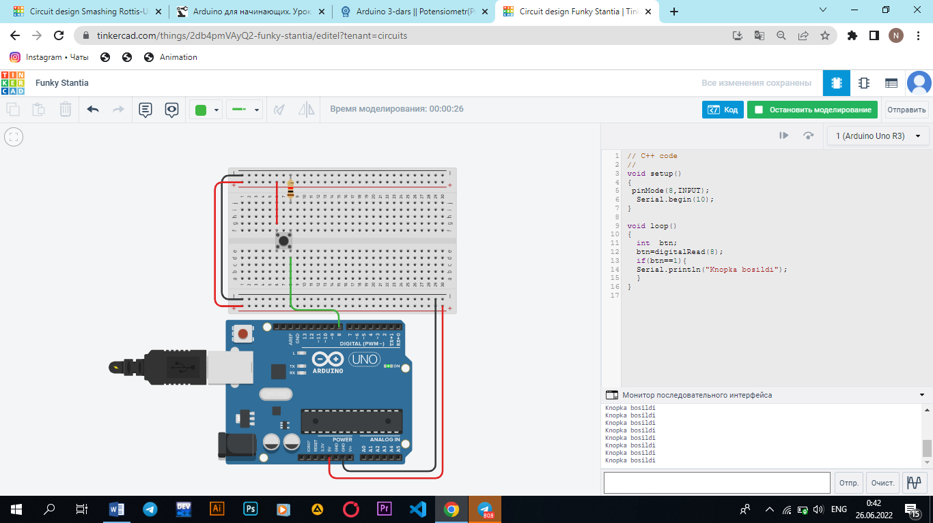

void setup()

{

pinMode(8,INPUT);

Serial.begin(9600);

}

void loop()

{

int btn;

btn=digitalRead(8);

if(btn==1){

Serial.println("Knopka bosildi");

}

}

1. Quyidagi elementlardan Potensiometr ni aylantirganingizda LED yorqinligi o’zgaradigan dasturni tuzing.

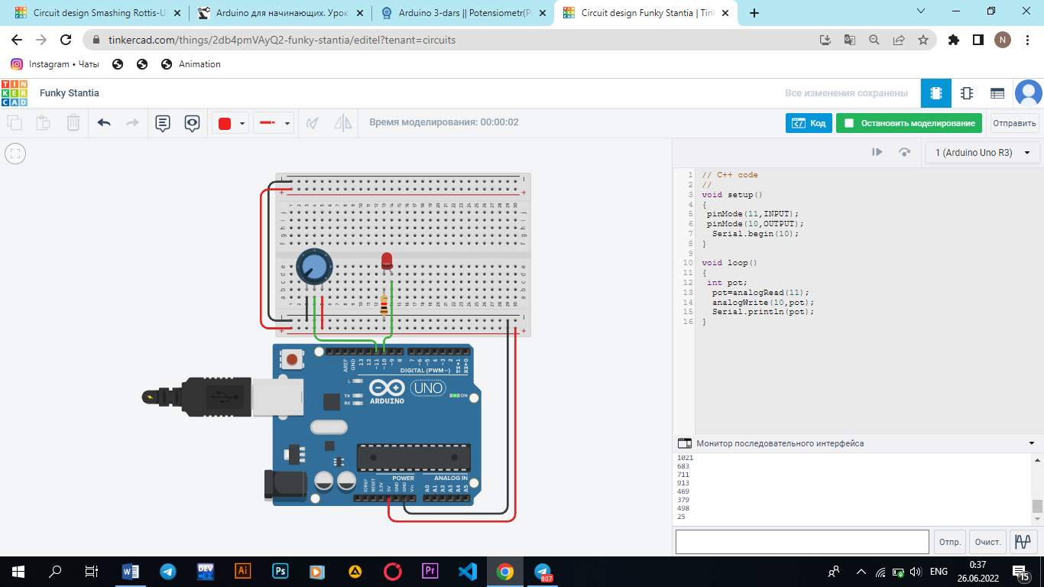

void setup()

{

pinMode(11,INPUT);

pinMode(10,OUTPUT);

Serial.begin(10);

}

void loop()

{

int pot;

pot=analogRead(11);

analogWrite(10,pot);

Serial.println(pot); }

1. Quyidagi elementlardan AnalogWrite funksiyasidan foydalangan holda 1 - LEDni asta o'chiring/yoqing. Loop funksiyai bir marotaba bajarilganda 2 – LED bir soniya davomida yonsin

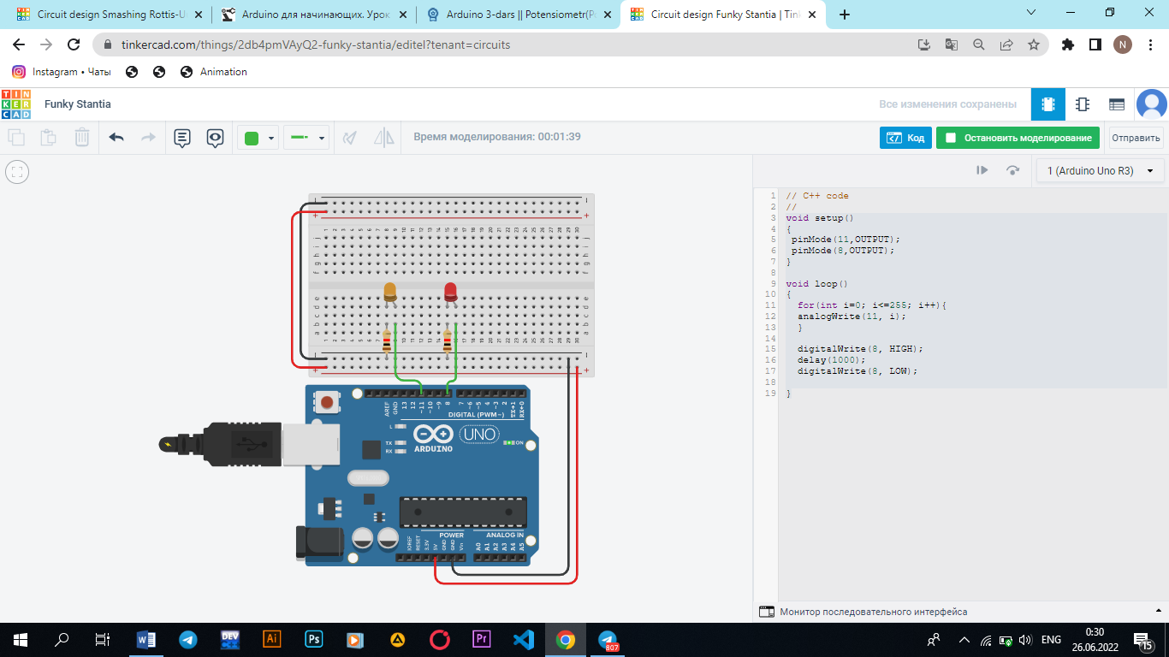

void setup()

{

pinMode(11,OUTPUT);

pinMode(7,OUTPUT);

digitalWrite(7, HIGH);

delay(1000);

digitalWrite(7, LOW);

delay(1000);

}

void loop() {

for(int i=0; i<=255; i++){

analogWrite(11, i); }

for(int j=255; j>1; j--){

analogWrite(11, j); }

}

1. Quyidagi elementlardan Potensiometr ni aylantirganingizda LED lar ketma ket yonadigan dasturni tuzing.

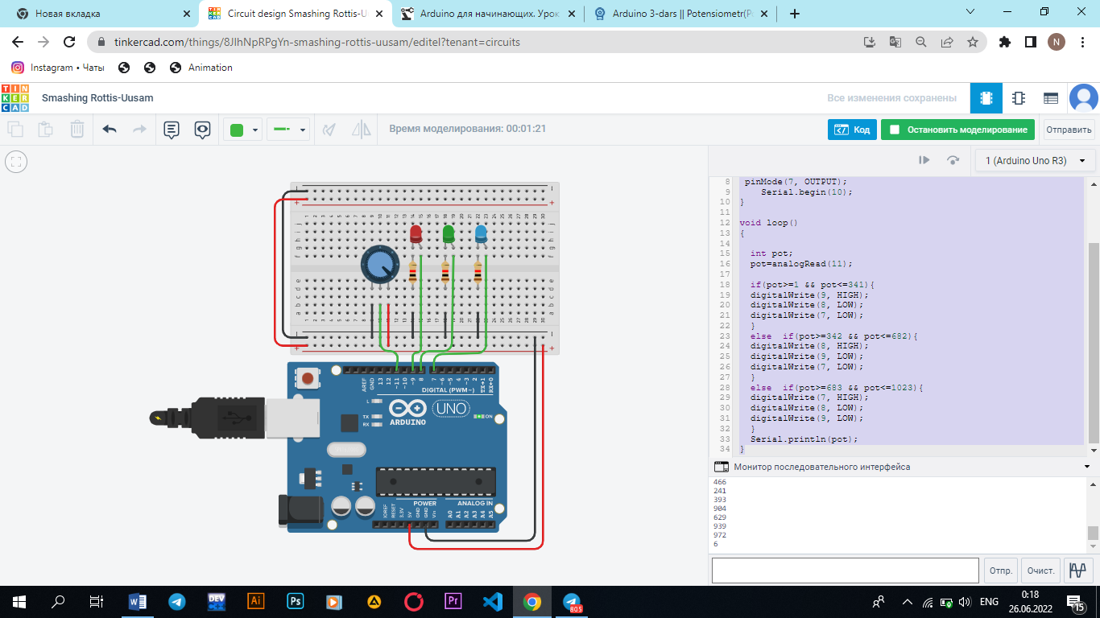

void setup()

{

pinMode(11, INPUT);

pinMode(9, OUTPUT);

pinMode(8, OUTPUT);

pinMode(7, OUTPUT);

Serial.begin(10);

}

void loop()

{

int pot;

pot=analogRead(11);

if(pot>=1 && pot<=341){

digitalWrite(9, HIGH);

digitalWrite(8, LOW);

digitalWrite(7, LOW);

}

else if(pot>=342 && pot<=682){

digitalWrite(8, HIGH);

digitalWrite(9, LOW);

digitalWrite(7, LOW);

}

else if(pot>=683 && pot<=1023){

digitalWrite(7, HIGH);

digitalWrite(8, LOW);

digitalWrite(9, LOW);

}

Serial.println(pot);

}

1. Quyidagi elementlardan 1 - Tugmani bosganingizda 1 -LED yonadigan, 2 – tugmani bosganda 2 - LED yonadigan, 3 – tugmani bosganda 3 - LED yonadigan dasturni tuzing.

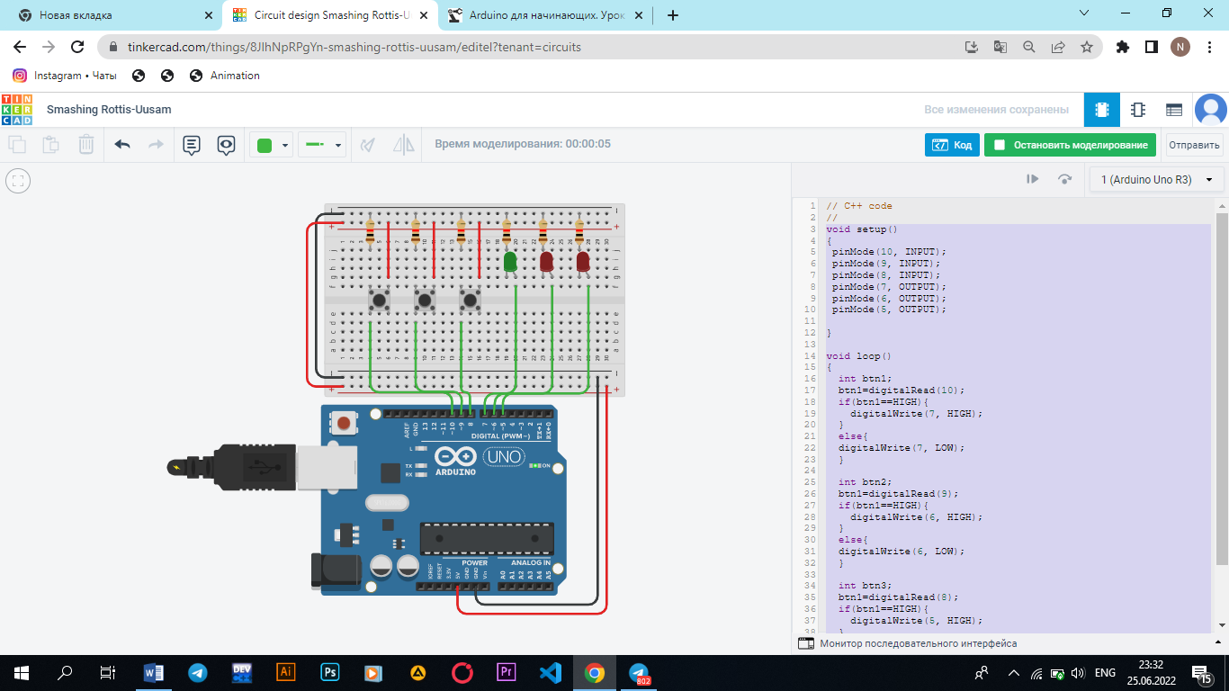

void setup()

{

pinMode(10, INPUT);

pinMode(9, INPUT);

pinMode(8, INPUT);

pinMode(7, OUTPUT);

pinMode(6, OUTPUT);

pinMode(5, OUTPUT);

}

void loop()

{

int btn1;

btn1=digitalRead(10);

if(btn1==HIGH){

digitalWrite(7, HIGH);

}

else{

digitalWrite(7, LOW);

}

int btn2;

btn1=digitalRead(9);

if(btn1==HIGH){

digitalWrite(6, HIGH);

}

else{

digitalWrite(6, LOW);

}

int btn3;

btn1=digitalRead(8);

if(btn1==HIGH){

digitalWrite(5, HIGH);

}

else{

digitalWrite(5, LOW);

}

}

6. Quyidagi elementlardan 1 - Tugmani bosganingizda LED yonadigan, 2 – tugmani bosganda LED o’chadigan dasturni tuzing.

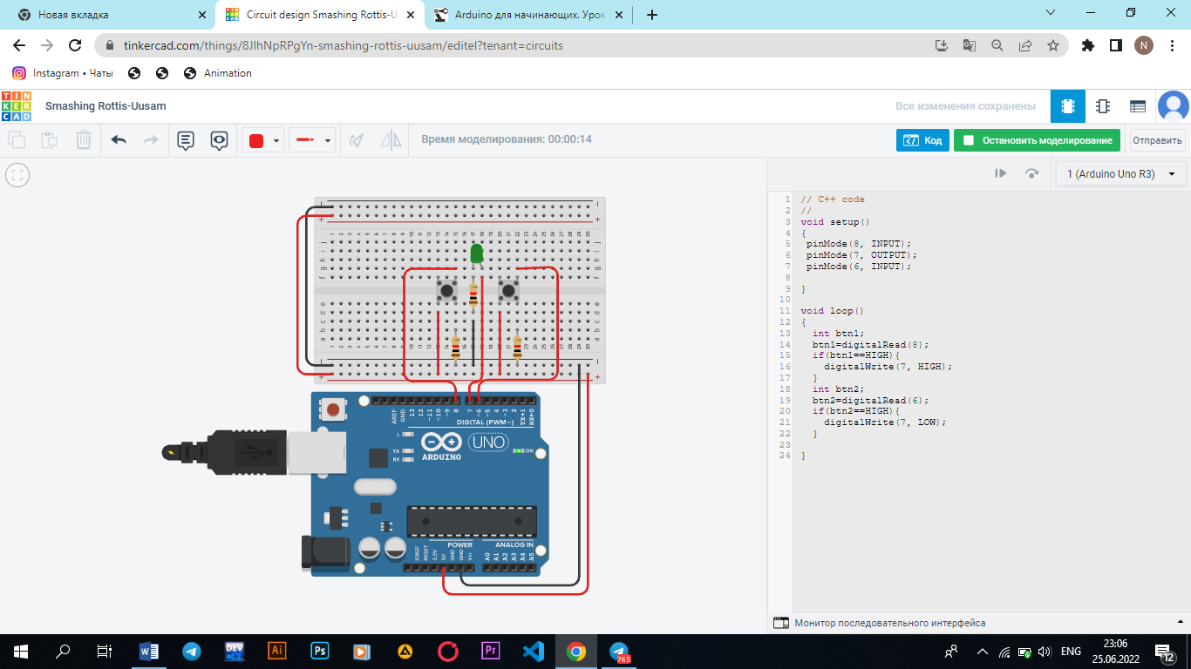

void setup()

{

pinMode(8, INPUT);

pinMode(7, OUTPUT);

pinMode(6, INPUT);

}

void loop()

{

int btn1;

btn1=digitalRead(8);

if(btn1==HIGH){

digitalWrite(7, HIGH);

}

int btn2;

btn2=digitalRead(6);

if(btn2==HIGH){

digitalWrite(7, LOW);

}

}