URL Shortener — Implementation & Test Report

Evidence-based summary of application startup, workflow creation,
Java tests, and automated Maven validation

Project | Agentic Software Engineering System — URL Shortener
Primary components | Spring Boot / Java service and Python orchestration API
Evidence source | Project workflow screenshots and latest apply-and-test results
Report status | Completed — the URL Shortener project workflow was exercised, the analytics test was added and passed, and the recorded Java and Python test checks succeeded. The report reflects the captured results;

LATEST TEST EXECUTION — 22 OCTOBER 2026

1. Executive Summary
This report shows the URL-shortener application and Python orchestrator working together to propose, apply, and test a Java analytics test. The Java service starts on localhost:8080, while the orchestrator exposes its API and Swagger UI on localhost:8000. A brownfield workflow is created for adding URL analytics by short code while preserving existing URL creation and redirect behavior.

2. System Overview
The demonstrated local setup contains two main applications:
- Java URL-shortener service: Spring Boot application on http://localhost:8080.
- Python orchestrator: workflow and implementation API on http://localhost:8000.
- Swagger UI: http://localhost:8000/docs.

3. Demonstrated Workflow
- Start the Java application: The project documentation shows the Spring Boot application being started and a URL-shortening request returning a short code and short URL.
- Start the Python orchestrator: The report shows the Python environment/dependencies being prepared and the FastAPI application starting.
- Open API documentation: Swagger UI is opened at http://localhost:8000/docs.
- Create a brownfield workflow: The stated requirement is to add an endpoint to retrieve URL analytics by short code, preserve URL creation and redirect behavior, add tests, and update API documentation.
- Generate an implementation proposal: The proposal instructions ask the agent to inspect the existing Java architecture, generate complete source/test files, preserve behavior, and include regression tests.
- Apply and test: The latest execution response shows UrlControllerAnalyticsTest.java as the changed file and Maven running the test suite.

4. Test Results
Test suite / class | Tests run | Failures / errors | Result
UrlControllerAnalyticsTest | 1 | 0 / 0 | Passed
UrlControllerTest | 4 | 0 / 0 | Passed
UrlServiceImplTest | 10 | 0 / 0 | Passed
Latest orchestrator response: status=tests_passed, exit_code=0, rollback_performed=false, test_cases_added=1(Generated from Python orchestrator). Maven reported BUILD SUCCESS. The analytics test class ran successfully; the table below lists the test classes with recorded passing results.

5. Issues and Notes
- Timezone / startup issue: The source report records a startup issue and the suggested PowerShell commands `$env:JAVA_TOOL_OPTIONS="-Duser.timezone=Asia/Kolkata"` followed by `mvn spring-boot:run`. The report does not independently establish the underlying root cause.
- Build warnings: The captured Maven output includes a Mockito dynamic-agent warning. It did not cause the build to fail.
- Scope of evidence: The screenshots and logs demonstrate a successful test workflow for the generated analytics test. They do not, by themselves, prove every requested API-documentation change or the full analytics endpoint behavior beyond the test shown.

6. Recommended Next Steps
- Inspect the generated analytics test and controller implementation to ensure the test asserts the intended endpoint contract and response fields.
- Confirm the API documentation was updated as requested and verify the analytics endpoint manually through Swagger or an HTTP request.
- Retain the proposal, changed-file list, test output, and audit event together as a reproducible run record.

7. Screenshot Evidence
The following evidence images are retained from the project screenshots and arranged by topic. Screenshots are reproduced as supplied; any small or low-resolution console text should be verified against the raw logs.

7.1 Application startup
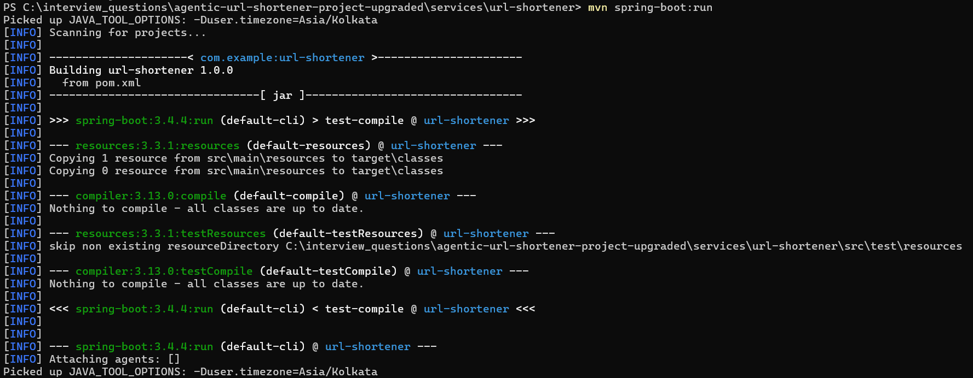
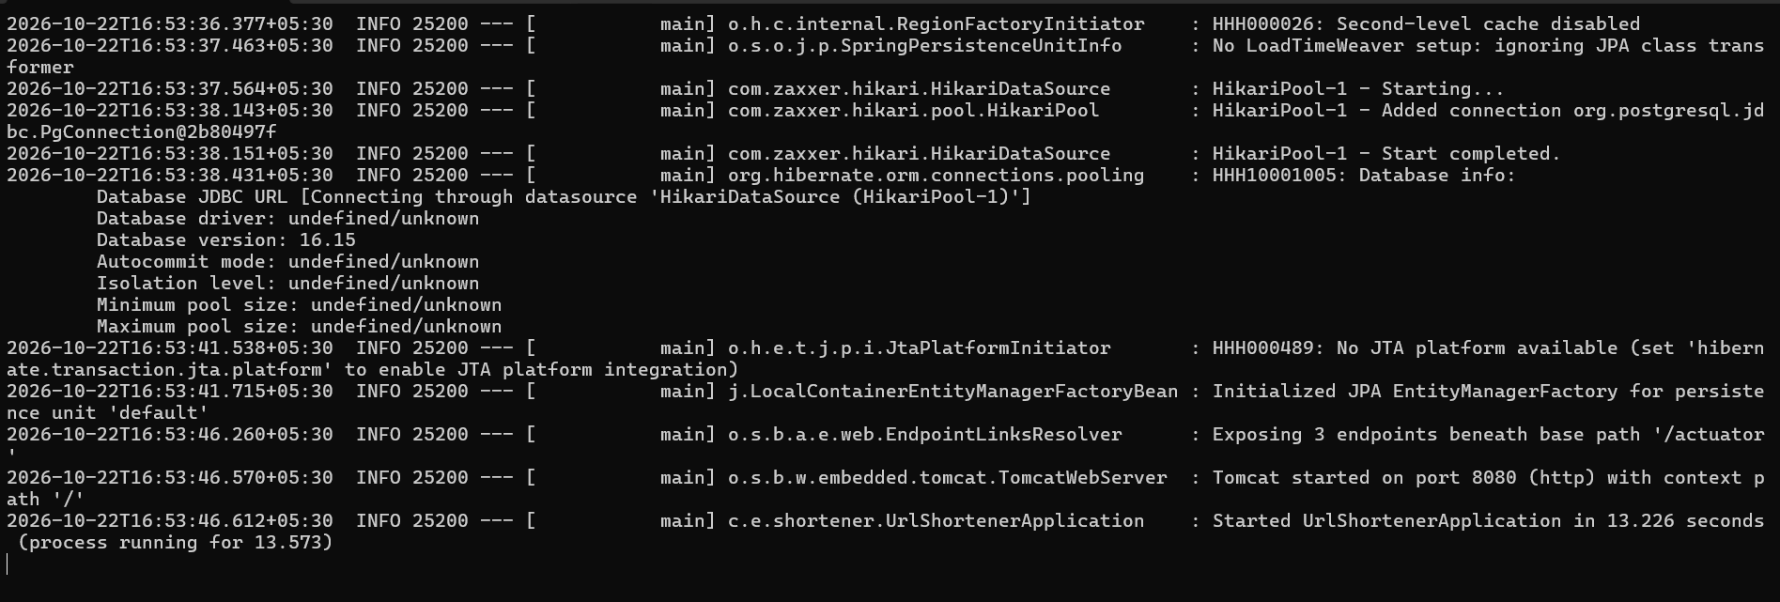
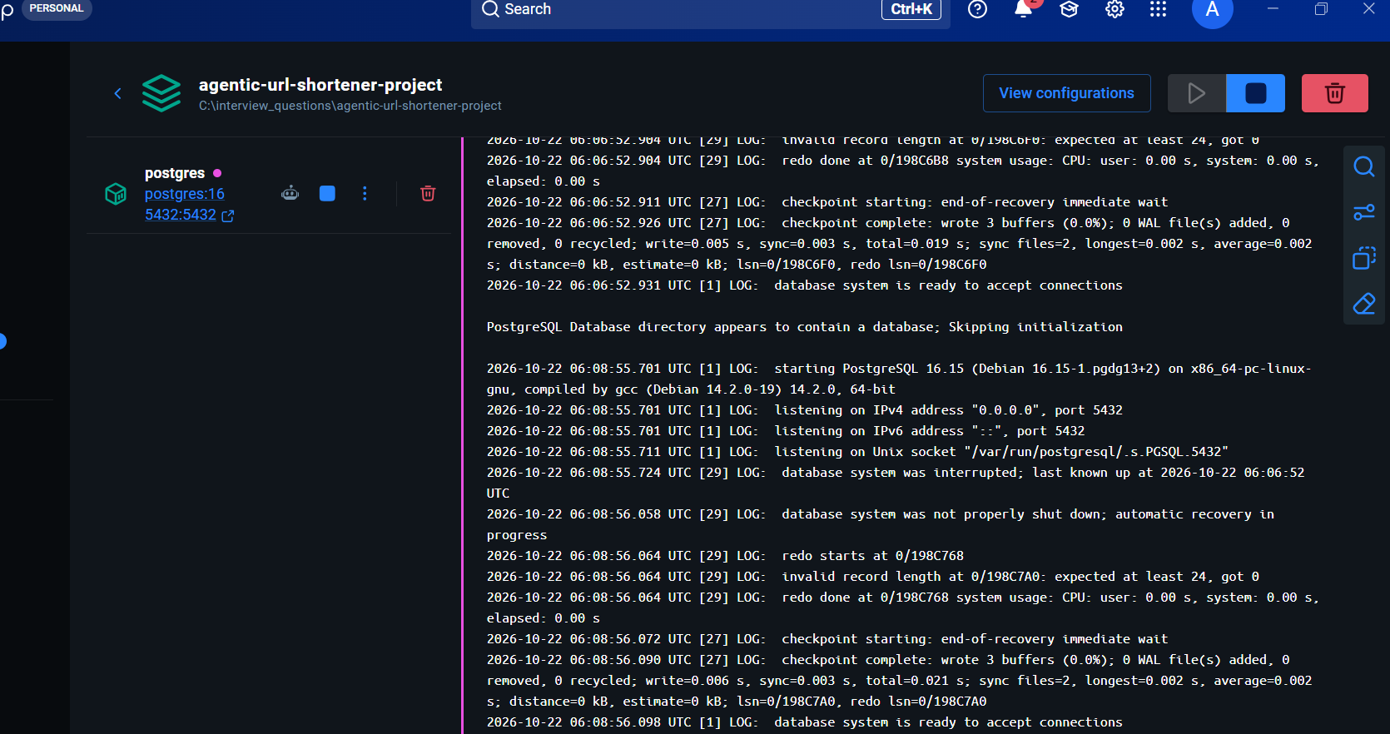
Evidence 1 — Java application / container startup.

7.2 Startup troubleshooting
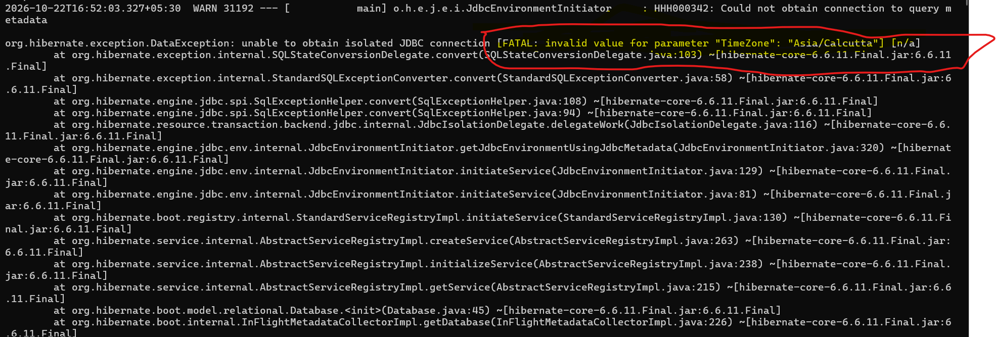
Evidence 2 — Startup issue and timezone workaround.

7.3 URL-shortener functional check
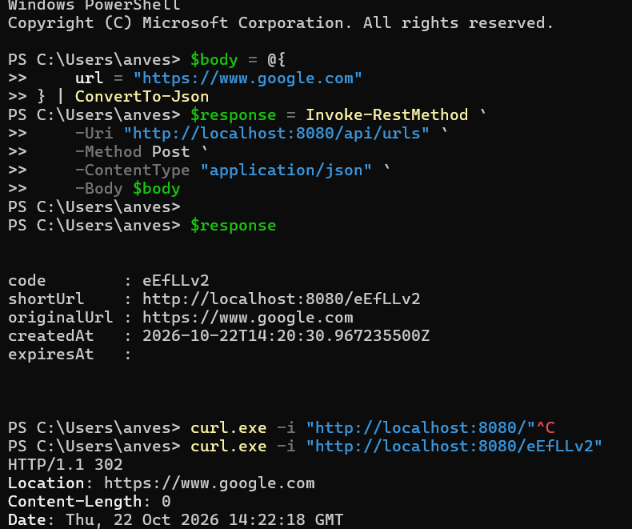
Evidence 3 — URL creation response and redirect behavior.

7.4 Orchestrator startup and API
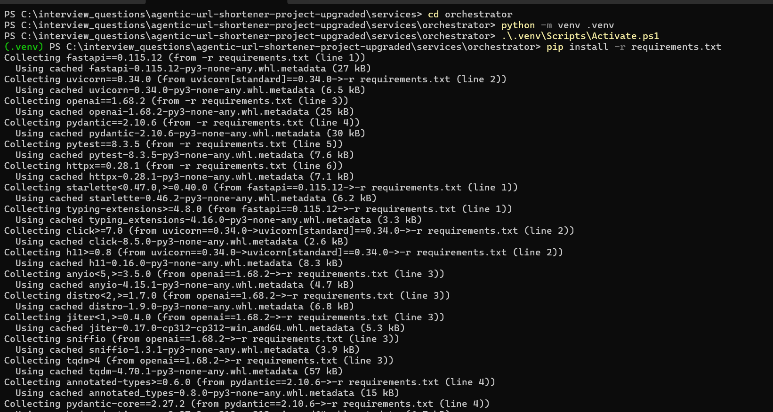
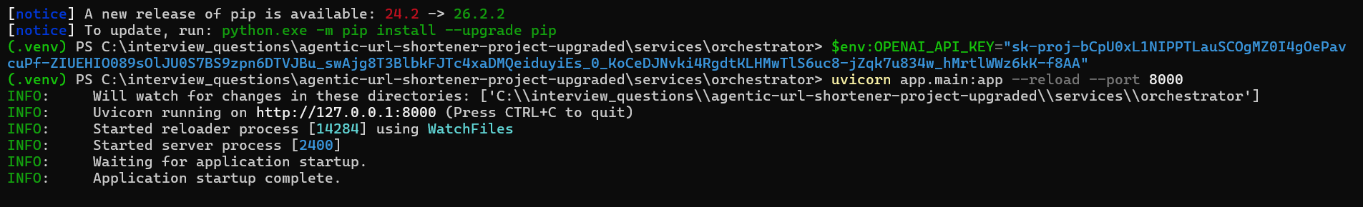
Evidence 4 — Python orchestrator setup and startup.

7.5 Workflow creation
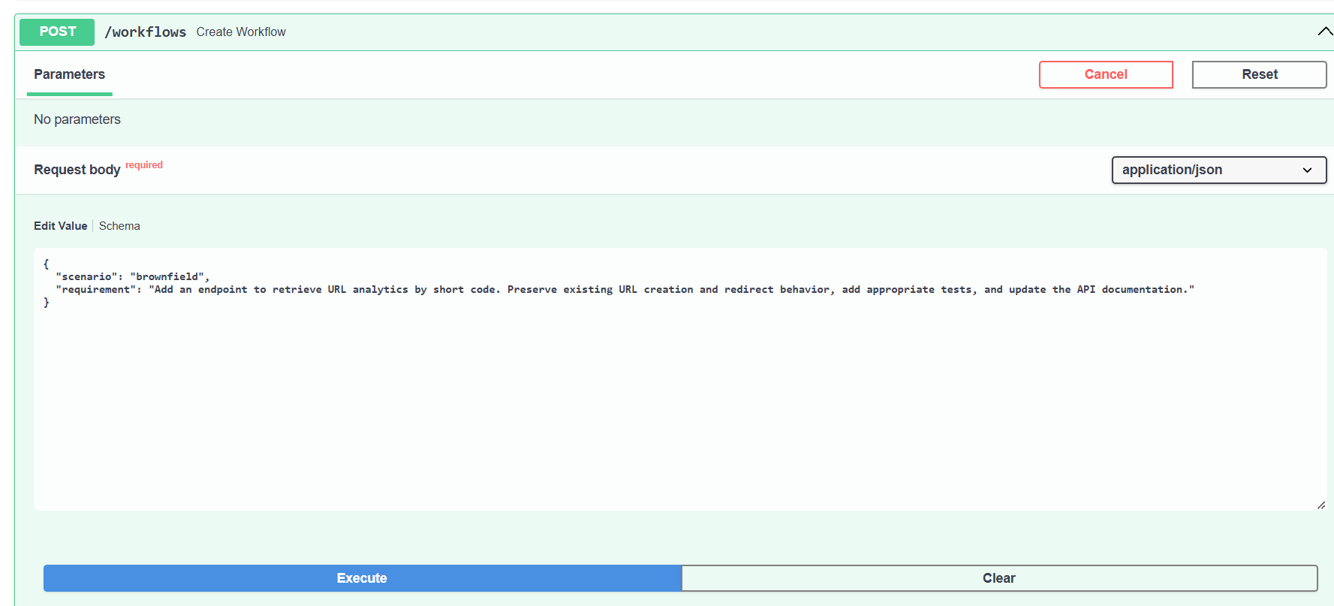
Evidence 5 — Swagger UI and brownfield workflow creation.
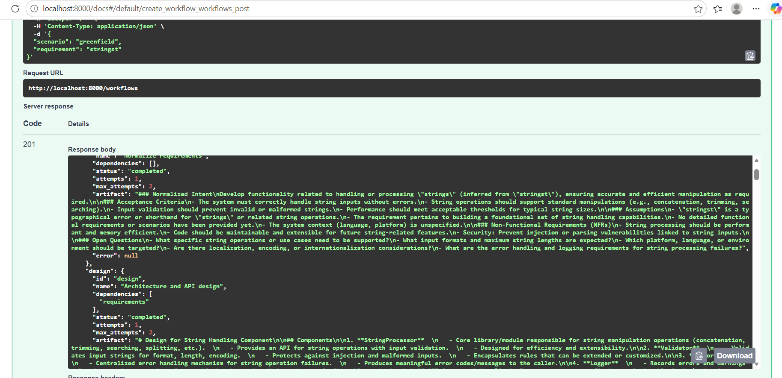
Evidence 6 — Workflow creation response and identifiers.

7.6 Proposal generation

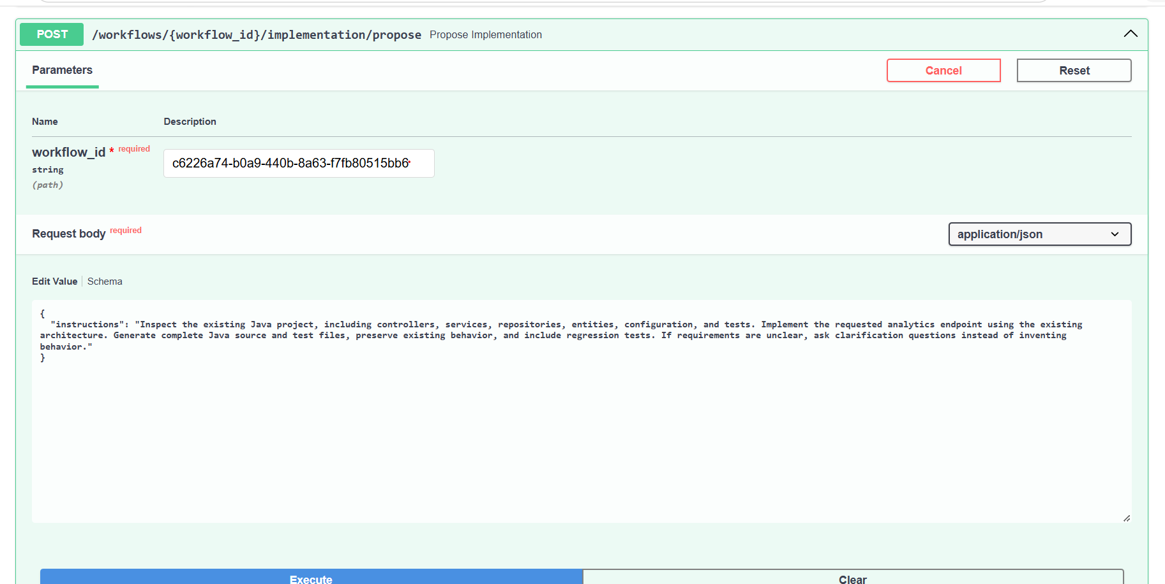
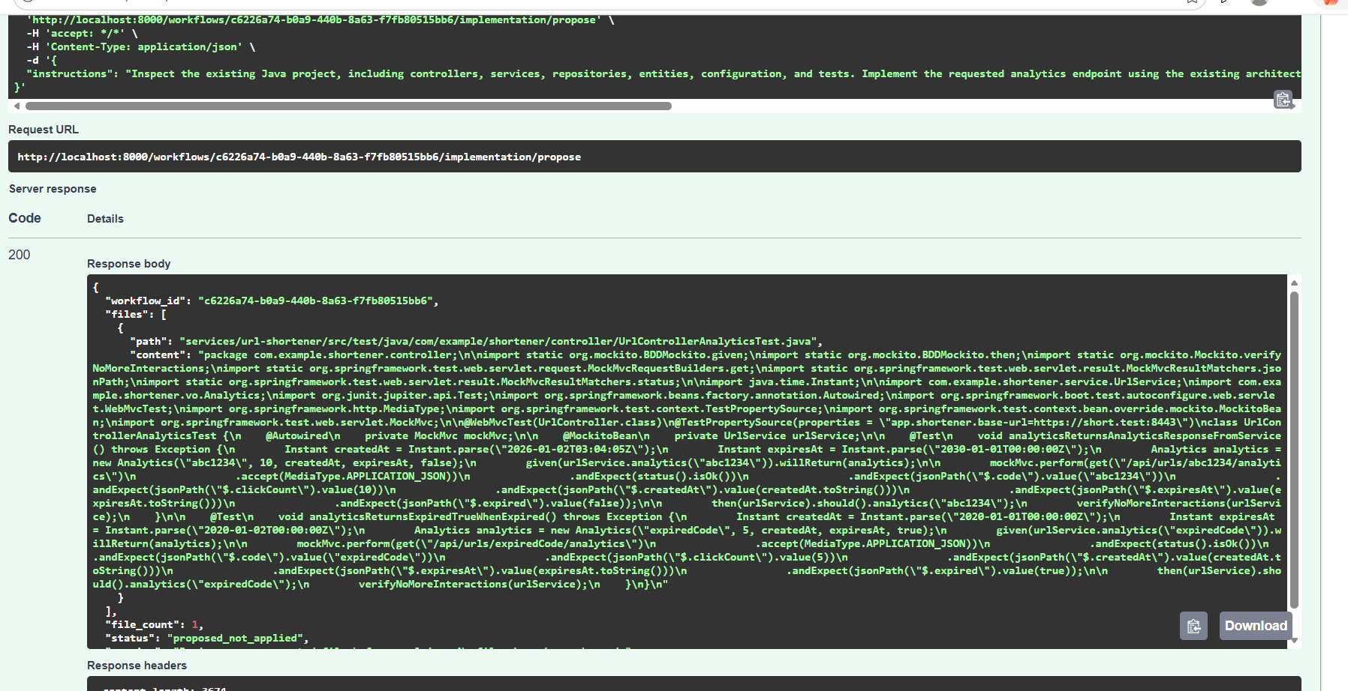
Evidence 7 — Implementation proposal request.

7.7 Generated Java test
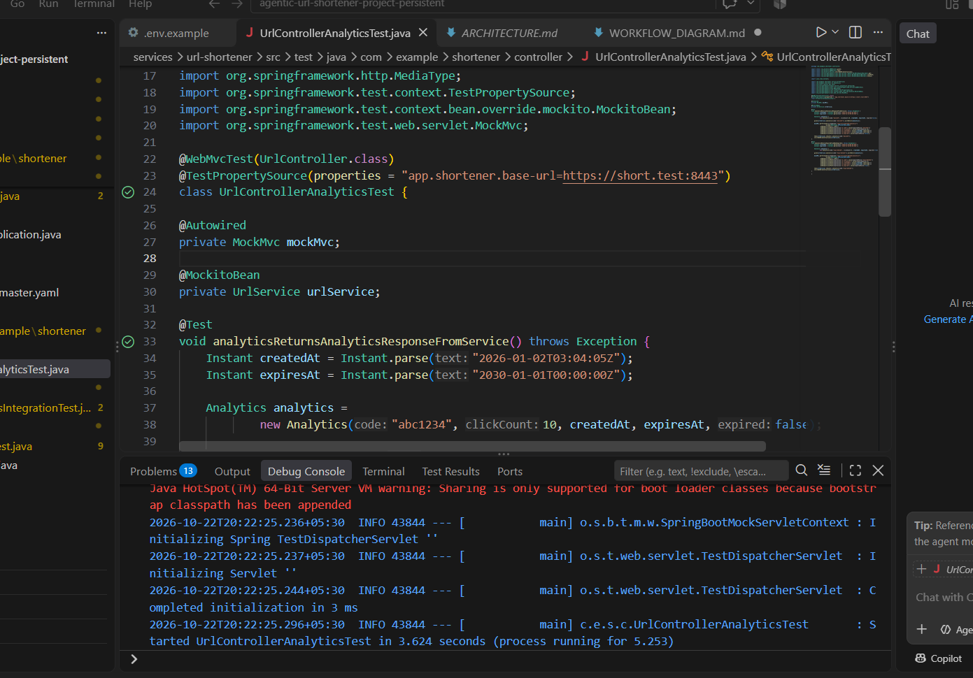
Generated Java analytics test and test execution.

7.8 Python tests
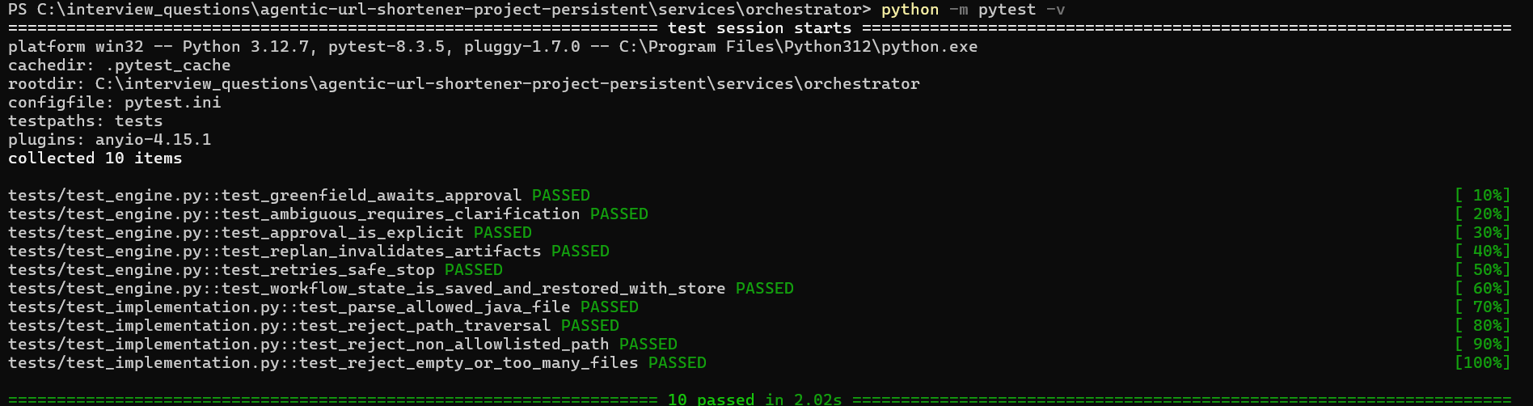
Python orchestrator test suite.

8 DB Evidences:
- Docker Container Name
- Short Urls table:
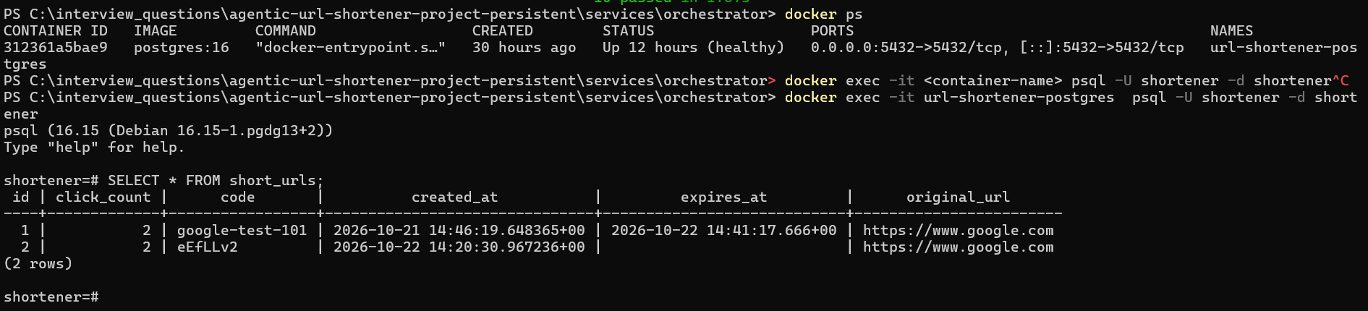
- Workflow Audit table:
