WSDL: http://ec2-13-232-250-89.ap-south-1.compute.amazonaws.com:8080/PersonWS/endpoints/PersonService.wsdl

Screenshot :

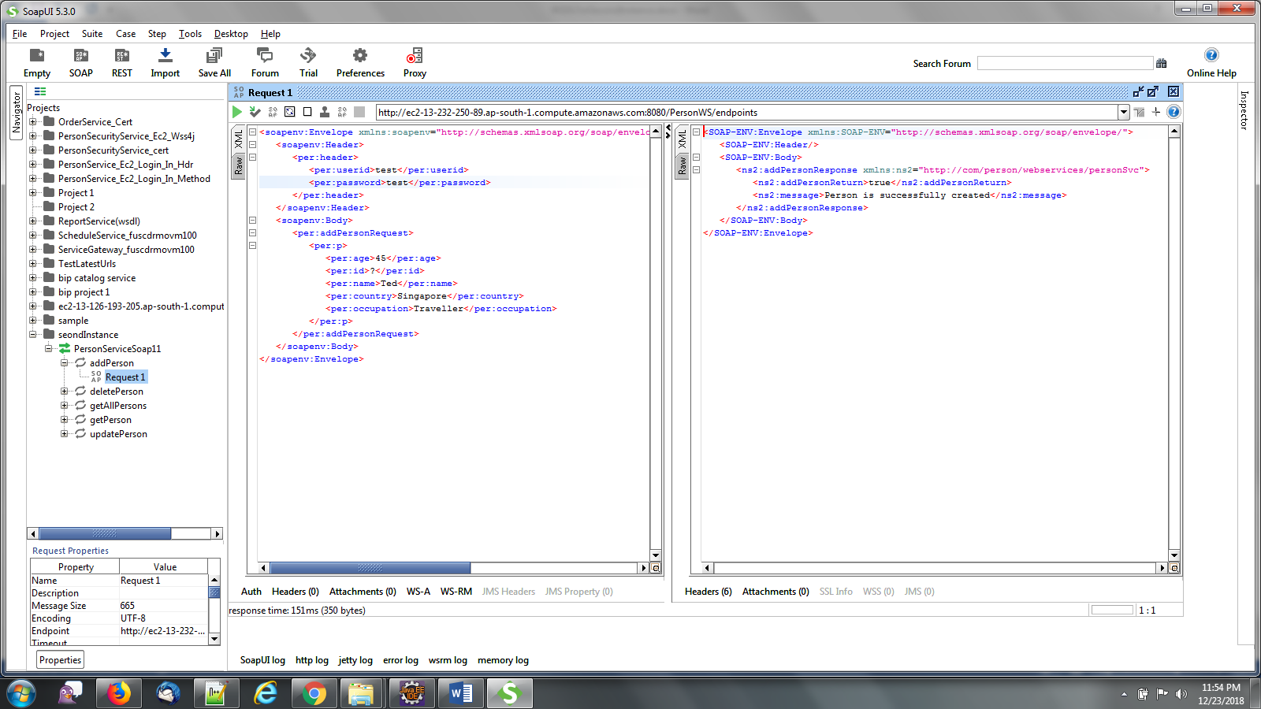

Sample xmls for Add, Delete,get and Update Person :

**AddPerson : Authentication in Header and credentials are *test/welcome***

<soapenv:Envelope xmlns:soapenv="http://schemas.xmlsoap.org/soap/envelope/" xmlns:per="http://com/person/webservices/personSvc">

<soapenv:Header>

<per:header>

<per:userid>test</per:userid>

<per:password>test</per:password>

</per:header>

</soapenv:Header>

<soapenv:Body>

<per:addPersonRequest>

<per:p>

<per:age>45</per:age>

<per:id>?</per:id>

<per:name>Ted</per:name>

<per:country>Sigapore</per:country>

<per:occupation>Traveller</per:occupation>

</per:p>

</per:addPersonRequest>

</soapenv:Body>

</soapenv:Envelope>

<SOAP-ENV:Envelope xmlns:SOAP-ENV="http://schemas.xmlsoap.org/soap/envelope/">

<SOAP-ENV:Header/>

<SOAP-ENV:Body>

<ns2:addPersonResponse xmlns:ns2="http://com/person/webservices/personSvc">

<ns2:addPersonReturn>true</ns2:addPersonReturn>

<ns2:message>Person is successfully created</ns2:message>

</ns2:addPersonResponse>

</SOAP-ENV:Body>

</SOAP-ENV:Envelope>

**Delete Person : No Authentication**

<soapenv:Envelope xmlns:soapenv="http://schemas.xmlsoap.org/soap/envelope/" xmlns:per="http://com/person/webservices/personSvc">

<soapenv:Header/>

<soapenv:Body>

<per:deletePersonRequest>

<per:id>6</per:id>

</per:deletePersonRequest>

</soapenv:Body>

</soapenv:Envelope>

<SOAP-ENV:Envelope xmlns:SOAP-ENV="http://schemas.xmlsoap.org/soap/envelope/">

<SOAP-ENV:Header/>

<SOAP-ENV:Body>

<ns2:deletePersonResponse xmlns:ns2="http://com/person/webservices/personSvc">

<ns2:deletePersonReturn>false</ns2:deletePersonReturn>

<ns2:message>Person is deleted successfully</ns2:message>

</ns2:deletePersonResponse>

</SOAP-ENV:Body>

</SOAP-ENV:Envelope>

**GetPerson : Authentication in Body and credentials are *test/welcome***

<soapenv:Envelope xmlns:soapenv="http://schemas.xmlsoap.org/soap/envelope/" xmlns:per="http://com/person/webservices/personSvc">

<soapenv:Header/>

<soapenv:Body>

<per:getPersonRequest>

<per:login>

<per:name>test</per:name>

<per:password>test</per:password>

</per:login>

<per:id>11</per:id>

</per:getPersonRequest>

</soapenv:Body>

</soapenv:Envelope>

<SOAP-ENV:Envelope xmlns:SOAP-ENV="http://schemas.xmlsoap.org/soap/envelope/">

<SOAP-ENV:Header/>

<SOAP-ENV:Body>

<ns2:getPersonResponse xmlns:ns2="http://com/person/webservices/personSvc">

<ns2:getPersonReturn>

<ns2:age>34</ns2:age>

<ns2:id>11</ns2:id>

<ns2:name>French</ns2:name>

<ns2:country>France</ns2:country>

<ns2:occupation>Football</ns2:occupation>

</ns2:getPersonReturn>

<ns2:message>Person details are retrieved successfully</ns2:message>

</ns2:getPersonResponse>

</SOAP-ENV:Body>

</SOAP-ENV:Envelope>

**UpdatePerson : Authentication in Header and credentials are *test/welcome***

<soapenv:Envelope xmlns:soapenv="http://schemas.xmlsoap.org/soap/envelope/" xmlns:per="http://com/person/webservices/personSvc">

<soapenv:Header>

<per:header>

<per:userid>test</per:userid>

<per:password>test</per:password>

</per:header>

</soapenv:Header>

<soapenv:Body>

<per:updatePersonRequest>

<per:p>

<per:age>4</per:age>

<per:id>1</per:id>

<per:name>Nandu</per:name>

<per:country>India</per:country>

<per:occupation>Student</per:occupation>

</per:p>

</per:updatePersonRequest>

</soapenv:Body>

</soapenv:Envelope>

<SOAP-ENV:Envelope xmlns:SOAP-ENV="http://schemas.xmlsoap.org/soap/envelope/">

<SOAP-ENV:Header/>

<SOAP-ENV:Body>

<ns2:updatePersonResponse xmlns:ns2="http://com/person/webservices/personSvc">

<ns2:addPersonReturn>true</ns2:addPersonReturn>

<ns2:message>Person is successfully updated</ns2:message>

</ns2:updatePersonResponse>

</SOAP-ENV:Body>

</SOAP-ENV:Envelope>