FRONT-END UI

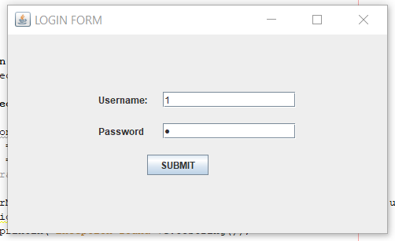  
 Login Page

The first page that pops up is the login where the employee must log on to the system to access the cartridge inventory system. For convenience the employee id has been set as the password which can later be changed.

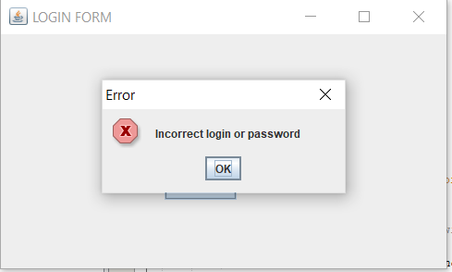

Error window

If the user id and password is incorrect an error message is displayed on the screen and the user is again directed to the login page.

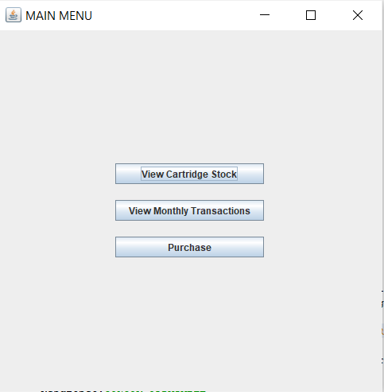

Main menu

After the user is successfully authenticated a new frame appears. This window has all required tabs which the user will need to either purchase a cartridge or view the previous monthly transactions. The employee id with which the user is logged in will be used for making the purchase.

VIEW CARTRIDGE STOCK

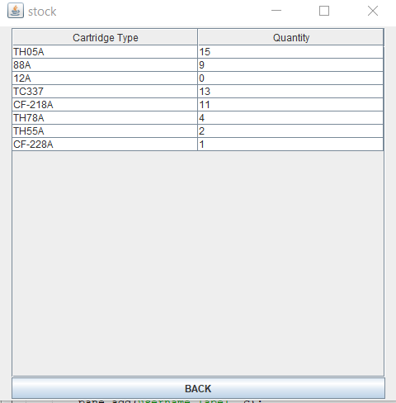

The above frame displays the quantity of each type of cartridge that is left in the stock.

VIEW MONTHLY TRANSACTIONS

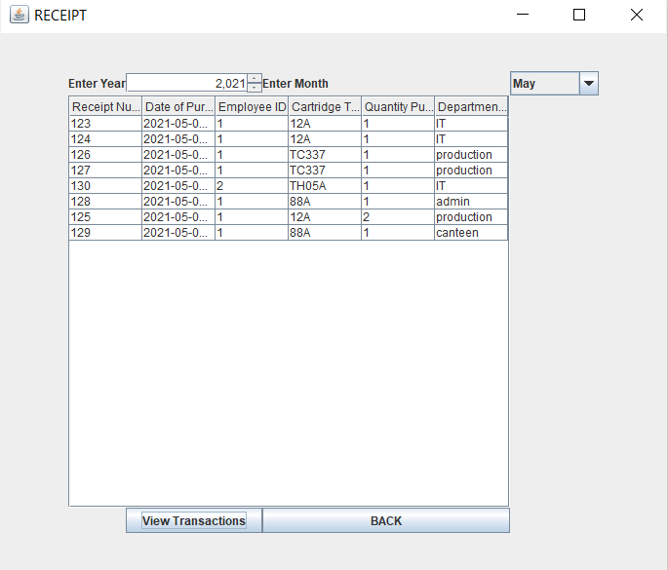

Monthly receipt

The above frame has a combo box for the year and the month for which the user wants to view the transaction. After selecting the required options from the combo box when the user clicks on view transactions the entire monthly receipt is generated for the company to review the cartridge consumption for that month.

PURCAHSE

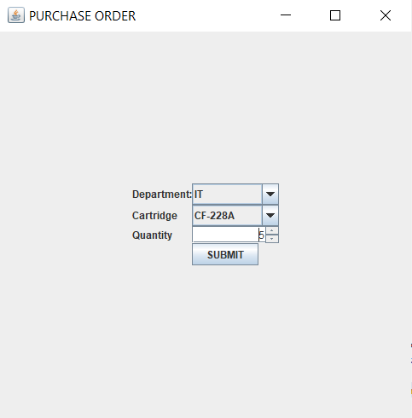

Purchase window

The user can make a purchase by selecting the cartridge type and the department for which the cartridge is being purchased. A validation is done for the data entered by the user. If the quantity requested is more than the quantity available in stock, then the below error message is displayed-:

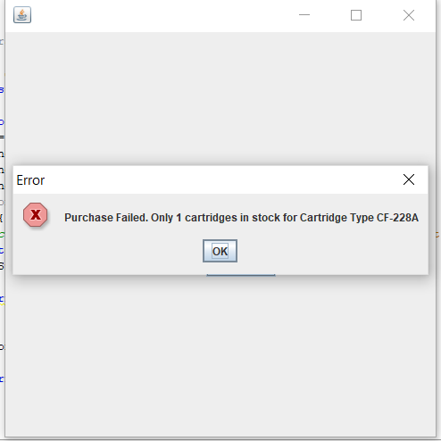

Error frame

The user will again be directed to the purchase window. if the purchase is successful then the below frame is displayed on the screen. The stock for the cartridge will be updated in the cartridge database. This is accomplished with the use of triggers. The new purchase entry will be added in the receipt which the user can later view with the help of view transactions.

