Game Design Document

Fill up the Following document

1. Write the title of your project.

Ans: THE LOST GIRL ‘CANDY’.

1. What is the goal of the game?

Ans: to make candy reach her home safely through the dense forest.

1. Write a brief story of your game?

Here is this girl called candy, whose house is in the middle of the forest.

One day she lost her way and his searching for the way to reach her home.the adventure /problems she faces while going home is the game.

1. Which are the playing characters of this game?

* Playing characters are the ones which respond to the user based on the input from the user
* Cars, monkeys, dinos, wizards etc, are the playing characters in the game.

|  |  |  |
| --- | --- | --- |
| Number | Character Name | What can this character do? |
| 1 | candy | run,stand still. |
| 2 |  |  |
| 3 |  |  |
| 4 |  |  |
| 5 |  |  |
| 6 |  |  |
| 7 |  |  |
| 8 |  |  |

1. Which are the Non Playing Characters of this game?

* Non Playing characters are the ones which don't have an action or a behaviour when the user interacts with the game.
* Hurdles, stones, bananas, coins, etc are non playing characters in the game.

|  |  |  |
| --- | --- | --- |
| Number | Character Name | What can this character do? |
| 1 | bush | Moves to negative x direction. |
| 2 | stone | Moves to negative x direction. |
| 3 | bird | Moves to negative x direction. |
| 4 | coins | Moves to negative x direction. |
| 5 |  |  |
| 6 |  |  |
| 7 |  |  |
| 8 |  |  |

Draw your imagination of this game. What does this game look like?

* Draw the game either on your computer or on paper,
* Add images of scenes of the game to show each of the playing and non-playing characters at least once.

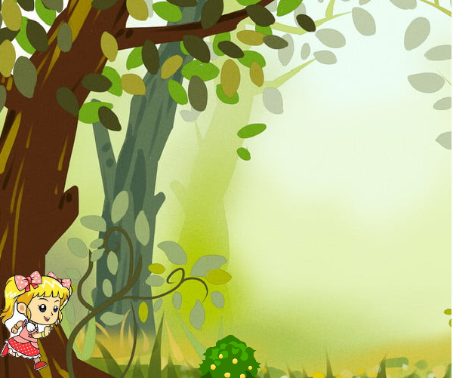

How do you plan to make your game engaging?

By creating more obstacles, giving rewards as coins,having ambience sounds etc.