**IVF**

**What is IVF?**

IVF, or in vitro fertilization, is a sophisticated set of processes that has the potential to result in pregnancy. It is a treatment for infertility, a disorder in which most couples are unable to conceive despite at least a year of trying. It is also possible to avoid passing on genetic issues to a child through IVF.

IVF may be a frame of helped regenerative innovation (Craftsmanship). This means uncommon therapeutic procedures are utilized to assist a lady gotten to be pregnant. It is most frequently attempted when other, less costly richness strategies have fizzled.

**Five essential steps to IVF:**

**Step 1: Incitement, too called super ovulation:**

Solutions, called richness drugs, are given to the lady to boost egg generation. Ordinarily, a lady produces one egg per month. Richness drugs tell the ovaries to create a few eggs. Amid this step, the lady will have normal transvaginal ultrasounds to look at the ovaries and blood tests to check hormone levels.

**Step 2: Egg recovery:**

A minor surgery, called follicular desire, is done to remove the eggs from the woman's body. The surgery is wiped out the doctor's office most of the time. The lady will be given medications so she does not feel torment amid the method. Utilizing ultrasound pictures as a direct, the wellbeing care supplier embeds a lean needle through the vagina into the ovary and sacs (follicles) containing the eggs. The needle is associated to a suction gadget, which pulls the eggs and liquid out of each follicle, one at a time. The procedure is rehashed for the other ovary. There may be a few cramping after the method, but it'll go absent inside a day. In uncommon cases, a pelvic laparoscopy may be required to evacuate the eggs. In the event that a lady does not or cannot create any eggs, donated eggs may be used.

**Step 3: Insemination and fertilization:**

The man's sperm is set in conjunction with the most excellent quality eggs. The blending of the sperm and egg is called insemination. Eggs and sperm are at that point put away in an naturally controlled chamber. The sperm most regularly enters (fertilizes) an egg a number of hours after insemination. On the off chance that the specialist considers the chance of fertilization is moo, the sperm may be straightforwardly infused into the egg. This is often called intracytoplasmic sperm infusion (ICSI). Many fertility programs routinely do ICSI on a few of the eggs, indeed in the event that things show up ordinary.

**Step 4: Developing life culture:**

When the fertilized egg isolates, it gets to be an fetus. Research facility staff will routinely check the fetus to form beyond any doubt it is developing appropriately. Inside approximately 5 days, a ordinary developing life has a few cells that are effectively partitioning. Couples who have a tall chance of passing a hereditary (genetic) clutter to a child may consider pre-implantation hereditary determination (PGD). The strategy is most frequently done 3 to 5days after fertilization. Research facility researchers evacuate a single cell or cells from each developing life and screen the fabric for particular hereditary disarranges. Concurring to the American Society for Regenerative Pharmaceutical, PGD can offer assistance guardians choose which embryos to embed. This diminishes the chance of passing a clutter on the child. The technique is questionable and not advertised at all centers.

**Step 5: Fetus exchange**

Embryos are set into the woman's womb 3 to 5 days after egg recovery and fertilization. The method is tired the doctor's office whereas the lady is wakeful. The specialist embeds a lean tube (catheter) containing the embryos into the woman's vagina, through the cervix, and up into the womb. In the event that an embryo sticks to (inserts) within the lining of the womb and develops, pregnancy comes about. More than one developing life may be put into the womb at the same time, which can lead to twins, triplets, or more. The precise number of embryos exchanged may be a complex issue that depends on numerous components, particularly the woman's age. Unused embryos may be solidified and embedded or given at a afterward date.

**FIRST IVF BABY BORN IN THE WORLD**

Louise Bliss Brown (born 25 July 1978) is an English lady who was the primary human to have been born after conception by in vitro preparation try (IVF). Her birth, taking after a method spearheaded in Britain, has been commended among "the foremost exceptional therapeutic breakthroughs of the 20th Century".

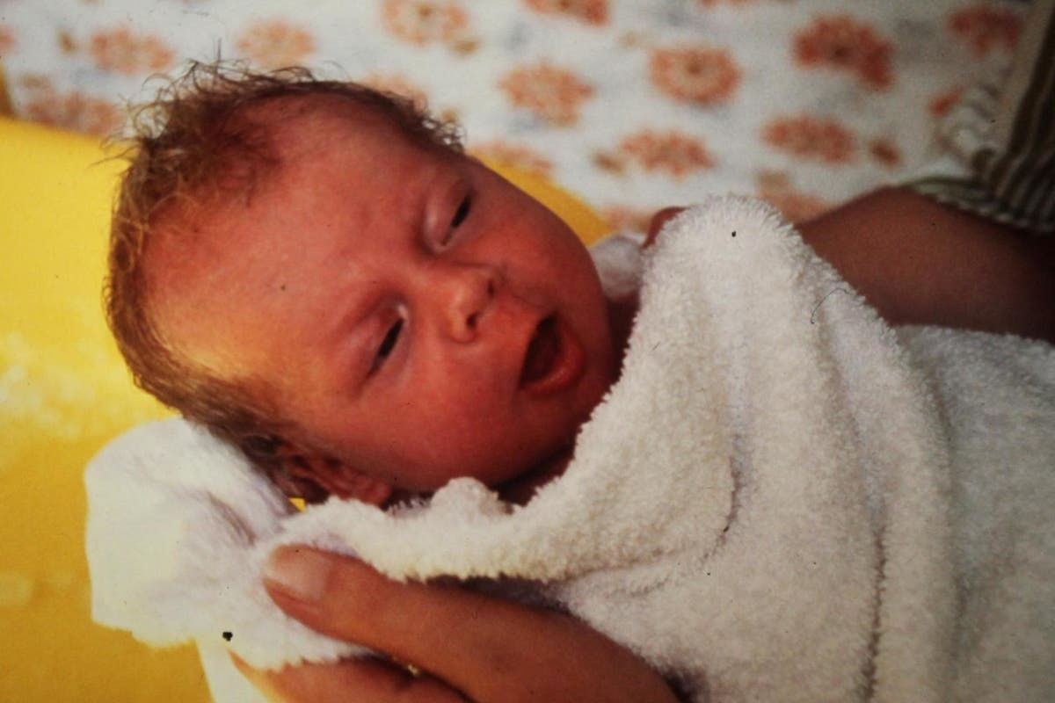

Louise Bliss Brown was born at Oldham Common Clinic, Lancashire, by arranged Caesarean area performed by enlistment center John Webster. She weighed 5 pounds, 12 ounces (2.608 kg) at birth. Her parents, Lesley and John Brown, had been attempting to conceive normally for nine a long time, but Lesley confronted complications of blocked fallopian tubes.

On 10 November 1977, Lesley Brown experienced a method, afterward to ended up known as in vitro treatment (IVF), developed by Patrick Steptoe, Robert Edwards, and Jean Purdy. Purdy was the primary to see her embryonic cells dividing. Edwards, as the as it were surviving accomplice, was granted the 2010 Nobel Prize in Pharmaceutical for this work. In Walk 2022, a plaque was introduced on Regal Oldham Clinic to record the significance of Sister Muriel Harris and Jean Purdy to the work. In spite of the fact that the media alluded to Brown as a "test tube baby", her conception really took put in a Petri dish. Her more youthful sister, Natalie Brown, was too conceived through IVF four a long time afterward, and became the world's 40th child born after conception by IVF. In May 1999, Natalie was the primary human born after conception by IVF to allow birth herself without IVF.

**FIRST IVF BABY IN INDIA**

India’s to begin with test tube child, Kanupriya Agarwal aka Durga may be a cheerful 43- year-old individual nowadays. Born in Pune on October 3, 1978, she speaks to both the victory and headway of In Vitro Preparation (IVF), a strategy which has brought trust to millions of couples.

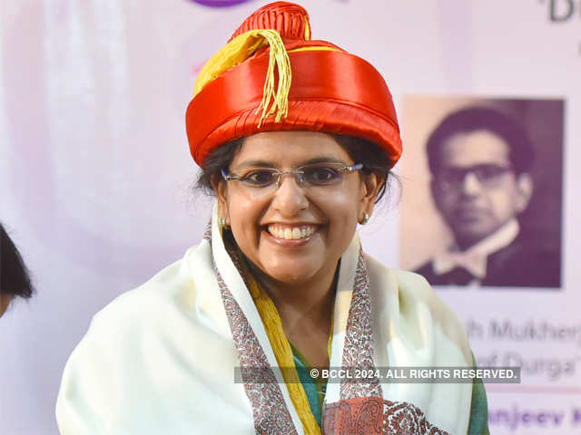

Interests, she is the worlds moment test tube infant born fair 70 days after Louise Delight Brown to begin with made history being conveyed on July 25 in Britain by Dr Robert Edwards and Dr Patrick Steptoe. Dr Edwards went on to win the Nobel Prize in Pharmaceutical and Physiology in 2010.

The IVF treatment is perceived as one of the a milestones of cutting edge medicine by the Nobel Committee and a exceptional restorative breakthrough of the 20th century. Around eight million babies have been born since 1978 through diverse helped propagation advances, counting IVF. India has been one of the nations to broadly accomplish advance in this field as well.

**Top 7 Best IVF Hospitals in India with High Success Rate**

**1.Nova IVF Clinic Delhi NCR India**

Nova IVF Richness may be a top richness benefit provider in India that gives progressed medicines to assist individuals have babies. They have cutting edge procedures like vitrification, embryoscope, and Period to move forward the victory of procedures like IVF and IUI. NIF too gives administrations for ICSI and IMSI, in which the leading quality sperms are chosen for the IVF method. These headways cruel superior chances of pregnancy, indeed for those who have had fizzled endeavors some time recently. NIF's administrations meet worldwide benchmarks, appearing their high-quality care in India.

**Dr. Manish Investor**

Dr. Manish Investor is the Therapeutic Chief at Nova IVI Richness. He is portion of the biggest bunch of IVF clinics in India, which incorporates 20 clinics over 15 cities. He graduated and completed his post-graduation with respects from VS Therapeutic College and Clinic in Ahmedabad. Dr. Investor proceeded his preparing in IVF and Endoscopy in Australia and Germany. He started his IVF hone in 1996, decided to exceed expectations within the field. Nowadays, he is recognized as one of the pioneers in IVF, with an amazing track record of over 8000 fruitful IVF pregnancies.

**2.Fortis Commemoration Inquire about Organized Gurgaon India**

FMRI is the best IVF clinic in India and is known for its mastery in treating fruitlessness. The committed fruitlessness medication group specializes in tending to different conditions like unexplained barrenness, endometriosis, and fizzled IUI. They basically center on patients who have had different unsuccessful cycles. With their broad encounter and talented clinical group, they tailor person treatment conventions based on each patient's reaction. Their approach incorporates a run of strategies such as intrauterine insemination, surgery, restorative mediations, and progressed regenerative advances. Each IVF cycle regularly keeps going 4-6 weeks, coming full circle in a pregnancy test around 1-2 weeks after developing life exchange. The team's master counseling and commitment to utilizing secure innovation have brought about in effective results, altogether progressing fulfillment levels for numerous couples.

**Dr. Hrishikesh Pai**

Dr. Hrishikesh Pai may be a noticeable IVF master in India. He brags over 40 a long time of tremendous encounter in Obstetrics, Gynecology, and Fruitlessness. All through his career, he has effectively overseen thousands of cases. Dr. Pai is the Author and Executive of the Sprout IVF Gather, supervising eight IVF centers over India. Besides, he is related with a few prestigious healing centers, counting Lilavati Healing center in Mumbai, DY Patil Clinic in Navi Mumbai, and Fortis Clinics in Unused Delhi, Gurgaon, and Mohali Chandigarh.

**3.Jaslok Clinic & Inquire about Middle Mumbai India**

Jaslok Healing center & Inquire about Middle is the leading clinic for IVF in India. It is among the country's most seasoned specialized private believe clinics. Since October 1990, their Helped Propagation & Hereditary qualities Clinic in Mumbai has advertised progressed ripeness administrations. They have made a difference more than 9000 couples from India and 50 other nations, coming about in over 13,000 babies being born. The clinic gives different administrations, counting In Vitro Fertilization (IVF), Micromanipulation (ICSI), Laser Helped Bring forth (LAH), Semen and Developing life Cryopreservation, and a completely prepared Andrology Research facility. They moreover offer atomic hereditary testing such as Polymerase Chain Response (PCR) and symptomatic tests for pregnancy, conveyance, and Preimplantation Hereditary Diagnostics (PGD).

**Dr. Firuza Parikh**

Dr. Firuza R. Parikh may be a famous Gynecologist and Obstetrician with 43 a long time of encounter. She has given herself only to richness treatment, accomplishing brilliance in demonstrative, laparoscopic, and hysteroscopic surgeries for barrenness. Dr. Firuza centers on overcoming challenges such as Repetitive Implantation Disappointment, destitute ovarian save, and PCOD.

**4.Indraprastha Apollo Healing centers Modern Delhi India**

Indraprastha Apollo Clinic Delhi is India’s best IVF healing center and is profoundly respected as the driving IVF center within the capital. Indraprastha Apollo Clinic has an progressed lab with the most recent advances that offer tall victory rates. The hospital's mission is to supply personalized treatment exhortation, utilizing a group of exceedingly talented richness pros and embryologists nearby demonstrative modalities and research facility administrations. Indraprastha Apollo Healing center emphasizes the complications of barrenness and works for a comprehensive assessment to distinguish and address the one of a kind causes basic couples' challenges in conceiving.

**Dr. Shakti Bhan Khanna**

Dr. Shakti Bhan Khanna may be a profoundly experienced gynecologist and obstetrician based in Delhi with an noteworthy 59 a long time of hone. She has broad mastery in Obstetrics, Gynecology, and Barrenness administration. Dr. Khanna is exceptionally experienced in regenerative wellbeing, counting transvaginal ultrasound, ovarian incitement, ovum pick-up, fetus exchange, hysteroscopy, and others.

**5.Apollo Ripeness Clinic India**

Apollo Richness offers specialized investigative methods for both men and ladies confronting barrenness issues, pointing to supply couples with the most noteworthy probability of accomplishing a fruitful pregnancy. With 17 centers spread over 11 cities in India, counting Delhi, Chennai, Hyderabad, Bengaluru, Mumbai, Thane, Amritsar, Solapur, Kolkata, Varanasi, and Guwahati, Apollo Richness has brought trust and joy to over 28,000 couples across the country. The devoted group of pros at Apollo Richness receives a comprehensive approach to richness treatment, guaranteeing comfort and the bliss of parenthood for trying couples at their closest Apollo Ripeness Middle.

**Dr. Jayashree Natarajan**

After working as a non-PG recorder within the Office of Obstetrics and Gynecology at CMC Vellore from 2010 to 2011, she sought after post-graduation at Amrita Established of Restorative Sciences, Kochi, graduating in 2016. Taking after this, she completed a Partnership in Regenerative Pharmaceutical at Create Clinic, Kodungallur, Kerala, in 2017. She at that point moved to Esjay Create Ripeness Middle in Coimbatore, where she begun as a Ripeness Specialist in 2019 and afterward got to be the Clinical Chief. She proceeds to hone in this part nowadays.

**6.Ruby Corridor, Healing center Pune India**

Ruby Corridor Clinic may be a well-known IVF center in India that has been giving fabulous care for over 50 a long time. Over time, the clinic has developed into a 600-bed multi-specialty center. It is Pune's to begin with broadly certify multi-specialty center known for making strides quality, giving personalized healthcare, and utilizing progressed innovation. The clinic is committed to assembly the different wellbeing needs of the community with a center on compassionate and high-quality care.

**Dr. Seema Jain**

Dr. Seema Jain is an Fruitlessness Pro and Obstetrician-Gynecologist with around 19 a long time of involvement. She is fascinated by helped propagation and has worked there for 15 a long time. Dr. Jain is energetic almost the intriguing angles of Obstetrics and gynecology, and she moreover has additional aptitudes in High-Risk Pregnancy and Menopausal Medication.

**7.Cloud Nine Ripeness and IVF Clinic India**

The Times of India recognized Cloudnine Clinic as Indians beat ripeness healing center for its comprehensive ripeness administrations. Cloudnine points to ended up the leading IVF center in India by 2024. It combines ability with progressed innovation to assist you involvement the delight of parenthood. Its driving pros have over 35 a long time of encounter. The clinic offers a run of master administrations, counting tubal assessment, IVF, IUI, ovulation acceptance, surgical sperm recovery, fetus cryopreservation, and different progressed methods. Cloudnine Ripeness is committed to giving amazing richness care, guaranteeing the travel to parenthood is as smooth as conceivable.

**Dr. Gurjeet Kaur Mallhi**

Dr. Gurjeet Mallhi could be a given richness master with more than 23 a long time of encounter in obstetrics and gynecology. She created a energy for overseeing fruitlessness after working as an OBGY specialist in noticeable clinics. Over the past 12 a long time, Dr. Mallhi has centered exclusively on richness, exceeding expectations in symptomatic, laparoscopic, and hysteroscopic surgeries related to fruitlessness. She advance sharpened her aptitudes with a 2-year Craftsmanship and hands-on embryology preparing. Dr. Mallhi's mastery lies in zones such as Repetitive Implantation Disappointment, destitute ovarian save, and PCOD. She prioritizes accomplishing tall victory rates whereas giving compassionate care and is devoted to helping patients confronting ripeness challenges.

**10 SUCCESS FACTORS OF IVF TREATMENT**

In Vitro Fertilization (IVF) may be a complicated handle including parcels of moving parts, which are profoundly subordinate on timing and precision. All through IVF methods, there's a heap of components which influence the chances of a fruitful circular of IVF treatment.

1. **Past Pregnancy** - In case you and your current accomplice have had a successful pregnancy within the past, it implies you've got distant better; a much better; a higher; a stronger; an improved" a distant better chance of effective pregnancy with IVF. Different unsuccessful labors or other richness issues with a unused accomplice can make IVF more troublesome. Be that as it may, you ought to not compose it off through and through.
2. **Age** - From 24 to 34, ladies have the most elevated chances of victory with IVF treatment (32.2%) since usually the age run when ladies are most rich. By the time a lady comes to age 40, victory rates drop to around 13.6%. Ladies in each arrange of regenerative life have been able to effectively utilize IVF. In spite of the fact that, victory rates drop with age, you ought to still investigate IVF choices, as the victory of treatment is exceedingly subordinate on your one of a kind body and therapeutic history.
3. **Sort of Richness Issue** - Certain richness issues make victory with IVF less likely, counting: fibroid tumors, uterine variations from the norm, double fruitlessness, ovarian brokenness and the sum of time the couple has had trouble conceiving (in other words, the longer you hold up to look for treatment, the less likely it'll be effective). IVF, in any case, can exceptionally effectively overcome parts of richness issues.
4. **Egg and Fetus Quality** - The quality of eggs and embryos depends on a few of the other things in this list, such as age, ovarian save, incitement convention and sperm quality. The higher quality eggs and embryos, the way better probability IVF treatment will be successful.
5. **Sperm Quality** - Around 90% of chromosomal fetus issues happen due to egg quality. However, male ripeness components still influence embryos. In the event that the male accomplice has ripeness issues, unused innovation is making a difference to moderate the unfavorable impacts to form fruitful pregnancy more likely.
6. **Benefactor Eggs** - For patients whose quality of eggs could be compromised due to age or other variables, utilizing giver eggs can increment the chances of victory.
7. **Controlled Ovarian Incitement (COH) Convention** - These conventions detail the sorts of ripeness medicine managed and the plan on which they are conveyed. These protocols call for both accuracy in timing and measurements, as well as individualization depending on ovulation. Right now, a number of COH conventions exist for IVF, and your specialist will work with you to decide which conventions will be most favorable for you.
8. **Embryo Transfer** - A few accept the developing life exchange prepare is the foremost basic step within the whole handle of IVF medicines. The wellbeing of embryos and fruitful embed within the uterus depend on a immaculate exchange. Any catch with timing or natural variables can be inconvenient to the method.
9. **Uterine Receptivity** - Typically as imperative as fetus quality. Comparable to planting a seed, in case either the quality of the seeder soil is compromised, then the likelihood of developing a solid plant is diminished. Components influencing receptivity incorporate the thickness of uterine lining, immunological components, and the uterine cavity form.
10. **Way of life Components** - Living a sound way of life will make a thriving environment for an developing life. At slightest three months earlier to starting IVF, halt smoking and drinking alcohol; both of these propensities reduce chances of success. Smokers chances of implantation are 50% lower than non-smokers. Keeping

up a sound weight is additionally critical in expanding victory rates of IVF. Weight has been appeared to influence how the body forms hormones and ripeness drugs, directs menstrual cycles, and being overweight makes it more difficult to carry a infant to term. The good news is that you simply can control your way of life, and these variables can be effectively made strides.

**How likely are you to have a baby after one, two or three IVF cycles?**

On the off chance that you are considering of beginning IVF, or you are as of now going through it, you'll be pondering how numerous cycles it might take to have a infant.

Modern information compiled for VARTA sheds a few light on this. Investigate following thousands of ladies who begun IVF in Victoria in 2016 and 2017 appears how numerous had a child after one, two and three fortified cycles. A fortified IVF cycle implies a cycle where eggs are collected and all of the embryos made from that cycle, counting new and solidified embryos, are exchanged one by one.

The inquire about, conducted by the College of Modern South Grains National Perinatal The study of disease transmission and Measurements Unit, taken after these ladies for a least of three a long time and a most extreme of four a long time to see what happened to them.The comes about appear most individuals who go through IVF, regardless of their age, don't have a infant after one cycle. The data also demonstrates that the more youthful you're after you start IVF, the more likely you're to have a infant.

As you'll be able see within the chart underneath, 48 per cent of ladies who were matured 30-31 when they begun treatment had a child after one fortified cycle. This expanded to 61 per cent after two cycles and 67 per cent after three cycles. This estimation is known as the a cumulative live birth rate.

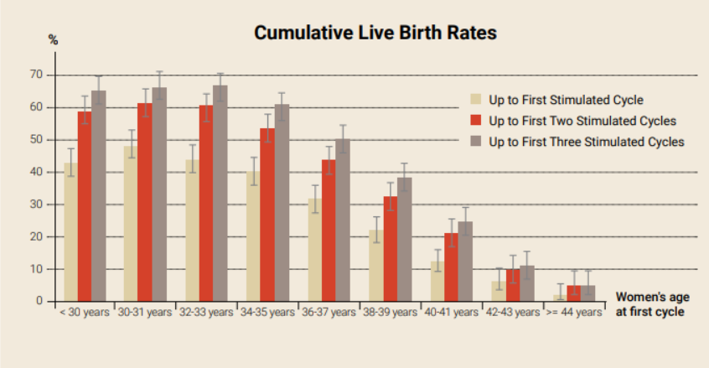

In comparison, ladies who begun treatment matured 34-35 had a 40 per cent chance of a infant after one cycle, a 54 per cent chance after two cycles and a 61 per cent chance after three cycles.For ladies matured 40-41 when they begun, there was a 13 per cent chance of a child after one cycle, a 21 per cent chance after two cycles and a 25 per cent chance after three cycles.

Whereas the objective for everybody who begins IVF is to have a infant, ideally on the primary endeavor, this investigate can offer assistance individuals have more practical desires of what is conceivable with IVF. Knowing that most individuals require more than one fortified cycle for a reasonable chance of victory which IVF births after the age of 40 are uncommon can be supportive when choosing how long to undertake for.

You'll see a full breakdown of the information for ladies agreeing to their age at the starting of treatment underneath:

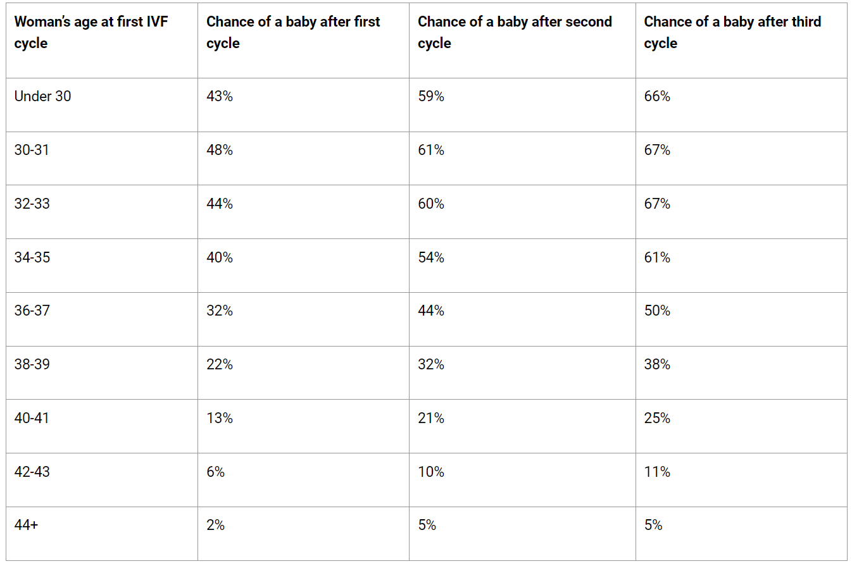

It is critical to note that this information produces midpoints as it were, and whereas age could be a key figure in a womens chance of victory with IVF, other variables contribute as well. Moreover, in the event that a lady in her 40s uses eggs given by a more youthful lady, she has the same chance as a lady the age of the giver.

It is additionally conceivable that a few ladies in this think about fell pregnant normally and had a infant. These births are not numbered in this dataset since they were not due to IVF.