Write a Servlet to
demonstrate session tracking using HttpSession.
AIM:
To demonstrate session tracking
using HttpSession in a Servlet-based web application. The exercise involves
implementing a simple login system where a user can log in with their username
and password, and their session will be tracked throughout their interaction
with the web application.
ALGORITHM:
1. Input:

- The user will enter their username and password in a login
form.
- The servlet will validate the credentials and create an HTTP
session for the user if authentication is successful.
2. Steps for Implementing Session Tracking with
HttpSession:
Create the Login Form (HTML):

- Create an HTML form with two input fields for username and password.
- Provide a submit button to send the data to the servlet for
authentication.
Create the Login Servlet:

- Write a Java servlet class to handle login requests.
- The servlet will:
- Retrieve the username and password from the form.
- Authenticate the user by comparing the credentials to a stored
value (e.g., hardcoded or from a database).
- Create a new HTTP session for the user if the credentials
are valid.
- Set session attributes such as the user's username to
track the session.
Validate User Credentials:

- In the servlet, check if the username and password
match the expected values.
- If valid, create a session and store the username in the
session.
- If invalid, redirect the user back to the login page with an error
message.
Create and Track User Session:

- Upon successful login, use the HttpSession object to store the
session data.
- Use the session.setAttribute("username", username)
method to save the username.
- Optionally, set session timeout using
session.setMaxInactiveInterval(time_in_seconds) to manage session
expiration.
Redirect to a Protected Page:

- After a successful login, the user will be redirected to a protected
page (e.g., a dashboard or home page).
- The protected page should check if the user is authenticated by
checking the session attribute.
Logout and Session Invalidation:

- Provide a logout feature that invalidates the session using
session.invalidate() when the user logs out.
- After logout, redirect the user back to the login page.
Session Expiration:

- If the session expires or the user manually logs out, the session
will be invalidated, and the user will be redirected to the login page.

PROGRAMS –
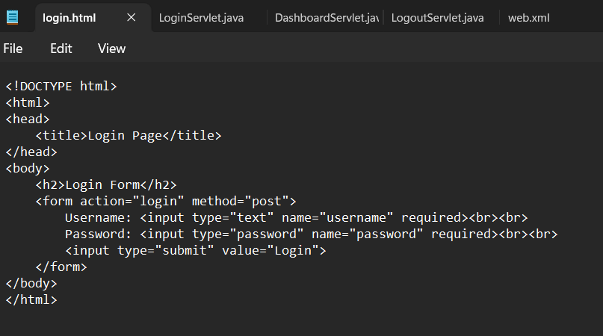
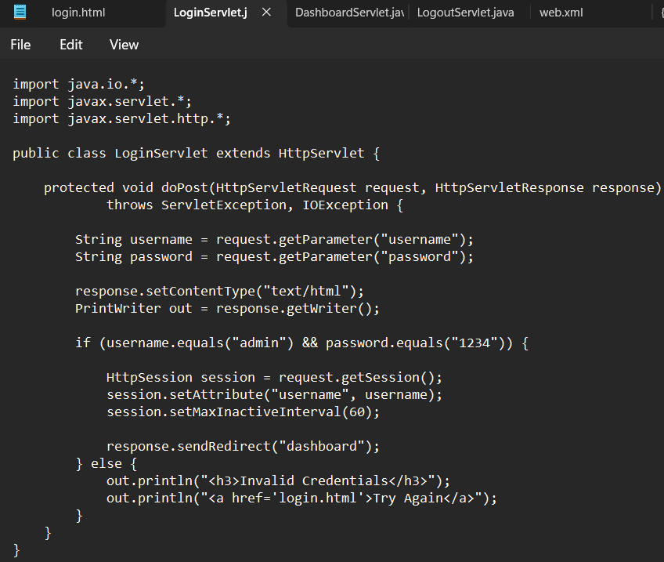
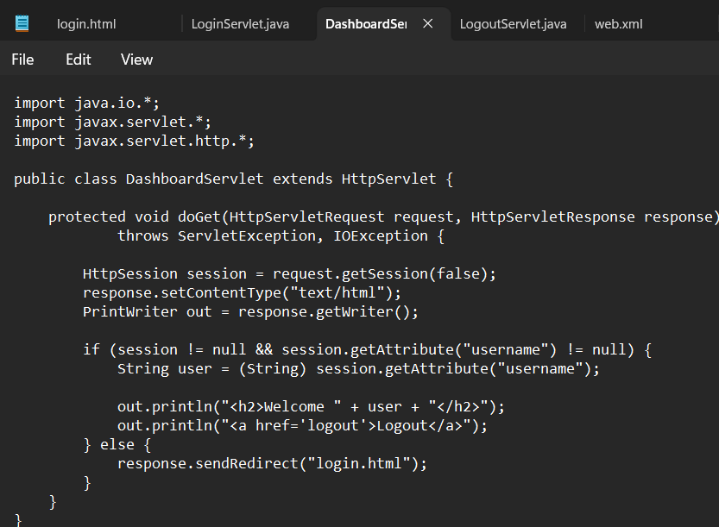
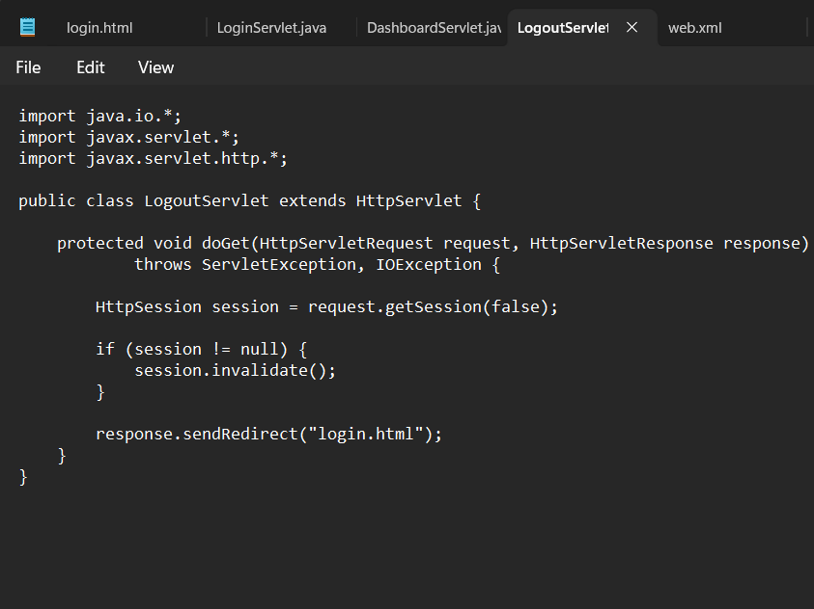
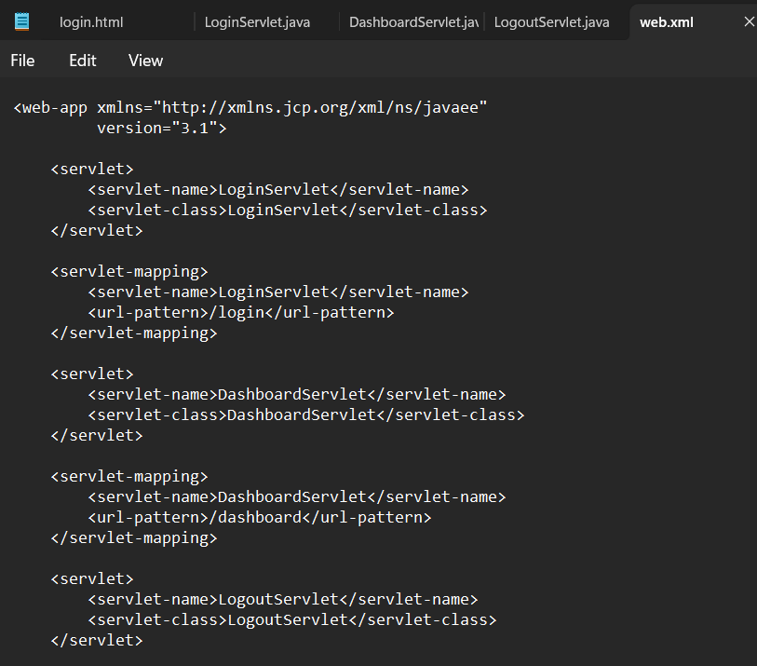
OUTPUT –
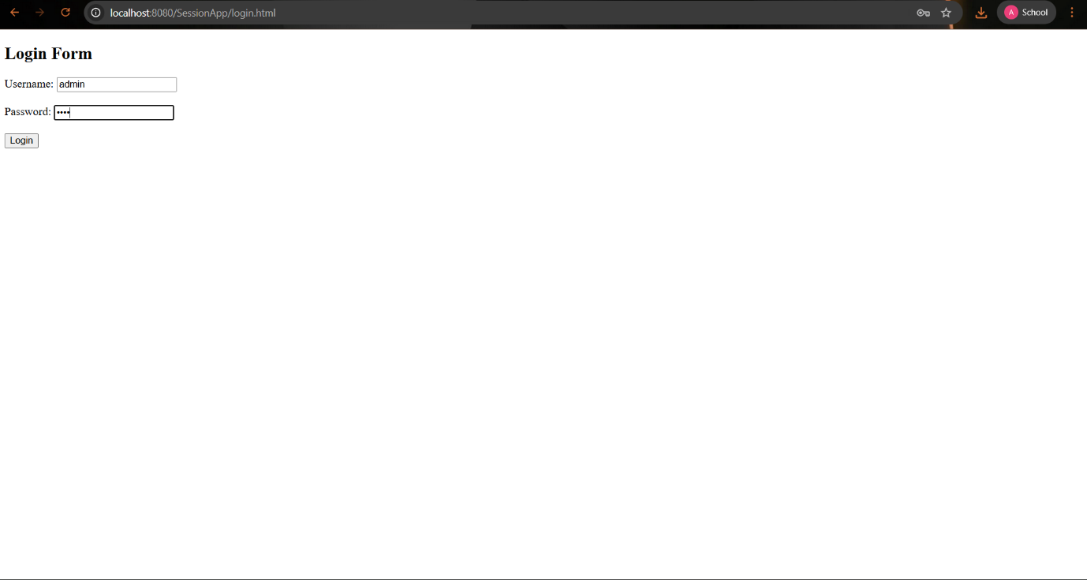
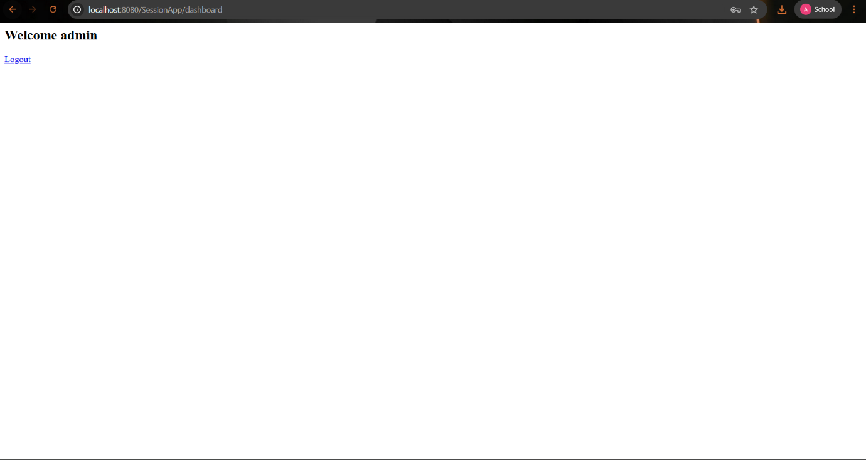
RESULT:
A simple login system is created where the user's session is tracked by a servlet
to demonstrate session tracking using HttpSession.

