**Assignment #4: Visualization Critique**

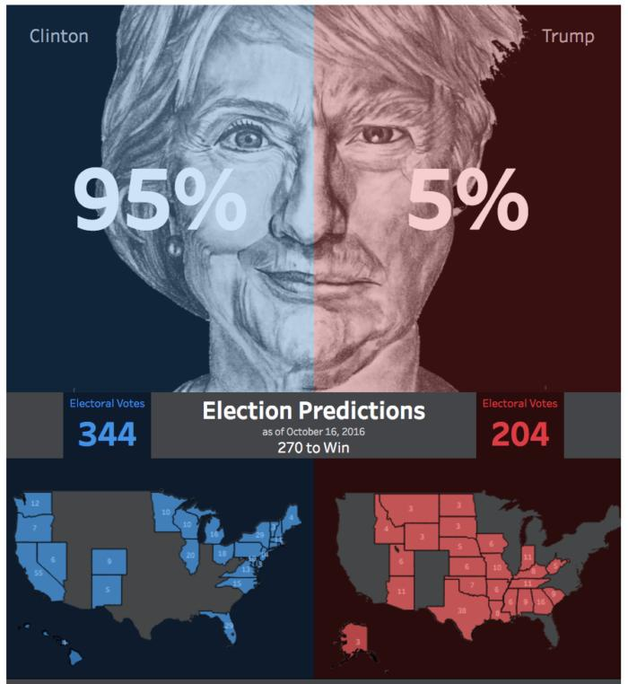

**Source**: <https://www.infoworld.com/article/3136206/data-analytics/data-visualization-and-the-us-election-throughout-history.html>

**b) Write the critique in 1 page, visualization and citations can be appended as extra pages.**

**Principles and Techniques used to critique data:**

1.Data Ink ratio

* Maximize the data ink ratio
* Erase non-data ink

2.Above all, else show the data.

**1. Who are the audience?**

1. Citizens of the United States America reading New York times.

2.People all over the world interested in current affairs.

3.Political parties taking part in the election.

**2. Where is the data source?**

I do not have access to it, it is confidential. I can provide a sample dataset. I have provided a link to a similar dataset:

<https://www.kaggle.com/benhamner/2016-us-election/data>

*Visual source***:**<https://www.infoworld.com/article/3136206/data-analytics/data-visualization-and-the-us-election-throughout-history.html>

Dataset contains: State label, party, state code, and predicted value.

**3. Strengths and weaknesses?**

**Strengths:**

1.Using US map to display data was a good way, this makes it easy for users to understand that we are trying to tell them something about USA. Using the right image or object to convey what is intended to be a very important factor.

2.Also displaying the names of opponents, that is headers are displayed rightly. This helps the users who are not aware of whom we are talking about to know the names of these leaders and go ahead in understanding the story.

3.Contrasting colors are apt. Red and blue are good contrasting colors. Makes it easy for users to compare data among them.

4.Predictions are clearly represented and are of the right font size. Having the right font size in important as making it too small or too big makes the data either unreachable to the user ormakes it too clumsy. But in this the predictions are clearly represented that catches user’s attention easily.

5.Data is not clumsy. Contents are placed neatly, first the predictions and then an elaborate detail on these predictions. Flow of data is right.

**Weakness:**

1.Data Ink Ratio:

* A good data visual is the one, that has maximum data ink ratio. Considering this visual, the predicted values 95 and 5% are supposed to have maximum data ink ratio compared to the background image.
* Erase non-data ink: Background images cover up the predicted value, which implies predicted values have minimum data ink ratio. Thus, reducing data ink ratio of non-data ink would rectify it.

2.Names of leaders are very small in size. This cannot be identified in the first go. This visualization is about two leaders, so it’s important for us to have their names in the right size. So that users know whom we are talking about.

3.There are values mentioned for each state, but they are not visible to the user. Thus the purpose of adding it is not served.

**What are your opinions?**

Overall, it is a good visual which provides us the probability of these two leaders winning an election. Components are very neatly placed, it is not clumsy and it’s of the right size. Font sizes of headers are right, just the font size of values for each state are small and not legible to users. The color combinations chosen for contrasting two parties are right. But as mentioned having the right data ink ratio for representing the predicted value is a missing factor. Predicted values being the story highlight require maximum data-ink ratio. All non-data must have less data ink ratio. By incorporating these changes, this visual can be a good one and convey the untold story.

**How would you design it differently?**

1.Increase data-ink ratio of the predicted values i.e. 95% and 5%.

2.Increase size of maps and text values, to make values visible to users.

3.Increase size of party leaders name, so that users can catch whom and what we are talking about.

4.The headings does not mention which countries election and what are the parties involved. This fails to provide a complete picture. This still leaves an untold story for a person who is unaware of it in the first go. So, creating a right header or caption is equally important