**Assignment 8 -Question 7**

**Anvitha Dinesh Rao –(1213204536)**

**GUI of TryIt Page:**

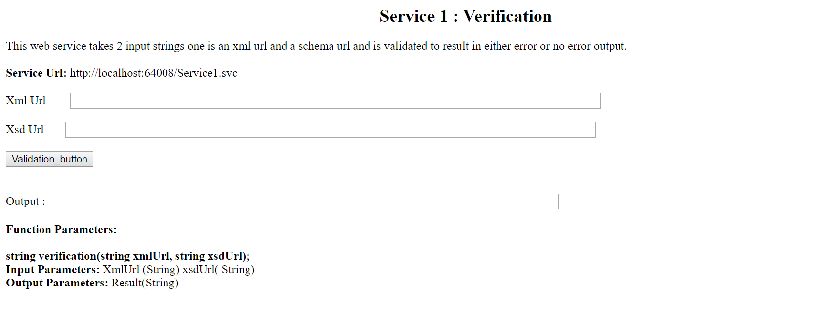

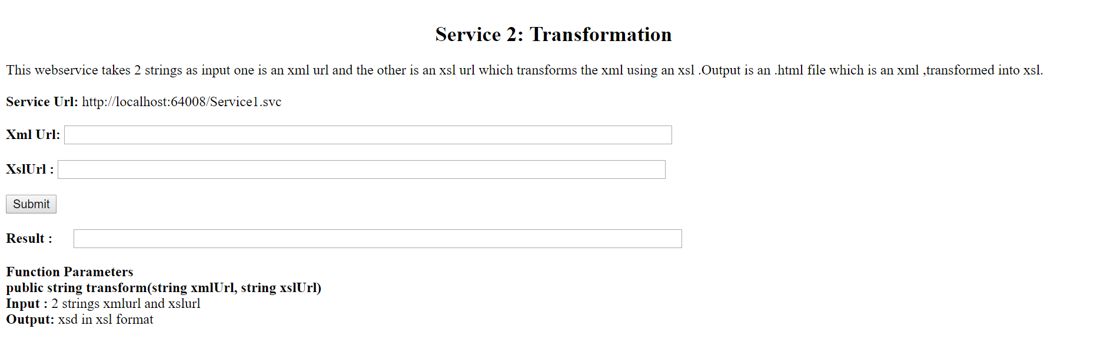

**SERVICE 1: VERIFICATION**

**Testing Service “Verification” with right xml file:**



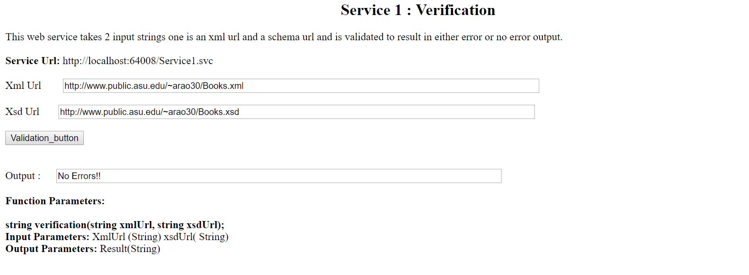



**Testing Service “Verification” with errors: Required attribute missing**

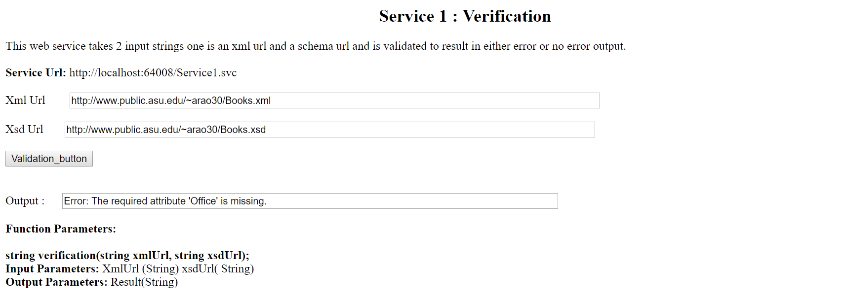



**Service 2: Transformation**



