WLCOME TO HOMESQUARE

Our passion is to help you with the task that takes up so much of your time. This isn't your typical office job. Cleaning, gardening, pet care, and babysitting are just a few of the household duties we can support you with. You can also enjoy the services such as plumbing, electric repairs, internet services, fixing and repair of cc cameras.

Finding time for yourself and relaxing is essential in such a hectic schedule. Rest and self-care are extremely important to us. How about taking use of the beauty services from home? Isn't that fantastic? Spa and salon services are also available at our HomeSquare. The important thing to remember is that we never compromise on our quality and cleanliness standards. As a result, our customers prefer us.

Our website is created in a clear and user-friendly manner. As a result, booking your service won't take up much of your time. The following are the steps you must take:

 Choose a service

Choose your time slot (We provide services from 8 am to 7 pm)

* Relax and enjoy the services (Two hours prior to the service, one of our pros will contact you)

CUSTOMER REVIEWS AND RATINGS

ABOUT US

We strive to give exceptional service to our clients by providing first-class treatment and utilising all available resources to get the best possible results for them.

The company’s objectives are as follows:

* To help customers maintain their independence and quality of life in the comfort of their own homes.
* To provide the finest service possible while remaining friendly, caring, and empathetic.
* To provide appropriate trained and skilled staff that fit our clients’ needs
* To provide continuity of care wherever possible
* To respect the dignity and privacy of our clients

SALON SERVICES

Choose your gender

Male



Female

FEMALE:

Select the services you want

* Hair services
* Waxing
* Threading
* Facial
* Pedicure
* Manicure

HAIR SERVICES

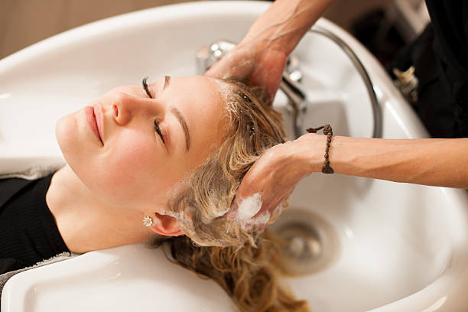 hair wash

 hair cut

 hair color

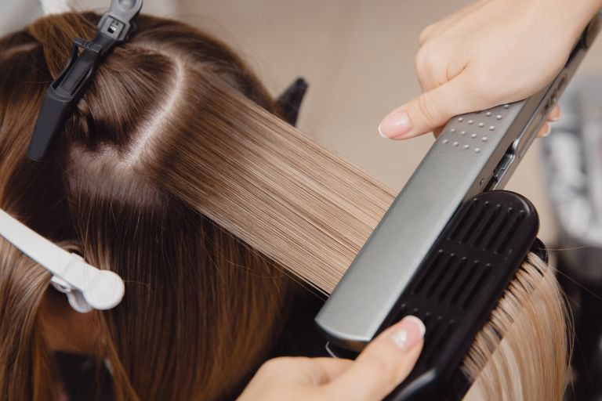 hair straightening

 hair curling