WLCOME TO HOMESQUARE

Our passion is to help you with the task that takes up so much of your time. This isn't your typical office job. Cleaning, gardening, pet care, and babysitting are just a few of the household duties we can support you with. You can also enjoy the services such as plumbing, electric repairs, internet services, fixing and repair of cc cameras.

Finding time for yourself and relaxing is essential in such a hectic schedule. Rest and self-care are extremely important to us. How about taking use of the beauty services from home? Isn't that fantastic? Spa and salon services are also available at our HomeSquare. The important thing to remember is that we never compromise on our quality and cleanliness standards. As a result, our customers prefer us.

Our website is created in a clear and user-friendly manner. As a result, booking your service won't take up much of your time. The following are the steps you must take:

 Choose a service

Choose your time slot (We provide services from 8 am to 7 pm)

* Relax and enjoy the services (Two hours prior to the service, one of our pros will contact you)

CUSTOMER REVIEWS AND RATINGS

ABOUT US

We try to provide outstanding service to our clients by offering first-class therapy and utilising all available resources to get the best possible results. In the comfort of their own homes, we help our customers in maintaining their independence and quality of life. You can have the best services while still being friendly, caring, and understanding. We make every effort to supply appropriate, trained, and skilled personnel to meet the demands of our clients.

* To provide continuity of care wherever possible
* To respect the dignity and privacy of our clients

SALON SERVICES

Choose your gender

Male



Female

FEMALE:

Select the services you want

* Hair services
* Waxing
* Threading
* Facial
* Pedicure
* Manicure

HAIR SERVICES

 hair wash

 hair cut

 hair color

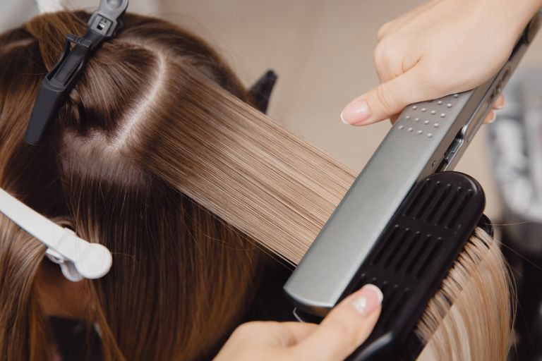 hair straightening

 hair curling

 waxing

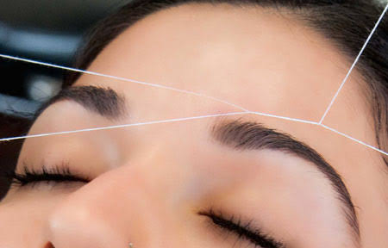 threading

 facial

 pedicure and manicure

MALE:

**Top 5 Home Maintenance tips**

**Gardening!**

While it is critical to water your plants or garden on a daily basis, you must also clean them on a regular basis. Here are a few key points to keep in mind:

* Remove weeds and unwanted detritus from your plant pots and garden.
* Check your plants for pests or insects.
* Mix one and a half teaspoons of mild liquid soap with a litre of water to make a simple pesticide. The solution can be sprayed directly on the plant's damaged areas. Make sure you only spray the solution late at night or early in the morning.

**Cleaning**

Dusting your entire house once every few months is one of the most vital home cleaning duties. All of your furniture, ceiling fans, windows, and appliances should be cleaned. Don't forget to cover door edges and other areas where excess water could cause damage. It is critical to have a robust lock system in place for your doors and windows if you have children at home.

**Painting**

You can look for paint chipping on the outside of your home. Touching up the exterior of your home at least once a year is advised. You have the option of doing the re-painting yourself or hiring a professional.

It's important to remember that re-painting your home during the monsoon season is not a good idea because rain might damage wet paint.

**Plumbing**

It's far too easy to take amenities like flushing toilets and running water for granted. Minor plumbing difficulties, on the other hand, can be a nuisance if something goes wrong, and you should call a licensed plumber to solve it as soon as possible. Using standard supplies should be a priority in any plumbing operation, whether you are a plumber or a property owner who is repairing or updating. You can save money by choosing lower-cost, lower-quality parts and goods, but there are numerous advantages to using high-quality parts and components.

**Electricity**

A regular plan of electrical maintenance is recommended for both old and new properties. Electrical wiring, appliances, switchboards, fittings, and earthing connections must all be in good operating order. Checking your metres, indicators, and instruments for appropriate operation is part of a mid-year inspection. You can test the operation of a thermostat or heater while fastening all panel bolts. Annual maintenance, on the other hand, entails a thorough examination of your complete electrical system. Any discoloured insulation indicates a faulty connection that must be repaired.

Also, double-check that all cables are firmly attached. If the control wiring shows symptoms of wear and corrosion, you should get it replaced as soon as possible by a licenced electrician.