FEDERATED LEARNING

FEDAVGS VS LOCALS

Algorithm | Optimizer | Clients | Epochs | Learning Rate | Seed | Best Iteration | Accuracy | Accuracy (%) | Loss
FedAvg | Adam | 2 | 5 | 0.0005 | 42 | 24 | 0.8548 | 85.48% | 0.3990
FedAvg | SGD | 2 | 5 | 0.0005 | 42 | 1 | 0.4677 | 46.77% | 0.6988
FedAvg | RMSprop | 2 | 5 | 0.0005 | 42 | 35 | 0.8548 | 85.48% | 0.4853
FedAvg | Adagrad | 2 | 5 | 0.0005 | 42 | 48 | 0.7742 | 77.42% | 0.6513

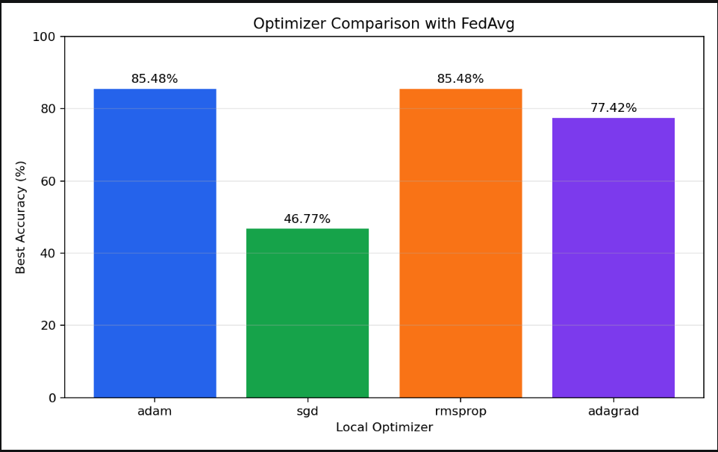
Algorithm | Optimizer | Clients | Epochs | Learning Rate | Seed | Best Iteration | Accuracy | Accuracy (%) | Loss
FedAvgM | Adam | 2 | 5 | 0.0005 | 42 | 20 | 0.8548 | 85.48% | 1.0694
FedAvgM | SGD | 2 | 5 | 0.0005 | 42 | 1 | 0.4677 | 46.77% | 0.6988
FedAvgM | RMSprop | 2 | 5 | 0.0005 | 42 | 10 | 0.8710 | 87.10% | 1.4372
FedAvgM | Adagrad | 2 | 5 | 0.0005 | 42 | 33 | 0.8548 | 85.48% | 0.4485
FEDAVGM VS LOCALS
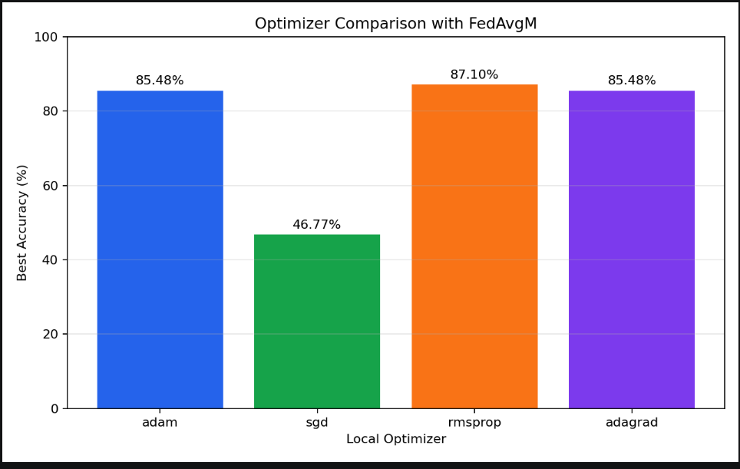

Algorithm | Optimizer | Clients | Epochs | Learning Rate | Seed | Best Iteration | Accuracy | Accuracy (%) | Loss
FedAdam | Adam | 2 | 5 | 0.0005 | 42 | 5 | 0.8387 | 83.87% | 0.8698
FedAdam | SGD | 2 | 5 | 0.0005 | 42 | 49 | 0.7097 | 70.97% | 0.6217
FedAdam | RMSprop | 2 | 5 | 0.0005 | 42 | 5 | 0.8710 | 87.10% | 6.3507
FedAdam | Adagrad | 2 | 5 | 0.0005 | 42 | 10 | 0.8548 | 85.48% | 1.1415
FEDADAM VS LOCALS
