Software Requirements Specification
for
<Software Engineering>
Version 1.0 approved
Prepared by <Otea Andrei-Alexandru,Popa Andrei-Alexandru and Smarandachescu Mircea>
<Facultatea de Automatica,Calculatoare si Electronica Craiova>
<09.03.2021>
Table of Contents
Table of Contents ii
Revision History ii
1. Introduction 1
1.1 Purpose 1
1.2 Document Conventions 1
1.3 Intended Audience and Reading Suggestions 1
1.4 Product Scope 1
1.5 References 1
2. Overall Description 2
2.1 Product Perspective 2
2.2 Product Functions 2
2.3 User Classes and Characteristics 2
2.4 Operating Environment 2
2.5 Design and Implementation Constraints 2
2.6 User Documentation 2
2.7 Assumptions and Dependencies 3
3. External Interface Requirements 3
3.1 User Interfaces 3
3.2 Hardware Interfaces 3
3.3 Software Interfaces 3
3.4 Communications Interfaces 3
4. System Features 4
4.1 System Feature 1 4
4.2 System Feature 2 (and so on) 4
5. Other Nonfunctional Requirements 4
5.1 Performance Requirements 4
5.2 Safety Requirements 5
5.3 Security Requirements 5
5.4 Software Quality Attributes 5
5.5 Business Rules 5
6. Other Requirements 5
Appendix A: Glossary 5
Appendix B: Analysis Models 5
Appendix C: To Be Determined List 6

Revision History

Name | Date | Reason For Changes | Version
Otea Andrei-Alexandru | 08.03.2021 | Analysed the general structure of the SRS and completed some of the subchapters | 1.0
Smarandachescu Mircea | 09.03.2021 | Commit changes | 1.1
Popa Andrei-Alexandru | 10.03.2021 | System Features | 1.2

Introduction

Purpose
So in this document we will describe the software requirements specification for an IT system that will allow the students to send on-line their projects to the teachers and then to receive a grade.Also in this document we will explain some things like the interfaces of the software ,features and characteristics of it and what we will try to implement.

Document Conventions
The document was creating using the srs_template_ieee.doc we received on Google Classroom platform.

Intended Audience and Reading Suggestions
-Guests are the ones who are not logged-in;
-Ordinary users and advanced users, such as students and respectively teachers, who use it for university work (for better organization of student projects);
-Administrator who is interested in working on the project by further developing it or fix existing bugs.

Product Scope
Lecture room will allow students to submit their projects online to teachers (upload facility) and teachers to evaluate them. The computer system comprises an interface with the user (web browser or dedicated application), a database server that will store information about students, students, grades, application server that manages students, projects, notes and a Web server. The user has access to the service only through the interface with the user. The system will provide facilities to students and teachers after they successfully authenticate [password and identifier] (the identifier and password are already considered generated):
- viewing account information
- password change
- uploading projects by the student and entering the required information
- the teacher's visualization of the project files and the afferent information, date, student name
- giving grades and comments by teachers
Depending on the type of authentication (student, teacher) the user will be allowed certain functionalities. A student can have several projects and a teacher can coordinate more many projects.

References
https://goo.gl/nsUFwy

https://www.google.com/url?sa=t&rct=j&q=&esrc=s&source=web&cd=&ved=2ahUKEwijkrPrwaXvAhVPxYUKHcV6A6kQFjAKegQIAhAD&url=https%3A%2F%2Fuccs.edu%2FDocuments%2Ftboult%2Fsrs.doc&usg=AOvVaw0b_gBm3b9h-ELvAvQQg9N_

https://relevant.software/blog/software-requirements-specification-srs-document/

Overall Description

Product Perspective
Lecture Room is a free web service for schools, targeting the educational environment and aiming for simplyfing the creation, distribution and grade assignments. The primary purpose of Lecture Room is to streamline the process of sharing files between teachers and students. It is split into 2 sides, the frontend ( the client side ) and the backend ( the server side ) .
•The client side is a client-window that actively communicates with the Lecture Room’s Server . •The Lecture Room’s Server is a Firebase Realtime Database in a cloud-hosted database in which the JSON file is stored. The data is synchronized in real-time to every connected client. The Firebase Realtime Database is a NoSQL ( Not Only Structured Query Language ) and it is going to store all the data.

Product Functions
-createUser(); the registration function. Values will be captured from a form and then the data is parsed and stored into Firebase project.
-login($username, $password); the function for the login. Values will be captured from a form and then passed to signInWithEmailAndPassword (firebase.auth().signInWithEmailAndPassword(email,password)
-logout(); the function that allows the user to sign out ( firebase.auth().signOut() )
-message(); the function that will either display a successful login or it will display the ‘Sorry, wrong username or password;
-upload(); the function that will upload the files to the Firebase Database Cloud Storage. A reference needs to be created to the full path of the file.
-viewProfile(); the function that will redirect the user to it’s profile where the user can see it’s personal details.
-addComment(); the function that allows either the teacher or the student to add a comment. First it checks for the user’s status ( either it is signed in or signed out ) and if the user is signed it you are allowed to add a comment.
-addGrade(); the function that allows the teacher to give a relative mark to the student.

User Classes and Characteristics
Stundent: The student is the one that is going to upload his projects to the teachers.All of the students that logged in can upload files at simultaneous time, and no knowledge is required to use it due to it’s great User Experience ( UX )

Teacher:The teacher is the one that is going to review the student’s uploaded content,to give marks and comments and also it is able to see just a few personal details about the student (i.g.:Name,Class his attending and so on).

Client: The system that connects to the server and handles the uploads and submit the information back to the server.

Server:The server is the system that is going to store the data and information.

2.4 Operating Environment
It is going to operate in the following operating systems:

-Windows
-Mac OS X
-Linux

Design and Implementation Constraints
The User Interface (UI) of the program is created using HTML5 for it’s structure and style it with CSS3(Cascading Style Sheets) for the frontend. The backend is created using Firebase Framework developed by Google. The requirements for this platform are low, so basically everyone can enjoy it.

User Documentation
The official links of the project are going to be released as soon as possible as the whole project is still in progress.

Assumptions and Dependencies
First of all, you need a stable internet connection. There are a few assumptions we have with this project. One is that the two major types of users for this program will be school teachers and students. Keeping this in mind, the group also assumes that the interface has to be very simple because of the lack of experience the users may have. We also assume that the open-source websites we will get our simulations from will not drastically change their technology or decide to cut off access to their resources. Another assumption that the group has is that one person will be put in charge of adding teachers to the database, so that false teacher accounts are not created.

External Interface Requirements

User Interfaces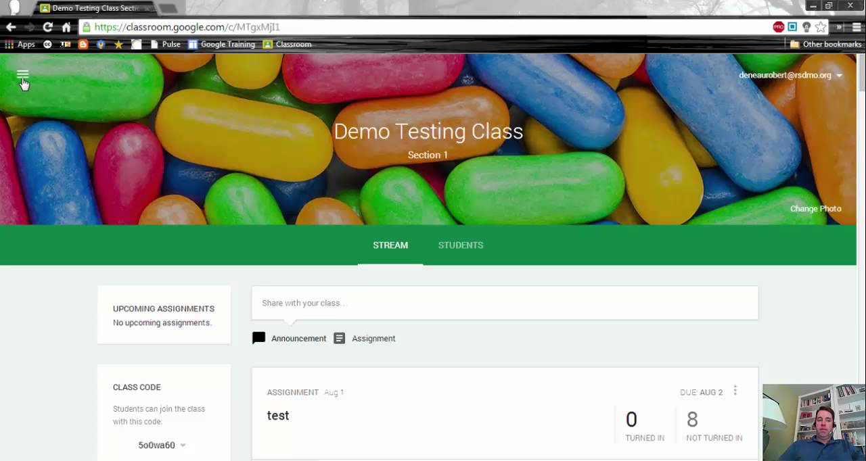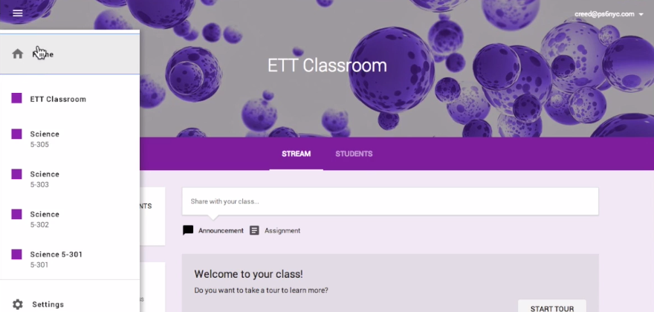

The User Interface is going to a simple one, considering that in a service like the one we are creating (for students to upload their projects, see their classes and so on) the most important thing is the UX( User Experience ) so the students can easily use it and interact with it. It is going to contain boxes for every class the student attends to (the boxes are going to contain the name of the teacher,the name of the class and a button to access the course details ). After the student enters the course details he will be able to see the requirements of the teacher (The assignments he was given and also the courses he was given) and he will also be able to upload his assignments.

Hardware Interfaces
Bandwidth greater than 50 KBps (400 kbps) and latency under 150 ms

Component | Minimum | Recommended
Procesor | 1.9 GHz x86- or x64-bit dual core processor with SSE2 instruction set | 3.3 gigahertz (GHz) or faster 64-bit dual core processor with SSE2 instruction set
Memory | 2GB-RAM | 4-GB RAM or more
Display | Super VGA with a resolution of 1024 x 768 | Super VGA with a resolution of 1024 x 768

Software Interfaces

The Frontend for this Web Application is created in HTML5/CSS3/JS . The database for this platform is going to be a noSQL one ( Firebase ) with node.js Firebase Admin node.js SDK. The Firebase Realtime Database is a cloud-hosted NoSQL database that lets you store and sync data between your users in realtime. Realtime syncing makes it easy for your users to access their data from any device: web or mobile, and it helps your users collaborate with one another. The Realtime Database integrates with Firebase Authentication to provide simple and intuitive authentication for developers. You can use our declarative security model to allow access based on user identity or with pattern matching on your data.

Communications Interfaces
HTTP is a classic "client-server" protocol. Users click a link on their web browser (the client), and the browser sends a request over the internet to a web server that houses the site the user requested. The server sends back the content of the site, such as text and images, which display in users' web browsers. HTTP is an unsecure communications protocol because the data it sends back and forth between a browser and a server is unencrypted and can be intercepted by third parties.

System Features
This section shows most prominent features and explains how they can be used and the results they will give back to the user.

System Feature Student
4.1.1 Description and Priority

A student enters Learn Room’s URl and enters the website.
Priority level: low

4.1.2 Stimulus/Response Sequences

Preconditions: none
- Student enters the URl
- The Learn Room Interface shows up.
4.1.3 Functional Requirements

REQ-1: Can Login to their account through a username and a password.
REQ-2: Password requires atleast ONE CAPITAL LETTER , one symbol ( %, ^, @, *, and so on) and atleast 1 number.
REQ-3: The student is able to make the password either visible or hidden via a checkbox.
REQ-4: The student is able to log out of their account via a sign out button.
REQ-5: The student is able to change the password via a “change password” button.
REQ-6: The student is able to retrieve his password via a “I forgot my password” button
REQ-7: The student will receive a popup message even if the login was successful or the login failed.
REQ-8: The student can view information about their account and personal information.
REQ-9: The student can have simultaneous projects at once.
REQ-10: The student can upload multiple projects.
REQ-11: The student can leave comments to the assignments.

System Feature Teacher
4.1.1 Description and Priority

A Teacher has a medium rank. Its rank is higher than a student’s, but lower than an administrator. The teacher is also able to connect to the Learn Room platform via a URl and has the right to see the student’s assignments, give marks to them and see just a few personal information about them (i.g: their name and minor stuff )

Priority level: medium

4.1.2 Stimulus/Response Sequences

Preconditions: none
- Teacher enters the URl
- The Learn Room Interface shows up.
4.1.3 Functional Requirements

REQ-1: Can Login to their account through a username and a password.
REQ-2: Password requires atleast ONE CAPITAL LETTER , one symbol ( %, ^, @, *, and so on) and atleast 1 number.
REQ-3: The teacher is able to make the password either visible or hidden via a checkbox.
REQ-4: The teacher is able to log out of their account via a sign out button.
REQ-5: The teacher is able to change the password via a “change password” button.
REQ-6: The teacher is able to retrieve his password via a “I forgot my password” button
REQ-7: The teacher will receive a popup message even if the login was successful or the login failed.
REQ-8: The teacher can view information about their account and personal information and some minor informations about the student.
REQ-9: The teacher is able to create/delete a class.
REQ-10: The teacher can send invitations to the courses to the students.
REQ-11: The teacher is able to remove a student from the course.
REQ-11: The teacher can have simultaneous courses at once.
REQ-12: The teacher can send multiple assignments at once.
REQ-13: The teacher can leave comments to the assignments.
REQ-14: The teacher is able to give marks to the students.

System Feature Administrator
4.1.1 Description and Priority

An Administrator has a high rank. Its rank is the highest and it is responsible for managing the teachers and students like adding a new student, adding a new teacher, remove a teacher, remove a student and see all the information about them and modify their data.

4.1.2 Stimulus/Response Sequences

Preconditions: none
- Administrator enters the URl
- The Learn Room Admin Panel Interface shows up.
4.1.3 Functional Requirements

REQ-1: Can Login to their account through a username and a password.
REQ-2: Password requires atleast ONE CAPITAL LETTER , one symbol ( %, ^, @, *, and so on) and atleast 1 number.
REQ-3: The admin is able to make the password either visible or hidden via a checkbox.
REQ-4: The admin is able to log out of their account via a sign out button.
REQ-5: The admin is able to change the password via a “change password” button.
REQ-6: The admin is able to retrieve his password via a “I forgot my password” button
REQ-7: The admin will receive a popup message even if the login was successful or the login failed.
REQ-8: The admin is able to add/remove a student from a class.
REQ-9: The admin is able to modify data about student/teacher.
REQ-10: The admin is able to add a class/remove a class.
REQ-11: The platform is based on a client-server protocol
REQ-12: The login information is stored in a secured field from the database.

Other Nonfunctional Requirements

Performance Requirements
• A fast response is required when the user enters the URl. It should not exceed 2000ms as the user must see action within that time.
• The application should fully load and be fully responsive in less than 2000ms.
• Whenever the user interacts with the interface the requested update should not exceed 1000ms.
• The database is updated in realtime and must be updated in less than 1000ms.
• Due to Firebase the system is able to create a large number of users (more than 100.000 )

Safety Requirements

Not Applicable.

Security Requirements
• If someone tries to use an administrator’s credentials, an email will be sent to the associated email of that username (if both usernames are the same but the password is incorrect ) to notify the admin that someone is trying to login.
• If a lower rank user tries to use the credentials (if the username matches) but the password is incorrect, a popup message will appear notifying him that the username/password are wrong.
• If a lower rank user tries to use the credentials but the username does not match, he will be prompted with a message if he would like to create an account.
• If a lower rank user fails to log in 3 times in a row in less than 3 minutes he will be receiving a cooldown for 15 minutes before he has 3 more attempts.
• If a lower rank user tries to create an account and the username he is trying to create already exists, he will be prompted with a message to set a different username.
• The Authentication is encrypted with associated data (AEAD)

Software Quality Attributes
Usability: Checking that the system is easy to handle and navigates in the most expected way with no delays.

Functionality: Checking that the system provide the right tools for editing question databases,creating session tests and analyzing the test sessions.

Modifiability: To ensure we don’t code ourselves into a corner and can maintain and evolve what we have built.

Availability: Checking that the system always has something to funtion and always pop up error messages in case of component failure.

Quaility code rules

-DRY(Don’t repeat yourself), duplication must be avoided;
-there should be one statement per line;
-there should be also one declaration per line;
-each ‘if’ statement should have an else statement;
-meaningful names for query variables;
-using of KISS (keep it simple,stupid);
-using software entities (like subprograms and classes);
-a method should have a single purpose;
-a method should use all provided parameters

Business Rules
Not applicable.

Other Requirements
<Define any other requirements not covered elsewhere in the SRS. This might include database requirements, internationalization requirements, legal requirements, reuse objectives for the project, and so on. Add any new sections that are pertinent to the project.>
Appendix A: Glossary
<Define all the terms necessary to properly interpret the SRS, including acronyms and abbreviations. You may wish to build a separate glossary that spans multiple projects or the entire organization, and just include terms specific to a single project in each SRS.>
Appendix B: Analysis Models
<Optionally, include any pertinent analysis models, such as data flow diagrams, class diagrams, state-transition diagrams, or entity-relationship diagrams.>
Appendix C: To Be Determined List
<Collect a numbered list of the TBD (to be determined) references that remain in the SRS so they can be tracked to closure.>

